BET PS data for Stock Synthesis

Haikun Xu

2022-06-10

This example code demonstrates how to compile the purse-seine catch and length composition data for the stock assessment of bigeye tuna in the eastern Pacific Ocean.

library(tidyverse)  
save_dir <- "D:/OneDrive - IATTC/IATTC/2022/BSE stuff from Cleridy/BET/"  
yr.end <- 2021  
  
BET.OBJ.Catch.20002021 <- read.csv(paste0(save_dir,"BET.OBJ.Catch.20002021.csv"))  
BET.OBJ.Catch.19751999 <- read.csv(paste0(save_dir,"BET.OBJ.Catch.19751999.csv"))  
  
BET.NOA.Catch.20002021 <- read.csv(paste0(save_dir,"BET.NOA.Catch.20002021.csv"))  
BET.NOA.Catch.19751999 <- read.csv(paste0(save_dir,"BET.NOA.Catch.19751999.csv"))  
  
BET.DEL.Catch.20002021 <- read.csv(paste0(save_dir,"BET.DEL.Catch.20002021.csv"))  
BET.DEL.Catch.19751999 <- read.csv(paste0(save_dir,"BET.DEL.Catch.19751999.csv"))

Year_all <- data.frame(Year = seq(1,(yr.end-1974)*4),  
 Area = rep(c("A1","A2","A3","A4","A5"), each = (yr.end-1974)*4))  
  
BET_OBJ_Catch <- rbind(BET.OBJ.Catch.19751999,BET.OBJ.Catch.20002021) %>%   
 mutate(Year=(year-1975)*4+quarter) %>%  
 gather(3:7,key="Area",value="Catch") %>%   
 select(Year,Area,Catch)  
BET_OBJ_Catch <- left_join(Year_all,BET_OBJ_Catch) %>%  
 mutate(Catch=ifelse(is.na(Catch),0,Catch),  
 Type="OBJ")  
  
BET_NOA_Catch <- rbind(BET.NOA.Catch.19751999,BET.NOA.Catch.20002021) %>%   
 mutate(Year=(year-1975)*4+quarter) %>%  
 gather(3:7,key="Area",value="Catch") %>%   
 select(Year,Area,Catch)  
BET_NOA_Catch <- left_join(Year_all,BET_NOA_Catch) %>%  
 mutate(Catch=ifelse(is.na(Catch),0,Catch),  
 Type="NOA")  
  
BET_DEL_Catch <- rbind(BET.DEL.Catch.19751999,BET.DEL.Catch.20002021) %>%   
 mutate(Year=(year-1975)*4+quarter) %>%  
 gather(3:7,key="Area",value="Catch") %>%   
 select(Year,Area,Catch)  
BET_DEL_Catch <- left_join(Year_all,BET_DEL_Catch) %>%  
 mutate(Catch=ifelse(is.na(Catch),0,Catch),  
 Type="DEL")  
  
BET_NOA_Catch$Catch <- BET_NOA_Catch$Catch + BET_DEL_Catch$Catch  
  
BET_PS_Catch <- rbind(BET_OBJ_Catch,BET_NOA_Catch)  
write.csv(BET_PS_Catch,file=paste0(save_dir,"BET_PS_Catch_1975-",yr.end,".csv"),row.names = FALSE)

ggplot(data=BET_PS_Catch) +  
 geom_line(aes(x=Year,y=Catch,color=Type)) +  
 facet_wrap(~Area,nrow=5,scales = "free") +  
 geom_vline(xintercept = 100.5,linetype = "dashed") +  
 theme_bw(16)

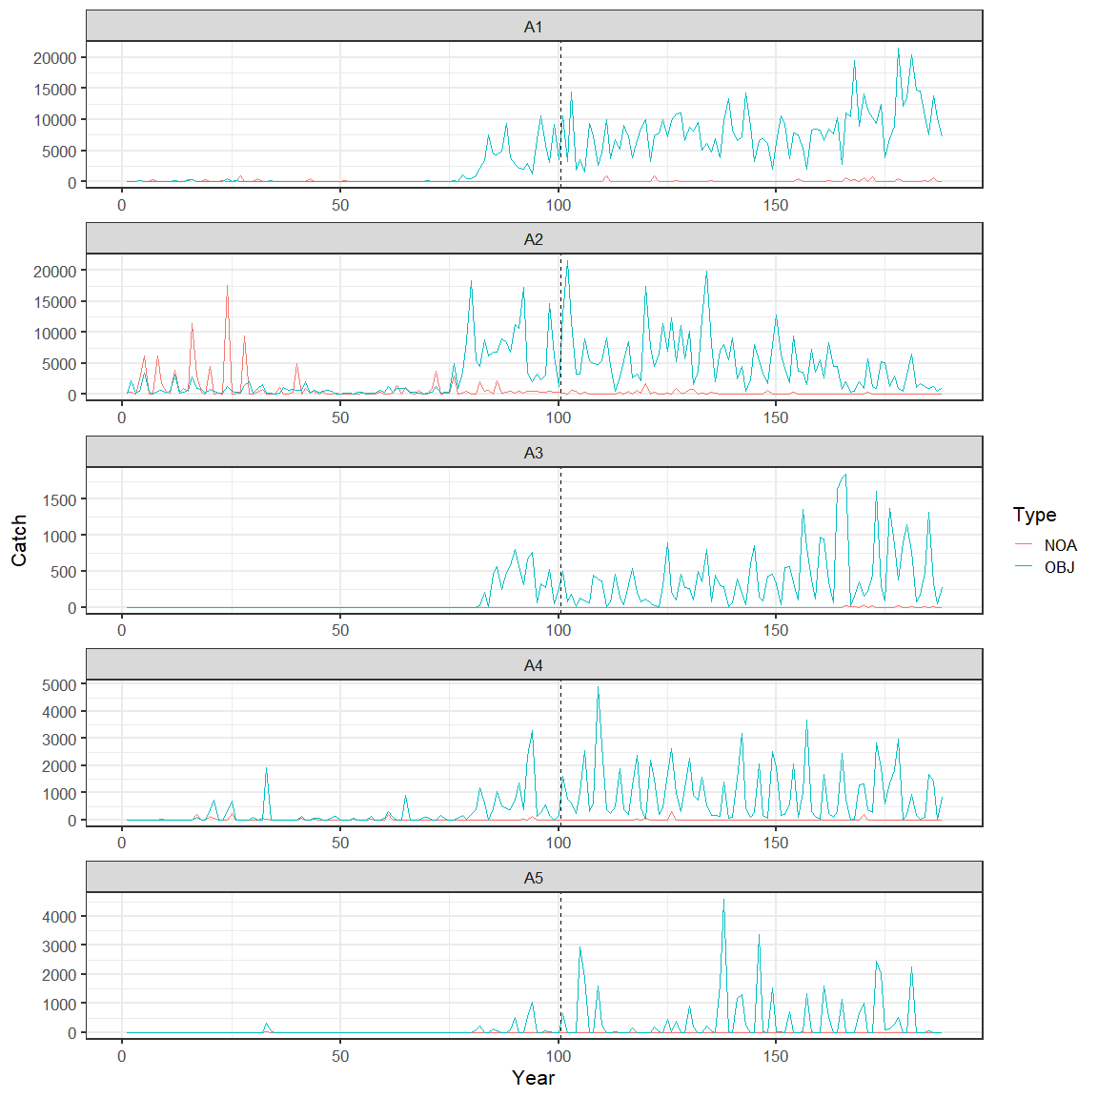

BET.OBJ.Comp.20002021 <- read.csv(paste0(save_dir,"BET.OBJ.Comp.20002021.csv"))  
BET.OBJ.Comp.19751999 <- read.csv(paste0(save_dir,"BET.OBJ.Comp.19751999.csv"))  
  
BET.NOA.Comp.20002021 <- read.csv(paste0(save_dir,"BET.NOA.Comp.20002021.csv"))  
BET.NOA.Comp.19751999 <- read.csv(paste0(save_dir,"BET.NOA.Comp.19751999.csv"))  
  
# BET.DEL.Comp.20002021 <- read.csv(paste0(save_dir,"BET.DEL.Comp.20002021.csv"))  
# BET.DEL.Comp.19751999 <- read.csv(paste0(save_dir,"BET.DEL.Comp.19751999.csv"))

BET_OBJ_Comp <- rbind(BET.OBJ.Comp.19751999,BET.OBJ.Comp.20002021) %>%  
 mutate(Year=(year-1975)*4+quarter, Type="OBJ") %>%  
 arrange(area,Year)  
BET_OBJ_Comp <- BET_OBJ_Comp[c(207,206,3:205)]  
  
BET_NOA_Comp <- rbind(BET.NOA.Comp.19751999,BET.NOA.Comp.20002021) %>%  
 mutate(Year=(year-1975)*4+quarter, Type="NOA") %>%  
 arrange(area,Year)  
BET_NOA_Comp <- BET_NOA_Comp[c(207,206,3:205)]  
  
BET_PS_Comp <- rbind(BET_OBJ_Comp,BET_NOA_Comp)  
write.csv(BET_PS_Comp,file=paste0(save_dir,"BET_PS_Comp_1975-",yr.end,".csv"),row.names = FALSE)

names(BET_PS_Comp)[5:205] <- 1:201  
BET_PS_Comp_mean <- BET_PS_Comp %>%  
 gather(5:205,key="Length",value=comp) %>%  
 group_by(Type,area,Length) %>%  
 summarise(Comp=sum(comp*nwells)) %>%  
 group_by(Type,area) %>%  
 mutate(Length=as.numeric(Length),Comp=Comp/sum(Comp))  
  
ggplot(data=BET_PS_Comp_mean) +  
 geom_line(aes(x=Length,y=Comp,color=Type)) +  
 facet_wrap(~area,nrow = 3) +  
 theme_bw(16)

