SKJ PS data for Stock Synthesis

Haikun Xu

2022-06-10

This example code demonstrates how to compile the purse-seine catch and length composition data for the stock assessment of skipjack tuna in the eastern Pacific Ocean.

library(tidyverse)  
save_dir <- "D:/OneDrive - IATTC/IATTC/2022/BSE stuff from Cleridy/SKJ/"  
yr.end <- 2021  
  
SKJ.OBJ.Catch.20002021 <- read.csv(paste0(save_dir,"SKJ.OBJ.Catch.20002021.csv"))  
  
SKJ.NOA.Catch.20002021 <- read.csv(paste0(save_dir,"SKJ.NOA.Catch.20002021.csv"))  
  
SKJ.DEL.Catch.20002021 <- read.csv(paste0(save_dir,"SKJ.DEL.Catch.20002021.csv"))

Year_OBJ <- data.frame(Year = seq(101,(yr.end-1974)*4),  
 Area = rep(c("A1","A2","A3","A4"), each = (yr.end-1999)*4))  
  
SKJ_OBJ_Catch <- SKJ.OBJ.Catch.20002021 %>%   
 mutate(Year=(year-1975)*4+quarter) %>%  
 gather(3:6,key="Area",value="Catch") %>%   
 select(Year,Area,Catch)  
SKJ_OBJ_Catch <- left_join(Year_OBJ,SKJ_OBJ_Catch) %>%  
 mutate(Catch=ifelse(is.na(Catch),0,Catch),  
 Type="OBJ")  
  
Year_NOA <- data.frame(Year = seq(101,(yr.end-1974)*4),  
 Area = rep(c("A1","A2","A3","A4"), each = (yr.end-1999)*4))  
SKJ_NOA_Catch <- SKJ.NOA.Catch.20002021 %>%   
 mutate(Year=(year-1975)*4+quarter) %>%  
 gather(3:6,key="Area",value="Catch") %>%   
 select(Year,Area,Catch)  
SKJ_NOA_Catch <- left_join(Year_NOA,SKJ_NOA_Catch) %>%  
 mutate(Catch=ifelse(is.na(Catch),0,Catch),  
 Type="NOA")  
  
Year_DEL <- data.frame(Year = seq(101,(yr.end-1974)*4),  
 Area = rep(c("A1","A2"), each = (yr.end-1999)*4))  
SKJ_DEL_Catch <- SKJ.DEL.Catch.20002021 %>%   
 mutate(Year=(year-1975)*4+quarter) %>%  
 gather(3:4,key="Area",value="Catch") %>%   
 select(Year,Area,Catch)  
SKJ_DEL_Catch <- left_join(Year_DEL,SKJ_DEL_Catch) %>%  
 mutate(Catch=ifelse(is.na(Catch),0,Catch),  
 Type="DEL")  
  
SKJ_PS_Catch <- rbind(SKJ_OBJ_Catch,SKJ_NOA_Catch,SKJ_DEL_Catch)  
write.csv(SKJ_PS_Catch,file=paste0(save_dir,"SKJ_PS_Catch_1975-",yr.end,".csv"),row.names = FALSE)

ggplot(data=SKJ_PS_Catch) +  
 geom_line(aes(x=Year,y=Catch,color=Area)) +  
 facet_wrap(~Type,nrow=4,scales = "free") +  
 theme_bw(16)

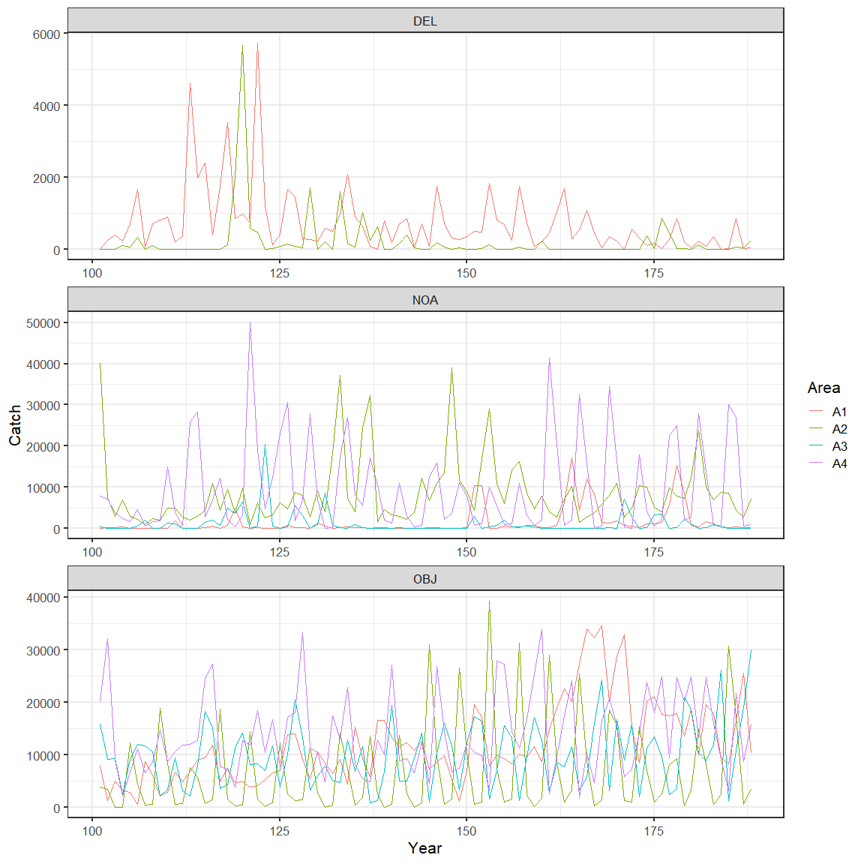

SKJ.OBJ.Comp.20002021 <- read.csv(paste0(save_dir,"SKJ.OBJ.Comp.20002021.csv"))  
  
SKJ.NOA.Comp.20002021 <- read.csv(paste0(save_dir,"SKJ.NOA.Comp.20002021.csv"))  
  
SKJ.DEL.Comp.20002021 <- read.csv(paste0(save_dir,"SKJ.DEL.Comp.20002021.csv"))

SKJ_OBJ_Comp <- SKJ.OBJ.Comp.20002021 %>%  
 mutate(Year=(year-1975)*4+quarter, Type="OBJ") %>%  
 arrange(area,Year)  
SKJ_OBJ_Comp <- SKJ_OBJ_Comp[c(207,206,3:205)]  
  
SKJ_NOA_Comp <- SKJ.NOA.Comp.20002021 %>%  
 mutate(Year=(year-1975)*4+quarter, Type="NOA") %>%  
 arrange(area,Year)  
SKJ_NOA_Comp <- SKJ_NOA_Comp[c(207,206,3:205)]  
  
SKJ_DEL_Comp <- SKJ.DEL.Comp.20002021 %>%  
 mutate(Year=(year-1975)*4+quarter, Type="DEL") %>%  
 arrange(area,Year)  
SKJ_DEL_Comp <- SKJ_DEL_Comp[c(207,206,3:205)]  
  
SKJ_PS_Comp <- rbind(SKJ_OBJ_Comp,SKJ_NOA_Comp,SKJ_DEL_Comp)  
write.csv(SKJ_PS_Comp,file=paste0(save_dir,"SKJ_PS_Comp_1975-",yr.end,".csv"),row.names = FALSE)

names(SKJ_PS_Comp)[5:205] <- 1:201  
SKJ_PS_Comp_mean <- SKJ_PS_Comp %>%  
 gather(5:205,key="Length",value=comp) %>%  
 group_by(Type,area,Length) %>%  
 summarise(Comp=sum(comp*nwells)) %>%  
 group_by(Type,area) %>%  
 mutate(Length=as.numeric(Length),Comp=Comp/sum(Comp))  
  
ggplot(data=SKJ_PS_Comp_mean) +  
 geom_line(aes(x=Length,y=Comp,color=area)) +  
 facet_wrap(~Type,nrow = 3) +  
 theme_bw(16)

