YFT PS data for Stock Synthesis

Haikun Xu

2024-11-18

This example code demonstrates how to compile the purse-seine catch and length composition data for the stock assessment of yellowfin tuna in the eastern Pacific Ocean.

library(tidyverse)  
save_dir <- "D:/OneDrive - IATTC/IATTC/2022/BSE stuff from Cleridy/YFT/"  
yr.end <- 2023  
  
YFT.OBJ.Catch.20002023 <- read.csv(paste0(save_dir,"YFT.OBJ.Catch.20002023.csv"))  
YFT.OBJ.Catch.19751999 <- read.csv(paste0(save_dir,"YFT.OBJ.Catch.19751999.csv"))  
  
YFT.NOA.Catch.20002023 <- read.csv(paste0(save_dir,"YFT.NOA.Catch.20002023.csv"))  
YFT.NOA.Catch.19751999 <- read.csv(paste0(save_dir,"YFT.NOA.Catch.19751999.csv"))  
  
YFT.DEL.Catch.20002023 <- read.csv(paste0(save_dir,"YFT.DEL.Catch.20002023.csv"))  
YFT.DEL.Catch.19751999 <- read.csv(paste0(save_dir,"YFT.DEL.Catch.19751999.csv"))

Year_OBJ <- data.frame(Year = seq(1,(yr.end-1974)*4),  
 Area = rep(c("A1","A2","A3","A4","A5"), each = (yr.end-1974)*4))  
  
YFT_OBJ_Catch <- rbind(YFT.OBJ.Catch.19751999,YFT.OBJ.Catch.20002023) %>%   
 mutate(Year=(year-1975)*4+quarter) %>%  
 gather(3:7,key="Area",value="Catch") %>%   
 select(Year,Area,Catch)  
YFT_OBJ_Catch <- left_join(Year_OBJ,YFT_OBJ_Catch) %>%  
 mutate(Catch=ifelse(is.na(Catch),0,Catch),  
 Type="OBJ")  
  
Year_NOA <- data.frame(Year = seq(1,(yr.end-1974)*4),  
 Area = rep(c("A1","A2","A3","A4","A5"), each = (yr.end-1974)*4))  
YFT_NOA_Catch <- rbind(YFT.NOA.Catch.19751999,YFT.NOA.Catch.20002023) %>%   
 mutate(Year=(year-1975)*4+quarter) %>%  
 gather(3:7,key="Area",value="Catch") %>%   
 select(Year,Area,Catch)  
YFT_NOA_Catch <- left_join(Year_NOA,YFT_NOA_Catch) %>%  
 mutate(Catch=ifelse(is.na(Catch),0,Catch),  
 Type="NOA")  
  
Year_DEL <- data.frame(Year = seq(1,(yr.end-1974)*4),  
 Area = rep(c("A1","A2","A3","A4"), each = (yr.end-1974)*4))  
YFT_DEL_Catch <- rbind(YFT.DEL.Catch.19751999,YFT.DEL.Catch.20002023) %>%   
 mutate(Year=(year-1975)*4+quarter) %>%  
 gather(3:6,key="Area",value="Catch") %>%   
 select(Year,Area,Catch)  
YFT_DEL_Catch <- left_join(Year_DEL,YFT_DEL_Catch) %>%  
 mutate(Catch=ifelse(is.na(Catch),0,Catch),  
 Type="DEL")  
  
YFT_PS_Catch <- rbind(YFT_OBJ_Catch,YFT_NOA_Catch,YFT_DEL_Catch)  
write.csv(YFT_PS_Catch,file=paste0(save_dir,"YFT_PS_Catch_1975-",yr.end,".csv"),row.names = FALSE)

ggplot(data=YFT_PS_Catch) +  
 geom_line(aes(x=Year,y=Catch,color=Area)) +  
 facet_wrap(~Type,nrow=3,scales = "free") +  
 geom_vline(xintercept = 100.5,linetype = "dashed") +  
 theme_bw(16)

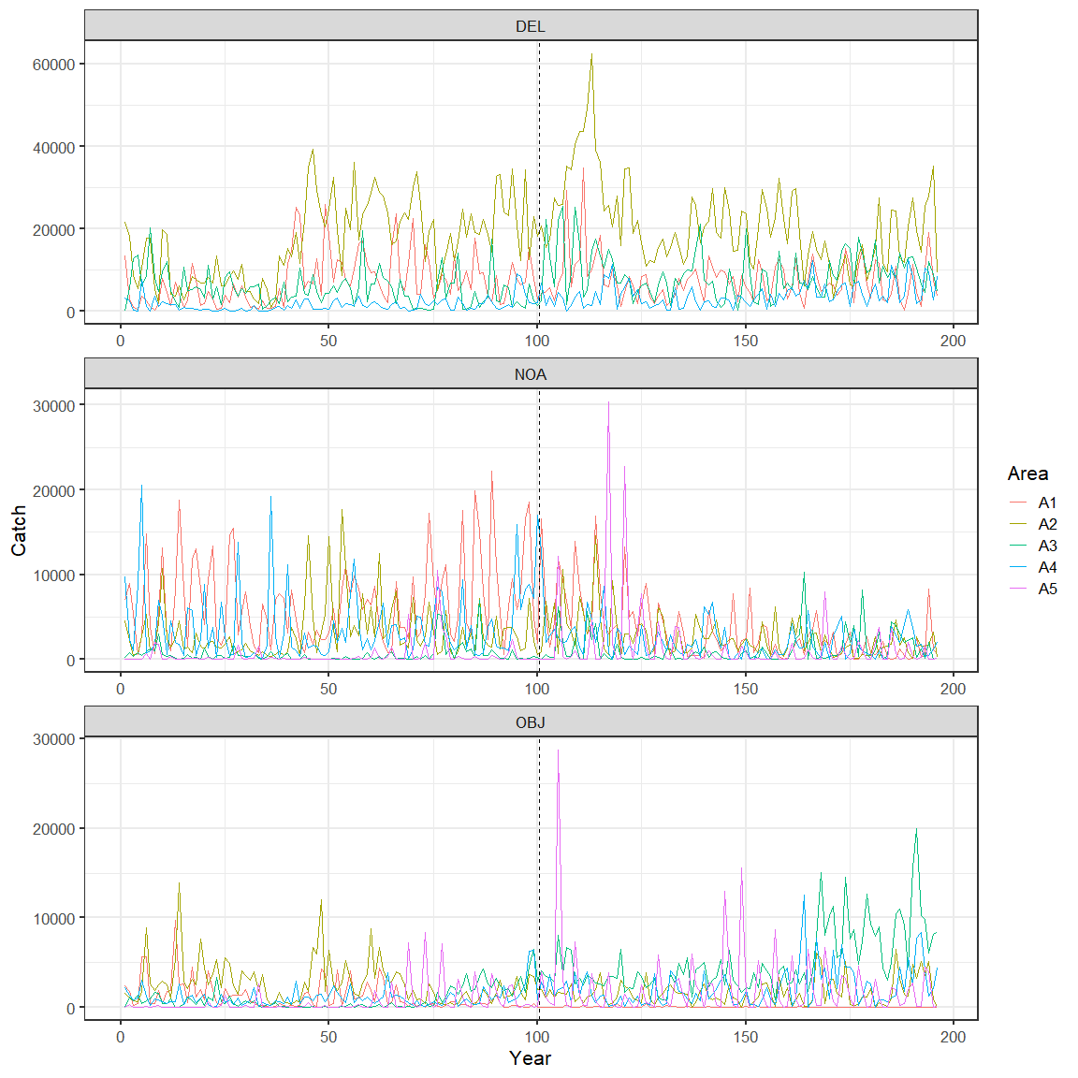

YFT.OBJ.Comp.20002023 <- read.csv(paste0(save_dir,"YFT.OBJ.Comp.20002023.csv"))  
YFT.OBJ.Comp.19751999 <- read.csv(paste0(save_dir,"YFT.OBJ.Comp.19751999.csv"))  
  
YFT.NOA.Comp.20002023 <- read.csv(paste0(save_dir,"YFT.NOA.Comp.20002023.csv"))  
YFT.NOA.Comp.19751999 <- read.csv(paste0(save_dir,"YFT.NOA.Comp.19751999.csv"))  
  
YFT.DEL.Comp.20002023 <- read.csv(paste0(save_dir,"YFT.DEL.Comp.20002023.csv"))  
YFT.DEL.Comp.19751999 <- read.csv(paste0(save_dir,"YFT.DEL.Comp.19751999.csv"))

YFT_OBJ_Comp <- rbind(YFT.OBJ.Comp.19751999,YFT.OBJ.Comp.20002023) %>%  
 mutate(Year=(year-1975)*4+quarter, Type="OBJ") %>%  
 arrange(area,Year)  
YFT_OBJ_Comp <- YFT_OBJ_Comp[c(207,206,3:205)]  
  
YFT_NOA_Comp <- rbind(YFT.NOA.Comp.19751999,YFT.NOA.Comp.20002023) %>%  
 mutate(Year=(year-1975)*4+quarter, Type="NOA") %>%  
 arrange(area,Year)  
YFT_NOA_Comp <- YFT_NOA_Comp[c(207,206,3:205)]  
  
YFT_DEL_Comp <- rbind(YFT.DEL.Comp.19751999,YFT.DEL.Comp.20002023) %>%  
 mutate(Year=(year-1975)*4+quarter, Type="DEL") %>%  
 arrange(area,Year)  
YFT_DEL_Comp <- YFT_DEL_Comp[c(207,206,3:205)]  
  
YFT_PS_Comp <- rbind(YFT_OBJ_Comp,YFT_NOA_Comp,YFT_DEL_Comp)  
write.csv(YFT_PS_Comp,file=paste0(save_dir,"YFT_PS_Comp_1975-",yr.end,".csv"),row.names = FALSE)

names(YFT_DEL_Comp)[5:205] <- 1:201  
  
YFT_DEL_Comp_Long <- YFT_DEL_Comp %>% gather(5:205,key="l",value="lf") %>%  
 mutate(L=cut(as.numeric(l), breaks = c(0,seq(22,198,2), Inf), right=F, labels = seq(20,198,2))) %>% na.omit() %>%  
 select(Year,area,L,lf) %>%  
 mutate(L = as.numeric(L)*2+18) %>%  
 group_by(area,Year,L) %>%  
 summarise(LF=sum(lf*L^3)) %>%  
 group_by(area, Year) %>%  
 mutate(LF2 = LF/sum(LF))  
  
ggplot(data=YFT_DEL_Comp_Long %>% filter(Year>104, Year<113)) +  
 geom_smooth(aes(x=L,y=LF2,color=area),span=0.2,se=FALSE) +  
 facet_wrap(~Year, nrow = 8, dir= "v") +  
 ylab("LF * body weight") +   
 theme_bw()

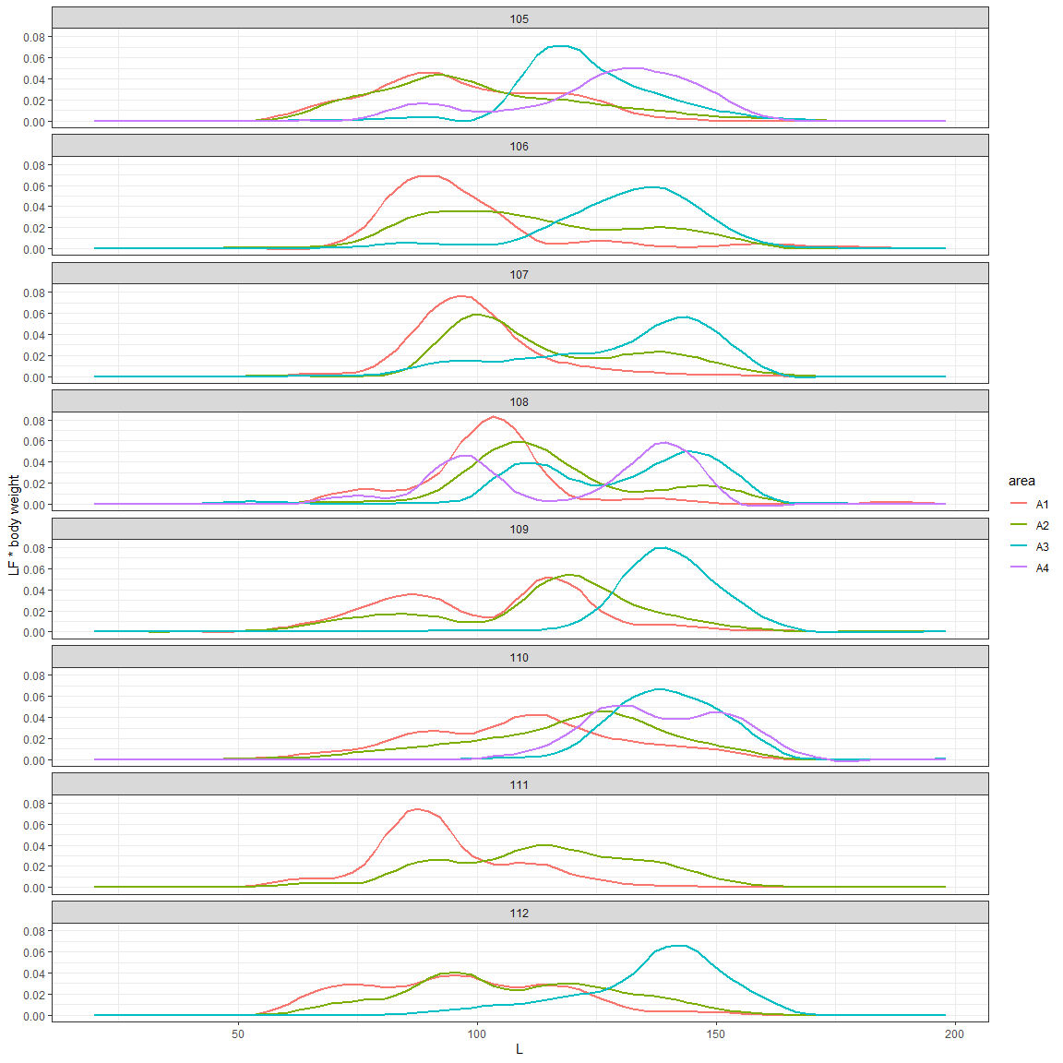

names(YFT_PS_Comp)[5:205] <- 1:201  
YFT_PS_Comp_mean <- YFT_PS_Comp %>%  
 gather(5:205,key="Length",value=comp) %>%  
 group_by(Type,area,Length) %>%  
 summarise(Comp=sum(comp*nwells)) %>%  
 group_by(Type,area) %>%  
 mutate(Length=as.numeric(Length),Comp=Comp/sum(Comp))  
  
ggplot(data=YFT_PS_Comp_mean) +  
 geom_smooth(aes(x=Length,y=Comp,color=area), se = FALSE, span = 0.2) +  
 facet_wrap(~Type,nrow = 3) +  
 theme_bw(16)

