Fishery definition for YFT in OBJ sets

Haikun Xu

2024-09-25

library(FishFreqClustering)  
library(FishFreqTree)  
library(tidyverse)

## ── Attaching core tidyverse packages ──────────────────────── tidyverse 2.0.0 ──  
## ✔ dplyr 1.1.2 ✔ readr 2.1.4  
## ✔ forcats 1.0.0 ✔ stringr 1.5.0  
## ✔ ggplot2 3.4.2 ✔ tibble 3.2.1  
## ✔ lubridate 1.9.2 ✔ tidyr 1.3.0  
## ✔ purrr 1.0.1   
## ── Conflicts ────────────────────────────────────────── tidyverse_conflicts() ──  
## ✖ dplyr::filter() masks stats::filter()  
## ✖ dplyr::lag() masks stats::lag()  
## ℹ Use the conflicted package (<http://conflicted.r-lib.org/>) to force all conflicts to become errors

directory <- "D:/OneDrive - IATTC/IATTC/2024/Irregular clustering/YFT OBJ/"  
setwd(directory)  
  
Raw <- read.csv("yft_lf_2000_to_2022.csv")  
Raw$quarter = ceiling(Raw$month / 3)  
Raw$lat = Raw$lat.5deg + 2.5  
Raw$lon = Raw$lon.5deg - 2.5

LF.DEL <- Raw %>% filter(class == 6, setype == 5) # 1=DEL; 4=NOA; 5=OBJ  
  
LF <- LF.DEL[, c("year", "quarter", "lat", "lon", paste0("X", 1:201))] %>%  
 group_by(lat, lon) %>%  
 mutate(N = length(unique(paste0(year, "-", quarter)))) %>%  
 filter(N > 9, lat > -40) # remove the cells with less than 4 quarters of data since 2000  
  
bins <- seq(1, 201, 1) # data length bins  
new_bins <- seq(21, 160, 1) # bins to be used in the clustering analysis  
  
# first aggregate the raw LF to the new bins by quarter  
LF1 <- lf.aggregate(LF, fcol = 5, lcol = 205, bins, new_bins, LengthOnly = FALSE)  
  
# Chekcing the data by making two plots  
bins <- new_bins # use the new bins  
nbins <- length(bins)  
fcol = 5  
lcol = 4 + length(bins)  
save_dir=directory  
  
# Area <- read.csv("D:/OneDrive - IATTC/IATTC/2024/Irregular clustering/YFT DEL/cluster_YFT.csv")  
# LF1 <- left_join(LF1, Area)

catch <- read.csv("D:/OneDrive - IATTC/IATTC/2024/Irregular clustering/YFT OBJ/EPO PS YFT by set type 1x1.csv")  
  
YFT_OBJ_catch <- catch[which(catch$CatchYear>1999),c(1,2,3,6)] %>%  
 mutate(lat = floor(LatC1/5)*5+2.5,  
 lon = floor(LonC1/5)*5+2.5) %>%  
 group_by(lat, lon) %>%  
 summarise(Catch = sum(OBJ/1000, na.rm = TRUE))

## `summarise()` has grouped output by 'lat'. You can override using the `.groups`  
## argument.

wmap <- map_data("world")  
ggplot(data = YFT_OBJ_catch) +  
 geom_tile(aes(x = lon, y = lat, fill = Catch), color = "black") +  
 scale_fill_gradient(  
 low = "white",  
 high = "red",  
 na.value = "white",  
 limits = c(0, max(YFT_OBJ_catch$Catch))  
 ) +  
 geom_polygon(  
 data = wmap,  
 aes(long, lat, group = group),  
 fill = "black",  
 colour = "white",  
 lwd = 0.5  
 ) +  
 coord_quickmap(ylim = c(min(YFT_OBJ_catch$lat), max(YFT_OBJ_catch$lat)), xlim = c(min(YFT_OBJ_catch$lon), max(YFT_OBJ_catch$lon))) +  
 theme_bw()

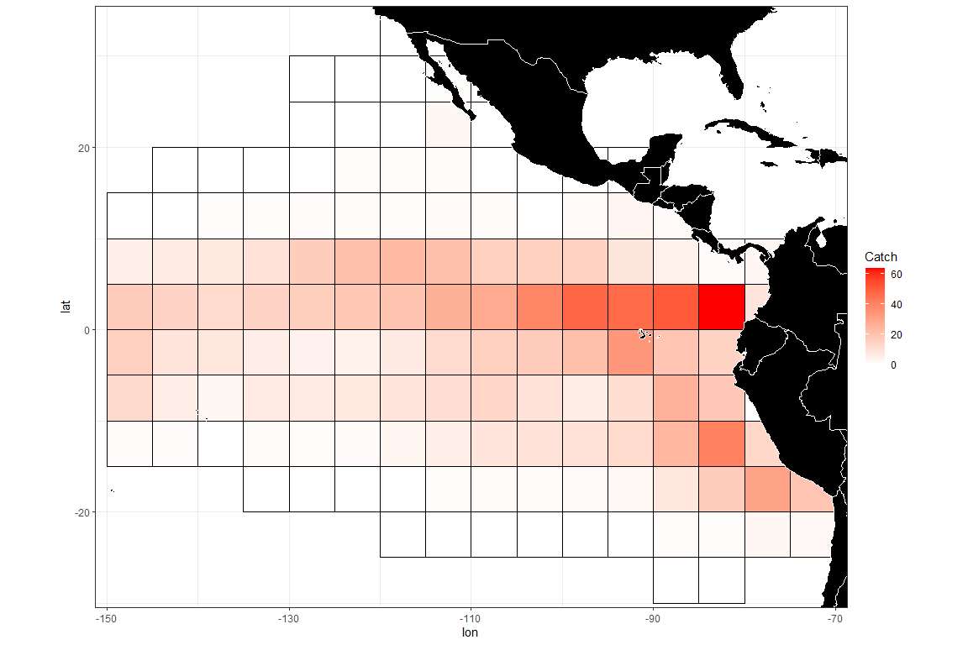

# divide the LF by the mean LF for the year-quarter  
area <- function(lat, lon) {  
 area1 = 0  
   
 if(lon < -130) area1 <- 1  
 if(lat < 5 & lon < -80) area1 <- 1  
 if(lat < 0) area1 <- 1  
   
 return(area1)  
}  
  
LF1_a1 <- LF1 %>% mutate(area1 = area(lat,lon)) %>% filter(area1 == 1)  
  
make.meanl.map(LF1_a1, fcol, lcol, bins, save_dir, width = 10, height = 10)

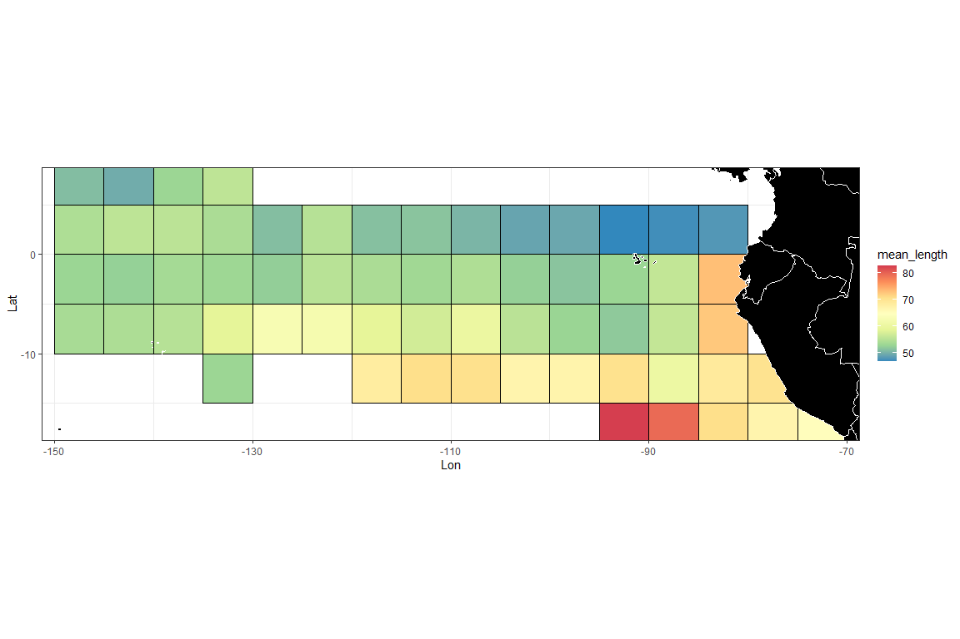

make.lf.map(LF1_a1, fcol, lcol, bins, save_dir)

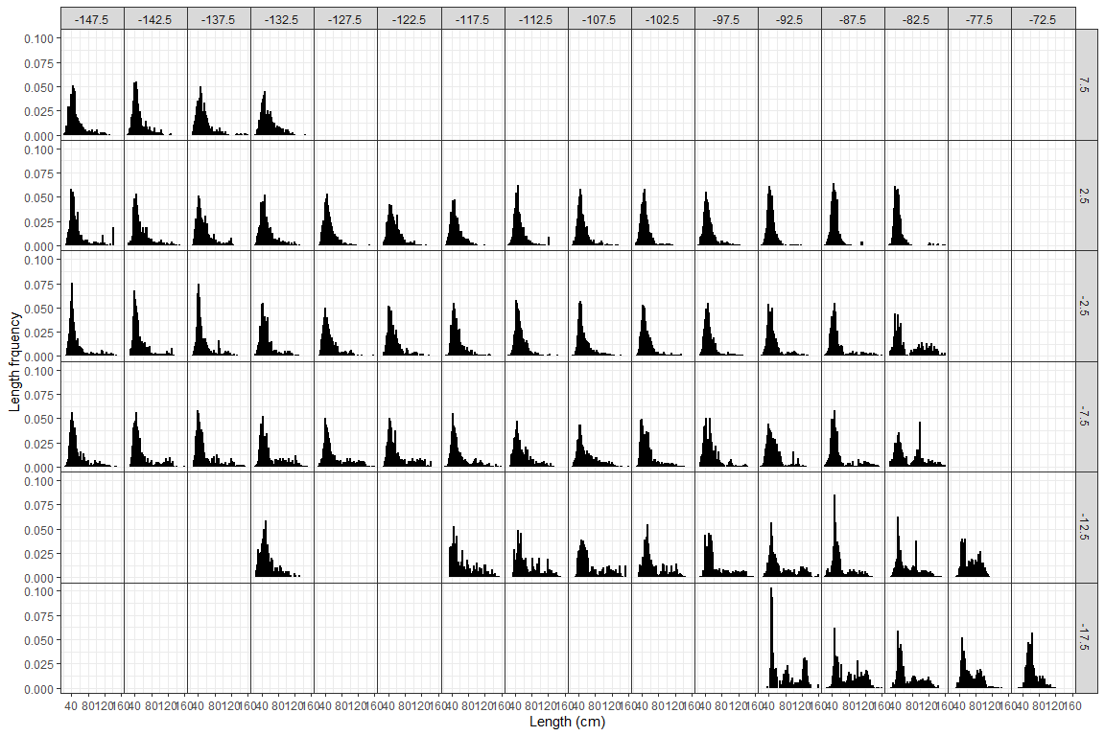

LF2 <- lf.demean(LF1_a1, fcol, lcol, bins)  
  
mmd <- LF2[,c(2,4:(lcol+1))] # mmd is the input data for the clustering analysis - it should have year, lat, lon, and bin numbers  
  
# setting up input data frames for clustering algorithm  
temp = packbylatlon(mmd, 5, 5, nbins) # aggregate the input LF across time for each grid cell  
  
packedmmd3 = temp$table1  
packedpdf3 = topdf(packedmmd3, 4, 3 + nbins)  
# packedcdf3 = tocdf(packedpdf3, 4, 3 + nbins)  
mmdt = packedmmd3[packedmmd3[, 4 + nbins] > 0,]  
# rrs = mmdt[, 4 + nbins] # sample size  
mmdtpdf = packedpdf3[packedmmd3[, 4 + nbins] > 0,] # PDF sums to 1 for each grid  
mmdtpdf[, 4 + nbins] = mmdt[, 4 + nbins]  
# mmdtcdf = packedcdf3[packedmmd3[, 4 + nbins] > 0,]  
# mmdtcdf[, 4 + nbins] = mmdt[, 4 + nbins]  
  
names(mmdtpdf)[2:3] <- c("lat", "lon")  
mmdtpdf$Number <- 1:nrow(mmdtpdf)  
mmdfpdf_catch <- left_join(mmdtpdf, YFT_OBJ_catch)

## Joining with `by = join_by(lat, lon)`

# check grid ID  
ggplot(data = mmdfpdf_catch) +  
 geom_polygon(  
 data = wmap,  
 aes(long, lat, group = group),  
 fill = "black",  
 colour = "white",  
 lwd = 0.5  
 ) +  
 geom_text(aes(x = lon, y = lat, label = Number), color = "red", size = 5) +  
 coord_quickmap(ylim = c(min(mmdfpdf_catch$lat), max(mmdfpdf_catch$lat)), xlim = c(min(mmdfpdf_catch$lon), max(mmdfpdf_catch$lon))) +  
 ggtitle("Grid ID") +  
 theme_bw()

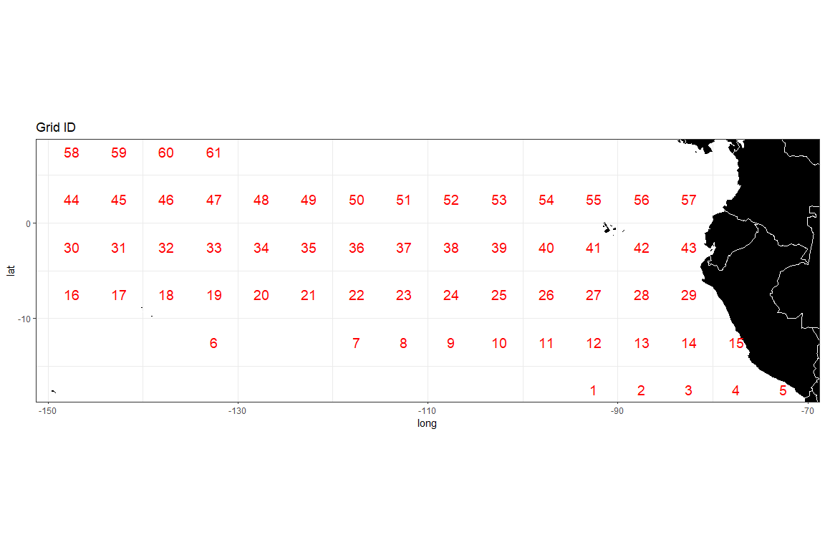

densmatx = matrix(0, nrow(mmdt), 420)  
densmaty = matrix(0, nrow(mmdt), 420)  
for(i in 1:nrow(mmdt)) {  
 weightvec = t(mmdt[i, 4:(3 + nbins)])  
 weightvec = weightvec / sum(weightvec)  
 tempmmd = density(seq(0.21, 1.60, 0.01), weights = weightvec, bw = 0.05)  
 ii <- which(tempmmd$x>=0.21 & tempmmd$x<=1.60)  
 densmatx[i, ] = tempmmd$x[ii]  
 densmaty[i, ] = tempmmd$y[ii]  
}  
  
# run distributional clustering with adjacency criterion  
adjmat <- adjinf(mmdtpdf[, 2], mmdtpdf[, 3], mindist = 5 * sqrt(2)) # the matrix specifying adjacency   
  
rrs <- mmdfpdf_catch$Catch  
alydens.spatial23 <-  
 hclust.regionsmm(  
 as.matrix(densmaty),  
 adj = TRUE, # adjacent areas  
 adjmat = adjmat,  
 rr = rrs # rr is the weighting factor; equal weighting is used in this case  
 )

teststat <- heterodist(  
 alydens.spatial23$merges,  
 alydens.spatial23$distseq,  
 densmatx[1,],  
 densmaty,  
 rrs,  
 doko = c(1, 20),  
 BB = 100,  
 bins = seq(0.21, 1.60, 0.01)  
)

## [1] "node 60: 1%"  
## [1] "node 60: 2%"  
## [1] "node 60: 3%"  
## [1] "node 60: 4%"  
## [1] "node 60: 5%"  
## [1] "node 60: 6%"  
## [1] "node 60: 7%"  
## [1] "node 60: 8%"  
## [1] "node 60: 9%"  
## [1] "node 60: 10%"  
## [1] "node 60: 11%"  
## [1] "node 60: 12%"  
## [1] "node 60: 13%"  
## [1] "node 60: 14%"  
## [1] "node 60: 15%"  
## [1] "node 60: 16%"  
## [1] "node 60: 17%"  
## [1] "node 60: 18%"  
## [1] "node 60: 19%"  
## [1] "node 60: 20%"  
## [1] "node 60: 21%"  
## [1] "node 60: 22%"  
## [1] "node 60: 23%"  
## [1] "node 60: 24%"  
## [1] "node 60: 25%"  
## [1] "node 60: 26%"  
## [1] "node 60: 27%"  
## [1] "node 60: 28%"  
## [1] "node 60: 29%"  
## [1] "node 60: 30%"  
## [1] "node 60: 31%"  
## [1] "node 60: 32%"  
## [1] "node 60: 33%"  
## [1] "node 60: 34%"  
## [1] "node 60: 35%"  
## [1] "node 60: 36%"  
## [1] "node 60: 37%"  
## [1] "node 60: 38%"  
## [1] "node 60: 39%"  
## [1] "node 60: 40%"  
## [1] "node 60: 41%"  
## [1] "node 60: 42%"  
## [1] "node 60: 43%"  
## [1] "node 60: 44%"  
## [1] "node 60: 45%"  
## [1] "node 60: 46%"  
## [1] "node 60: 47%"  
## [1] "node 60: 48%"  
## [1] "node 60: 49%"  
## [1] "node 60: 50%"  
## [1] "node 60: 51%"  
## [1] "node 60: 52%"  
## [1] "node 60: 53%"  
## [1] "node 60: 54%"  
## [1] "node 60: 55%"  
## [1] "node 60: 56%"  
## [1] "node 60: 57%"  
## [1] "node 60: 58%"  
## [1] "node 60: 59%"  
## [1] "node 60: 60%"  
## [1] "node 60: 61%"  
## [1] "node 60: 62%"  
## [1] "node 60: 63%"  
## [1] "node 60: 64%"  
## [1] "node 60: 65%"  
## [1] "node 60: 66%"  
## [1] "node 60: 67%"  
## [1] "node 60: 68%"  
## [1] "node 60: 69%"  
## [1] "node 60: 70%"  
## [1] "node 60: 71%"  
## [1] "node 60: 72%"  
## [1] "node 60: 73%"  
## [1] "node 60: 74%"  
## [1] "node 60: 75%"  
## [1] "node 60: 76%"  
## [1] "node 60: 77%"  
## [1] "node 60: 78%"  
## [1] "node 60: 79%"  
## [1] "node 60: 80%"  
## [1] "node 60: 81%"  
## [1] "node 60: 82%"  
## [1] "node 60: 83%"  
## [1] "node 60: 84%"  
## [1] "node 60: 85%"  
## [1] "node 60: 86%"  
## [1] "node 60: 87%"  
## [1] "node 60: 88%"  
## [1] "node 60: 89%"  
## [1] "node 60: 90%"  
## [1] "node 60: 91%"  
## [1] "node 60: 92%"  
## [1] "node 60: 93%"  
## [1] "node 60: 94%"  
## [1] "node 60: 95%"  
## [1] "node 60: 96%"  
## [1] "node 60: 97%"  
## [1] "node 60: 98%"  
## [1] "node 60: 99%"  
## [1] "node 60: 100%"  
## [1] "node 59: 1%"  
## [1] "node 59: 2%"  
## [1] "node 59: 3%"  
## [1] "node 59: 4%"  
## [1] "node 59: 5%"  
## [1] "node 59: 6%"  
## [1] "node 59: 7%"  
## [1] "node 59: 8%"  
## [1] "node 59: 9%"  
## [1] "node 59: 10%"  
## [1] "node 59: 11%"  
## [1] "node 59: 12%"  
## [1] "node 59: 13%"  
## [1] "node 59: 14%"  
## [1] "node 59: 15%"  
## [1] "node 59: 16%"  
## [1] "node 59: 17%"  
## [1] "node 59: 18%"  
## [1] "node 59: 19%"  
## [1] "node 59: 20%"  
## [1] "node 59: 21%"  
## [1] "node 59: 22%"  
## [1] "node 59: 23%"  
## [1] "node 59: 24%"  
## [1] "node 59: 25%"  
## [1] "node 59: 26%"  
## [1] "node 59: 27%"  
## [1] "node 59: 28%"  
## [1] "node 59: 29%"  
## [1] "node 59: 30%"  
## [1] "node 59: 31%"  
## [1] "node 59: 32%"  
## [1] "node 59: 33%"  
## [1] "node 59: 34%"  
## [1] "node 59: 35%"  
## [1] "node 59: 36%"  
## [1] "node 59: 37%"  
## [1] "node 59: 38%"  
## [1] "node 59: 39%"  
## [1] "node 59: 40%"  
## [1] "node 59: 41%"  
## [1] "node 59: 42%"  
## [1] "node 59: 43%"  
## [1] "node 59: 44%"  
## [1] "node 59: 45%"  
## [1] "node 59: 46%"  
## [1] "node 59: 47%"  
## [1] "node 59: 48%"  
## [1] "node 59: 49%"  
## [1] "node 59: 50%"  
## [1] "node 59: 51%"  
## [1] "node 59: 52%"  
## [1] "node 59: 53%"  
## [1] "node 59: 54%"  
## [1] "node 59: 55%"  
## [1] "node 59: 56%"  
## [1] "node 59: 57%"  
## [1] "node 59: 58%"  
## [1] "node 59: 59%"  
## [1] "node 59: 60%"  
## [1] "node 59: 61%"  
## [1] "node 59: 62%"  
## [1] "node 59: 63%"  
## [1] "node 59: 64%"  
## [1] "node 59: 65%"  
## [1] "node 59: 66%"  
## [1] "node 59: 67%"  
## [1] "node 59: 68%"  
## [1] "node 59: 69%"  
## [1] "node 59: 70%"  
## [1] "node 59: 71%"  
## [1] "node 59: 72%"  
## [1] "node 59: 73%"  
## [1] "node 59: 74%"  
## [1] "node 59: 75%"  
## [1] "node 59: 76%"  
## [1] "node 59: 77%"  
## [1] "node 59: 78%"  
## [1] "node 59: 79%"  
## [1] "node 59: 80%"  
## [1] "node 59: 81%"  
## [1] "node 59: 82%"  
## [1] "node 59: 83%"  
## [1] "node 59: 84%"  
## [1] "node 59: 85%"  
## [1] "node 59: 86%"  
## [1] "node 59: 87%"  
## [1] "node 59: 88%"  
## [1] "node 59: 89%"  
## [1] "node 59: 90%"  
## [1] "node 59: 91%"  
## [1] "node 59: 92%"  
## [1] "node 59: 93%"  
## [1] "node 59: 94%"  
## [1] "node 59: 95%"  
## [1] "node 59: 96%"  
## [1] "node 59: 97%"  
## [1] "node 59: 98%"  
## [1] "node 59: 99%"  
## [1] "node 59: 100%"  
## [1] "node 58: 1%"  
## [1] "node 58: 2%"  
## [1] "node 58: 3%"  
## [1] "node 58: 4%"  
## [1] "node 58: 5%"  
## [1] "node 58: 6%"  
## [1] "node 58: 7%"  
## [1] "node 58: 8%"  
## [1] "node 58: 9%"  
## [1] "node 58: 10%"  
## [1] "node 58: 11%"  
## [1] "node 58: 12%"  
## [1] "node 58: 13%"  
## [1] "node 58: 14%"  
## [1] "node 58: 15%"  
## [1] "node 58: 16%"  
## [1] "node 58: 17%"  
## [1] "node 58: 18%"  
## [1] "node 58: 19%"  
## [1] "node 58: 20%"  
## [1] "node 58: 21%"  
## [1] "node 58: 22%"  
## [1] "node 58: 23%"  
## [1] "node 58: 24%"  
## [1] "node 58: 25%"  
## [1] "node 58: 26%"  
## [1] "node 58: 27%"  
## [1] "node 58: 28%"  
## [1] "node 58: 29%"  
## [1] "node 58: 30%"  
## [1] "node 58: 31%"  
## [1] "node 58: 32%"  
## [1] "node 58: 33%"  
## [1] "node 58: 34%"  
## [1] "node 58: 35%"  
## [1] "node 58: 36%"  
## [1] "node 58: 37%"  
## [1] "node 58: 38%"  
## [1] "node 58: 39%"  
## [1] "node 58: 40%"  
## [1] "node 58: 41%"  
## [1] "node 58: 42%"  
## [1] "node 58: 43%"  
## [1] "node 58: 44%"  
## [1] "node 58: 45%"  
## [1] "node 58: 46%"  
## [1] "node 58: 47%"  
## [1] "node 58: 48%"  
## [1] "node 58: 49%"  
## [1] "node 58: 50%"  
## [1] "node 58: 51%"  
## [1] "node 58: 52%"  
## [1] "node 58: 53%"  
## [1] "node 58: 54%"  
## [1] "node 58: 55%"  
## [1] "node 58: 56%"  
## [1] "node 58: 57%"  
## [1] "node 58: 58%"  
## [1] "node 58: 59%"  
## [1] "node 58: 60%"  
## [1] "node 58: 61%"  
## [1] "node 58: 62%"  
## [1] "node 58: 63%"  
## [1] "node 58: 64%"  
## [1] "node 58: 65%"  
## [1] "node 58: 66%"  
## [1] "node 58: 67%"  
## [1] "node 58: 68%"  
## [1] "node 58: 69%"  
## [1] "node 58: 70%"  
## [1] "node 58: 71%"  
## [1] "node 58: 72%"  
## [1] "node 58: 73%"  
## [1] "node 58: 74%"  
## [1] "node 58: 75%"  
## [1] "node 58: 76%"  
## [1] "node 58: 77%"  
## [1] "node 58: 78%"  
## [1] "node 58: 79%"  
## [1] "node 58: 80%"  
## [1] "node 58: 81%"  
## [1] "node 58: 82%"  
## [1] "node 58: 83%"  
## [1] "node 58: 84%"  
## [1] "node 58: 85%"  
## [1] "node 58: 86%"  
## [1] "node 58: 87%"  
## [1] "node 58: 88%"  
## [1] "node 58: 89%"  
## [1] "node 58: 90%"  
## [1] "node 58: 91%"  
## [1] "node 58: 92%"  
## [1] "node 58: 93%"  
## [1] "node 58: 94%"  
## [1] "node 58: 95%"  
## [1] "node 58: 96%"  
## [1] "node 58: 97%"  
## [1] "node 58: 98%"  
## [1] "node 58: 99%"  
## [1] "node 58: 100%"  
## [1] "node 57: 1%"  
## [1] "node 57: 2%"  
## [1] "node 57: 3%"  
## [1] "node 57: 4%"  
## [1] "node 57: 5%"  
## [1] "node 57: 6%"  
## [1] "node 57: 7%"  
## [1] "node 57: 8%"  
## [1] "node 57: 9%"  
## [1] "node 57: 10%"  
## [1] "node 57: 11%"  
## [1] "node 57: 12%"  
## [1] "node 57: 13%"  
## [1] "node 57: 14%"  
## [1] "node 57: 15%"  
## [1] "node 57: 16%"  
## [1] "node 57: 17%"  
## [1] "node 57: 18%"  
## [1] "node 57: 19%"  
## [1] "node 57: 20%"  
## [1] "node 57: 21%"  
## [1] "node 57: 22%"  
## [1] "node 57: 23%"  
## [1] "node 57: 24%"  
## [1] "node 57: 25%"  
## [1] "node 57: 26%"  
## [1] "node 57: 27%"  
## [1] "node 57: 28%"  
## [1] "node 57: 29%"  
## [1] "node 57: 30%"  
## [1] "node 57: 31%"  
## [1] "node 57: 32%"  
## [1] "node 57: 33%"  
## [1] "node 57: 34%"  
## [1] "node 57: 35%"  
## [1] "node 57: 36%"  
## [1] "node 57: 37%"  
## [1] "node 57: 38%"  
## [1] "node 57: 39%"  
## [1] "node 57: 40%"  
## [1] "node 57: 41%"  
## [1] "node 57: 42%"  
## [1] "node 57: 43%"  
## [1] "node 57: 44%"  
## [1] "node 57: 45%"  
## [1] "node 57: 46%"  
## [1] "node 57: 47%"  
## [1] "node 57: 48%"  
## [1] "node 57: 49%"  
## [1] "node 57: 50%"  
## [1] "node 57: 51%"  
## [1] "node 57: 52%"  
## [1] "node 57: 53%"  
## [1] "node 57: 54%"  
## [1] "node 57: 55%"  
## [1] "node 57: 56%"  
## [1] "node 57: 57%"  
## [1] "node 57: 58%"  
## [1] "node 57: 59%"  
## [1] "node 57: 60%"  
## [1] "node 57: 61%"  
## [1] "node 57: 62%"  
## [1] "node 57: 63%"  
## [1] "node 57: 64%"  
## [1] "node 57: 65%"  
## [1] "node 57: 66%"  
## [1] "node 57: 67%"  
## [1] "node 57: 68%"  
## [1] "node 57: 69%"  
## [1] "node 57: 70%"  
## [1] "node 57: 71%"  
## [1] "node 57: 72%"  
## [1] "node 57: 73%"  
## [1] "node 57: 74%"  
## [1] "node 57: 75%"  
## [1] "node 57: 76%"  
## [1] "node 57: 77%"  
## [1] "node 57: 78%"  
## [1] "node 57: 79%"  
## [1] "node 57: 80%"  
## [1] "node 57: 81%"  
## [1] "node 57: 82%"  
## [1] "node 57: 83%"  
## [1] "node 57: 84%"  
## [1] "node 57: 85%"  
## [1] "node 57: 86%"  
## [1] "node 57: 87%"  
## [1] "node 57: 88%"  
## [1] "node 57: 89%"  
## [1] "node 57: 90%"  
## [1] "node 57: 91%"  
## [1] "node 57: 92%"  
## [1] "node 57: 93%"  
## [1] "node 57: 94%"  
## [1] "node 57: 95%"  
## [1] "node 57: 96%"  
## [1] "node 57: 97%"  
## [1] "node 57: 98%"  
## [1] "node 57: 99%"  
## [1] "node 57: 100%"  
## [1] "node 56: 1%"  
## [1] "node 56: 2%"  
## [1] "node 56: 3%"  
## [1] "node 56: 4%"  
## [1] "node 56: 5%"  
## [1] "node 56: 6%"  
## [1] "node 56: 7%"  
## [1] "node 56: 8%"  
## [1] "node 56: 9%"  
## [1] "node 56: 10%"  
## [1] "node 56: 11%"  
## [1] "node 56: 12%"  
## [1] "node 56: 13%"  
## [1] "node 56: 14%"  
## [1] "node 56: 15%"  
## [1] "node 56: 16%"  
## [1] "node 56: 17%"  
## [1] "node 56: 18%"  
## [1] "node 56: 19%"  
## [1] "node 56: 20%"  
## [1] "node 56: 21%"  
## [1] "node 56: 22%"  
## [1] "node 56: 23%"  
## [1] "node 56: 24%"  
## [1] "node 56: 25%"  
## [1] "node 56: 26%"  
## [1] "node 56: 27%"  
## [1] "node 56: 28%"  
## [1] "node 56: 29%"  
## [1] "node 56: 30%"  
## [1] "node 56: 31%"  
## [1] "node 56: 32%"  
## [1] "node 56: 33%"  
## [1] "node 56: 34%"  
## [1] "node 56: 35%"  
## [1] "node 56: 36%"  
## [1] "node 56: 37%"  
## [1] "node 56: 38%"  
## [1] "node 56: 39%"  
## [1] "node 56: 40%"  
## [1] "node 56: 41%"  
## [1] "node 56: 42%"  
## [1] "node 56: 43%"  
## [1] "node 56: 44%"  
## [1] "node 56: 45%"  
## [1] "node 56: 46%"  
## [1] "node 56: 47%"  
## [1] "node 56: 48%"  
## [1] "node 56: 49%"  
## [1] "node 56: 50%"  
## [1] "node 56: 51%"  
## [1] "node 56: 52%"  
## [1] "node 56: 53%"  
## [1] "node 56: 54%"  
## [1] "node 56: 55%"  
## [1] "node 56: 56%"  
## [1] "node 56: 57%"  
## [1] "node 56: 58%"  
## [1] "node 56: 59%"  
## [1] "node 56: 60%"  
## [1] "node 56: 61%"  
## [1] "node 56: 62%"  
## [1] "node 56: 63%"  
## [1] "node 56: 64%"  
## [1] "node 56: 65%"  
## [1] "node 56: 66%"  
## [1] "node 56: 67%"  
## [1] "node 56: 68%"  
## [1] "node 56: 69%"  
## [1] "node 56: 70%"  
## [1] "node 56: 71%"  
## [1] "node 56: 72%"  
## [1] "node 56: 73%"  
## [1] "node 56: 74%"  
## [1] "node 56: 75%"  
## [1] "node 56: 76%"  
## [1] "node 56: 77%"  
## [1] "node 56: 78%"  
## [1] "node 56: 79%"  
## [1] "node 56: 80%"  
## [1] "node 56: 81%"  
## [1] "node 56: 82%"  
## [1] "node 56: 83%"  
## [1] "node 56: 84%"  
## [1] "node 56: 85%"  
## [1] "node 56: 86%"  
## [1] "node 56: 87%"  
## [1] "node 56: 88%"  
## [1] "node 56: 89%"  
## [1] "node 56: 90%"  
## [1] "node 56: 91%"  
## [1] "node 56: 92%"  
## [1] "node 56: 93%"  
## [1] "node 56: 94%"  
## [1] "node 56: 95%"  
## [1] "node 56: 96%"  
## [1] "node 56: 97%"  
## [1] "node 56: 98%"  
## [1] "node 56: 99%"  
## [1] "node 56: 100%"  
## [1] "node 55: 1%"  
## [1] "node 55: 2%"  
## [1] "node 55: 3%"  
## [1] "node 55: 4%"  
## [1] "node 55: 5%"  
## [1] "node 55: 6%"  
## [1] "node 55: 7%"  
## [1] "node 55: 8%"  
## [1] "node 55: 9%"  
## [1] "node 55: 10%"  
## [1] "node 55: 11%"  
## [1] "node 55: 12%"  
## [1] "node 55: 13%"  
## [1] "node 55: 14%"  
## [1] "node 55: 15%"  
## [1] "node 55: 16%"  
## [1] "node 55: 17%"  
## [1] "node 55: 18%"  
## [1] "node 55: 19%"  
## [1] "node 55: 20%"  
## [1] "node 55: 21%"  
## [1] "node 55: 22%"  
## [1] "node 55: 23%"  
## [1] "node 55: 24%"  
## [1] "node 55: 25%"  
## [1] "node 55: 26%"  
## [1] "node 55: 27%"  
## [1] "node 55: 28%"  
## [1] "node 55: 29%"  
## [1] "node 55: 30%"  
## [1] "node 55: 31%"  
## [1] "node 55: 32%"  
## [1] "node 55: 33%"  
## [1] "node 55: 34%"  
## [1] "node 55: 35%"  
## [1] "node 55: 36%"  
## [1] "node 55: 37%"  
## [1] "node 55: 38%"  
## [1] "node 55: 39%"  
## [1] "node 55: 40%"  
## [1] "node 55: 41%"  
## [1] "node 55: 42%"  
## [1] "node 55: 43%"  
## [1] "node 55: 44%"  
## [1] "node 55: 45%"  
## [1] "node 55: 46%"  
## [1] "node 55: 47%"  
## [1] "node 55: 48%"  
## [1] "node 55: 49%"  
## [1] "node 55: 50%"  
## [1] "node 55: 51%"  
## [1] "node 55: 52%"  
## [1] "node 55: 53%"  
## [1] "node 55: 54%"  
## [1] "node 55: 55%"  
## [1] "node 55: 56%"  
## [1] "node 55: 57%"  
## [1] "node 55: 58%"  
## [1] "node 55: 59%"  
## [1] "node 55: 60%"  
## [1] "node 55: 61%"  
## [1] "node 55: 62%"  
## [1] "node 55: 63%"  
## [1] "node 55: 64%"  
## [1] "node 55: 65%"  
## [1] "node 55: 66%"  
## [1] "node 55: 67%"  
## [1] "node 55: 68%"  
## [1] "node 55: 69%"  
## [1] "node 55: 70%"  
## [1] "node 55: 71%"  
## [1] "node 55: 72%"  
## [1] "node 55: 73%"  
## [1] "node 55: 74%"  
## [1] "node 55: 75%"  
## [1] "node 55: 76%"  
## [1] "node 55: 77%"  
## [1] "node 55: 78%"  
## [1] "node 55: 79%"  
## [1] "node 55: 80%"  
## [1] "node 55: 81%"  
## [1] "node 55: 82%"  
## [1] "node 55: 83%"  
## [1] "node 55: 84%"  
## [1] "node 55: 85%"  
## [1] "node 55: 86%"  
## [1] "node 55: 87%"  
## [1] "node 55: 88%"  
## [1] "node 55: 89%"  
## [1] "node 55: 90%"  
## [1] "node 55: 91%"  
## [1] "node 55: 92%"  
## [1] "node 55: 93%"  
## [1] "node 55: 94%"  
## [1] "node 55: 95%"  
## [1] "node 55: 96%"  
## [1] "node 55: 97%"  
## [1] "node 55: 98%"  
## [1] "node 55: 99%"  
## [1] "node 55: 100%"  
## [1] "node 54: 1%"  
## [1] "node 54: 2%"  
## [1] "node 54: 3%"  
## [1] "node 54: 4%"  
## [1] "node 54: 5%"  
## [1] "node 54: 6%"  
## [1] "node 54: 7%"  
## [1] "node 54: 8%"  
## [1] "node 54: 9%"  
## [1] "node 54: 10%"  
## [1] "node 54: 11%"  
## [1] "node 54: 12%"  
## [1] "node 54: 13%"  
## [1] "node 54: 14%"  
## [1] "node 54: 15%"  
## [1] "node 54: 16%"  
## [1] "node 54: 17%"  
## [1] "node 54: 18%"  
## [1] "node 54: 19%"  
## [1] "node 54: 20%"  
## [1] "node 54: 21%"  
## [1] "node 54: 22%"  
## [1] "node 54: 23%"  
## [1] "node 54: 24%"  
## [1] "node 54: 25%"  
## [1] "node 54: 26%"  
## [1] "node 54: 27%"  
## [1] "node 54: 28%"  
## [1] "node 54: 29%"  
## [1] "node 54: 30%"  
## [1] "node 54: 31%"  
## [1] "node 54: 32%"  
## [1] "node 54: 33%"  
## [1] "node 54: 34%"  
## [1] "node 54: 35%"  
## [1] "node 54: 36%"  
## [1] "node 54: 37%"  
## [1] "node 54: 38%"  
## [1] "node 54: 39%"  
## [1] "node 54: 40%"  
## [1] "node 54: 41%"  
## [1] "node 54: 42%"  
## [1] "node 54: 43%"  
## [1] "node 54: 44%"  
## [1] "node 54: 45%"  
## [1] "node 54: 46%"  
## [1] "node 54: 47%"  
## [1] "node 54: 48%"  
## [1] "node 54: 49%"  
## [1] "node 54: 50%"  
## [1] "node 54: 51%"  
## [1] "node 54: 52%"  
## [1] "node 54: 53%"  
## [1] "node 54: 54%"  
## [1] "node 54: 55%"  
## [1] "node 54: 56%"  
## [1] "node 54: 57%"  
## [1] "node 54: 58%"  
## [1] "node 54: 59%"  
## [1] "node 54: 60%"  
## [1] "node 54: 61%"  
## [1] "node 54: 62%"  
## [1] "node 54: 63%"  
## [1] "node 54: 64%"  
## [1] "node 54: 65%"  
## [1] "node 54: 66%"  
## [1] "node 54: 67%"  
## [1] "node 54: 68%"  
## [1] "node 54: 69%"  
## [1] "node 54: 70%"  
## [1] "node 54: 71%"  
## [1] "node 54: 72%"  
## [1] "node 54: 73%"  
## [1] "node 54: 74%"  
## [1] "node 54: 75%"  
## [1] "node 54: 76%"  
## [1] "node 54: 77%"  
## [1] "node 54: 78%"  
## [1] "node 54: 79%"  
## [1] "node 54: 80%"  
## [1] "node 54: 81%"  
## [1] "node 54: 82%"  
## [1] "node 54: 83%"  
## [1] "node 54: 84%"  
## [1] "node 54: 85%"  
## [1] "node 54: 86%"  
## [1] "node 54: 87%"  
## [1] "node 54: 88%"  
## [1] "node 54: 89%"  
## [1] "node 54: 90%"  
## [1] "node 54: 91%"  
## [1] "node 54: 92%"  
## [1] "node 54: 93%"  
## [1] "node 54: 94%"  
## [1] "node 54: 95%"  
## [1] "node 54: 96%"  
## [1] "node 54: 97%"  
## [1] "node 54: 98%"  
## [1] "node 54: 99%"  
## [1] "node 54: 100%"  
## [1] "node 53: 1%"  
## [1] "node 53: 2%"  
## [1] "node 53: 3%"  
## [1] "node 53: 4%"  
## [1] "node 53: 5%"  
## [1] "node 53: 6%"  
## [1] "node 53: 7%"  
## [1] "node 53: 8%"  
## [1] "node 53: 9%"  
## [1] "node 53: 10%"  
## [1] "node 53: 11%"  
## [1] "node 53: 12%"  
## [1] "node 53: 13%"  
## [1] "node 53: 14%"  
## [1] "node 53: 15%"  
## [1] "node 53: 16%"  
## [1] "node 53: 17%"  
## [1] "node 53: 18%"  
## [1] "node 53: 19%"  
## [1] "node 53: 20%"  
## [1] "node 53: 21%"  
## [1] "node 53: 22%"  
## [1] "node 53: 23%"  
## [1] "node 53: 24%"  
## [1] "node 53: 25%"  
## [1] "node 53: 26%"  
## [1] "node 53: 27%"  
## [1] "node 53: 28%"  
## [1] "node 53: 29%"  
## [1] "node 53: 30%"  
## [1] "node 53: 31%"  
## [1] "node 53: 32%"  
## [1] "node 53: 33%"  
## [1] "node 53: 34%"  
## [1] "node 53: 35%"  
## [1] "node 53: 36%"  
## [1] "node 53: 37%"  
## [1] "node 53: 38%"  
## [1] "node 53: 39%"  
## [1] "node 53: 40%"  
## [1] "node 53: 41%"  
## [1] "node 53: 42%"  
## [1] "node 53: 43%"  
## [1] "node 53: 44%"  
## [1] "node 53: 45%"  
## [1] "node 53: 46%"  
## [1] "node 53: 47%"  
## [1] "node 53: 48%"  
## [1] "node 53: 49%"  
## [1] "node 53: 50%"  
## [1] "node 53: 51%"  
## [1] "node 53: 52%"  
## [1] "node 53: 53%"  
## [1] "node 53: 54%"  
## [1] "node 53: 55%"  
## [1] "node 53: 56%"  
## [1] "node 53: 57%"  
## [1] "node 53: 58%"  
## [1] "node 53: 59%"  
## [1] "node 53: 60%"  
## [1] "node 53: 61%"  
## [1] "node 53: 62%"  
## [1] "node 53: 63%"  
## [1] "node 53: 64%"  
## [1] "node 53: 65%"  
## [1] "node 53: 66%"  
## [1] "node 53: 67%"  
## [1] "node 53: 68%"  
## [1] "node 53: 69%"  
## [1] "node 53: 70%"  
## [1] "node 53: 71%"  
## [1] "node 53: 72%"  
## [1] "node 53: 73%"  
## [1] "node 53: 74%"  
## [1] "node 53: 75%"  
## [1] "node 53: 76%"  
## [1] "node 53: 77%"  
## [1] "node 53: 78%"  
## [1] "node 53: 79%"  
## [1] "node 53: 80%"  
## [1] "node 53: 81%"  
## [1] "node 53: 82%"  
## [1] "node 53: 83%"  
## [1] "node 53: 84%"  
## [1] "node 53: 85%"  
## [1] "node 53: 86%"  
## [1] "node 53: 87%"  
## [1] "node 53: 88%"  
## [1] "node 53: 89%"  
## [1] "node 53: 90%"  
## [1] "node 53: 91%"  
## [1] "node 53: 92%"  
## [1] "node 53: 93%"  
## [1] "node 53: 94%"  
## [1] "node 53: 95%"  
## [1] "node 53: 96%"  
## [1] "node 53: 97%"  
## [1] "node 53: 98%"  
## [1] "node 53: 99%"  
## [1] "node 53: 100%"  
## [1] "node 52: 1%"  
## [1] "node 52: 2%"  
## [1] "node 52: 3%"  
## [1] "node 52: 4%"  
## [1] "node 52: 5%"  
## [1] "node 52: 6%"  
## [1] "node 52: 7%"  
## [1] "node 52: 8%"  
## [1] "node 52: 9%"  
## [1] "node 52: 10%"  
## [1] "node 52: 11%"  
## [1] "node 52: 12%"  
## [1] "node 52: 13%"  
## [1] "node 52: 14%"  
## [1] "node 52: 15%"  
## [1] "node 52: 16%"  
## [1] "node 52: 17%"  
## [1] "node 52: 18%"  
## [1] "node 52: 19%"  
## [1] "node 52: 20%"  
## [1] "node 52: 21%"  
## [1] "node 52: 22%"  
## [1] "node 52: 23%"  
## [1] "node 52: 24%"  
## [1] "node 52: 25%"  
## [1] "node 52: 26%"  
## [1] "node 52: 27%"  
## [1] "node 52: 28%"  
## [1] "node 52: 29%"  
## [1] "node 52: 30%"  
## [1] "node 52: 31%"  
## [1] "node 52: 32%"  
## [1] "node 52: 33%"  
## [1] "node 52: 34%"  
## [1] "node 52: 35%"  
## [1] "node 52: 36%"  
## [1] "node 52: 37%"  
## [1] "node 52: 38%"  
## [1] "node 52: 39%"  
## [1] "node 52: 40%"  
## [1] "node 52: 41%"  
## [1] "node 52: 42%"  
## [1] "node 52: 43%"  
## [1] "node 52: 44%"  
## [1] "node 52: 45%"  
## [1] "node 52: 46%"  
## [1] "node 52: 47%"  
## [1] "node 52: 48%"  
## [1] "node 52: 49%"  
## [1] "node 52: 50%"  
## [1] "node 52: 51%"  
## [1] "node 52: 52%"  
## [1] "node 52: 53%"  
## [1] "node 52: 54%"  
## [1] "node 52: 55%"  
## [1] "node 52: 56%"  
## [1] "node 52: 57%"  
## [1] "node 52: 58%"  
## [1] "node 52: 59%"  
## [1] "node 52: 60%"  
## [1] "node 52: 61%"  
## [1] "node 52: 62%"  
## [1] "node 52: 63%"  
## [1] "node 52: 64%"  
## [1] "node 52: 65%"  
## [1] "node 52: 66%"  
## [1] "node 52: 67%"  
## [1] "node 52: 68%"  
## [1] "node 52: 69%"  
## [1] "node 52: 70%"  
## [1] "node 52: 71%"  
## [1] "node 52: 72%"  
## [1] "node 52: 73%"  
## [1] "node 52: 74%"  
## [1] "node 52: 75%"  
## [1] "node 52: 76%"  
## [1] "node 52: 77%"  
## [1] "node 52: 78%"  
## [1] "node 52: 79%"  
## [1] "node 52: 80%"  
## [1] "node 52: 81%"  
## [1] "node 52: 82%"  
## [1] "node 52: 83%"  
## [1] "node 52: 84%"  
## [1] "node 52: 85%"  
## [1] "node 52: 86%"  
## [1] "node 52: 87%"  
## [1] "node 52: 88%"  
## [1] "node 52: 89%"  
## [1] "node 52: 90%"  
## [1] "node 52: 91%"  
## [1] "node 52: 92%"  
## [1] "node 52: 93%"  
## [1] "node 52: 94%"  
## [1] "node 52: 95%"  
## [1] "node 52: 96%"  
## [1] "node 52: 97%"  
## [1] "node 52: 98%"  
## [1] "node 52: 99%"  
## [1] "node 52: 100%"  
## [1] "node 51: 1%"  
## [1] "node 51: 2%"  
## [1] "node 51: 3%"  
## [1] "node 51: 4%"  
## [1] "node 51: 5%"  
## [1] "node 51: 6%"  
## [1] "node 51: 7%"  
## [1] "node 51: 8%"  
## [1] "node 51: 9%"  
## [1] "node 51: 10%"  
## [1] "node 51: 11%"  
## [1] "node 51: 12%"  
## [1] "node 51: 13%"  
## [1] "node 51: 14%"  
## [1] "node 51: 15%"  
## [1] "node 51: 16%"  
## [1] "node 51: 17%"  
## [1] "node 51: 18%"  
## [1] "node 51: 19%"  
## [1] "node 51: 20%"  
## [1] "node 51: 21%"  
## [1] "node 51: 22%"  
## [1] "node 51: 23%"  
## [1] "node 51: 24%"  
## [1] "node 51: 25%"  
## [1] "node 51: 26%"  
## [1] "node 51: 27%"  
## [1] "node 51: 28%"  
## [1] "node 51: 29%"  
## [1] "node 51: 30%"  
## [1] "node 51: 31%"  
## [1] "node 51: 32%"  
## [1] "node 51: 33%"  
## [1] "node 51: 34%"  
## [1] "node 51: 35%"  
## [1] "node 51: 36%"  
## [1] "node 51: 37%"  
## [1] "node 51: 38%"  
## [1] "node 51: 39%"  
## [1] "node 51: 40%"  
## [1] "node 51: 41%"  
## [1] "node 51: 42%"  
## [1] "node 51: 43%"  
## [1] "node 51: 44%"  
## [1] "node 51: 45%"  
## [1] "node 51: 46%"  
## [1] "node 51: 47%"  
## [1] "node 51: 48%"  
## [1] "node 51: 49%"  
## [1] "node 51: 50%"  
## [1] "node 51: 51%"  
## [1] "node 51: 52%"  
## [1] "node 51: 53%"  
## [1] "node 51: 54%"  
## [1] "node 51: 55%"  
## [1] "node 51: 56%"  
## [1] "node 51: 57%"  
## [1] "node 51: 58%"  
## [1] "node 51: 59%"  
## [1] "node 51: 60%"  
## [1] "node 51: 61%"  
## [1] "node 51: 62%"  
## [1] "node 51: 63%"  
## [1] "node 51: 64%"  
## [1] "node 51: 65%"  
## [1] "node 51: 66%"  
## [1] "node 51: 67%"  
## [1] "node 51: 68%"  
## [1] "node 51: 69%"  
## [1] "node 51: 70%"  
## [1] "node 51: 71%"  
## [1] "node 51: 72%"  
## [1] "node 51: 73%"  
## [1] "node 51: 74%"  
## [1] "node 51: 75%"  
## [1] "node 51: 76%"  
## [1] "node 51: 77%"  
## [1] "node 51: 78%"  
## [1] "node 51: 79%"  
## [1] "node 51: 80%"  
## [1] "node 51: 81%"  
## [1] "node 51: 82%"  
## [1] "node 51: 83%"  
## [1] "node 51: 84%"  
## [1] "node 51: 85%"  
## [1] "node 51: 86%"  
## [1] "node 51: 87%"  
## [1] "node 51: 88%"  
## [1] "node 51: 89%"  
## [1] "node 51: 90%"  
## [1] "node 51: 91%"  
## [1] "node 51: 92%"  
## [1] "node 51: 93%"  
## [1] "node 51: 94%"  
## [1] "node 51: 95%"  
## [1] "node 51: 96%"  
## [1] "node 51: 97%"  
## [1] "node 51: 98%"  
## [1] "node 51: 99%"  
## [1] "node 51: 100%"  
## [1] "node 50: 1%"  
## [1] "node 50: 2%"  
## [1] "node 50: 3%"  
## [1] "node 50: 4%"  
## [1] "node 50: 5%"  
## [1] "node 50: 6%"  
## [1] "node 50: 7%"  
## [1] "node 50: 8%"  
## [1] "node 50: 9%"  
## [1] "node 50: 10%"  
## [1] "node 50: 11%"  
## [1] "node 50: 12%"  
## [1] "node 50: 13%"  
## [1] "node 50: 14%"  
## [1] "node 50: 15%"  
## [1] "node 50: 16%"  
## [1] "node 50: 17%"  
## [1] "node 50: 18%"  
## [1] "node 50: 19%"  
## [1] "node 50: 20%"  
## [1] "node 50: 21%"  
## [1] "node 50: 22%"  
## [1] "node 50: 23%"  
## [1] "node 50: 24%"  
## [1] "node 50: 25%"  
## [1] "node 50: 26%"  
## [1] "node 50: 27%"  
## [1] "node 50: 28%"  
## [1] "node 50: 29%"  
## [1] "node 50: 30%"  
## [1] "node 50: 31%"  
## [1] "node 50: 32%"  
## [1] "node 50: 33%"  
## [1] "node 50: 34%"  
## [1] "node 50: 35%"  
## [1] "node 50: 36%"  
## [1] "node 50: 37%"  
## [1] "node 50: 38%"  
## [1] "node 50: 39%"  
## [1] "node 50: 40%"  
## [1] "node 50: 41%"  
## [1] "node 50: 42%"  
## [1] "node 50: 43%"  
## [1] "node 50: 44%"  
## [1] "node 50: 45%"  
## [1] "node 50: 46%"  
## [1] "node 50: 47%"  
## [1] "node 50: 48%"  
## [1] "node 50: 49%"  
## [1] "node 50: 50%"  
## [1] "node 50: 51%"  
## [1] "node 50: 52%"  
## [1] "node 50: 53%"  
## [1] "node 50: 54%"  
## [1] "node 50: 55%"  
## [1] "node 50: 56%"  
## [1] "node 50: 57%"  
## [1] "node 50: 58%"  
## [1] "node 50: 59%"  
## [1] "node 50: 60%"  
## [1] "node 50: 61%"  
## [1] "node 50: 62%"  
## [1] "node 50: 63%"  
## [1] "node 50: 64%"  
## [1] "node 50: 65%"  
## [1] "node 50: 66%"  
## [1] "node 50: 67%"  
## [1] "node 50: 68%"  
## [1] "node 50: 69%"  
## [1] "node 50: 70%"  
## [1] "node 50: 71%"  
## [1] "node 50: 72%"  
## [1] "node 50: 73%"  
## [1] "node 50: 74%"  
## [1] "node 50: 75%"  
## [1] "node 50: 76%"  
## [1] "node 50: 77%"  
## [1] "node 50: 78%"  
## [1] "node 50: 79%"  
## [1] "node 50: 80%"  
## [1] "node 50: 81%"  
## [1] "node 50: 82%"  
## [1] "node 50: 83%"  
## [1] "node 50: 84%"  
## [1] "node 50: 85%"  
## [1] "node 50: 86%"  
## [1] "node 50: 87%"  
## [1] "node 50: 88%"  
## [1] "node 50: 89%"  
## [1] "node 50: 90%"  
## [1] "node 50: 91%"  
## [1] "node 50: 92%"  
## [1] "node 50: 93%"  
## [1] "node 50: 94%"  
## [1] "node 50: 95%"  
## [1] "node 50: 96%"  
## [1] "node 50: 97%"  
## [1] "node 50: 98%"  
## [1] "node 50: 99%"  
## [1] "node 50: 100%"  
## [1] "node 49: 1%"  
## [1] "node 49: 2%"  
## [1] "node 49: 3%"  
## [1] "node 49: 4%"  
## [1] "node 49: 5%"  
## [1] "node 49: 6%"  
## [1] "node 49: 7%"  
## [1] "node 49: 8%"  
## [1] "node 49: 9%"  
## [1] "node 49: 10%"  
## [1] "node 49: 11%"  
## [1] "node 49: 12%"  
## [1] "node 49: 13%"  
## [1] "node 49: 14%"  
## [1] "node 49: 15%"  
## [1] "node 49: 16%"  
## [1] "node 49: 17%"  
## [1] "node 49: 18%"  
## [1] "node 49: 19%"  
## [1] "node 49: 20%"  
## [1] "node 49: 21%"  
## [1] "node 49: 22%"  
## [1] "node 49: 23%"  
## [1] "node 49: 24%"  
## [1] "node 49: 25%"  
## [1] "node 49: 26%"  
## [1] "node 49: 27%"  
## [1] "node 49: 28%"  
## [1] "node 49: 29%"  
## [1] "node 49: 30%"  
## [1] "node 49: 31%"  
## [1] "node 49: 32%"  
## [1] "node 49: 33%"  
## [1] "node 49: 34%"  
## [1] "node 49: 35%"  
## [1] "node 49: 36%"  
## [1] "node 49: 37%"  
## [1] "node 49: 38%"  
## [1] "node 49: 39%"  
## [1] "node 49: 40%"  
## [1] "node 49: 41%"  
## [1] "node 49: 42%"  
## [1] "node 49: 43%"  
## [1] "node 49: 44%"  
## [1] "node 49: 45%"  
## [1] "node 49: 46%"  
## [1] "node 49: 47%"  
## [1] "node 49: 48%"  
## [1] "node 49: 49%"  
## [1] "node 49: 50%"  
## [1] "node 49: 51%"  
## [1] "node 49: 52%"  
## [1] "node 49: 53%"  
## [1] "node 49: 54%"  
## [1] "node 49: 55%"  
## [1] "node 49: 56%"  
## [1] "node 49: 57%"  
## [1] "node 49: 58%"  
## [1] "node 49: 59%"  
## [1] "node 49: 60%"  
## [1] "node 49: 61%"  
## [1] "node 49: 62%"  
## [1] "node 49: 63%"  
## [1] "node 49: 64%"  
## [1] "node 49: 65%"  
## [1] "node 49: 66%"  
## [1] "node 49: 67%"  
## [1] "node 49: 68%"  
## [1] "node 49: 69%"  
## [1] "node 49: 70%"  
## [1] "node 49: 71%"  
## [1] "node 49: 72%"  
## [1] "node 49: 73%"  
## [1] "node 49: 74%"  
## [1] "node 49: 75%"  
## [1] "node 49: 76%"  
## [1] "node 49: 77%"  
## [1] "node 49: 78%"  
## [1] "node 49: 79%"  
## [1] "node 49: 80%"  
## [1] "node 49: 81%"  
## [1] "node 49: 82%"  
## [1] "node 49: 83%"  
## [1] "node 49: 84%"  
## [1] "node 49: 85%"  
## [1] "node 49: 86%"  
## [1] "node 49: 87%"  
## [1] "node 49: 88%"  
## [1] "node 49: 89%"  
## [1] "node 49: 90%"  
## [1] "node 49: 91%"  
## [1] "node 49: 92%"  
## [1] "node 49: 93%"  
## [1] "node 49: 94%"  
## [1] "node 49: 95%"  
## [1] "node 49: 96%"  
## [1] "node 49: 97%"  
## [1] "node 49: 98%"  
## [1] "node 49: 99%"  
## [1] "node 49: 100%"  
## [1] "node 48: 1%"  
## [1] "node 48: 2%"  
## [1] "node 48: 3%"  
## [1] "node 48: 4%"  
## [1] "node 48: 5%"  
## [1] "node 48: 6%"  
## [1] "node 48: 7%"  
## [1] "node 48: 8%"  
## [1] "node 48: 9%"  
## [1] "node 48: 10%"  
## [1] "node 48: 11%"  
## [1] "node 48: 12%"  
## [1] "node 48: 13%"  
## [1] "node 48: 14%"  
## [1] "node 48: 15%"  
## [1] "node 48: 16%"  
## [1] "node 48: 17%"  
## [1] "node 48: 18%"  
## [1] "node 48: 19%"  
## [1] "node 48: 20%"  
## [1] "node 48: 21%"  
## [1] "node 48: 22%"  
## [1] "node 48: 23%"  
## [1] "node 48: 24%"  
## [1] "node 48: 25%"  
## [1] "node 48: 26%"  
## [1] "node 48: 27%"  
## [1] "node 48: 28%"  
## [1] "node 48: 29%"  
## [1] "node 48: 30%"  
## [1] "node 48: 31%"  
## [1] "node 48: 32%"  
## [1] "node 48: 33%"  
## [1] "node 48: 34%"  
## [1] "node 48: 35%"  
## [1] "node 48: 36%"  
## [1] "node 48: 37%"  
## [1] "node 48: 38%"  
## [1] "node 48: 39%"  
## [1] "node 48: 40%"  
## [1] "node 48: 41%"  
## [1] "node 48: 42%"  
## [1] "node 48: 43%"  
## [1] "node 48: 44%"  
## [1] "node 48: 45%"  
## [1] "node 48: 46%"  
## [1] "node 48: 47%"  
## [1] "node 48: 48%"  
## [1] "node 48: 49%"  
## [1] "node 48: 50%"  
## [1] "node 48: 51%"  
## [1] "node 48: 52%"  
## [1] "node 48: 53%"  
## [1] "node 48: 54%"  
## [1] "node 48: 55%"  
## [1] "node 48: 56%"  
## [1] "node 48: 57%"  
## [1] "node 48: 58%"  
## [1] "node 48: 59%"  
## [1] "node 48: 60%"  
## [1] "node 48: 61%"  
## [1] "node 48: 62%"  
## [1] "node 48: 63%"  
## [1] "node 48: 64%"  
## [1] "node 48: 65%"  
## [1] "node 48: 66%"  
## [1] "node 48: 67%"  
## [1] "node 48: 68%"  
## [1] "node 48: 69%"  
## [1] "node 48: 70%"  
## [1] "node 48: 71%"  
## [1] "node 48: 72%"  
## [1] "node 48: 73%"  
## [1] "node 48: 74%"  
## [1] "node 48: 75%"  
## [1] "node 48: 76%"  
## [1] "node 48: 77%"  
## [1] "node 48: 78%"  
## [1] "node 48: 79%"  
## [1] "node 48: 80%"  
## [1] "node 48: 81%"  
## [1] "node 48: 82%"  
## [1] "node 48: 83%"  
## [1] "node 48: 84%"  
## [1] "node 48: 85%"  
## [1] "node 48: 86%"  
## [1] "node 48: 87%"  
## [1] "node 48: 88%"  
## [1] "node 48: 89%"  
## [1] "node 48: 90%"  
## [1] "node 48: 91%"  
## [1] "node 48: 92%"  
## [1] "node 48: 93%"  
## [1] "node 48: 94%"  
## [1] "node 48: 95%"  
## [1] "node 48: 96%"  
## [1] "node 48: 97%"  
## [1] "node 48: 98%"  
## [1] "node 48: 99%"  
## [1] "node 48: 100%"  
## [1] "node 47: 1%"  
## [1] "node 47: 2%"  
## [1] "node 47: 3%"  
## [1] "node 47: 4%"  
## [1] "node 47: 5%"  
## [1] "node 47: 6%"  
## [1] "node 47: 7%"  
## [1] "node 47: 8%"  
## [1] "node 47: 9%"  
## [1] "node 47: 10%"  
## [1] "node 47: 11%"  
## [1] "node 47: 12%"  
## [1] "node 47: 13%"  
## [1] "node 47: 14%"  
## [1] "node 47: 15%"  
## [1] "node 47: 16%"  
## [1] "node 47: 17%"  
## [1] "node 47: 18%"  
## [1] "node 47: 19%"  
## [1] "node 47: 20%"  
## [1] "node 47: 21%"  
## [1] "node 47: 22%"  
## [1] "node 47: 23%"  
## [1] "node 47: 24%"  
## [1] "node 47: 25%"  
## [1] "node 47: 26%"  
## [1] "node 47: 27%"  
## [1] "node 47: 28%"  
## [1] "node 47: 29%"  
## [1] "node 47: 30%"  
## [1] "node 47: 31%"  
## [1] "node 47: 32%"  
## [1] "node 47: 33%"  
## [1] "node 47: 34%"  
## [1] "node 47: 35%"  
## [1] "node 47: 36%"  
## [1] "node 47: 37%"  
## [1] "node 47: 38%"  
## [1] "node 47: 39%"  
## [1] "node 47: 40%"  
## [1] "node 47: 41%"  
## [1] "node 47: 42%"  
## [1] "node 47: 43%"  
## [1] "node 47: 44%"  
## [1] "node 47: 45%"  
## [1] "node 47: 46%"  
## [1] "node 47: 47%"  
## [1] "node 47: 48%"  
## [1] "node 47: 49%"  
## [1] "node 47: 50%"  
## [1] "node 47: 51%"  
## [1] "node 47: 52%"  
## [1] "node 47: 53%"  
## [1] "node 47: 54%"  
## [1] "node 47: 55%"  
## [1] "node 47: 56%"  
## [1] "node 47: 57%"  
## [1] "node 47: 58%"  
## [1] "node 47: 59%"  
## [1] "node 47: 60%"  
## [1] "node 47: 61%"  
## [1] "node 47: 62%"  
## [1] "node 47: 63%"  
## [1] "node 47: 64%"  
## [1] "node 47: 65%"  
## [1] "node 47: 66%"  
## [1] "node 47: 67%"  
## [1] "node 47: 68%"  
## [1] "node 47: 69%"  
## [1] "node 47: 70%"  
## [1] "node 47: 71%"  
## [1] "node 47: 72%"  
## [1] "node 47: 73%"  
## [1] "node 47: 74%"  
## [1] "node 47: 75%"  
## [1] "node 47: 76%"  
## [1] "node 47: 77%"  
## [1] "node 47: 78%"  
## [1] "node 47: 79%"  
## [1] "node 47: 80%"  
## [1] "node 47: 81%"  
## [1] "node 47: 82%"  
## [1] "node 47: 83%"  
## [1] "node 47: 84%"  
## [1] "node 47: 85%"  
## [1] "node 47: 86%"  
## [1] "node 47: 87%"  
## [1] "node 47: 88%"  
## [1] "node 47: 89%"  
## [1] "node 47: 90%"  
## [1] "node 47: 91%"  
## [1] "node 47: 92%"  
## [1] "node 47: 93%"  
## [1] "node 47: 94%"  
## [1] "node 47: 95%"  
## [1] "node 47: 96%"  
## [1] "node 47: 97%"  
## [1] "node 47: 98%"  
## [1] "node 47: 99%"  
## [1] "node 47: 100%"  
## [1] "node 46: 1%"  
## [1] "node 46: 2%"  
## [1] "node 46: 3%"  
## [1] "node 46: 4%"  
## [1] "node 46: 5%"  
## [1] "node 46: 6%"  
## [1] "node 46: 7%"  
## [1] "node 46: 8%"  
## [1] "node 46: 9%"  
## [1] "node 46: 10%"  
## [1] "node 46: 11%"  
## [1] "node 46: 12%"  
## [1] "node 46: 13%"  
## [1] "node 46: 14%"  
## [1] "node 46: 15%"  
## [1] "node 46: 16%"  
## [1] "node 46: 17%"  
## [1] "node 46: 18%"  
## [1] "node 46: 19%"  
## [1] "node 46: 20%"  
## [1] "node 46: 21%"  
## [1] "node 46: 22%"  
## [1] "node 46: 23%"  
## [1] "node 46: 24%"  
## [1] "node 46: 25%"  
## [1] "node 46: 26%"  
## [1] "node 46: 27%"  
## [1] "node 46: 28%"  
## [1] "node 46: 29%"  
## [1] "node 46: 30%"  
## [1] "node 46: 31%"  
## [1] "node 46: 32%"  
## [1] "node 46: 33%"  
## [1] "node 46: 34%"  
## [1] "node 46: 35%"  
## [1] "node 46: 36%"  
## [1] "node 46: 37%"  
## [1] "node 46: 38%"  
## [1] "node 46: 39%"  
## [1] "node 46: 40%"  
## [1] "node 46: 41%"  
## [1] "node 46: 42%"  
## [1] "node 46: 43%"  
## [1] "node 46: 44%"  
## [1] "node 46: 45%"  
## [1] "node 46: 46%"  
## [1] "node 46: 47%"  
## [1] "node 46: 48%"  
## [1] "node 46: 49%"  
## [1] "node 46: 50%"  
## [1] "node 46: 51%"  
## [1] "node 46: 52%"  
## [1] "node 46: 53%"  
## [1] "node 46: 54%"  
## [1] "node 46: 55%"  
## [1] "node 46: 56%"  
## [1] "node 46: 57%"  
## [1] "node 46: 58%"  
## [1] "node 46: 59%"  
## [1] "node 46: 60%"  
## [1] "node 46: 61%"  
## [1] "node 46: 62%"  
## [1] "node 46: 63%"  
## [1] "node 46: 64%"  
## [1] "node 46: 65%"  
## [1] "node 46: 66%"  
## [1] "node 46: 67%"  
## [1] "node 46: 68%"  
## [1] "node 46: 69%"  
## [1] "node 46: 70%"  
## [1] "node 46: 71%"  
## [1] "node 46: 72%"  
## [1] "node 46: 73%"  
## [1] "node 46: 74%"  
## [1] "node 46: 75%"  
## [1] "node 46: 76%"  
## [1] "node 46: 77%"  
## [1] "node 46: 78%"  
## [1] "node 46: 79%"  
## [1] "node 46: 80%"  
## [1] "node 46: 81%"  
## [1] "node 46: 82%"  
## [1] "node 46: 83%"  
## [1] "node 46: 84%"  
## [1] "node 46: 85%"  
## [1] "node 46: 86%"  
## [1] "node 46: 87%"  
## [1] "node 46: 88%"  
## [1] "node 46: 89%"  
## [1] "node 46: 90%"  
## [1] "node 46: 91%"  
## [1] "node 46: 92%"  
## [1] "node 46: 93%"  
## [1] "node 46: 94%"  
## [1] "node 46: 95%"  
## [1] "node 46: 96%"  
## [1] "node 46: 97%"  
## [1] "node 46: 98%"  
## [1] "node 46: 99%"  
## [1] "node 46: 100%"  
## [1] "node 45: 1%"  
## [1] "node 45: 2%"  
## [1] "node 45: 3%"  
## [1] "node 45: 4%"  
## [1] "node 45: 5%"  
## [1] "node 45: 6%"  
## [1] "node 45: 7%"  
## [1] "node 45: 8%"  
## [1] "node 45: 9%"  
## [1] "node 45: 10%"  
## [1] "node 45: 11%"  
## [1] "node 45: 12%"  
## [1] "node 45: 13%"  
## [1] "node 45: 14%"  
## [1] "node 45: 15%"  
## [1] "node 45: 16%"  
## [1] "node 45: 17%"  
## [1] "node 45: 18%"  
## [1] "node 45: 19%"  
## [1] "node 45: 20%"  
## [1] "node 45: 21%"  
## [1] "node 45: 22%"  
## [1] "node 45: 23%"  
## [1] "node 45: 24%"  
## [1] "node 45: 25%"  
## [1] "node 45: 26%"  
## [1] "node 45: 27%"  
## [1] "node 45: 28%"  
## [1] "node 45: 29%"  
## [1] "node 45: 30%"  
## [1] "node 45: 31%"  
## [1] "node 45: 32%"  
## [1] "node 45: 33%"  
## [1] "node 45: 34%"  
## [1] "node 45: 35%"  
## [1] "node 45: 36%"  
## [1] "node 45: 37%"  
## [1] "node 45: 38%"  
## [1] "node 45: 39%"  
## [1] "node 45: 40%"  
## [1] "node 45: 41%"  
## [1] "node 45: 42%"  
## [1] "node 45: 43%"  
## [1] "node 45: 44%"  
## [1] "node 45: 45%"  
## [1] "node 45: 46%"  
## [1] "node 45: 47%"  
## [1] "node 45: 48%"  
## [1] "node 45: 49%"  
## [1] "node 45: 50%"  
## [1] "node 45: 51%"  
## [1] "node 45: 52%"  
## [1] "node 45: 53%"  
## [1] "node 45: 54%"  
## [1] "node 45: 55%"  
## [1] "node 45: 56%"  
## [1] "node 45: 57%"  
## [1] "node 45: 58%"  
## [1] "node 45: 59%"  
## [1] "node 45: 60%"  
## [1] "node 45: 61%"  
## [1] "node 45: 62%"  
## [1] "node 45: 63%"  
## [1] "node 45: 64%"  
## [1] "node 45: 65%"  
## [1] "node 45: 66%"  
## [1] "node 45: 67%"  
## [1] "node 45: 68%"  
## [1] "node 45: 69%"  
## [1] "node 45: 70%"  
## [1] "node 45: 71%"  
## [1] "node 45: 72%"  
## [1] "node 45: 73%"  
## [1] "node 45: 74%"  
## [1] "node 45: 75%"  
## [1] "node 45: 76%"  
## [1] "node 45: 77%"  
## [1] "node 45: 78%"  
## [1] "node 45: 79%"  
## [1] "node 45: 80%"  
## [1] "node 45: 81%"  
## [1] "node 45: 82%"  
## [1] "node 45: 83%"  
## [1] "node 45: 84%"  
## [1] "node 45: 85%"  
## [1] "node 45: 86%"  
## [1] "node 45: 87%"  
## [1] "node 45: 88%"  
## [1] "node 45: 89%"  
## [1] "node 45: 90%"  
## [1] "node 45: 91%"  
## [1] "node 45: 92%"  
## [1] "node 45: 93%"  
## [1] "node 45: 94%"  
## [1] "node 45: 95%"  
## [1] "node 45: 96%"  
## [1] "node 45: 97%"  
## [1] "node 45: 98%"  
## [1] "node 45: 99%"  
## [1] "node 45: 100%"  
## [1] "node 44: 1%"  
## [1] "node 44: 2%"  
## [1] "node 44: 3%"  
## [1] "node 44: 4%"  
## [1] "node 44: 5%"  
## [1] "node 44: 6%"  
## [1] "node 44: 7%"  
## [1] "node 44: 8%"  
## [1] "node 44: 9%"  
## [1] "node 44: 10%"  
## [1] "node 44: 11%"  
## [1] "node 44: 12%"  
## [1] "node 44: 13%"  
## [1] "node 44: 14%"  
## [1] "node 44: 15%"  
## [1] "node 44: 16%"  
## [1] "node 44: 17%"  
## [1] "node 44: 18%"  
## [1] "node 44: 19%"  
## [1] "node 44: 20%"  
## [1] "node 44: 21%"  
## [1] "node 44: 22%"  
## [1] "node 44: 23%"  
## [1] "node 44: 24%"  
## [1] "node 44: 25%"  
## [1] "node 44: 26%"  
## [1] "node 44: 27%"  
## [1] "node 44: 28%"  
## [1] "node 44: 29%"  
## [1] "node 44: 30%"  
## [1] "node 44: 31%"  
## [1] "node 44: 32%"  
## [1] "node 44: 33%"  
## [1] "node 44: 34%"  
## [1] "node 44: 35%"  
## [1] "node 44: 36%"  
## [1] "node 44: 37%"  
## [1] "node 44: 38%"  
## [1] "node 44: 39%"  
## [1] "node 44: 40%"  
## [1] "node 44: 41%"  
## [1] "node 44: 42%"  
## [1] "node 44: 43%"  
## [1] "node 44: 44%"  
## [1] "node 44: 45%"  
## [1] "node 44: 46%"  
## [1] "node 44: 47%"  
## [1] "node 44: 48%"  
## [1] "node 44: 49%"  
## [1] "node 44: 50%"  
## [1] "node 44: 51%"  
## [1] "node 44: 52%"  
## [1] "node 44: 53%"  
## [1] "node 44: 54%"  
## [1] "node 44: 55%"  
## [1] "node 44: 56%"  
## [1] "node 44: 57%"  
## [1] "node 44: 58%"  
## [1] "node 44: 59%"  
## [1] "node 44: 60%"  
## [1] "node 44: 61%"  
## [1] "node 44: 62%"  
## [1] "node 44: 63%"  
## [1] "node 44: 64%"  
## [1] "node 44: 65%"  
## [1] "node 44: 66%"  
## [1] "node 44: 67%"  
## [1] "node 44: 68%"  
## [1] "node 44: 69%"  
## [1] "node 44: 70%"  
## [1] "node 44: 71%"  
## [1] "node 44: 72%"  
## [1] "node 44: 73%"  
## [1] "node 44: 74%"  
## [1] "node 44: 75%"  
## [1] "node 44: 76%"  
## [1] "node 44: 77%"  
## [1] "node 44: 78%"  
## [1] "node 44: 79%"  
## [1] "node 44: 80%"  
## [1] "node 44: 81%"  
## [1] "node 44: 82%"  
## [1] "node 44: 83%"  
## [1] "node 44: 84%"  
## [1] "node 44: 85%"  
## [1] "node 44: 86%"  
## [1] "node 44: 87%"  
## [1] "node 44: 88%"  
## [1] "node 44: 89%"  
## [1] "node 44: 90%"  
## [1] "node 44: 91%"  
## [1] "node 44: 92%"  
## [1] "node 44: 93%"  
## [1] "node 44: 94%"  
## [1] "node 44: 95%"  
## [1] "node 44: 96%"  
## [1] "node 44: 97%"  
## [1] "node 44: 98%"  
## [1] "node 44: 99%"  
## [1] "node 44: 100%"  
## [1] "node 43: 1%"  
## [1] "node 43: 2%"  
## [1] "node 43: 3%"  
## [1] "node 43: 4%"  
## [1] "node 43: 5%"  
## [1] "node 43: 6%"  
## [1] "node 43: 7%"  
## [1] "node 43: 8%"  
## [1] "node 43: 9%"  
## [1] "node 43: 10%"  
## [1] "node 43: 11%"  
## [1] "node 43: 12%"  
## [1] "node 43: 13%"  
## [1] "node 43: 14%"  
## [1] "node 43: 15%"  
## [1] "node 43: 16%"  
## [1] "node 43: 17%"  
## [1] "node 43: 18%"  
## [1] "node 43: 19%"  
## [1] "node 43: 20%"  
## [1] "node 43: 21%"  
## [1] "node 43: 22%"  
## [1] "node 43: 23%"  
## [1] "node 43: 24%"  
## [1] "node 43: 25%"  
## [1] "node 43: 26%"  
## [1] "node 43: 27%"  
## [1] "node 43: 28%"  
## [1] "node 43: 29%"  
## [1] "node 43: 30%"  
## [1] "node 43: 31%"  
## [1] "node 43: 32%"  
## [1] "node 43: 33%"  
## [1] "node 43: 34%"  
## [1] "node 43: 35%"  
## [1] "node 43: 36%"  
## [1] "node 43: 37%"  
## [1] "node 43: 38%"  
## [1] "node 43: 39%"  
## [1] "node 43: 40%"  
## [1] "node 43: 41%"  
## [1] "node 43: 42%"  
## [1] "node 43: 43%"  
## [1] "node 43: 44%"  
## [1] "node 43: 45%"  
## [1] "node 43: 46%"  
## [1] "node 43: 47%"  
## [1] "node 43: 48%"  
## [1] "node 43: 49%"  
## [1] "node 43: 50%"  
## [1] "node 43: 51%"  
## [1] "node 43: 52%"  
## [1] "node 43: 53%"  
## [1] "node 43: 54%"  
## [1] "node 43: 55%"  
## [1] "node 43: 56%"  
## [1] "node 43: 57%"  
## [1] "node 43: 58%"  
## [1] "node 43: 59%"  
## [1] "node 43: 60%"  
## [1] "node 43: 61%"  
## [1] "node 43: 62%"  
## [1] "node 43: 63%"  
## [1] "node 43: 64%"  
## [1] "node 43: 65%"  
## [1] "node 43: 66%"  
## [1] "node 43: 67%"  
## [1] "node 43: 68%"  
## [1] "node 43: 69%"  
## [1] "node 43: 70%"  
## [1] "node 43: 71%"  
## [1] "node 43: 72%"  
## [1] "node 43: 73%"  
## [1] "node 43: 74%"  
## [1] "node 43: 75%"  
## [1] "node 43: 76%"  
## [1] "node 43: 77%"  
## [1] "node 43: 78%"  
## [1] "node 43: 79%"  
## [1] "node 43: 80%"  
## [1] "node 43: 81%"  
## [1] "node 43: 82%"  
## [1] "node 43: 83%"  
## [1] "node 43: 84%"  
## [1] "node 43: 85%"  
## [1] "node 43: 86%"  
## [1] "node 43: 87%"  
## [1] "node 43: 88%"  
## [1] "node 43: 89%"  
## [1] "node 43: 90%"  
## [1] "node 43: 91%"  
## [1] "node 43: 92%"  
## [1] "node 43: 93%"  
## [1] "node 43: 94%"  
## [1] "node 43: 95%"  
## [1] "node 43: 96%"  
## [1] "node 43: 97%"  
## [1] "node 43: 98%"  
## [1] "node 43: 99%"  
## [1] "node 43: 100%"  
## [1] "node 42: 1%"  
## [1] "node 42: 2%"  
## [1] "node 42: 3%"  
## [1] "node 42: 4%"  
## [1] "node 42: 5%"  
## [1] "node 42: 6%"  
## [1] "node 42: 7%"  
## [1] "node 42: 8%"  
## [1] "node 42: 9%"  
## [1] "node 42: 10%"  
## [1] "node 42: 11%"  
## [1] "node 42: 12%"  
## [1] "node 42: 13%"  
## [1] "node 42: 14%"  
## [1] "node 42: 15%"  
## [1] "node 42: 16%"  
## [1] "node 42: 17%"  
## [1] "node 42: 18%"  
## [1] "node 42: 19%"  
## [1] "node 42: 20%"  
## [1] "node 42: 21%"  
## [1] "node 42: 22%"  
## [1] "node 42: 23%"  
## [1] "node 42: 24%"  
## [1] "node 42: 25%"  
## [1] "node 42: 26%"  
## [1] "node 42: 27%"  
## [1] "node 42: 28%"  
## [1] "node 42: 29%"  
## [1] "node 42: 30%"  
## [1] "node 42: 31%"  
## [1] "node 42: 32%"  
## [1] "node 42: 33%"  
## [1] "node 42: 34%"  
## [1] "node 42: 35%"  
## [1] "node 42: 36%"  
## [1] "node 42: 37%"  
## [1] "node 42: 38%"  
## [1] "node 42: 39%"  
## [1] "node 42: 40%"  
## [1] "node 42: 41%"  
## [1] "node 42: 42%"  
## [1] "node 42: 43%"  
## [1] "node 42: 44%"  
## [1] "node 42: 45%"  
## [1] "node 42: 46%"  
## [1] "node 42: 47%"  
## [1] "node 42: 48%"  
## [1] "node 42: 49%"  
## [1] "node 42: 50%"  
## [1] "node 42: 51%"  
## [1] "node 42: 52%"  
## [1] "node 42: 53%"  
## [1] "node 42: 54%"  
## [1] "node 42: 55%"  
## [1] "node 42: 56%"  
## [1] "node 42: 57%"  
## [1] "node 42: 58%"  
## [1] "node 42: 59%"  
## [1] "node 42: 60%"  
## [1] "node 42: 61%"  
## [1] "node 42: 62%"  
## [1] "node 42: 63%"  
## [1] "node 42: 64%"  
## [1] "node 42: 65%"  
## [1] "node 42: 66%"  
## [1] "node 42: 67%"  
## [1] "node 42: 68%"  
## [1] "node 42: 69%"  
## [1] "node 42: 70%"  
## [1] "node 42: 71%"  
## [1] "node 42: 72%"  
## [1] "node 42: 73%"  
## [1] "node 42: 74%"  
## [1] "node 42: 75%"  
## [1] "node 42: 76%"  
## [1] "node 42: 77%"  
## [1] "node 42: 78%"  
## [1] "node 42: 79%"  
## [1] "node 42: 80%"  
## [1] "node 42: 81%"  
## [1] "node 42: 82%"  
## [1] "node 42: 83%"  
## [1] "node 42: 84%"  
## [1] "node 42: 85%"  
## [1] "node 42: 86%"  
## [1] "node 42: 87%"  
## [1] "node 42: 88%"  
## [1] "node 42: 89%"  
## [1] "node 42: 90%"  
## [1] "node 42: 91%"  
## [1] "node 42: 92%"  
## [1] "node 42: 93%"  
## [1] "node 42: 94%"  
## [1] "node 42: 95%"  
## [1] "node 42: 96%"  
## [1] "node 42: 97%"  
## [1] "node 42: 98%"  
## [1] "node 42: 99%"  
## [1] "node 42: 100%"  
## [1] "node 41: 1%"  
## [1] "node 41: 2%"  
## [1] "node 41: 3%"  
## [1] "node 41: 4%"  
## [1] "node 41: 5%"  
## [1] "node 41: 6%"  
## [1] "node 41: 7%"  
## [1] "node 41: 8%"  
## [1] "node 41: 9%"  
## [1] "node 41: 10%"  
## [1] "node 41: 11%"  
## [1] "node 41: 12%"  
## [1] "node 41: 13%"  
## [1] "node 41: 14%"  
## [1] "node 41: 15%"  
## [1] "node 41: 16%"  
## [1] "node 41: 17%"  
## [1] "node 41: 18%"  
## [1] "node 41: 19%"  
## [1] "node 41: 20%"  
## [1] "node 41: 21%"  
## [1] "node 41: 22%"  
## [1] "node 41: 23%"  
## [1] "node 41: 24%"  
## [1] "node 41: 25%"  
## [1] "node 41: 26%"  
## [1] "node 41: 27%"  
## [1] "node 41: 28%"  
## [1] "node 41: 29%"  
## [1] "node 41: 30%"  
## [1] "node 41: 31%"  
## [1] "node 41: 32%"  
## [1] "node 41: 33%"  
## [1] "node 41: 34%"  
## [1] "node 41: 35%"  
## [1] "node 41: 36%"  
## [1] "node 41: 37%"  
## [1] "node 41: 38%"  
## [1] "node 41: 39%"  
## [1] "node 41: 40%"  
## [1] "node 41: 41%"  
## [1] "node 41: 42%"  
## [1] "node 41: 43%"  
## [1] "node 41: 44%"  
## [1] "node 41: 45%"  
## [1] "node 41: 46%"  
## [1] "node 41: 47%"  
## [1] "node 41: 48%"  
## [1] "node 41: 49%"  
## [1] "node 41: 50%"  
## [1] "node 41: 51%"  
## [1] "node 41: 52%"  
## [1] "node 41: 53%"  
## [1] "node 41: 54%"  
## [1] "node 41: 55%"  
## [1] "node 41: 56%"  
## [1] "node 41: 57%"  
## [1] "node 41: 58%"  
## [1] "node 41: 59%"  
## [1] "node 41: 60%"  
## [1] "node 41: 61%"  
## [1] "node 41: 62%"  
## [1] "node 41: 63%"  
## [1] "node 41: 64%"  
## [1] "node 41: 65%"  
## [1] "node 41: 66%"  
## [1] "node 41: 67%"  
## [1] "node 41: 68%"  
## [1] "node 41: 69%"  
## [1] "node 41: 70%"  
## [1] "node 41: 71%"  
## [1] "node 41: 72%"  
## [1] "node 41: 73%"  
## [1] "node 41: 74%"  
## [1] "node 41: 75%"  
## [1] "node 41: 76%"  
## [1] "node 41: 77%"  
## [1] "node 41: 78%"  
## [1] "node 41: 79%"  
## [1] "node 41: 80%"  
## [1] "node 41: 81%"  
## [1] "node 41: 82%"  
## [1] "node 41: 83%"  
## [1] "node 41: 84%"  
## [1] "node 41: 85%"  
## [1] "node 41: 86%"  
## [1] "node 41: 87%"  
## [1] "node 41: 88%"  
## [1] "node 41: 89%"  
## [1] "node 41: 90%"  
## [1] "node 41: 91%"  
## [1] "node 41: 92%"  
## [1] "node 41: 93%"  
## [1] "node 41: 94%"  
## [1] "node 41: 95%"  
## [1] "node 41: 96%"  
## [1] "node 41: 97%"  
## [1] "node 41: 98%"  
## [1] "node 41: 99%"  
## [1] "node 41: 100%"

catch_prop <- rep(0, nrow(teststat$statmat))  
for (i in 1:nrow(teststat$statmat)) {  
 Cells <- teststat$childnodes[i][[1]]  
 catch_prop[i] <- sum(mmdfpdf_catch$Catch[Cells]) / sum(mmdfpdf_catch$Catch)  
}  
  
MJS_statistics <- data.frame(cbind(1:nrow(teststat$statmat), teststat$statmat[,4], round(catch_prop,2)))  
names(MJS_statistics) <- c("Node_Number", "STD_distance", "Catch_Proportion")  
# write.csv(MJS_statistics, file = "MJS distance (Fishery Structure).csv", row.names = FALSE)  
  
  
# draw density curves by cluster  
final_nodes <- find_clusters(MJS_statistics, distance_threshold = 20, catch_threshold = 0.2)  
  
# Look at the tree structure  
cplotu(alydens.spatial23$merges, alydens.spatial23$distseq, hopt = 'dist', plotnum = final_nodes)

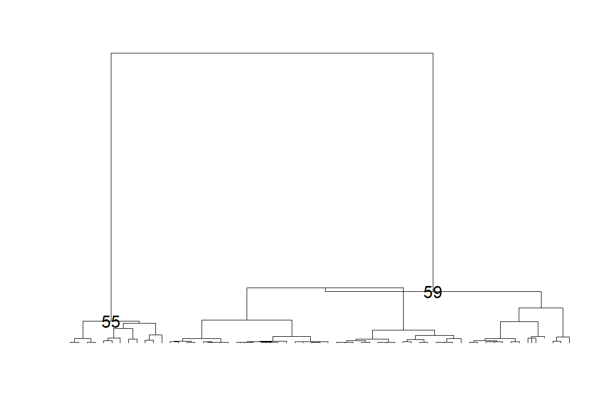

## NULL

temp2 <- rep(1, nrow(mmdt))  
for (i in 2:length(final_nodes)) {  
 temp2[teststat$childnodes[final_nodes[i]][[1]]] <- i  
}  
  
cluster <- cbind(mmdt[,2:3], factor(temp2), round(mmdfpdf_catch$Catch,0))  
names(cluster) <- c("lat", "lon", "cell", "Weight")  
# write.csv(cluster, file = paste0(save_dir, "cluster_YFT", kk, ".csv"), row.names = FALSE)  
  
# # map of clusters  
ggplot(data = cluster) +  
 geom_tile(aes(x = lon, y = lat, fill = cell), color = "black") +  
 geom_polygon(  
 data = wmap,  
 aes(long, lat, group = group),  
 fill = "black",  
 colour = "white",  
 lwd = 0.5  
 ) +  
 geom_text(aes(x = lon, y = lat, label = Weight),  
 color = "white",  
 size = 7,  
 ) +  
 coord_quickmap(ylim = c(min(cluster$lat), max(cluster$lat)), xlim = c(min(cluster$lon), max(cluster$lon))) +  
 theme_bw()

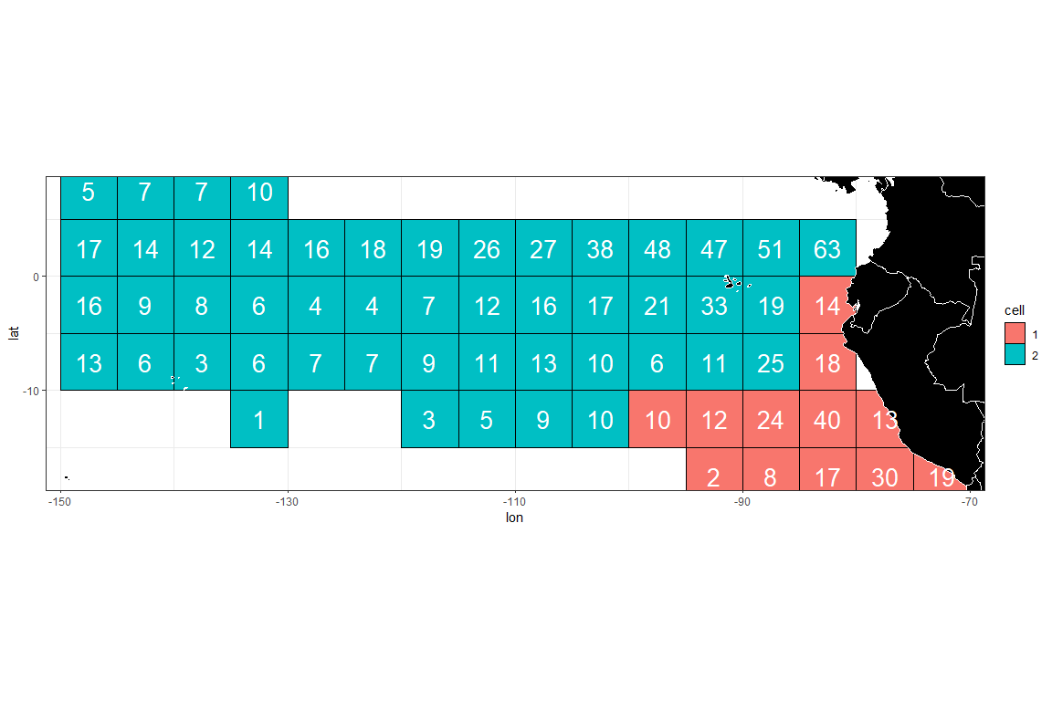

# ggsave(file = paste0(save_dir, "Clustering_map.png"), h = 5, w= 8)  
  
colcol = rep(c(2, 3, 4, 5, 6, 7, 8), 3)  
densy_df <- clusthistd3(kk = length(final_nodes), colseq = temp2 + 1, colcol, plot = FALSE)  
  
ggplot(data = densy_df) +  
 geom_line(aes(x = Length, y = Density, color = Cell), linewidth = 2) +  
 theme_bw()

