* cplotu(alydens.spatial23$merges,alydens.spatial23$distseq,hopt='dist') is used in the code to plot the dendrogram: what are the options for hopt? I see ‘dist’ is used in the code but the function has two more options (‘dev’ and ‘unit’).

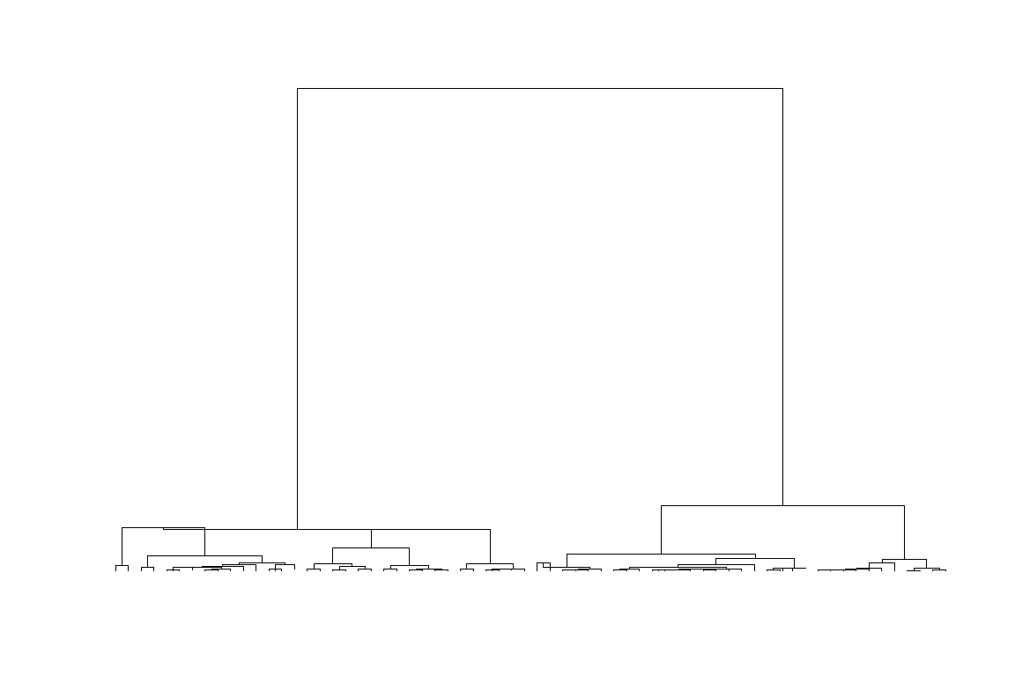

* Should we weight each cell by the number of data available?
* Is the clustering result sensitive to 0 observations? Can I remove the smallest and largest bins with most 0 observations?