Fishery definition for YFT in dolphin sets

Haikun Xu

2024-08-14

library(FishFreqClustering)  
library(FishFreqTree)  
library(tidyverse)

## ── Attaching core tidyverse packages ──────────────────────── tidyverse 2.0.0 ──  
## ✔ dplyr 1.1.4 ✔ readr 2.1.5  
## ✔ forcats 1.0.0 ✔ stringr 1.5.1  
## ✔ ggplot2 3.5.1 ✔ tibble 3.2.1  
## ✔ lubridate 1.9.3 ✔ tidyr 1.3.1  
## ✔ purrr 1.0.2   
## ── Conflicts ────────────────────────────────────────── tidyverse_conflicts() ──  
## ✖ dplyr::filter() masks stats::filter()  
## ✖ dplyr::lag() masks stats::lag()  
## ℹ Use the conflicted package (<http://conflicted.r-lib.org/>) to force all conflicts to become errors

directory <- "D:/OneDrive - IATTC/IATTC/2024/Irregular clustering/YFT DEL/"  
setwd(directory)  
  
Raw <- read.csv("yft_lf_2000_to_2022.csv")  
Raw$quarter = ceiling(Raw$month / 3)  
Raw$lat = Raw$lat.5deg + 2.5  
Raw$lon = Raw$lon.5deg - 2.5

LF.DEL <- Raw %>% filter(class == 6, setype == 1) # 1=DEL; 4=NOA; 5=OBJ  
  
LF <- LF.DEL[, c("year", "quarter", "lat", "lon", paste0("X", 1:201))] %>%  
 group_by(lat, lon) %>%  
 mutate(N = length(unique(paste0(year, "-", quarter)))) %>%  
 filter(N > 3, lat > -10) # remove the cells with less than 4 quarters of data since 2000  
  
bins <- seq(1, 201, 1) # data length bins  
new_bins <- seq(61, 200, 1) # bins to be used in the clustering analysis  
  
# first aggregate the raw LF to the new bins by quarter  
LF1 <- lf.aggregate(LF, fcol = 5, lcol = 205, bins, new_bins, LengthOnly = FALSE)  
  
# Chekcing the data by making two plots  
bins <- new_bins # use the new bins  
nbins <- length(bins)  
fcol = 5  
lcol = 4 + length(bins)  
save_dir=directory  
  
make.meanl.map(LF1, fcol, lcol, bins, save_dir, width = 10, height = 10)

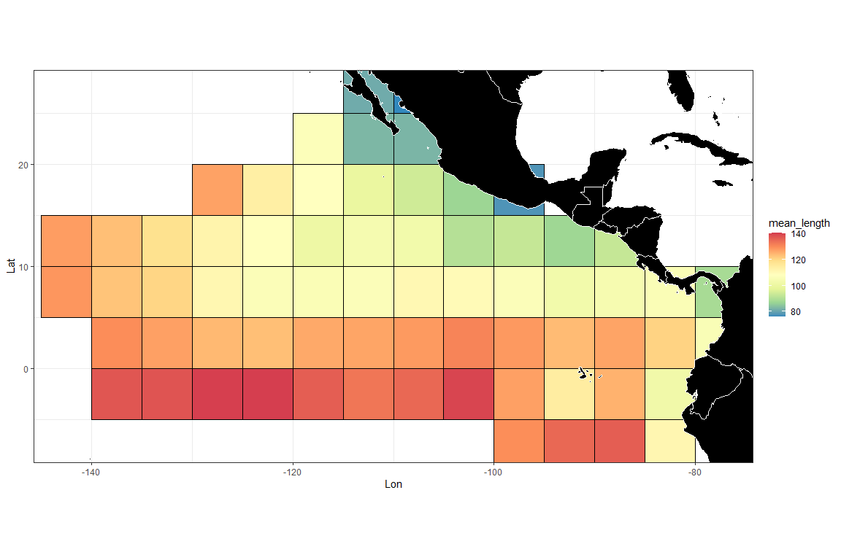

make.lf.map(LF1, fcol, lcol, bins, save_dir)

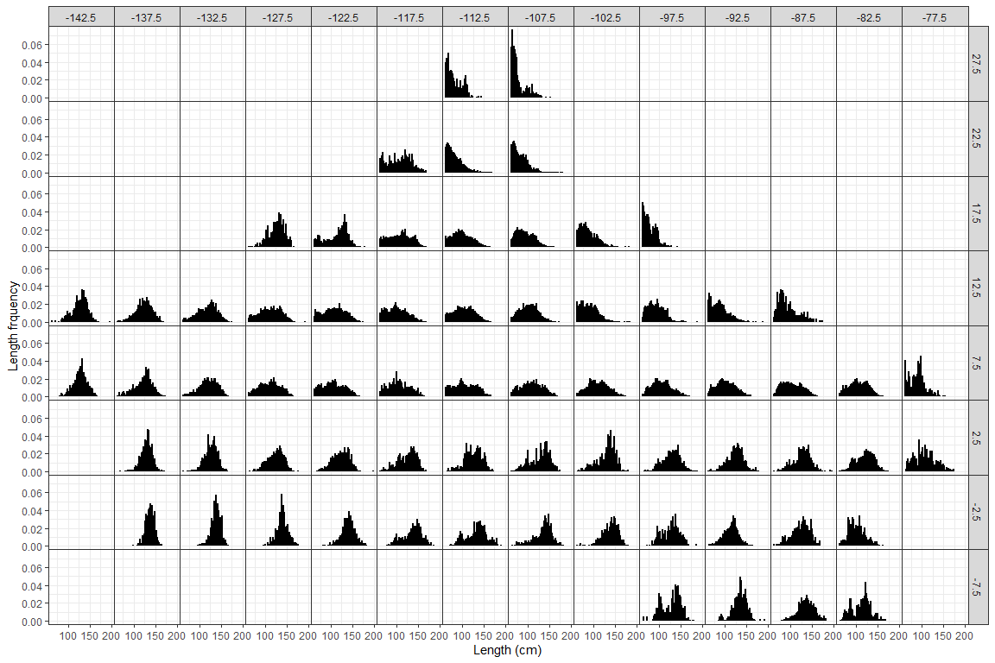

# divide the LF by the mean LF for the year-quarter  
LF2 <- lf.demean(LF1, fcol, lcol, bins)

cae <- BSE::read.cae.f("D:/OneDrive - IATTC/IATTC/2024/SAC15/PS Database/", "CAE-LatLon2000-2023.txt",2000,2023)  
  
YFT_DEL_catch <- cae %>%  
 filter(setype == 1, class == 6) %>%  
 rename(lat = latc5, lon = lonc5) %>%  
 group_by(lat, lon) %>%  
 summarise(Catch = sum(sum.trop.tunas)/1000)

## `summarise()` has grouped output by 'lat'. You can override using the `.groups`  
## argument.

wmap <- map_data("world")  
ggplot(data = YFT_DEL_catch) +  
 geom_tile(aes(x = lon, y = lat, fill = Catch), color = "black") +  
 scale_fill_gradient(  
 low = "white",  
 high = "red",  
 na.value = "white",  
 limits = c(0, max(YFT_DEL_catch$Catch))  
 ) +  
 geom_polygon(  
 data = wmap,  
 aes(long, lat, group = group),  
 fill = "black",  
 colour = "white",  
 lwd = 0.5  
 ) +  
 coord_quickmap(ylim = c(min(YFT_DEL_catch$lat), max(YFT_DEL_catch$lat)), xlim = c(min(YFT_DEL_catch$lon), max(YFT_DEL_catch$lon))) +  
 theme_bw()

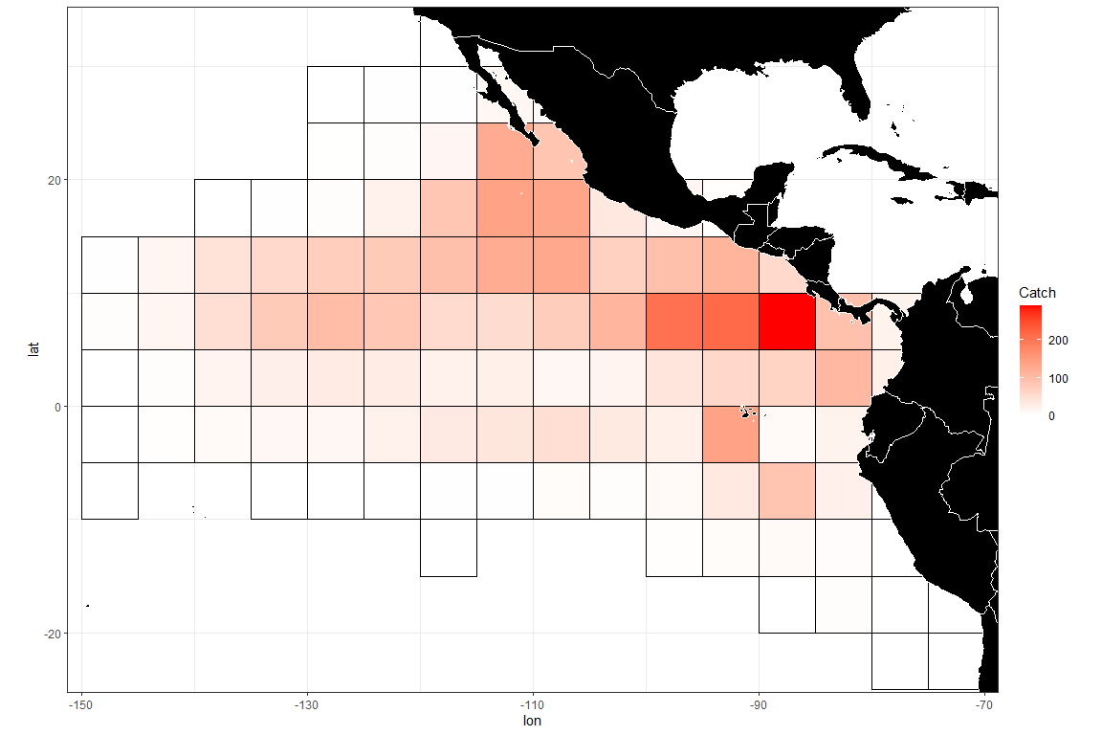

mmd <- LF2[,c(2,4:(lcol+1))] # mmd is the input data for the clustering analysis - it should have year, lat, lon, and bin numbers  
  
# setting up input data frames for clustering algorithm  
temp = packbylatlon(mmd, 5, 5, nbins) # aggregate the input LF across time for each grid cell  
  
packedmmd3 = temp$table1  
packedpdf3 = topdf(packedmmd3, 4, 3 + nbins)  
# packedcdf3 = tocdf(packedpdf3, 4, 3 + nbins)  
mmdt = packedmmd3[packedmmd3[, 4 + nbins] > 0,]  
rrs = mmdt[, 4 + nbins] # sample size  
mmdtpdf = packedpdf3[packedmmd3[, 4 + nbins] > 0,] # PDF sums to 1 for each grid  
mmdtpdf[, 4 + nbins] = mmdt[, 4 + nbins]  
# mmdtcdf = packedcdf3[packedmmd3[, 4 + nbins] > 0,]  
# mmdtcdf[, 4 + nbins] = mmdt[, 4 + nbins]  
  
names(mmdtpdf)[2:3] <- c("lat", "lon")  
mmdtpdf$Number <- 1:nrow(mmdtpdf)  
mmdfpdf_catch <- left_join(mmdtpdf, YFT_DEL_catch)

## Joining with `by = join_by(lat, lon)`

# check grid ID  
ggplot(data = mmdfpdf_catch) +  
 geom_polygon(  
 data = wmap,  
 aes(long, lat, group = group),  
 fill = "black",  
 colour = "white",  
 lwd = 0.5  
 ) +  
 geom_text(aes(x = lon, y = lat, label = Number), color = "red", size = 5) +  
 coord_quickmap(ylim = c(min(mmdfpdf_catch$lat), max(mmdfpdf_catch$lat)), xlim = c(min(mmdfpdf_catch$lon), max(mmdfpdf_catch$lon))) +  
 ggtitle("Grid ID") +  
 theme_bw()

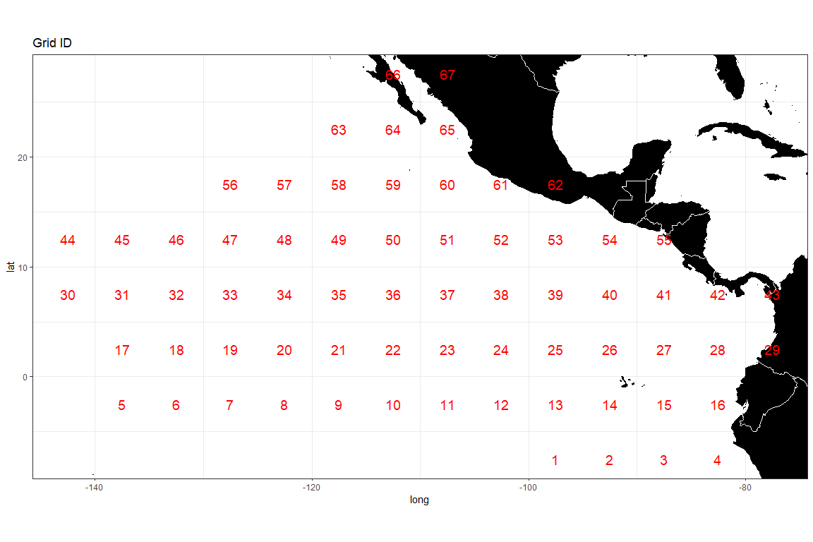

densmatx = matrix(0, nrow(mmdt), 512)  
densmaty = matrix(0, nrow(mmdt), 512)  
for(i in 1:nrow(mmdt)) {  
 weightvec = t(mmdt[i, 4:(3 + nbins)])  
 weightvec = weightvec / sum(weightvec)  
 tempmmd = density(seq(0.61, 2.00, 0.01), weights = weightvec, bw = 0.10)  
 densmatx[i, ] = tempmmd$x  
 densmaty[i, ] = tempmmd$y  
}  
  
# run distributional clustering with adjacency criterion  
adjmat <- adjinf(mmdtpdf[, 2], mmdtpdf[, 3], mindist = 5) # the matrix specifying adjacency   
  
alydens.spatial23 <-  
 hclust.regionsmm(  
 as.matrix(densmaty),  
 adj = TRUE, # adjacent areas  
 adjmat = adjmat,  
 rr = mmdfpdf_catch$Catch # rr is the weighting factor; equal weighting is used in this case  
 )  
  
# Look at the tree structure  
cplotu(alydens.spatial23$merges, alydens.spatial23$distseq, hopt = 'dist')

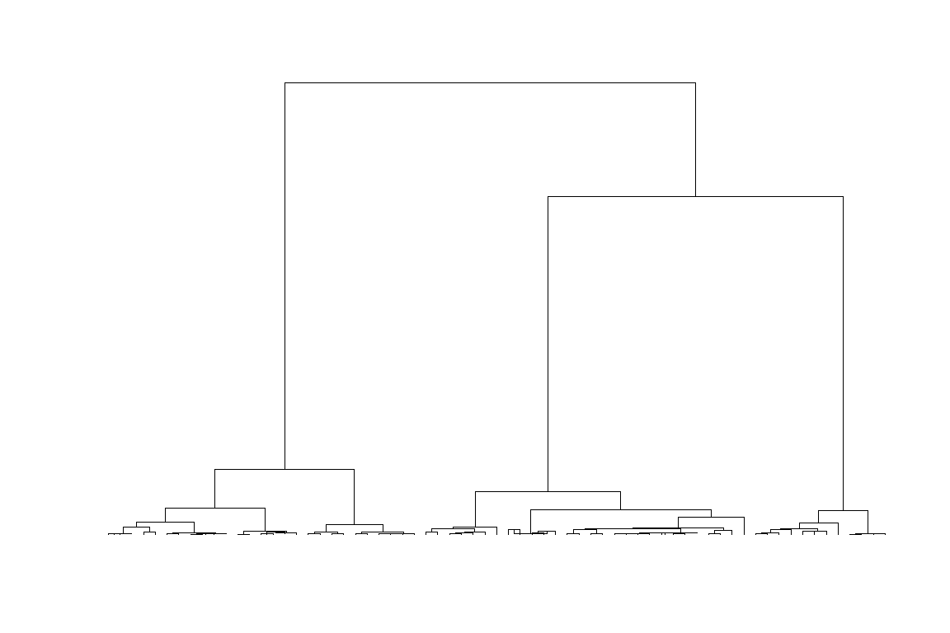

## NULL

distantmat <- alydens.spatial23$distantmat  
write.csv(distantmat, file = "distantmax.csv", row.names = FALSE)  
  
for (i in 2:nrow(distantmat)) {  
 for (j in 1:(i - 1)) {  
 distantmat[i, j] <- distantmat[j, i]   
 }  
}  
  
# you want to check the distance between, for example [12.5, -112.5], and other grids  
Lat <- 2.5  
Lon <- -112.5  
  
n <- which(mmdt[,2] == Lat & mmdt[,3] == Lon) # find the grid ID of [2.5, -132.5]  
dist <- cbind(distantmat[,n], mmdt[, 2:3])  
dist[n,1] <- NA  
names(dist) <- c("MJS", "lat", "lon")  
  
wmap <- map_data("world")  
ggplot(data = dist) +  
 geom_tile(aes(x = lon, y = lat, fill = MJS), color = "black") +  
 scale_fill_gradient(  
 low = "white",  
 high = "red",  
 na.value = "white",  
 limits = c(0, max(dist$MJS))  
 ) +  
 geom_point(  
 aes(x = -112.5, y = 2.5),  
 color = "blue",  
 size = 5,  
 shape = 13  
 ) +  
 geom_polygon(  
 data = wmap,  
 aes(long, lat, group = group),  
 fill = "black",  
 colour = "white",  
 lwd = 0.5  
 ) +  
 geom_text(aes(x = lon, y = lat, label = round(MJS,0)), color = "blue") +  
 coord_quickmap(ylim = c(min(dist$lat), max(dist$lat)), xlim = c(min(dist$lon), max(dist$lon))) +  
 theme_bw() +  
 ggtitle(paste0("Distance map for ", Lat, "N and ", -Lon, "W"))

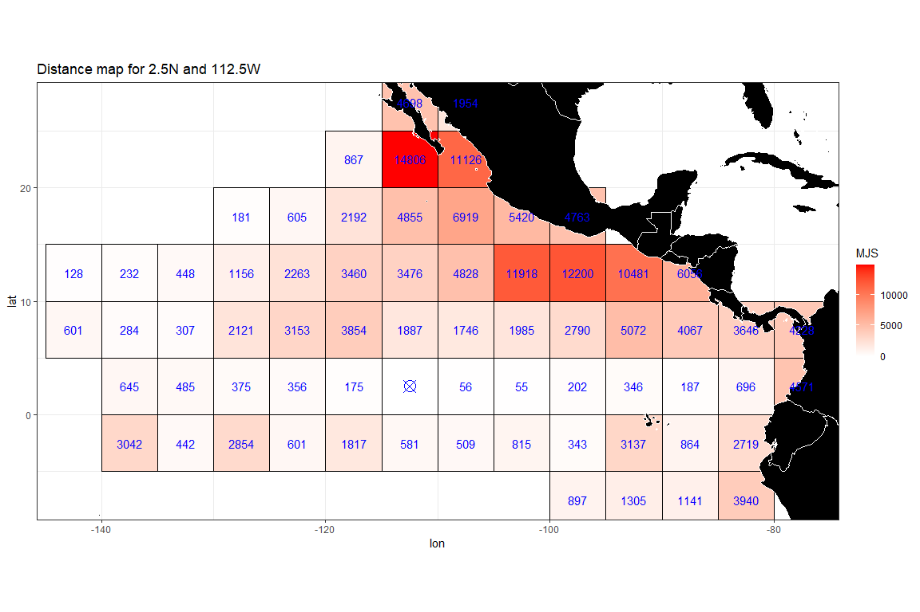

ggsave(file = paste0(save_dir, "Distance_map(", Lat, Lon, ").png"), h = 4, w = 6)

# making maps of the clusters and corresponding L-F density curves  
  
# kk is the number of clusters to use  
kk = 5  
# save clustering results  
temp <- putcolor(alydens.spatial23$merges, kk)  
cluster <- cbind(mmdt[,2:3], factor(temp-1), round(mmdfpdf_catch$Catch,0))  
names(cluster) <- c("lat", "lon", "cell", "Weight")  
write.csv(cluster, file = paste0(save_dir, "cluster_YFT", kk, ".csv"), row.names = FALSE)  
  
# # map of clusters  
ggplot(data = cluster) +  
 geom_tile(aes(x = lon, y = lat, fill = cell), color = "black") +  
 geom_polygon(  
 data = wmap,  
 aes(long, lat, group = group),  
 fill = "black",  
 colour = "white",  
 lwd = 0.5  
 ) +  
 geom_text(aes(x = lon, y = lat, label = Weight),  
 color = "white",  
 size = 7,  
 ) +  
 coord_quickmap(ylim = c(min(cluster$lat), max(cluster$lat)), xlim = c(min(cluster$lon), max(cluster$lon))) +  
 theme_bw()

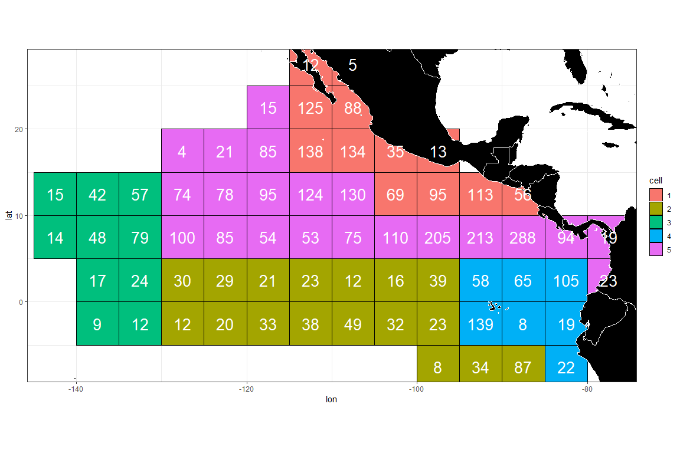

ggsave(file = paste0(save_dir, "Clustering_map", kk, ".png"))

## Saving 12 x 8 in image

# mean LF in each area  
# LF1_cluster <- left_join(LF1, cluster) %>% rename(Flag = cell)  
# make.lf.cell(LF1_cluster, fcol, lcol, bins, save_dir, plot_name = paste0("NewLF", kk))  
  
# draw density curves by cluster  
colcol = rep(c(2, 3, 4, 5, 6, 7, 8), 3)  
atitle.cl<-"2000-2023"  
clusthistd3(kk,colseq=temp,atitle.cl,colcol,xlims = c(0,2), ylims = c(0,2.5))

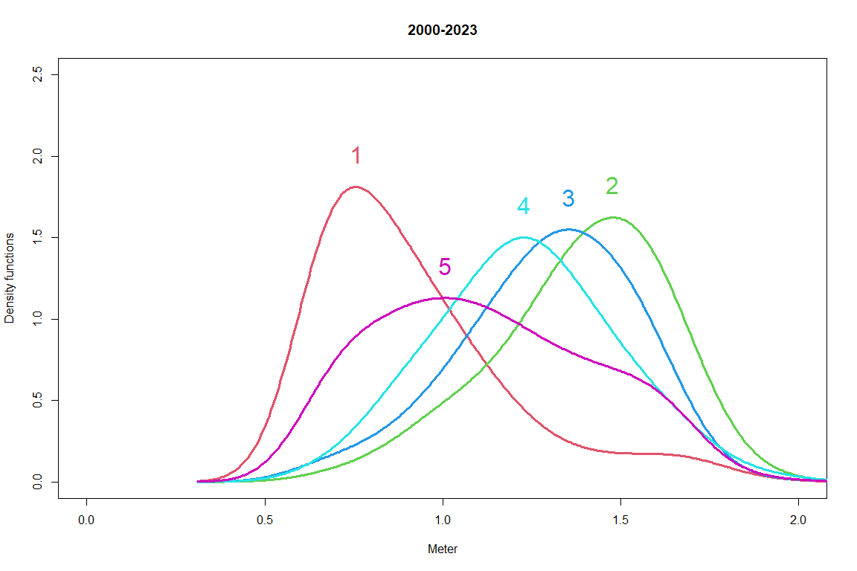

teststat <- heterodist(  
 alydens.spatial23$merges,  
 alydens.spatial23$distseq,  
 tempmmd$x,  
 densmaty,  
 mmdfpdf_catch$Catch,  
 doko = c(1, 20),  
 BB = 100  
)

## [1] "i= 66 j= 1"  
## [1] "i= 66 j= 2"  
## [1] "i= 66 j= 3"  
## [1] "i= 66 j= 4"  
## [1] "i= 66 j= 5"  
## [1] "i= 66 j= 6"  
## [1] "i= 66 j= 7"  
## [1] "i= 66 j= 8"  
## [1] "i= 66 j= 9"  
## [1] "i= 66 j= 10"  
## [1] "i= 66 j= 11"  
## [1] "i= 66 j= 12"  
## [1] "i= 66 j= 13"  
## [1] "i= 66 j= 14"  
## [1] "i= 66 j= 15"  
## [1] "i= 66 j= 16"  
## [1] "i= 66 j= 17"  
## [1] "i= 66 j= 18"  
## [1] "i= 66 j= 19"  
## [1] "i= 66 j= 20"  
## [1] "i= 66 j= 21"  
## [1] "i= 66 j= 22"  
## [1] "i= 66 j= 23"  
## [1] "i= 66 j= 24"  
## [1] "i= 66 j= 25"  
## [1] "i= 66 j= 26"  
## [1] "i= 66 j= 27"  
## [1] "i= 66 j= 28"  
## [1] "i= 66 j= 29"  
## [1] "i= 66 j= 30"  
## [1] "i= 66 j= 31"  
## [1] "i= 66 j= 32"  
## [1] "i= 66 j= 33"  
## [1] "i= 66 j= 34"  
## [1] "i= 66 j= 35"  
## [1] "i= 66 j= 36"  
## [1] "i= 66 j= 37"  
## [1] "i= 66 j= 38"  
## [1] "i= 66 j= 39"  
## [1] "i= 66 j= 40"  
## [1] "i= 66 j= 41"  
## [1] "i= 66 j= 42"  
## [1] "i= 66 j= 43"  
## [1] "i= 66 j= 44"  
## [1] "i= 66 j= 45"  
## [1] "i= 66 j= 46"  
## [1] "i= 66 j= 47"  
## [1] "i= 66 j= 48"  
## [1] "i= 66 j= 49"  
## [1] "i= 66 j= 50"  
## [1] "i= 66 j= 51"  
## [1] "i= 66 j= 52"  
## [1] "i= 66 j= 53"  
## [1] "i= 66 j= 54"  
## [1] "i= 66 j= 55"  
## [1] "i= 66 j= 56"  
## [1] "i= 66 j= 57"  
## [1] "i= 66 j= 58"  
## [1] "i= 66 j= 59"  
## [1] "i= 66 j= 60"  
## [1] "i= 66 j= 61"  
## [1] "i= 66 j= 62"  
## [1] "i= 66 j= 63"  
## [1] "i= 66 j= 64"  
## [1] "i= 66 j= 65"  
## [1] "i= 66 j= 66"  
## [1] "i= 66 j= 67"  
## [1] "i= 66 j= 68"  
## [1] "i= 66 j= 69"  
## [1] "i= 66 j= 70"  
## [1] "i= 66 j= 71"  
## [1] "i= 66 j= 72"  
## [1] "i= 66 j= 73"  
## [1] "i= 66 j= 74"  
## [1] "i= 66 j= 75"  
## [1] "i= 66 j= 76"  
## [1] "i= 66 j= 77"  
## [1] "i= 66 j= 78"  
## [1] "i= 66 j= 79"  
## [1] "i= 66 j= 80"  
## [1] "i= 66 j= 81"  
## [1] "i= 66 j= 82"  
## [1] "i= 66 j= 83"  
## [1] "i= 66 j= 84"  
## [1] "i= 66 j= 85"  
## [1] "i= 66 j= 86"  
## [1] "i= 66 j= 87"  
## [1] "i= 66 j= 88"  
## [1] "i= 66 j= 89"  
## [1] "i= 66 j= 90"  
## [1] "i= 66 j= 91"  
## [1] "i= 66 j= 92"  
## [1] "i= 66 j= 93"  
## [1] "i= 66 j= 94"  
## [1] "i= 66 j= 95"  
## [1] "i= 66 j= 96"  
## [1] "i= 66 j= 97"  
## [1] "i= 66 j= 98"  
## [1] "i= 66 j= 99"  
## [1] "i= 66 j= 100"  
## [1] "i= 65 j= 1"  
## [1] "i= 65 j= 2"  
## [1] "i= 65 j= 3"  
## [1] "i= 65 j= 4"  
## [1] "i= 65 j= 5"  
## [1] "i= 65 j= 6"  
## [1] "i= 65 j= 7"  
## [1] "i= 65 j= 8"  
## [1] "i= 65 j= 9"  
## [1] "i= 65 j= 10"  
## [1] "i= 65 j= 11"  
## [1] "i= 65 j= 12"  
## [1] "i= 65 j= 13"  
## [1] "i= 65 j= 14"  
## [1] "i= 65 j= 15"  
## [1] "i= 65 j= 16"  
## [1] "i= 65 j= 17"  
## [1] "i= 65 j= 18"  
## [1] "i= 65 j= 19"  
## [1] "i= 65 j= 20"  
## [1] "i= 65 j= 21"  
## [1] "i= 65 j= 22"  
## [1] "i= 65 j= 23"  
## [1] "i= 65 j= 24"  
## [1] "i= 65 j= 25"  
## [1] "i= 65 j= 26"  
## [1] "i= 65 j= 27"  
## [1] "i= 65 j= 28"  
## [1] "i= 65 j= 29"  
## [1] "i= 65 j= 30"  
## [1] "i= 65 j= 31"  
## [1] "i= 65 j= 32"  
## [1] "i= 65 j= 33"  
## [1] "i= 65 j= 34"  
## [1] "i= 65 j= 35"  
## [1] "i= 65 j= 36"  
## [1] "i= 65 j= 37"  
## [1] "i= 65 j= 38"  
## [1] "i= 65 j= 39"  
## [1] "i= 65 j= 40"  
## [1] "i= 65 j= 41"  
## [1] "i= 65 j= 42"  
## [1] "i= 65 j= 43"  
## [1] "i= 65 j= 44"  
## [1] "i= 65 j= 45"  
## [1] "i= 65 j= 46"  
## [1] "i= 65 j= 47"  
## [1] "i= 65 j= 48"  
## [1] "i= 65 j= 49"  
## [1] "i= 65 j= 50"  
## [1] "i= 65 j= 51"  
## [1] "i= 65 j= 52"  
## [1] "i= 65 j= 53"  
## [1] "i= 65 j= 54"  
## [1] "i= 65 j= 55"  
## [1] "i= 65 j= 56"  
## [1] "i= 65 j= 57"  
## [1] "i= 65 j= 58"  
## [1] "i= 65 j= 59"  
## [1] "i= 65 j= 60"  
## [1] "i= 65 j= 61"  
## [1] "i= 65 j= 62"  
## [1] "i= 65 j= 63"  
## [1] "i= 65 j= 64"  
## [1] "i= 65 j= 65"  
## [1] "i= 65 j= 66"  
## [1] "i= 65 j= 67"  
## [1] "i= 65 j= 68"  
## [1] "i= 65 j= 69"  
## [1] "i= 65 j= 70"  
## [1] "i= 65 j= 71"  
## [1] "i= 65 j= 72"  
## [1] "i= 65 j= 73"  
## [1] "i= 65 j= 74"  
## [1] "i= 65 j= 75"  
## [1] "i= 65 j= 76"  
## [1] "i= 65 j= 77"  
## [1] "i= 65 j= 78"  
## [1] "i= 65 j= 79"  
## [1] "i= 65 j= 80"  
## [1] "i= 65 j= 81"  
## [1] "i= 65 j= 82"  
## [1] "i= 65 j= 83"  
## [1] "i= 65 j= 84"  
## [1] "i= 65 j= 85"  
## [1] "i= 65 j= 86"  
## [1] "i= 65 j= 87"  
## [1] "i= 65 j= 88"  
## [1] "i= 65 j= 89"  
## [1] "i= 65 j= 90"  
## [1] "i= 65 j= 91"  
## [1] "i= 65 j= 92"  
## [1] "i= 65 j= 93"  
## [1] "i= 65 j= 94"  
## [1] "i= 65 j= 95"  
## [1] "i= 65 j= 96"  
## [1] "i= 65 j= 97"  
## [1] "i= 65 j= 98"  
## [1] "i= 65 j= 99"  
## [1] "i= 65 j= 100"  
## [1] "i= 64 j= 1"  
## [1] "i= 64 j= 2"  
## [1] "i= 64 j= 3"  
## [1] "i= 64 j= 4"  
## [1] "i= 64 j= 5"  
## [1] "i= 64 j= 6"  
## [1] "i= 64 j= 7"  
## [1] "i= 64 j= 8"  
## [1] "i= 64 j= 9"  
## [1] "i= 64 j= 10"  
## [1] "i= 64 j= 11"  
## [1] "i= 64 j= 12"  
## [1] "i= 64 j= 13"  
## [1] "i= 64 j= 14"  
## [1] "i= 64 j= 15"  
## [1] "i= 64 j= 16"  
## [1] "i= 64 j= 17"  
## [1] "i= 64 j= 18"  
## [1] "i= 64 j= 19"  
## [1] "i= 64 j= 20"  
## [1] "i= 64 j= 21"  
## [1] "i= 64 j= 22"  
## [1] "i= 64 j= 23"  
## [1] "i= 64 j= 24"  
## [1] "i= 64 j= 25"  
## [1] "i= 64 j= 26"  
## [1] "i= 64 j= 27"  
## [1] "i= 64 j= 28"  
## [1] "i= 64 j= 29"  
## [1] "i= 64 j= 30"  
## [1] "i= 64 j= 31"  
## [1] "i= 64 j= 32"  
## [1] "i= 64 j= 33"  
## [1] "i= 64 j= 34"  
## [1] "i= 64 j= 35"  
## [1] "i= 64 j= 36"  
## [1] "i= 64 j= 37"  
## [1] "i= 64 j= 38"  
## [1] "i= 64 j= 39"  
## [1] "i= 64 j= 40"  
## [1] "i= 64 j= 41"  
## [1] "i= 64 j= 42"  
## [1] "i= 64 j= 43"  
## [1] "i= 64 j= 44"  
## [1] "i= 64 j= 45"  
## [1] "i= 64 j= 46"  
## [1] "i= 64 j= 47"  
## [1] "i= 64 j= 48"  
## [1] "i= 64 j= 49"  
## [1] "i= 64 j= 50"  
## [1] "i= 64 j= 51"  
## [1] "i= 64 j= 52"  
## [1] "i= 64 j= 53"  
## [1] "i= 64 j= 54"  
## [1] "i= 64 j= 55"  
## [1] "i= 64 j= 56"  
## [1] "i= 64 j= 57"  
## [1] "i= 64 j= 58"  
## [1] "i= 64 j= 59"  
## [1] "i= 64 j= 60"  
## [1] "i= 64 j= 61"  
## [1] "i= 64 j= 62"  
## [1] "i= 64 j= 63"  
## [1] "i= 64 j= 64"  
## [1] "i= 64 j= 65"  
## [1] "i= 64 j= 66"  
## [1] "i= 64 j= 67"  
## [1] "i= 64 j= 68"  
## [1] "i= 64 j= 69"  
## [1] "i= 64 j= 70"  
## [1] "i= 64 j= 71"  
## [1] "i= 64 j= 72"  
## [1] "i= 64 j= 73"  
## [1] "i= 64 j= 74"  
## [1] "i= 64 j= 75"  
## [1] "i= 64 j= 76"  
## [1] "i= 64 j= 77"  
## [1] "i= 64 j= 78"  
## [1] "i= 64 j= 79"  
## [1] "i= 64 j= 80"  
## [1] "i= 64 j= 81"  
## [1] "i= 64 j= 82"  
## [1] "i= 64 j= 83"  
## [1] "i= 64 j= 84"  
## [1] "i= 64 j= 85"  
## [1] "i= 64 j= 86"  
## [1] "i= 64 j= 87"  
## [1] "i= 64 j= 88"  
## [1] "i= 64 j= 89"  
## [1] "i= 64 j= 90"  
## [1] "i= 64 j= 91"  
## [1] "i= 64 j= 92"  
## [1] "i= 64 j= 93"  
## [1] "i= 64 j= 94"  
## [1] "i= 64 j= 95"  
## [1] "i= 64 j= 96"  
## [1] "i= 64 j= 97"  
## [1] "i= 64 j= 98"  
## [1] "i= 64 j= 99"  
## [1] "i= 64 j= 100"  
## [1] "i= 63 j= 1"  
## [1] "i= 63 j= 2"  
## [1] "i= 63 j= 3"  
## [1] "i= 63 j= 4"  
## [1] "i= 63 j= 5"  
## [1] "i= 63 j= 6"  
## [1] "i= 63 j= 7"  
## [1] "i= 63 j= 8"  
## [1] "i= 63 j= 9"  
## [1] "i= 63 j= 10"  
## [1] "i= 63 j= 11"  
## [1] "i= 63 j= 12"  
## [1] "i= 63 j= 13"  
## [1] "i= 63 j= 14"  
## [1] "i= 63 j= 15"  
## [1] "i= 63 j= 16"  
## [1] "i= 63 j= 17"  
## [1] "i= 63 j= 18"  
## [1] "i= 63 j= 19"  
## [1] "i= 63 j= 20"  
## [1] "i= 63 j= 21"  
## [1] "i= 63 j= 22"  
## [1] "i= 63 j= 23"  
## [1] "i= 63 j= 24"  
## [1] "i= 63 j= 25"  
## [1] "i= 63 j= 26"  
## [1] "i= 63 j= 27"  
## [1] "i= 63 j= 28"  
## [1] "i= 63 j= 29"  
## [1] "i= 63 j= 30"  
## [1] "i= 63 j= 31"  
## [1] "i= 63 j= 32"  
## [1] "i= 63 j= 33"  
## [1] "i= 63 j= 34"  
## [1] "i= 63 j= 35"  
## [1] "i= 63 j= 36"  
## [1] "i= 63 j= 37"  
## [1] "i= 63 j= 38"  
## [1] "i= 63 j= 39"  
## [1] "i= 63 j= 40"  
## [1] "i= 63 j= 41"  
## [1] "i= 63 j= 42"  
## [1] "i= 63 j= 43"  
## [1] "i= 63 j= 44"  
## [1] "i= 63 j= 45"  
## [1] "i= 63 j= 46"  
## [1] "i= 63 j= 47"  
## [1] "i= 63 j= 48"  
## [1] "i= 63 j= 49"  
## [1] "i= 63 j= 50"  
## [1] "i= 63 j= 51"  
## [1] "i= 63 j= 52"  
## [1] "i= 63 j= 53"  
## [1] "i= 63 j= 54"  
## [1] "i= 63 j= 55"  
## [1] "i= 63 j= 56"  
## [1] "i= 63 j= 57"  
## [1] "i= 63 j= 58"  
## [1] "i= 63 j= 59"  
## [1] "i= 63 j= 60"  
## [1] "i= 63 j= 61"  
## [1] "i= 63 j= 62"  
## [1] "i= 63 j= 63"  
## [1] "i= 63 j= 64"  
## [1] "i= 63 j= 65"  
## [1] "i= 63 j= 66"  
## [1] "i= 63 j= 67"  
## [1] "i= 63 j= 68"  
## [1] "i= 63 j= 69"  
## [1] "i= 63 j= 70"  
## [1] "i= 63 j= 71"  
## [1] "i= 63 j= 72"  
## [1] "i= 63 j= 73"  
## [1] "i= 63 j= 74"  
## [1] "i= 63 j= 75"  
## [1] "i= 63 j= 76"  
## [1] "i= 63 j= 77"  
## [1] "i= 63 j= 78"  
## [1] "i= 63 j= 79"  
## [1] "i= 63 j= 80"  
## [1] "i= 63 j= 81"  
## [1] "i= 63 j= 82"  
## [1] "i= 63 j= 83"  
## [1] "i= 63 j= 84"  
## [1] "i= 63 j= 85"  
## [1] "i= 63 j= 86"  
## [1] "i= 63 j= 87"  
## [1] "i= 63 j= 88"  
## [1] "i= 63 j= 89"  
## [1] "i= 63 j= 90"  
## [1] "i= 63 j= 91"  
## [1] "i= 63 j= 92"  
## [1] "i= 63 j= 93"  
## [1] "i= 63 j= 94"  
## [1] "i= 63 j= 95"  
## [1] "i= 63 j= 96"  
## [1] "i= 63 j= 97"  
## [1] "i= 63 j= 98"  
## [1] "i= 63 j= 99"  
## [1] "i= 63 j= 100"  
## [1] "i= 62 j= 1"  
## [1] "i= 62 j= 2"  
## [1] "i= 62 j= 3"  
## [1] "i= 62 j= 4"  
## [1] "i= 62 j= 5"  
## [1] "i= 62 j= 6"  
## [1] "i= 62 j= 7"  
## [1] "i= 62 j= 8"  
## [1] "i= 62 j= 9"  
## [1] "i= 62 j= 10"  
## [1] "i= 62 j= 11"  
## [1] "i= 62 j= 12"  
## [1] "i= 62 j= 13"  
## [1] "i= 62 j= 14"  
## [1] "i= 62 j= 15"  
## [1] "i= 62 j= 16"  
## [1] "i= 62 j= 17"  
## [1] "i= 62 j= 18"  
## [1] "i= 62 j= 19"  
## [1] "i= 62 j= 20"  
## [1] "i= 62 j= 21"  
## [1] "i= 62 j= 22"  
## [1] "i= 62 j= 23"  
## [1] "i= 62 j= 24"  
## [1] "i= 62 j= 25"  
## [1] "i= 62 j= 26"  
## [1] "i= 62 j= 27"  
## [1] "i= 62 j= 28"  
## [1] "i= 62 j= 29"  
## [1] "i= 62 j= 30"  
## [1] "i= 62 j= 31"  
## [1] "i= 62 j= 32"  
## [1] "i= 62 j= 33"  
## [1] "i= 62 j= 34"  
## [1] "i= 62 j= 35"  
## [1] "i= 62 j= 36"  
## [1] "i= 62 j= 37"  
## [1] "i= 62 j= 38"  
## [1] "i= 62 j= 39"  
## [1] "i= 62 j= 40"  
## [1] "i= 62 j= 41"  
## [1] "i= 62 j= 42"  
## [1] "i= 62 j= 43"  
## [1] "i= 62 j= 44"  
## [1] "i= 62 j= 45"  
## [1] "i= 62 j= 46"  
## [1] "i= 62 j= 47"  
## [1] "i= 62 j= 48"  
## [1] "i= 62 j= 49"  
## [1] "i= 62 j= 50"  
## [1] "i= 62 j= 51"  
## [1] "i= 62 j= 52"  
## [1] "i= 62 j= 53"  
## [1] "i= 62 j= 54"  
## [1] "i= 62 j= 55"  
## [1] "i= 62 j= 56"  
## [1] "i= 62 j= 57"  
## [1] "i= 62 j= 58"  
## [1] "i= 62 j= 59"  
## [1] "i= 62 j= 60"  
## [1] "i= 62 j= 61"  
## [1] "i= 62 j= 62"  
## [1] "i= 62 j= 63"  
## [1] "i= 62 j= 64"  
## [1] "i= 62 j= 65"  
## [1] "i= 62 j= 66"  
## [1] "i= 62 j= 67"  
## [1] "i= 62 j= 68"  
## [1] "i= 62 j= 69"  
## [1] "i= 62 j= 70"  
## [1] "i= 62 j= 71"  
## [1] "i= 62 j= 72"  
## [1] "i= 62 j= 73"  
## [1] "i= 62 j= 74"  
## [1] "i= 62 j= 75"  
## [1] "i= 62 j= 76"  
## [1] "i= 62 j= 77"  
## [1] "i= 62 j= 78"  
## [1] "i= 62 j= 79"  
## [1] "i= 62 j= 80"  
## [1] "i= 62 j= 81"  
## [1] "i= 62 j= 82"  
## [1] "i= 62 j= 83"  
## [1] "i= 62 j= 84"  
## [1] "i= 62 j= 85"  
## [1] "i= 62 j= 86"  
## [1] "i= 62 j= 87"  
## [1] "i= 62 j= 88"  
## [1] "i= 62 j= 89"  
## [1] "i= 62 j= 90"  
## [1] "i= 62 j= 91"  
## [1] "i= 62 j= 92"  
## [1] "i= 62 j= 93"  
## [1] "i= 62 j= 94"  
## [1] "i= 62 j= 95"  
## [1] "i= 62 j= 96"  
## [1] "i= 62 j= 97"  
## [1] "i= 62 j= 98"  
## [1] "i= 62 j= 99"  
## [1] "i= 62 j= 100"  
## [1] "i= 61 j= 1"  
## [1] "i= 61 j= 2"  
## [1] "i= 61 j= 3"  
## [1] "i= 61 j= 4"  
## [1] "i= 61 j= 5"  
## [1] "i= 61 j= 6"  
## [1] "i= 61 j= 7"  
## [1] "i= 61 j= 8"  
## [1] "i= 61 j= 9"  
## [1] "i= 61 j= 10"  
## [1] "i= 61 j= 11"  
## [1] "i= 61 j= 12"  
## [1] "i= 61 j= 13"  
## [1] "i= 61 j= 14"  
## [1] "i= 61 j= 15"  
## [1] "i= 61 j= 16"  
## [1] "i= 61 j= 17"  
## [1] "i= 61 j= 18"  
## [1] "i= 61 j= 19"  
## [1] "i= 61 j= 20"  
## [1] "i= 61 j= 21"  
## [1] "i= 61 j= 22"  
## [1] "i= 61 j= 23"  
## [1] "i= 61 j= 24"  
## [1] "i= 61 j= 25"  
## [1] "i= 61 j= 26"  
## [1] "i= 61 j= 27"  
## [1] "i= 61 j= 28"  
## [1] "i= 61 j= 29"  
## [1] "i= 61 j= 30"  
## [1] "i= 61 j= 31"  
## [1] "i= 61 j= 32"  
## [1] "i= 61 j= 33"  
## [1] "i= 61 j= 34"  
## [1] "i= 61 j= 35"  
## [1] "i= 61 j= 36"  
## [1] "i= 61 j= 37"  
## [1] "i= 61 j= 38"  
## [1] "i= 61 j= 39"  
## [1] "i= 61 j= 40"  
## [1] "i= 61 j= 41"  
## [1] "i= 61 j= 42"  
## [1] "i= 61 j= 43"  
## [1] "i= 61 j= 44"  
## [1] "i= 61 j= 45"  
## [1] "i= 61 j= 46"  
## [1] "i= 61 j= 47"  
## [1] "i= 61 j= 48"  
## [1] "i= 61 j= 49"  
## [1] "i= 61 j= 50"  
## [1] "i= 61 j= 51"  
## [1] "i= 61 j= 52"  
## [1] "i= 61 j= 53"  
## [1] "i= 61 j= 54"  
## [1] "i= 61 j= 55"  
## [1] "i= 61 j= 56"  
## [1] "i= 61 j= 57"  
## [1] "i= 61 j= 58"  
## [1] "i= 61 j= 59"  
## [1] "i= 61 j= 60"  
## [1] "i= 61 j= 61"  
## [1] "i= 61 j= 62"  
## [1] "i= 61 j= 63"  
## [1] "i= 61 j= 64"  
## [1] "i= 61 j= 65"  
## [1] "i= 61 j= 66"  
## [1] "i= 61 j= 67"  
## [1] "i= 61 j= 68"  
## [1] "i= 61 j= 69"  
## [1] "i= 61 j= 70"  
## [1] "i= 61 j= 71"  
## [1] "i= 61 j= 72"  
## [1] "i= 61 j= 73"  
## [1] "i= 61 j= 74"  
## [1] "i= 61 j= 75"  
## [1] "i= 61 j= 76"  
## [1] "i= 61 j= 77"  
## [1] "i= 61 j= 78"  
## [1] "i= 61 j= 79"  
## [1] "i= 61 j= 80"  
## [1] "i= 61 j= 81"  
## [1] "i= 61 j= 82"  
## [1] "i= 61 j= 83"  
## [1] "i= 61 j= 84"  
## [1] "i= 61 j= 85"  
## [1] "i= 61 j= 86"  
## [1] "i= 61 j= 87"  
## [1] "i= 61 j= 88"  
## [1] "i= 61 j= 89"  
## [1] "i= 61 j= 90"  
## [1] "i= 61 j= 91"  
## [1] "i= 61 j= 92"  
## [1] "i= 61 j= 93"  
## [1] "i= 61 j= 94"  
## [1] "i= 61 j= 95"  
## [1] "i= 61 j= 96"  
## [1] "i= 61 j= 97"  
## [1] "i= 61 j= 98"  
## [1] "i= 61 j= 99"  
## [1] "i= 61 j= 100"  
## [1] "i= 60 j= 1"  
## [1] "i= 60 j= 2"  
## [1] "i= 60 j= 3"  
## [1] "i= 60 j= 4"  
## [1] "i= 60 j= 5"  
## [1] "i= 60 j= 6"  
## [1] "i= 60 j= 7"  
## [1] "i= 60 j= 8"  
## [1] "i= 60 j= 9"  
## [1] "i= 60 j= 10"  
## [1] "i= 60 j= 11"  
## [1] "i= 60 j= 12"  
## [1] "i= 60 j= 13"  
## [1] "i= 60 j= 14"  
## [1] "i= 60 j= 15"  
## [1] "i= 60 j= 16"  
## [1] "i= 60 j= 17"  
## [1] "i= 60 j= 18"  
## [1] "i= 60 j= 19"  
## [1] "i= 60 j= 20"  
## [1] "i= 60 j= 21"  
## [1] "i= 60 j= 22"  
## [1] "i= 60 j= 23"  
## [1] "i= 60 j= 24"  
## [1] "i= 60 j= 25"  
## [1] "i= 60 j= 26"  
## [1] "i= 60 j= 27"  
## [1] "i= 60 j= 28"  
## [1] "i= 60 j= 29"  
## [1] "i= 60 j= 30"  
## [1] "i= 60 j= 31"  
## [1] "i= 60 j= 32"  
## [1] "i= 60 j= 33"  
## [1] "i= 60 j= 34"  
## [1] "i= 60 j= 35"  
## [1] "i= 60 j= 36"  
## [1] "i= 60 j= 37"  
## [1] "i= 60 j= 38"  
## [1] "i= 60 j= 39"  
## [1] "i= 60 j= 40"  
## [1] "i= 60 j= 41"  
## [1] "i= 60 j= 42"  
## [1] "i= 60 j= 43"  
## [1] "i= 60 j= 44"  
## [1] "i= 60 j= 45"  
## [1] "i= 60 j= 46"  
## [1] "i= 60 j= 47"  
## [1] "i= 60 j= 48"  
## [1] "i= 60 j= 49"  
## [1] "i= 60 j= 50"  
## [1] "i= 60 j= 51"  
## [1] "i= 60 j= 52"  
## [1] "i= 60 j= 53"  
## [1] "i= 60 j= 54"  
## [1] "i= 60 j= 55"  
## [1] "i= 60 j= 56"  
## [1] "i= 60 j= 57"  
## [1] "i= 60 j= 58"  
## [1] "i= 60 j= 59"  
## [1] "i= 60 j= 60"  
## [1] "i= 60 j= 61"  
## [1] "i= 60 j= 62"  
## [1] "i= 60 j= 63"  
## [1] "i= 60 j= 64"  
## [1] "i= 60 j= 65"  
## [1] "i= 60 j= 66"  
## [1] "i= 60 j= 67"  
## [1] "i= 60 j= 68"  
## [1] "i= 60 j= 69"  
## [1] "i= 60 j= 70"  
## [1] "i= 60 j= 71"  
## [1] "i= 60 j= 72"  
## [1] "i= 60 j= 73"  
## [1] "i= 60 j= 74"  
## [1] "i= 60 j= 75"  
## [1] "i= 60 j= 76"  
## [1] "i= 60 j= 77"  
## [1] "i= 60 j= 78"  
## [1] "i= 60 j= 79"  
## [1] "i= 60 j= 80"  
## [1] "i= 60 j= 81"  
## [1] "i= 60 j= 82"  
## [1] "i= 60 j= 83"  
## [1] "i= 60 j= 84"  
## [1] "i= 60 j= 85"  
## [1] "i= 60 j= 86"  
## [1] "i= 60 j= 87"  
## [1] "i= 60 j= 88"  
## [1] "i= 60 j= 89"  
## [1] "i= 60 j= 90"  
## [1] "i= 60 j= 91"  
## [1] "i= 60 j= 92"  
## [1] "i= 60 j= 93"  
## [1] "i= 60 j= 94"  
## [1] "i= 60 j= 95"  
## [1] "i= 60 j= 96"  
## [1] "i= 60 j= 97"  
## [1] "i= 60 j= 98"  
## [1] "i= 60 j= 99"  
## [1] "i= 60 j= 100"  
## [1] "i= 59 j= 1"  
## [1] "i= 59 j= 2"  
## [1] "i= 59 j= 3"  
## [1] "i= 59 j= 4"  
## [1] "i= 59 j= 5"  
## [1] "i= 59 j= 6"  
## [1] "i= 59 j= 7"  
## [1] "i= 59 j= 8"  
## [1] "i= 59 j= 9"  
## [1] "i= 59 j= 10"  
## [1] "i= 59 j= 11"  
## [1] "i= 59 j= 12"  
## [1] "i= 59 j= 13"  
## [1] "i= 59 j= 14"  
## [1] "i= 59 j= 15"  
## [1] "i= 59 j= 16"  
## [1] "i= 59 j= 17"  
## [1] "i= 59 j= 18"  
## [1] "i= 59 j= 19"  
## [1] "i= 59 j= 20"  
## [1] "i= 59 j= 21"  
## [1] "i= 59 j= 22"  
## [1] "i= 59 j= 23"  
## [1] "i= 59 j= 24"  
## [1] "i= 59 j= 25"  
## [1] "i= 59 j= 26"  
## [1] "i= 59 j= 27"  
## [1] "i= 59 j= 28"  
## [1] "i= 59 j= 29"  
## [1] "i= 59 j= 30"  
## [1] "i= 59 j= 31"  
## [1] "i= 59 j= 32"  
## [1] "i= 59 j= 33"  
## [1] "i= 59 j= 34"  
## [1] "i= 59 j= 35"  
## [1] "i= 59 j= 36"  
## [1] "i= 59 j= 37"  
## [1] "i= 59 j= 38"  
## [1] "i= 59 j= 39"  
## [1] "i= 59 j= 40"  
## [1] "i= 59 j= 41"  
## [1] "i= 59 j= 42"  
## [1] "i= 59 j= 43"  
## [1] "i= 59 j= 44"  
## [1] "i= 59 j= 45"  
## [1] "i= 59 j= 46"  
## [1] "i= 59 j= 47"  
## [1] "i= 59 j= 48"  
## [1] "i= 59 j= 49"  
## [1] "i= 59 j= 50"  
## [1] "i= 59 j= 51"  
## [1] "i= 59 j= 52"  
## [1] "i= 59 j= 53"  
## [1] "i= 59 j= 54"  
## [1] "i= 59 j= 55"  
## [1] "i= 59 j= 56"  
## [1] "i= 59 j= 57"  
## [1] "i= 59 j= 58"  
## [1] "i= 59 j= 59"  
## [1] "i= 59 j= 60"  
## [1] "i= 59 j= 61"  
## [1] "i= 59 j= 62"  
## [1] "i= 59 j= 63"  
## [1] "i= 59 j= 64"  
## [1] "i= 59 j= 65"  
## [1] "i= 59 j= 66"  
## [1] "i= 59 j= 67"  
## [1] "i= 59 j= 68"  
## [1] "i= 59 j= 69"  
## [1] "i= 59 j= 70"  
## [1] "i= 59 j= 71"  
## [1] "i= 59 j= 72"  
## [1] "i= 59 j= 73"  
## [1] "i= 59 j= 74"  
## [1] "i= 59 j= 75"  
## [1] "i= 59 j= 76"  
## [1] "i= 59 j= 77"  
## [1] "i= 59 j= 78"  
## [1] "i= 59 j= 79"  
## [1] "i= 59 j= 80"  
## [1] "i= 59 j= 81"  
## [1] "i= 59 j= 82"  
## [1] "i= 59 j= 83"  
## [1] "i= 59 j= 84"  
## [1] "i= 59 j= 85"  
## [1] "i= 59 j= 86"  
## [1] "i= 59 j= 87"  
## [1] "i= 59 j= 88"  
## [1] "i= 59 j= 89"  
## [1] "i= 59 j= 90"  
## [1] "i= 59 j= 91"  
## [1] "i= 59 j= 92"  
## [1] "i= 59 j= 93"  
## [1] "i= 59 j= 94"  
## [1] "i= 59 j= 95"  
## [1] "i= 59 j= 96"  
## [1] "i= 59 j= 97"  
## [1] "i= 59 j= 98"  
## [1] "i= 59 j= 99"  
## [1] "i= 59 j= 100"  
## [1] "i= 58 j= 1"  
## [1] "i= 58 j= 2"  
## [1] "i= 58 j= 3"  
## [1] "i= 58 j= 4"  
## [1] "i= 58 j= 5"  
## [1] "i= 58 j= 6"  
## [1] "i= 58 j= 7"  
## [1] "i= 58 j= 8"  
## [1] "i= 58 j= 9"  
## [1] "i= 58 j= 10"  
## [1] "i= 58 j= 11"  
## [1] "i= 58 j= 12"  
## [1] "i= 58 j= 13"  
## [1] "i= 58 j= 14"  
## [1] "i= 58 j= 15"  
## [1] "i= 58 j= 16"  
## [1] "i= 58 j= 17"  
## [1] "i= 58 j= 18"  
## [1] "i= 58 j= 19"  
## [1] "i= 58 j= 20"  
## [1] "i= 58 j= 21"  
## [1] "i= 58 j= 22"  
## [1] "i= 58 j= 23"  
## [1] "i= 58 j= 24"  
## [1] "i= 58 j= 25"  
## [1] "i= 58 j= 26"  
## [1] "i= 58 j= 27"  
## [1] "i= 58 j= 28"  
## [1] "i= 58 j= 29"  
## [1] "i= 58 j= 30"  
## [1] "i= 58 j= 31"  
## [1] "i= 58 j= 32"  
## [1] "i= 58 j= 33"  
## [1] "i= 58 j= 34"  
## [1] "i= 58 j= 35"  
## [1] "i= 58 j= 36"  
## [1] "i= 58 j= 37"  
## [1] "i= 58 j= 38"  
## [1] "i= 58 j= 39"  
## [1] "i= 58 j= 40"  
## [1] "i= 58 j= 41"  
## [1] "i= 58 j= 42"  
## [1] "i= 58 j= 43"  
## [1] "i= 58 j= 44"  
## [1] "i= 58 j= 45"  
## [1] "i= 58 j= 46"  
## [1] "i= 58 j= 47"  
## [1] "i= 58 j= 48"  
## [1] "i= 58 j= 49"  
## [1] "i= 58 j= 50"  
## [1] "i= 58 j= 51"  
## [1] "i= 58 j= 52"  
## [1] "i= 58 j= 53"  
## [1] "i= 58 j= 54"  
## [1] "i= 58 j= 55"  
## [1] "i= 58 j= 56"  
## [1] "i= 58 j= 57"  
## [1] "i= 58 j= 58"  
## [1] "i= 58 j= 59"  
## [1] "i= 58 j= 60"  
## [1] "i= 58 j= 61"  
## [1] "i= 58 j= 62"  
## [1] "i= 58 j= 63"  
## [1] "i= 58 j= 64"  
## [1] "i= 58 j= 65"  
## [1] "i= 58 j= 66"  
## [1] "i= 58 j= 67"  
## [1] "i= 58 j= 68"  
## [1] "i= 58 j= 69"  
## [1] "i= 58 j= 70"  
## [1] "i= 58 j= 71"  
## [1] "i= 58 j= 72"  
## [1] "i= 58 j= 73"  
## [1] "i= 58 j= 74"  
## [1] "i= 58 j= 75"  
## [1] "i= 58 j= 76"  
## [1] "i= 58 j= 77"  
## [1] "i= 58 j= 78"  
## [1] "i= 58 j= 79"  
## [1] "i= 58 j= 80"  
## [1] "i= 58 j= 81"  
## [1] "i= 58 j= 82"  
## [1] "i= 58 j= 83"  
## [1] "i= 58 j= 84"  
## [1] "i= 58 j= 85"  
## [1] "i= 58 j= 86"  
## [1] "i= 58 j= 87"  
## [1] "i= 58 j= 88"  
## [1] "i= 58 j= 89"  
## [1] "i= 58 j= 90"  
## [1] "i= 58 j= 91"  
## [1] "i= 58 j= 92"  
## [1] "i= 58 j= 93"  
## [1] "i= 58 j= 94"  
## [1] "i= 58 j= 95"  
## [1] "i= 58 j= 96"  
## [1] "i= 58 j= 97"  
## [1] "i= 58 j= 98"  
## [1] "i= 58 j= 99"  
## [1] "i= 58 j= 100"  
## [1] "i= 57 j= 1"  
## [1] "i= 57 j= 2"  
## [1] "i= 57 j= 3"  
## [1] "i= 57 j= 4"  
## [1] "i= 57 j= 5"  
## [1] "i= 57 j= 6"  
## [1] "i= 57 j= 7"  
## [1] "i= 57 j= 8"  
## [1] "i= 57 j= 9"  
## [1] "i= 57 j= 10"  
## [1] "i= 57 j= 11"  
## [1] "i= 57 j= 12"  
## [1] "i= 57 j= 13"  
## [1] "i= 57 j= 14"  
## [1] "i= 57 j= 15"  
## [1] "i= 57 j= 16"  
## [1] "i= 57 j= 17"  
## [1] "i= 57 j= 18"  
## [1] "i= 57 j= 19"  
## [1] "i= 57 j= 20"  
## [1] "i= 57 j= 21"  
## [1] "i= 57 j= 22"  
## [1] "i= 57 j= 23"  
## [1] "i= 57 j= 24"  
## [1] "i= 57 j= 25"  
## [1] "i= 57 j= 26"  
## [1] "i= 57 j= 27"  
## [1] "i= 57 j= 28"  
## [1] "i= 57 j= 29"  
## [1] "i= 57 j= 30"  
## [1] "i= 57 j= 31"  
## [1] "i= 57 j= 32"  
## [1] "i= 57 j= 33"  
## [1] "i= 57 j= 34"  
## [1] "i= 57 j= 35"  
## [1] "i= 57 j= 36"  
## [1] "i= 57 j= 37"  
## [1] "i= 57 j= 38"  
## [1] "i= 57 j= 39"  
## [1] "i= 57 j= 40"  
## [1] "i= 57 j= 41"  
## [1] "i= 57 j= 42"  
## [1] "i= 57 j= 43"  
## [1] "i= 57 j= 44"  
## [1] "i= 57 j= 45"  
## [1] "i= 57 j= 46"  
## [1] "i= 57 j= 47"  
## [1] "i= 57 j= 48"  
## [1] "i= 57 j= 49"  
## [1] "i= 57 j= 50"  
## [1] "i= 57 j= 51"  
## [1] "i= 57 j= 52"  
## [1] "i= 57 j= 53"  
## [1] "i= 57 j= 54"  
## [1] "i= 57 j= 55"  
## [1] "i= 57 j= 56"  
## [1] "i= 57 j= 57"  
## [1] "i= 57 j= 58"  
## [1] "i= 57 j= 59"  
## [1] "i= 57 j= 60"  
## [1] "i= 57 j= 61"  
## [1] "i= 57 j= 62"  
## [1] "i= 57 j= 63"  
## [1] "i= 57 j= 64"  
## [1] "i= 57 j= 65"  
## [1] "i= 57 j= 66"  
## [1] "i= 57 j= 67"  
## [1] "i= 57 j= 68"  
## [1] "i= 57 j= 69"  
## [1] "i= 57 j= 70"  
## [1] "i= 57 j= 71"  
## [1] "i= 57 j= 72"  
## [1] "i= 57 j= 73"  
## [1] "i= 57 j= 74"  
## [1] "i= 57 j= 75"  
## [1] "i= 57 j= 76"  
## [1] "i= 57 j= 77"  
## [1] "i= 57 j= 78"  
## [1] "i= 57 j= 79"  
## [1] "i= 57 j= 80"  
## [1] "i= 57 j= 81"  
## [1] "i= 57 j= 82"  
## [1] "i= 57 j= 83"  
## [1] "i= 57 j= 84"  
## [1] "i= 57 j= 85"  
## [1] "i= 57 j= 86"  
## [1] "i= 57 j= 87"  
## [1] "i= 57 j= 88"  
## [1] "i= 57 j= 89"  
## [1] "i= 57 j= 90"  
## [1] "i= 57 j= 91"  
## [1] "i= 57 j= 92"  
## [1] "i= 57 j= 93"  
## [1] "i= 57 j= 94"  
## [1] "i= 57 j= 95"  
## [1] "i= 57 j= 96"  
## [1] "i= 57 j= 97"  
## [1] "i= 57 j= 98"  
## [1] "i= 57 j= 99"  
## [1] "i= 57 j= 100"  
## [1] "i= 56 j= 1"  
## [1] "i= 56 j= 2"  
## [1] "i= 56 j= 3"  
## [1] "i= 56 j= 4"  
## [1] "i= 56 j= 5"  
## [1] "i= 56 j= 6"  
## [1] "i= 56 j= 7"  
## [1] "i= 56 j= 8"  
## [1] "i= 56 j= 9"  
## [1] "i= 56 j= 10"  
## [1] "i= 56 j= 11"  
## [1] "i= 56 j= 12"  
## [1] "i= 56 j= 13"  
## [1] "i= 56 j= 14"  
## [1] "i= 56 j= 15"  
## [1] "i= 56 j= 16"  
## [1] "i= 56 j= 17"  
## [1] "i= 56 j= 18"  
## [1] "i= 56 j= 19"  
## [1] "i= 56 j= 20"  
## [1] "i= 56 j= 21"  
## [1] "i= 56 j= 22"  
## [1] "i= 56 j= 23"  
## [1] "i= 56 j= 24"  
## [1] "i= 56 j= 25"  
## [1] "i= 56 j= 26"  
## [1] "i= 56 j= 27"  
## [1] "i= 56 j= 28"  
## [1] "i= 56 j= 29"  
## [1] "i= 56 j= 30"  
## [1] "i= 56 j= 31"  
## [1] "i= 56 j= 32"  
## [1] "i= 56 j= 33"  
## [1] "i= 56 j= 34"  
## [1] "i= 56 j= 35"  
## [1] "i= 56 j= 36"  
## [1] "i= 56 j= 37"  
## [1] "i= 56 j= 38"  
## [1] "i= 56 j= 39"  
## [1] "i= 56 j= 40"  
## [1] "i= 56 j= 41"  
## [1] "i= 56 j= 42"  
## [1] "i= 56 j= 43"  
## [1] "i= 56 j= 44"  
## [1] "i= 56 j= 45"  
## [1] "i= 56 j= 46"  
## [1] "i= 56 j= 47"  
## [1] "i= 56 j= 48"  
## [1] "i= 56 j= 49"  
## [1] "i= 56 j= 50"  
## [1] "i= 56 j= 51"  
## [1] "i= 56 j= 52"  
## [1] "i= 56 j= 53"  
## [1] "i= 56 j= 54"  
## [1] "i= 56 j= 55"  
## [1] "i= 56 j= 56"  
## [1] "i= 56 j= 57"  
## [1] "i= 56 j= 58"  
## [1] "i= 56 j= 59"  
## [1] "i= 56 j= 60"  
## [1] "i= 56 j= 61"  
## [1] "i= 56 j= 62"  
## [1] "i= 56 j= 63"  
## [1] "i= 56 j= 64"  
## [1] "i= 56 j= 65"  
## [1] "i= 56 j= 66"  
## [1] "i= 56 j= 67"  
## [1] "i= 56 j= 68"  
## [1] "i= 56 j= 69"  
## [1] "i= 56 j= 70"  
## [1] "i= 56 j= 71"  
## [1] "i= 56 j= 72"  
## [1] "i= 56 j= 73"  
## [1] "i= 56 j= 74"  
## [1] "i= 56 j= 75"  
## [1] "i= 56 j= 76"  
## [1] "i= 56 j= 77"  
## [1] "i= 56 j= 78"  
## [1] "i= 56 j= 79"  
## [1] "i= 56 j= 80"  
## [1] "i= 56 j= 81"  
## [1] "i= 56 j= 82"  
## [1] "i= 56 j= 83"  
## [1] "i= 56 j= 84"  
## [1] "i= 56 j= 85"  
## [1] "i= 56 j= 86"  
## [1] "i= 56 j= 87"  
## [1] "i= 56 j= 88"  
## [1] "i= 56 j= 89"  
## [1] "i= 56 j= 90"  
## [1] "i= 56 j= 91"  
## [1] "i= 56 j= 92"  
## [1] "i= 56 j= 93"  
## [1] "i= 56 j= 94"  
## [1] "i= 56 j= 95"  
## [1] "i= 56 j= 96"  
## [1] "i= 56 j= 97"  
## [1] "i= 56 j= 98"  
## [1] "i= 56 j= 99"  
## [1] "i= 56 j= 100"  
## [1] "i= 55 j= 1"  
## [1] "i= 55 j= 2"  
## [1] "i= 55 j= 3"  
## [1] "i= 55 j= 4"  
## [1] "i= 55 j= 5"  
## [1] "i= 55 j= 6"  
## [1] "i= 55 j= 7"  
## [1] "i= 55 j= 8"  
## [1] "i= 55 j= 9"  
## [1] "i= 55 j= 10"  
## [1] "i= 55 j= 11"  
## [1] "i= 55 j= 12"  
## [1] "i= 55 j= 13"  
## [1] "i= 55 j= 14"  
## [1] "i= 55 j= 15"  
## [1] "i= 55 j= 16"  
## [1] "i= 55 j= 17"  
## [1] "i= 55 j= 18"  
## [1] "i= 55 j= 19"  
## [1] "i= 55 j= 20"  
## [1] "i= 55 j= 21"  
## [1] "i= 55 j= 22"  
## [1] "i= 55 j= 23"  
## [1] "i= 55 j= 24"  
## [1] "i= 55 j= 25"  
## [1] "i= 55 j= 26"  
## [1] "i= 55 j= 27"  
## [1] "i= 55 j= 28"  
## [1] "i= 55 j= 29"  
## [1] "i= 55 j= 30"  
## [1] "i= 55 j= 31"  
## [1] "i= 55 j= 32"  
## [1] "i= 55 j= 33"  
## [1] "i= 55 j= 34"  
## [1] "i= 55 j= 35"  
## [1] "i= 55 j= 36"  
## [1] "i= 55 j= 37"  
## [1] "i= 55 j= 38"  
## [1] "i= 55 j= 39"  
## [1] "i= 55 j= 40"  
## [1] "i= 55 j= 41"  
## [1] "i= 55 j= 42"  
## [1] "i= 55 j= 43"  
## [1] "i= 55 j= 44"  
## [1] "i= 55 j= 45"  
## [1] "i= 55 j= 46"  
## [1] "i= 55 j= 47"  
## [1] "i= 55 j= 48"  
## [1] "i= 55 j= 49"  
## [1] "i= 55 j= 50"  
## [1] "i= 55 j= 51"  
## [1] "i= 55 j= 52"  
## [1] "i= 55 j= 53"  
## [1] "i= 55 j= 54"  
## [1] "i= 55 j= 55"  
## [1] "i= 55 j= 56"  
## [1] "i= 55 j= 57"  
## [1] "i= 55 j= 58"  
## [1] "i= 55 j= 59"  
## [1] "i= 55 j= 60"  
## [1] "i= 55 j= 61"  
## [1] "i= 55 j= 62"  
## [1] "i= 55 j= 63"  
## [1] "i= 55 j= 64"  
## [1] "i= 55 j= 65"  
## [1] "i= 55 j= 66"  
## [1] "i= 55 j= 67"  
## [1] "i= 55 j= 68"  
## [1] "i= 55 j= 69"  
## [1] "i= 55 j= 70"  
## [1] "i= 55 j= 71"  
## [1] "i= 55 j= 72"  
## [1] "i= 55 j= 73"  
## [1] "i= 55 j= 74"  
## [1] "i= 55 j= 75"  
## [1] "i= 55 j= 76"  
## [1] "i= 55 j= 77"  
## [1] "i= 55 j= 78"  
## [1] "i= 55 j= 79"  
## [1] "i= 55 j= 80"  
## [1] "i= 55 j= 81"  
## [1] "i= 55 j= 82"  
## [1] "i= 55 j= 83"  
## [1] "i= 55 j= 84"  
## [1] "i= 55 j= 85"  
## [1] "i= 55 j= 86"  
## [1] "i= 55 j= 87"  
## [1] "i= 55 j= 88"  
## [1] "i= 55 j= 89"  
## [1] "i= 55 j= 90"  
## [1] "i= 55 j= 91"  
## [1] "i= 55 j= 92"  
## [1] "i= 55 j= 93"  
## [1] "i= 55 j= 94"  
## [1] "i= 55 j= 95"  
## [1] "i= 55 j= 96"  
## [1] "i= 55 j= 97"  
## [1] "i= 55 j= 98"  
## [1] "i= 55 j= 99"  
## [1] "i= 55 j= 100"  
## [1] "i= 54 j= 1"  
## [1] "i= 54 j= 2"  
## [1] "i= 54 j= 3"  
## [1] "i= 54 j= 4"  
## [1] "i= 54 j= 5"  
## [1] "i= 54 j= 6"  
## [1] "i= 54 j= 7"  
## [1] "i= 54 j= 8"  
## [1] "i= 54 j= 9"  
## [1] "i= 54 j= 10"  
## [1] "i= 54 j= 11"  
## [1] "i= 54 j= 12"  
## [1] "i= 54 j= 13"  
## [1] "i= 54 j= 14"  
## [1] "i= 54 j= 15"  
## [1] "i= 54 j= 16"  
## [1] "i= 54 j= 17"  
## [1] "i= 54 j= 18"  
## [1] "i= 54 j= 19"  
## [1] "i= 54 j= 20"  
## [1] "i= 54 j= 21"  
## [1] "i= 54 j= 22"  
## [1] "i= 54 j= 23"  
## [1] "i= 54 j= 24"  
## [1] "i= 54 j= 25"  
## [1] "i= 54 j= 26"  
## [1] "i= 54 j= 27"  
## [1] "i= 54 j= 28"  
## [1] "i= 54 j= 29"  
## [1] "i= 54 j= 30"  
## [1] "i= 54 j= 31"  
## [1] "i= 54 j= 32"  
## [1] "i= 54 j= 33"  
## [1] "i= 54 j= 34"  
## [1] "i= 54 j= 35"  
## [1] "i= 54 j= 36"  
## [1] "i= 54 j= 37"  
## [1] "i= 54 j= 38"  
## [1] "i= 54 j= 39"  
## [1] "i= 54 j= 40"  
## [1] "i= 54 j= 41"  
## [1] "i= 54 j= 42"  
## [1] "i= 54 j= 43"  
## [1] "i= 54 j= 44"  
## [1] "i= 54 j= 45"  
## [1] "i= 54 j= 46"  
## [1] "i= 54 j= 47"  
## [1] "i= 54 j= 48"  
## [1] "i= 54 j= 49"  
## [1] "i= 54 j= 50"  
## [1] "i= 54 j= 51"  
## [1] "i= 54 j= 52"  
## [1] "i= 54 j= 53"  
## [1] "i= 54 j= 54"  
## [1] "i= 54 j= 55"  
## [1] "i= 54 j= 56"  
## [1] "i= 54 j= 57"  
## [1] "i= 54 j= 58"  
## [1] "i= 54 j= 59"  
## [1] "i= 54 j= 60"  
## [1] "i= 54 j= 61"  
## [1] "i= 54 j= 62"  
## [1] "i= 54 j= 63"  
## [1] "i= 54 j= 64"  
## [1] "i= 54 j= 65"  
## [1] "i= 54 j= 66"  
## [1] "i= 54 j= 67"  
## [1] "i= 54 j= 68"  
## [1] "i= 54 j= 69"  
## [1] "i= 54 j= 70"  
## [1] "i= 54 j= 71"  
## [1] "i= 54 j= 72"  
## [1] "i= 54 j= 73"  
## [1] "i= 54 j= 74"  
## [1] "i= 54 j= 75"  
## [1] "i= 54 j= 76"  
## [1] "i= 54 j= 77"  
## [1] "i= 54 j= 78"  
## [1] "i= 54 j= 79"  
## [1] "i= 54 j= 80"  
## [1] "i= 54 j= 81"  
## [1] "i= 54 j= 82"  
## [1] "i= 54 j= 83"  
## [1] "i= 54 j= 84"  
## [1] "i= 54 j= 85"  
## [1] "i= 54 j= 86"  
## [1] "i= 54 j= 87"  
## [1] "i= 54 j= 88"  
## [1] "i= 54 j= 89"  
## [1] "i= 54 j= 90"  
## [1] "i= 54 j= 91"  
## [1] "i= 54 j= 92"  
## [1] "i= 54 j= 93"  
## [1] "i= 54 j= 94"  
## [1] "i= 54 j= 95"  
## [1] "i= 54 j= 96"  
## [1] "i= 54 j= 97"  
## [1] "i= 54 j= 98"  
## [1] "i= 54 j= 99"  
## [1] "i= 54 j= 100"  
## [1] "i= 53 j= 1"  
## [1] "i= 53 j= 2"  
## [1] "i= 53 j= 3"  
## [1] "i= 53 j= 4"  
## [1] "i= 53 j= 5"  
## [1] "i= 53 j= 6"  
## [1] "i= 53 j= 7"  
## [1] "i= 53 j= 8"  
## [1] "i= 53 j= 9"  
## [1] "i= 53 j= 10"  
## [1] "i= 53 j= 11"  
## [1] "i= 53 j= 12"  
## [1] "i= 53 j= 13"  
## [1] "i= 53 j= 14"  
## [1] "i= 53 j= 15"  
## [1] "i= 53 j= 16"  
## [1] "i= 53 j= 17"  
## [1] "i= 53 j= 18"  
## [1] "i= 53 j= 19"  
## [1] "i= 53 j= 20"  
## [1] "i= 53 j= 21"  
## [1] "i= 53 j= 22"  
## [1] "i= 53 j= 23"  
## [1] "i= 53 j= 24"  
## [1] "i= 53 j= 25"  
## [1] "i= 53 j= 26"  
## [1] "i= 53 j= 27"  
## [1] "i= 53 j= 28"  
## [1] "i= 53 j= 29"  
## [1] "i= 53 j= 30"  
## [1] "i= 53 j= 31"  
## [1] "i= 53 j= 32"  
## [1] "i= 53 j= 33"  
## [1] "i= 53 j= 34"  
## [1] "i= 53 j= 35"  
## [1] "i= 53 j= 36"  
## [1] "i= 53 j= 37"  
## [1] "i= 53 j= 38"  
## [1] "i= 53 j= 39"  
## [1] "i= 53 j= 40"  
## [1] "i= 53 j= 41"  
## [1] "i= 53 j= 42"  
## [1] "i= 53 j= 43"  
## [1] "i= 53 j= 44"  
## [1] "i= 53 j= 45"  
## [1] "i= 53 j= 46"  
## [1] "i= 53 j= 47"  
## [1] "i= 53 j= 48"  
## [1] "i= 53 j= 49"  
## [1] "i= 53 j= 50"  
## [1] "i= 53 j= 51"  
## [1] "i= 53 j= 52"  
## [1] "i= 53 j= 53"  
## [1] "i= 53 j= 54"  
## [1] "i= 53 j= 55"  
## [1] "i= 53 j= 56"  
## [1] "i= 53 j= 57"  
## [1] "i= 53 j= 58"  
## [1] "i= 53 j= 59"  
## [1] "i= 53 j= 60"  
## [1] "i= 53 j= 61"  
## [1] "i= 53 j= 62"  
## [1] "i= 53 j= 63"  
## [1] "i= 53 j= 64"  
## [1] "i= 53 j= 65"  
## [1] "i= 53 j= 66"  
## [1] "i= 53 j= 67"  
## [1] "i= 53 j= 68"  
## [1] "i= 53 j= 69"  
## [1] "i= 53 j= 70"  
## [1] "i= 53 j= 71"  
## [1] "i= 53 j= 72"  
## [1] "i= 53 j= 73"  
## [1] "i= 53 j= 74"  
## [1] "i= 53 j= 75"  
## [1] "i= 53 j= 76"  
## [1] "i= 53 j= 77"  
## [1] "i= 53 j= 78"  
## [1] "i= 53 j= 79"  
## [1] "i= 53 j= 80"  
## [1] "i= 53 j= 81"  
## [1] "i= 53 j= 82"  
## [1] "i= 53 j= 83"  
## [1] "i= 53 j= 84"  
## [1] "i= 53 j= 85"  
## [1] "i= 53 j= 86"  
## [1] "i= 53 j= 87"  
## [1] "i= 53 j= 88"  
## [1] "i= 53 j= 89"  
## [1] "i= 53 j= 90"  
## [1] "i= 53 j= 91"  
## [1] "i= 53 j= 92"  
## [1] "i= 53 j= 93"  
## [1] "i= 53 j= 94"  
## [1] "i= 53 j= 95"  
## [1] "i= 53 j= 96"  
## [1] "i= 53 j= 97"  
## [1] "i= 53 j= 98"  
## [1] "i= 53 j= 99"  
## [1] "i= 53 j= 100"  
## [1] "i= 52 j= 1"  
## [1] "i= 52 j= 2"  
## [1] "i= 52 j= 3"  
## [1] "i= 52 j= 4"  
## [1] "i= 52 j= 5"  
## [1] "i= 52 j= 6"  
## [1] "i= 52 j= 7"  
## [1] "i= 52 j= 8"  
## [1] "i= 52 j= 9"  
## [1] "i= 52 j= 10"  
## [1] "i= 52 j= 11"  
## [1] "i= 52 j= 12"  
## [1] "i= 52 j= 13"  
## [1] "i= 52 j= 14"  
## [1] "i= 52 j= 15"  
## [1] "i= 52 j= 16"  
## [1] "i= 52 j= 17"  
## [1] "i= 52 j= 18"  
## [1] "i= 52 j= 19"  
## [1] "i= 52 j= 20"  
## [1] "i= 52 j= 21"  
## [1] "i= 52 j= 22"  
## [1] "i= 52 j= 23"  
## [1] "i= 52 j= 24"  
## [1] "i= 52 j= 25"  
## [1] "i= 52 j= 26"  
## [1] "i= 52 j= 27"  
## [1] "i= 52 j= 28"  
## [1] "i= 52 j= 29"  
## [1] "i= 52 j= 30"  
## [1] "i= 52 j= 31"  
## [1] "i= 52 j= 32"  
## [1] "i= 52 j= 33"  
## [1] "i= 52 j= 34"  
## [1] "i= 52 j= 35"  
## [1] "i= 52 j= 36"  
## [1] "i= 52 j= 37"  
## [1] "i= 52 j= 38"  
## [1] "i= 52 j= 39"  
## [1] "i= 52 j= 40"  
## [1] "i= 52 j= 41"  
## [1] "i= 52 j= 42"  
## [1] "i= 52 j= 43"  
## [1] "i= 52 j= 44"  
## [1] "i= 52 j= 45"  
## [1] "i= 52 j= 46"  
## [1] "i= 52 j= 47"  
## [1] "i= 52 j= 48"  
## [1] "i= 52 j= 49"  
## [1] "i= 52 j= 50"  
## [1] "i= 52 j= 51"  
## [1] "i= 52 j= 52"  
## [1] "i= 52 j= 53"  
## [1] "i= 52 j= 54"  
## [1] "i= 52 j= 55"  
## [1] "i= 52 j= 56"  
## [1] "i= 52 j= 57"  
## [1] "i= 52 j= 58"  
## [1] "i= 52 j= 59"  
## [1] "i= 52 j= 60"  
## [1] "i= 52 j= 61"  
## [1] "i= 52 j= 62"  
## [1] "i= 52 j= 63"  
## [1] "i= 52 j= 64"  
## [1] "i= 52 j= 65"  
## [1] "i= 52 j= 66"  
## [1] "i= 52 j= 67"  
## [1] "i= 52 j= 68"  
## [1] "i= 52 j= 69"  
## [1] "i= 52 j= 70"  
## [1] "i= 52 j= 71"  
## [1] "i= 52 j= 72"  
## [1] "i= 52 j= 73"  
## [1] "i= 52 j= 74"  
## [1] "i= 52 j= 75"  
## [1] "i= 52 j= 76"  
## [1] "i= 52 j= 77"  
## [1] "i= 52 j= 78"  
## [1] "i= 52 j= 79"  
## [1] "i= 52 j= 80"  
## [1] "i= 52 j= 81"  
## [1] "i= 52 j= 82"  
## [1] "i= 52 j= 83"  
## [1] "i= 52 j= 84"  
## [1] "i= 52 j= 85"  
## [1] "i= 52 j= 86"  
## [1] "i= 52 j= 87"  
## [1] "i= 52 j= 88"  
## [1] "i= 52 j= 89"  
## [1] "i= 52 j= 90"  
## [1] "i= 52 j= 91"  
## [1] "i= 52 j= 92"  
## [1] "i= 52 j= 93"  
## [1] "i= 52 j= 94"  
## [1] "i= 52 j= 95"  
## [1] "i= 52 j= 96"  
## [1] "i= 52 j= 97"  
## [1] "i= 52 j= 98"  
## [1] "i= 52 j= 99"  
## [1] "i= 52 j= 100"  
## [1] "i= 51 j= 1"  
## [1] "i= 51 j= 2"  
## [1] "i= 51 j= 3"  
## [1] "i= 51 j= 4"  
## [1] "i= 51 j= 5"  
## [1] "i= 51 j= 6"  
## [1] "i= 51 j= 7"  
## [1] "i= 51 j= 8"  
## [1] "i= 51 j= 9"  
## [1] "i= 51 j= 10"  
## [1] "i= 51 j= 11"  
## [1] "i= 51 j= 12"  
## [1] "i= 51 j= 13"  
## [1] "i= 51 j= 14"  
## [1] "i= 51 j= 15"  
## [1] "i= 51 j= 16"  
## [1] "i= 51 j= 17"  
## [1] "i= 51 j= 18"  
## [1] "i= 51 j= 19"  
## [1] "i= 51 j= 20"  
## [1] "i= 51 j= 21"  
## [1] "i= 51 j= 22"  
## [1] "i= 51 j= 23"  
## [1] "i= 51 j= 24"  
## [1] "i= 51 j= 25"  
## [1] "i= 51 j= 26"  
## [1] "i= 51 j= 27"  
## [1] "i= 51 j= 28"  
## [1] "i= 51 j= 29"  
## [1] "i= 51 j= 30"  
## [1] "i= 51 j= 31"  
## [1] "i= 51 j= 32"  
## [1] "i= 51 j= 33"  
## [1] "i= 51 j= 34"  
## [1] "i= 51 j= 35"  
## [1] "i= 51 j= 36"  
## [1] "i= 51 j= 37"  
## [1] "i= 51 j= 38"  
## [1] "i= 51 j= 39"  
## [1] "i= 51 j= 40"  
## [1] "i= 51 j= 41"  
## [1] "i= 51 j= 42"  
## [1] "i= 51 j= 43"  
## [1] "i= 51 j= 44"  
## [1] "i= 51 j= 45"  
## [1] "i= 51 j= 46"  
## [1] "i= 51 j= 47"  
## [1] "i= 51 j= 48"  
## [1] "i= 51 j= 49"  
## [1] "i= 51 j= 50"  
## [1] "i= 51 j= 51"  
## [1] "i= 51 j= 52"  
## [1] "i= 51 j= 53"  
## [1] "i= 51 j= 54"  
## [1] "i= 51 j= 55"  
## [1] "i= 51 j= 56"  
## [1] "i= 51 j= 57"  
## [1] "i= 51 j= 58"  
## [1] "i= 51 j= 59"  
## [1] "i= 51 j= 60"  
## [1] "i= 51 j= 61"  
## [1] "i= 51 j= 62"  
## [1] "i= 51 j= 63"  
## [1] "i= 51 j= 64"  
## [1] "i= 51 j= 65"  
## [1] "i= 51 j= 66"  
## [1] "i= 51 j= 67"  
## [1] "i= 51 j= 68"  
## [1] "i= 51 j= 69"  
## [1] "i= 51 j= 70"  
## [1] "i= 51 j= 71"  
## [1] "i= 51 j= 72"  
## [1] "i= 51 j= 73"  
## [1] "i= 51 j= 74"  
## [1] "i= 51 j= 75"  
## [1] "i= 51 j= 76"  
## [1] "i= 51 j= 77"  
## [1] "i= 51 j= 78"  
## [1] "i= 51 j= 79"  
## [1] "i= 51 j= 80"  
## [1] "i= 51 j= 81"  
## [1] "i= 51 j= 82"  
## [1] "i= 51 j= 83"  
## [1] "i= 51 j= 84"  
## [1] "i= 51 j= 85"  
## [1] "i= 51 j= 86"  
## [1] "i= 51 j= 87"  
## [1] "i= 51 j= 88"  
## [1] "i= 51 j= 89"  
## [1] "i= 51 j= 90"  
## [1] "i= 51 j= 91"  
## [1] "i= 51 j= 92"  
## [1] "i= 51 j= 93"  
## [1] "i= 51 j= 94"  
## [1] "i= 51 j= 95"  
## [1] "i= 51 j= 96"  
## [1] "i= 51 j= 97"  
## [1] "i= 51 j= 98"  
## [1] "i= 51 j= 99"  
## [1] "i= 51 j= 100"  
## [1] "i= 50 j= 1"  
## [1] "i= 50 j= 2"  
## [1] "i= 50 j= 3"  
## [1] "i= 50 j= 4"  
## [1] "i= 50 j= 5"  
## [1] "i= 50 j= 6"  
## [1] "i= 50 j= 7"  
## [1] "i= 50 j= 8"  
## [1] "i= 50 j= 9"  
## [1] "i= 50 j= 10"  
## [1] "i= 50 j= 11"  
## [1] "i= 50 j= 12"  
## [1] "i= 50 j= 13"  
## [1] "i= 50 j= 14"  
## [1] "i= 50 j= 15"  
## [1] "i= 50 j= 16"  
## [1] "i= 50 j= 17"  
## [1] "i= 50 j= 18"  
## [1] "i= 50 j= 19"  
## [1] "i= 50 j= 20"  
## [1] "i= 50 j= 21"  
## [1] "i= 50 j= 22"  
## [1] "i= 50 j= 23"  
## [1] "i= 50 j= 24"  
## [1] "i= 50 j= 25"  
## [1] "i= 50 j= 26"  
## [1] "i= 50 j= 27"  
## [1] "i= 50 j= 28"  
## [1] "i= 50 j= 29"  
## [1] "i= 50 j= 30"  
## [1] "i= 50 j= 31"  
## [1] "i= 50 j= 32"  
## [1] "i= 50 j= 33"  
## [1] "i= 50 j= 34"  
## [1] "i= 50 j= 35"  
## [1] "i= 50 j= 36"  
## [1] "i= 50 j= 37"  
## [1] "i= 50 j= 38"  
## [1] "i= 50 j= 39"  
## [1] "i= 50 j= 40"  
## [1] "i= 50 j= 41"  
## [1] "i= 50 j= 42"  
## [1] "i= 50 j= 43"  
## [1] "i= 50 j= 44"  
## [1] "i= 50 j= 45"  
## [1] "i= 50 j= 46"  
## [1] "i= 50 j= 47"  
## [1] "i= 50 j= 48"  
## [1] "i= 50 j= 49"  
## [1] "i= 50 j= 50"  
## [1] "i= 50 j= 51"  
## [1] "i= 50 j= 52"  
## [1] "i= 50 j= 53"  
## [1] "i= 50 j= 54"  
## [1] "i= 50 j= 55"  
## [1] "i= 50 j= 56"  
## [1] "i= 50 j= 57"  
## [1] "i= 50 j= 58"  
## [1] "i= 50 j= 59"  
## [1] "i= 50 j= 60"  
## [1] "i= 50 j= 61"  
## [1] "i= 50 j= 62"  
## [1] "i= 50 j= 63"  
## [1] "i= 50 j= 64"  
## [1] "i= 50 j= 65"  
## [1] "i= 50 j= 66"  
## [1] "i= 50 j= 67"  
## [1] "i= 50 j= 68"  
## [1] "i= 50 j= 69"  
## [1] "i= 50 j= 70"  
## [1] "i= 50 j= 71"  
## [1] "i= 50 j= 72"  
## [1] "i= 50 j= 73"  
## [1] "i= 50 j= 74"  
## [1] "i= 50 j= 75"  
## [1] "i= 50 j= 76"  
## [1] "i= 50 j= 77"  
## [1] "i= 50 j= 78"  
## [1] "i= 50 j= 79"  
## [1] "i= 50 j= 80"  
## [1] "i= 50 j= 81"  
## [1] "i= 50 j= 82"  
## [1] "i= 50 j= 83"  
## [1] "i= 50 j= 84"  
## [1] "i= 50 j= 85"  
## [1] "i= 50 j= 86"  
## [1] "i= 50 j= 87"  
## [1] "i= 50 j= 88"  
## [1] "i= 50 j= 89"  
## [1] "i= 50 j= 90"  
## [1] "i= 50 j= 91"  
## [1] "i= 50 j= 92"  
## [1] "i= 50 j= 93"  
## [1] "i= 50 j= 94"  
## [1] "i= 50 j= 95"  
## [1] "i= 50 j= 96"  
## [1] "i= 50 j= 97"  
## [1] "i= 50 j= 98"  
## [1] "i= 50 j= 99"  
## [1] "i= 50 j= 100"  
## [1] "i= 49 j= 1"  
## [1] "i= 49 j= 2"  
## [1] "i= 49 j= 3"  
## [1] "i= 49 j= 4"  
## [1] "i= 49 j= 5"  
## [1] "i= 49 j= 6"  
## [1] "i= 49 j= 7"  
## [1] "i= 49 j= 8"  
## [1] "i= 49 j= 9"  
## [1] "i= 49 j= 10"  
## [1] "i= 49 j= 11"  
## [1] "i= 49 j= 12"  
## [1] "i= 49 j= 13"  
## [1] "i= 49 j= 14"  
## [1] "i= 49 j= 15"  
## [1] "i= 49 j= 16"  
## [1] "i= 49 j= 17"  
## [1] "i= 49 j= 18"  
## [1] "i= 49 j= 19"  
## [1] "i= 49 j= 20"  
## [1] "i= 49 j= 21"  
## [1] "i= 49 j= 22"  
## [1] "i= 49 j= 23"  
## [1] "i= 49 j= 24"  
## [1] "i= 49 j= 25"  
## [1] "i= 49 j= 26"  
## [1] "i= 49 j= 27"  
## [1] "i= 49 j= 28"  
## [1] "i= 49 j= 29"  
## [1] "i= 49 j= 30"  
## [1] "i= 49 j= 31"  
## [1] "i= 49 j= 32"  
## [1] "i= 49 j= 33"  
## [1] "i= 49 j= 34"  
## [1] "i= 49 j= 35"  
## [1] "i= 49 j= 36"  
## [1] "i= 49 j= 37"  
## [1] "i= 49 j= 38"  
## [1] "i= 49 j= 39"  
## [1] "i= 49 j= 40"  
## [1] "i= 49 j= 41"  
## [1] "i= 49 j= 42"  
## [1] "i= 49 j= 43"  
## [1] "i= 49 j= 44"  
## [1] "i= 49 j= 45"  
## [1] "i= 49 j= 46"  
## [1] "i= 49 j= 47"  
## [1] "i= 49 j= 48"  
## [1] "i= 49 j= 49"  
## [1] "i= 49 j= 50"  
## [1] "i= 49 j= 51"  
## [1] "i= 49 j= 52"  
## [1] "i= 49 j= 53"  
## [1] "i= 49 j= 54"  
## [1] "i= 49 j= 55"  
## [1] "i= 49 j= 56"  
## [1] "i= 49 j= 57"  
## [1] "i= 49 j= 58"  
## [1] "i= 49 j= 59"  
## [1] "i= 49 j= 60"  
## [1] "i= 49 j= 61"  
## [1] "i= 49 j= 62"  
## [1] "i= 49 j= 63"  
## [1] "i= 49 j= 64"  
## [1] "i= 49 j= 65"  
## [1] "i= 49 j= 66"  
## [1] "i= 49 j= 67"  
## [1] "i= 49 j= 68"  
## [1] "i= 49 j= 69"  
## [1] "i= 49 j= 70"  
## [1] "i= 49 j= 71"  
## [1] "i= 49 j= 72"  
## [1] "i= 49 j= 73"  
## [1] "i= 49 j= 74"  
## [1] "i= 49 j= 75"  
## [1] "i= 49 j= 76"  
## [1] "i= 49 j= 77"  
## [1] "i= 49 j= 78"  
## [1] "i= 49 j= 79"  
## [1] "i= 49 j= 80"  
## [1] "i= 49 j= 81"  
## [1] "i= 49 j= 82"  
## [1] "i= 49 j= 83"  
## [1] "i= 49 j= 84"  
## [1] "i= 49 j= 85"  
## [1] "i= 49 j= 86"  
## [1] "i= 49 j= 87"  
## [1] "i= 49 j= 88"  
## [1] "i= 49 j= 89"  
## [1] "i= 49 j= 90"  
## [1] "i= 49 j= 91"  
## [1] "i= 49 j= 92"  
## [1] "i= 49 j= 93"  
## [1] "i= 49 j= 94"  
## [1] "i= 49 j= 95"  
## [1] "i= 49 j= 96"  
## [1] "i= 49 j= 97"  
## [1] "i= 49 j= 98"  
## [1] "i= 49 j= 99"  
## [1] "i= 49 j= 100"  
## [1] "i= 48 j= 1"  
## [1] "i= 48 j= 2"  
## [1] "i= 48 j= 3"  
## [1] "i= 48 j= 4"  
## [1] "i= 48 j= 5"  
## [1] "i= 48 j= 6"  
## [1] "i= 48 j= 7"  
## [1] "i= 48 j= 8"  
## [1] "i= 48 j= 9"  
## [1] "i= 48 j= 10"  
## [1] "i= 48 j= 11"  
## [1] "i= 48 j= 12"  
## [1] "i= 48 j= 13"  
## [1] "i= 48 j= 14"  
## [1] "i= 48 j= 15"  
## [1] "i= 48 j= 16"  
## [1] "i= 48 j= 17"  
## [1] "i= 48 j= 18"  
## [1] "i= 48 j= 19"  
## [1] "i= 48 j= 20"  
## [1] "i= 48 j= 21"  
## [1] "i= 48 j= 22"  
## [1] "i= 48 j= 23"  
## [1] "i= 48 j= 24"  
## [1] "i= 48 j= 25"  
## [1] "i= 48 j= 26"  
## [1] "i= 48 j= 27"  
## [1] "i= 48 j= 28"  
## [1] "i= 48 j= 29"  
## [1] "i= 48 j= 30"  
## [1] "i= 48 j= 31"  
## [1] "i= 48 j= 32"  
## [1] "i= 48 j= 33"  
## [1] "i= 48 j= 34"  
## [1] "i= 48 j= 35"  
## [1] "i= 48 j= 36"  
## [1] "i= 48 j= 37"  
## [1] "i= 48 j= 38"  
## [1] "i= 48 j= 39"  
## [1] "i= 48 j= 40"  
## [1] "i= 48 j= 41"  
## [1] "i= 48 j= 42"  
## [1] "i= 48 j= 43"  
## [1] "i= 48 j= 44"  
## [1] "i= 48 j= 45"  
## [1] "i= 48 j= 46"  
## [1] "i= 48 j= 47"  
## [1] "i= 48 j= 48"  
## [1] "i= 48 j= 49"  
## [1] "i= 48 j= 50"  
## [1] "i= 48 j= 51"  
## [1] "i= 48 j= 52"  
## [1] "i= 48 j= 53"  
## [1] "i= 48 j= 54"  
## [1] "i= 48 j= 55"  
## [1] "i= 48 j= 56"  
## [1] "i= 48 j= 57"  
## [1] "i= 48 j= 58"  
## [1] "i= 48 j= 59"  
## [1] "i= 48 j= 60"  
## [1] "i= 48 j= 61"  
## [1] "i= 48 j= 62"  
## [1] "i= 48 j= 63"  
## [1] "i= 48 j= 64"  
## [1] "i= 48 j= 65"  
## [1] "i= 48 j= 66"  
## [1] "i= 48 j= 67"  
## [1] "i= 48 j= 68"  
## [1] "i= 48 j= 69"  
## [1] "i= 48 j= 70"  
## [1] "i= 48 j= 71"  
## [1] "i= 48 j= 72"  
## [1] "i= 48 j= 73"  
## [1] "i= 48 j= 74"  
## [1] "i= 48 j= 75"  
## [1] "i= 48 j= 76"  
## [1] "i= 48 j= 77"  
## [1] "i= 48 j= 78"  
## [1] "i= 48 j= 79"  
## [1] "i= 48 j= 80"  
## [1] "i= 48 j= 81"  
## [1] "i= 48 j= 82"  
## [1] "i= 48 j= 83"  
## [1] "i= 48 j= 84"  
## [1] "i= 48 j= 85"  
## [1] "i= 48 j= 86"  
## [1] "i= 48 j= 87"  
## [1] "i= 48 j= 88"  
## [1] "i= 48 j= 89"  
## [1] "i= 48 j= 90"  
## [1] "i= 48 j= 91"  
## [1] "i= 48 j= 92"  
## [1] "i= 48 j= 93"  
## [1] "i= 48 j= 94"  
## [1] "i= 48 j= 95"  
## [1] "i= 48 j= 96"  
## [1] "i= 48 j= 97"  
## [1] "i= 48 j= 98"  
## [1] "i= 48 j= 99"  
## [1] "i= 48 j= 100"  
## [1] "i= 47 j= 1"  
## [1] "i= 47 j= 2"  
## [1] "i= 47 j= 3"  
## [1] "i= 47 j= 4"  
## [1] "i= 47 j= 5"  
## [1] "i= 47 j= 6"  
## [1] "i= 47 j= 7"  
## [1] "i= 47 j= 8"  
## [1] "i= 47 j= 9"  
## [1] "i= 47 j= 10"  
## [1] "i= 47 j= 11"  
## [1] "i= 47 j= 12"  
## [1] "i= 47 j= 13"  
## [1] "i= 47 j= 14"  
## [1] "i= 47 j= 15"  
## [1] "i= 47 j= 16"  
## [1] "i= 47 j= 17"  
## [1] "i= 47 j= 18"  
## [1] "i= 47 j= 19"  
## [1] "i= 47 j= 20"  
## [1] "i= 47 j= 21"  
## [1] "i= 47 j= 22"  
## [1] "i= 47 j= 23"  
## [1] "i= 47 j= 24"  
## [1] "i= 47 j= 25"  
## [1] "i= 47 j= 26"  
## [1] "i= 47 j= 27"  
## [1] "i= 47 j= 28"  
## [1] "i= 47 j= 29"  
## [1] "i= 47 j= 30"  
## [1] "i= 47 j= 31"  
## [1] "i= 47 j= 32"  
## [1] "i= 47 j= 33"  
## [1] "i= 47 j= 34"  
## [1] "i= 47 j= 35"  
## [1] "i= 47 j= 36"  
## [1] "i= 47 j= 37"  
## [1] "i= 47 j= 38"  
## [1] "i= 47 j= 39"  
## [1] "i= 47 j= 40"  
## [1] "i= 47 j= 41"  
## [1] "i= 47 j= 42"  
## [1] "i= 47 j= 43"  
## [1] "i= 47 j= 44"  
## [1] "i= 47 j= 45"  
## [1] "i= 47 j= 46"  
## [1] "i= 47 j= 47"  
## [1] "i= 47 j= 48"  
## [1] "i= 47 j= 49"  
## [1] "i= 47 j= 50"  
## [1] "i= 47 j= 51"  
## [1] "i= 47 j= 52"  
## [1] "i= 47 j= 53"  
## [1] "i= 47 j= 54"  
## [1] "i= 47 j= 55"  
## [1] "i= 47 j= 56"  
## [1] "i= 47 j= 57"  
## [1] "i= 47 j= 58"  
## [1] "i= 47 j= 59"  
## [1] "i= 47 j= 60"  
## [1] "i= 47 j= 61"  
## [1] "i= 47 j= 62"  
## [1] "i= 47 j= 63"  
## [1] "i= 47 j= 64"  
## [1] "i= 47 j= 65"  
## [1] "i= 47 j= 66"  
## [1] "i= 47 j= 67"  
## [1] "i= 47 j= 68"  
## [1] "i= 47 j= 69"  
## [1] "i= 47 j= 70"  
## [1] "i= 47 j= 71"  
## [1] "i= 47 j= 72"  
## [1] "i= 47 j= 73"  
## [1] "i= 47 j= 74"  
## [1] "i= 47 j= 75"  
## [1] "i= 47 j= 76"  
## [1] "i= 47 j= 77"  
## [1] "i= 47 j= 78"  
## [1] "i= 47 j= 79"  
## [1] "i= 47 j= 80"  
## [1] "i= 47 j= 81"  
## [1] "i= 47 j= 82"  
## [1] "i= 47 j= 83"  
## [1] "i= 47 j= 84"  
## [1] "i= 47 j= 85"  
## [1] "i= 47 j= 86"  
## [1] "i= 47 j= 87"  
## [1] "i= 47 j= 88"  
## [1] "i= 47 j= 89"  
## [1] "i= 47 j= 90"  
## [1] "i= 47 j= 91"  
## [1] "i= 47 j= 92"  
## [1] "i= 47 j= 93"  
## [1] "i= 47 j= 94"  
## [1] "i= 47 j= 95"  
## [1] "i= 47 j= 96"  
## [1] "i= 47 j= 97"  
## [1] "i= 47 j= 98"  
## [1] "i= 47 j= 99"  
## [1] "i= 47 j= 100"

catch_prop <- rep(0, nrow(teststat$statmat))  
for (i in 1:nrow(teststat$statmat)) {  
 Cells <- teststat$childnodes[i][[1]]  
 catch_prop[i] <- sum(mmdfpdf_catch$Catch[Cells]) / sum(mmdfpdf_catch$Catch)  
}  
  
MJS_statistics <- cbind(1:nrow(teststat$statmat), teststat$statmat, round(catch_prop,2))  
write.csv(MJS_statistics, file = "MJS distance.csv", row.names = FALSE)