MSE_analysis

Haikun Xu

2025-09-02

library(tidyr)

## Warning: package 'tidyr' was built under R version 4.2.3

library(dplyr)

## Warning: package 'dplyr' was built under R version 4.2.3

##   
## Attaching package: 'dplyr'

## The following objects are masked from 'package:stats':  
##   
## filter, lag

## The following objects are masked from 'package:base':  
##   
## intersect, setdiff, setequal, union

library(ggplot2)  
  
# Specify path of parent directory  
pdir = "D:/OneDrive - IATTC/IATTC/2025/MSE/Test/"  
  
# Specify the path of conditioned initial OM  
sdir = "D:/OneDrive - IATTC/IATTC/2025/SAC16/BET F30/"  
  
# Dimensions  
library(IATTCMSE)  
library(foreach)  
library(doParallel)

## Loading required package: iterators

## Loading required package: parallel

#Specify path of parent directory  
pdir <- "D:/OneDrive - IATTC/IATTC/2025/MSE/Test/"  
  
#Specify the path of conditioned initial OM  
sdir <- "D:/OneDrive - IATTC/IATTC/2025/SAC16/BET F30/"  
  
# Dimensions  
niterations <- 5  
nyears <- 9  
nquarters <- nyears * 4  
Mcycle <- 3  
nsteps <- nyears / Mcycle  
endquarter <- 196  
startquarter <- 17  
n_extra_R <- 2 #number of assessment period recruitment in the projection  
EM_comp_fleet <- c(4, 23) # fleets with comps in ASPM Rdevs+  
  
# # simulate and save recruitment devs  
# set.seed(123)  
# seeds <- sample(1:1e3, size = niterations, replace = FALSE) # Sample 5 elements without replacement  
# write.csv(seeds, file = paste0(pdir,"seeds.csv"), row.names = FALSE)  
#   
# R_devs <- matrix(NA, nrow = nquarters, ncol = niterations)  
# for (i in 1:niterations) {  
# set.seed(seeds[i])  
# R_devs[,i] <- rnorm(n = nquarters, mean = 0, sd = 0.6) - 0.6 ^ 2 / 2  
# }  
#   
# write.csv(R_devs, file = paste0(pdir,"R_devs.csv"), row.names = FALSE)  
  
OM_name <- c("Fix-1-1", "Sel-1-1")  
HCR_name <- c("HCR_staff", "HCR_staff_0")  
  
# Set the harvest strategy  
HSnum <- 1  
HS <- paste0("HS", HSnum, "/")  
  
# Set the HCR  
HCRnum <- 2  
HCR <- paste0(HCR_name[HCRnum], "/")  
  
# Set the scenario  
OMnum <- 2  
OM <- paste0(OM_name[OMnum], "/")

# extract saved management output  
for (itrnum in 1:niterations) {  
 itr = paste0("itr", itrnum, "/")  
 Record <- read.csv(paste0(paste0(pdir, HS, HCR, OM, itr, "Record.csv")))  
 Record$Step <- 1:nsteps  
 Record$OM <- OM_name[OMnum]  
 Record$itr <- itrnum  
   
 if(itrnum == 1) Record_all <- Record  
 else Record_all <- rbind(Record_all, Record)  
}  
  
Record_all$itr <- as.factor(Record_all$itr)  
  
ggplot(data = Record_all) +  
 geom_line(aes(x = Step, y = closure, color = itr)) +  
 geom_point(aes(x = Step, y = closure, color = itr)) +  
 theme_bw()

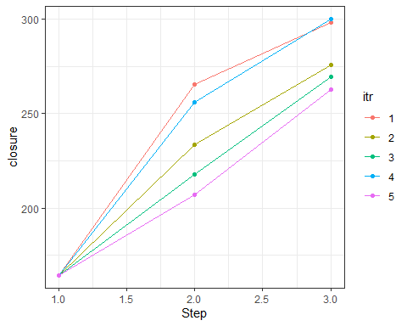

ggplot(data = Record_all) +  
 geom_line(aes(x = Step, y = SBR_d, color = itr)) +  
 geom_point(aes(x = Step, y = SBR_d, color = itr)) +  
 theme_bw()

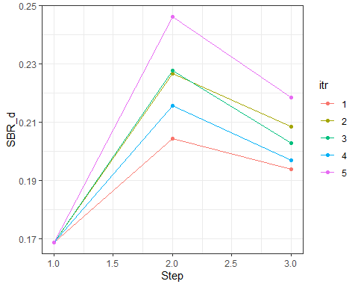

ggplot(data = Record_all) +  
 geom_line(aes(x = Step, y = Fadjust, color = itr)) +  
 geom_point(aes(x = Step, y = Fadjust, color = itr)) +  
 geom_hline(yintercept = 1) +  
 ylab("F/F30%") +   
 theme_bw()

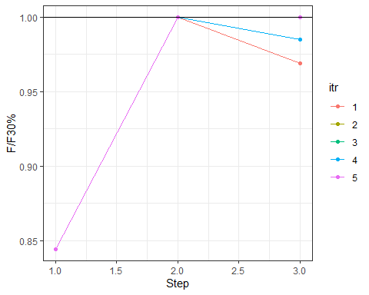

for (itrnum in 1:niterations) {  
 itr = paste0("itr", itrnum, "/")  
 Output <- read.csv(paste0(paste0(pdir, HS, HCR, OM, itr, "Output.csv")))  
 Output$OM <- OM_name[OMnum]  
 Output$itr <- itrnum  
   
 if(itrnum == 1) Output_all <- Output  
 else Output_all <- rbind(Output_all, Output)  
}  
  
Output_all_long <- Output_all %>%  
 mutate(itr = as.factor(itr),  
 Year = Year / 4 + 1974.875) %>%  
 gather(2:7, key = "Quantity", value = "Value")  
  
ggplot(data = Output_all_long %>% filter(Year > 2020, Quantity != "R_devs")) +  
 geom_line(aes(x = Year, y = Value, color = itr)) +  
 geom_point(aes(x = Year, y = Value, color = itr)) +  
 geom_vline(xintercept = c(seq(0, nyears, Mcycle) + 2023.875)) +  
 facet_wrap(~Quantity, scales = "free_y", nrow = 6) +  
 theme_bw()

## Warning: Removed 5 rows containing missing values or values outside the scale range  
## (`geom_point()`).

