MSE_analysis_HCR1

Haikun Xu

2025-10-01

##   
## Attaching package: 'dplyr'

## The following objects are masked from 'package:stats':  
##   
## filter, lag

## The following objects are masked from 'package:base':  
##   
## intersect, setdiff, setequal, union

## Loading required package: iterators

## Loading required package: parallel

## Joining with `by = join_by(OM, itr)`

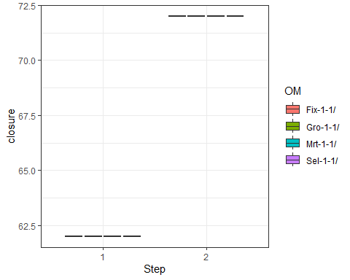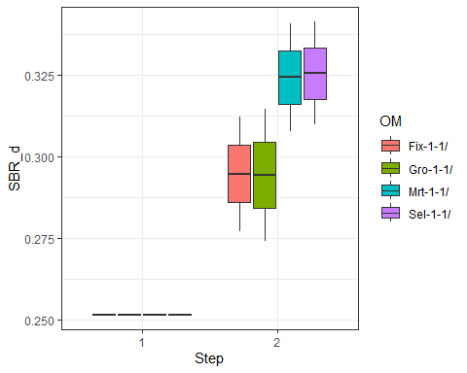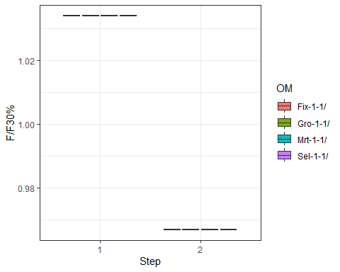

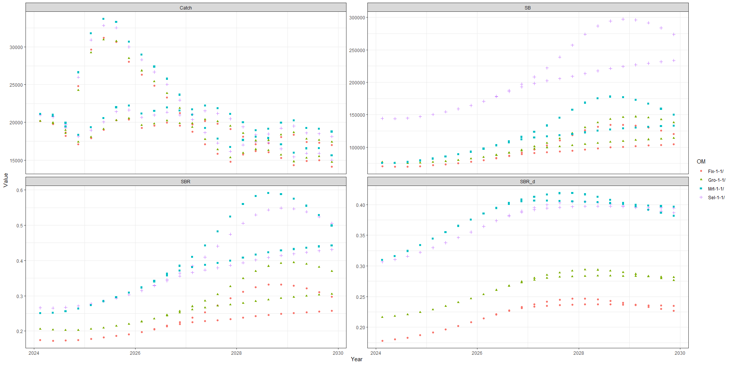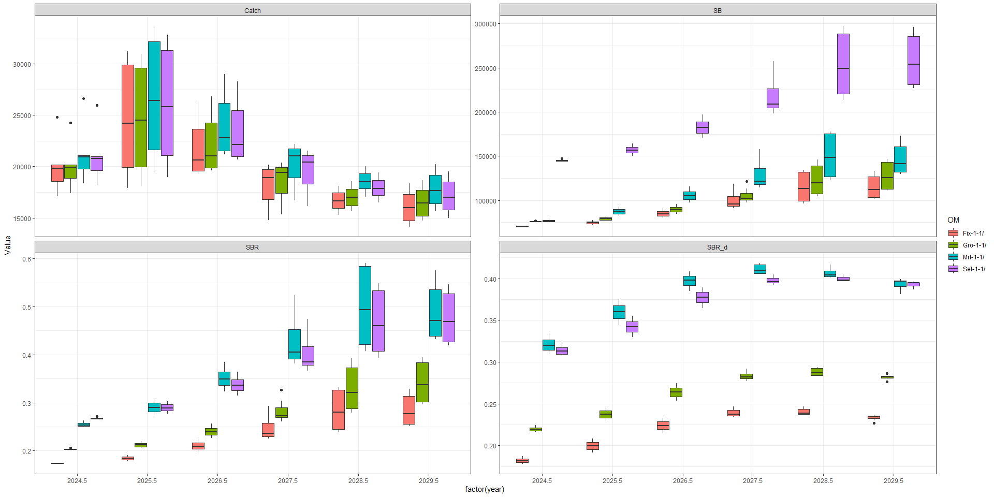

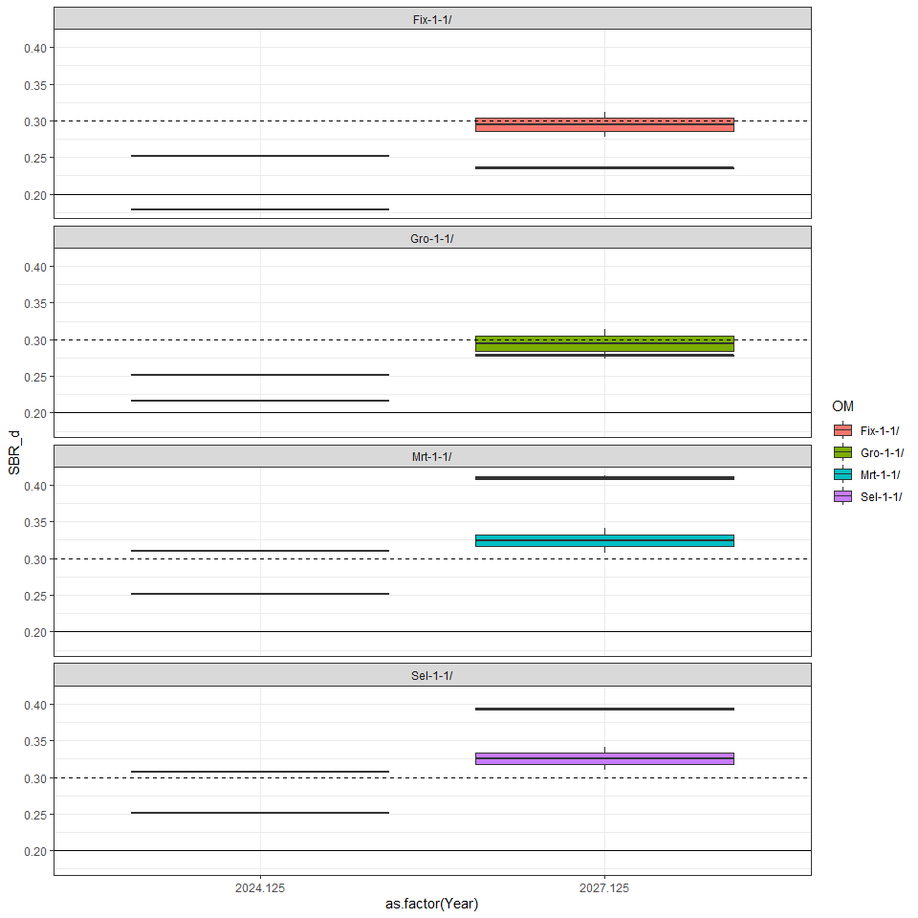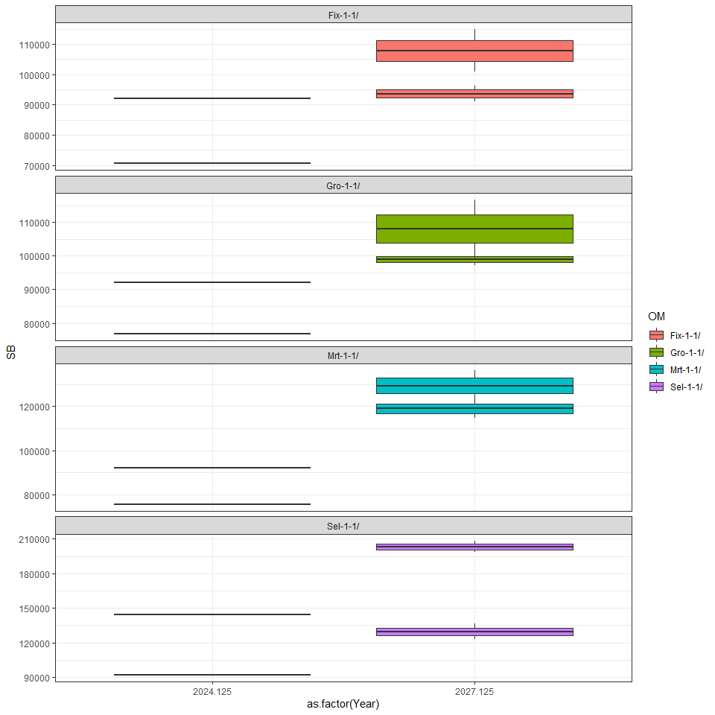

## Joining with `by = join_by(OM, itr, Year)`

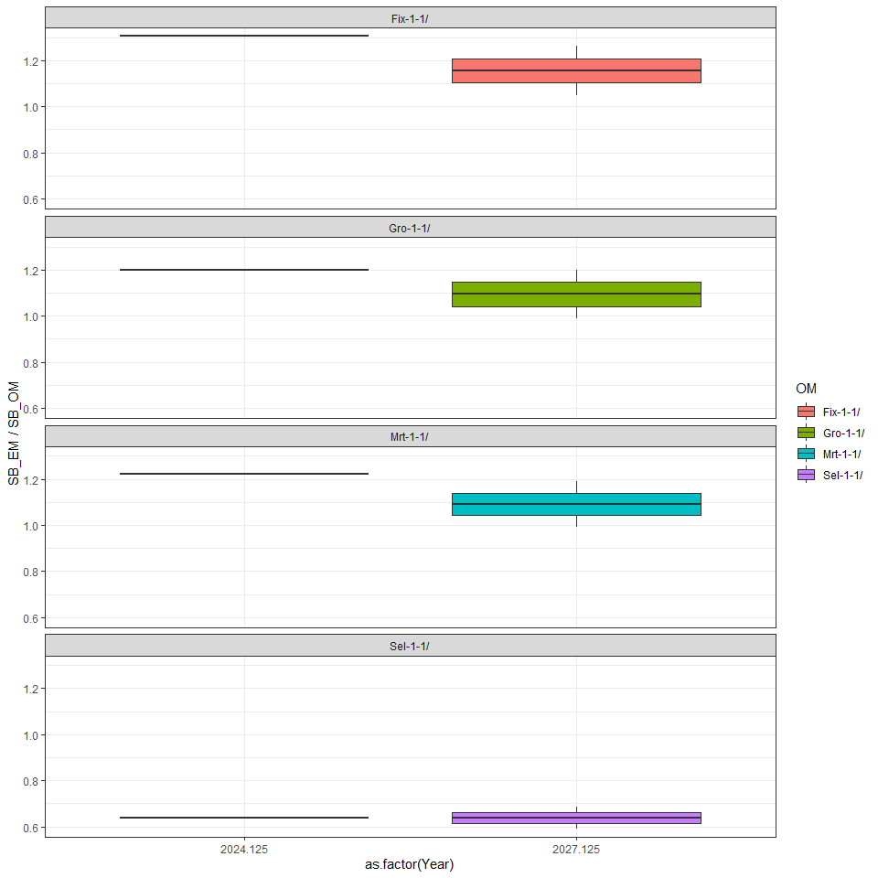

## Joining with `by = join_by(OM, itr, Year)`

