MSE_analysis_HCR3

Haikun Xu

2025-09-10

##   
## Attaching package: 'dplyr'

## The following objects are masked from 'package:stats':  
##   
## filter, lag

## The following objects are masked from 'package:base':  
##   
## intersect, setdiff, setequal, union

## Loading required package: iterators

## Loading required package: parallel

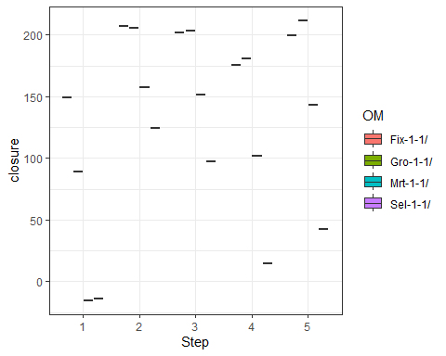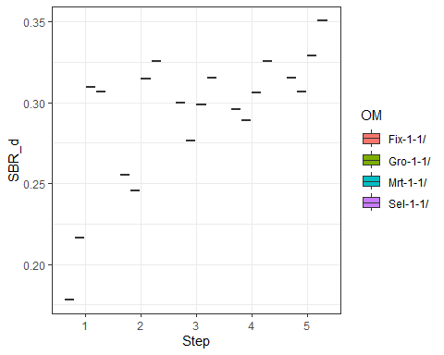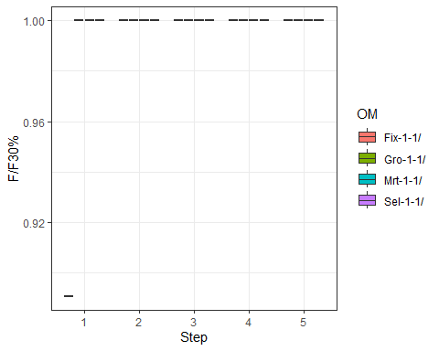

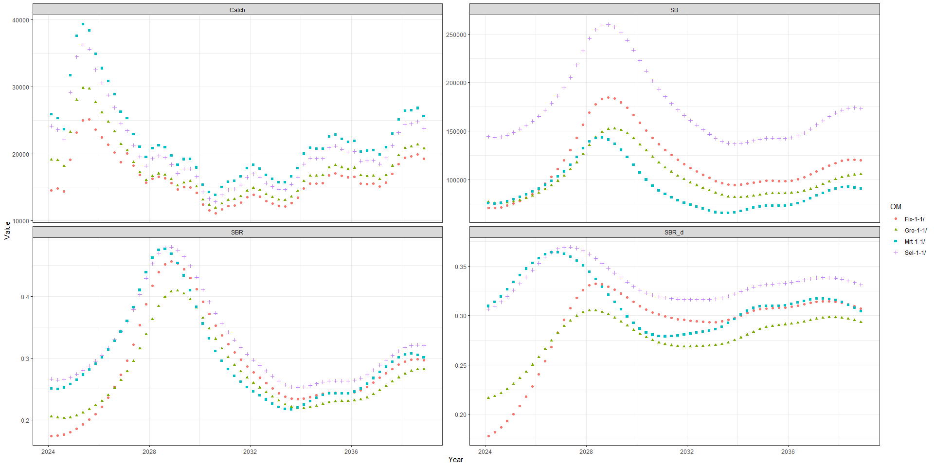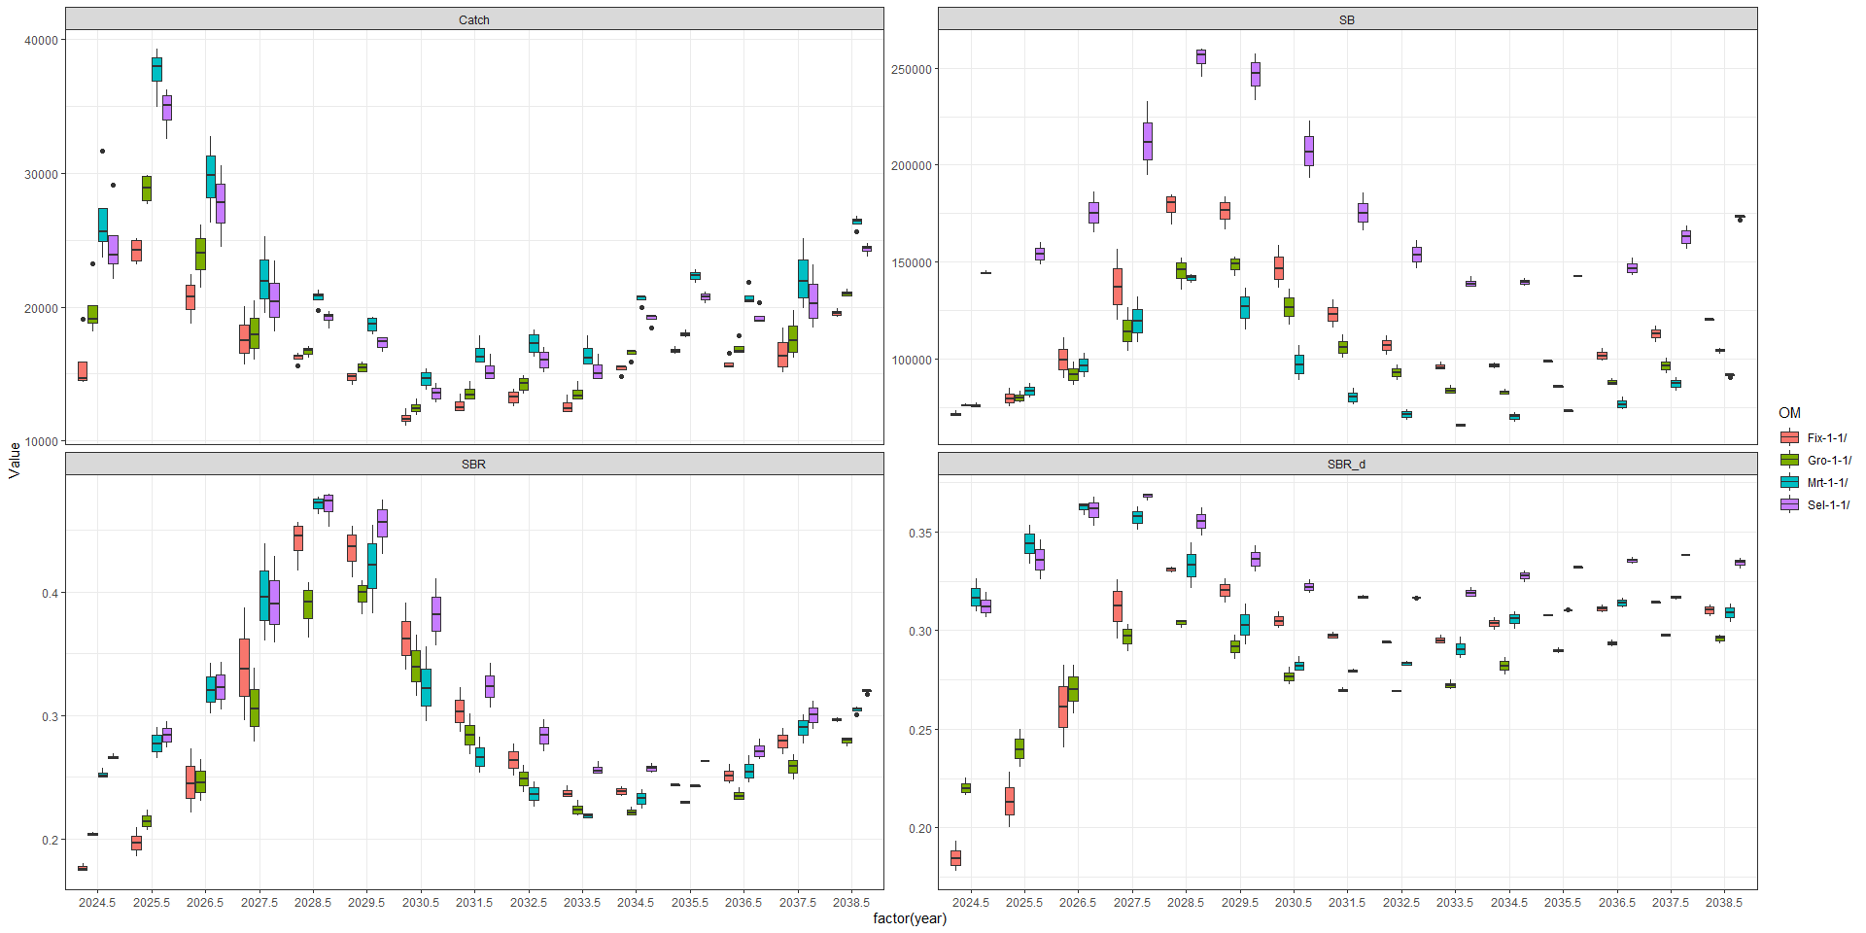

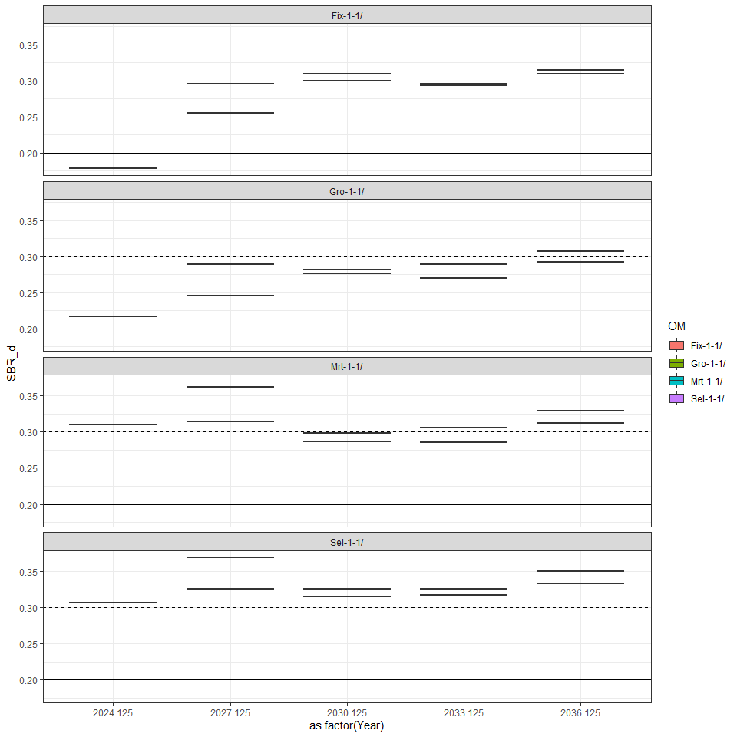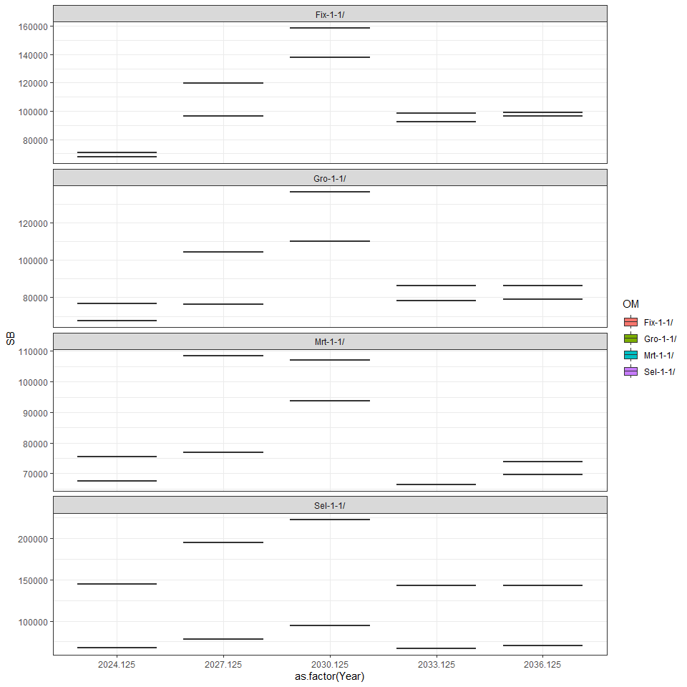

## Joining with `by = join_by(OM, itr, Year)`

