MSE_analysis_all

Haikun Xu

2025-10-06

##   
## Attaching package: 'dplyr'

## The following objects are masked from 'package:stats':  
##   
## filter, lag

## The following objects are masked from 'package:base':  
##   
## intersect, setdiff, setequal, union

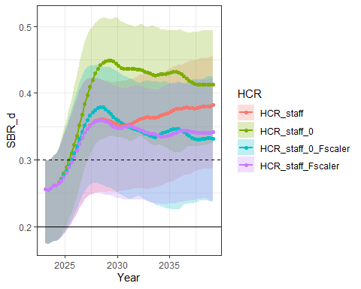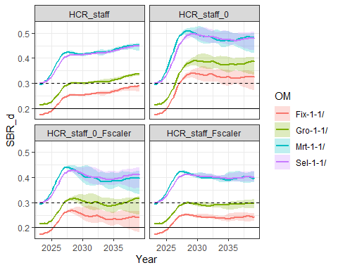

p(SBR_d) < 0.2

| HCR | p |
| --- | --- |
| HCR_staff | 0.0384615 |
| HCR_staff_0 | 0.0307692 |
| HCR_staff_0_Fscaler | 0.0430769 |
| HCR_staff_Fscaler | 0.0384615 |

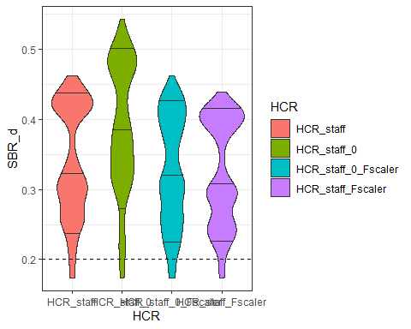

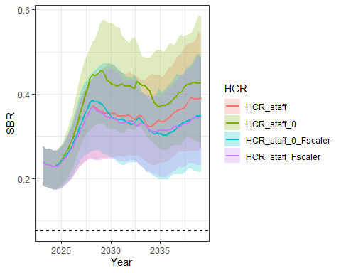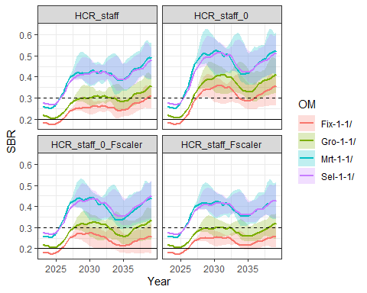

p(SBR) < 0.077

| HCR | p |
| --- | --- |
| HCR_staff | 0 |
| HCR_staff_0 | 0 |
| HCR_staff_0_Fscaler | 0 |
| HCR_staff_Fscaler | 0 |

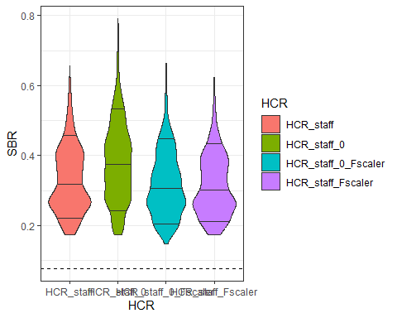

## `summarise()` has grouped output by 'HCR', 'OM', 'itr'. You can override using  
## the `.groups` argument.  
## `summarise()` has grouped output by 'HCR'. You can override using the `.groups`  
## argument.

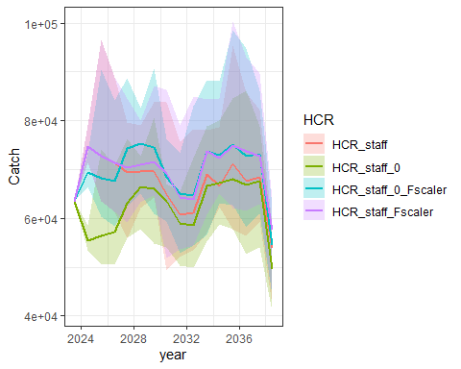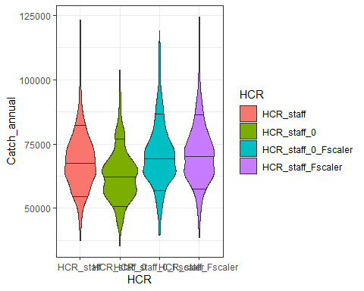

## `summarise()` has grouped output by 'HCR'. You can override using the `.groups`  
## argument.

Catch

| HCR | ave_catch | std_catch |
| --- | --- | --- |
| HCR_staff | 68309.81 | 6143.844 |
| HCR_staff_0 | 62850.86 | 5508.512 |
| HCR_staff_0_Fscaler | 70649.91 | 6026.091 |
| HCR_staff_Fscaler | 71162.94 | 5868.718 |

## `summarise()` has grouped output by 'HCR'. You can override using the `.groups`  
## argument.

