Indicators for SAC13

Haikun Xu

2022-04-15

# Figures

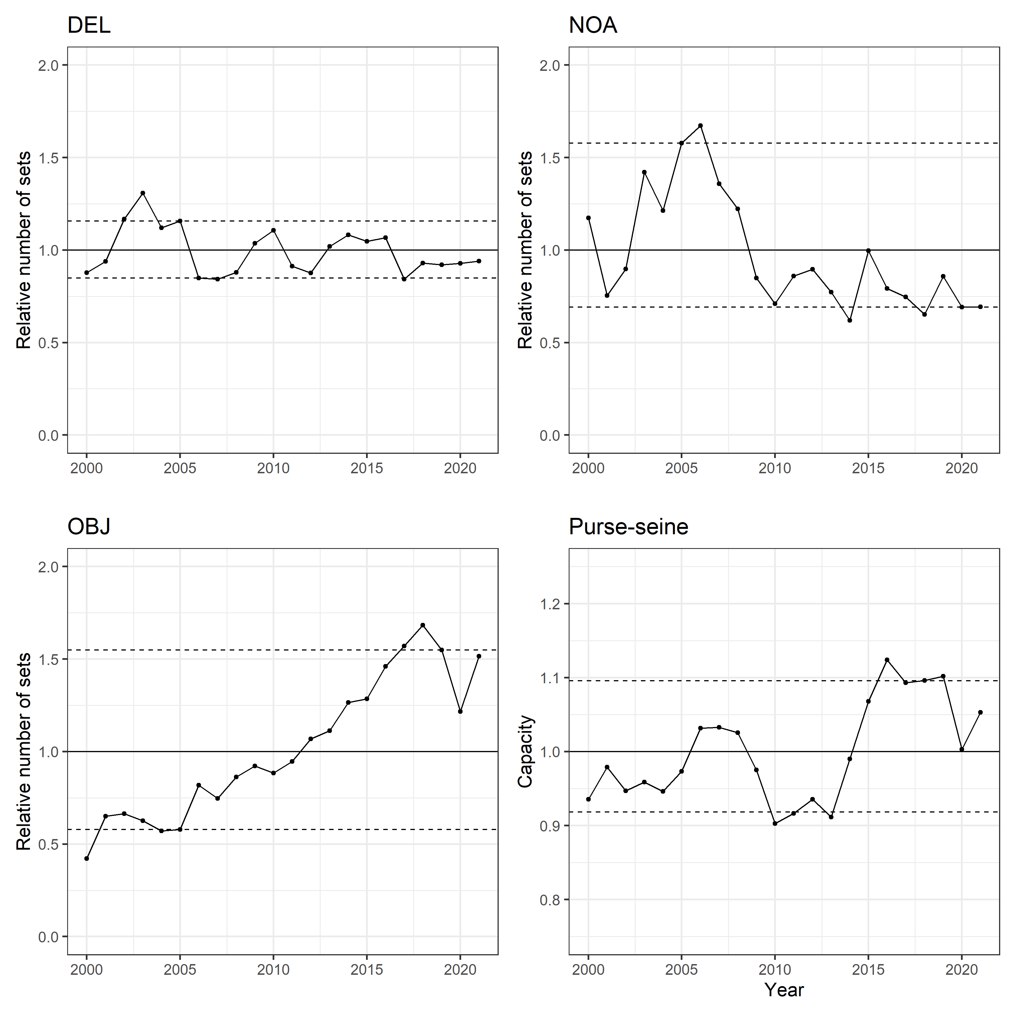   
Figure 1

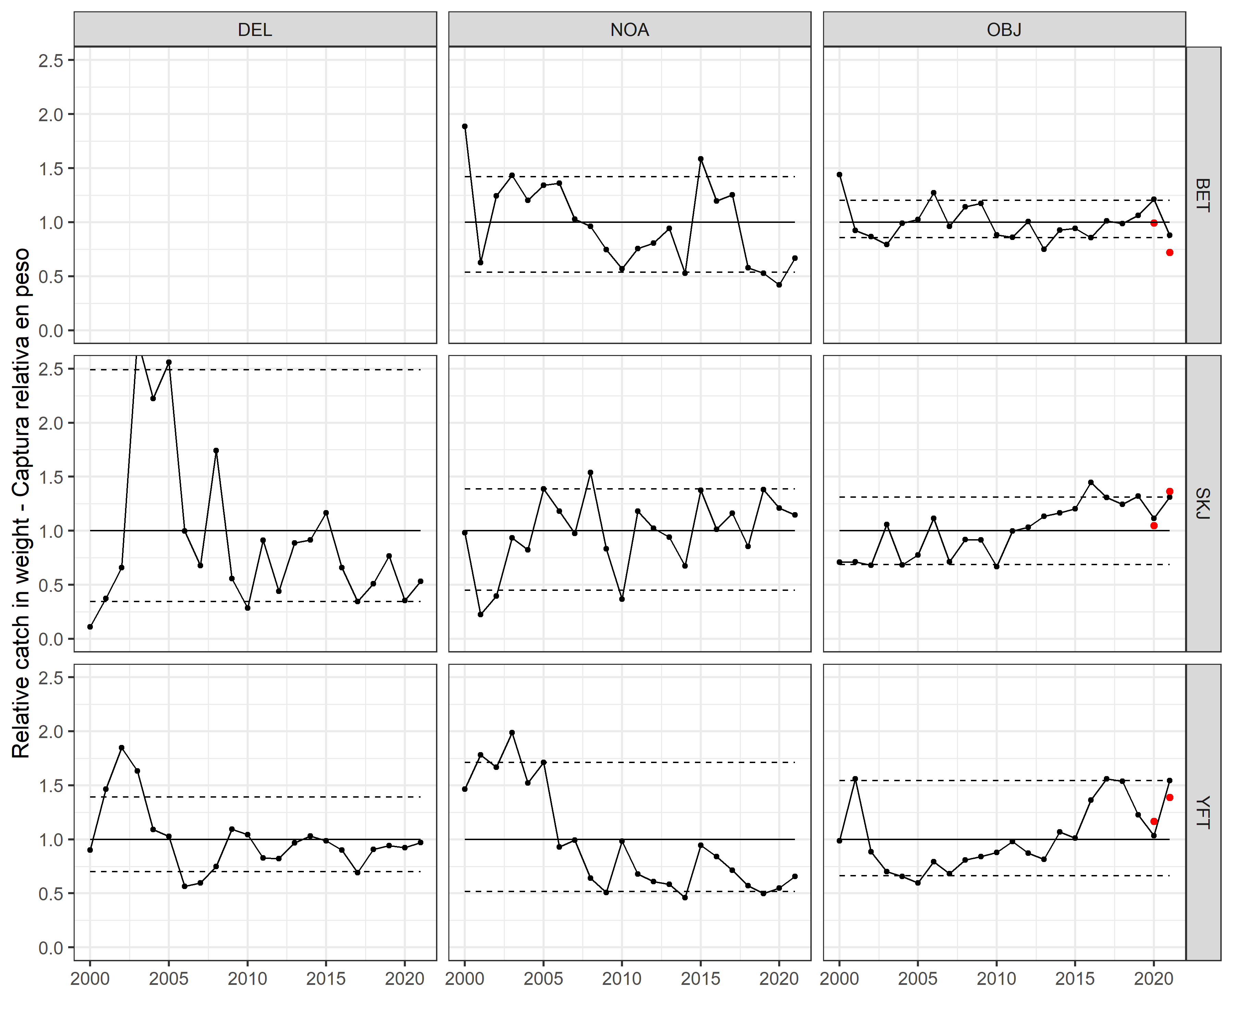   
Figure 2a

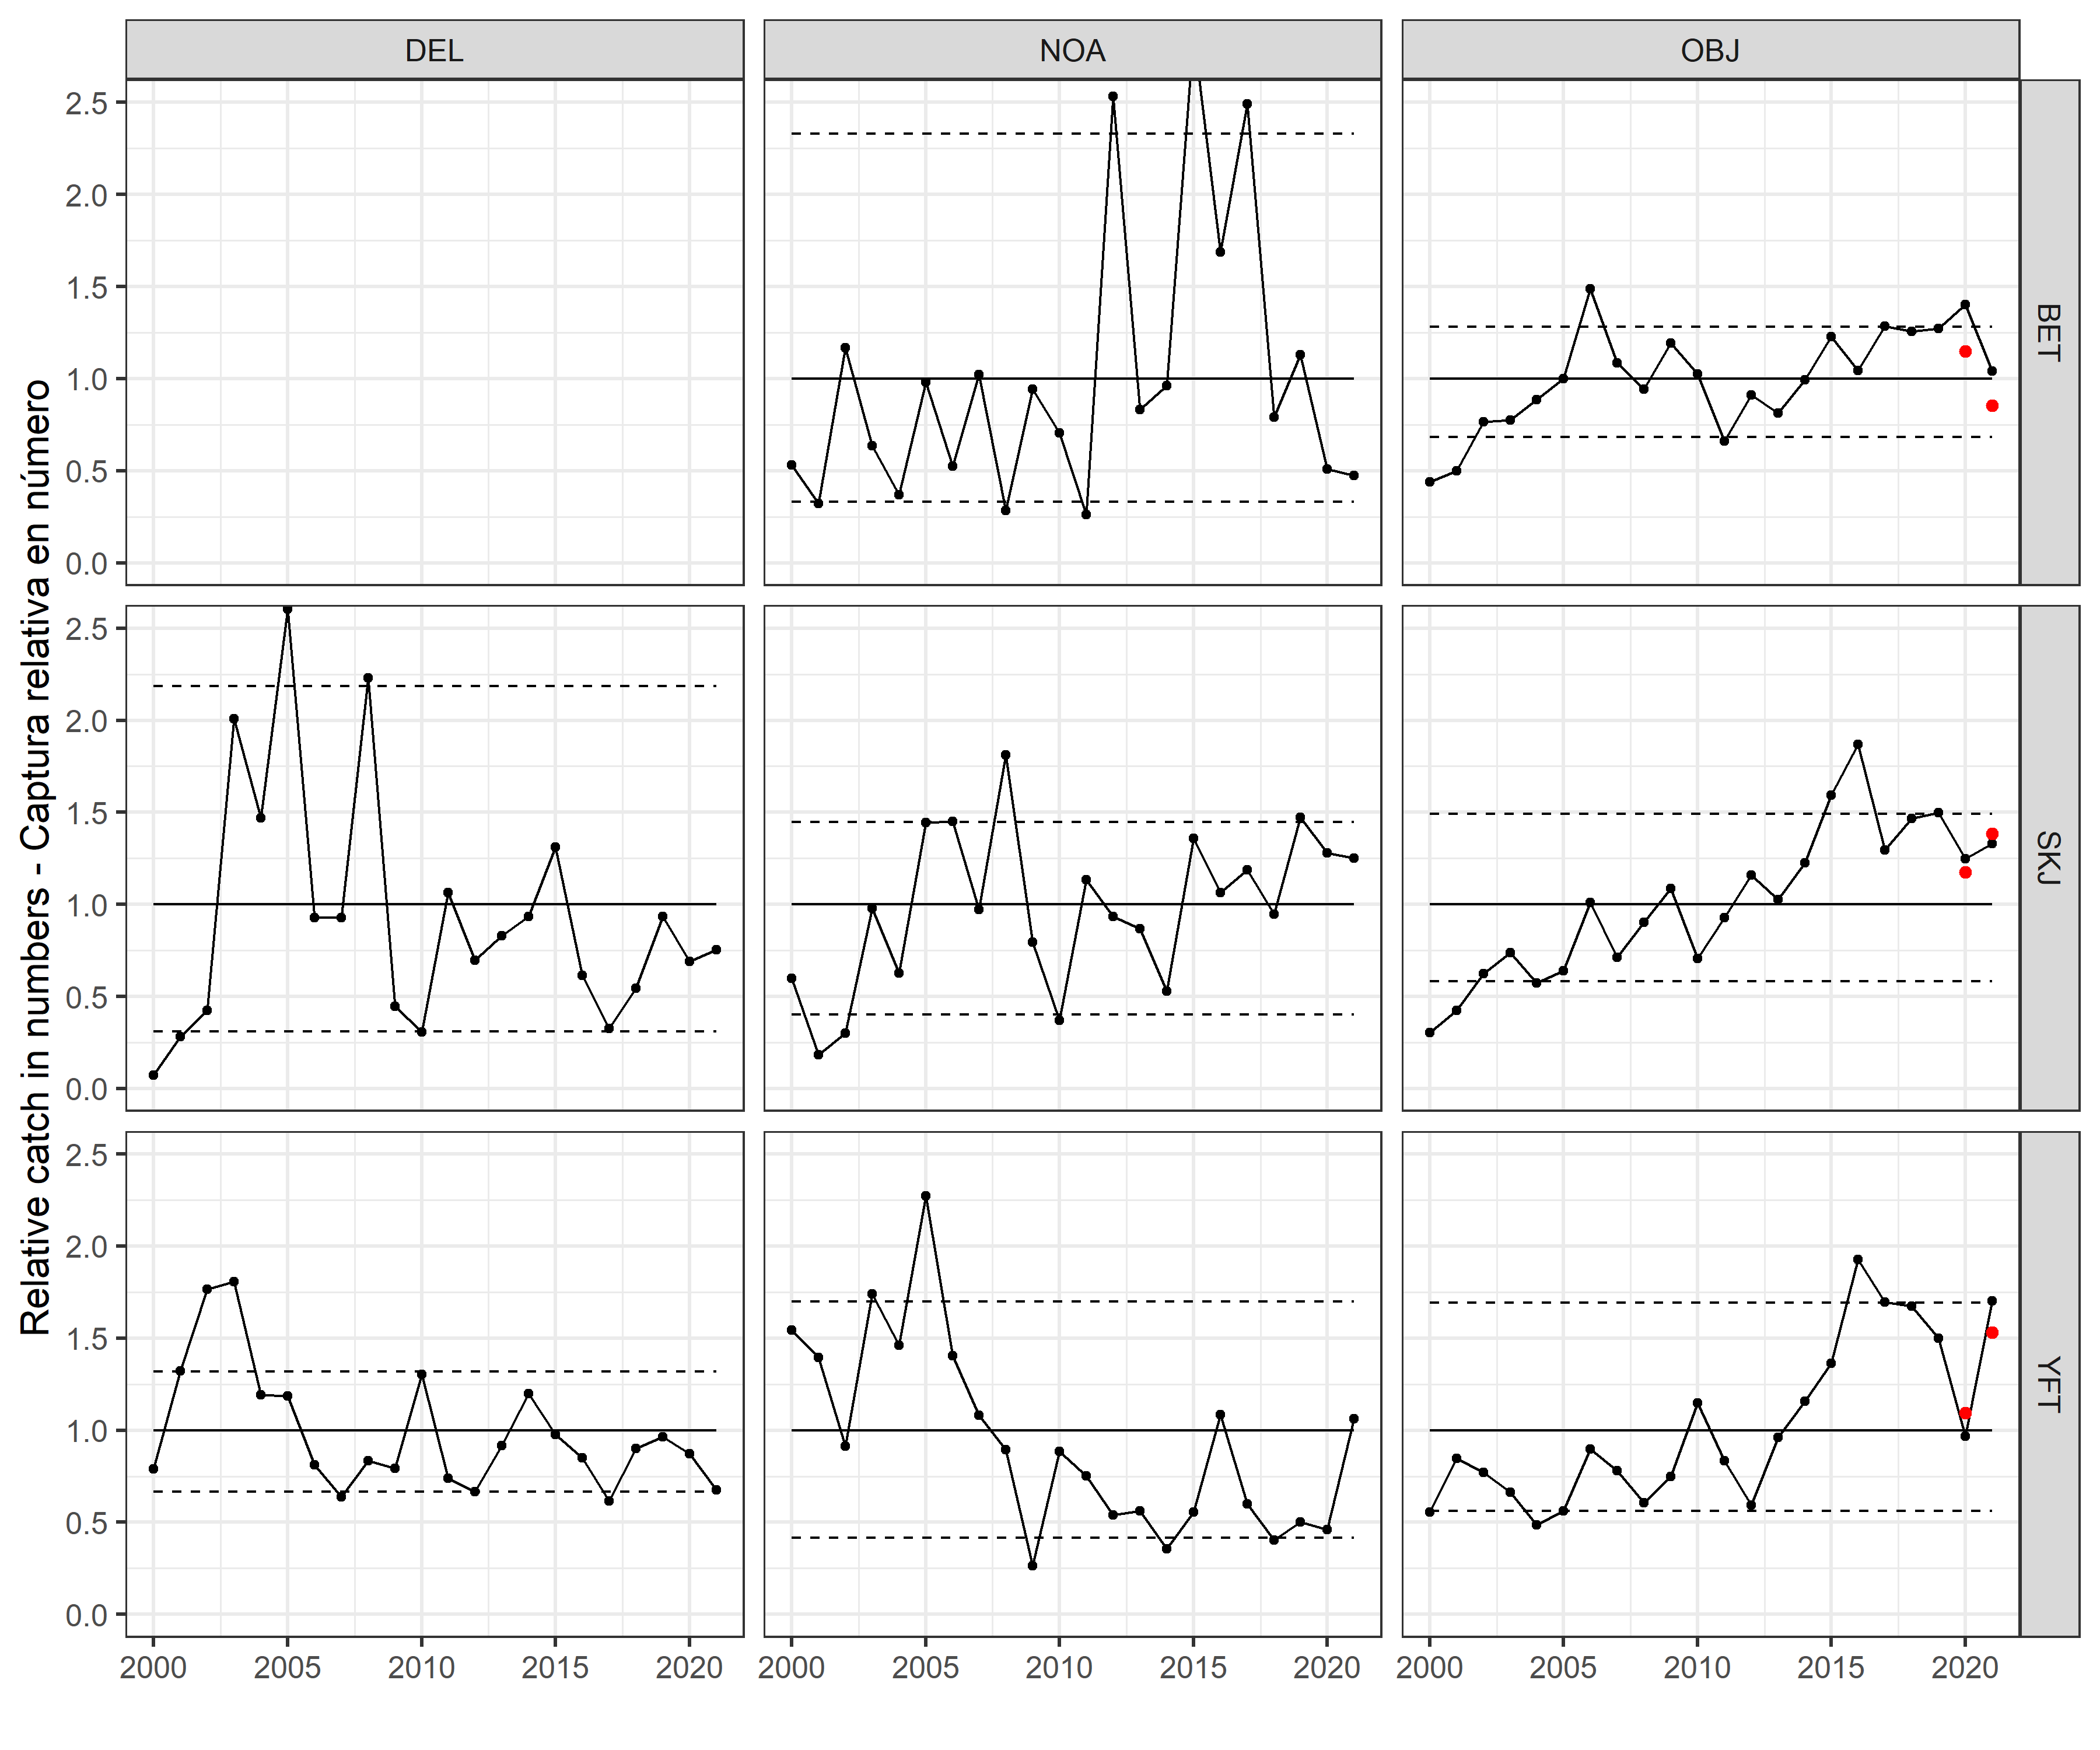   
Figure 2b

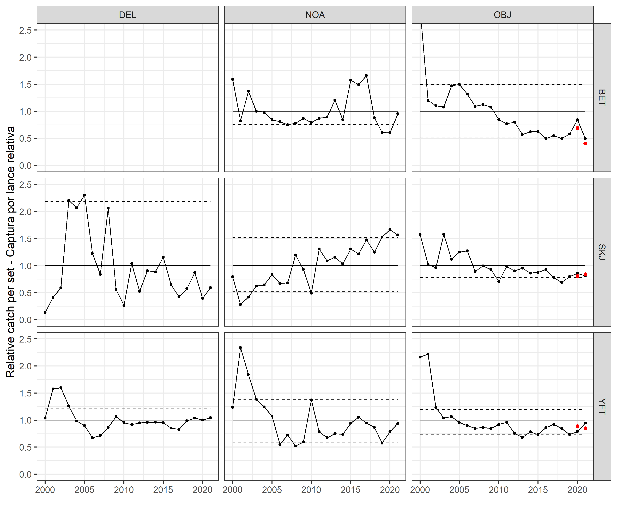   
Figure 3

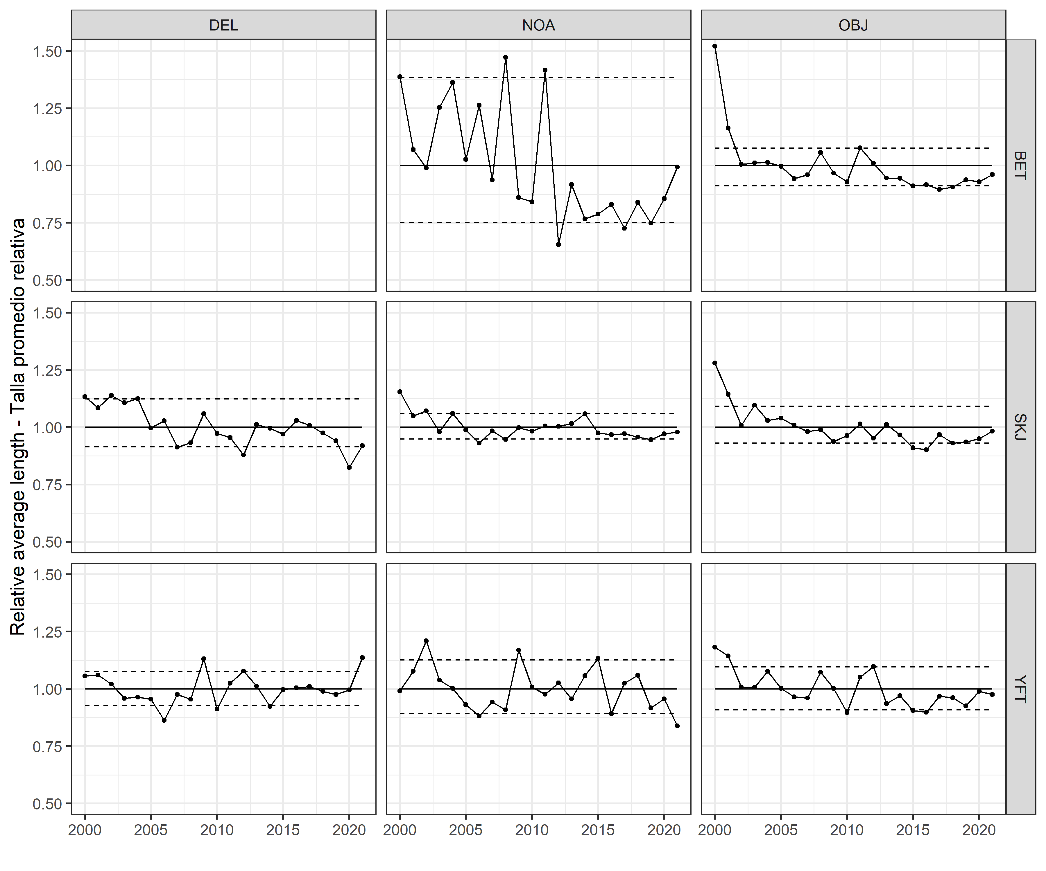   
Figure 4

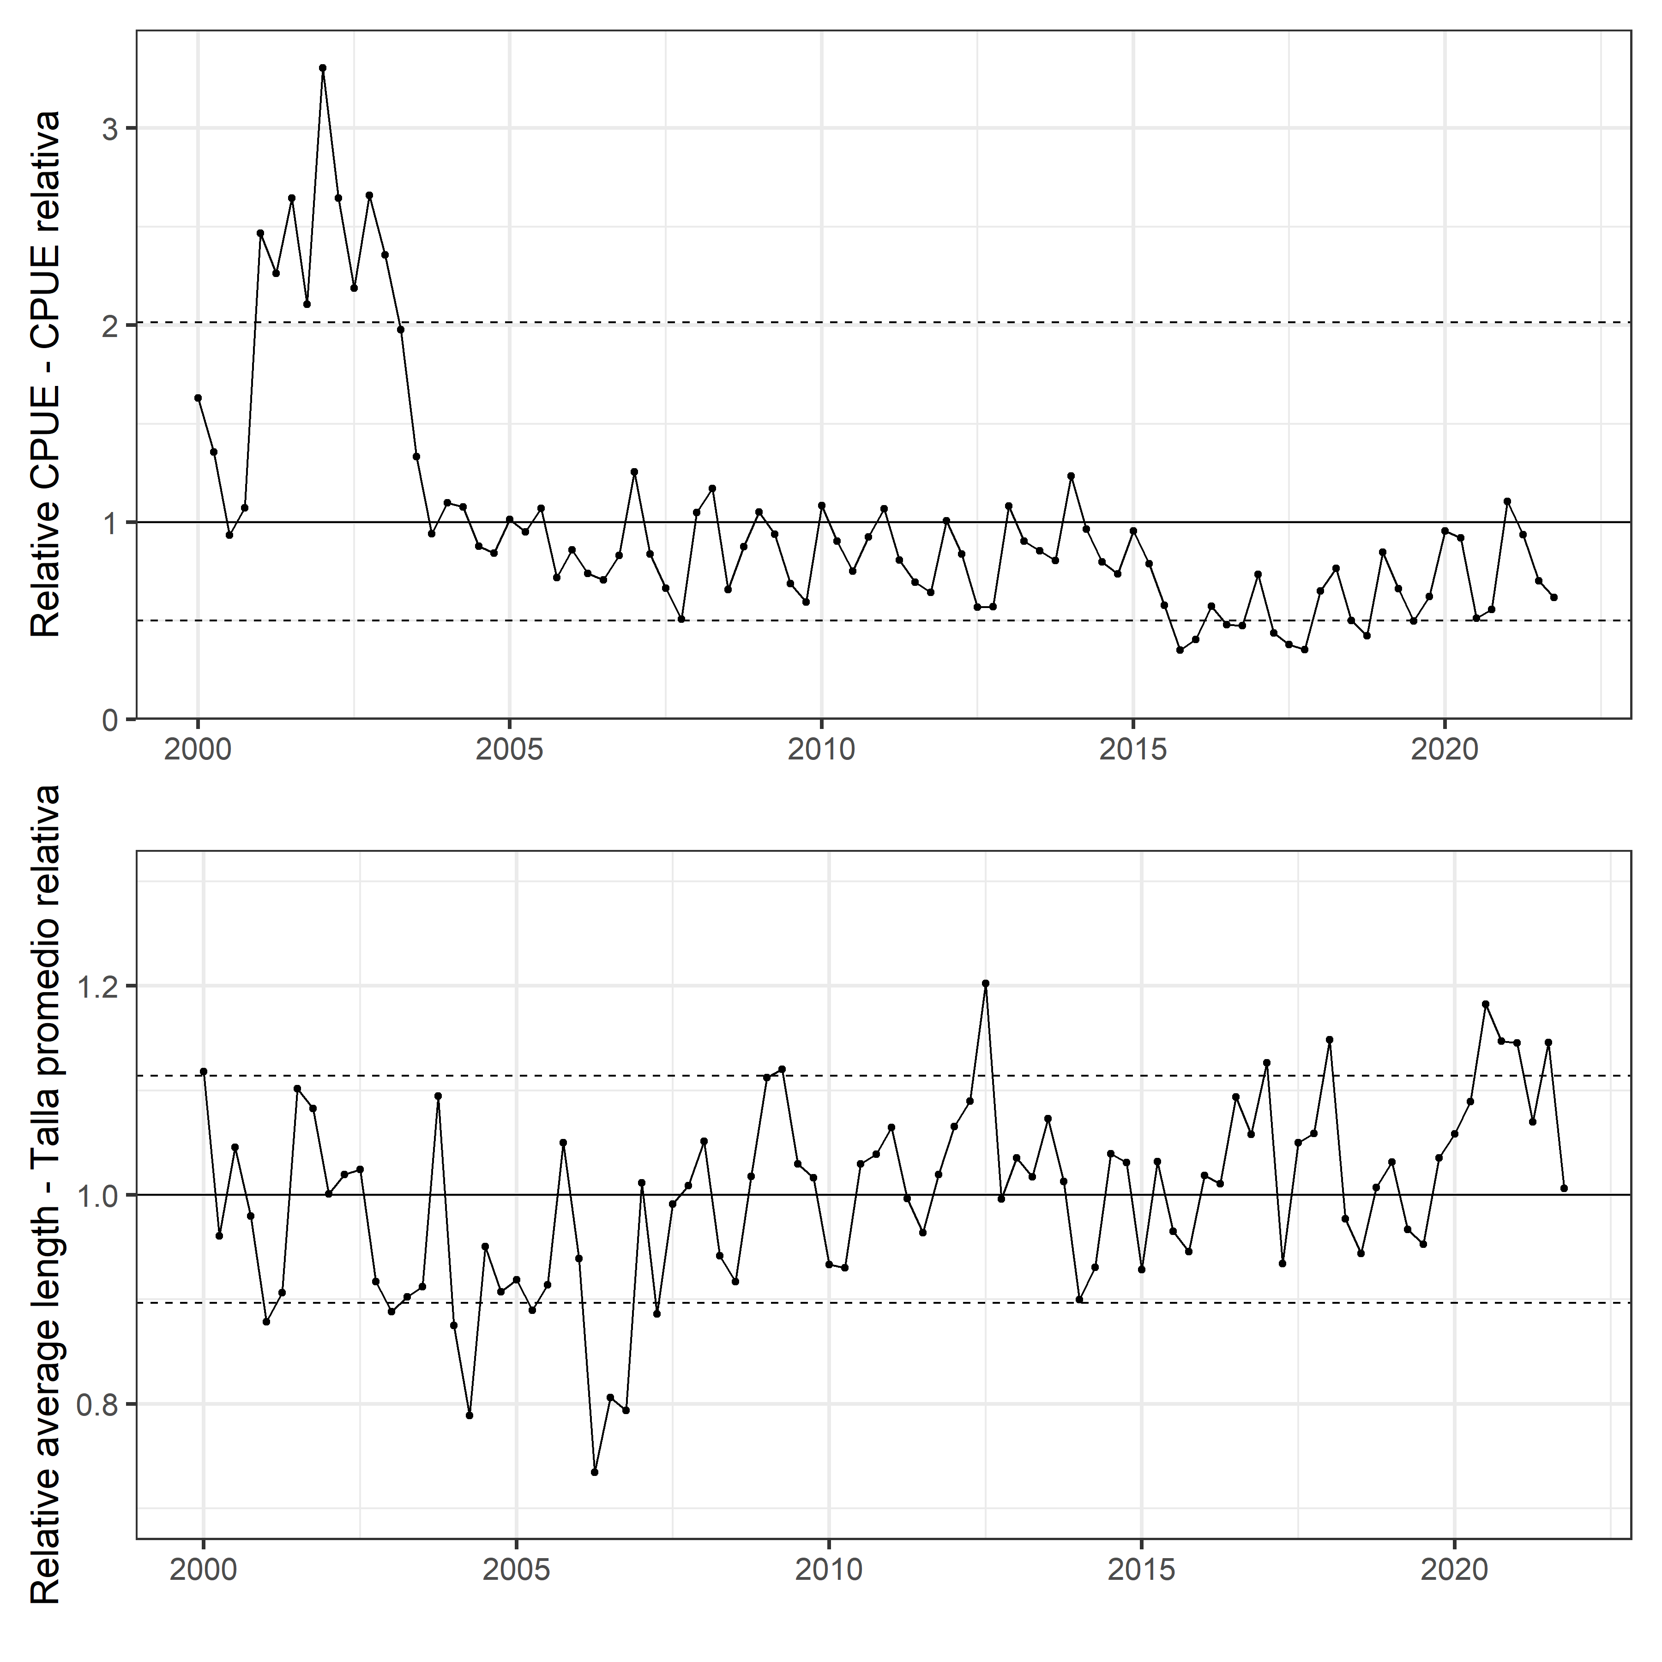   
Figure 5

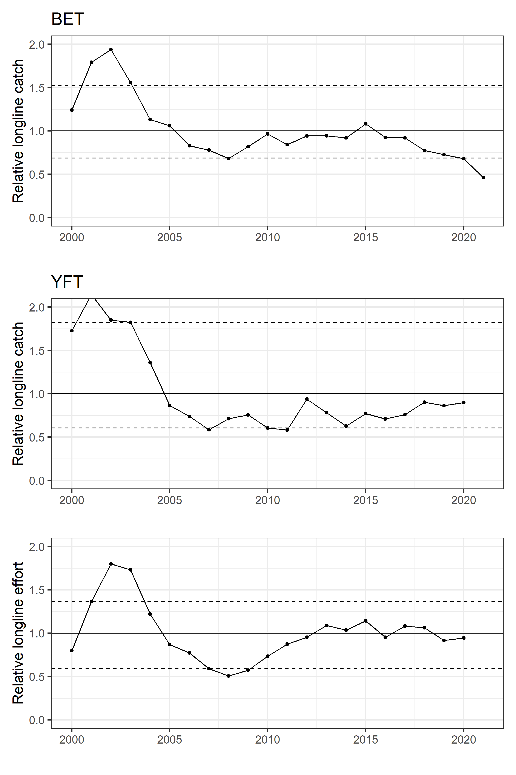   
Figure 6

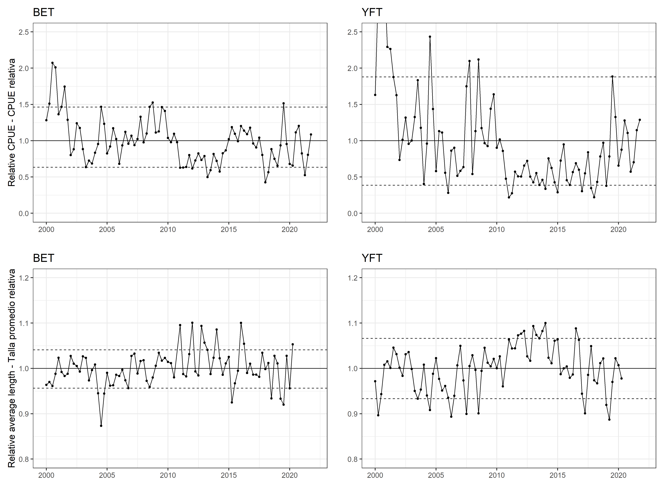   
Figure 7

# Tables

YFT DEL index

| Year | Unit | Fleet | Estimate_metric_tons | SD_log | SD_mt | CPUE |
| --- | --- | --- | --- | --- | --- | --- |
| 2000.00 | 1 | 1 | 37500.794 | 0.1543339 | 5556.7035 | 1.6291039 |
| 2000.25 | 1 | 1 | 31200.917 | 0.1088272 | 3276.4409 | 1.3554256 |
| 2000.50 | 1 | 1 | 21512.830 | 0.0794786 | 1652.8843 | 0.9345572 |
| 2000.75 | 1 | 1 | 24670.519 | 0.1015864 | 2384.3109 | 1.0717330 |
| 2001.00 | 1 | 1 | 56783.699 | 0.0959257 | 5362.5849 | 2.4667890 |
| 2001.25 | 1 | 1 | 52086.718 | 0.0551963 | 2819.5868 | 2.2627435 |
| 2001.50 | 1 | 1 | 60851.189 | 0.0452373 | 2706.9853 | 2.6434883 |
| 2001.75 | 1 | 1 | 48452.039 | 0.0653489 | 3096.1922 | 2.1048463 |
| 2002.00 | 1 | 1 | 76088.844 | 0.0929388 | 6944.0276 | 3.3054402 |
| 2002.25 | 1 | 1 | 60883.233 | 0.0575256 | 3437.4904 | 2.6448804 |
| 2002.50 | 1 | 1 | 50343.732 | 0.0442606 | 2190.9091 | 2.1870249 |
| 2002.75 | 1 | 1 | 61211.367 | 0.0792914 | 4775.8218 | 2.6591351 |
| 2003.00 | 1 | 1 | 54252.465 | 0.0846527 | 4493.7861 | 2.3568275 |
| 2003.25 | 1 | 1 | 45497.737 | 0.0506925 | 2260.9109 | 1.9765059 |
| 2003.50 | 1 | 1 | 30682.929 | 0.0629735 | 1874.4195 | 1.3329232 |
| 2003.75 | 1 | 1 | 21656.269 | 0.0603623 | 1274.8893 | 0.9407884 |
| 2004.00 | 1 | 1 | 25299.257 | 0.1029832 | 2508.1570 | 1.0990466 |
| 2004.25 | 1 | 1 | 24773.813 | 0.0591187 | 1428.5603 | 1.0762203 |
| 2004.50 | 1 | 1 | 20213.876 | 0.0615277 | 1208.9555 | 0.8781282 |
| 2004.75 | 1 | 1 | 19427.782 | 0.0896123 | 1670.6358 | 0.8439788 |
| 2005.00 | 1 | 1 | 23330.378 | 0.1124495 | 2525.3789 | 1.0135148 |
| 2005.25 | 1 | 1 | 21865.184 | 0.0524717 | 1122.6385 | 0.9498641 |
| 2005.50 | 1 | 1 | 24628.245 | 0.0837779 | 1983.4176 | 1.0698965 |
| 2005.75 | 1 | 1 | 16526.954 | 0.0811319 | 1287.5547 | 0.7179615 |
| 2006.00 | 1 | 1 | 19775.030 | 0.1333299 | 2497.9859 | 0.8590639 |
| 2006.25 | 1 | 1 | 17053.636 | 0.0760195 | 1253.9419 | 0.7408415 |
| 2006.50 | 1 | 1 | 16297.763 | 0.0952798 | 1491.9270 | 0.7080050 |
| 2006.75 | 1 | 1 | 19163.871 | 0.1256647 | 2291.5633 | 0.8325140 |
| 2007.00 | 1 | 1 | 28902.322 | 0.1663748 | 4690.3099 | 1.2555703 |
| 2007.25 | 1 | 1 | 19308.962 | 0.1354531 | 2469.3532 | 0.8388170 |
| 2007.50 | 1 | 1 | 15310.503 | 0.1427262 | 2041.2812 | 0.6651166 |
| 2007.75 | 1 | 1 | 11687.938 | 0.1914215 | 2031.0610 | 0.5077457 |
| 2008.00 | 1 | 1 | 24171.395 | 0.0992627 | 2338.2756 | 1.0500501 |
| 2008.25 | 1 | 1 | 26934.678 | 0.0842383 | 2210.1672 | 1.1700923 |
| 2008.50 | 1 | 1 | 15162.494 | 0.0893388 | 1302.4667 | 0.6586868 |
| 2008.75 | 1 | 1 | 20136.425 | 0.1004330 | 1947.2538 | 0.8747636 |
| 2009.00 | 1 | 1 | 24207.871 | 0.0999885 | 2294.7194 | 1.0516347 |
| 2009.25 | 1 | 1 | 21638.696 | 0.0543975 | 1149.0479 | 0.9400250 |
| 2009.50 | 1 | 1 | 15839.329 | 0.0702119 | 1073.5228 | 0.6880898 |
| 2009.75 | 1 | 1 | 13708.908 | 0.0841227 | 1100.0937 | 0.5955403 |
| 2010.00 | 1 | 1 | 24947.415 | 0.1028588 | 2467.2838 | 1.0837619 |
| 2010.25 | 1 | 1 | 20825.657 | 0.0485782 | 990.4225 | 0.9047051 |
| 2010.50 | 1 | 1 | 17280.233 | 0.0611370 | 1025.7686 | 0.7506853 |
| 2010.75 | 1 | 1 | 21313.484 | 0.0675989 | 1392.3472 | 0.9258972 |
| 2011.00 | 1 | 1 | 24566.164 | 0.1075280 | 2513.7526 | 1.0671996 |
| 2011.25 | 1 | 1 | 18572.224 | 0.0598999 | 1083.7647 | 0.8068118 |
| 2011.50 | 1 | 1 | 16032.622 | 0.0695067 | 1073.8504 | 0.6964868 |
| 2011.75 | 1 | 1 | 14843.127 | 0.0951475 | 1343.1507 | 0.6448129 |
| 2012.00 | 1 | 1 | 23184.400 | 0.1151051 | 2510.6693 | 1.0071733 |
| 2012.25 | 1 | 1 | 19315.401 | 0.0688657 | 1282.2420 | 0.8390968 |
| 2012.50 | 1 | 1 | 13071.153 | 0.0737300 | 928.1697 | 0.5678351 |
| 2012.75 | 1 | 1 | 13134.039 | 0.0932077 | 1171.7849 | 0.5705670 |
| 2013.00 | 1 | 1 | 24913.876 | 0.1056880 | 2507.8585 | 1.0823049 |
| 2013.25 | 1 | 1 | 20790.797 | 0.0525083 | 1064.0259 | 0.9031907 |
| 2013.50 | 1 | 1 | 19694.916 | 0.0560840 | 1074.1263 | 0.8555836 |
| 2013.75 | 1 | 1 | 18534.271 | 0.0730208 | 1306.2886 | 0.8051631 |
| 2014.00 | 1 | 1 | 28402.266 | 0.0943500 | 2590.9510 | 1.2338470 |
| 2014.25 | 1 | 1 | 22219.476 | 0.0640172 | 1382.9318 | 0.9652552 |
| 2014.50 | 1 | 1 | 18382.100 | 0.0499591 | 896.3040 | 0.7985525 |
| 2014.75 | 1 | 1 | 16994.873 | 0.0739647 | 1212.7358 | 0.7382887 |
| 2015.00 | 1 | 1 | 22002.369 | 0.1136010 | 2379.8036 | 0.9558236 |
| 2015.25 | 1 | 1 | 18174.202 | 0.0677915 | 1193.3972 | 0.7895210 |
| 2015.50 | 1 | 1 | 13307.847 | 0.0810218 | 1034.6443 | 0.5781175 |
| 2015.75 | 1 | 1 | 8107.614 | 0.1206129 | 912.8010 | 0.3522098 |
| 2016.00 | 1 | 1 | 9323.261 | 0.0963995 | 847.6169 | 0.4050197 |
| 2016.25 | 1 | 1 | 13202.705 | 0.0661031 | 843.3679 | 0.5735499 |
| 2016.50 | 1 | 1 | 11051.531 | 0.0594068 | 638.1467 | 0.4800990 |
| 2016.75 | 1 | 1 | 10938.590 | 0.0879778 | 924.2274 | 0.4751926 |
| 2017.00 | 1 | 1 | 16917.582 | 0.1012745 | 1637.3032 | 0.7349311 |
| 2017.25 | 1 | 1 | 10057.092 | 0.0757996 | 731.4427 | 0.4368987 |
| 2017.50 | 1 | 1 | 8735.781 | 0.0933192 | 776.1271 | 0.3794985 |
| 2017.75 | 1 | 1 | 8158.244 | 0.1141882 | 874.4202 | 0.3544092 |
| 2018.00 | 1 | 1 | 14966.427 | 0.0748589 | 1081.1864 | 0.6501693 |
| 2018.25 | 1 | 1 | 17607.984 | 0.0625227 | 1069.3695 | 0.7649234 |
| 2018.50 | 1 | 1 | 11540.261 | 0.0789145 | 873.6662 | 0.5013303 |
| 2018.75 | 1 | 1 | 9755.895 | 0.0947934 | 883.4231 | 0.4238141 |
| 2019.00 | 1 | 1 | 19519.390 | 0.0934043 | 1739.8948 | 0.8479584 |
| 2019.25 | 1 | 1 | 15250.163 | 0.0633909 | 939.0215 | 0.6624953 |
| 2019.50 | 1 | 1 | 11500.698 | 0.0832743 | 918.3912 | 0.4996116 |
| 2019.75 | 1 | 1 | 14334.681 | 0.0983519 | 1345.1872 | 0.6227251 |
| 2020.00 | 1 | 1 | 21980.341 | 0.0978006 | 2048.5556 | 0.9548667 |
| 2020.25 | 1 | 1 | 21204.832 | 0.0511103 | 1059.1454 | 0.9211772 |
| 2020.50 | 1 | 1 | 11805.377 | 0.0768099 | 874.8599 | 0.5128474 |
| 2020.75 | 1 | 1 | 12804.384 | 0.0827496 | 1019.4163 | 0.5562462 |
| 2021.00 | 1 | 1 | 25442.314 | 0.1005064 | 2453.2667 | 1.1052612 |
| 2021.25 | 1 | 1 | 21577.685 | 0.0582753 | 1225.1842 | 0.9373746 |
| 2021.50 | 1 | 1 | 16147.942 | 0.0831578 | 1289.1781 | 0.7014965 |
| 2021.75 | 1 | 1 | 14222.092 | 0.0918664 | 1247.5833 | 0.6178340 |

BET LL index

| Year | Unit | Fleet | Estimate_metric_tons | SD_log | SD_mt | Species | CPUE | low | high |
| --- | --- | --- | --- | --- | --- | --- | --- | --- | --- |
| 2000.00 | 1 | 1 | 17567.337 | 0.1265986 | 2177.0713 | Bigeye | 1.2823661 | 0.6342138 | 1.463673 |
| 2000.25 | 1 | 1 | 20691.113 | 0.0988188 | 2017.1366 | Bigeye | 1.5103929 | 0.6342138 | 1.463673 |
| 2000.50 | 1 | 1 | 28407.251 | 0.0959552 | 2691.6600 | Bigeye | 2.0736493 | 0.6342138 | 1.463673 |
| 2000.75 | 1 | 1 | 27552.314 | 0.0911379 | 2491.9194 | Bigeye | 2.0112414 | 0.6342138 | 1.463673 |
| 2001.00 | 1 | 1 | 18681.722 | 0.0911619 | 1685.0863 | Bigeye | 1.3637131 | 0.6342138 | 1.463673 |
| 2001.25 | 1 | 1 | 20105.645 | 0.0949713 | 1885.7342 | Bigeye | 1.4676554 | 0.6342138 | 1.463673 |
| 2001.50 | 1 | 1 | 23907.635 | 0.0910715 | 2157.1317 | Bigeye | 1.7451901 | 0.6342138 | 1.463673 |
| 2001.75 | 1 | 1 | 17645.958 | 0.1008158 | 1756.8299 | Bigeye | 1.2881052 | 0.6342138 | 1.463673 |
| 2002.00 | 1 | 1 | 10975.702 | 0.1013830 | 1094.6124 | Bigeye | 0.8011953 | 0.6342138 | 1.463673 |
| 2002.25 | 1 | 1 | 12071.335 | 0.0976040 | 1162.1359 | Bigeye | 0.8811735 | 0.6342138 | 1.463673 |
| 2002.50 | 1 | 1 | 16979.768 | 0.0939363 | 1576.2976 | Bigeye | 1.2394752 | 0.6342138 | 1.463673 |
| 2002.75 | 1 | 1 | 16090.148 | 0.0992739 | 1578.8055 | Bigeye | 1.1745355 | 0.6342138 | 1.463673 |
| 2003.00 | 1 | 1 | 12104.575 | 0.1034665 | 1235.0784 | Bigeye | 0.8835999 | 0.6342138 | 1.463673 |
| 2003.25 | 1 | 1 | 8715.451 | 0.1079020 | 924.5794 | Bigeye | 0.6362034 | 0.6342138 | 1.463673 |
| 2003.50 | 1 | 1 | 9927.234 | 0.1005909 | 984.2767 | Bigeye | 0.7246601 | 0.6342138 | 1.463673 |
| 2003.75 | 1 | 1 | 9392.395 | 0.1117291 | 1029.5836 | Bigeye | 0.6856184 | 0.6342138 | 1.463673 |
| 2004.00 | 1 | 1 | 11431.168 | 0.0969745 | 1095.8782 | Bigeye | 0.8344430 | 0.6342138 | 1.463673 |
| 2004.25 | 1 | 1 | 13079.356 | 0.1027353 | 1322.3138 | Bigeye | 0.9547562 | 0.6342138 | 1.463673 |
| 2004.50 | 1 | 1 | 20093.591 | 0.1024573 | 2027.5185 | Bigeye | 1.4667756 | 0.6342138 | 1.463673 |
| 2004.75 | 1 | 1 | 16895.810 | 0.1074853 | 1787.1040 | Bigeye | 1.2333465 | 0.6342138 | 1.463673 |
| 2005.00 | 1 | 1 | 11304.942 | 0.1153471 | 1273.8479 | Bigeye | 0.8252289 | 0.6342138 | 1.463673 |
| 2005.25 | 1 | 1 | 12609.495 | 0.1034267 | 1283.2232 | Bigeye | 0.9204576 | 0.6342138 | 1.463673 |
| 2005.50 | 1 | 1 | 16034.896 | 0.1021940 | 1613.3709 | Bigeye | 1.1705023 | 0.6342138 | 1.463673 |
| 2005.75 | 1 | 1 | 14021.676 | 0.1155993 | 1591.3897 | Bigeye | 1.0235428 | 0.6342138 | 1.463673 |
| 2006.00 | 1 | 1 | 9331.963 | 0.1259103 | 1136.3080 | Bigeye | 0.6812070 | 0.6342138 | 1.463673 |
| 2006.25 | 1 | 1 | 12808.359 | 0.1104758 | 1385.9084 | Bigeye | 0.9349742 | 0.6342138 | 1.463673 |
| 2006.50 | 1 | 1 | 15366.170 | 0.1048727 | 1585.9291 | Bigeye | 1.1216871 | 0.6342138 | 1.463673 |
| 2006.75 | 1 | 1 | 13117.291 | 0.1168249 | 1504.5177 | Bigeye | 0.9575253 | 0.6342138 | 1.463673 |
| 2007.00 | 1 | 1 | 14640.736 | 0.1197182 | 1717.2162 | Bigeye | 1.0687325 | 0.6342138 | 1.463673 |
| 2007.25 | 1 | 1 | 12872.462 | 0.0993106 | 1259.6130 | Bigeye | 0.9396535 | 0.6342138 | 1.463673 |
| 2007.50 | 1 | 1 | 14001.973 | 0.1215967 | 1666.8146 | Bigeye | 1.0221046 | 0.6342138 | 1.463673 |
| 2007.75 | 1 | 1 | 18207.470 | 0.1186907 | 2115.6736 | Bigeye | 1.3290940 | 0.6342138 | 1.463673 |
| 2008.00 | 1 | 1 | 13378.674 | 0.1188089 | 1557.4918 | Bigeye | 0.9766055 | 0.6342138 | 1.463673 |
| 2008.25 | 1 | 1 | 15048.253 | 0.1048454 | 1551.3246 | Bigeye | 1.0984801 | 0.6342138 | 1.463673 |
| 2008.50 | 1 | 1 | 20089.990 | 0.1018415 | 2015.7299 | Bigeye | 1.4665127 | 0.6342138 | 1.463673 |
| 2008.75 | 1 | 1 | 20919.134 | 0.1101421 | 2268.5704 | Bigeye | 1.5270379 | 0.6342138 | 1.463673 |
| 2009.00 | 1 | 1 | 15233.081 | 0.1211769 | 1808.9836 | Bigeye | 1.1119720 | 0.6342138 | 1.463673 |
| 2009.25 | 1 | 1 | 15441.446 | 0.1268982 | 1903.0420 | Bigeye | 1.1271821 | 0.6342138 | 1.463673 |
| 2009.50 | 1 | 1 | 20034.409 | 0.1035396 | 2038.6299 | Bigeye | 1.4624555 | 0.6342138 | 1.463673 |
| 2009.75 | 1 | 1 | 19318.485 | 0.1161281 | 2204.1496 | Bigeye | 1.4101950 | 0.6342138 | 1.463673 |
| 2010.00 | 1 | 1 | 14230.619 | 0.1257849 | 1749.2215 | Bigeye | 1.0387951 | 0.6342138 | 1.463673 |
| 2010.25 | 1 | 1 | 13417.534 | 0.1056451 | 1390.7447 | Bigeye | 0.9794422 | 0.6342138 | 1.463673 |
| 2010.50 | 1 | 1 | 15002.540 | 0.0967910 | 1432.2567 | Bigeye | 1.0951432 | 0.6342138 | 1.463673 |
| 2010.75 | 1 | 1 | 13410.051 | 0.1251306 | 1644.3660 | Bigeye | 0.9788959 | 0.6342138 | 1.463673 |
| 2011.00 | 1 | 1 | 8592.005 | 0.1408472 | 1173.8078 | Bigeye | 0.6271922 | 0.6342138 | 1.463673 |
| 2011.25 | 1 | 1 | 8624.598 | 0.1224398 | 1029.9868 | Bigeye | 0.6295713 | 0.6342138 | 1.463673 |
| 2011.50 | 1 | 1 | 8740.920 | 0.1190337 | 1012.7892 | Bigeye | 0.6380626 | 0.6342138 | 1.463673 |
| 2011.75 | 1 | 1 | 10972.507 | 0.1744126 | 1841.9186 | Bigeye | 0.8009621 | 0.6342138 | 1.463673 |
| 2012.00 | 1 | 1 | 8439.759 | 0.1510257 | 1230.1291 | Bigeye | 0.6160787 | 0.6342138 | 1.463673 |
| 2012.25 | 1 | 1 | 9957.200 | 0.1231170 | 1196.2368 | Bigeye | 0.7268475 | 0.6342138 | 1.463673 |
| 2012.50 | 1 | 1 | 11292.287 | 0.1143258 | 1265.0900 | Bigeye | 0.8243052 | 0.6342138 | 1.463673 |
| 2012.75 | 1 | 1 | 10056.166 | 0.1459503 | 1414.8620 | Bigeye | 0.7340718 | 0.6342138 | 1.463673 |
| 2013.00 | 1 | 1 | 10791.510 | 0.1438124 | 1510.3863 | Bigeye | 0.7877498 | 0.6342138 | 1.463673 |
| 2013.25 | 1 | 1 | 6816.184 | 0.1346394 | 887.5172 | Bigeye | 0.4975623 | 0.6342138 | 1.463673 |
| 2013.50 | 1 | 1 | 8129.874 | 0.1414111 | 1109.8951 | Bigeye | 0.5934579 | 0.6342138 | 1.463673 |
| 2013.75 | 1 | 1 | 11197.046 | 0.1545120 | 1671.7136 | Bigeye | 0.8173528 | 0.6342138 | 1.463673 |
| 2014.00 | 1 | 1 | 9891.279 | 0.1384701 | 1333.7086 | Bigeye | 0.7220355 | 0.6342138 | 1.463673 |
| 2014.25 | 1 | 1 | 7879.689 | 0.1271309 | 973.4798 | Bigeye | 0.5751951 | 0.6342138 | 1.463673 |
| 2014.50 | 1 | 1 | 11307.781 | 0.1219843 | 1348.3910 | Bigeye | 0.8254361 | 0.6342138 | 1.463673 |
| 2014.75 | 1 | 1 | 11861.200 | 0.1909937 | 2161.3663 | Bigeye | 0.8658342 | 0.6342138 | 1.463673 |
| 2015.00 | 1 | 1 | 13980.363 | 0.1184098 | 1623.0136 | Bigeye | 1.0205271 | 0.6342138 | 1.463673 |
| 2015.25 | 1 | 1 | 16243.207 | 0.1091916 | 1743.3796 | Bigeye | 1.1857084 | 0.6342138 | 1.463673 |
| 2015.50 | 1 | 1 | 15012.583 | 0.1153540 | 1698.6126 | Bigeye | 1.0958763 | 0.6342138 | 1.463673 |
| 2015.75 | 1 | 1 | 13589.299 | 0.1230732 | 1636.3623 | Bigeye | 0.9919805 | 0.6342138 | 1.463673 |
| 2016.00 | 1 | 1 | 16469.929 | 0.1172602 | 1895.3922 | Bigeye | 1.2022584 | 0.6342138 | 1.463673 |
| 2016.25 | 1 | 1 | 15593.457 | 0.1077481 | 1652.4169 | Bigeye | 1.1382785 | 0.6342138 | 1.463673 |
| 2016.50 | 1 | 1 | 14925.803 | 0.1320949 | 1925.1401 | Bigeye | 1.0895416 | 0.6342138 | 1.463673 |
| 2016.75 | 1 | 1 | 16145.088 | 0.1520875 | 2393.0579 | Bigeye | 1.1785459 | 0.6342138 | 1.463673 |
| 2017.00 | 1 | 1 | 13170.235 | 0.1234764 | 1593.3137 | Bigeye | 0.9613901 | 0.6342138 | 1.463673 |
| 2017.25 | 1 | 1 | 12405.330 | 0.1175352 | 1428.1441 | Bigeye | 0.9055542 | 0.6342138 | 1.463673 |
| 2017.50 | 1 | 1 | 14282.997 | 0.1181719 | 1655.8071 | Bigeye | 1.0426185 | 0.6342138 | 1.463673 |
| 2017.75 | 1 | 1 | 11016.262 | 0.1455867 | 1565.8127 | Bigeye | 0.8041561 | 0.6342138 | 1.463673 |
| 2018.00 | 1 | 1 | 5834.512 | 0.1539947 | 865.6726 | Bigeye | 0.4259029 | 0.6342138 | 1.463673 |
| 2018.25 | 1 | 1 | 7748.662 | 0.1313228 | 989.3997 | Bigeye | 0.5656305 | 0.6342138 | 1.463673 |
| 2018.50 | 1 | 1 | 12096.741 | 0.1242976 | 1472.2934 | Bigeye | 0.8830280 | 0.6342138 | 1.463673 |
| 2018.75 | 1 | 1 | 10285.288 | 0.1809195 | 1789.7743 | Bigeye | 0.7507971 | 0.6342138 | 1.463673 |
| 2019.00 | 1 | 1 | 8970.703 | 0.2167980 | 1863.6935 | Bigeye | 0.6548361 | 0.6342138 | 1.463673 |
| 2019.25 | 1 | 1 | 12813.203 | 0.1213550 | 1519.4522 | Bigeye | 0.9353278 | 0.6342138 | 1.463673 |
| 2019.50 | 1 | 1 | 20758.388 | 0.1314271 | 2648.4747 | Bigeye | 1.5153038 | 0.6342138 | 1.463673 |
| 2019.75 | 1 | 1 | 13074.729 | 0.1383324 | 1760.0748 | Bigeye | 0.9544184 | 0.6342138 | 1.463673 |
| 2020.00 | 1 | 1 | 9310.146 | 0.1661348 | 1486.0302 | Bigeye | 0.6796144 | 0.6342138 | 1.463673 |
| 2020.25 | 1 | 1 | 8990.115 | 0.1469408 | 1284.3897 | Bigeye | 0.6562531 | 0.6342138 | 1.463673 |
| 2020.50 | 1 | 1 | 15251.591 | 0.1365224 | 2031.6723 | Bigeye | 1.1133232 | 0.6342138 | 1.463673 |
| 2020.75 | 1 | 1 | 16478.045 | 0.1560265 | 2493.7250 | Bigeye | 1.2028509 | 0.6342138 | 1.463673 |
| 2021.00 | 1 | 1 | 11284.971 | 0.2298223 | 2487.3994 | Bigeye | 0.8237711 | 0.6342138 | 1.463673 |
| 2021.25 | 1 | 1 | 7185.764 | 0.1544255 | 1070.5311 | Bigeye | 0.5245406 | 0.6342138 | 1.463673 |
| 2021.50 | 1 | 1 | 11028.618 | 0.1512194 | 1625.3403 | Bigeye | 0.8050581 | 0.6342138 | 1.463673 |
| 2021.75 | 1 | 1 | 14872.771 | 0.1820218 | 2599.6606 | Bigeye | 1.0856704 | 0.6342138 | 1.463673 |

YFT LL index

| Year | Unit | Fleet | Estimate_metric_tons | SD_log | SD_mt | Species | CPUE | low | high |
| --- | --- | --- | --- | --- | --- | --- | --- | --- | --- |
| 2000.00 | 1 | 1 | 11842.407 | 0.1255535 | 1446.6917 | Yellowfin | 1.6311488 | 0.3862398 | 1.879283 |
| 2000.25 | 1 | 1 | 22242.636 | 0.1092223 | 2391.9864 | Yellowfin | 3.0636548 | 0.3862398 | 1.879283 |
| 2000.50 | 1 | 1 | 29830.971 | 0.1192016 | 3465.0423 | Yellowfin | 4.1088565 | 0.3862398 | 1.879283 |
| 2000.75 | 1 | 1 | 24045.316 | 0.1023985 | 2433.3628 | Yellowfin | 3.3119523 | 0.3862398 | 1.879283 |
| 2001.00 | 1 | 1 | 16645.452 | 0.1216589 | 1989.2594 | Yellowfin | 2.2927103 | 0.3862398 | 1.879283 |
| 2001.25 | 1 | 1 | 16443.280 | 0.1093404 | 1765.9336 | Yellowfin | 2.2648635 | 0.3862398 | 1.879283 |
| 2001.50 | 1 | 1 | 13629.308 | 0.1035194 | 1393.5972 | Yellowfin | 1.8772728 | 0.3862398 | 1.879283 |
| 2001.75 | 1 | 1 | 11819.858 | 0.1121744 | 1304.9335 | Yellowfin | 1.6280429 | 0.3862398 | 1.879283 |
| 2002.00 | 1 | 1 | 5331.264 | 0.1216481 | 634.4785 | Yellowfin | 0.7343173 | 0.3862398 | 1.879283 |
| 2002.25 | 1 | 1 | 7359.265 | 0.1108677 | 803.1306 | Yellowfin | 1.0136500 | 0.3862398 | 1.879283 |
| 2002.50 | 1 | 1 | 9574.016 | 0.1217752 | 1138.8979 | Yellowfin | 1.3187053 | 0.3862398 | 1.879283 |
| 2002.75 | 1 | 1 | 6936.065 | 0.1346786 | 913.6425 | Yellowfin | 0.9553593 | 0.3862398 | 1.879283 |
| 2003.00 | 1 | 1 | 7278.757 | 0.1195565 | 851.7369 | Yellowfin | 1.0025609 | 0.3862398 | 1.879283 |
| 2003.25 | 1 | 1 | 9626.932 | 0.1061837 | 1010.9827 | Yellowfin | 1.3259938 | 0.3862398 | 1.879283 |
| 2003.50 | 1 | 1 | 13308.023 | 0.1075762 | 1415.1092 | Yellowfin | 1.8330197 | 0.3862398 | 1.879283 |
| 2003.75 | 1 | 1 | 8551.011 | 0.1291792 | 1086.6499 | Yellowfin | 1.1777986 | 0.3862398 | 1.879283 |
| 2004.00 | 1 | 1 | 2920.127 | 0.1361781 | 389.2467 | Yellowfin | 0.4022123 | 0.3862398 | 1.879283 |
| 2004.25 | 1 | 1 | 6965.923 | 0.1265812 | 863.6724 | Yellowfin | 0.9594719 | 0.3862398 | 1.879283 |
| 2004.50 | 1 | 1 | 17671.989 | 0.1143595 | 1976.6111 | Yellowfin | 2.4341033 | 0.3862398 | 1.879283 |
| 2004.75 | 1 | 1 | 10428.282 | 0.1318984 | 1337.5440 | Yellowfin | 1.4363701 | 0.3862398 | 1.879283 |
| 2005.00 | 1 | 1 | 4207.841 | 0.1427710 | 578.6374 | Yellowfin | 0.5795793 | 0.3862398 | 1.879283 |
| 2005.25 | 1 | 1 | 8217.294 | 0.1170020 | 943.3624 | Yellowfin | 1.1318332 | 0.3862398 | 1.879283 |
| 2005.50 | 1 | 1 | 8078.437 | 0.1242822 | 977.1784 | Yellowfin | 1.1127073 | 0.3862398 | 1.879283 |
| 2005.75 | 1 | 1 | 4039.624 | 0.1765250 | 684.7493 | Yellowfin | 0.5564094 | 0.3862398 | 1.879283 |
| 2006.00 | 1 | 1 | 2041.757 | 0.1609107 | 315.6015 | Yellowfin | 0.2812275 | 0.3862398 | 1.879283 |
| 2006.25 | 1 | 1 | 6264.797 | 0.1292193 | 789.9751 | Yellowfin | 0.8629003 | 0.3862398 | 1.879283 |
| 2006.50 | 1 | 1 | 6557.770 | 0.1240807 | 792.9628 | Yellowfin | 0.9032537 | 0.3862398 | 1.879283 |
| 2006.75 | 1 | 1 | 3735.245 | 0.1537825 | 552.2246 | Yellowfin | 0.5144850 | 0.3862398 | 1.879283 |
| 2007.00 | 1 | 1 | 4239.464 | 0.1864517 | 748.5861 | Yellowfin | 0.5839350 | 0.3862398 | 1.879283 |
| 2007.25 | 1 | 1 | 4612.350 | 0.1284554 | 578.1963 | Yellowfin | 0.6352956 | 0.3862398 | 1.879283 |
| 2007.50 | 1 | 1 | 12695.327 | 0.1283241 | 1586.6327 | Yellowfin | 1.7486282 | 0.3862398 | 1.879283 |
| 2007.75 | 1 | 1 | 15228.307 | 0.2193580 | 3179.2091 | Yellowfin | 2.0975157 | 0.3862398 | 1.879283 |
| 2008.00 | 1 | 1 | 3918.968 | 0.1820091 | 670.8494 | Yellowfin | 0.5397906 | 0.3862398 | 1.879283 |
| 2008.25 | 1 | 1 | 8218.281 | 0.1183487 | 950.5060 | Yellowfin | 1.1319691 | 0.3862398 | 1.879283 |
| 2008.50 | 1 | 1 | 15380.241 | 0.1123041 | 1692.4117 | Yellowfin | 2.1184428 | 0.3862398 | 1.879283 |
| 2008.75 | 1 | 1 | 8520.003 | 0.1377373 | 1136.3350 | Yellowfin | 1.1735276 | 0.3862398 | 1.879283 |
| 2009.00 | 1 | 1 | 7013.437 | 0.1602374 | 1078.6143 | Yellowfin | 0.9660164 | 0.3862398 | 1.879283 |
| 2009.25 | 1 | 1 | 6719.304 | 0.1462331 | 943.1977 | Yellowfin | 0.9255031 | 0.3862398 | 1.879283 |
| 2009.50 | 1 | 1 | 10450.103 | 0.1351519 | 1362.2724 | Yellowfin | 1.4393757 | 0.3862398 | 1.879283 |
| 2009.75 | 1 | 1 | 11901.539 | 0.1381983 | 1585.2198 | Yellowfin | 1.6392935 | 0.3862398 | 1.879283 |
| 2010.00 | 1 | 1 | 6551.839 | 0.1588473 | 1002.3624 | Yellowfin | 0.9024369 | 0.3862398 | 1.879283 |
| 2010.25 | 1 | 1 | 7383.121 | 0.1175047 | 847.5479 | Yellowfin | 1.0169358 | 0.3862398 | 1.879283 |
| 2010.50 | 1 | 1 | 6234.805 | 0.1278810 | 771.5654 | Yellowfin | 0.8587692 | 0.3862398 | 1.879283 |
| 2010.75 | 1 | 1 | 3444.602 | 0.1922370 | 620.4601 | Yellowfin | 0.4744524 | 0.3862398 | 1.879283 |
| 2011.00 | 1 | 1 | 1579.389 | 0.1771680 | 266.5750 | Yellowfin | 0.2175418 | 0.3862398 | 1.879283 |
| 2011.25 | 1 | 1 | 2001.280 | 0.1670407 | 320.9965 | Yellowfin | 0.2756521 | 0.3862398 | 1.879283 |
| 2011.50 | 1 | 1 | 4159.623 | 0.1367891 | 550.1766 | Yellowfin | 0.5729379 | 0.3862398 | 1.879283 |
| 2011.75 | 1 | 1 | 3680.541 | 0.1789266 | 619.1891 | Yellowfin | 0.5069501 | 0.3862398 | 1.879283 |
| 2012.00 | 1 | 1 | 3667.753 | 0.1768082 | 611.0370 | Yellowfin | 0.5051887 | 0.3862398 | 1.879283 |
| 2012.25 | 1 | 1 | 4762.153 | 0.1199452 | 559.3884 | Yellowfin | 0.6559291 | 0.3862398 | 1.879283 |
| 2012.50 | 1 | 1 | 5243.545 | 0.1313080 | 669.5080 | Yellowfin | 0.7222351 | 0.3862398 | 1.879283 |
| 2012.75 | 1 | 1 | 3651.946 | 0.1625591 | 563.4685 | Yellowfin | 0.5030115 | 0.3862398 | 1.879283 |
| 2013.00 | 1 | 1 | 3095.748 | 0.1579104 | 463.9606 | Yellowfin | 0.4264020 | 0.3862398 | 1.879283 |
| 2013.25 | 1 | 1 | 4024.615 | 0.1417579 | 550.5661 | Yellowfin | 0.5543422 | 0.3862398 | 1.879283 |
| 2013.50 | 1 | 1 | 2832.052 | 0.1490671 | 406.2304 | Yellowfin | 0.3900810 | 0.3862398 | 1.879283 |
| 2013.75 | 1 | 1 | 3343.431 | 0.1810565 | 569.9353 | Yellowfin | 0.4605173 | 0.3862398 | 1.879283 |
| 2014.00 | 1 | 1 | 2435.636 | 0.1688117 | 388.6141 | Yellowfin | 0.3354795 | 0.3862398 | 1.879283 |
| 2014.25 | 1 | 1 | 5484.111 | 0.1393706 | 741.9673 | Yellowfin | 0.7553702 | 0.3862398 | 1.879283 |
| 2014.50 | 1 | 1 | 4531.094 | 0.1445932 | 628.1066 | Yellowfin | 0.6241035 | 0.3862398 | 1.879283 |
| 2014.75 | 1 | 1 | 3089.644 | 0.2317434 | 653.1520 | Yellowfin | 0.4255613 | 0.3862398 | 1.879283 |
| 2015.00 | 1 | 1 | 2099.841 | 0.1793203 | 352.7002 | Yellowfin | 0.2892278 | 0.3862398 | 1.879283 |
| 2015.25 | 1 | 1 | 5261.767 | 0.1387822 | 703.9109 | Yellowfin | 0.7247449 | 0.3862398 | 1.879283 |
| 2015.50 | 1 | 1 | 6886.933 | 0.1338468 | 889.1537 | Yellowfin | 0.9485920 | 0.3862398 | 1.879283 |
| 2015.75 | 1 | 1 | 3300.715 | 0.1813080 | 565.5847 | Yellowfin | 0.4546337 | 0.3862398 | 1.879283 |
| 2016.00 | 1 | 1 | 2832.454 | 0.1596164 | 432.3582 | Yellowfin | 0.3901363 | 0.3862398 | 1.879283 |
| 2016.25 | 1 | 1 | 4119.740 | 0.1366950 | 542.5481 | Yellowfin | 0.5674446 | 0.3862398 | 1.879283 |
| 2016.50 | 1 | 1 | 5008.456 | 0.1905221 | 894.7556 | Yellowfin | 0.6898545 | 0.3862398 | 1.879283 |
| 2016.75 | 1 | 1 | 4345.288 | 0.2592933 | 1035.4037 | Yellowfin | 0.5985110 | 0.3862398 | 1.879283 |
| 2017.00 | 1 | 1 | 2206.442 | 0.1817461 | 379.7527 | Yellowfin | 0.3039108 | 0.3862398 | 1.879283 |
| 2017.25 | 1 | 1 | 3987.803 | 0.1566770 | 595.0572 | Yellowfin | 0.5492717 | 0.3862398 | 1.879283 |
| 2017.50 | 1 | 1 | 6099.321 | 0.1464817 | 854.4083 | Yellowfin | 0.8401079 | 0.3862398 | 1.879283 |
| 2017.75 | 1 | 1 | 2506.586 | 0.2356968 | 543.9577 | Yellowfin | 0.3452520 | 0.3862398 | 1.879283 |
| 2018.00 | 1 | 1 | 1598.962 | 0.1888849 | 282.5111 | Yellowfin | 0.2202377 | 0.3862398 | 1.879283 |
| 2018.25 | 1 | 1 | 3127.964 | 0.1519180 | 454.2024 | Yellowfin | 0.4308393 | 0.3862398 | 1.879283 |
| 2018.50 | 1 | 1 | 5686.127 | 0.1663309 | 898.2751 | Yellowfin | 0.7831955 | 0.3862398 | 1.879283 |
| 2018.75 | 1 | 1 | 7054.992 | 0.2056231 | 1367.1244 | Yellowfin | 0.9717401 | 0.3862398 | 1.879283 |
| 2019.00 | 1 | 1 | 2739.093 | 0.2492582 | 626.3328 | Yellowfin | 0.3772770 | 0.3862398 | 1.879283 |
| 2019.25 | 1 | 1 | 5678.006 | 0.1842532 | 983.9958 | Yellowfin | 0.7820768 | 0.3862398 | 1.879283 |
| 2019.50 | 1 | 1 | 13677.965 | 0.2440027 | 3081.2589 | Yellowfin | 1.8839747 | 0.3862398 | 1.879283 |
| 2019.75 | 1 | 1 | 9629.175 | 0.2026444 | 1830.5568 | Yellowfin | 1.3263027 | 0.3862398 | 1.879283 |
| 2020.00 | 1 | 1 | 4771.550 | 0.1807247 | 806.1912 | Yellowfin | 0.6572235 | 0.3862398 | 1.879283 |
| 2020.25 | 1 | 1 | 6351.818 | 0.1899182 | 1131.2577 | Yellowfin | 0.8748863 | 0.3862398 | 1.879283 |
| 2020.50 | 1 | 1 | 9286.331 | 0.1992333 | 1736.5766 | Yellowfin | 1.2790801 | 0.3862398 | 1.879283 |
| 2020.75 | 1 | 1 | 8037.858 | 0.2531242 | 1880.1158 | Yellowfin | 1.1071180 | 0.3862398 | 1.879283 |
| 2021.00 | 1 | 1 | 4163.745 | 0.3320910 | 1232.4507 | Yellowfin | 0.5735056 | 0.3862398 | 1.879283 |
| 2021.25 | 1 | 1 | 5093.618 | 0.1999567 | 949.9538 | Yellowfin | 0.7015845 | 0.3862398 | 1.879283 |
| 2021.50 | 1 | 1 | 8307.079 | 0.2102647 | 1633.2484 | Yellowfin | 1.1442000 | 0.3862398 | 1.879283 |
| 2021.75 | 1 | 1 | 9346.880 | 0.3141351 | 2668.5206 | Yellowfin | 1.2874200 | 0.3862398 | 1.879283 |

BET LL length

| Year | Mean_L | Species |
| --- | --- | --- |
| 2000.00 | 0.9636184 | Bigeye |
| 2000.25 | 0.9699593 | Bigeye |
| 2000.50 | 0.9613012 | Bigeye |
| 2000.75 | 0.9882333 | Bigeye |
| 2001.00 | 1.0233445 | Bigeye |
| 2001.25 | 0.9920506 | Bigeye |
| 2001.50 | 0.9831357 | Bigeye |
| 2001.75 | 0.9880977 | Bigeye |
| 2002.00 | 1.0274175 | Bigeye |
| 2002.25 | 1.0102960 | Bigeye |
| 2002.50 | 1.0052826 | Bigeye |
| 2002.75 | 0.9930375 | Bigeye |
| 2003.00 | 1.0264113 | Bigeye |
| 2003.25 | 1.0231706 | Bigeye |
| 2003.50 | 0.9733854 | Bigeye |
| 2003.75 | 0.9963421 | Bigeye |
| 2004.00 | 1.0085480 | Bigeye |
| 2004.25 | 0.9451529 | Bigeye |
| 2004.50 | 0.8734633 | Bigeye |
| 2004.75 | 0.9445939 | Bigeye |
| 2005.00 | 0.9902894 | Bigeye |
| 2005.25 | 0.9618102 | Bigeye |
| 2005.50 | 0.9627495 | Bigeye |
| 2005.75 | 0.9858680 | Bigeye |
| 2006.00 | 0.9831231 | Bigeye |
| 2006.25 | 0.9969553 | Bigeye |
| 2006.50 | 0.9738660 | Bigeye |
| 2006.75 | 0.9563662 | Bigeye |
| 2007.00 | 1.0275381 | Bigeye |
| 2007.25 | 1.0326683 | Bigeye |
| 2007.50 | 0.9885734 | Bigeye |
| 2007.75 | 1.0161936 | Bigeye |
| 2008.00 | 1.0178834 | Bigeye |
| 2008.25 | 0.9725887 | Bigeye |
| 2008.50 | 0.9590702 | Bigeye |
| 2008.75 | 0.9798132 | Bigeye |
| 2009.00 | 1.0058903 | Bigeye |
| 2009.25 | 1.0343631 | Bigeye |
| 2009.50 | 1.0170083 | Bigeye |
| 2009.75 | 1.0230454 | Bigeye |
| 2010.00 | 1.0142925 | Bigeye |
| 2010.25 | 1.0115656 | Bigeye |
| 2010.50 | 0.9802144 | Bigeye |
| 2011.00 | 1.0956215 | Bigeye |
| 2011.25 | 0.9875271 | Bigeye |
| 2011.50 | 0.9822332 | Bigeye |
| 2011.75 | 1.0313585 | Bigeye |
| 2012.00 | 1.1005790 | Bigeye |
| 2012.25 | 0.9933955 | Bigeye |
| 2012.50 | 0.9845526 | Bigeye |
| 2012.75 | 1.0937008 | Bigeye |
| 2013.00 | 1.0567253 | Bigeye |
| 2013.25 | 1.0410184 | Bigeye |
| 2013.50 | 0.9875789 | Bigeye |
| 2013.75 | 1.0235248 | Bigeye |
| 2014.00 | 1.0857648 | Bigeye |
| 2014.25 | 1.0223363 | Bigeye |
| 2014.50 | 0.9858414 | Bigeye |
| 2014.75 | 1.0109706 | Bigeye |
| 2015.00 | 1.0254109 | Bigeye |
| 2015.25 | 0.9248373 | Bigeye |
| 2015.50 | 0.9670102 | Bigeye |
| 2015.75 | 0.9948121 | Bigeye |
| 2016.00 | 1.1003454 | Bigeye |
| 2016.25 | 1.0542612 | Bigeye |
| 2016.50 | 0.9900041 | Bigeye |
| 2016.75 | 1.0104882 | Bigeye |
| 2017.00 | 0.9863450 | Bigeye |
| 2017.25 | 0.9862977 | Bigeye |
| 2017.50 | 0.9812500 | Bigeye |
| 2017.75 | 1.0345360 | Bigeye |
| 2018.00 | 0.9984919 | Bigeye |
| 2018.25 | 1.0119933 | Bigeye |
| 2018.50 | 0.9338266 | Bigeye |
| 2018.75 | 1.0276782 | Bigeye |
| 2019.00 | 1.0110737 | Bigeye |
| 2019.25 | 0.9330753 | Bigeye |
| 2019.50 | 0.9201915 | Bigeye |
| 2019.75 | 1.0276629 | Bigeye |
| 2020.00 | 0.9559105 | Bigeye |
| 2020.25 | 1.0531915 | Bigeye |

YFT LL length

| Year | Mean_L | Species |
| --- | --- | --- |
| 2000.00 | 0.9714748 | Yellowfin |
| 2000.25 | 0.8966565 | Yellowfin |
| 2000.50 | 0.9431883 | Yellowfin |
| 2000.75 | 1.0080129 | Yellowfin |
| 2001.00 | 1.0155855 | Yellowfin |
| 2001.25 | 1.0010185 | Yellowfin |
| 2001.50 | 1.0456715 | Yellowfin |
| 2001.75 | 1.0313690 | Yellowfin |
| 2002.00 | 1.0015649 | Yellowfin |
| 2002.25 | 0.9835269 | Yellowfin |
| 2002.50 | 1.0312290 | Yellowfin |
| 2002.75 | 1.0358811 | Yellowfin |
| 2003.00 | 0.9986549 | Yellowfin |
| 2003.25 | 0.9503629 | Yellowfin |
| 2003.50 | 0.9330636 | Yellowfin |
| 2003.75 | 0.9534333 | Yellowfin |
| 2004.00 | 1.0080993 | Yellowfin |
| 2004.25 | 0.9401830 | Yellowfin |
| 2004.50 | 0.9081056 | Yellowfin |
| 2004.75 | 0.9882223 | Yellowfin |
| 2005.00 | 1.0224224 | Yellowfin |
| 2005.25 | 0.9769287 | Yellowfin |
| 2005.50 | 0.9511182 | Yellowfin |
| 2005.75 | 0.9612092 | Yellowfin |
| 2006.00 | 0.9351899 | Yellowfin |
| 2006.25 | 0.8935013 | Yellowfin |
| 2006.50 | 0.9396020 | Yellowfin |
| 2006.75 | 1.0067372 | Yellowfin |
| 2007.00 | 1.0496808 | Yellowfin |
| 2007.25 | 0.9735174 | Yellowfin |
| 2007.50 | 0.8996023 | Yellowfin |
| 2007.75 | 1.0050224 | Yellowfin |
| 2008.00 | 1.0288624 | Yellowfin |
| 2008.25 | 0.9967658 | Yellowfin |
| 2008.50 | 0.9008413 | Yellowfin |
| 2008.75 | 0.9943427 | Yellowfin |
| 2009.00 | 1.0453895 | Yellowfin |
| 2009.25 | 1.0126408 | Yellowfin |
| 2009.50 | 1.0045989 | Yellowfin |
| 2009.75 | 1.0210684 | Yellowfin |
| 2010.00 | 1.0002585 | Yellowfin |
| 2010.25 | 1.0266209 | Yellowfin |
| 2010.50 | 0.9602654 | Yellowfin |
| 2011.00 | 1.0634168 | Yellowfin |
| 2011.25 | 1.0439549 | Yellowfin |
| 2011.50 | 1.0443738 | Yellowfin |
| 2011.75 | 1.0728838 | Yellowfin |
| 2012.00 | 1.0765858 | Yellowfin |
| 2012.25 | 1.0827324 | Yellowfin |
| 2012.50 | 1.0266567 | Yellowfin |
| 2012.75 | 1.0168467 | Yellowfin |
| 2013.00 | 1.0933288 | Yellowfin |
| 2013.25 | 1.0737300 | Yellowfin |
| 2013.50 | 1.0661299 | Yellowfin |
| 2013.75 | 1.0823266 | Yellowfin |
| 2014.00 | 1.1000485 | Yellowfin |
| 2014.25 | 1.0236215 | Yellowfin |
| 2014.50 | 1.0114226 | Yellowfin |
| 2014.75 | 1.0609578 | Yellowfin |
| 2015.00 | 1.0638957 | Yellowfin |
| 2015.25 | 0.9871650 | Yellowfin |
| 2015.50 | 0.9998515 | Yellowfin |
| 2015.75 | 1.0042005 | Yellowfin |
| 2016.00 | 0.9793560 | Yellowfin |
| 2016.25 | 0.9864166 | Yellowfin |
| 2016.50 | 1.0880502 | Yellowfin |
| 2016.75 | 1.0627160 | Yellowfin |
| 2017.00 | 0.9440837 | Yellowfin |
| 2017.25 | 0.9008184 | Yellowfin |
| 2017.50 | 0.9855715 | Yellowfin |
| 2017.75 | 1.0491915 | Yellowfin |
| 2018.00 | 0.9737981 | Yellowfin |
| 2018.25 | 0.9670524 | Yellowfin |
| 2018.50 | 1.0114283 | Yellowfin |
| 2018.75 | 1.0220264 | Yellowfin |
| 2019.00 | 0.9193323 | Yellowfin |
| 2019.25 | 0.8871407 | Yellowfin |
| 2019.50 | 0.9701802 | Yellowfin |
| 2019.75 | 1.0222950 | Yellowfin |
| 2020.00 | 1.0071326 | Yellowfin |
| 2020.25 | 0.9777907 | Yellowfin |