Indicators for SAC14

Haikun Xu

2023-12-05

# Figures

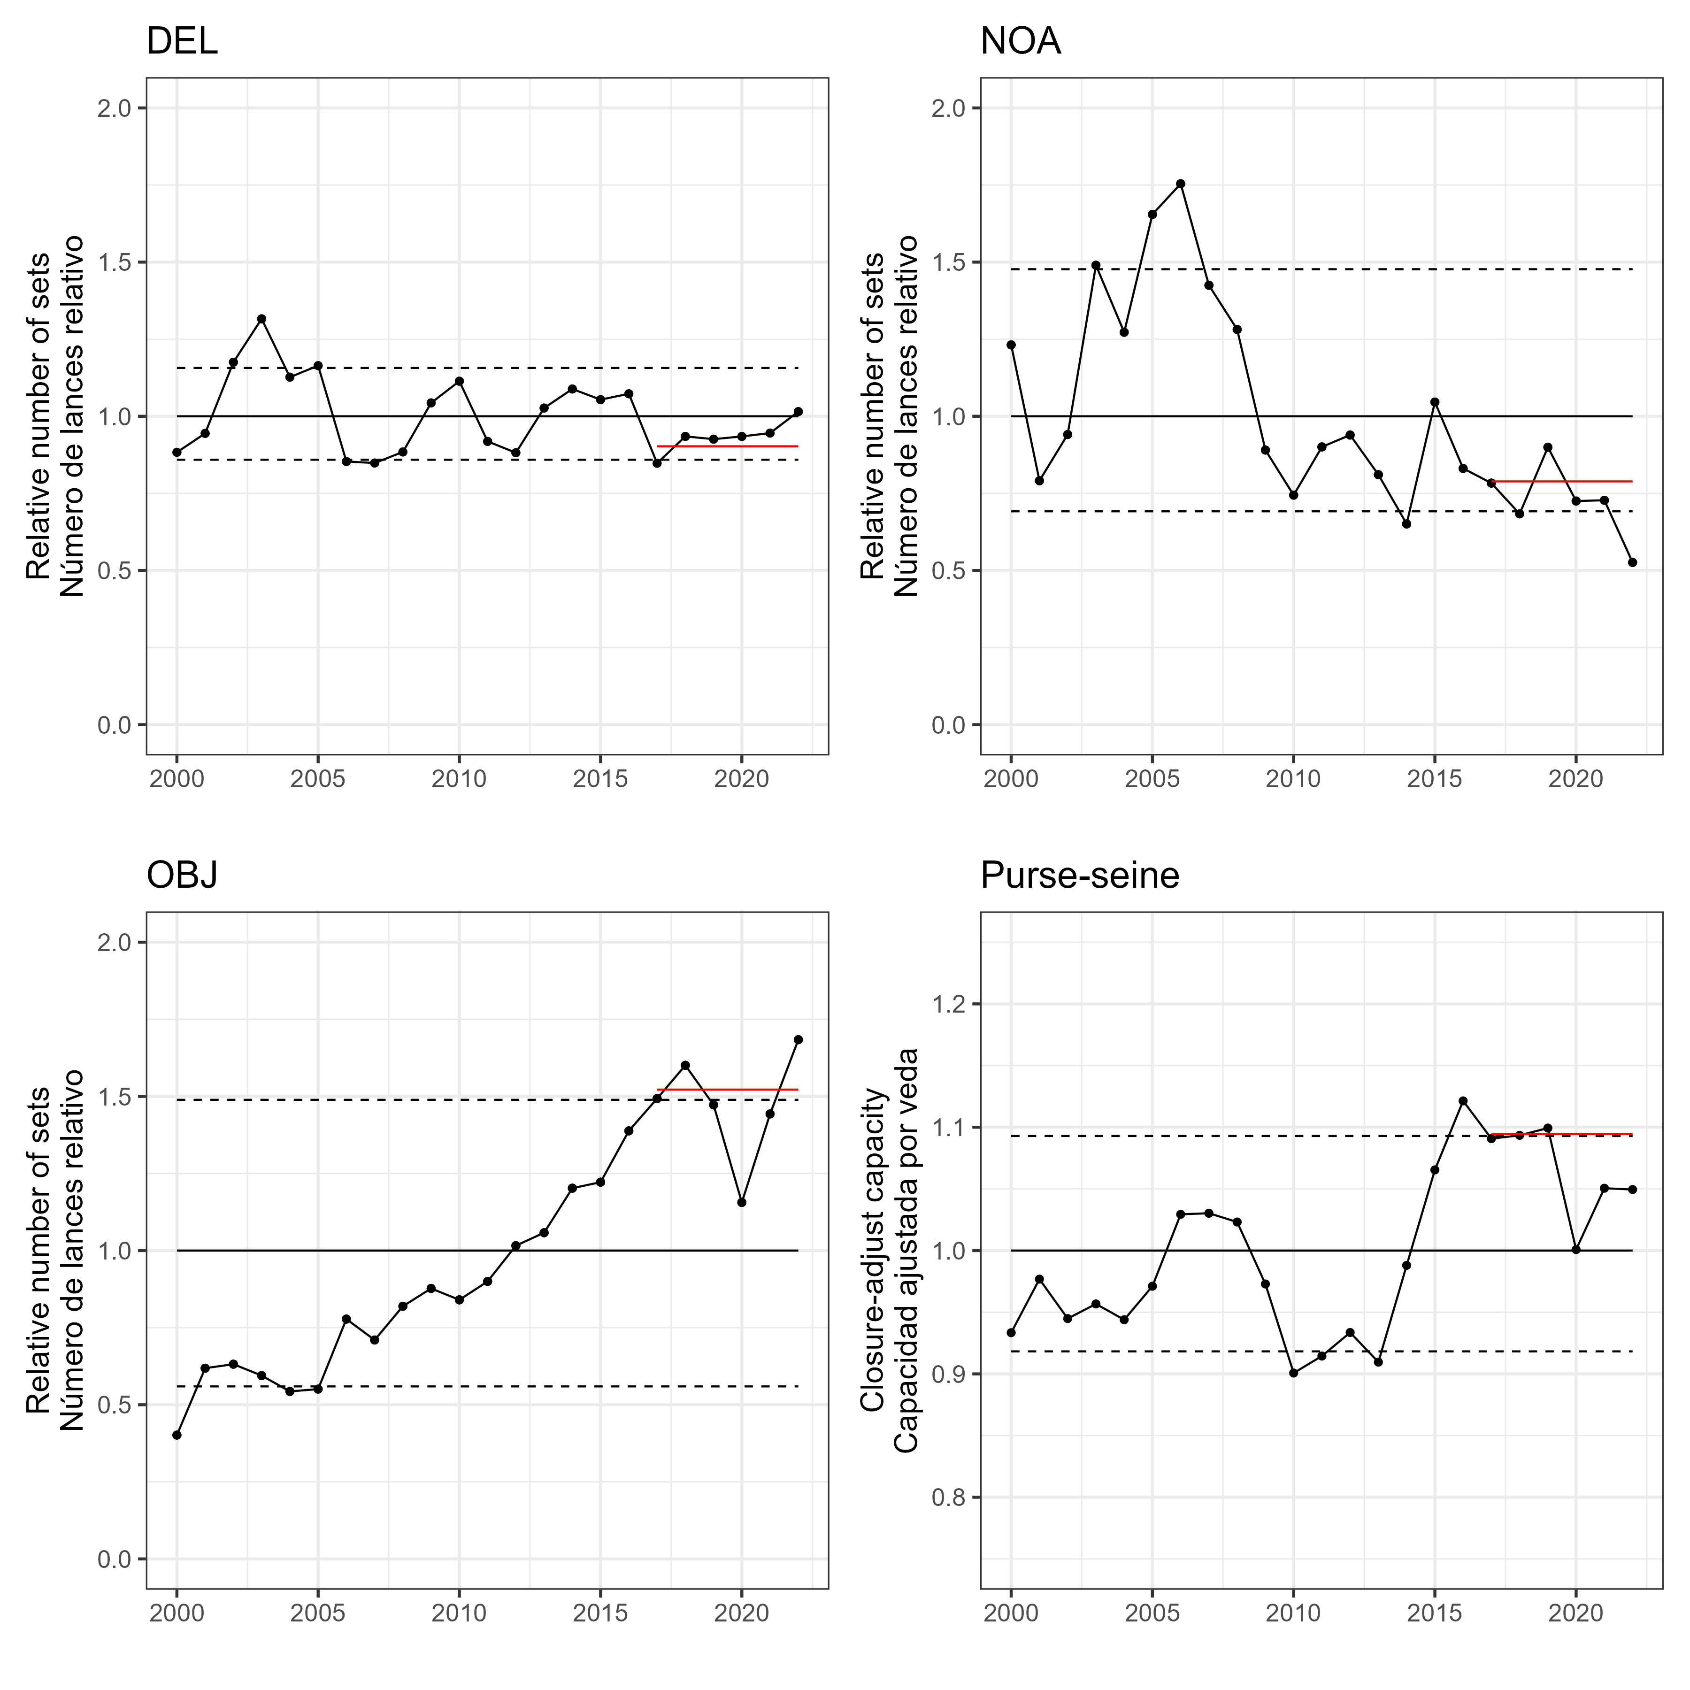   
Figure 1

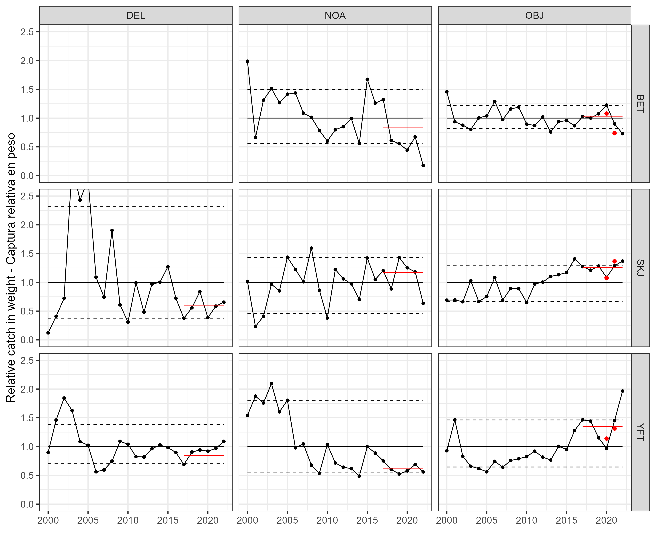   
Figure 2a

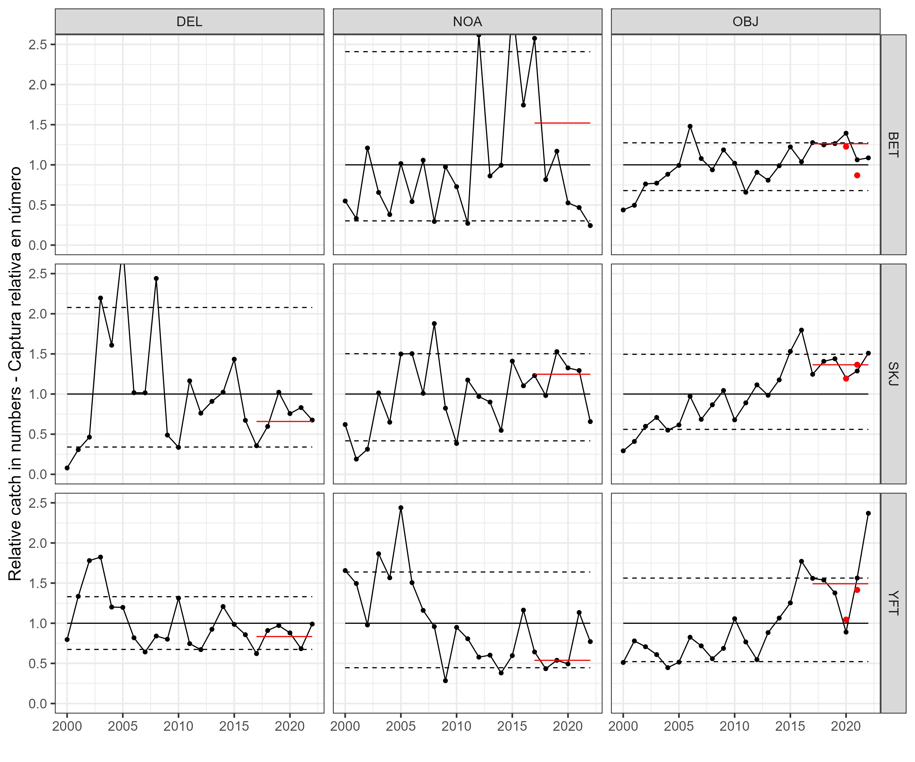   
Figure 2b

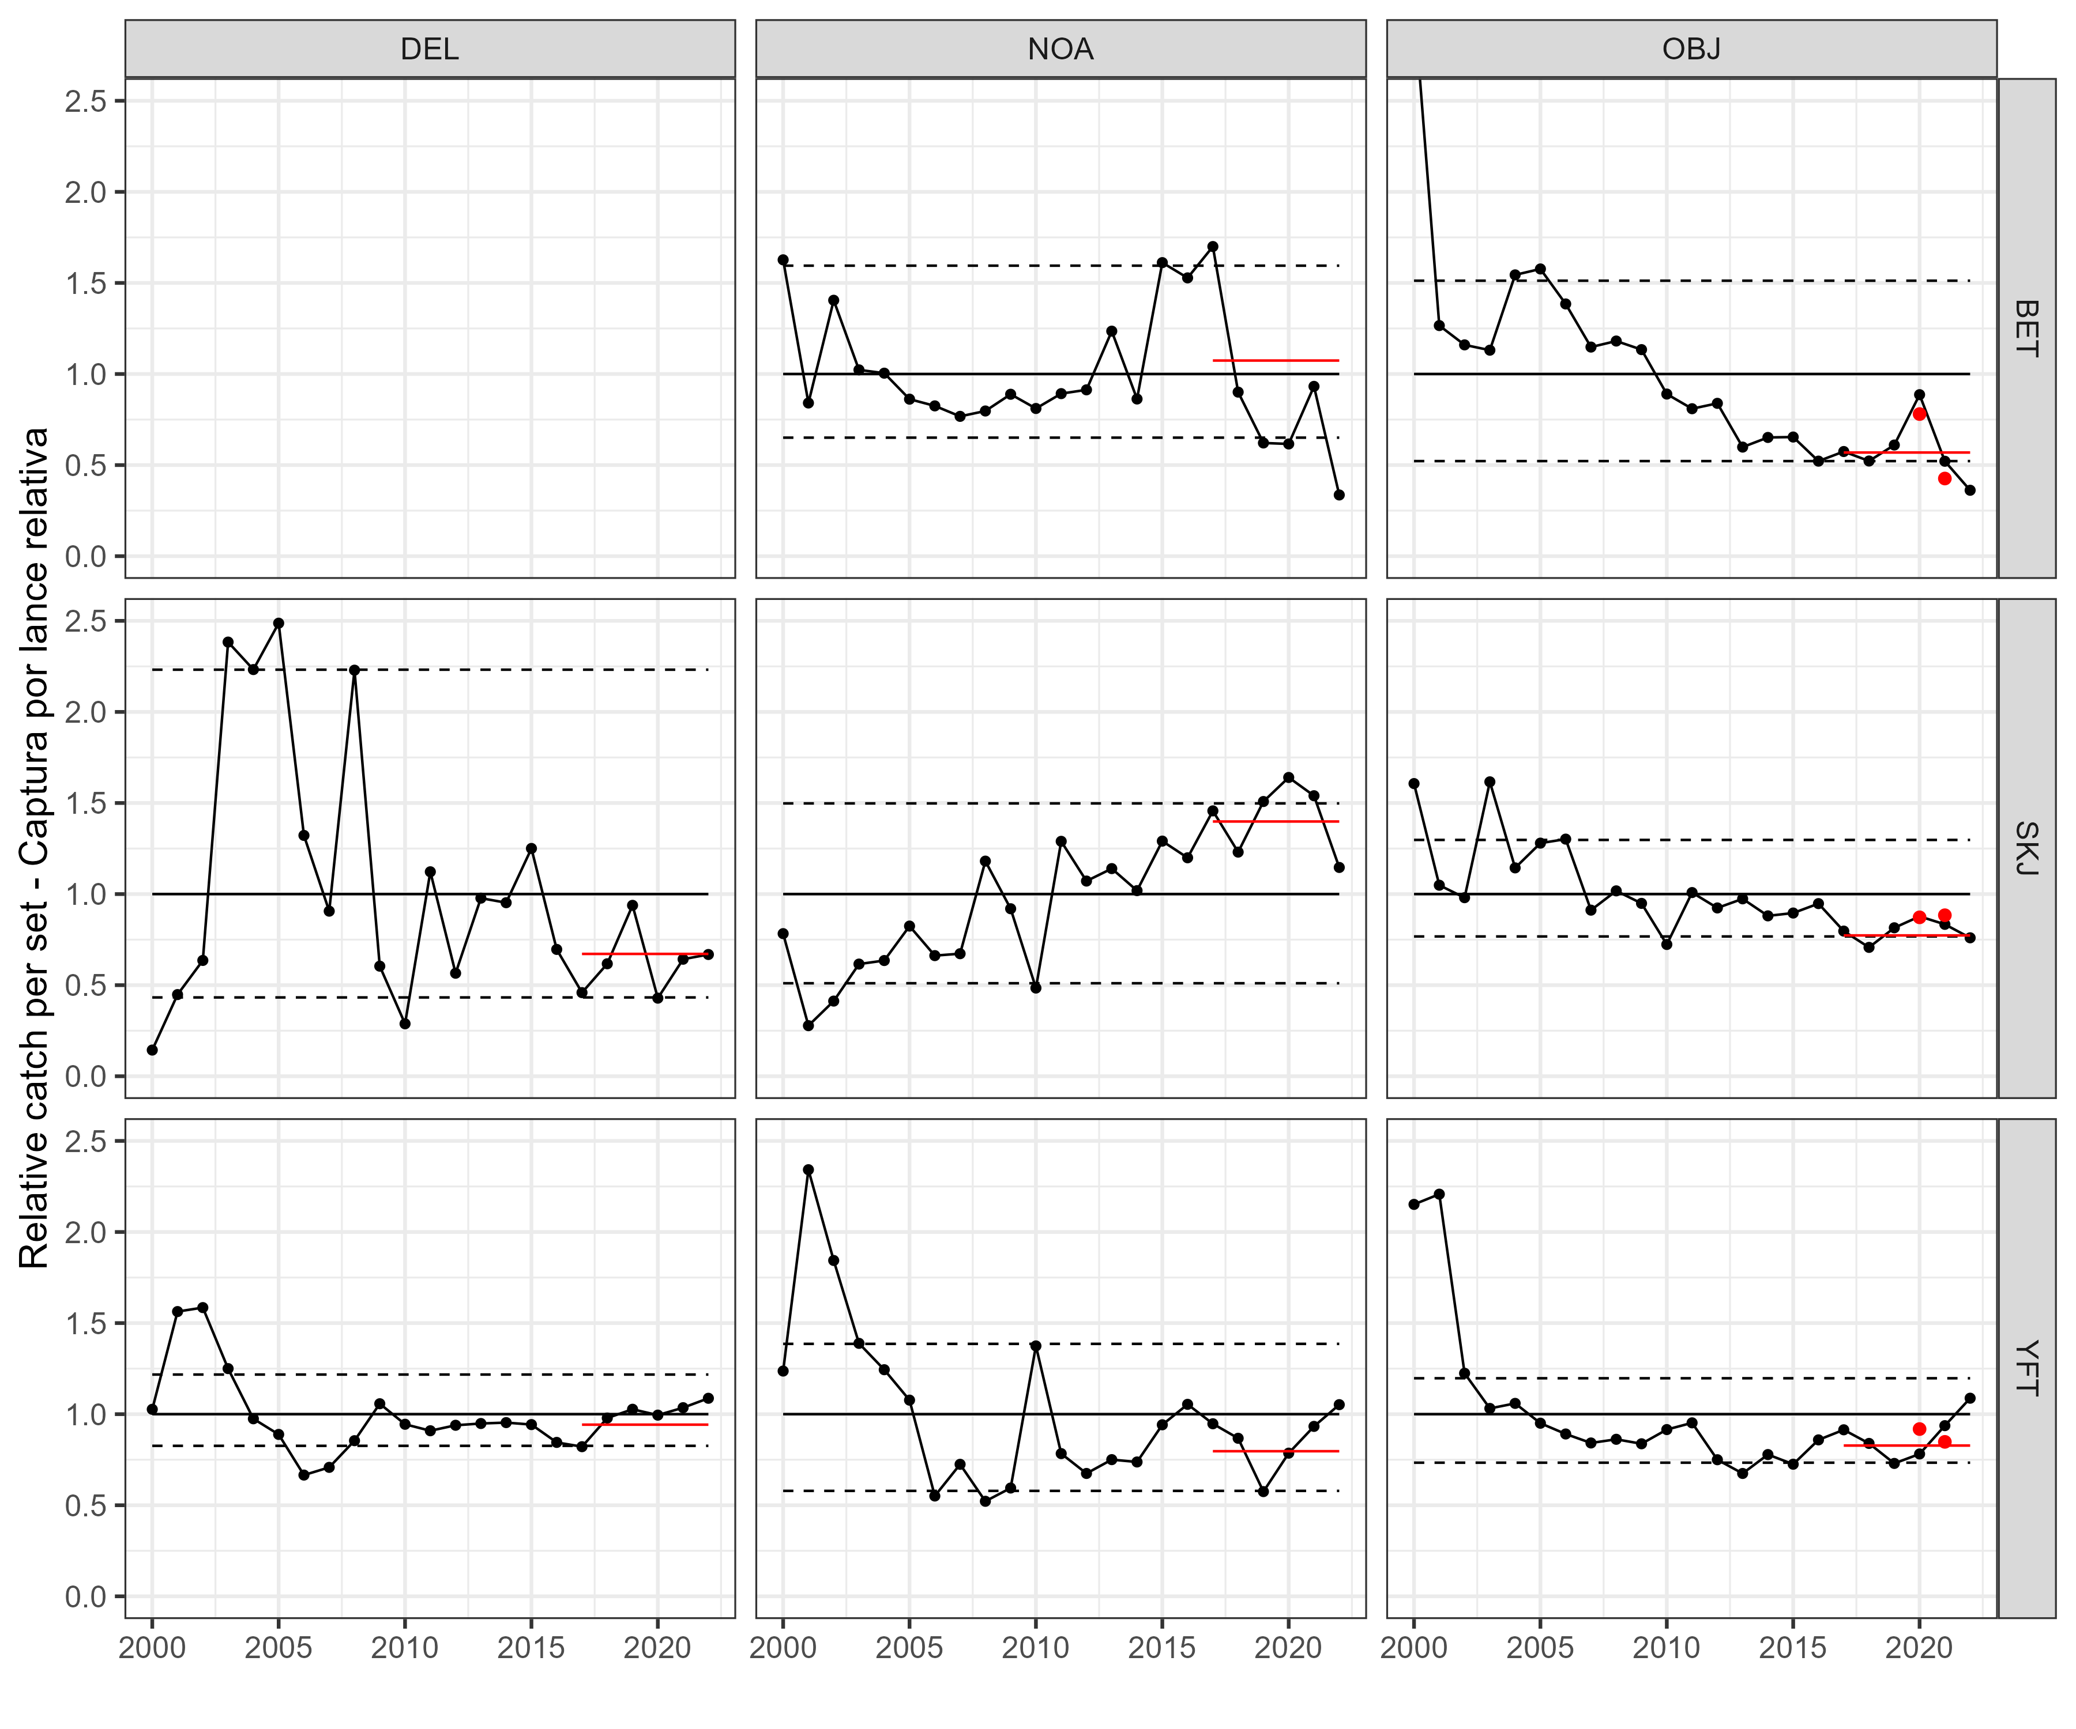   
Figure 3

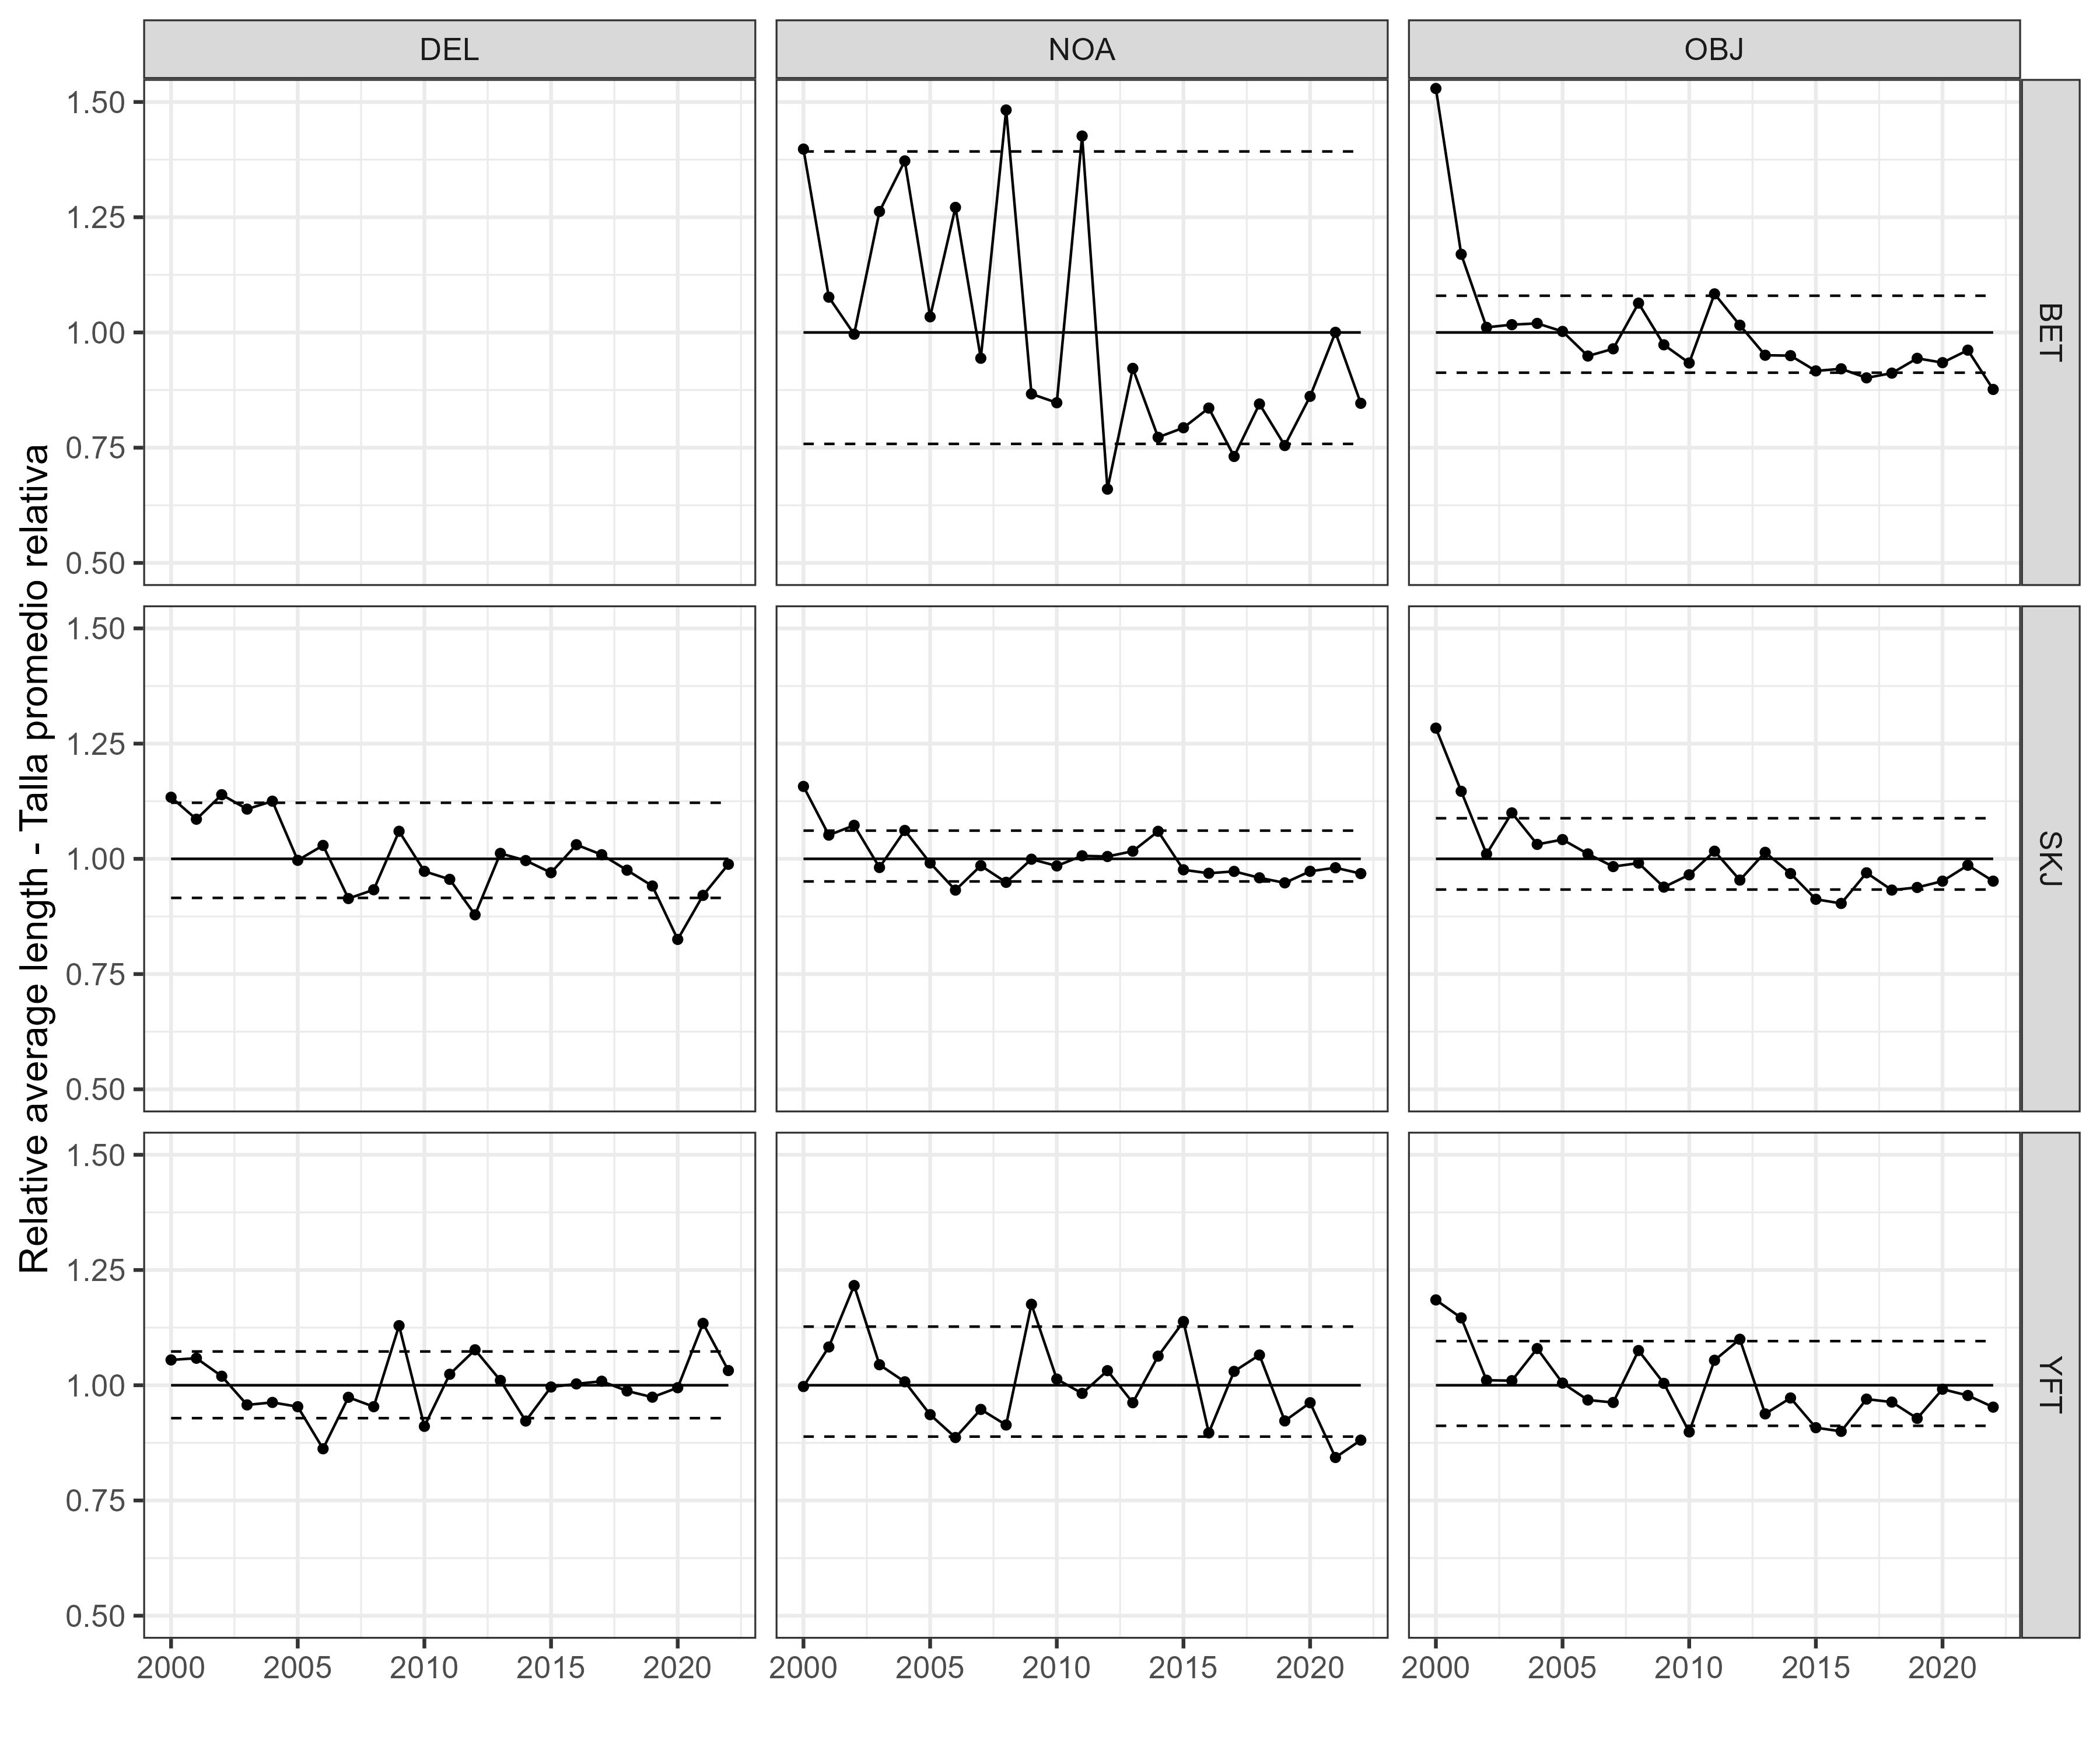   
Figure 4

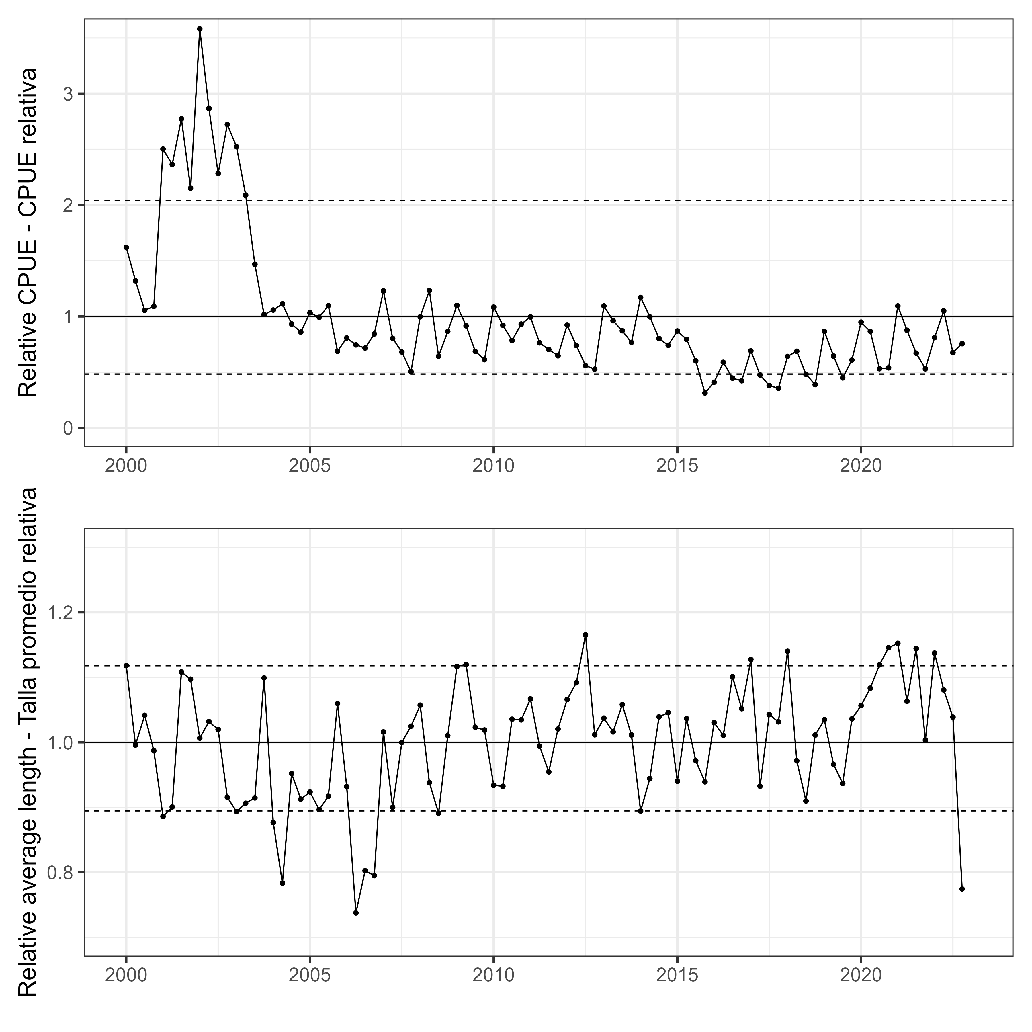   
Figure 5

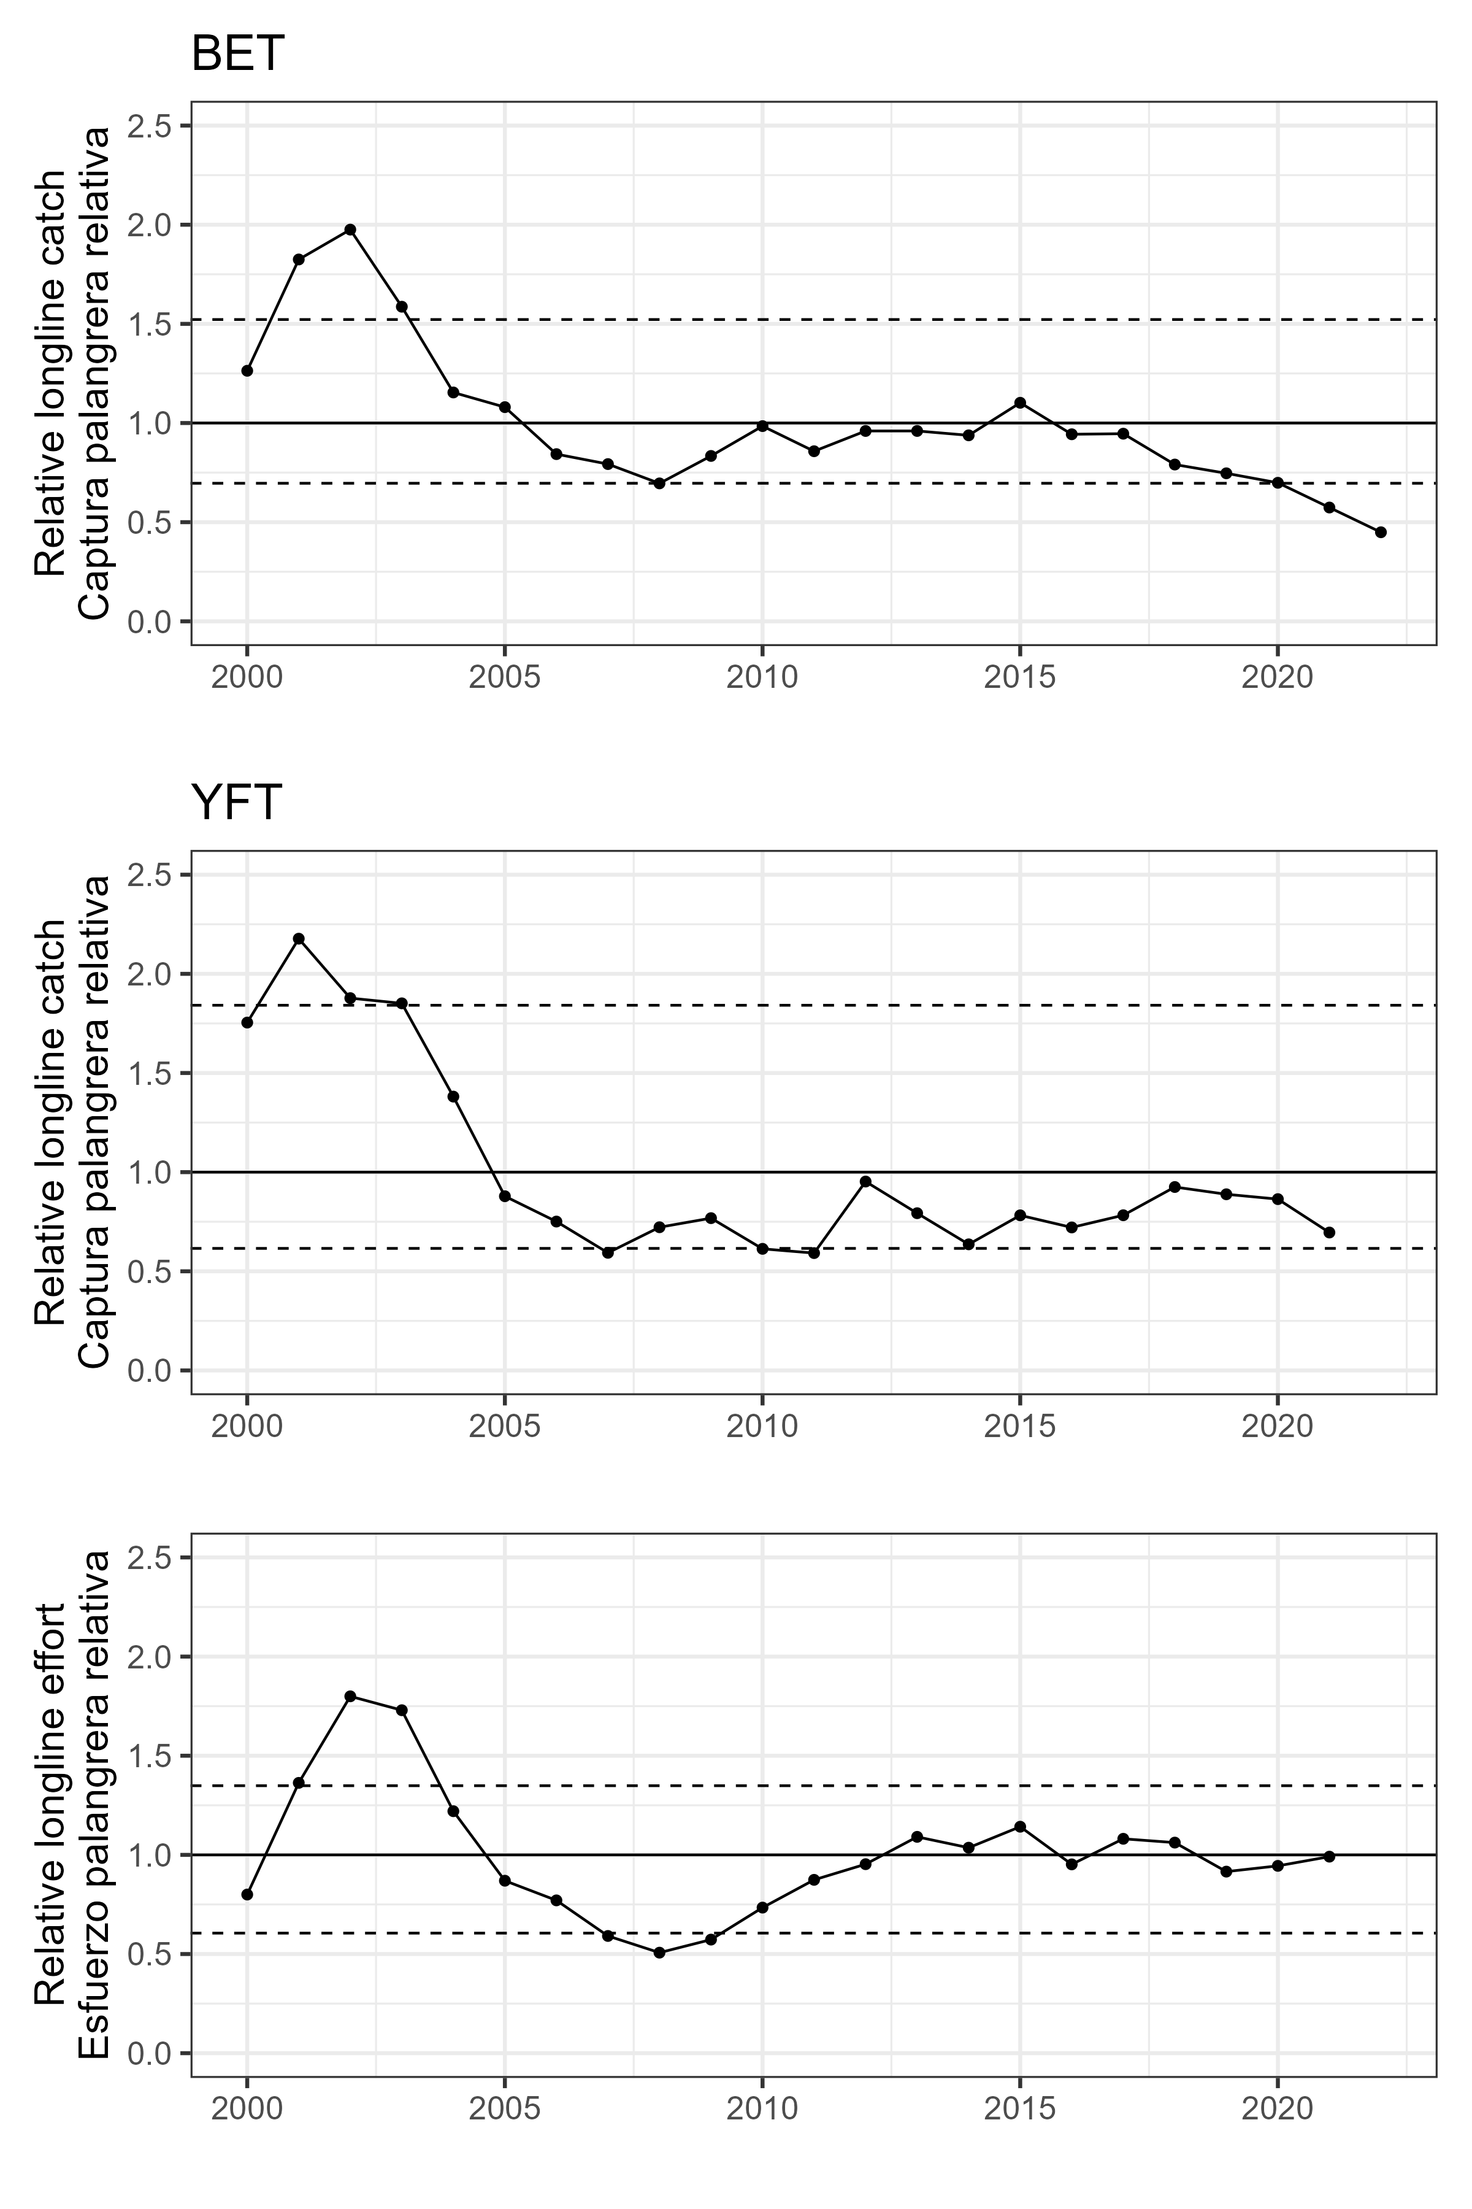   
Figure 6

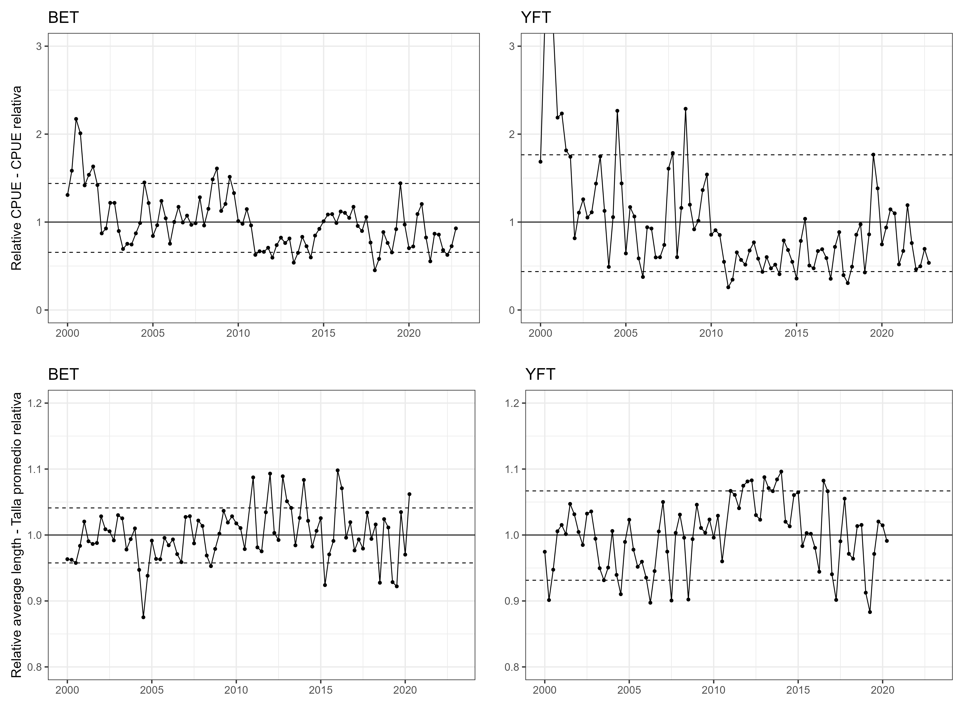   
Figure 7

# Tables

YFT DEL index

| Year | Unit | Fleet | Estimate_metric_tons | SD_log | SD_mt | CPUE |
| --- | --- | --- | --- | --- | --- | --- |
| 2000.00 | 1 | 1 | 36841.445 | 0.1553452 | 5723.1434 | 1.6202581 |
| 2000.25 | 1 | 1 | 30011.406 | 0.1084059 | 3253.4141 | 1.3198783 |
| 2000.50 | 1 | 1 | 23977.776 | 0.0790272 | 1894.8953 | 1.0545239 |
| 2000.75 | 1 | 1 | 24783.634 | 0.1010444 | 2504.2481 | 1.0899649 |
| 2001.00 | 1 | 1 | 56898.649 | 0.1000001 | 5689.8680 | 2.5023583 |
| 2001.25 | 1 | 1 | 53759.255 | 0.0604411 | 3249.2660 | 2.3642902 |
| 2001.50 | 1 | 1 | 63059.455 | 0.0516992 | 3260.1212 | 2.7733057 |
| 2001.75 | 1 | 1 | 48911.374 | 0.0695871 | 3403.6015 | 2.1510841 |
| 2002.00 | 1 | 1 | 81441.873 | 0.0949369 | 7731.8396 | 3.5817502 |
| 2002.25 | 1 | 1 | 65194.375 | 0.0619413 | 4038.2256 | 2.8671979 |
| 2002.50 | 1 | 1 | 51927.848 | 0.0523438 | 2718.0991 | 2.2837463 |
| 2002.75 | 1 | 1 | 61909.382 | 0.0839024 | 5194.3441 | 2.7227264 |
| 2003.00 | 1 | 1 | 57382.776 | 0.0886534 | 5087.1760 | 2.5236498 |
| 2003.25 | 1 | 1 | 47496.690 | 0.0562119 | 2669.8786 | 2.0888675 |
| 2003.50 | 1 | 1 | 33372.241 | 0.0653190 | 2179.8401 | 1.4676852 |
| 2003.75 | 1 | 1 | 23112.059 | 0.0681539 | 1575.1766 | 1.0164504 |
| 2004.00 | 1 | 1 | 24036.558 | 0.1114866 | 2679.7550 | 1.0571091 |
| 2004.25 | 1 | 1 | 25295.902 | 0.0659614 | 1668.5541 | 1.1124941 |
| 2004.50 | 1 | 1 | 21194.846 | 0.0690582 | 1463.6786 | 0.9321328 |
| 2004.75 | 1 | 1 | 19537.998 | 0.0904969 | 1768.1287 | 0.8592659 |
| 2005.00 | 1 | 1 | 23485.534 | 0.1179489 | 2770.0921 | 1.0328755 |
| 2005.25 | 1 | 1 | 22562.650 | 0.0627342 | 1415.4489 | 0.9922878 |
| 2005.50 | 1 | 1 | 24941.983 | 0.0832496 | 2076.4091 | 1.0969290 |
| 2005.75 | 1 | 1 | 15625.575 | 0.0855546 | 1336.8394 | 0.6872006 |
| 2006.00 | 1 | 1 | 18338.778 | 0.1379273 | 2529.4181 | 0.8065252 |
| 2006.25 | 1 | 1 | 16934.551 | 0.0833518 | 1411.5247 | 0.7447684 |
| 2006.50 | 1 | 1 | 16276.233 | 0.0974569 | 1586.2317 | 0.7158160 |
| 2006.75 | 1 | 1 | 19163.184 | 0.1181454 | 2264.0422 | 0.8427819 |
| 2007.00 | 1 | 1 | 27939.926 | 0.1657293 | 4630.4630 | 1.2287762 |
| 2007.25 | 1 | 1 | 18262.858 | 0.1305116 | 2383.5145 | 0.8031863 |
| 2007.50 | 1 | 1 | 15468.194 | 0.1322110 | 2045.0655 | 0.6802791 |
| 2007.75 | 1 | 1 | 11463.058 | 0.1823908 | 2090.7565 | 0.5041364 |
| 2008.00 | 1 | 1 | 22660.939 | 0.1065776 | 2415.1493 | 0.9966105 |
| 2008.25 | 1 | 1 | 28038.709 | 0.0869236 | 2437.2241 | 1.2331206 |
| 2008.50 | 1 | 1 | 14601.843 | 0.0916555 | 1338.3387 | 0.6421777 |
| 2008.75 | 1 | 1 | 19681.538 | 0.1062152 | 2090.4780 | 0.8655787 |
| 2009.00 | 1 | 1 | 24968.063 | 0.0981416 | 2450.4067 | 1.0980760 |
| 2009.25 | 1 | 1 | 20822.701 | 0.0649763 | 1352.9830 | 0.9157662 |
| 2009.50 | 1 | 1 | 15583.420 | 0.0766690 | 1194.7644 | 0.6853467 |
| 2009.75 | 1 | 1 | 13903.442 | 0.0883100 | 1227.8132 | 0.6114626 |
| 2010.00 | 1 | 1 | 24633.807 | 0.1084136 | 2670.6387 | 1.0833757 |
| 2010.25 | 1 | 1 | 20947.568 | 0.0585493 | 1226.4645 | 0.9212577 |
| 2010.50 | 1 | 1 | 17834.917 | 0.0680472 | 1213.6154 | 0.7843658 |
| 2010.75 | 1 | 1 | 21170.361 | 0.0742804 | 1572.5433 | 0.9310560 |
| 2011.00 | 1 | 1 | 22629.083 | 0.1142802 | 2586.0563 | 0.9952095 |
| 2011.25 | 1 | 1 | 17351.235 | 0.0685061 | 1188.6654 | 0.7630938 |
| 2011.50 | 1 | 1 | 15978.281 | 0.0769318 | 1229.2377 | 0.7027124 |
| 2011.75 | 1 | 1 | 14706.804 | 0.1005784 | 1479.1867 | 0.6467938 |
| 2012.00 | 1 | 1 | 20993.489 | 0.1201131 | 2521.5929 | 0.9232773 |
| 2012.25 | 1 | 1 | 16788.084 | 0.0758791 | 1273.8643 | 0.7383269 |
| 2012.50 | 1 | 1 | 12700.929 | 0.0827893 | 1051.5008 | 0.5585770 |
| 2012.75 | 1 | 1 | 11977.428 | 0.0974309 | 1166.9721 | 0.5267580 |
| 2013.00 | 1 | 1 | 24865.710 | 0.1098003 | 2730.2616 | 1.0935746 |
| 2013.25 | 1 | 1 | 21865.351 | 0.0628009 | 1373.1642 | 0.9616211 |
| 2013.50 | 1 | 1 | 19816.667 | 0.0669744 | 1327.2095 | 0.8715216 |
| 2013.75 | 1 | 1 | 17422.920 | 0.0790040 | 1376.4801 | 0.7662465 |
| 2014.00 | 1 | 1 | 26618.994 | 0.1033200 | 2750.2748 | 1.1706827 |
| 2014.25 | 1 | 1 | 22652.695 | 0.0690673 | 1564.5596 | 0.9962479 |
| 2014.50 | 1 | 1 | 18226.424 | 0.0610650 | 1112.9971 | 0.8015840 |
| 2014.75 | 1 | 1 | 16848.109 | 0.0818150 | 1378.4282 | 0.7409667 |
| 2015.00 | 1 | 1 | 19762.784 | 0.1178873 | 2329.7822 | 0.8691519 |
| 2015.25 | 1 | 1 | 18064.864 | 0.0745695 | 1347.0874 | 0.7944786 |
| 2015.50 | 1 | 1 | 13660.561 | 0.0843226 | 1151.8943 | 0.6007808 |
| 2015.75 | 1 | 1 | 7093.707 | 0.1206736 | 856.0229 | 0.3119757 |
| 2016.00 | 1 | 1 | 9316.324 | 0.0987606 | 920.0853 | 0.4097247 |
| 2016.25 | 1 | 1 | 13374.513 | 0.0732746 | 980.0126 | 0.5882007 |
| 2016.50 | 1 | 1 | 10149.136 | 0.0676822 | 686.9160 | 0.4463511 |
| 2016.75 | 1 | 1 | 9602.377 | 0.0898998 | 863.2513 | 0.4223050 |
| 2017.00 | 1 | 1 | 15710.816 | 0.1051757 | 1652.3961 | 0.6909495 |
| 2017.25 | 1 | 1 | 10810.009 | 0.0834151 | 901.7179 | 0.4754158 |
| 2017.50 | 1 | 1 | 8625.234 | 0.0931057 | 803.0584 | 0.3793311 |
| 2017.75 | 1 | 1 | 8072.900 | 0.1104917 | 891.9886 | 0.3550399 |
| 2018.00 | 1 | 1 | 14567.265 | 0.0796901 | 1160.8662 | 0.6406570 |
| 2018.25 | 1 | 1 | 15626.807 | 0.0719131 | 1123.7725 | 0.6872548 |
| 2018.50 | 1 | 1 | 10928.864 | 0.0841856 | 920.0529 | 0.4806429 |
| 2018.75 | 1 | 1 | 8821.784 | 0.0998578 | 880.9243 | 0.3879752 |
| 2019.00 | 1 | 1 | 19699.499 | 0.0956958 | 1885.1590 | 0.8663686 |
| 2019.25 | 1 | 1 | 14648.607 | 0.0710738 | 1041.1324 | 0.6442343 |
| 2019.50 | 1 | 1 | 10199.193 | 0.0874850 | 892.2763 | 0.4485526 |
| 2019.75 | 1 | 1 | 13831.739 | 0.0998437 | 1381.0120 | 0.6083091 |
| 2020.00 | 1 | 1 | 21562.999 | 0.0998875 | 2153.8747 | 0.9483239 |
| 2020.25 | 1 | 1 | 19701.356 | 0.0622297 | 1226.0102 | 0.8664503 |
| 2020.50 | 1 | 1 | 12058.437 | 0.0820014 | 988.8087 | 0.5303207 |
| 2020.75 | 1 | 1 | 12253.887 | 0.0873601 | 1070.5002 | 0.5389164 |
| 2021.00 | 1 | 1 | 24866.221 | 0.1042281 | 2591.7589 | 1.0935970 |
| 2021.25 | 1 | 1 | 19912.759 | 0.0668570 | 1331.3070 | 0.8757476 |
| 2021.50 | 1 | 1 | 15227.962 | 0.0838778 | 1277.2885 | 0.6697139 |
| 2021.75 | 1 | 1 | 12047.404 | 0.0952506 | 1147.5228 | 0.5298354 |
| 2022.00 | 1 | 1 | 18413.960 | 0.0767270 | 1412.8484 | 0.8098316 |
| 2022.25 | 1 | 1 | 23876.679 | 0.0681048 | 1626.1176 | 1.0500778 |
| 2022.50 | 1 | 1 | 15336.103 | 0.0797868 | 1223.6187 | 0.6744699 |
| 2022.75 | 1 | 1 | 17174.628 | 0.0965600 | 1658.3826 | 0.7553268 |

BET LL index

| Year | Unit | Fleet | Estimate_metric_tons | SD_log | SD_mt | Species | CPUE | low | high |
| --- | --- | --- | --- | --- | --- | --- | --- | --- | --- |
| 2000.00 | 1 | 1 | 24568.860 | 0.1150202 | 2825.915 | Bigeye | 1.3080808 | 0.6556972 | 1.438744 |
| 2000.25 | 1 | 1 | 29748.467 | 0.0976082 | 2903.694 | Bigeye | 1.5838504 | 0.6556972 | 1.438744 |
| 2000.50 | 1 | 1 | 40803.175 | 0.0967839 | 3949.091 | Bigeye | 2.1724187 | 0.6556972 | 1.438744 |
| 2000.75 | 1 | 1 | 37739.079 | 0.0914333 | 3450.610 | Bigeye | 2.0092819 | 0.6556972 | 1.438744 |
| 2001.00 | 1 | 1 | 26624.559 | 0.0910514 | 2424.203 | Bigeye | 1.4175291 | 0.6556972 | 1.438744 |
| 2001.25 | 1 | 1 | 28873.206 | 0.0935973 | 2702.453 | Bigeye | 1.5372503 | 0.6556972 | 1.438744 |
| 2001.50 | 1 | 1 | 30651.638 | 0.0902449 | 2766.155 | Bigeye | 1.6319365 | 0.6556972 | 1.438744 |
| 2001.75 | 1 | 1 | 26688.101 | 0.0952818 | 2542.890 | Bigeye | 1.4209122 | 0.6556972 | 1.438744 |
| 2002.00 | 1 | 1 | 16368.194 | 0.0999391 | 1635.822 | Bigeye | 0.8714658 | 0.6556972 | 1.438744 |
| 2002.25 | 1 | 1 | 17413.665 | 0.0951411 | 1656.755 | Bigeye | 0.9271282 | 0.6556972 | 1.438744 |
| 2002.50 | 1 | 1 | 22885.210 | 0.0945766 | 2164.405 | Bigeye | 1.2184409 | 0.6556972 | 1.438744 |
| 2002.75 | 1 | 1 | 22877.797 | 0.0928159 | 2123.424 | Bigeye | 1.2180462 | 0.6556972 | 1.438744 |
| 2003.00 | 1 | 1 | 16867.017 | 0.0992910 | 1674.743 | Bigeye | 0.8980238 | 0.6556972 | 1.438744 |
| 2003.25 | 1 | 1 | 13038.489 | 0.0984148 | 1283.181 | Bigeye | 0.6941876 | 0.6556972 | 1.438744 |
| 2003.50 | 1 | 1 | 14137.854 | 0.0980384 | 1386.053 | Bigeye | 0.7527193 | 0.6556972 | 1.438744 |
| 2003.75 | 1 | 1 | 13994.266 | 0.1028337 | 1439.082 | Bigeye | 0.7450745 | 0.6556972 | 1.438744 |
| 2004.00 | 1 | 1 | 16374.351 | 0.0955967 | 1565.334 | Bigeye | 0.8717936 | 0.6556972 | 1.438744 |
| 2004.25 | 1 | 1 | 18577.955 | 0.1008746 | 1874.043 | Bigeye | 0.9891166 | 0.6556972 | 1.438744 |
| 2004.50 | 1 | 1 | 27234.717 | 0.1034569 | 2817.619 | Bigeye | 1.4500148 | 0.6556972 | 1.438744 |
| 2004.75 | 1 | 1 | 22847.929 | 0.1037435 | 2370.324 | Bigeye | 1.2164560 | 0.6556972 | 1.438744 |
| 2005.00 | 1 | 1 | 15809.258 | 0.1085489 | 1716.078 | Bigeye | 0.8417072 | 0.6556972 | 1.438744 |
| 2005.25 | 1 | 1 | 18110.532 | 0.1033237 | 1871.247 | Bigeye | 0.9642303 | 0.6556972 | 1.438744 |
| 2005.50 | 1 | 1 | 23292.470 | 0.1058252 | 2464.931 | Bigeye | 1.2401240 | 0.6556972 | 1.438744 |
| 2005.75 | 1 | 1 | 19588.450 | 0.1075863 | 2107.448 | Bigeye | 1.0429168 | 0.6556972 | 1.438744 |
| 2006.00 | 1 | 1 | 14157.412 | 0.1164460 | 1648.574 | Bigeye | 0.7537606 | 0.6556972 | 1.438744 |
| 2006.25 | 1 | 1 | 18805.805 | 0.1076169 | 2023.823 | Bigeye | 1.0012476 | 0.6556972 | 1.438744 |
| 2006.50 | 1 | 1 | 22028.155 | 0.1057147 | 2328.699 | Bigeye | 1.1728101 | 0.6556972 | 1.438744 |
| 2006.75 | 1 | 1 | 18692.118 | 0.1135481 | 2122.454 | Bigeye | 0.9951948 | 0.6556972 | 1.438744 |
| 2007.00 | 1 | 1 | 20157.146 | 0.1169003 | 2356.376 | Bigeye | 1.0731949 | 0.6556972 | 1.438744 |
| 2007.25 | 1 | 1 | 18195.206 | 0.1004511 | 1827.729 | Bigeye | 0.9687385 | 0.6556972 | 1.438744 |
| 2007.50 | 1 | 1 | 18536.052 | 0.1217262 | 2256.323 | Bigeye | 0.9868856 | 0.6556972 | 1.438744 |
| 2007.75 | 1 | 1 | 24071.467 | 0.1210476 | 2913.793 | Bigeye | 1.2815989 | 0.6556972 | 1.438744 |
| 2008.00 | 1 | 1 | 18049.924 | 0.1140141 | 2057.945 | Bigeye | 0.9610035 | 0.6556972 | 1.438744 |
| 2008.25 | 1 | 1 | 21616.560 | 0.1017901 | 2200.352 | Bigeye | 1.1508962 | 0.6556972 | 1.438744 |
| 2008.50 | 1 | 1 | 27896.860 | 0.1017380 | 2838.171 | Bigeye | 1.4852682 | 0.6556972 | 1.438744 |
| 2008.75 | 1 | 1 | 30221.098 | 0.1175119 | 3551.338 | Bigeye | 1.6090139 | 0.6556972 | 1.438744 |
| 2009.00 | 1 | 1 | 21159.574 | 0.1157461 | 2449.139 | Bigeye | 1.1265656 | 0.6556972 | 1.438744 |
| 2009.25 | 1 | 1 | 22655.963 | 0.1197011 | 2711.945 | Bigeye | 1.2062355 | 0.6556972 | 1.438744 |
| 2009.50 | 1 | 1 | 28439.107 | 0.1091506 | 3104.146 | Bigeye | 1.5141382 | 0.6556972 | 1.438744 |
| 2009.75 | 1 | 1 | 24969.982 | 0.1150453 | 2872.680 | Bigeye | 1.3294371 | 0.6556972 | 1.438744 |
| 2010.00 | 1 | 1 | 18987.298 | 0.1178155 | 2236.997 | Bigeye | 1.0109106 | 0.6556972 | 1.438744 |
| 2010.25 | 1 | 1 | 18411.497 | 0.1063076 | 1957.282 | Bigeye | 0.9802541 | 0.6556972 | 1.438744 |
| 2010.50 | 1 | 1 | 21541.763 | 0.1035180 | 2229.961 | Bigeye | 1.1469139 | 0.6556972 | 1.438744 |
| 2010.75 | 1 | 1 | 18073.818 | 0.1196492 | 2162.519 | Bigeye | 0.9622756 | 0.6556972 | 1.438744 |
| 2011.00 | 1 | 1 | 11781.067 | 0.1306054 | 1538.671 | Bigeye | 0.6272407 | 0.6556972 | 1.438744 |
| 2011.25 | 1 | 1 | 12541.091 | 0.1171770 | 1469.527 | Bigeye | 0.6677054 | 0.6556972 | 1.438744 |
| 2011.50 | 1 | 1 | 12428.604 | 0.1157047 | 1438.048 | Bigeye | 0.6617164 | 0.6556972 | 1.438744 |
| 2011.75 | 1 | 1 | 13294.892 | 0.1637219 | 2176.666 | Bigeye | 0.7078389 | 0.6556972 | 1.438744 |
| 2012.00 | 1 | 1 | 11183.637 | 0.1378229 | 1541.361 | Bigeye | 0.5954326 | 0.6556972 | 1.438744 |
| 2012.25 | 1 | 1 | 13860.487 | 0.1204698 | 1669.769 | Bigeye | 0.7379519 | 0.6556972 | 1.438744 |
| 2012.50 | 1 | 1 | 15448.349 | 0.1052729 | 1626.292 | Bigeye | 0.8224919 | 0.6556972 | 1.438744 |
| 2012.75 | 1 | 1 | 14309.816 | 0.1314158 | 1880.536 | Bigeye | 0.7618748 | 0.6556972 | 1.438744 |
| 2013.00 | 1 | 1 | 15276.017 | 0.1391687 | 2125.943 | Bigeye | 0.8133167 | 0.6556972 | 1.438744 |
| 2013.25 | 1 | 1 | 10116.993 | 0.1280716 | 1295.700 | Bigeye | 0.5386430 | 0.6556972 | 1.438744 |
| 2013.50 | 1 | 1 | 12208.086 | 0.1328469 | 1621.806 | Bigeye | 0.6499757 | 0.6556972 | 1.438744 |
| 2013.75 | 1 | 1 | 15624.478 | 0.1292934 | 2020.143 | Bigeye | 0.8318693 | 0.6556972 | 1.438744 |
| 2014.00 | 1 | 1 | 13619.263 | 0.1389179 | 1891.959 | Bigeye | 0.7251088 | 0.6556972 | 1.438744 |
| 2014.25 | 1 | 1 | 11233.669 | 0.1229831 | 1381.551 | Bigeye | 0.5980964 | 0.6556972 | 1.438744 |
| 2014.50 | 1 | 1 | 15896.023 | 0.1135258 | 1804.608 | Bigeye | 0.8463267 | 0.6556972 | 1.438744 |
| 2014.75 | 1 | 1 | 17333.161 | 0.1750602 | 3034.346 | Bigeye | 0.9228420 | 0.6556972 | 1.438744 |
| 2015.00 | 1 | 1 | 18943.600 | 0.1216769 | 2304.998 | Bigeye | 1.0085840 | 0.6556972 | 1.438744 |
| 2015.25 | 1 | 1 | 20389.083 | 0.1077618 | 2197.165 | Bigeye | 1.0855436 | 0.6556972 | 1.438744 |
| 2015.50 | 1 | 1 | 20477.529 | 0.1094180 | 2240.610 | Bigeye | 1.0902526 | 0.6556972 | 1.438744 |
| 2015.75 | 1 | 1 | 18587.874 | 0.1246832 | 2317.596 | Bigeye | 0.9896447 | 0.6556972 | 1.438744 |
| 2016.00 | 1 | 1 | 21035.774 | 0.1164174 | 2448.930 | Bigeye | 1.1199743 | 0.6556972 | 1.438744 |
| 2016.25 | 1 | 1 | 20748.543 | 0.1101102 | 2284.627 | Bigeye | 1.1046818 | 0.6556972 | 1.438744 |
| 2016.50 | 1 | 1 | 19685.296 | 0.1261403 | 2483.108 | Bigeye | 1.0480730 | 0.6556972 | 1.438744 |
| 2016.75 | 1 | 1 | 22038.607 | 0.1574881 | 3470.819 | Bigeye | 1.1733666 | 0.6556972 | 1.438744 |
| 2017.00 | 1 | 1 | 17947.160 | 0.1264906 | 2270.147 | Bigeye | 0.9555322 | 0.6556972 | 1.438744 |
| 2017.25 | 1 | 1 | 16880.269 | 0.1262721 | 2131.508 | Bigeye | 0.8987294 | 0.6556972 | 1.438744 |
| 2017.50 | 1 | 1 | 19849.248 | 0.1181917 | 2346.017 | Bigeye | 1.0568020 | 0.6556972 | 1.438744 |
| 2017.75 | 1 | 1 | 14404.032 | 0.1475572 | 2125.419 | Bigeye | 0.7668910 | 0.6556972 | 1.438744 |
| 2018.00 | 1 | 1 | 8486.312 | 0.1418182 | 1203.513 | Bigeye | 0.4518232 | 0.6556972 | 1.438744 |
| 2018.25 | 1 | 1 | 10914.808 | 0.1204816 | 1315.033 | Bigeye | 0.5811198 | 0.6556972 | 1.438744 |
| 2018.50 | 1 | 1 | 16634.466 | 0.1216357 | 2023.344 | Bigeye | 0.8856425 | 0.6556972 | 1.438744 |
| 2018.75 | 1 | 1 | 14326.561 | 0.1649772 | 2363.556 | Bigeye | 0.7627663 | 0.6556972 | 1.438744 |
| 2019.00 | 1 | 1 | 12302.987 | 0.1941572 | 2388.713 | Bigeye | 0.6550284 | 0.6556972 | 1.438744 |
| 2019.25 | 1 | 1 | 17267.383 | 0.1246145 | 2151.767 | Bigeye | 0.9193399 | 0.6556972 | 1.438744 |
| 2019.50 | 1 | 1 | 27060.232 | 0.1491680 | 4036.521 | Bigeye | 1.4407250 | 0.6556972 | 1.438744 |
| 2019.75 | 1 | 1 | 18251.862 | 0.1394519 | 2545.256 | Bigeye | 0.9717549 | 0.6556972 | 1.438744 |
| 2020.00 | 1 | 1 | 13214.252 | 0.1458779 | 1927.668 | Bigeye | 0.7035455 | 0.6556972 | 1.438744 |
| 2020.25 | 1 | 1 | 13568.335 | 0.1350713 | 1832.693 | Bigeye | 0.7223973 | 0.6556972 | 1.438744 |
| 2020.50 | 1 | 1 | 20492.938 | 0.1389949 | 2848.414 | Bigeye | 1.0910730 | 0.6556972 | 1.438744 |
| 2020.75 | 1 | 1 | 22631.059 | 0.1649802 | 3733.678 | Bigeye | 1.2049096 | 0.6556972 | 1.438744 |
| 2021.00 | 1 | 1 | 15477.158 | 0.2079116 | 3217.881 | Bigeye | 0.8240258 | 0.6556972 | 1.438744 |
| 2021.25 | 1 | 1 | 10398.156 | 0.1432311 | 1489.340 | Bigeye | 0.5536125 | 0.6556972 | 1.438744 |
| 2021.50 | 1 | 1 | 16289.873 | 0.1437423 | 2341.544 | Bigeye | 0.8672958 | 0.6556972 | 1.438744 |
| 2021.75 | 1 | 1 | 16100.734 | 0.2144466 | 3452.747 | Bigeye | 0.8572258 | 0.6556972 | 1.438744 |
| 2022.00 | 1 | 1 | 12795.576 | 0.2171232 | 2778.216 | Bigeye | 0.6812545 | 0.6556972 | 1.438744 |
| 2022.25 | 1 | 1 | 11774.423 | 0.1679379 | 1977.371 | Bigeye | 0.6268869 | 0.6556972 | 1.438744 |
| 2022.50 | 1 | 1 | 13630.868 | 0.1709318 | 2329.949 | Bigeye | 0.7257267 | 0.6556972 | 1.438744 |
| 2022.75 | 1 | 1 | 17435.509 | 0.2301589 | 4012.938 | Bigeye | 0.9282911 | 0.6556972 | 1.438744 |

YFT LL index

| Year | Unit | Fleet | Estimate_metric_tons | SD_log | SD_mt | Species | CPUE | low | high |
| --- | --- | --- | --- | --- | --- | --- | --- | --- | --- |
| 2000.00 | 1 | 1 | 17028.363 | 0.1223582 | 2083.5605 | Yellowfin | 1.6861096 | 0.437054 | 1.764778 |
| 2000.25 | 1 | 1 | 32742.542 | 0.1089310 | 3566.6794 | Yellowfin | 3.2420917 | 0.437054 | 1.764778 |
| 2000.50 | 1 | 1 | 41270.426 | 0.1157861 | 4778.5400 | Yellowfin | 4.0865033 | 0.437054 | 1.764778 |
| 2000.75 | 1 | 1 | 32249.363 | 0.1041286 | 3358.0800 | Yellowfin | 3.1932583 | 0.437054 | 1.764778 |
| 2001.00 | 1 | 1 | 22096.064 | 0.1234239 | 2727.1822 | Yellowfin | 2.1879019 | 0.437054 | 1.764778 |
| 2001.25 | 1 | 1 | 22564.459 | 0.1121407 | 2530.3940 | Yellowfin | 2.2342813 | 0.437054 | 1.764778 |
| 2001.50 | 1 | 1 | 18328.233 | 0.1055464 | 1934.4795 | Yellowfin | 1.8148198 | 0.437054 | 1.764778 |
| 2001.75 | 1 | 1 | 17597.988 | 0.1099344 | 1934.6239 | Yellowfin | 1.7425126 | 0.437054 | 1.764778 |
| 2002.00 | 1 | 1 | 8240.080 | 0.1140104 | 939.4550 | Yellowfin | 0.8159140 | 0.437054 | 1.764778 |
| 2002.25 | 1 | 1 | 11176.867 | 0.1081035 | 1208.2579 | Yellowfin | 1.1067078 | 0.437054 | 1.764778 |
| 2002.50 | 1 | 1 | 12711.116 | 0.1134556 | 1442.1472 | Yellowfin | 1.2586257 | 0.437054 | 1.764778 |
| 2002.75 | 1 | 1 | 10621.317 | 0.1159556 | 1231.6006 | Yellowfin | 1.0516985 | 0.437054 | 1.764778 |
| 2003.00 | 1 | 1 | 11223.047 | 0.1140163 | 1279.6098 | Yellowfin | 1.1112805 | 0.437054 | 1.764778 |
| 2003.25 | 1 | 1 | 14516.946 | 0.1054136 | 1530.2830 | Yellowfin | 1.4374349 | 0.437054 | 1.764778 |
| 2003.50 | 1 | 1 | 17636.257 | 0.1045361 | 1843.6261 | Yellowfin | 1.7463019 | 0.437054 | 1.764778 |
| 2003.75 | 1 | 1 | 11383.890 | 0.1162335 | 1323.1894 | Yellowfin | 1.1272068 | 0.437054 | 1.764778 |
| 2004.00 | 1 | 1 | 4949.122 | 0.1196802 | 592.3117 | Yellowfin | 0.4900508 | 0.437054 | 1.764778 |
| 2004.25 | 1 | 1 | 10666.650 | 0.1152068 | 1228.8705 | Yellowfin | 1.0561874 | 0.437054 | 1.764778 |
| 2004.50 | 1 | 1 | 22875.516 | 0.1138182 | 2603.6493 | Yellowfin | 2.2650813 | 0.437054 | 1.764778 |
| 2004.75 | 1 | 1 | 14535.822 | 0.1210907 | 1760.1534 | Yellowfin | 1.4393039 | 0.437054 | 1.764778 |
| 2005.00 | 1 | 1 | 6499.061 | 0.1305269 | 848.3025 | Yellowfin | 0.6435222 | 0.437054 | 1.764778 |
| 2005.25 | 1 | 1 | 11818.872 | 0.1180300 | 1394.9816 | Yellowfin | 1.1702777 | 0.437054 | 1.764778 |
| 2005.50 | 1 | 1 | 10739.143 | 0.1185157 | 1272.7568 | Yellowfin | 1.0633654 | 0.437054 | 1.764778 |
| 2005.75 | 1 | 1 | 5926.541 | 0.1463623 | 867.4219 | Yellowfin | 0.5868325 | 0.437054 | 1.764778 |
| 2006.00 | 1 | 1 | 3793.681 | 0.1384863 | 525.3729 | Yellowfin | 0.3756417 | 0.437054 | 1.764778 |
| 2006.25 | 1 | 1 | 9499.189 | 0.1238582 | 1176.5529 | Yellowfin | 0.9405880 | 0.437054 | 1.764778 |
| 2006.50 | 1 | 1 | 9356.109 | 0.1165758 | 1090.6958 | Yellowfin | 0.9264206 | 0.437054 | 1.764778 |
| 2006.75 | 1 | 1 | 6040.014 | 0.1339354 | 808.9716 | Yellowfin | 0.5980684 | 0.437054 | 1.764778 |
| 2007.00 | 1 | 1 | 6060.210 | 0.1598568 | 968.7655 | Yellowfin | 0.6000682 | 0.437054 | 1.764778 |
| 2007.25 | 1 | 1 | 7472.912 | 0.1187247 | 887.2191 | Yellowfin | 0.7399507 | 0.437054 | 1.764778 |
| 2007.50 | 1 | 1 | 16233.213 | 0.1304241 | 2117.2020 | Yellowfin | 1.6073757 | 0.437054 | 1.764778 |
| 2007.75 | 1 | 1 | 18029.934 | 0.1731328 | 3121.5723 | Yellowfin | 1.7852829 | 0.437054 | 1.764778 |
| 2008.00 | 1 | 1 | 6067.005 | 0.1567134 | 950.7809 | Yellowfin | 0.6007410 | 0.437054 | 1.764778 |
| 2008.25 | 1 | 1 | 11724.762 | 0.1143391 | 1340.5992 | Yellowfin | 1.1609592 | 0.437054 | 1.764778 |
| 2008.50 | 1 | 1 | 23107.356 | 0.1205086 | 2784.6344 | Yellowfin | 2.2880376 | 0.437054 | 1.764778 |
| 2008.75 | 1 | 1 | 12094.430 | 0.1377736 | 1666.2929 | Yellowfin | 1.1975629 | 0.437054 | 1.764778 |
| 2009.00 | 1 | 1 | 9266.563 | 0.1433224 | 1328.1062 | Yellowfin | 0.9175539 | 0.437054 | 1.764778 |
| 2009.25 | 1 | 1 | 10247.299 | 0.1337358 | 1370.4307 | Yellowfin | 1.0146641 | 0.437054 | 1.764778 |
| 2009.50 | 1 | 1 | 13773.222 | 0.1282828 | 1766.8677 | Yellowfin | 1.3637930 | 0.437054 | 1.764778 |
| 2009.75 | 1 | 1 | 15557.345 | 0.1346463 | 2094.7382 | Yellowfin | 1.5404528 | 0.437054 | 1.764778 |
| 2010.00 | 1 | 1 | 8647.209 | 0.1323897 | 1144.8015 | Yellowfin | 0.8562269 | 0.437054 | 1.764778 |
| 2010.25 | 1 | 1 | 9161.521 | 0.1152043 | 1055.4465 | Yellowfin | 0.9071529 | 0.437054 | 1.764778 |
| 2010.50 | 1 | 1 | 8615.861 | 0.1254420 | 1080.7909 | Yellowfin | 0.8531229 | 0.437054 | 1.764778 |
| 2010.75 | 1 | 1 | 5533.360 | 0.1618641 | 895.6525 | Yellowfin | 0.5479007 | 0.437054 | 1.764778 |
| 2011.00 | 1 | 1 | 2608.928 | 0.1479872 | 386.0880 | Yellowfin | 0.2583301 | 0.437054 | 1.764778 |
| 2011.25 | 1 | 1 | 3486.244 | 0.1469450 | 512.2862 | Yellowfin | 0.3451999 | 0.437054 | 1.764778 |
| 2011.50 | 1 | 1 | 6615.727 | 0.1212069 | 801.8721 | Yellowfin | 0.6550742 | 0.437054 | 1.764778 |
| 2011.75 | 1 | 1 | 5750.584 | 0.1714568 | 985.9771 | Yellowfin | 0.5694097 | 0.437054 | 1.764778 |
| 2012.00 | 1 | 1 | 5211.240 | 0.1613206 | 840.6805 | Yellowfin | 0.5160051 | 0.437054 | 1.764778 |
| 2012.25 | 1 | 1 | 6832.638 | 0.1116898 | 763.1358 | Yellowfin | 0.6765522 | 0.437054 | 1.764778 |
| 2012.50 | 1 | 1 | 7763.249 | 0.1178770 | 915.1086 | Yellowfin | 0.7686992 | 0.437054 | 1.764778 |
| 2012.75 | 1 | 1 | 5898.978 | 0.1416016 | 835.3046 | Yellowfin | 0.5841033 | 0.437054 | 1.764778 |
| 2013.00 | 1 | 1 | 4384.404 | 0.1455956 | 638.3498 | Yellowfin | 0.4341337 | 0.437054 | 1.764778 |
| 2013.25 | 1 | 1 | 6073.697 | 0.1308487 | 794.7353 | Yellowfin | 0.6014036 | 0.437054 | 1.764778 |
| 2013.50 | 1 | 1 | 4785.283 | 0.1292754 | 618.6195 | Yellowfin | 0.4738278 | 0.437054 | 1.764778 |
| 2013.75 | 1 | 1 | 5206.300 | 0.1512253 | 787.3242 | Yellowfin | 0.5155160 | 0.437054 | 1.764778 |
| 2014.00 | 1 | 1 | 4115.610 | 0.1615621 | 664.9265 | Yellowfin | 0.4075183 | 0.437054 | 1.764778 |
| 2014.25 | 1 | 1 | 7982.689 | 0.1497771 | 1195.6244 | Yellowfin | 0.7904277 | 0.437054 | 1.764778 |
| 2014.50 | 1 | 1 | 6892.353 | 0.1289345 | 888.6622 | Yellowfin | 0.6824651 | 0.437054 | 1.764778 |
| 2014.75 | 1 | 1 | 5535.118 | 0.2116250 | 1171.3695 | Yellowfin | 0.5480748 | 0.437054 | 1.764778 |
| 2015.00 | 1 | 1 | 3612.441 | 0.1766955 | 638.3021 | Yellowfin | 0.3576956 | 0.437054 | 1.764778 |
| 2015.25 | 1 | 1 | 7933.036 | 0.1278625 | 1014.3377 | Yellowfin | 0.7855111 | 0.437054 | 1.764778 |
| 2015.50 | 1 | 1 | 10471.451 | 0.1222318 | 1279.9438 | Yellowfin | 1.0368592 | 0.437054 | 1.764778 |
| 2015.75 | 1 | 1 | 5105.362 | 0.1815789 | 927.0259 | Yellowfin | 0.5055213 | 0.437054 | 1.764778 |
| 2016.00 | 1 | 1 | 4794.258 | 0.1517480 | 727.5188 | Yellowfin | 0.4747165 | 0.437054 | 1.764778 |
| 2016.25 | 1 | 1 | 6768.887 | 0.1394307 | 943.7905 | Yellowfin | 0.6702397 | 0.437054 | 1.764778 |
| 2016.50 | 1 | 1 | 6977.797 | 0.1590978 | 1110.1522 | Yellowfin | 0.6909256 | 0.437054 | 1.764778 |
| 2016.75 | 1 | 1 | 5966.241 | 0.2316165 | 1381.8796 | Yellowfin | 0.5907635 | 0.437054 | 1.764778 |
| 2017.00 | 1 | 1 | 3587.006 | 0.1772407 | 635.7633 | Yellowfin | 0.3551771 | 0.437054 | 1.764778 |
| 2017.25 | 1 | 1 | 7249.224 | 0.1561478 | 1131.9504 | Yellowfin | 0.7178016 | 0.437054 | 1.764778 |
| 2017.50 | 1 | 1 | 8942.024 | 0.1342232 | 1200.2273 | Yellowfin | 0.8854188 | 0.437054 | 1.764778 |
| 2017.75 | 1 | 1 | 4003.444 | 0.2033054 | 813.9218 | Yellowfin | 0.3964119 | 0.437054 | 1.764778 |
| 2018.00 | 1 | 1 | 3095.345 | 0.1656262 | 512.6702 | Yellowfin | 0.3064940 | 0.437054 | 1.764778 |
| 2018.25 | 1 | 1 | 4970.164 | 0.1333502 | 662.7722 | Yellowfin | 0.4921343 | 0.437054 | 1.764778 |
| 2018.50 | 1 | 1 | 8643.423 | 0.1433351 | 1238.9057 | Yellowfin | 0.8558520 | 0.437054 | 1.764778 |
| 2018.75 | 1 | 1 | 9836.826 | 0.1815099 | 1785.4814 | Yellowfin | 0.9740200 | 0.437054 | 1.764778 |
| 2019.00 | 1 | 1 | 4314.955 | 0.2424868 | 1046.3197 | Yellowfin | 0.4272570 | 0.437054 | 1.764778 |
| 2019.25 | 1 | 1 | 8681.343 | 0.1697384 | 1473.5572 | Yellowfin | 0.8596067 | 0.437054 | 1.764778 |
| 2019.50 | 1 | 1 | 17843.578 | 0.2293538 | 4092.4922 | Yellowfin | 1.7668303 | 0.437054 | 1.764778 |
| 2019.75 | 1 | 1 | 13969.617 | 0.1893664 | 2645.3759 | Yellowfin | 1.3832396 | 0.437054 | 1.764778 |
| 2020.00 | 1 | 1 | 7536.838 | 0.1581490 | 1191.9437 | Yellowfin | 0.7462805 | 0.437054 | 1.764778 |
| 2020.25 | 1 | 1 | 9468.171 | 0.1672682 | 1583.7237 | Yellowfin | 0.9375167 | 0.437054 | 1.764778 |
| 2020.50 | 1 | 1 | 11558.490 | 0.1869861 | 2161.2768 | Yellowfin | 1.1444953 | 0.437054 | 1.764778 |
| 2020.75 | 1 | 1 | 11100.708 | 0.2479444 | 2752.3583 | Yellowfin | 1.0991667 | 0.437054 | 1.764778 |
| 2021.00 | 1 | 1 | 5237.298 | 0.2831448 | 1482.9136 | Yellowfin | 0.5185853 | 0.437054 | 1.764778 |
| 2021.25 | 1 | 1 | 6780.221 | 0.1621096 | 1099.1392 | Yellowfin | 0.6713620 | 0.437054 | 1.764778 |
| 2021.50 | 1 | 1 | 12037.526 | 0.1991448 | 2397.2112 | Yellowfin | 1.1919283 | 0.437054 | 1.764778 |
| 2021.75 | 1 | 1 | 7688.092 | 0.2695510 | 2072.3331 | Yellowfin | 0.7612573 | 0.437054 | 1.764778 |
| 2022.00 | 1 | 1 | 4679.332 | 0.2408764 | 1127.1406 | Yellowfin | 0.4633368 | 0.437054 | 1.764778 |
| 2022.25 | 1 | 1 | 5018.822 | 0.1981829 | 994.6450 | Yellowfin | 0.4969523 | 0.437054 | 1.764778 |
| 2022.50 | 1 | 1 | 7018.209 | 0.2483210 | 1742.7684 | Yellowfin | 0.6949270 | 0.437054 | 1.764778 |
| 2022.75 | 1 | 1 | 5414.601 | 0.2881357 | 1560.1398 | Yellowfin | 0.5361414 | 0.437054 | 1.764778 |

BET LL length

| Time | Mean_L | Species | Year |
| --- | --- | --- | --- |
| 101 | 0.9633509 | Bigeye | 2000.00 |
| 102 | 0.9624285 | Bigeye | 2000.25 |
| 103 | 0.9576687 | Bigeye | 2000.50 |
| 104 | 0.9835772 | Bigeye | 2000.75 |
| 105 | 1.0203912 | Bigeye | 2001.00 |
| 106 | 0.9904923 | Bigeye | 2001.25 |
| 107 | 0.9864374 | Bigeye | 2001.50 |
| 108 | 0.9878771 | Bigeye | 2001.75 |
| 109 | 1.0282972 | Bigeye | 2002.00 |
| 110 | 1.0087344 | Bigeye | 2002.25 |
| 111 | 1.0056193 | Bigeye | 2002.50 |
| 112 | 0.9918567 | Bigeye | 2002.75 |
| 113 | 1.0300760 | Bigeye | 2003.00 |
| 114 | 1.0252754 | Bigeye | 2003.25 |
| 115 | 0.9779911 | Bigeye | 2003.50 |
| 116 | 0.9937398 | Bigeye | 2003.75 |
| 117 | 1.0100213 | Bigeye | 2004.00 |
| 118 | 0.9471466 | Bigeye | 2004.25 |
| 119 | 0.8752416 | Bigeye | 2004.50 |
| 120 | 0.9382337 | Bigeye | 2004.75 |
| 121 | 0.9914631 | Bigeye | 2005.00 |
| 122 | 0.9637648 | Bigeye | 2005.25 |
| 123 | 0.9631983 | Bigeye | 2005.50 |
| 124 | 0.9956470 | Bigeye | 2005.75 |
| 125 | 0.9844327 | Bigeye | 2006.00 |
| 126 | 0.9933016 | Bigeye | 2006.25 |
| 127 | 0.9710016 | Bigeye | 2006.50 |
| 128 | 0.9588740 | Bigeye | 2006.75 |
| 129 | 1.0273406 | Bigeye | 2007.00 |
| 130 | 1.0285141 | Bigeye | 2007.25 |
| 131 | 0.9872905 | Bigeye | 2007.50 |
| 132 | 1.0219280 | Bigeye | 2007.75 |
| 133 | 1.0137323 | Bigeye | 2008.00 |
| 134 | 0.9689021 | Bigeye | 2008.25 |
| 135 | 0.9527916 | Bigeye | 2008.50 |
| 136 | 0.9789344 | Bigeye | 2008.75 |
| 137 | 1.0020025 | Bigeye | 2009.00 |
| 138 | 1.0366996 | Bigeye | 2009.25 |
| 139 | 1.0189158 | Bigeye | 2009.50 |
| 140 | 1.0283592 | Bigeye | 2009.75 |
| 141 | 1.0176067 | Bigeye | 2010.00 |
| 142 | 1.0105500 | Bigeye | 2010.25 |
| 143 | 0.9786719 | Bigeye | 2010.50 |
| 145 | 1.0873573 | Bigeye | 2011.00 |
| 146 | 0.9811982 | Bigeye | 2011.25 |
| 147 | 0.9752503 | Bigeye | 2011.50 |
| 148 | 1.0344538 | Bigeye | 2011.75 |
| 149 | 1.0930950 | Bigeye | 2012.00 |
| 150 | 1.0031353 | Bigeye | 2012.25 |
| 151 | 0.9924372 | Bigeye | 2012.50 |
| 152 | 1.0890536 | Bigeye | 2012.75 |
| 153 | 1.0511295 | Bigeye | 2013.00 |
| 154 | 1.0410589 | Bigeye | 2013.25 |
| 155 | 0.9843484 | Bigeye | 2013.50 |
| 156 | 1.0259009 | Bigeye | 2013.75 |
| 157 | 1.0835006 | Bigeye | 2014.00 |
| 158 | 1.0214958 | Bigeye | 2014.25 |
| 159 | 0.9824350 | Bigeye | 2014.50 |
| 160 | 1.0062937 | Bigeye | 2014.75 |
| 161 | 1.0255070 | Bigeye | 2015.00 |
| 162 | 0.9240754 | Bigeye | 2015.25 |
| 163 | 0.9705545 | Bigeye | 2015.50 |
| 164 | 0.9909868 | Bigeye | 2015.75 |
| 165 | 1.0980509 | Bigeye | 2016.00 |
| 166 | 1.0708687 | Bigeye | 2016.25 |
| 167 | 0.9959535 | Bigeye | 2016.50 |
| 168 | 1.0194068 | Bigeye | 2016.75 |
| 169 | 0.9765840 | Bigeye | 2017.00 |
| 170 | 0.9933208 | Bigeye | 2017.25 |
| 171 | 0.9794489 | Bigeye | 2017.50 |
| 172 | 1.0339565 | Bigeye | 2017.75 |
| 173 | 0.9941061 | Bigeye | 2018.00 |
| 174 | 1.0159785 | Bigeye | 2018.25 |
| 175 | 0.9276174 | Bigeye | 2018.50 |
| 176 | 1.0240731 | Bigeye | 2018.75 |
| 177 | 1.0113776 | Bigeye | 2019.00 |
| 178 | 0.9285499 | Bigeye | 2019.25 |
| 179 | 0.9221415 | Bigeye | 2019.50 |
| 180 | 1.0347081 | Bigeye | 2019.75 |
| 181 | 0.9702873 | Bigeye | 2020.00 |
| 182 | 1.0619243 | Bigeye | 2020.25 |

YFT LL length

| Time | Mean_L | Species | Year |
| --- | --- | --- | --- |
| 101 | 0.9745425 | Yellowfin | 2000.00 |
| 102 | 0.9013614 | Yellowfin | 2000.25 |
| 103 | 0.9474299 | Yellowfin | 2000.50 |
| 104 | 1.0056253 | Yellowfin | 2000.75 |
| 105 | 1.0151991 | Yellowfin | 2001.00 |
| 106 | 1.0013724 | Yellowfin | 2001.25 |
| 107 | 1.0471460 | Yellowfin | 2001.50 |
| 108 | 1.0314296 | Yellowfin | 2001.75 |
| 109 | 1.0045855 | Yellowfin | 2002.00 |
| 110 | 0.9848790 | Yellowfin | 2002.25 |
| 111 | 1.0323865 | Yellowfin | 2002.50 |
| 112 | 1.0356989 | Yellowfin | 2002.75 |
| 113 | 0.9943033 | Yellowfin | 2003.00 |
| 114 | 0.9496305 | Yellowfin | 2003.25 |
| 115 | 0.9314257 | Yellowfin | 2003.50 |
| 116 | 0.9506077 | Yellowfin | 2003.75 |
| 117 | 1.0060569 | Yellowfin | 2004.00 |
| 118 | 0.9395180 | Yellowfin | 2004.25 |
| 119 | 0.9102484 | Yellowfin | 2004.50 |
| 120 | 0.9895157 | Yellowfin | 2004.75 |
| 121 | 1.0231286 | Yellowfin | 2005.00 |
| 122 | 0.9778223 | Yellowfin | 2005.25 |
| 123 | 0.9518224 | Yellowfin | 2005.50 |
| 124 | 0.9594780 | Yellowfin | 2005.75 |
| 125 | 0.9352873 | Yellowfin | 2006.00 |
| 126 | 0.8973225 | Yellowfin | 2006.25 |
| 127 | 0.9452829 | Yellowfin | 2006.50 |
| 128 | 1.0053818 | Yellowfin | 2006.75 |
| 129 | 1.0500548 | Yellowfin | 2007.00 |
| 130 | 0.9747830 | Yellowfin | 2007.25 |
| 131 | 0.9006998 | Yellowfin | 2007.50 |
| 132 | 1.0032388 | Yellowfin | 2007.75 |
| 133 | 1.0309021 | Yellowfin | 2008.00 |
| 134 | 0.9958713 | Yellowfin | 2008.25 |
| 135 | 0.9021806 | Yellowfin | 2008.50 |
| 136 | 0.9937355 | Yellowfin | 2008.75 |
| 137 | 1.0459036 | Yellowfin | 2009.00 |
| 138 | 1.0106775 | Yellowfin | 2009.25 |
| 139 | 1.0035193 | Yellowfin | 2009.50 |
| 140 | 1.0235026 | Yellowfin | 2009.75 |
| 141 | 0.9960538 | Yellowfin | 2010.00 |
| 142 | 1.0292445 | Yellowfin | 2010.25 |
| 143 | 0.9600307 | Yellowfin | 2010.50 |
| 145 | 1.0668501 | Yellowfin | 2011.00 |
| 146 | 1.0607907 | Yellowfin | 2011.25 |
| 147 | 1.0406407 | Yellowfin | 2011.50 |
| 148 | 1.0746639 | Yellowfin | 2011.75 |
| 149 | 1.0812126 | Yellowfin | 2012.00 |
| 150 | 1.0828347 | Yellowfin | 2012.25 |
| 151 | 1.0301562 | Yellowfin | 2012.50 |
| 152 | 1.0231949 | Yellowfin | 2012.75 |
| 153 | 1.0876379 | Yellowfin | 2013.00 |
| 154 | 1.0711021 | Yellowfin | 2013.25 |
| 155 | 1.0665012 | Yellowfin | 2013.50 |
| 156 | 1.0842498 | Yellowfin | 2013.75 |
| 157 | 1.0961586 | Yellowfin | 2014.00 |
| 158 | 1.0201543 | Yellowfin | 2014.25 |
| 159 | 1.0131647 | Yellowfin | 2014.50 |
| 160 | 1.0605353 | Yellowfin | 2014.75 |
| 161 | 1.0646581 | Yellowfin | 2015.00 |
| 162 | 0.9832180 | Yellowfin | 2015.25 |
| 163 | 1.0029276 | Yellowfin | 2015.50 |
| 164 | 1.0018148 | Yellowfin | 2015.75 |
| 165 | 0.9805134 | Yellowfin | 2016.00 |
| 166 | 0.9442820 | Yellowfin | 2016.25 |
| 167 | 1.0824276 | Yellowfin | 2016.50 |
| 168 | 1.0663010 | Yellowfin | 2016.75 |
| 169 | 0.9404900 | Yellowfin | 2017.00 |
| 170 | 0.9015831 | Yellowfin | 2017.25 |
| 171 | 0.9904190 | Yellowfin | 2017.50 |
| 172 | 1.0551838 | Yellowfin | 2017.75 |
| 173 | 0.9714344 | Yellowfin | 2018.00 |
| 174 | 0.9640890 | Yellowfin | 2018.25 |
| 175 | 1.0135555 | Yellowfin | 2018.50 |
| 176 | 1.0152636 | Yellowfin | 2018.75 |
| 177 | 0.9125205 | Yellowfin | 2019.00 |
| 178 | 0.8831562 | Yellowfin | 2019.25 |
| 179 | 0.9712800 | Yellowfin | 2019.50 |
| 180 | 1.0203927 | Yellowfin | 2019.75 |
| 181 | 1.0146690 | Yellowfin | 2020.00 |
| 182 | 0.9910870 | Yellowfin | 2020.25 |