Indicators (internal) for SAC15

Haikun Xu

2024-04-23

# Figures

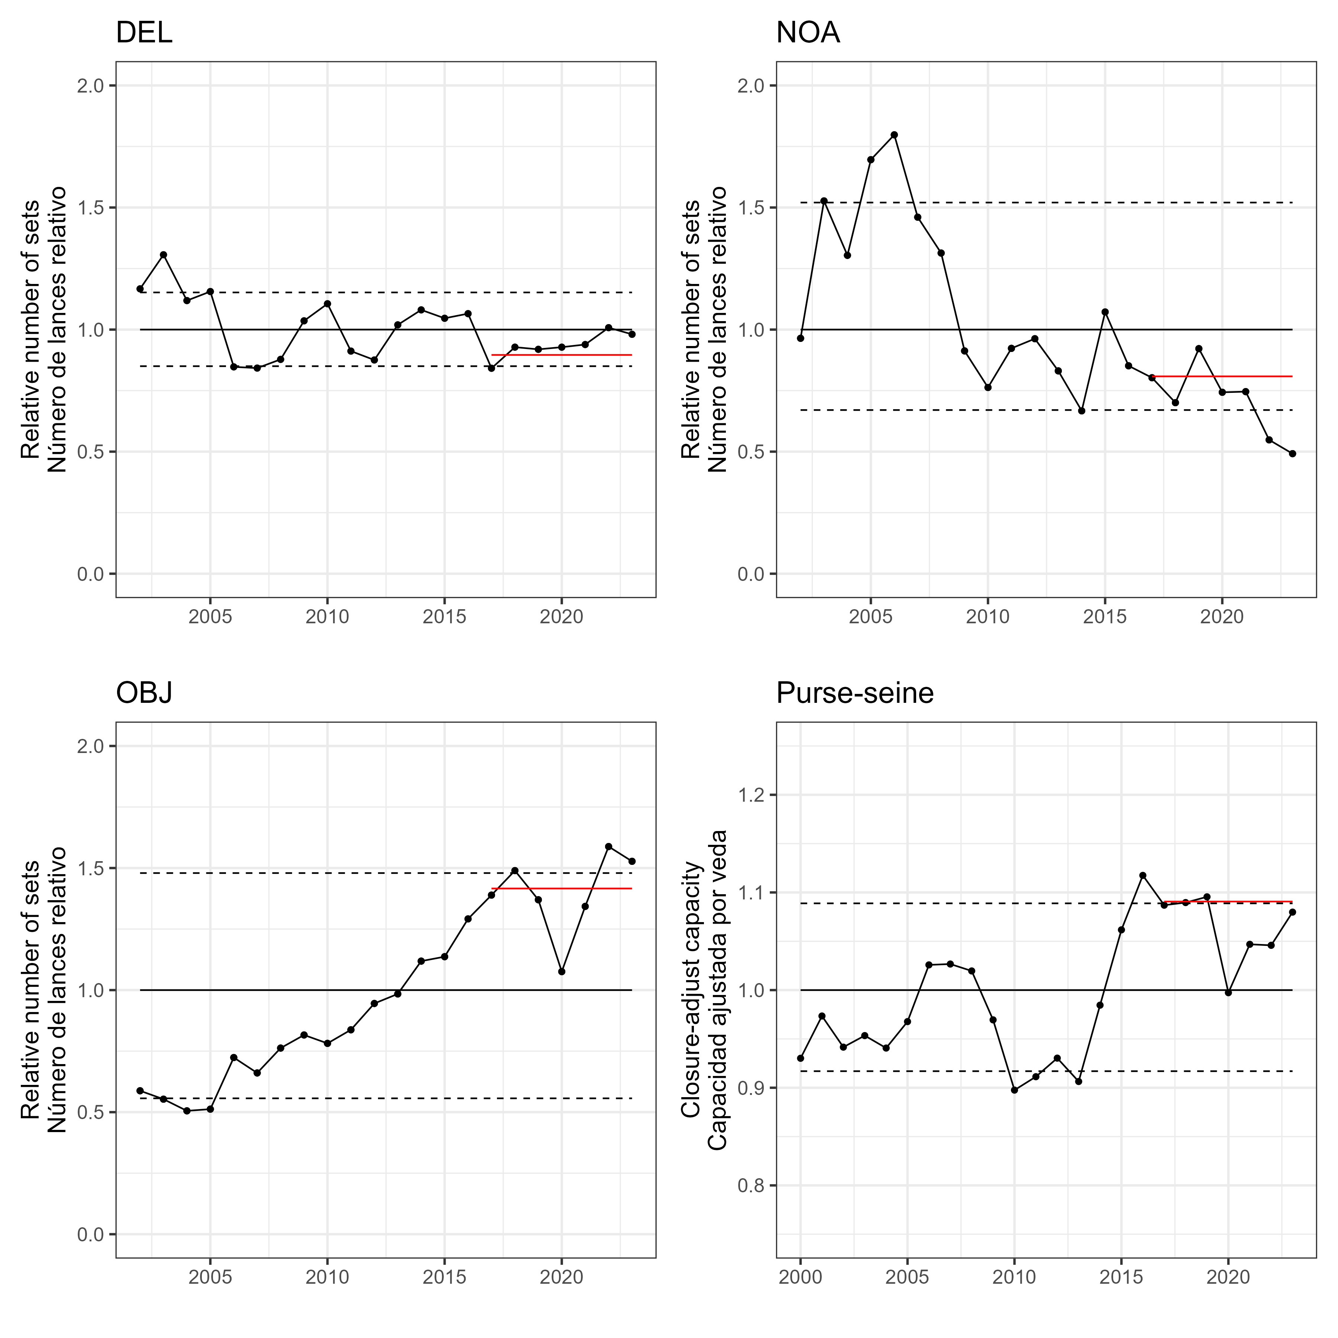   
Figure 1

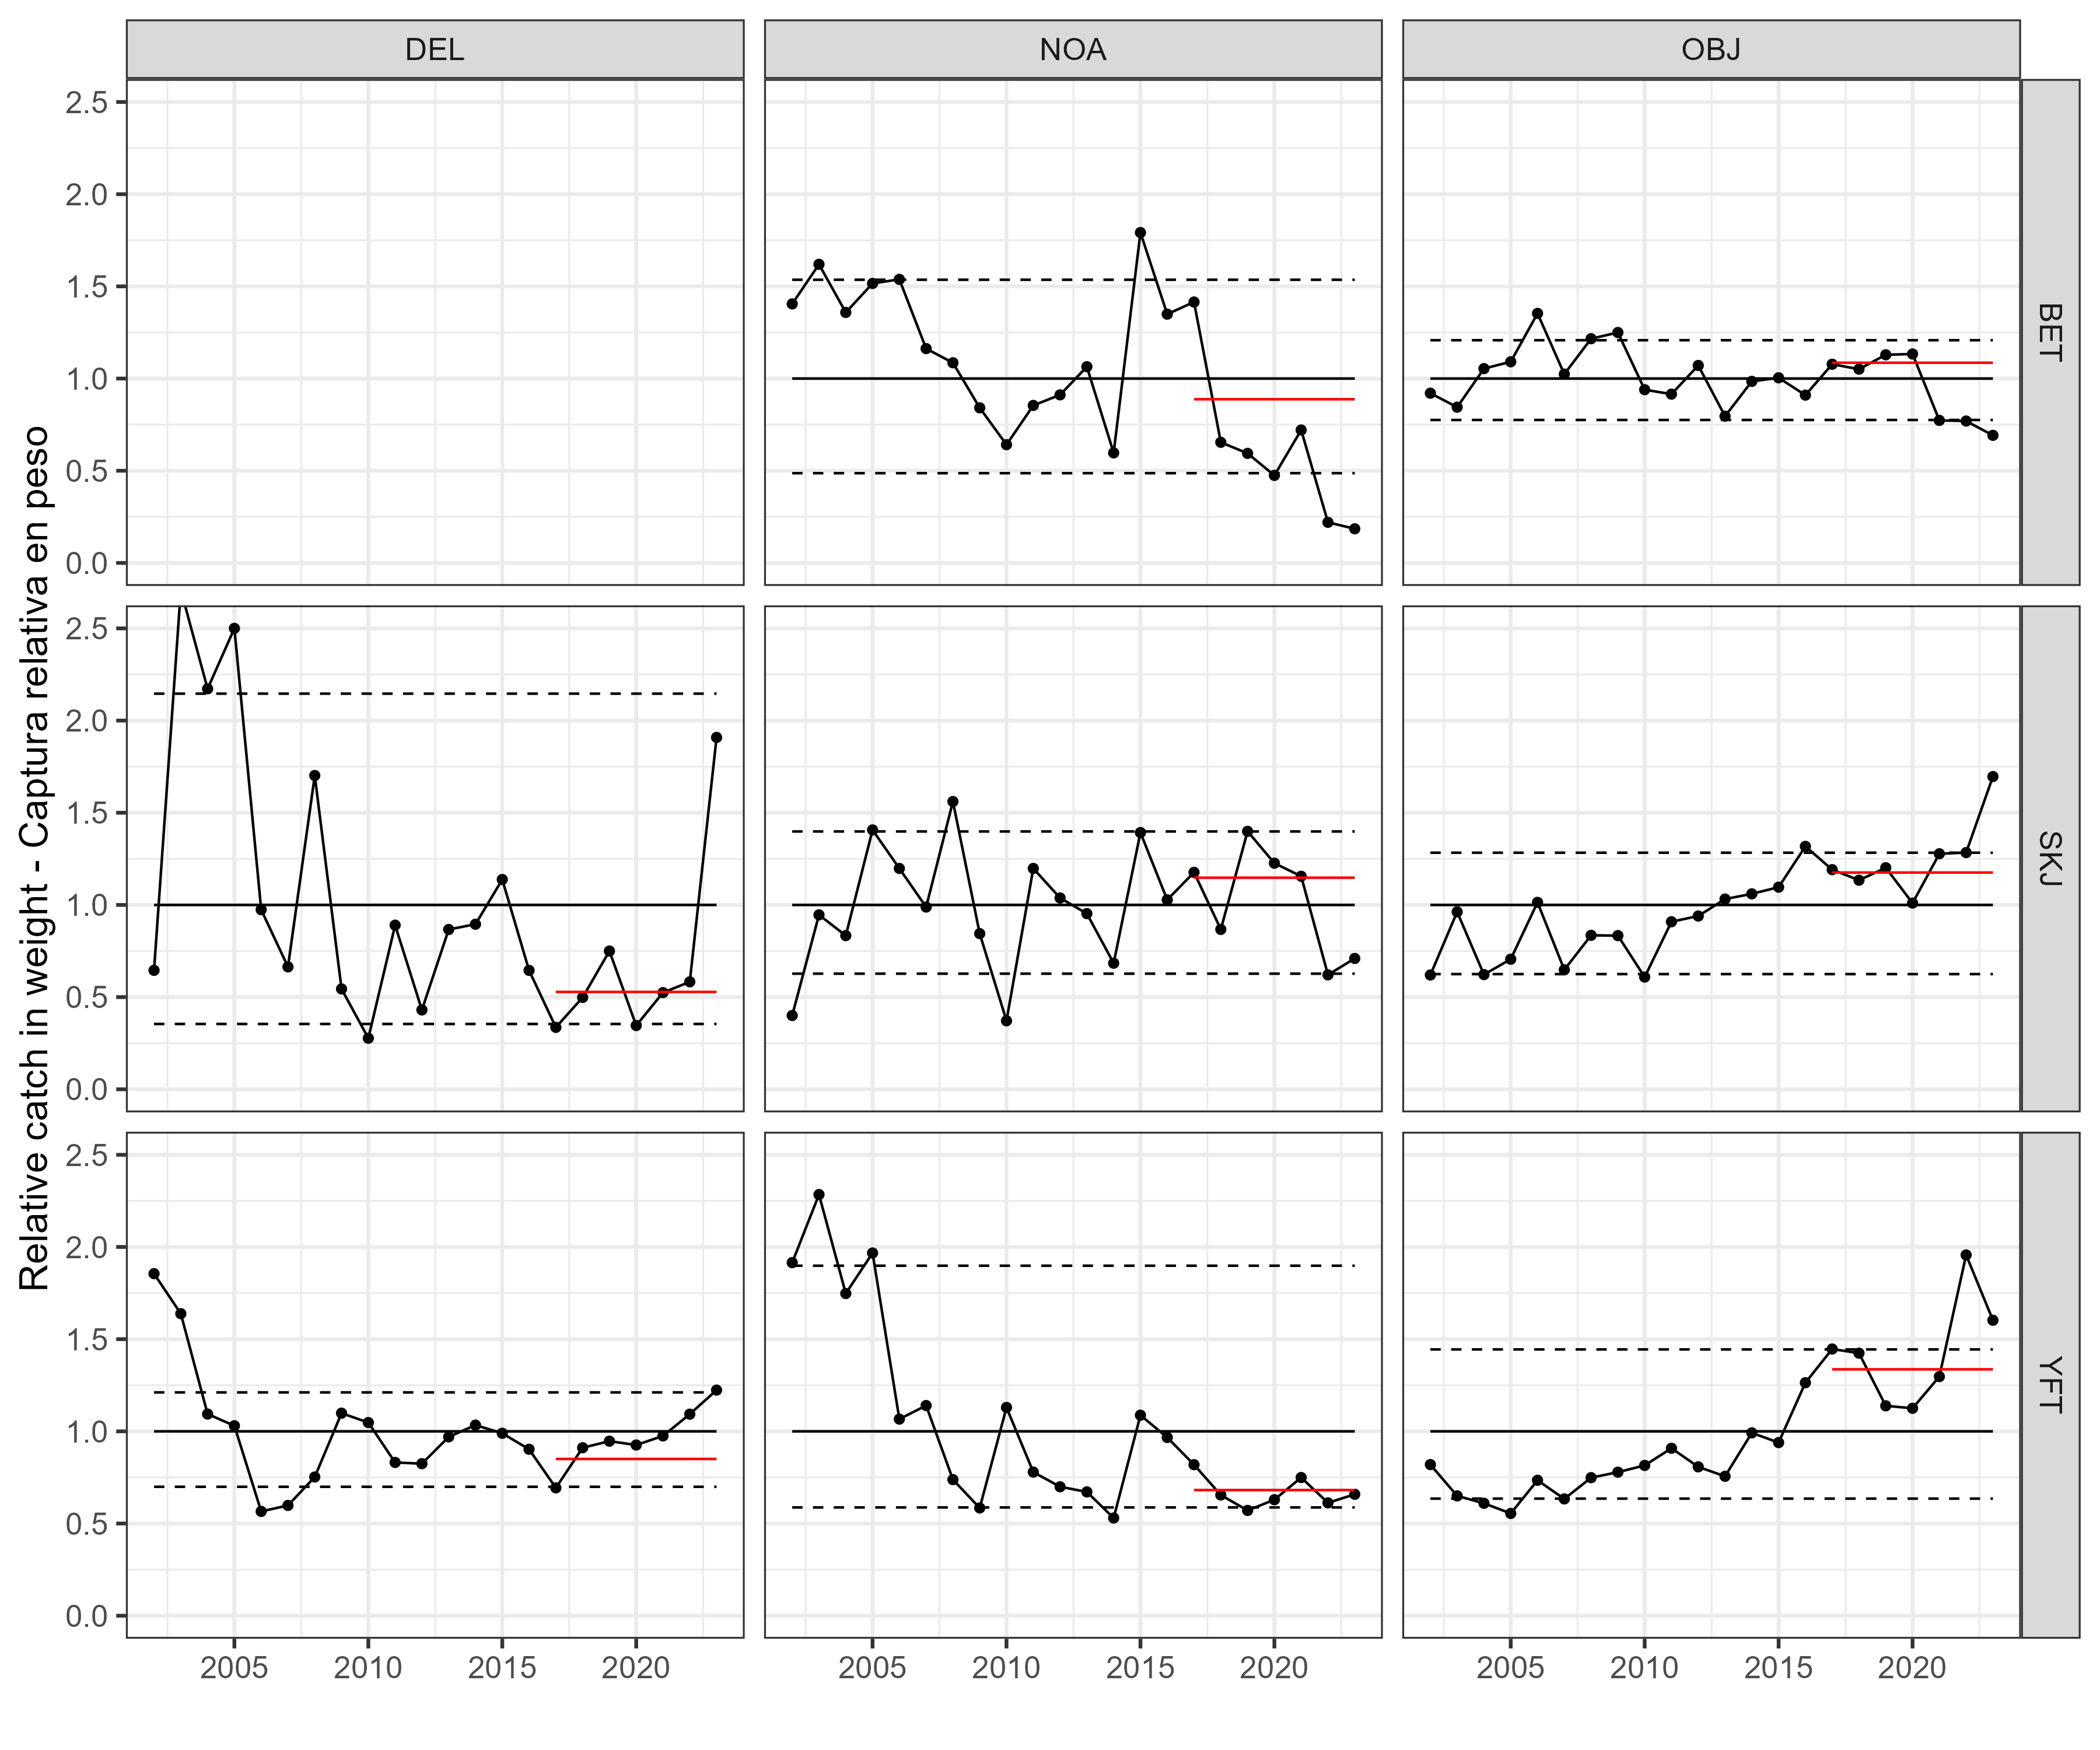   
Figure 2a

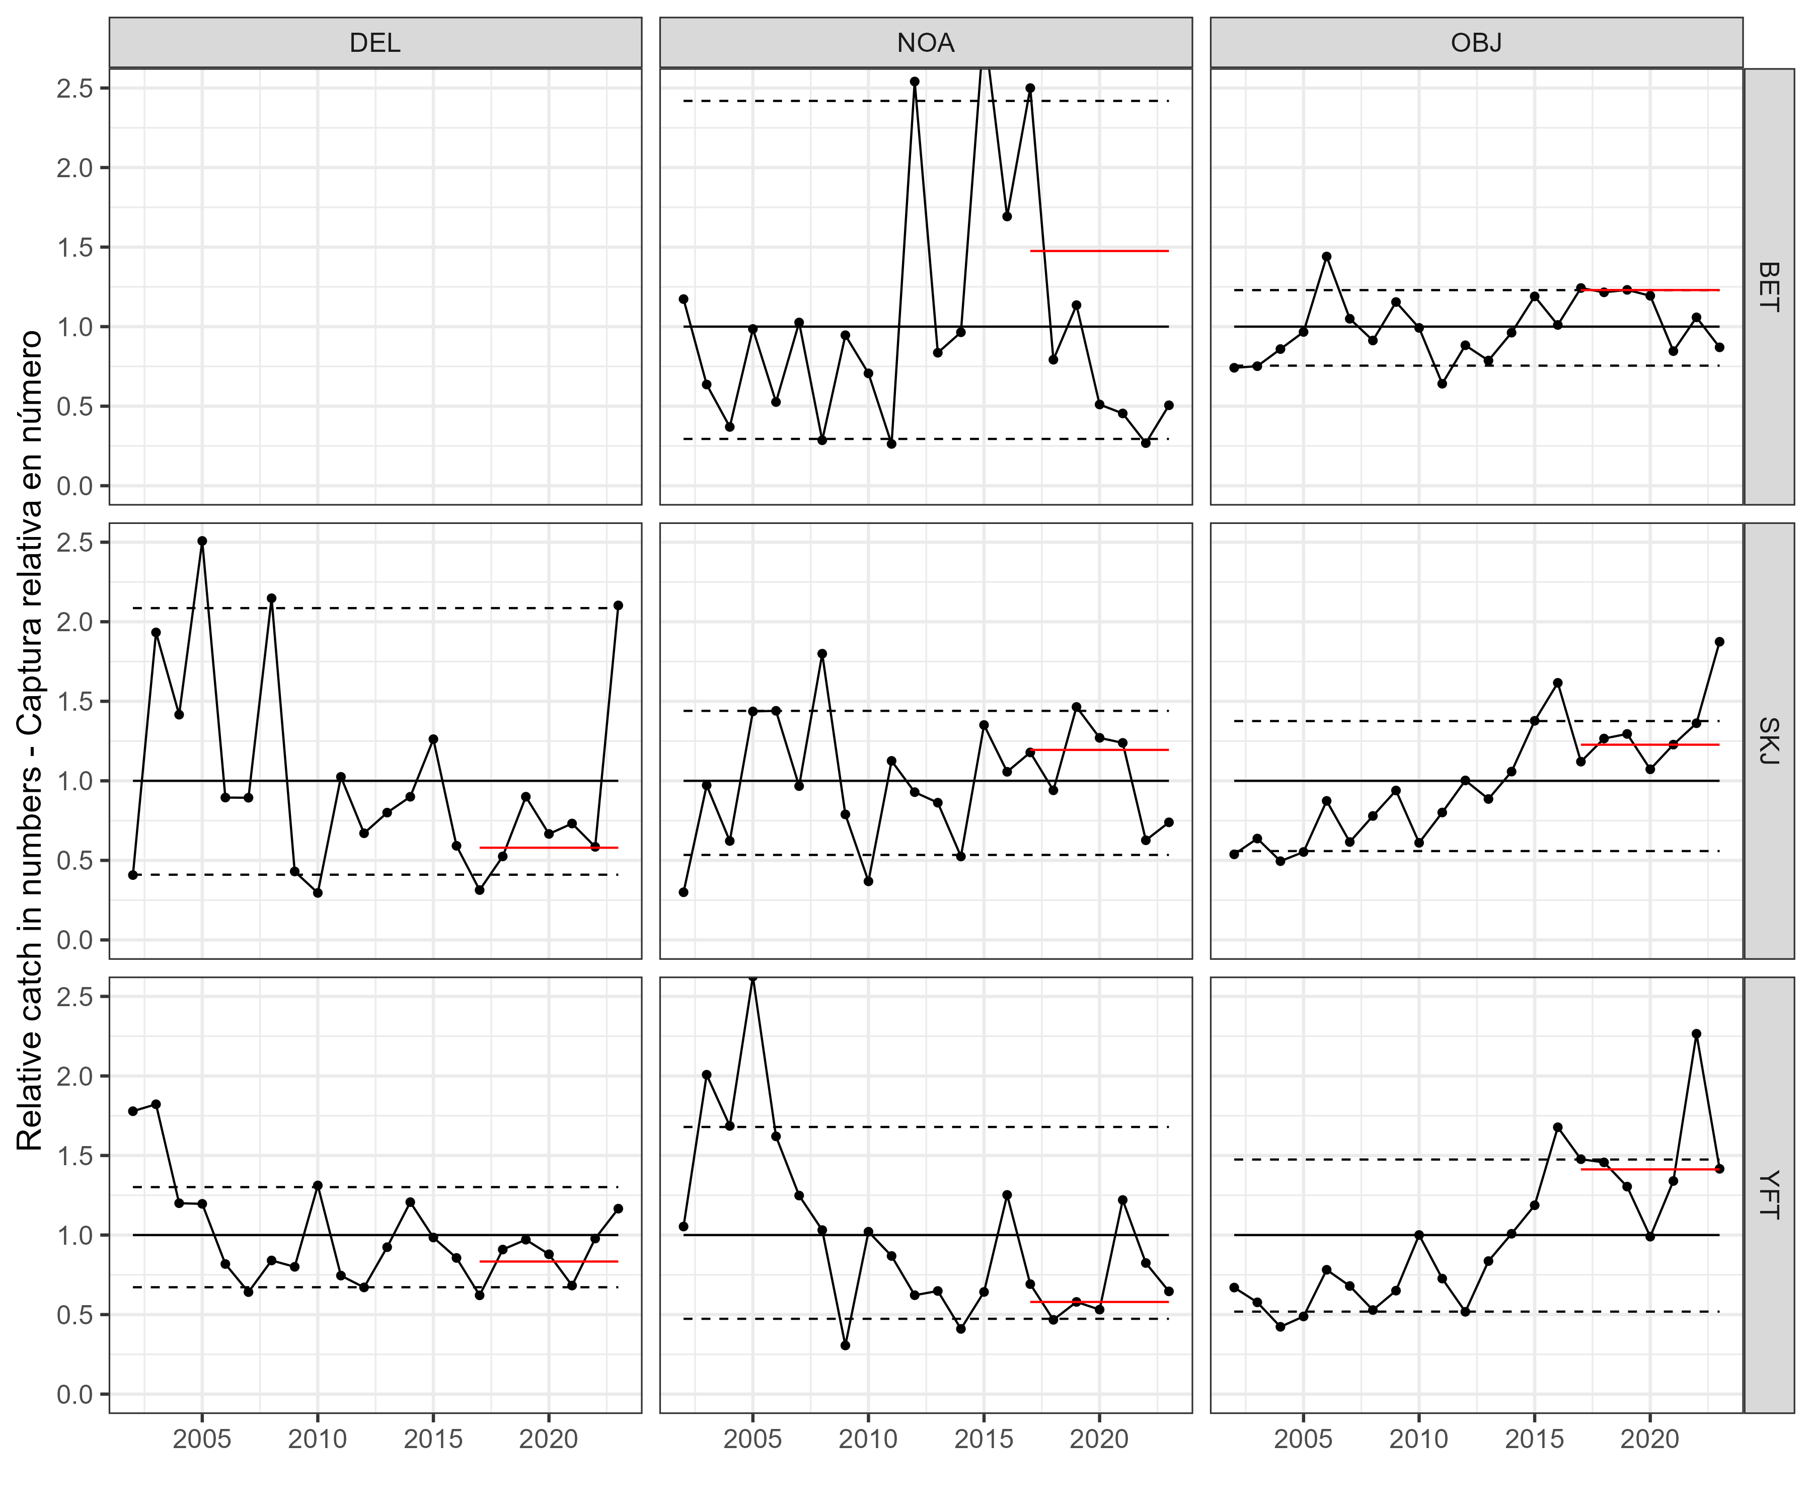   
Figure 2b

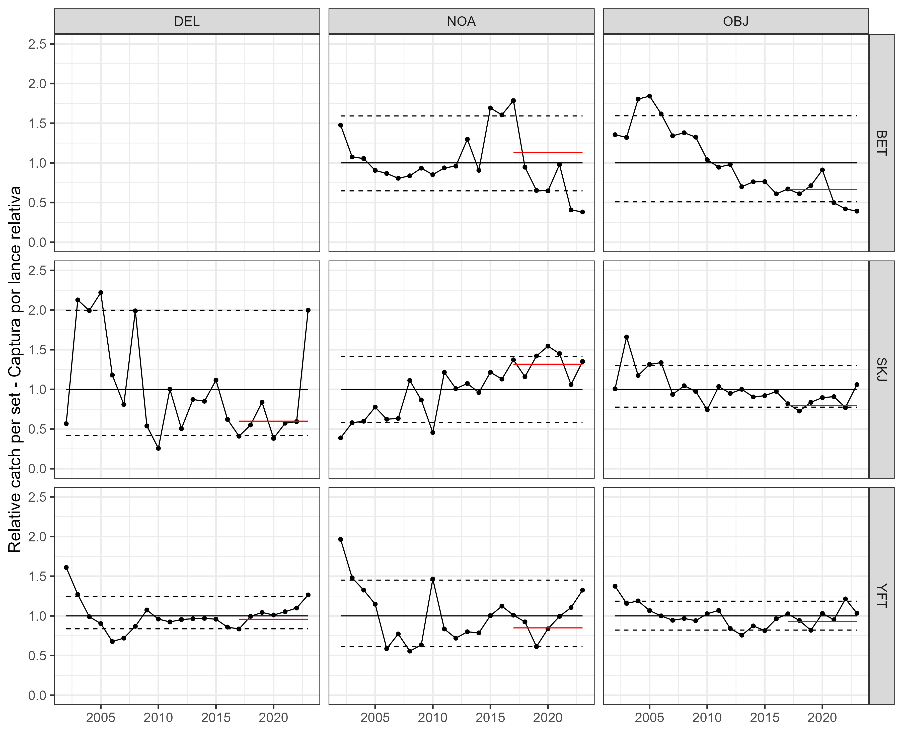   
Figure 3

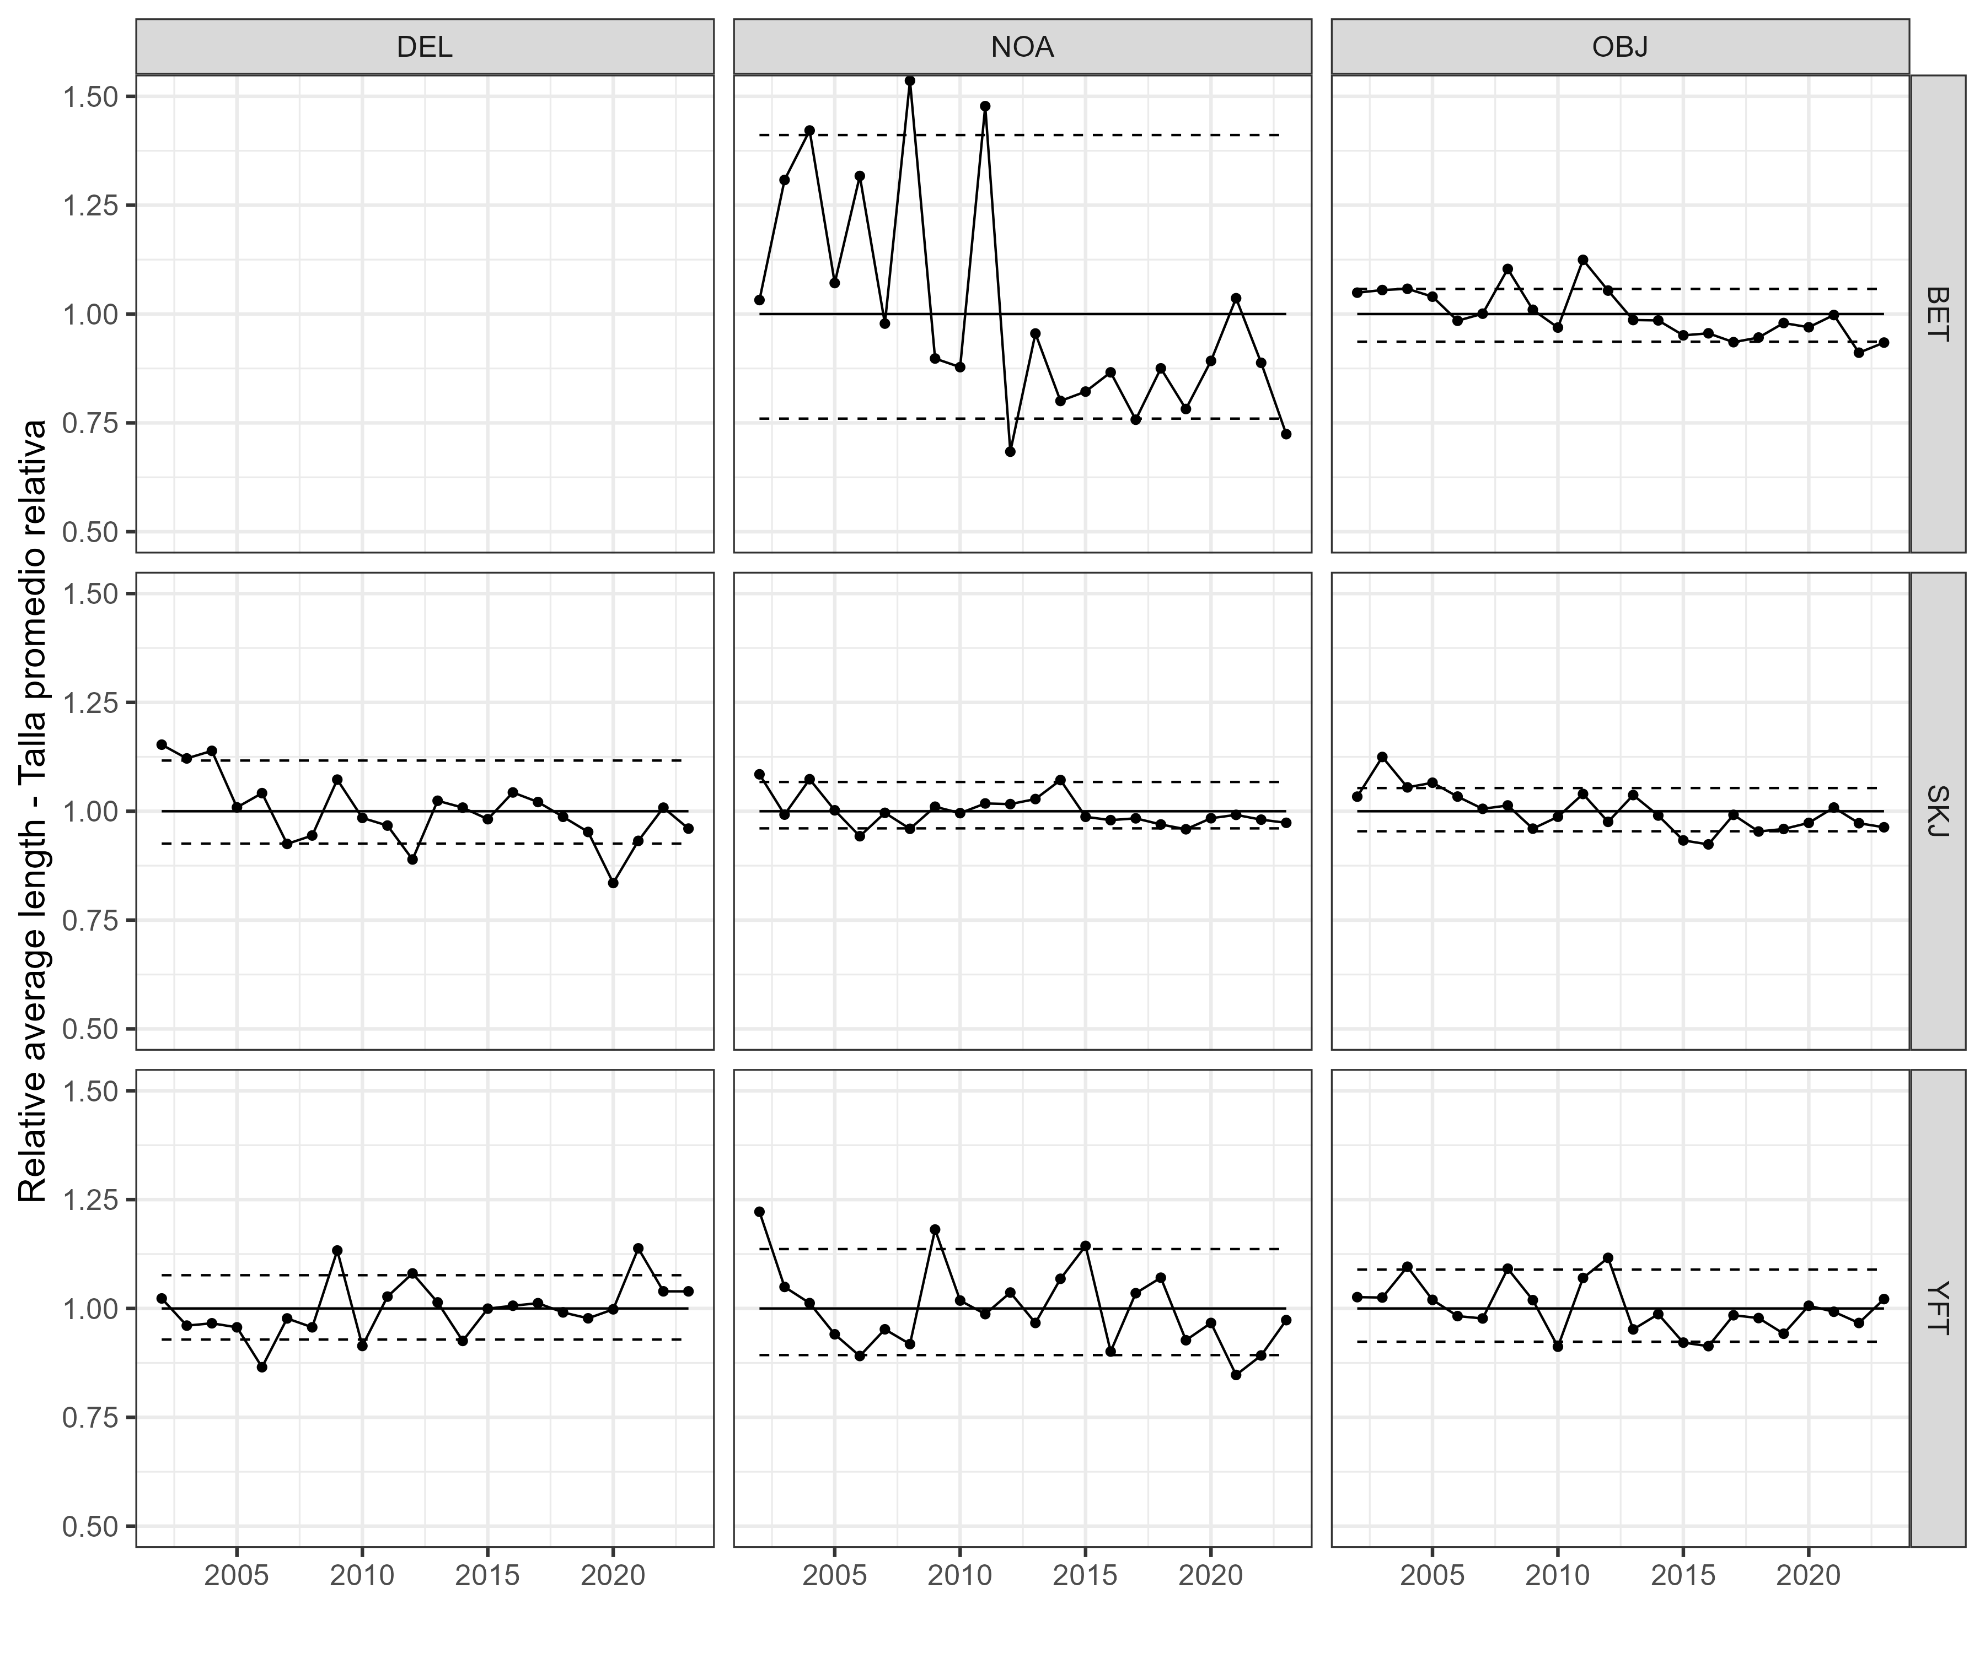   
Figure 4