Indicators for SAC15

Haikun Xu

2024-08-26

# Figures

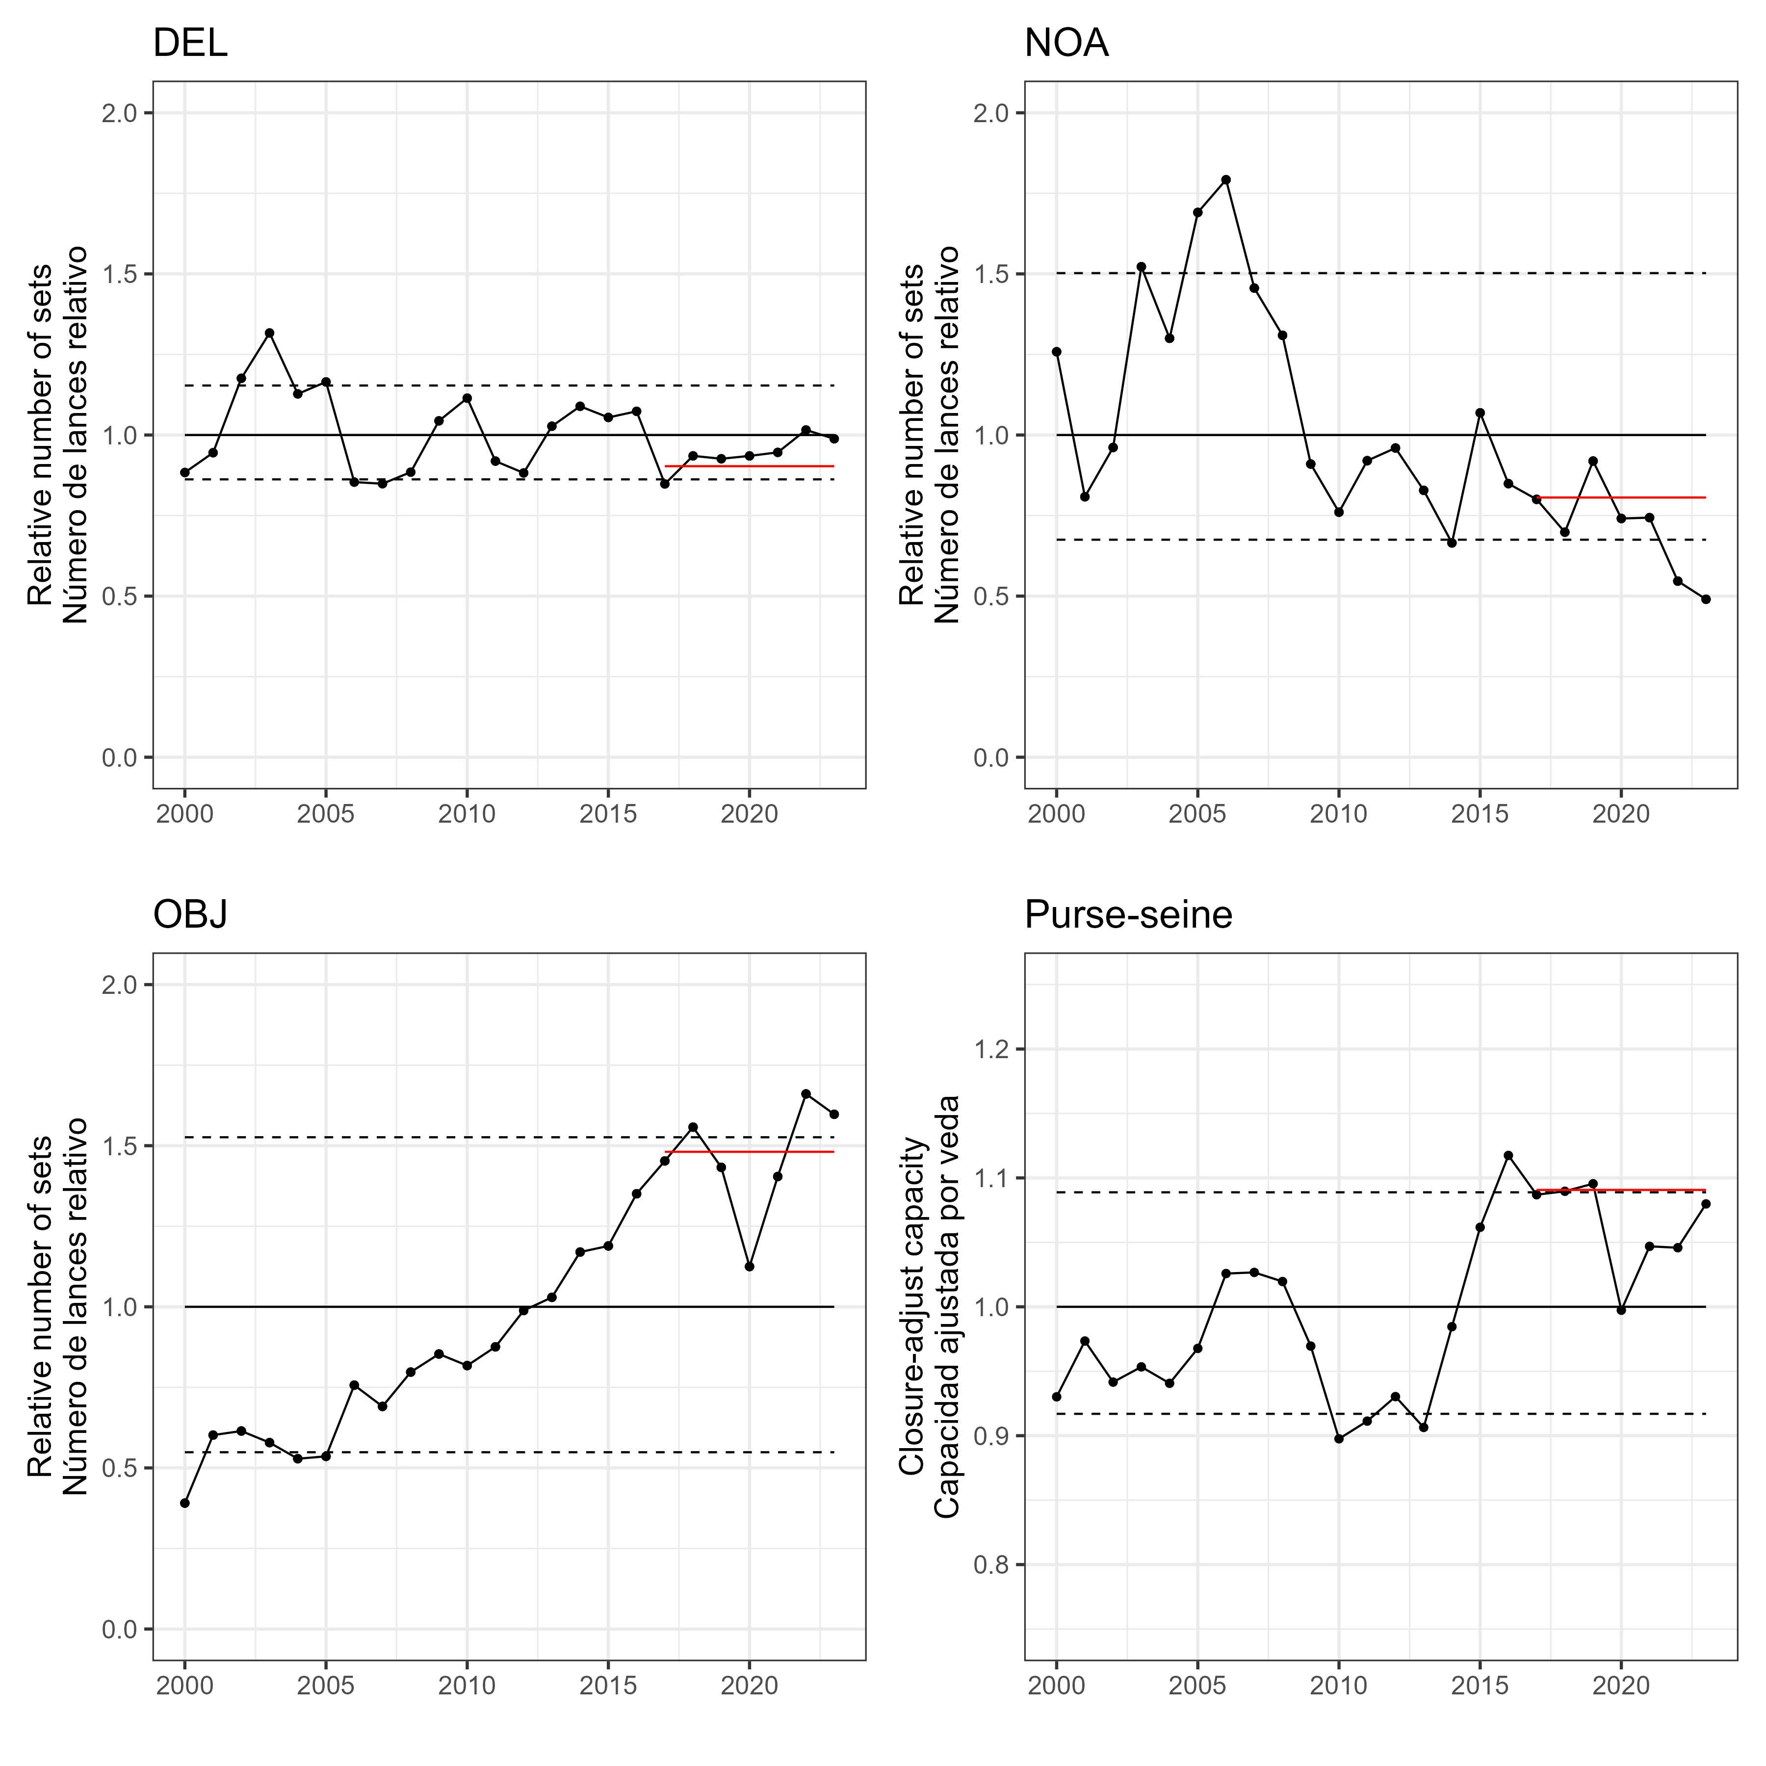   
Figure 1

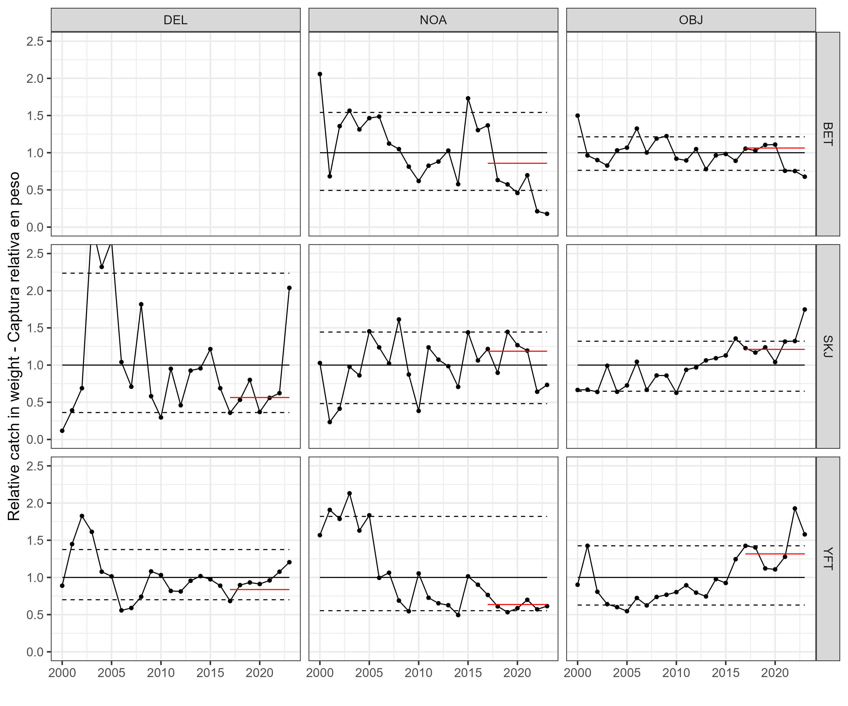   
Figure 2a

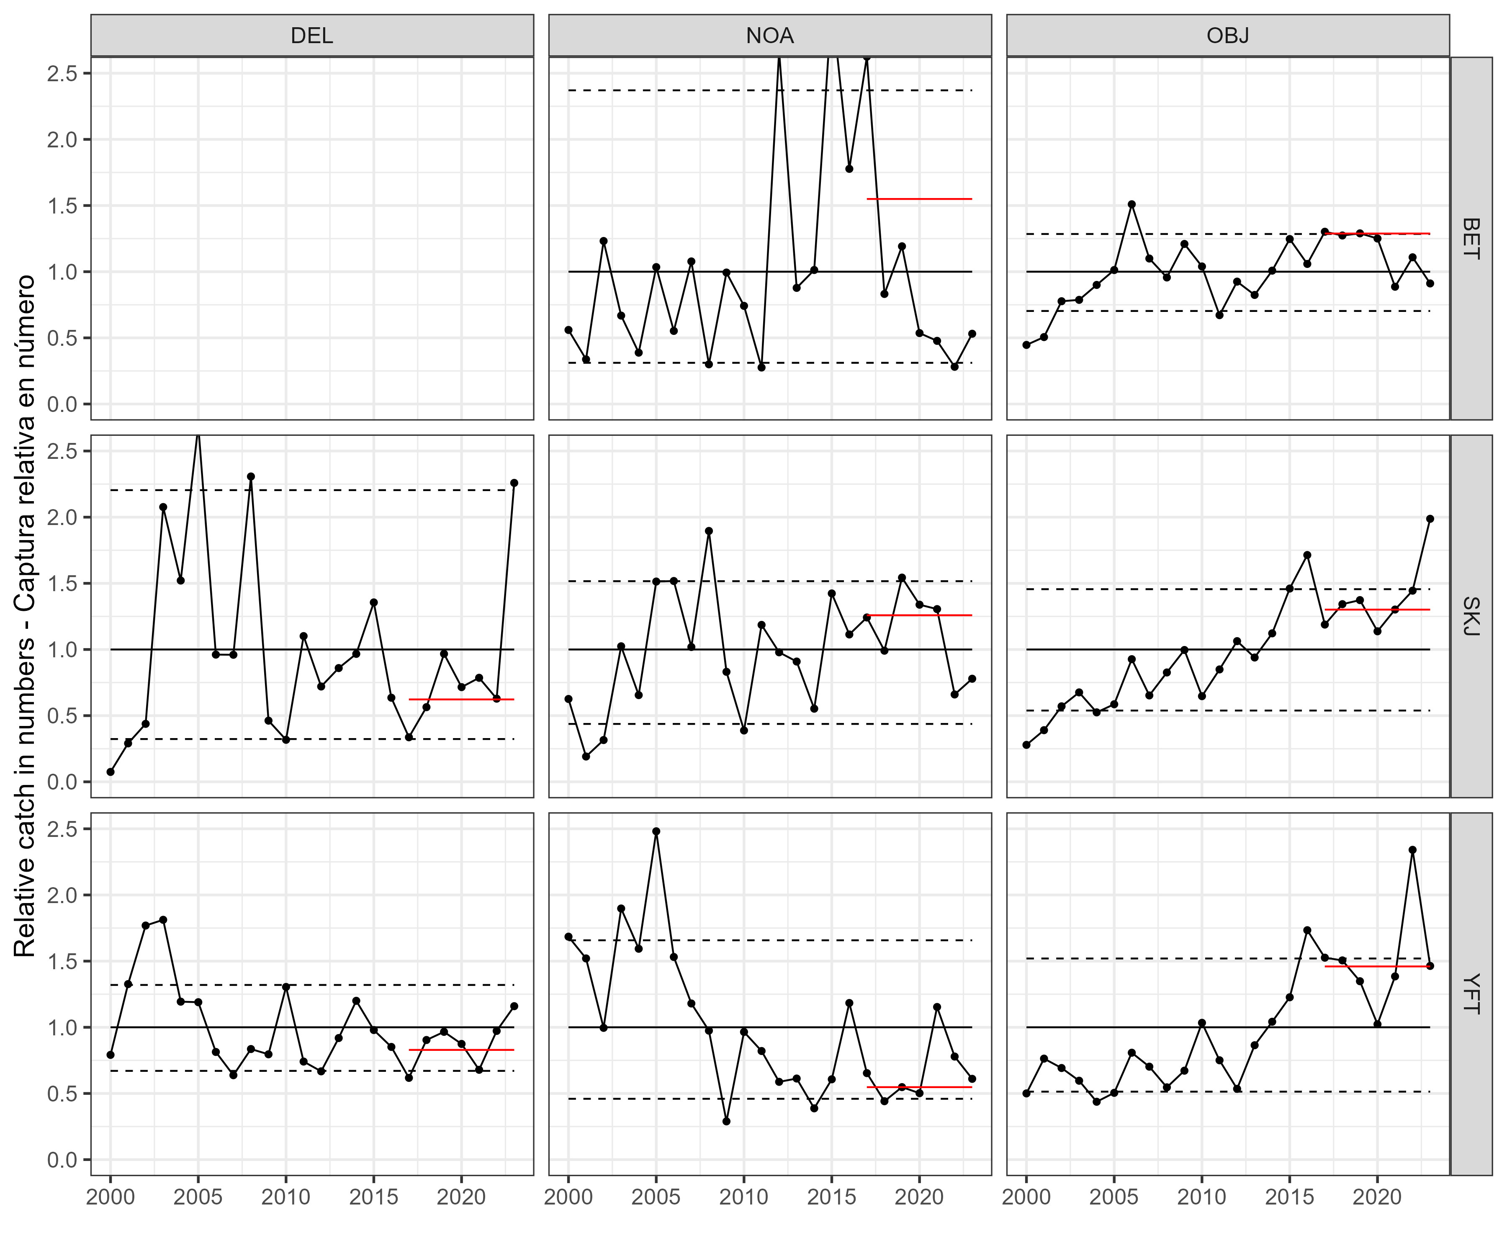   
Figure 2b

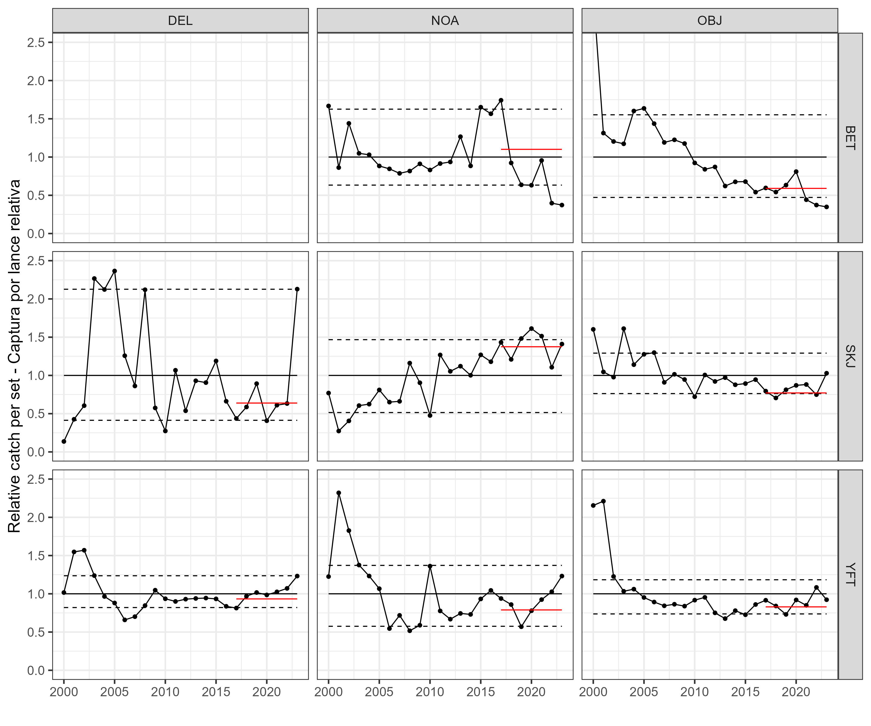   
Figure 3

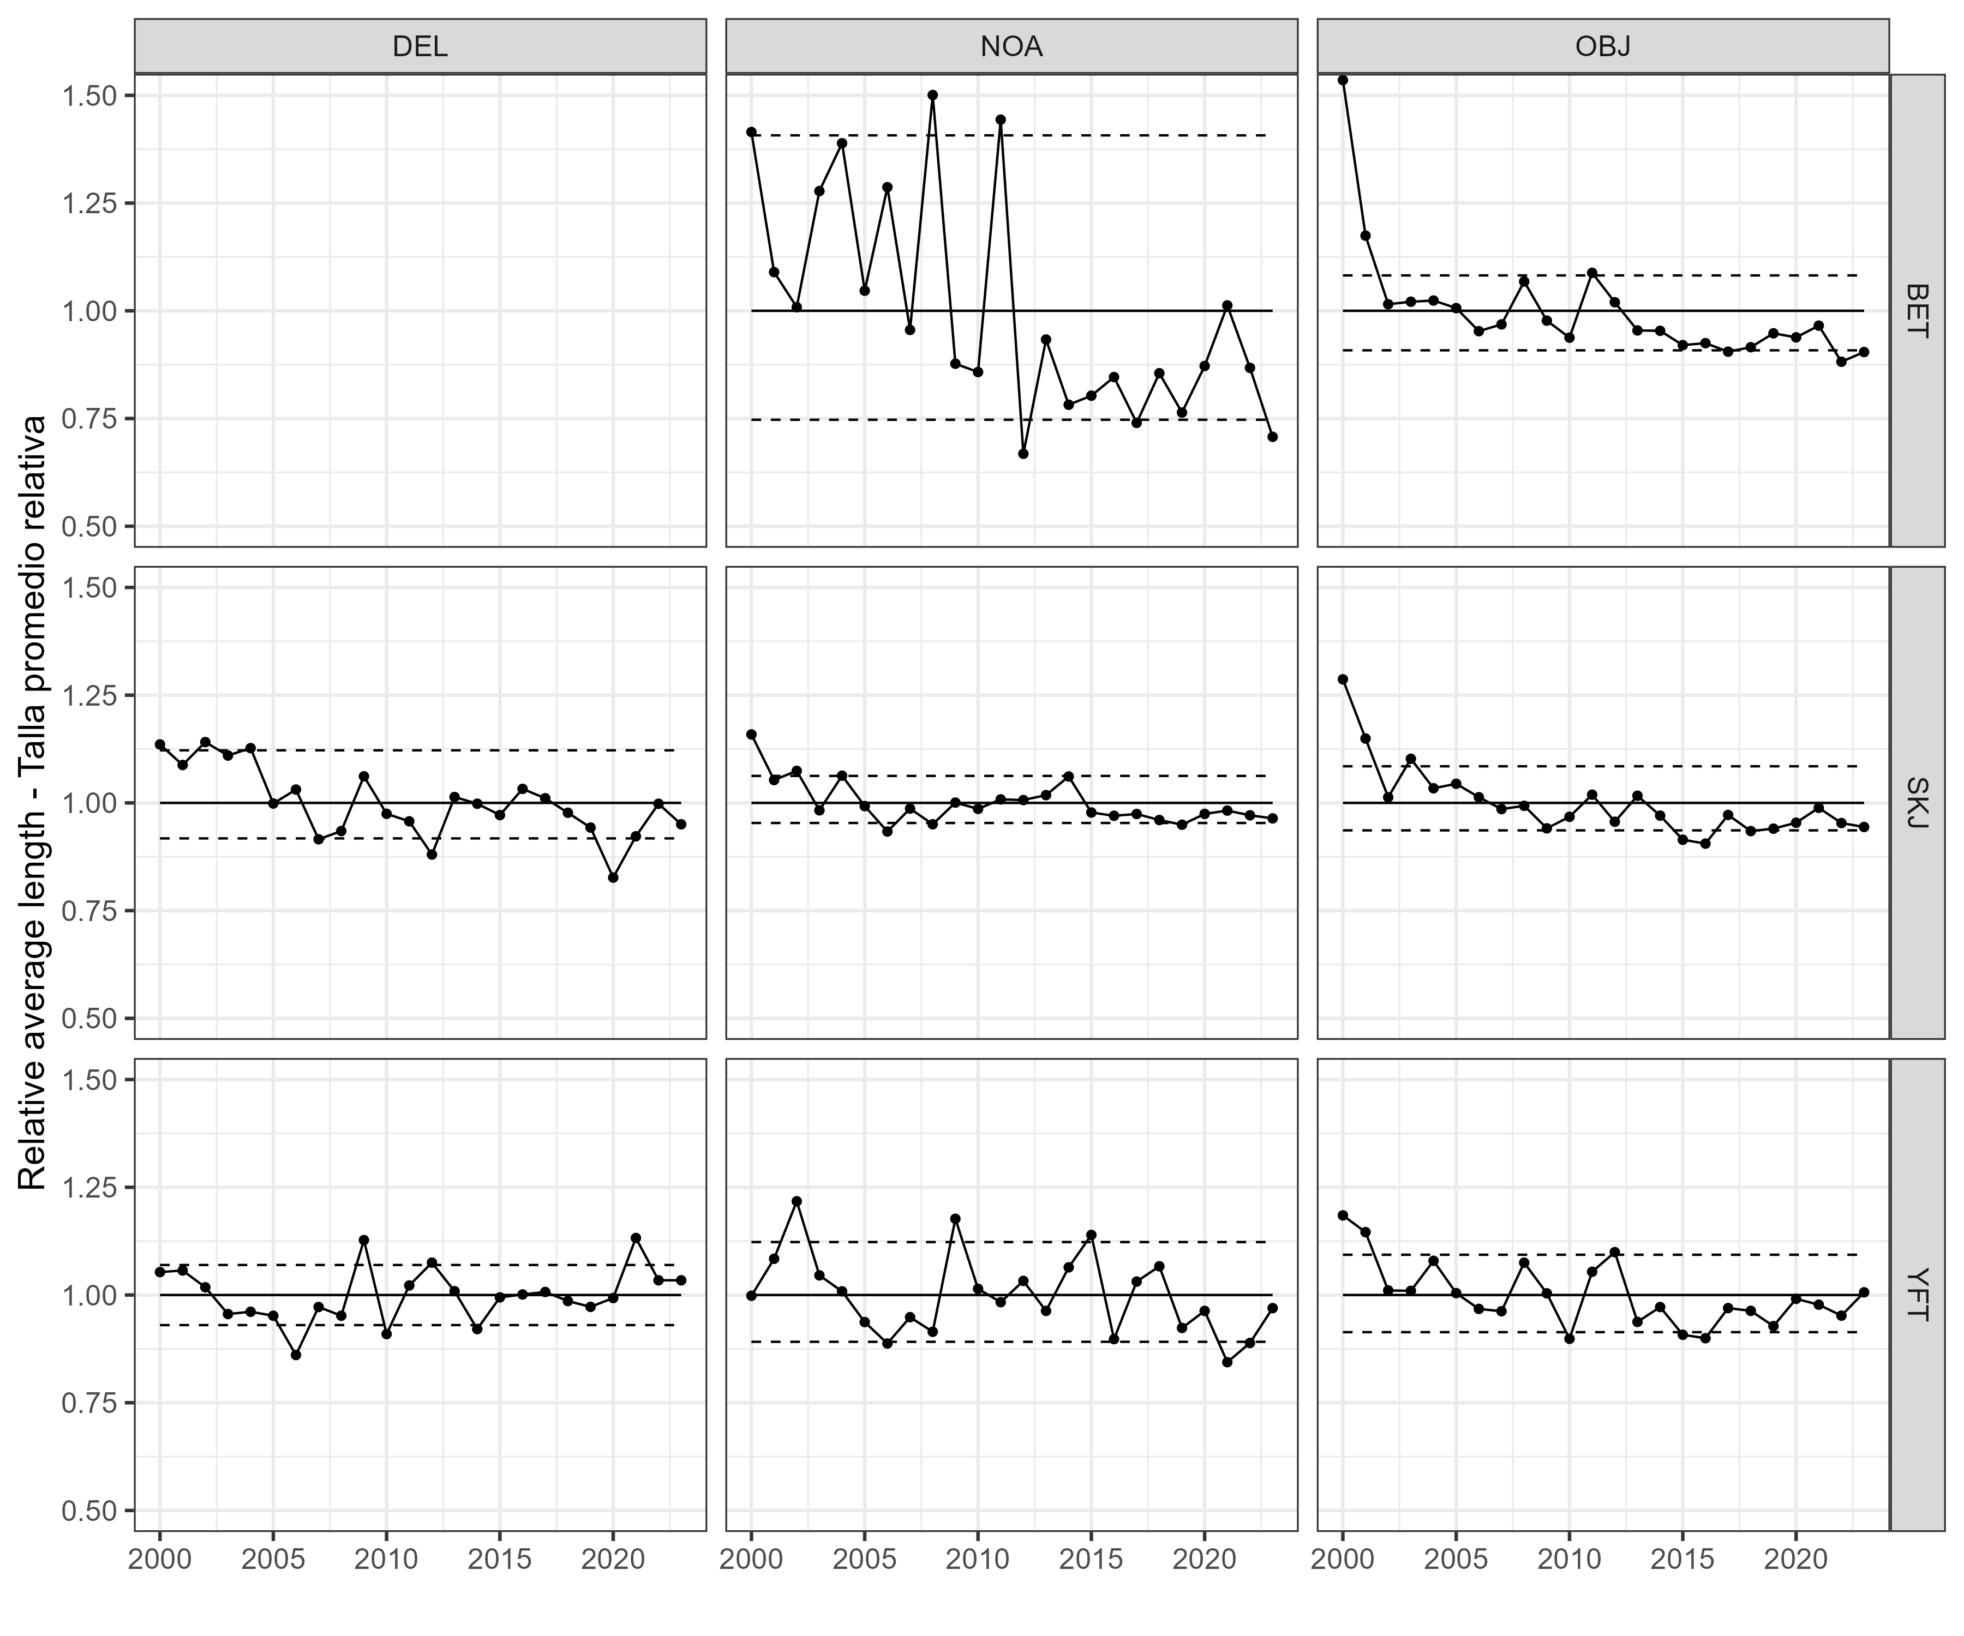   
Figure 4

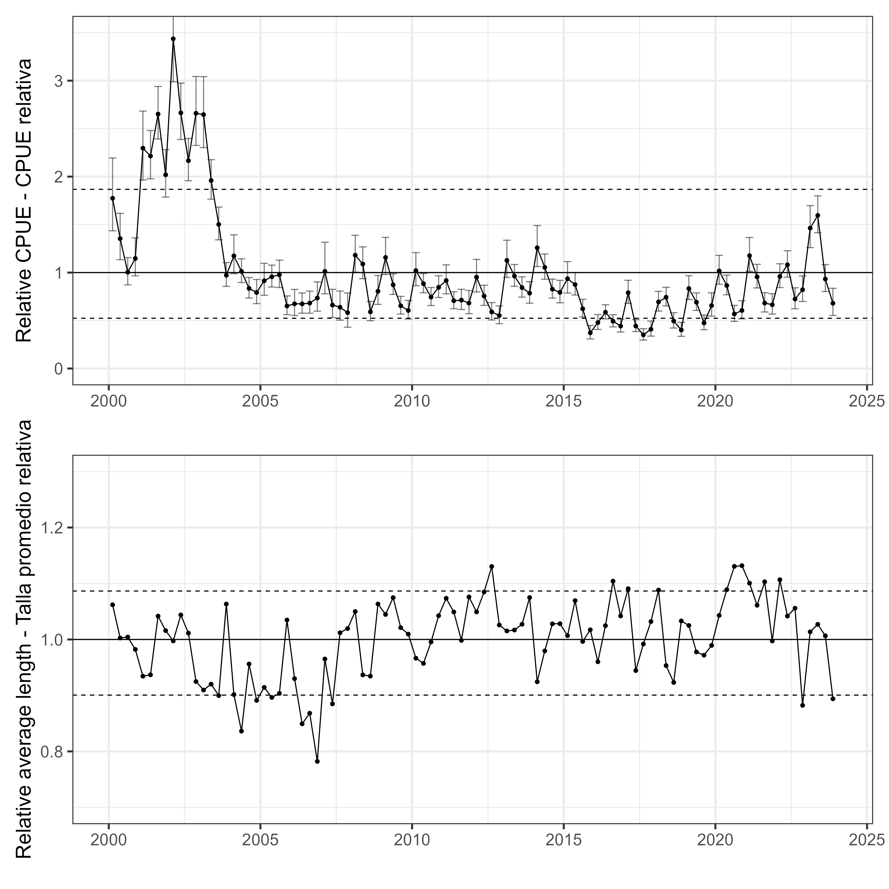   
Figure 5

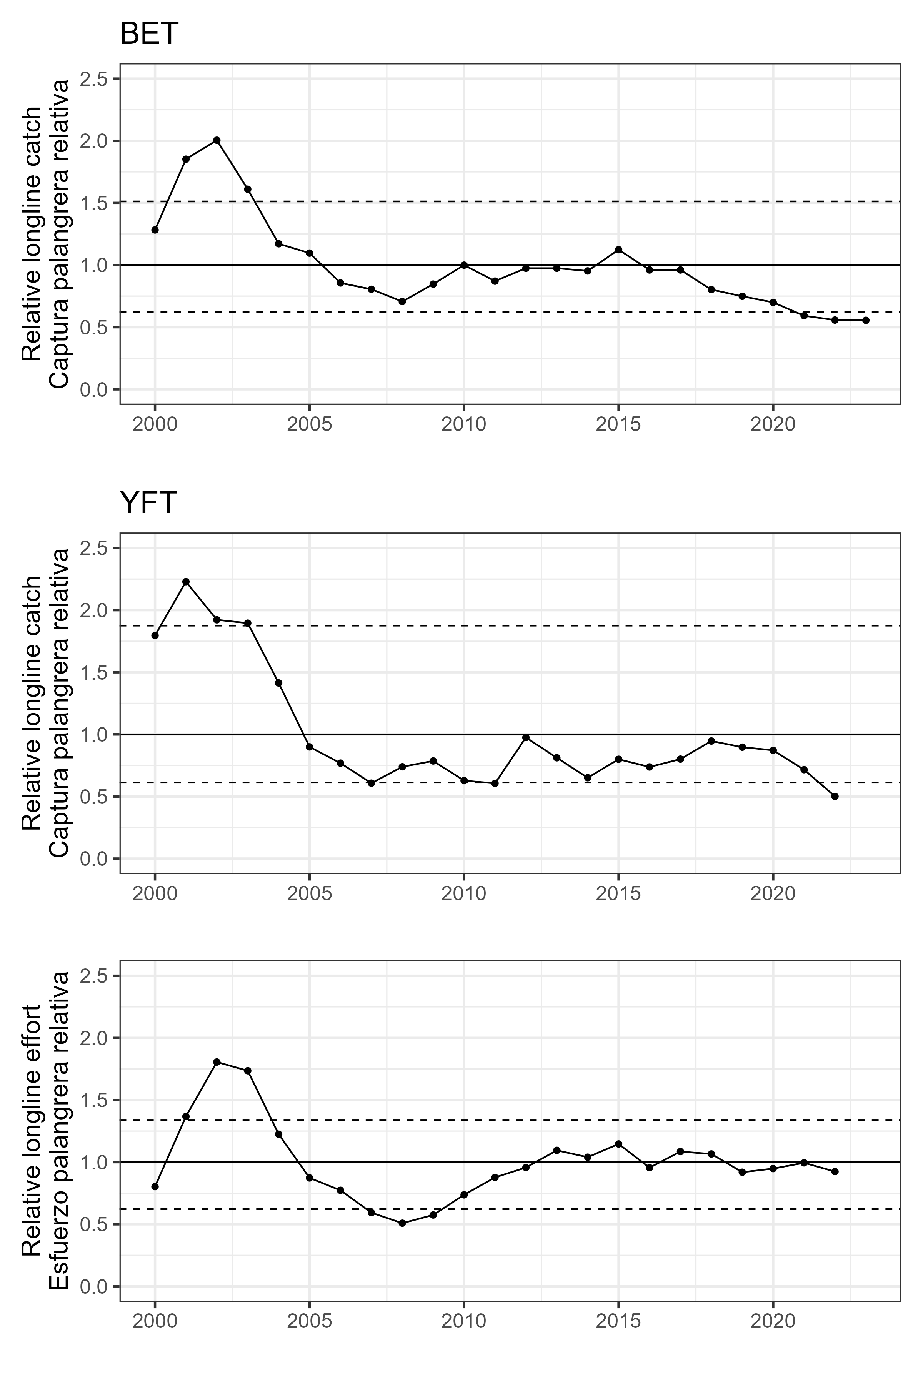   
Figure 6

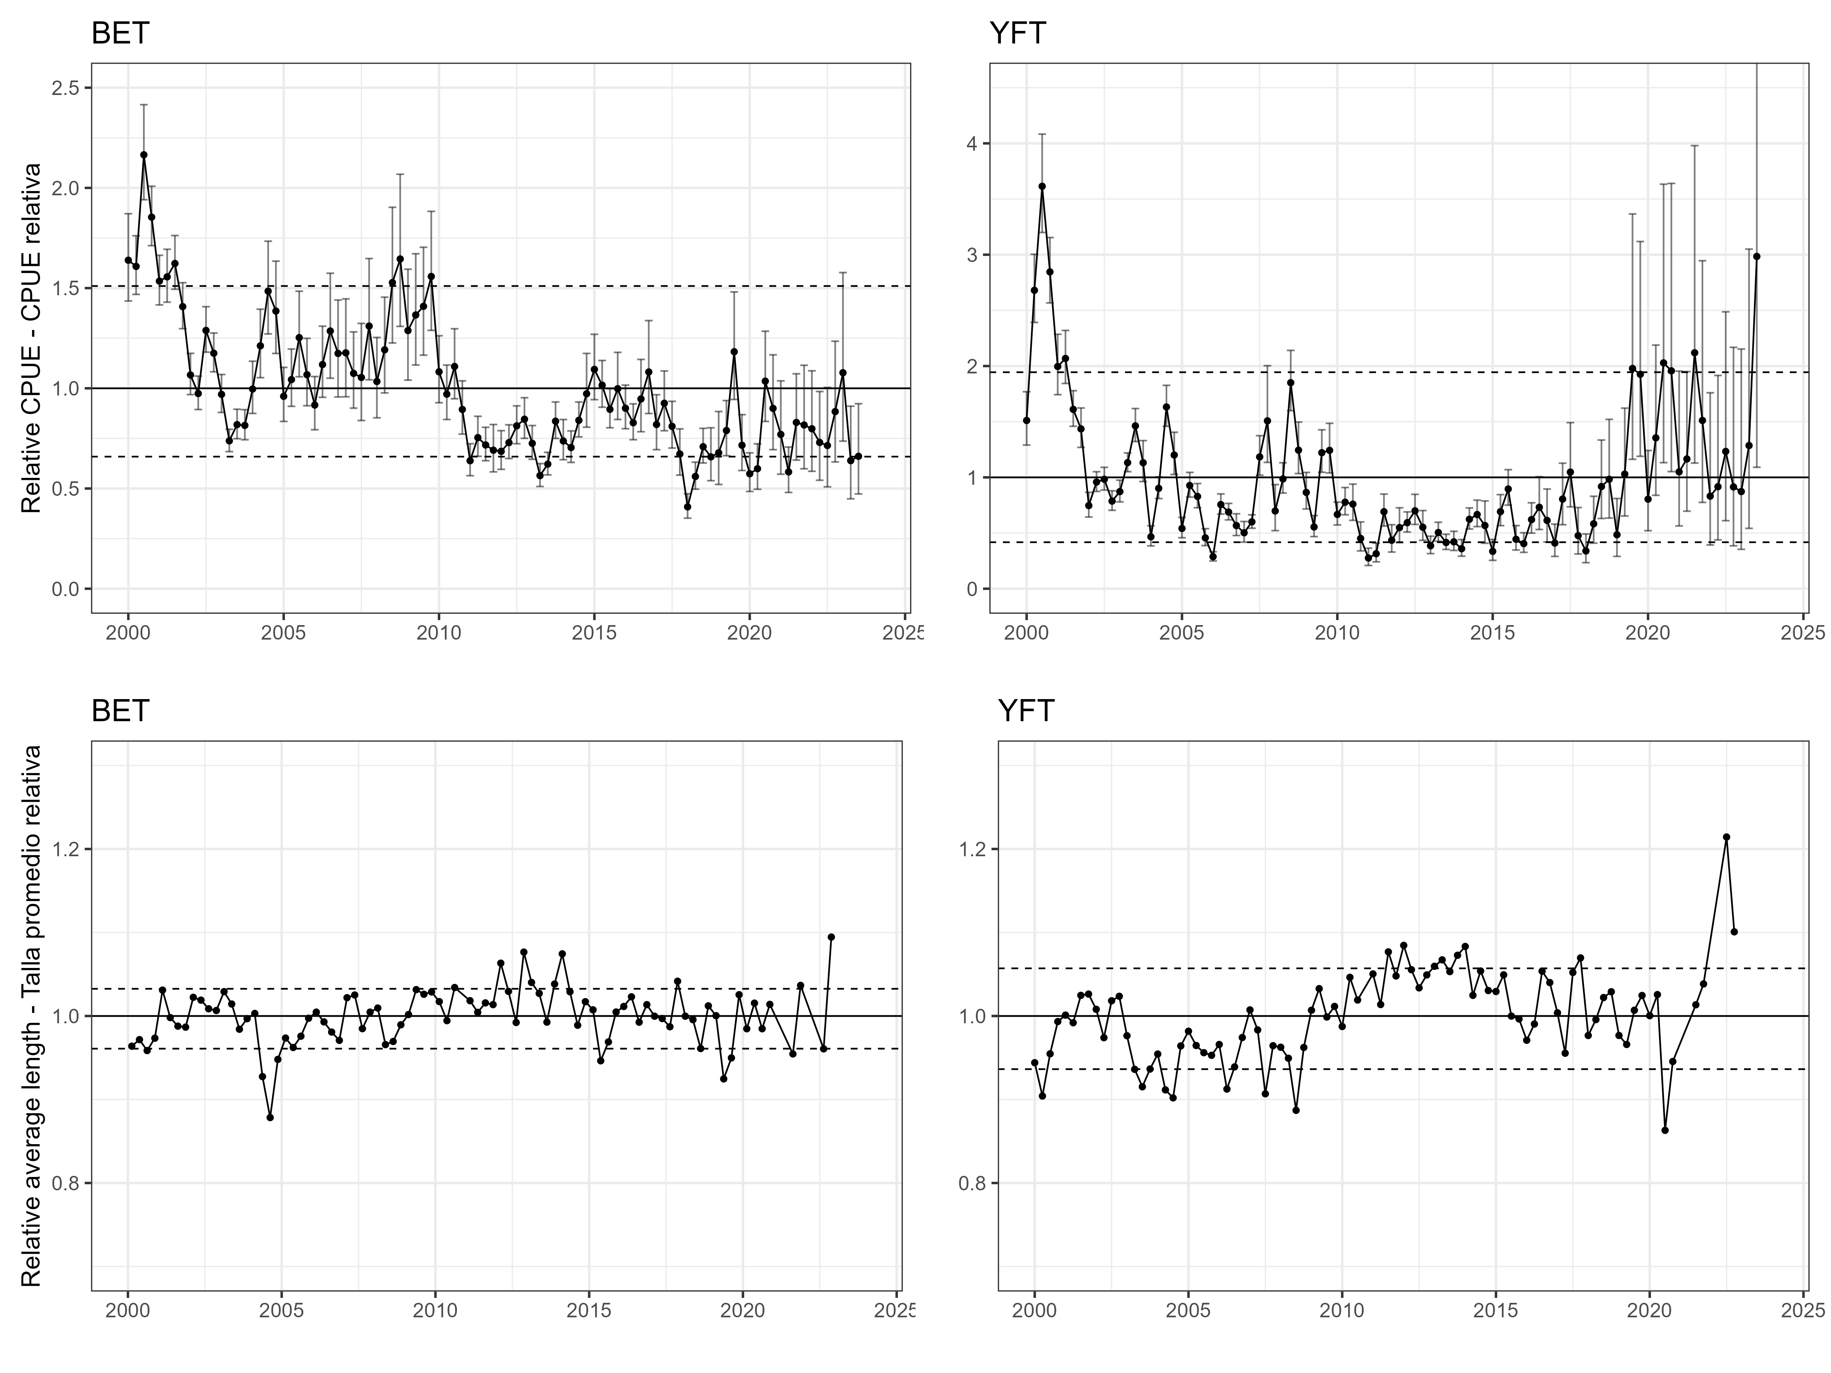   
Figure 7

# Tables

YFT DEL index

| Category | Time | Stratum | Units | Estimate | Std..Error.for.Estimate | Std..Error.for.ln.Estimate. | Year | CPUE | Low | High |
| --- | --- | --- | --- | --- | --- | --- | --- | --- | --- | --- |
| 1 | 101 | Stratum_1 | [kg*km2/km2] | 47358438 | 5079867.0 | 0.1081996 | 2000.125 | 1.7746329 | 1.4355131 | 2.1938650 |
| 1 | 102 | Stratum_1 | [kg*km2/km2] | 36135525 | 3238685.1 | 0.0905297 | 2000.375 | 1.3540838 | 1.1339270 | 1.6169850 |
| 1 | 103 | Stratum_1 | [kg*km2/km2] | 26790261 | 1912997.1 | 0.0720343 | 2000.625 | 1.0038946 | 0.8717085 | 1.1561254 |
| 1 | 104 | Stratum_1 | [kg*km2/km2] | 30611520 | 2642831.3 | 0.0876792 | 2000.875 | 1.1470862 | 0.9659665 | 1.3621661 |
| 1 | 105 | Stratum_1 | [kg*km2/km2] | 61275388 | 4847383.8 | 0.0795104 | 2001.125 | 2.2961341 | 1.9647922 | 2.6833534 |
| 1 | 106 | Stratum_1 | [kg*km2/km2] | 59099607 | 3394590.8 | 0.0578193 | 2001.375 | 2.2146024 | 1.9773292 | 2.4803476 |
| 1 | 107 | Stratum_1 | [kg*km2/km2] | 70762637 | 3697299.5 | 0.0525467 | 2001.625 | 2.6516438 | 2.3921397 | 2.9392993 |
| 1 | 108 | Stratum_1 | [kg*km2/km2] | 53885888 | 3336373.8 | 0.0624690 | 2001.875 | 2.0192320 | 1.7865350 | 2.2822378 |
| 1 | 109 | Stratum_1 | [kg*km2/km2] | 91704871 | 6515068.3 | 0.0713720 | 2002.125 | 3.4363989 | 2.9877928 | 3.9523615 |
| 1 | 110 | Stratum_1 | [kg*km2/km2] | 71111316 | 3972245.2 | 0.0561330 | 2002.375 | 2.6647096 | 2.3870887 | 2.9746181 |
| 1 | 111 | Stratum_1 | [kg*km2/km2] | 57812998 | 2978036.5 | 0.0518197 | 2002.625 | 2.1663901 | 1.9571622 | 2.3979852 |
| 1 | 112 | Stratum_1 | [kg*km2/km2] | 70985967 | 4852802.9 | 0.0686608 | 2002.875 | 2.6600125 | 2.3250830 | 3.0431887 |
| 1 | 113 | Stratum_1 | [kg*km2/km2] | 70625542 | 4988322.3 | 0.0709994 | 2003.125 | 2.6465065 | 2.3026984 | 3.0416474 |
| 1 | 114 | Stratum_1 | [kg*km2/km2] | 52303187 | 2782666.0 | 0.0535411 | 2003.375 | 1.9599244 | 1.7646728 | 2.1767795 |
| 1 | 115 | Stratum_1 | [kg*km2/km2] | 40091429 | 2300086.5 | 0.0578061 | 2003.625 | 1.5023209 | 1.3413965 | 1.6825510 |
| 1 | 116 | Stratum_1 | [kg*km2/km2] | 25941838 | 1671989.9 | 0.0649125 | 2003.875 | 0.9721022 | 0.8559674 | 1.1039936 |
| 1 | 117 | Stratum_1 | [kg*km2/km2] | 31318781 | 2722448.6 | 0.0875450 | 2004.125 | 1.1735890 | 0.9885444 | 1.3932718 |
| 1 | 118 | Stratum_1 | [kg*km2/km2] | 27023534 | 1673560.4 | 0.0623270 | 2004.375 | 1.0126359 | 0.8961887 | 1.1442137 |
| 1 | 119 | Stratum_1 | [kg*km2/km2] | 22285665 | 1441518.2 | 0.0652080 | 2004.625 | 0.8350967 | 0.7349040 | 0.9489491 |
| 1 | 120 | Stratum_1 | [kg*km2/km2] | 21141099 | 1688766.3 | 0.0807963 | 2004.875 | 0.7922071 | 0.6761819 | 0.9281408 |
| 1 | 121 | Stratum_1 | [kg*km2/km2] | 24422688 | 2230417.4 | 0.0923882 | 2005.125 | 0.9151760 | 0.7635934 | 1.0968496 |
| 1 | 122 | Stratum_1 | [kg*km2/km2] | 25536887 | 1541821.3 | 0.0607374 | 2005.375 | 0.9569277 | 0.8495294 | 1.0779034 |
| 1 | 123 | Stratum_1 | [kg*km2/km2] | 26063357 | 1915291.1 | 0.0741663 | 2005.625 | 0.9766558 | 0.8445199 | 1.1294659 |
| 1 | 124 | Stratum_1 | [kg*km2/km2] | 17399517 | 1301116.0 | 0.0757904 | 2005.875 | 0.6520012 | 0.5619973 | 0.7564191 |
| 1 | 125 | Stratum_1 | [kg*km2/km2] | 17999377 | 1811045.1 | 0.1023201 | 2006.125 | 0.6744793 | 0.5519148 | 0.8242619 |
| 1 | 126 | Stratum_1 | [kg*km2/km2] | 17981841 | 1411686.8 | 0.0794099 | 2006.375 | 0.6738222 | 0.5767004 | 0.7873002 |
| 1 | 127 | Stratum_1 | [kg*km2/km2] | 18197217 | 1540775.6 | 0.0857585 | 2006.625 | 0.6818929 | 0.5763908 | 0.8067059 |
| 1 | 128 | Stratum_1 | [kg*km2/km2] | 19604354 | 2029619.0 | 0.1052092 | 2006.875 | 0.7346216 | 0.5977338 | 0.9028583 |
| 1 | 129 | Stratum_1 | [kg*km2/km2] | 27021698 | 3588025.7 | 0.1338046 | 2007.125 | 1.0125671 | 0.7789813 | 1.3161960 |
| 1 | 130 | Stratum_1 | [kg*km2/km2] | 17662306 | 1958657.2 | 0.1128285 | 2007.375 | 0.6618485 | 0.5305387 | 0.8256578 |
| 1 | 131 | Stratum_1 | [kg*km2/km2] | 17039703 | 2001375.0 | 0.1199800 | 2007.625 | 0.6385181 | 0.5047126 | 0.8077970 |
| 1 | 132 | Stratum_1 | [kg*km2/km2] | 15541746 | 2334853.7 | 0.1540104 | 2007.875 | 0.5823861 | 0.4306403 | 0.7876028 |
| 1 | 133 | Stratum_1 | [kg*km2/km2] | 31513778 | 2600283.4 | 0.0826209 | 2008.125 | 1.1808960 | 1.0043459 | 1.3884811 |
| 1 | 134 | Stratum_1 | [kg*km2/km2] | 29068797 | 2235900.9 | 0.0773640 | 2008.375 | 1.0892767 | 0.9360190 | 1.2676278 |
| 1 | 135 | Stratum_1 | [kg*km2/km2] | 15766412 | 1346721.2 | 0.0866571 | 2008.625 | 0.5908048 | 0.4985171 | 0.7001773 |
| 1 | 136 | Stratum_1 | [kg*km2/km2] | 21479389 | 2020287.2 | 0.0949035 | 2008.875 | 0.8048836 | 0.6682663 | 0.9694303 |
| 1 | 137 | Stratum_1 | [kg*km2/km2] | 30890000 | 2588419.7 | 0.0848556 | 2009.125 | 1.1575215 | 0.9801636 | 1.3669719 |
| 1 | 138 | Stratum_1 | [kg*km2/km2] | 23303712 | 1446921.1 | 0.0625569 | 2009.375 | 0.8732453 | 0.7724792 | 0.9871560 |
| 1 | 139 | Stratum_1 | [kg*km2/km2] | 17443708 | 1239196.1 | 0.0717412 | 2009.625 | 0.6536571 | 0.5679141 | 0.7523455 |
| 1 | 140 | Stratum_1 | [kg*km2/km2] | 16144384 | 1294396.9 | 0.0812480 | 2009.875 | 0.6049683 | 0.5159089 | 0.7094018 |
| 1 | 141 | Stratum_1 | [kg*km2/km2] | 27236780 | 2317759.0 | 0.0859646 | 2010.125 | 1.0206267 | 0.8623676 | 1.2079291 |
| 1 | 142 | Stratum_1 | [kg*km2/km2] | 23599935 | 1351966.3 | 0.0576088 | 2010.375 | 0.8843455 | 0.7899223 | 0.9900555 |
| 1 | 143 | Stratum_1 | [kg*km2/km2] | 19864521 | 1265015.1 | 0.0641937 | 2010.625 | 0.7443707 | 0.6563667 | 0.8441741 |
| 1 | 144 | Stratum_1 | [kg*km2/km2] | 22579370 | 1524714.9 | 0.0681624 | 2010.875 | 0.8461025 | 0.7402902 | 0.9670390 |
| 1 | 145 | Stratum_1 | [kg*km2/km2] | 24474777 | 2018107.9 | 0.0836303 | 2011.125 | 0.9171279 | 0.7784708 | 1.0804819 |
| 1 | 146 | Stratum_1 | [kg*km2/km2] | 18851843 | 1185658.2 | 0.0634028 | 2011.375 | 0.7064232 | 0.6238719 | 0.7998978 |
| 1 | 147 | Stratum_1 | [kg*km2/km2] | 19027147 | 1413686.8 | 0.0750629 | 2011.625 | 0.7129923 | 0.6154461 | 0.8259994 |
| 1 | 148 | Stratum_1 | [kg*km2/km2] | 18195082 | 1612709.1 | 0.0899903 | 2011.875 | 0.6818129 | 0.5715627 | 0.8133294 |
| 1 | 149 | Stratum_1 | [kg*km2/km2] | 25426541 | 2262296.0 | 0.0903595 | 2012.125 | 0.9527928 | 0.7981470 | 1.1374021 |
| 1 | 150 | Stratum_1 | [kg*km2/km2] | 20170714 | 1413051.1 | 0.0707300 | 2012.375 | 0.7558445 | 0.6580000 | 0.8682385 |
| 1 | 151 | Stratum_1 | [kg*km2/km2] | 15740152 | 1211526.3 | 0.0777540 | 2012.625 | 0.5898208 | 0.5064476 | 0.6869192 |
| 1 | 152 | Stratum_1 | [kg*km2/km2] | 14742466 | 1242445.4 | 0.0853161 | 2012.875 | 0.5524351 | 0.4673678 | 0.6529859 |
| 1 | 153 | Stratum_1 | [kg*km2/km2] | 30073697 | 2595060.5 | 0.0872508 | 2013.125 | 1.1269327 | 0.9497922 | 1.3371108 |
| 1 | 154 | Stratum_1 | [kg*km2/km2] | 25719602 | 1538346.6 | 0.0602324 | 2013.375 | 0.9637744 | 0.8564550 | 1.0845417 |
| 1 | 155 | Stratum_1 | [kg*km2/km2] | 22510552 | 1427386.2 | 0.0639889 | 2013.625 | 0.8435238 | 0.7440959 | 0.9562374 |
| 1 | 156 | Stratum_1 | [kg*km2/km2] | 20959702 | 1506560.6 | 0.0727089 | 2013.875 | 0.7854097 | 0.6810911 | 0.9057061 |
| 1 | 157 | Stratum_1 | [kg*km2/km2] | 33587525 | 2865048.5 | 0.0861090 | 2014.125 | 1.2586042 | 1.0631431 | 1.4900011 |
| 1 | 158 | Stratum_1 | [kg*km2/km2] | 28122158 | 1769998.4 | 0.0634558 | 2014.375 | 1.0538039 | 0.9305616 | 1.1933683 |
| 1 | 159 | Stratum_1 | [kg*km2/km2] | 22079183 | 1328747.5 | 0.0606699 | 2014.625 | 0.8273593 | 0.7346000 | 0.9318315 |
| 1 | 160 | Stratum_1 | [kg*km2/km2] | 21169313 | 1570508.3 | 0.0750401 | 2014.875 | 0.7932643 | 0.6847666 | 0.9189531 |
| 1 | 161 | Stratum_1 | [kg*km2/km2] | 24991283 | 2185975.0 | 0.0886218 | 2015.125 | 0.9364826 | 0.7871605 | 1.1141307 |
| 1 | 162 | Stratum_1 | [kg*km2/km2] | 23353116 | 1568715.2 | 0.0677546 | 2015.375 | 0.8750966 | 0.7662705 | 0.9993783 |
| 1 | 163 | Stratum_1 | [kg*km2/km2] | 16612510 | 1234377.5 | 0.0750766 | 2015.625 | 0.6225101 | 0.5373285 | 0.7211954 |
| 1 | 164 | Stratum_1 | [kg*km2/km2] | 9935202 | 936834.6 | 0.0957416 | 2015.875 | 0.3722956 | 0.3085965 | 0.4491431 |
| 1 | 165 | Stratum_1 | [kg*km2/km2] | 12774830 | 1040335.0 | 0.0825362 | 2016.125 | 0.4787031 | 0.4072021 | 0.5627591 |
| 1 | 166 | Stratum_1 | [kg*km2/km2] | 15648255 | 993176.7 | 0.0639887 | 2016.375 | 0.5863772 | 0.5172599 | 0.6647302 |
| 1 | 167 | Stratum_1 | [kg*km2/km2] | 13160737 | 852929.2 | 0.0653737 | 2016.625 | 0.4931640 | 0.4338545 | 0.5605813 |
| 1 | 168 | Stratum_1 | [kg*km2/km2] | 11806257 | 898871.3 | 0.0770244 | 2016.875 | 0.4424084 | 0.3804161 | 0.5145030 |
| 1 | 169 | Stratum_1 | [kg*km2/km2] | 21088842 | 1617846.2 | 0.0774316 | 2017.125 | 0.7902489 | 0.6789734 | 0.9197611 |
| 1 | 170 | Stratum_1 | [kg*km2/km2] | 11835414 | 835185.3 | 0.0712918 | 2017.375 | 0.4435010 | 0.3856646 | 0.5100109 |
| 1 | 171 | Stratum_1 | [kg*km2/km2] | 9370784 | 788636.6 | 0.0853450 | 2017.625 | 0.3511455 | 0.2970571 | 0.4150823 |
| 1 | 172 | Stratum_1 | [kg*km2/km2] | 10913103 | 1048105.8 | 0.0975944 | 2017.875 | 0.4089398 | 0.3377423 | 0.4951462 |
| 1 | 173 | Stratum_1 | [kg*km2/km2] | 18514082 | 1383722.0 | 0.0754754 | 2018.125 | 0.6937665 | 0.5983667 | 0.8043763 |
| 1 | 174 | Stratum_1 | [kg*km2/km2] | 19825919 | 1303226.8 | 0.0663004 | 2018.375 | 0.7429242 | 0.6523917 | 0.8460198 |
| 1 | 175 | Stratum_1 | [kg*km2/km2] | 13219971 | 1066638.5 | 0.0816854 | 2018.625 | 0.4953836 | 0.4220945 | 0.5813982 |
| 1 | 176 | Stratum_1 | [kg*km2/km2] | 10724392 | 974008.7 | 0.0920985 | 2018.875 | 0.4018684 | 0.3354965 | 0.4813708 |
| 1 | 177 | Stratum_1 | [kg*km2/km2] | 22260845 | 1664758.6 | 0.0756873 | 2019.125 | 0.8341666 | 0.7191616 | 0.9675627 |
| 1 | 178 | Stratum_1 | [kg*km2/km2] | 18433453 | 1226989.2 | 0.0671758 | 2019.375 | 0.6907452 | 0.6055314 | 0.7879507 |
| 1 | 179 | Stratum_1 | [kg*km2/km2] | 12673408 | 1025648.3 | 0.0819563 | 2019.625 | 0.4749026 | 0.4044287 | 0.5576570 |
| 1 | 180 | Stratum_1 | [kg*km2/km2] | 17520786 | 1621920.7 | 0.0938084 | 2019.875 | 0.6565454 | 0.5462777 | 0.7890710 |
| 1 | 181 | Stratum_1 | [kg*km2/km2] | 27156255 | 2022221.1 | 0.0753754 | 2020.125 | 1.0176092 | 0.8778497 | 1.1796194 |
| 1 | 182 | Stratum_1 | [kg*km2/km2] | 23087905 | 1382592.6 | 0.0603555 | 2020.375 | 0.8651585 | 0.7686348 | 0.9738035 |
| 1 | 183 | Stratum_1 | [kg*km2/km2] | 15177287 | 1119490.1 | 0.0745009 | 2020.625 | 0.5687289 | 0.4914608 | 0.6581452 |
| 1 | 184 | Stratum_1 | [kg*km2/km2] | 16148163 | 1267769.0 | 0.0794327 | 2020.875 | 0.6051099 | 0.5178688 | 0.7070478 |
| 1 | 185 | Stratum_1 | [kg*km2/km2] | 31381820 | 2371163.2 | 0.0763156 | 2021.125 | 1.1759512 | 1.0125773 | 1.3656846 |
| 1 | 186 | Stratum_1 | [kg*km2/km2] | 25490328 | 1654007.5 | 0.0655457 | 2021.375 | 0.9551830 | 0.8400264 | 1.0861261 |
| 1 | 187 | Stratum_1 | [kg*km2/km2] | 18205807 | 1346532.5 | 0.0748405 | 2021.625 | 0.6822147 | 0.5891360 | 0.7899991 |
| 1 | 188 | Stratum_1 | [kg*km2/km2] | 17747141 | 1423942.5 | 0.0813225 | 2021.875 | 0.6650274 | 0.5670436 | 0.7799426 |
| 1 | 189 | Stratum_1 | [kg*km2/km2] | 25606763 | 1671907.0 | 0.0659375 | 2022.125 | 0.9595461 | 0.8432158 | 1.0919255 |
| 1 | 190 | Stratum_1 | [kg*km2/km2] | 28848409 | 1857486.8 | 0.0649574 | 2022.375 | 1.0810183 | 0.9517879 | 1.2277951 |
| 1 | 191 | Stratum_1 | [kg*km2/km2] | 19323057 | 1459129.4 | 0.0765839 | 2022.625 | 0.7240807 | 0.6231570 | 0.8413497 |
| 1 | 192 | Stratum_1 | [kg*km2/km2] | 21920586 | 1779535.4 | 0.0825341 | 2022.875 | 0.8214163 | 0.6987291 | 0.9656457 |
| 1 | 193 | Stratum_1 | [kg*km2/km2] | 39038963 | 2933866.7 | 0.0761918 | 2023.125 | 1.4628825 | 1.2599512 | 1.6984985 |
| 1 | 194 | Stratum_1 | [kg*km2/km2] | 42581321 | 2586021.1 | 0.0613780 | 2023.375 | 1.5956230 | 1.4147649 | 1.7996013 |
| 1 | 195 | Stratum_1 | [kg*km2/km2] | 24885597 | 1870432.8 | 0.0764020 | 2023.625 | 0.9325223 | 0.8028317 | 1.0831633 |
| 1 | 196 | Stratum_1 | [kg*km2/km2] | 18147551 | 1860131.9 | 0.1055115 | 2023.875 | 0.6800318 | 0.5529883 | 0.8362621 |

BET LL index

| Category | Time | Stratum | Units | Estimate | Std..Error.for.Estimate | Std..Error.for.ln.Estimate. | Species | Year | CPUE | low | high | Low | High |
| --- | --- | --- | --- | --- | --- | --- | --- | --- | --- | --- | --- | --- | --- |
| 1 | 101 | Stratum_1 | [kg*km2/km2] | 35971956 | 2326122.9 | 0.0675856 | Bigeye | 2000.00 | 1.6390243 | 0.6590456 | 1.510481 | 1.4356725 | 1.8711793 |
| 1 | 102 | Stratum_1 | [kg*km2/km2] | 35298427 | 1574601.9 | 0.0463849 | Bigeye | 2000.25 | 1.6083356 | 0.6590456 | 1.510481 | 1.4685646 | 1.7614095 |
| 1 | 103 | Stratum_1 | [kg*km2/km2] | 47518408 | 2543146.3 | 0.0557694 | Bigeye | 2000.50 | 2.1651262 | 0.6590456 | 1.510481 | 1.9409367 | 2.4152109 |
| 1 | 104 | Stratum_1 | [kg*km2/km2] | 40692647 | 1599850.8 | 0.0407570 | Bigeye | 2000.75 | 1.8541176 | 0.6590456 | 1.510481 | 1.7117654 | 2.0083080 |
| 1 | 105 | Stratum_1 | [kg*km2/km2] | 33687022 | 1338499.9 | 0.0411107 | Bigeye | 2001.00 | 1.5349137 | 0.6590456 | 1.510481 | 1.4160866 | 1.6637118 |
| 1 | 106 | Stratum_1 | [kg*km2/km2] | 34153957 | 1422029.2 | 0.0432183 | Bigeye | 2001.25 | 1.5561891 | 0.6590456 | 1.510481 | 1.4297963 | 1.6937549 |
| 1 | 107 | Stratum_1 | [kg*km2/km2] | 35616260 | 1445700.0 | 0.0420698 | Bigeye | 2001.50 | 1.6228174 | 0.6590456 | 1.510481 | 1.4943734 | 1.7623013 |
| 1 | 108 | Stratum_1 | [kg*km2/km2] | 30891142 | 1240463.7 | 0.0415621 | Bigeye | 2001.75 | 1.4075223 | 0.6590456 | 1.510481 | 1.2974092 | 1.5269810 |
| 1 | 109 | Stratum_1 | [kg*km2/km2] | 23408098 | 1107764.4 | 0.0491402 | Bigeye | 2002.00 | 1.0665653 | 0.6590456 | 1.510481 | 0.9686313 | 1.1744010 |
| 1 | 110 | Stratum_1 | [kg*km2/km2] | 21377102 | 897525.3 | 0.0436535 | Bigeye | 2002.25 | 0.9740251 | 0.6590456 | 1.510481 | 0.8941523 | 1.0610328 |
| 1 | 111 | Stratum_1 | [kg*km2/km2] | 28284488 | 1219556.1 | 0.0448616 | Bigeye | 2002.50 | 1.2887529 | 0.6590456 | 1.510481 | 1.1802735 | 1.4072026 |
| 1 | 112 | Stratum_1 | [kg*km2/km2] | 25789678 | 1040834.0 | 0.0419941 | Bigeye | 2002.75 | 1.1750795 | 0.6590456 | 1.510481 | 1.0822338 | 1.2758905 |
| 1 | 113 | Stratum_1 | [kg*km2/km2] | 21281735 | 1010875.3 | 0.0497129 | Bigeye | 2003.00 | 0.9696798 | 0.6590456 | 1.510481 | 0.8796540 | 1.0689191 |
| 1 | 114 | Stratum_1 | [kg*km2/km2] | 16193605 | 597743.6 | 0.0385242 | Bigeye | 2003.25 | 0.7378445 | 0.6590456 | 1.510481 | 0.6841832 | 0.7957145 |
| 1 | 115 | Stratum_1 | [kg*km2/km2] | 17968987 | 786474.1 | 0.0457789 | Bigeye | 2003.50 | 0.8187380 | 0.6590456 | 1.510481 | 0.7484747 | 0.8955971 |
| 1 | 116 | Stratum_1 | [kg*km2/km2] | 17886445 | 804080.3 | 0.0469729 | Bigeye | 2003.75 | 0.8149770 | 0.6590456 | 1.510481 | 0.7432950 | 0.8935719 |
| 1 | 117 | Stratum_1 | [kg*km2/km2] | 21869843 | 1367242.8 | 0.0664684 | Bigeye | 2004.00 | 0.9964763 | 0.6590456 | 1.510481 | 0.8747580 | 1.1351312 |
| 1 | 118 | Stratum_1 | [kg*km2/km2] | 26600460 | 1784331.4 | 0.0716742 | Bigeye | 2004.25 | 1.2120220 | 0.6590456 | 1.510481 | 1.0531741 | 1.3948284 |
| 1 | 119 | Stratum_1 | [kg*km2/km2] | 32586037 | 2396116.6 | 0.0792025 | Bigeye | 2004.50 | 1.4847484 | 0.6590456 | 1.510481 | 1.2712600 | 1.7340890 |
| 1 | 120 | Stratum_1 | [kg*km2/km2] | 30402879 | 2374144.5 | 0.0844605 | Bigeye | 2004.75 | 1.3852751 | 0.6590456 | 1.510481 | 1.1739290 | 1.6346706 |
| 1 | 121 | Stratum_1 | [kg*km2/km2] | 21072135 | 1407622.8 | 0.0713904 | Bigeye | 2005.00 | 0.9601296 | 0.6590456 | 1.510481 | 0.8347590 | 1.1043294 |
| 1 | 122 | Stratum_1 | [kg*km2/km2] | 22899595 | 1484358.9 | 0.0697239 | Bigeye | 2005.25 | 1.0433959 | 0.6590456 | 1.510481 | 0.9101206 | 1.1961876 |
| 1 | 123 | Stratum_1 | [kg*km2/km2] | 27500392 | 2186100.7 | 0.0865205 | Bigeye | 2005.50 | 1.2530264 | 0.6590456 | 1.510481 | 1.0575781 | 1.4845949 |
| 1 | 124 | Stratum_1 | [kg*km2/km2] | 23440972 | 1722663.9 | 0.0800081 | Bigeye | 2005.75 | 1.0680632 | 0.6590456 | 1.510481 | 0.9130460 | 1.2493993 |
| 1 | 125 | Stratum_1 | [kg*km2/km2] | 20113592 | 1362125.8 | 0.0736608 | Bigeye | 2006.00 | 0.9164546 | 0.6590456 | 1.510481 | 0.7932491 | 1.0587961 |
| 1 | 126 | Stratum_1 | [kg*km2/km2] | 24549673 | 1802590.3 | 0.0806103 | Bigeye | 2006.25 | 1.1185800 | 0.6590456 | 1.510481 | 0.9551029 | 1.3100381 |
| 1 | 127 | Stratum_1 | [kg*km2/km2] | 28222971 | 2620665.3 | 0.1031831 | Bigeye | 2006.50 | 1.2859499 | 0.6590456 | 1.510481 | 1.0504921 | 1.5741834 |
| 1 | 128 | Stratum_1 | [kg*km2/km2] | 25765711 | 2423774.7 | 0.1044242 | Bigeye | 2006.75 | 1.1739875 | 0.6590456 | 1.510481 | 0.9567000 | 1.4406258 |
| 1 | 129 | Stratum_1 | [kg*km2/km2] | 25830228 | 2440324.0 | 0.1051670 | Bigeye | 2007.00 | 1.1769271 | 0.6590456 | 1.510481 | 0.9577003 | 1.4463370 |
| 1 | 130 | Stratum_1 | [kg*km2/km2] | 23583495 | 1916640.0 | 0.0898526 | Bigeye | 2007.25 | 1.0745571 | 0.6590456 | 1.510481 | 0.9010429 | 1.2814851 |
| 1 | 131 | Stratum_1 | [kg*km2/km2] | 23135859 | 2388994.7 | 0.1162435 | Bigeye | 2007.50 | 1.0541611 | 0.6590456 | 1.510481 | 0.8393798 | 1.3239007 |
| 1 | 132 | Stratum_1 | [kg*km2/km2] | 28762934 | 2984648.8 | 0.1167705 | Bigeye | 2007.75 | 1.3105528 | 0.6590456 | 1.510481 | 1.0424553 | 1.6475994 |
| 1 | 133 | Stratum_1 | [kg*km2/km2] | 22693737 | 1999759.0 | 0.0983519 | Bigeye | 2008.00 | 1.0340162 | 0.6590456 | 1.510481 | 0.8527241 | 1.2538516 |
| 1 | 134 | Stratum_1 | [kg*km2/km2] | 26163885 | 2357266.0 | 0.1015801 | Bigeye | 2008.25 | 1.1921299 | 0.6590456 | 1.510481 | 0.9769151 | 1.4547566 |
| 1 | 135 | Stratum_1 | [kg*km2/km2] | 33527283 | 3299893.5 | 0.1121652 | Bigeye | 2008.50 | 1.5276353 | 0.6590456 | 1.510481 | 1.2261477 | 1.9032534 |
| 1 | 136 | Stratum_1 | [kg*km2/km2] | 36110111 | 3692490.8 | 0.1167097 | Bigeye | 2008.75 | 1.6453192 | 0.6590456 | 1.510481 | 1.3088951 | 2.0682140 |
| 1 | 137 | Stratum_1 | [kg*km2/km2] | 28271412 | 2707205.8 | 0.1087572 | Bigeye | 2009.00 | 1.2881571 | 0.6590456 | 1.510481 | 1.0408611 | 1.5942076 |
| 1 | 138 | Stratum_1 | [kg*km2/km2] | 29978520 | 2732287.3 | 0.1029916 | Bigeye | 2009.25 | 1.3659397 | 0.6590456 | 1.510481 | 1.1162546 | 1.6714746 |
| 1 | 139 | Stratum_1 | [kg*km2/km2] | 30924637 | 2651416.7 | 0.0968953 | Bigeye | 2009.50 | 1.4090485 | 0.6590456 | 1.510481 | 1.1653248 | 1.7037463 |
| 1 | 140 | Stratum_1 | [kg*km2/km2] | 34195165 | 2944700.8 | 0.0966577 | Bigeye | 2009.75 | 1.5580667 | 0.6590456 | 1.510481 | 1.2891675 | 1.8830538 |
| 1 | 141 | Stratum_1 | [kg*km2/km2] | 23754578 | 1690872.4 | 0.0784367 | Bigeye | 2010.00 | 1.0823523 | 0.6590456 | 1.510481 | 0.9281154 | 1.2622207 |
| 1 | 142 | Stratum_1 | [kg*km2/km2] | 21304050 | 1380215.0 | 0.0711262 | Bigeye | 2010.25 | 0.9706966 | 0.6590456 | 1.510481 | 0.8443833 | 1.1159054 |
| 1 | 143 | Stratum_1 | [kg*km2/km2] | 24335934 | 1758807.1 | 0.0800416 | Bigeye | 2010.50 | 1.1088412 | 0.6590456 | 1.510481 | 0.9478433 | 1.2971857 |
| 1 | 144 | Stratum_1 | [kg*km2/km2] | 19631743 | 1349356.8 | 0.0755277 | Bigeye | 2010.75 | 0.8944997 | 0.6590456 | 1.510481 | 0.7714179 | 1.0372194 |
| 1 | 145 | Stratum_1 | [kg*km2/km2] | 14019617 | 816213.8 | 0.0635610 | Bigeye | 2011.00 | 0.6387891 | 0.6590456 | 1.510481 | 0.5639665 | 0.7235385 |
| 1 | 146 | Stratum_1 | [kg*km2/km2] | 16546883 | 1013130.0 | 0.0673512 | Bigeye | 2011.25 | 0.7539413 | 0.6590456 | 1.510481 | 0.6607042 | 0.8603359 |
| 1 | 147 | Stratum_1 | [kg*km2/km2] | 15743248 | 854432.9 | 0.0591691 | Bigeye | 2011.50 | 0.7173245 | 0.6590456 | 1.510481 | 0.6387779 | 0.8055295 |
| 1 | 148 | Stratum_1 | [kg*km2/km2] | 15168417 | 1200842.8 | 0.0868544 | Bigeye | 2011.75 | 0.6911329 | 0.6590456 | 1.510481 | 0.5829477 | 0.8193955 |
| 1 | 149 | Stratum_1 | [kg*km2/km2] | 15042702 | 984580.6 | 0.0716576 | Bigeye | 2012.00 | 0.6854049 | 0.6590456 | 1.510481 | 0.5955949 | 0.7887573 |
| 1 | 150 | Stratum_1 | [kg*km2/km2] | 15997879 | 859575.4 | 0.0588671 | Bigeye | 2012.25 | 0.7289265 | 0.6590456 | 1.510481 | 0.6494938 | 0.8180738 |
| 1 | 151 | Stratum_1 | [kg*km2/km2] | 17832455 | 965106.2 | 0.0592026 | Bigeye | 2012.50 | 0.8125170 | 0.6590456 | 1.510481 | 0.7234994 | 0.9124871 |
| 1 | 152 | Stratum_1 | [kg*km2/km2] | 18559835 | 1050188.9 | 0.0610143 | Bigeye | 2012.75 | 0.8456593 | 0.6590456 | 1.510481 | 0.7503416 | 0.9530856 |
| 1 | 153 | Stratum_1 | [kg*km2/km2] | 15916029 | 870652.1 | 0.0590066 | Bigeye | 2013.00 | 0.7251971 | 0.6590456 | 1.510481 | 0.6459942 | 0.8141107 |
| 1 | 154 | Stratum_1 | [kg*km2/km2] | 12387062 | 598730.5 | 0.0515784 | Bigeye | 2013.25 | 0.5644034 | 0.6590456 | 1.510481 | 0.5101351 | 0.6244449 |
| 1 | 155 | Stratum_1 | [kg*km2/km2] | 13645104 | 590923.9 | 0.0461853 | Bigeye | 2013.50 | 0.6217248 | 0.6590456 | 1.510481 | 0.5679165 | 0.6806312 |
| 1 | 156 | Stratum_1 | [kg*km2/km2] | 18345710 | 954967.3 | 0.0554631 | Bigeye | 2013.75 | 0.8359029 | 0.6590456 | 1.510481 | 0.7497988 | 0.9318950 |
| 1 | 157 | Stratum_1 | [kg*km2/km2] | 16181543 | 1043061.7 | 0.0690861 | Bigeye | 2014.00 | 0.7372949 | 0.6590456 | 1.510481 | 0.6439230 | 0.8442063 |
| 1 | 158 | Stratum_1 | [kg*km2/km2] | 15461677 | 823878.6 | 0.0568204 | Bigeye | 2014.25 | 0.7044950 | 0.6590456 | 1.510481 | 0.6302479 | 0.7874890 |
| 1 | 159 | Stratum_1 | [kg*km2/km2] | 18439831 | 910903.3 | 0.0527983 | Bigeye | 2014.50 | 0.8401915 | 0.6590456 | 1.510481 | 0.7575921 | 0.9317966 |
| 1 | 160 | Stratum_1 | [kg*km2/km2] | 21350133 | 1898312.0 | 0.0959585 | Bigeye | 2014.75 | 0.9727963 | 0.6590456 | 1.510481 | 0.8060098 | 1.1740956 |
| 1 | 161 | Stratum_1 | [kg*km2/km2] | 24018002 | 1674261.2 | 0.0757617 | Bigeye | 2015.00 | 1.0943550 | 0.6590456 | 1.510481 | 0.9433407 | 1.2695443 |
| 1 | 162 | Stratum_1 | [kg*km2/km2] | 22289783 | 1193687.8 | 0.0584573 | Bigeye | 2015.25 | 1.0156105 | 0.6590456 | 1.510481 | 0.9056644 | 1.1389038 |
| 1 | 163 | Stratum_1 | [kg*km2/km2] | 19646926 | 1005843.4 | 0.0554818 | Bigeye | 2015.50 | 0.8951915 | 0.6590456 | 1.510481 | 0.8029507 | 0.9980287 |
| 1 | 164 | Stratum_1 | [kg*km2/km2] | 21901830 | 1724314.0 | 0.0852371 | Bigeye | 2015.75 | 0.9979338 | 0.6590456 | 1.510481 | 0.8443965 | 1.1793889 |
| 1 | 165 | Stratum_1 | [kg*km2/km2] | 19765017 | 1119993.6 | 0.0615173 | Bigeye | 2016.00 | 0.9005722 | 0.6590456 | 1.510481 | 0.7982776 | 1.0159752 |
| 1 | 166 | Stratum_1 | [kg*km2/km2] | 18173440 | 924843.5 | 0.0550706 | Bigeye | 2016.25 | 0.8280537 | 0.6590456 | 1.510481 | 0.7433296 | 0.9224345 |
| 1 | 167 | Stratum_1 | [kg*km2/km2] | 20778620 | 1826662.3 | 0.0966447 | Bigeye | 2016.50 | 0.9467559 | 0.6590456 | 1.510481 | 0.7833798 | 1.1442046 |
| 1 | 168 | Stratum_1 | [kg*km2/km2] | 23735919 | 2303494.8 | 0.1085346 | Bigeye | 2016.75 | 1.0815021 | 0.6590456 | 1.510481 | 0.8742605 | 1.3378699 |
| 1 | 169 | Stratum_1 | [kg*km2/km2] | 17986657 | 1373296.0 | 0.0849589 | Bigeye | 2017.00 | 0.8195431 | 0.6590456 | 1.510481 | 0.6938303 | 0.9680333 |
| 1 | 170 | Stratum_1 | [kg*km2/km2] | 20312221 | 1490416.8 | 0.0818535 | Bigeye | 2017.25 | 0.9255050 | 0.6590456 | 1.510481 | 0.7883220 | 1.0865603 |
| 1 | 171 | Stratum_1 | [kg*km2/km2] | 17780590 | 1170939.4 | 0.0731610 | Bigeye | 2017.50 | 0.8101538 | 0.6590456 | 1.510481 | 0.7019264 | 0.9350684 |
| 1 | 172 | Stratum_1 | [kg*km2/km2] | 14755190 | 1161200.5 | 0.0871943 | Bigeye | 2017.75 | 0.6723047 | 0.6590456 | 1.510481 | 0.5666891 | 0.7976042 |
| 1 | 173 | Stratum_1 | [kg*km2/km2] | 8965032 | 622169.4 | 0.0759222 | Bigeye | 2018.00 | 0.4084822 | 0.6590456 | 1.510481 | 0.3520035 | 0.4740230 |
| 1 | 174 | Stratum_1 | [kg*km2/km2] | 12291473 | 692493.5 | 0.0612726 | Bigeye | 2018.25 | 0.5600480 | 0.6590456 | 1.510481 | 0.4966712 | 0.6315119 |
| 1 | 175 | Stratum_1 | [kg*km2/km2] | 15551290 | 878573.6 | 0.0620985 | Bigeye | 2018.50 | 0.7085781 | 0.6590456 | 1.510481 | 0.6273768 | 0.8002894 |
| 1 | 176 | Stratum_1 | [kg*km2/km2] | 14439461 | 1315877.6 | 0.1016851 | Bigeye | 2018.75 | 0.6579188 | 0.6590456 | 1.510481 | 0.5390341 | 0.8030239 |
| 1 | 177 | Stratum_1 | [kg*km2/km2] | 14885133 | 1780402.5 | 0.1353044 | Bigeye | 2019.00 | 0.6782254 | 0.6590456 | 1.510481 | 0.5202362 | 0.8841938 |
| 1 | 178 | Stratum_1 | [kg*km2/km2] | 17324315 | 1334528.6 | 0.0885237 | Bigeye | 2019.25 | 0.7893641 | 0.6590456 | 1.510481 | 0.6636277 | 0.9389237 |
| 1 | 179 | Stratum_1 | [kg*km2/km2] | 25952658 | 2514132.9 | 0.1148028 | Bigeye | 2019.50 | 1.1825055 | 0.6590456 | 1.510481 | 0.9442371 | 1.4808985 |
| 1 | 180 | Stratum_1 | [kg*km2/km2] | 15709831 | 1354047.0 | 0.0987514 | Bigeye | 2019.75 | 0.7158019 | 0.6590456 | 1.510481 | 0.5898396 | 0.8686639 |
| 1 | 181 | Stratum_1 | [kg*km2/km2] | 12588502 | 940047.3 | 0.0853180 | Bigeye | 2020.00 | 0.5735818 | 0.6590456 | 1.510481 | 0.4852564 | 0.6779841 |
| 1 | 182 | Stratum_1 | [kg*km2/km2] | 13145413 | 1096429.8 | 0.0960675 | Bigeye | 2020.25 | 0.5989569 | 0.6590456 | 1.510481 | 0.4961595 | 0.7230526 |
| 1 | 183 | Stratum_1 | [kg*km2/km2] | 22729394 | 2061848.7 | 0.1100472 | Bigeye | 2020.50 | 1.0356409 | 0.6590456 | 1.510481 | 0.8347090 | 1.2849413 |
| 1 | 184 | Stratum_1 | [kg*km2/km2] | 19749665 | 2172724.5 | 0.1326567 | Bigeye | 2020.75 | 0.8998727 | 0.6590456 | 1.510481 | 0.6938433 | 1.1670804 |
| 1 | 185 | Stratum_1 | [kg*km2/km2] | 16894908 | 2145147.8 | 0.1521230 | Bigeye | 2021.00 | 0.7697987 | 0.6590456 | 1.510481 | 0.5713306 | 1.0372103 |
| 1 | 186 | Stratum_1 | [kg*km2/km2] | 12790439 | 1060111.4 | 0.0985664 | Bigeye | 2021.25 | 0.5827829 | 0.6590456 | 1.510481 | 0.4804026 | 0.7069817 |
| 1 | 187 | Stratum_1 | [kg*km2/km2] | 18208802 | 1926784.4 | 0.1309933 | Bigeye | 2021.50 | 0.8296649 | 0.6590456 | 1.510481 | 0.6417989 | 1.0725225 |
| 1 | 188 | Stratum_1 | [kg*km2/km2] | 17928008 | 2300101.4 | 0.1587393 | Bigeye | 2021.75 | 0.8168708 | 0.6590456 | 1.510481 | 0.5984553 | 1.1150003 |
| 1 | 189 | Stratum_1 | [kg*km2/km2] | 17517752 | 2195933.0 | 0.1577844 | Bigeye | 2022.00 | 0.7981779 | 0.6590456 | 1.510481 | 0.5858561 | 1.0874480 |
| 1 | 190 | Stratum_1 | [kg*km2/km2] | 16014750 | 1897594.7 | 0.1525512 | Bigeye | 2022.25 | 0.7296952 | 0.6590456 | 1.510481 | 0.5411122 | 0.9840014 |
| 1 | 191 | Stratum_1 | [kg*km2/km2] | 15682711 | 2086284.9 | 0.1737138 | Bigeye | 2022.50 | 0.7145662 | 0.6590456 | 1.510481 | 0.5083634 | 1.0044092 |
| 1 | 192 | Stratum_1 | [kg*km2/km2] | 19399152 | 2485171.1 | 0.1706916 | Bigeye | 2022.75 | 0.8839019 | 0.6590456 | 1.510481 | 0.6325698 | 1.2350932 |
| 1 | 193 | Stratum_1 | [kg*km2/km2] | 23655391 | 3317919.8 | 0.1943408 | Bigeye | 2023.00 | 1.0778330 | 0.6590456 | 1.510481 | 0.7364194 | 1.5775302 |
| 1 | 194 | Stratum_1 | [kg*km2/km2] | 14026350 | 1834583.9 | 0.1807258 | Bigeye | 2023.25 | 0.6390959 | 0.6590456 | 1.510481 | 0.4484655 | 0.9107579 |
| 1 | 195 | Stratum_1 | [kg*km2/km2] | 14501284 | 1805429.0 | 0.1706461 | Bigeye | 2023.50 | 0.6607357 | 0.6590456 | 1.510481 | 0.4729017 | 0.9231764 |

YFT LL index

| Category | Time | Stratum | Units | Estimate | Std..Error.for.Estimate | Std..Error.for.ln.Estimate. | Species | Year | CPUE | low | high | Low | High |
| --- | --- | --- | --- | --- | --- | --- | --- | --- | --- | --- | --- | --- | --- |
| 1 | 101 | Stratum_1 | [kg*km2/km2] | 21809091 | 1678632.7 | 0.0805453 | Yellowfin | 2000.00 | 1.5110415 | 0.4174823 | 1.944427 | 1.2903717 | 1.7694486 |
| 1 | 102 | Stratum_1 | [kg*km2/km2] | 38684815 | 2159316.2 | 0.0581130 | Yellowfin | 2000.25 | 2.6802749 | 0.4174823 | 1.944427 | 2.3917323 | 3.0036278 |
| 1 | 103 | Stratum_1 | [kg*km2/km2] | 52168940 | 3097893.1 | 0.0622110 | Yellowfin | 2000.50 | 3.6145217 | 0.4174823 | 1.944427 | 3.1996004 | 4.0832496 |
| 1 | 104 | Stratum_1 | [kg*km2/km2] | 41068173 | 2074394.5 | 0.0525744 | Yellowfin | 2000.75 | 2.8454057 | 0.4174823 | 1.944427 | 2.5667995 | 3.1542525 |
| 1 | 105 | Stratum_1 | [kg*km2/km2] | 28803625 | 1913079.7 | 0.0691511 | Yellowfin | 2001.00 | 1.9956573 | 0.4174823 | 1.944427 | 1.7427030 | 2.2853281 |
| 1 | 106 | Stratum_1 | [kg*km2/km2] | 29849424 | 1683592.9 | 0.0586176 | Yellowfin | 2001.25 | 2.0681155 | 0.4174823 | 1.944427 | 1.8436500 | 2.3199097 |
| 1 | 107 | Stratum_1 | [kg*km2/km2] | 23249730 | 1133240.6 | 0.0505945 | Yellowfin | 2001.50 | 1.6108560 | 0.4174823 | 1.944427 | 1.4587802 | 1.7787856 |
| 1 | 108 | Stratum_1 | [kg*km2/km2] | 20717756 | 1242729.2 | 0.0628107 | Yellowfin | 2001.75 | 1.4354284 | 0.4174823 | 1.944427 | 1.2691589 | 1.6234806 |
| 1 | 109 | Stratum_1 | [kg*km2/km2] | 10777875 | 773615.0 | 0.0754801 | Yellowfin | 2002.00 | 0.7467444 | 0.4174823 | 1.944427 | 0.6440535 | 0.8658087 |
| 1 | 110 | Stratum_1 | [kg*km2/km2] | 13831102 | 626245.3 | 0.0470512 | Yellowfin | 2002.25 | 0.9582870 | 0.4174823 | 1.944427 | 0.8738660 | 1.0508636 |
| 1 | 111 | Stratum_1 | [kg*km2/km2] | 14187210 | 721306.8 | 0.0528807 | Yellowfin | 2002.50 | 0.9829599 | 0.4174823 | 1.944427 | 0.8861819 | 1.0903069 |
| 1 | 112 | Stratum_1 | [kg*km2/km2] | 11357931 | 617527.9 | 0.0567150 | Yellowfin | 2002.75 | 0.7869335 | 0.4174823 | 1.944427 | 0.7041436 | 0.8794575 |
| 1 | 113 | Stratum_1 | [kg*km2/km2] | 12587031 | 688224.8 | 0.0569872 | Yellowfin | 2003.00 | 0.8720917 | 0.4174823 | 1.944427 | 0.7799264 | 0.9751482 |
| 1 | 114 | Stratum_1 | [kg*km2/km2] | 16341505 | 601157.8 | 0.0378942 | Yellowfin | 2003.25 | 1.1322201 | 0.4174823 | 1.944427 | 1.0511742 | 1.2195146 |
| 1 | 115 | Stratum_1 | [kg*km2/km2] | 21111377 | 1050672.3 | 0.0515924 | Yellowfin | 2003.50 | 1.4627004 | 0.4174823 | 1.944427 | 1.3220231 | 1.6183473 |
| 1 | 116 | Stratum_1 | [kg*km2/km2] | 16331511 | 1291152.5 | 0.0826077 | Yellowfin | 2003.75 | 1.1315277 | 0.4174823 | 1.944427 | 0.9623834 | 1.3304001 |
| 1 | 117 | Stratum_1 | [kg*km2/km2] | 6730036 | 624052.3 | 0.0982924 | Yellowfin | 2004.00 | 0.4662901 | 0.4174823 | 1.944427 | 0.3845812 | 0.5653590 |
| 1 | 118 | Stratum_1 | [kg*km2/km2] | 13013151 | 684515.9 | 0.0549702 | Yellowfin | 2004.25 | 0.9016153 | 0.4174823 | 1.944427 | 0.8095240 | 1.0041830 |
| 1 | 119 | Stratum_1 | [kg*km2/km2] | 23559494 | 1289245.9 | 0.0574123 | Yellowfin | 2004.50 | 1.6323180 | 0.4174823 | 1.944427 | 1.4585942 | 1.8267330 |
| 1 | 120 | Stratum_1 | [kg*km2/km2] | 17328262 | 1319519.0 | 0.0802862 | Yellowfin | 2004.75 | 1.2005875 | 0.4174823 | 1.944427 | 1.0257767 | 1.4051892 |
| 1 | 121 | Stratum_1 | [kg*km2/km2] | 7815224 | 631946.2 | 0.0857556 | Yellowfin | 2005.00 | 0.5414773 | 0.4174823 | 1.944427 | 0.4577028 | 0.6405852 |
| 1 | 122 | Stratum_1 | [kg*km2/km2] | 13380192 | 775438.5 | 0.0609699 | Yellowfin | 2005.25 | 0.9270457 | 0.4174823 | 1.944427 | 0.8226262 | 1.0447197 |
| 1 | 123 | Stratum_1 | [kg*km2/km2] | 11961702 | 753687.8 | 0.0667362 | Yellowfin | 2005.50 | 0.8287658 | 0.4174823 | 1.944427 | 0.7271513 | 0.9445802 |
| 1 | 124 | Stratum_1 | [kg*km2/km2] | 6596056 | 516855.7 | 0.0844568 | Yellowfin | 2005.75 | 0.4570073 | 0.4174823 | 1.944427 | 0.3872863 | 0.5392799 |
| 1 | 125 | Stratum_1 | [kg*km2/km2] | 4154335 | 283037.1 | 0.0730434 | Yellowfin | 2006.00 | 0.2878328 | 0.4174823 | 1.944427 | 0.2494391 | 0.3321361 |
| 1 | 126 | Stratum_1 | [kg*km2/km2] | 10905214 | 634041.4 | 0.0609977 | Yellowfin | 2006.25 | 0.7555671 | 0.4174823 | 1.944427 | 0.6704259 | 0.8515208 |
| 1 | 127 | Stratum_1 | [kg*km2/km2] | 9932744 | 515146.4 | 0.0547344 | Yellowfin | 2006.50 | 0.6881896 | 0.4174823 | 1.944427 | 0.6181832 | 0.7661238 |
| 1 | 128 | Stratum_1 | [kg*km2/km2] | 8186420 | 676259.0 | 0.0875148 | Yellowfin | 2006.75 | 0.5671956 | 0.4174823 | 1.944427 | 0.4777919 | 0.6733284 |
| 1 | 129 | Stratum_1 | [kg*km2/km2] | 7251133 | 635451.0 | 0.0937503 | Yellowfin | 2007.00 | 0.5023943 | 0.4174823 | 1.944427 | 0.4180640 | 0.6037353 |
| 1 | 130 | Stratum_1 | [kg*km2/km2] | 8668274 | 422319.8 | 0.0512119 | Yellowfin | 2007.25 | 0.6005808 | 0.4174823 | 1.944427 | 0.5432241 | 0.6639936 |
| 1 | 131 | Stratum_1 | [kg*km2/km2] | 17086210 | 1214614.2 | 0.0762752 | Yellowfin | 2007.50 | 1.1838170 | 0.4174823 | 1.944427 | 1.0194310 | 1.3747107 |
| 1 | 132 | Stratum_1 | [kg*km2/km2] | 21759619 | 2860947.8 | 0.1450121 | Yellowfin | 2007.75 | 1.5076138 | 0.4174823 | 1.944427 | 1.1346275 | 2.0032121 |
| 1 | 133 | Stratum_1 | [kg*km2/km2] | 10080648 | 1356089.5 | 0.1489770 | Yellowfin | 2008.00 | 0.6984371 | 0.4174823 | 1.944427 | 0.5215735 | 0.9352743 |
| 1 | 134 | Stratum_1 | [kg*km2/km2] | 14230737 | 926148.9 | 0.0701439 | Yellowfin | 2008.25 | 0.9859757 | 0.4174823 | 1.944427 | 0.8593272 | 1.1312899 |
| 1 | 135 | Stratum_1 | [kg*km2/km2] | 26705017 | 1837635.0 | 0.0743403 | Yellowfin | 2008.50 | 1.8502554 | 0.4174823 | 1.944427 | 1.5993810 | 2.1404813 |
| 1 | 136 | Stratum_1 | [kg*km2/km2] | 17957955 | 1551905.7 | 0.0943453 | Yellowfin | 2008.75 | 1.2442158 | 0.4174823 | 1.944427 | 1.0341591 | 1.4969388 |
| 1 | 137 | Stratum_1 | [kg*km2/km2] | 12485421 | 1096777.8 | 0.0961713 | Yellowfin | 2009.00 | 0.8650516 | 0.4174823 | 1.944427 | 0.7164393 | 1.0444909 |
| 1 | 138 | Stratum_1 | [kg*km2/km2] | 8004641 | 634576.1 | 0.0865650 | Yellowfin | 2009.25 | 0.5546010 | 0.4174823 | 1.944427 | 0.4680531 | 0.6571526 |
| 1 | 139 | Stratum_1 | [kg*km2/km2] | 17632776 | 1282985.6 | 0.0793301 | Yellowfin | 2009.50 | 1.2216857 | 0.4174823 | 1.944427 | 1.0457608 | 1.4272060 |
| 1 | 140 | Stratum_1 | [kg*km2/km2] | 17936963 | 1488192.9 | 0.0910419 | Yellowfin | 2009.75 | 1.2427613 | 0.4174823 | 1.944427 | 1.0396598 | 1.4855395 |
| 1 | 141 | Stratum_1 | [kg*km2/km2] | 9631526 | 683769.6 | 0.0780013 | Yellowfin | 2010.00 | 0.6673196 | 0.4174823 | 1.944427 | 0.5727140 | 0.7775530 |
| 1 | 142 | Stratum_1 | [kg*km2/km2] | 11212760 | 811106.8 | 0.0800353 | Yellowfin | 2010.25 | 0.7768754 | 0.4174823 | 1.944427 | 0.6640854 | 0.9088220 |
| 1 | 143 | Stratum_1 | [kg*km2/km2] | 10963045 | 1059496.8 | 0.1084088 | Yellowfin | 2010.50 | 0.7595739 | 0.4174823 | 1.944427 | 0.6141728 | 0.9393977 |
| 1 | 144 | Stratum_1 | [kg*km2/km2] | 6512388 | 810064.1 | 0.1451436 | Yellowfin | 2010.75 | 0.4512104 | 0.4174823 | 1.944427 | 0.3394926 | 0.5996914 |
| 1 | 145 | Stratum_1 | [kg*km2/km2] | 3977695 | 480506.9 | 0.1422841 | Yellowfin | 2011.00 | 0.2755944 | 0.4174823 | 1.944427 | 0.2085238 | 0.3642378 |
| 1 | 146 | Stratum_1 | [kg*km2/km2] | 4537306 | 516305.8 | 0.1348206 | Yellowfin | 2011.25 | 0.3143669 | 0.4174823 | 1.944427 | 0.2413655 | 0.4094477 |
| 1 | 147 | Stratum_1 | [kg*km2/km2] | 9982113 | 921856.9 | 0.1052909 | Yellowfin | 2011.50 | 0.6916100 | 0.4174823 | 1.944427 | 0.5626468 | 0.8501327 |
| 1 | 148 | Stratum_1 | [kg*km2/km2] | 6278865 | 769509.7 | 0.1421312 | Yellowfin | 2011.75 | 0.4350308 | 0.4174823 | 1.944427 | 0.3292574 | 0.5747838 |
| 1 | 149 | Stratum_1 | [kg*km2/km2] | 7921841 | 966472.0 | 0.1433447 | Yellowfin | 2012.00 | 0.5488642 | 0.4174823 | 1.944427 | 0.4144264 | 0.7269129 |
| 1 | 150 | Stratum_1 | [kg*km2/km2] | 8558931 | 596957.6 | 0.0771968 | Yellowfin | 2012.25 | 0.5930050 | 0.4174823 | 1.944427 | 0.5097381 | 0.6898737 |
| 1 | 151 | Stratum_1 | [kg*km2/km2] | 10097563 | 874582.5 | 0.0980046 | Yellowfin | 2012.50 | 0.6996090 | 0.4174823 | 1.944427 | 0.5773407 | 0.8477711 |
| 1 | 152 | Stratum_1 | [kg*km2/km2] | 7971329 | 855410.6 | 0.1224571 | Yellowfin | 2012.75 | 0.5522930 | 0.4174823 | 1.944427 | 0.4344422 | 0.7021132 |
| 1 | 153 | Stratum_1 | [kg*km2/km2] | 5568526 | 511901.6 | 0.1029371 | Yellowfin | 2013.00 | 0.3858150 | 0.4174823 | 1.944427 | 0.3153242 | 0.4720640 |
| 1 | 154 | Stratum_1 | [kg*km2/km2] | 7286462 | 562950.5 | 0.0855359 | Yellowfin | 2013.25 | 0.5048420 | 0.4174823 | 1.944427 | 0.4269193 | 0.5969874 |
| 1 | 155 | Stratum_1 | [kg*km2/km2] | 5990509 | 453248.5 | 0.0834788 | Yellowfin | 2013.50 | 0.4150520 | 0.4174823 | 1.944427 | 0.3524065 | 0.4888337 |
| 1 | 156 | Stratum_1 | [kg*km2/km2] | 6078200 | 558895.4 | 0.1036436 | Yellowfin | 2013.75 | 0.4211277 | 0.4174823 | 1.944427 | 0.3437087 | 0.5159849 |
| 1 | 157 | Stratum_1 | [kg*km2/km2] | 5185284 | 485667.4 | 0.1052134 | Yellowfin | 2014.00 | 0.3592621 | 0.4174823 | 1.944427 | 0.2923155 | 0.4415408 |
| 1 | 158 | Stratum_1 | [kg*km2/km2] | 9002589 | 629856.3 | 0.0772322 | Yellowfin | 2014.25 | 0.6237438 | 0.4174823 | 1.944427 | 0.5361235 | 0.7256841 |
| 1 | 159 | Stratum_1 | [kg*km2/km2] | 9615309 | 772371.2 | 0.0906499 | Yellowfin | 2014.50 | 0.6661961 | 0.4174823 | 1.944427 | 0.5577497 | 0.7957283 |
| 1 | 160 | Stratum_1 | [kg*km2/km2] | 8190672 | 1184744.5 | 0.1676978 | Yellowfin | 2014.75 | 0.5674902 | 0.4174823 | 1.944427 | 0.4085179 | 0.7883256 |
| 1 | 161 | Stratum_1 | [kg*km2/km2] | 4843570 | 584868.7 | 0.1406184 | Yellowfin | 2015.00 | 0.3355864 | 0.4174823 | 1.944427 | 0.2547461 | 0.4420803 |
| 1 | 162 | Stratum_1 | [kg*km2/km2] | 9987013 | 891021.3 | 0.1020844 | Yellowfin | 2015.25 | 0.6919496 | 0.4174823 | 1.944427 | 0.5664720 | 0.8452214 |
| 1 | 163 | Stratum_1 | [kg*km2/km2] | 12927559 | 1025869.8 | 0.0903620 | Yellowfin | 2015.50 | 0.8956851 | 0.4174823 | 1.944427 | 0.7503047 | 1.0692348 |
| 1 | 164 | Stratum_1 | [kg*km2/km2] | 6408454 | 707987.4 | 0.1249123 | Yellowfin | 2015.75 | 0.4440093 | 0.4174823 | 1.944427 | 0.3475878 | 0.5671783 |
| 1 | 165 | Stratum_1 | [kg*km2/km2] | 5847903 | 554429.2 | 0.1100575 | Yellowfin | 2016.00 | 0.4051716 | 0.4174823 | 1.944427 | 0.3265549 | 0.5027149 |
| 1 | 166 | Stratum_1 | [kg*km2/km2] | 8960659 | 862045.1 | 0.1111326 | Yellowfin | 2016.25 | 0.6208387 | 0.4174823 | 1.944427 | 0.4993221 | 0.7719280 |
| 1 | 167 | Stratum_1 | [kg*km2/km2] | 10558250 | 1436470.8 | 0.1626136 | Yellowfin | 2016.50 | 0.7315277 | 0.4174823 | 1.944427 | 0.5318771 | 1.0061210 |
| 1 | 168 | Stratum_1 | [kg*km2/km2] | 8849789 | 1376266.6 | 0.1932919 | Yellowfin | 2016.75 | 0.6131571 | 0.4174823 | 1.944427 | 0.4197961 | 0.8955816 |
| 1 | 169 | Stratum_1 | [kg*km2/km2] | 5920632 | 815064.7 | 0.1767925 | Yellowfin | 2017.00 | 0.4102106 | 0.4174823 | 1.944427 | 0.2900802 | 0.5800904 |
| 1 | 170 | Stratum_1 | [kg*km2/km2] | 11619366 | 1557128.8 | 0.1718232 | Yellowfin | 2017.25 | 0.8050471 | 0.4174823 | 1.944427 | 0.5748604 | 1.1274055 |
| 1 | 171 | Stratum_1 | [kg*km2/km2] | 15116569 | 2065621.0 | 0.1804044 | Yellowfin | 2017.50 | 1.0473505 | 0.4174823 | 1.944427 | 0.7354086 | 1.4916103 |
| 1 | 172 | Stratum_1 | [kg*km2/km2] | 6883834 | 1113719.3 | 0.2164802 | Yellowfin | 2017.75 | 0.4769460 | 0.4174823 | 1.944427 | 0.3120309 | 0.7290225 |
| 1 | 173 | Stratum_1 | [kg*km2/km2] | 4892658 | 692799.6 | 0.1893395 | Yellowfin | 2018.00 | 0.3389875 | 0.4174823 | 1.944427 | 0.2338916 | 0.4913067 |
| 1 | 174 | Stratum_1 | [kg*km2/km2] | 8415635 | 1159710.2 | 0.1803473 | Yellowfin | 2018.25 | 0.5830768 | 0.4174823 | 1.944427 | 0.4094595 | 0.8303104 |
| 1 | 175 | Stratum_1 | [kg*km2/km2] | 13247442 | 1889506.2 | 0.1913445 | Yellowfin | 2018.50 | 0.9178482 | 0.4174823 | 1.944427 | 0.6308050 | 1.3355081 |
| 1 | 176 | Stratum_1 | [kg*km2/km2] | 14181609 | 2283004.4 | 0.2229822 | Yellowfin | 2018.75 | 0.9825718 | 0.4174823 | 1.944427 | 0.6346847 | 1.5211448 |
| 1 | 177 | Stratum_1 | [kg*km2/km2] | 6999386 | 1284128.0 | 0.2618733 | Yellowfin | 2019.00 | 0.4849520 | 0.4174823 | 1.944427 | 0.2902604 | 0.8102328 |
| 1 | 178 | Stratum_1 | [kg*km2/km2] | 14856122 | 2408806.0 | 0.2319884 | Yellowfin | 2019.25 | 1.0293055 | 0.4174823 | 1.944427 | 0.6532384 | 1.6218729 |
| 1 | 179 | Stratum_1 | [kg*km2/km2] | 28548626 | 5120527.4 | 0.2712703 | Yellowfin | 2019.50 | 1.9779897 | 0.4174823 | 1.944427 | 1.1622889 | 3.3661539 |
| 1 | 180 | Stratum_1 | [kg*km2/km2] | 27793185 | 4600942.8 | 0.2459384 | Yellowfin | 2019.75 | 1.9256490 | 0.4174823 | 1.944427 | 1.1891322 | 3.1183448 |
| 1 | 181 | Stratum_1 | [kg*km2/km2] | 11607944 | 1736972.0 | 0.2215142 | Yellowfin | 2020.00 | 0.8042556 | 0.4174823 | 1.944427 | 0.5209997 | 1.2415116 |
| 1 | 182 | Stratum_1 | [kg*km2/km2] | 19556578 | 3153160.2 | 0.2445815 | Yellowfin | 2020.25 | 1.3549763 | 0.4174823 | 1.944427 | 0.8389570 | 2.1883845 |
| 1 | 183 | Stratum_1 | [kg*km2/km2] | 29273349 | 5445703.3 | 0.2974619 | Yellowfin | 2020.50 | 2.0282021 | 0.4174823 | 1.944427 | 1.1321567 | 3.6334229 |
| 1 | 184 | Stratum_1 | [kg*km2/km2] | 28244886 | 5563282.9 | 0.3166731 | Yellowfin | 2020.75 | 1.9569452 | 0.4174823 | 1.944427 | 1.0520128 | 3.6402924 |
| 1 | 185 | Stratum_1 | [kg*km2/km2] | 15149514 | 3031767.7 | 0.3171556 | Yellowfin | 2021.00 | 1.0496331 | 0.4174823 | 1.944427 | 0.5637275 | 1.9543657 |
| 1 | 186 | Stratum_1 | [kg*km2/km2] | 16819226 | 2752672.5 | 0.2626625 | Yellowfin | 2021.25 | 1.1653190 | 0.4174823 | 1.944427 | 0.6964052 | 1.9499688 |
| 1 | 187 | Stratum_1 | [kg*km2/km2] | 30584256 | 5777899.2 | 0.3215045 | Yellowfin | 2021.50 | 2.1190282 | 0.4174823 | 1.944427 | 1.1284090 | 3.9793023 |
| 1 | 188 | Stratum_1 | [kg*km2/km2] | 21811580 | 4292472.1 | 0.3405684 | Yellowfin | 2021.75 | 1.5112139 | 0.4174823 | 1.944427 | 0.7752260 | 2.9459379 |
| 1 | 189 | Stratum_1 | [kg*km2/km2] | 12002672 | 2553455.1 | 0.3824603 | Yellowfin | 2022.00 | 0.8316044 | 0.4174823 | 1.944427 | 0.3929705 | 1.7598416 |
| 1 | 190 | Stratum_1 | [kg*km2/km2] | 13224409 | 2735068.9 | 0.3762354 | Yellowfin | 2022.25 | 0.9162523 | 0.4174823 | 1.944427 | 0.4382855 | 1.9154602 |
| 1 | 191 | Stratum_1 | [kg*km2/km2] | 17794261 | 3551193.8 | 0.3580412 | Yellowfin | 2022.50 | 1.2328743 | 0.4174823 | 1.944427 | 0.6111502 | 2.4870794 |
| 1 | 192 | Stratum_1 | [kg*km2/km2] | 13193159 | 2963978.5 | 0.4406408 | Yellowfin | 2022.75 | 0.9140872 | 0.4174823 | 1.944427 | 0.3853954 | 2.1680469 |
| 1 | 193 | Stratum_1 | [kg*km2/km2] | 12596152 | 2885129.2 | 0.4606906 | Yellowfin | 2023.00 | 0.8727236 | 0.4174823 | 1.944427 | 0.3537765 | 2.1529031 |
| 1 | 194 | Stratum_1 | [kg*km2/km2] | 18560451 | 4093263.9 | 0.4406891 | Yellowfin | 2023.25 | 1.2859597 | 0.4174823 | 1.944427 | 0.5421323 | 3.0503485 |
| 1 | 195 | Stratum_1 | [kg*km2/km2] | 43070485 | 10084983.8 | 0.5135288 | Yellowfin | 2023.50 | 2.9841358 | 0.4174823 | 1.944427 | 1.0906718 | 8.1647538 |

BET LL length

| Year | L | Species | Mean_L |
| --- | --- | --- | --- |
| 2000.125 | 128.9796 | Bigeye | 0.9638477 |
| 2000.375 | 130.0314 | Bigeye | 0.9717079 |
| 2000.625 | 128.2748 | Bigeye | 0.9585814 |
| 2000.875 | 130.2640 | Bigeye | 0.9734459 |
| 2001.125 | 137.9628 | Bigeye | 1.0309780 |
| 2001.375 | 133.5625 | Bigeye | 0.9980956 |
| 2001.625 | 132.1889 | Bigeye | 0.9878305 |
| 2001.875 | 132.0297 | Bigeye | 0.9866414 |
| 2002.125 | 136.8078 | Bigeye | 1.0223472 |
| 2002.375 | 136.3584 | Bigeye | 1.0189891 |
| 2002.625 | 134.9739 | Bigeye | 1.0086429 |
| 2002.875 | 134.6973 | Bigeye | 1.0065756 |
| 2003.125 | 137.7200 | Bigeye | 1.0291642 |
| 2003.375 | 135.7363 | Bigeye | 1.0143401 |
| 2003.625 | 131.6944 | Bigeye | 0.9841357 |
| 2003.875 | 133.3831 | Bigeye | 0.9967548 |
| 2004.125 | 134.2276 | Bigeye | 1.0030660 |
| 2004.375 | 124.1076 | Bigeye | 0.9274403 |
| 2004.625 | 117.5399 | Bigeye | 0.8783608 |
| 2004.875 | 126.8579 | Bigeye | 0.9479929 |
| 2005.125 | 130.2812 | Bigeye | 0.9735746 |
| 2005.375 | 128.7710 | Bigeye | 0.9622893 |
| 2005.625 | 130.5807 | Bigeye | 0.9758132 |
| 2005.875 | 133.4592 | Bigeye | 0.9973233 |
| 2006.125 | 134.4404 | Bigeye | 1.0046558 |
| 2006.375 | 132.8725 | Bigeye | 0.9929393 |
| 2006.625 | 131.2413 | Bigeye | 0.9807495 |
| 2006.875 | 129.9104 | Bigeye | 0.9708038 |
| 2007.125 | 136.7500 | Bigeye | 1.0219154 |
| 2007.375 | 137.1825 | Bigeye | 1.0251471 |
| 2007.625 | 131.7884 | Bigeye | 0.9848378 |
| 2007.875 | 134.4355 | Bigeye | 1.0046195 |
| 2008.125 | 135.0919 | Bigeye | 1.0095247 |
| 2008.375 | 129.2314 | Bigeye | 0.9657298 |
| 2008.625 | 129.7323 | Bigeye | 0.9694731 |
| 2008.875 | 132.4042 | Bigeye | 0.9894397 |
| 2009.125 | 134.0497 | Bigeye | 1.0017362 |
| 2009.375 | 138.0412 | Bigeye | 1.0315643 |
| 2009.625 | 137.3013 | Bigeye | 1.0260353 |
| 2009.875 | 137.6724 | Bigeye | 1.0288080 |
| 2010.125 | 136.1232 | Bigeye | 1.0172313 |
| 2010.375 | 133.0718 | Bigeye | 0.9944285 |
| 2010.625 | 138.3799 | Bigeye | 1.0340950 |
| 2011.125 | 136.2697 | Bigeye | 1.0183263 |
| 2011.375 | 134.4003 | Bigeye | 1.0043565 |
| 2011.625 | 135.9153 | Bigeye | 1.0156773 |
| 2011.875 | 135.6381 | Bigeye | 1.0136063 |
| 2012.125 | 142.2822 | Bigeye | 1.0632566 |
| 2012.375 | 137.7615 | Bigeye | 1.0294739 |
| 2012.625 | 132.7750 | Bigeye | 0.9922108 |
| 2012.875 | 144.0597 | Bigeye | 1.0765398 |
| 2013.125 | 139.1890 | Bigeye | 1.0401417 |
| 2013.375 | 137.4395 | Bigeye | 1.0270678 |
| 2013.625 | 132.8331 | Bigeye | 0.9926450 |
| 2013.875 | 138.9405 | Bigeye | 1.0382849 |
| 2014.125 | 143.7758 | Bigeye | 1.0744182 |
| 2014.375 | 137.7024 | Bigeye | 1.0290323 |
| 2014.625 | 132.3344 | Bigeye | 0.9889184 |
| 2014.875 | 136.1070 | Bigeye | 1.0171104 |
| 2015.125 | 134.8044 | Bigeye | 1.0073757 |
| 2015.375 | 126.6357 | Bigeye | 0.9463324 |
| 2015.625 | 129.6595 | Bigeye | 0.9689290 |
| 2015.875 | 134.4557 | Bigeye | 1.0047701 |
| 2016.125 | 135.3406 | Bigeye | 1.0113830 |
| 2016.375 | 136.8897 | Bigeye | 1.0229596 |
| 2016.625 | 132.8244 | Bigeye | 0.9925798 |
| 2016.875 | 135.6319 | Bigeye | 1.0135601 |
| 2017.125 | 133.7834 | Bigeye | 0.9997465 |
| 2017.375 | 133.4057 | Bigeye | 0.9969234 |
| 2017.625 | 132.0920 | Bigeye | 0.9871064 |
| 2017.875 | 139.3876 | Bigeye | 1.0416257 |
| 2018.125 | 133.7855 | Bigeye | 0.9997622 |
| 2018.375 | 133.2260 | Bigeye | 0.9955806 |
| 2018.625 | 128.6032 | Bigeye | 0.9610350 |
| 2018.875 | 135.4458 | Bigeye | 1.0121694 |
| 2019.125 | 133.8654 | Bigeye | 1.0003593 |
| 2019.375 | 123.7353 | Bigeye | 0.9246577 |
| 2019.625 | 127.1013 | Bigeye | 0.9498120 |
| 2019.875 | 137.2273 | Bigeye | 1.0254818 |
| 2020.125 | 131.7735 | Bigeye | 0.9847266 |
| 2020.375 | 135.8773 | Bigeye | 1.0153941 |
| 2020.625 | 131.7721 | Bigeye | 0.9847163 |
| 2020.875 | 135.6813 | Bigeye | 1.0139288 |
| 2021.625 | 127.7358 | Bigeye | 0.9545533 |
| 2021.875 | 138.7175 | Bigeye | 1.0366182 |
| 2022.625 | 128.5495 | Bigeye | 0.9606341 |
| 2022.875 | 146.4684 | Bigeye | 1.0945400 |

YFT LL length

| Year | L | Species | Mean_L |
| --- | --- | --- | --- |
| 2000.00 | 120.5704 | Yellowfin | 0.9440504 |
| 2000.25 | 115.4769 | Yellowfin | 0.9041688 |
| 2000.50 | 121.9349 | Yellowfin | 0.9547338 |
| 2000.75 | 126.8646 | Yellowfin | 0.9933333 |
| 2001.00 | 127.8478 | Yellowfin | 1.0010311 |
| 2001.25 | 126.6857 | Yellowfin | 0.9919319 |
| 2001.50 | 130.8691 | Yellowfin | 1.0246877 |
| 2001.75 | 131.0706 | Yellowfin | 1.0262658 |
| 2002.00 | 128.7399 | Yellowfin | 1.0080163 |
| 2002.25 | 124.3939 | Yellowfin | 0.9739877 |
| 2002.50 | 130.0457 | Yellowfin | 1.0182406 |
| 2002.75 | 130.7318 | Yellowfin | 1.0236128 |
| 2003.00 | 124.6980 | Yellowfin | 0.9763684 |
| 2003.25 | 119.5621 | Yellowfin | 0.9361556 |
| 2003.50 | 116.8923 | Yellowfin | 0.9152513 |
| 2003.75 | 119.6021 | Yellowfin | 0.9364686 |
| 2004.00 | 121.8958 | Yellowfin | 0.9544281 |
| 2004.25 | 116.4135 | Yellowfin | 0.9115024 |
| 2004.50 | 115.1936 | Yellowfin | 0.9019505 |
| 2004.75 | 123.1412 | Yellowfin | 0.9641794 |
| 2005.00 | 125.3899 | Yellowfin | 0.9817864 |
| 2005.25 | 123.2033 | Yellowfin | 0.9646653 |
| 2005.50 | 122.1045 | Yellowfin | 0.9560618 |
| 2005.75 | 121.7047 | Yellowfin | 0.9529316 |
| 2006.00 | 123.3570 | Yellowfin | 0.9658693 |
| 2006.25 | 116.5413 | Yellowfin | 0.9125031 |
| 2006.50 | 119.9312 | Yellowfin | 0.9390456 |
| 2006.75 | 124.4212 | Yellowfin | 0.9742018 |
| 2007.00 | 128.6483 | Yellowfin | 1.0072987 |
| 2007.25 | 125.5873 | Yellowfin | 0.9833317 |
| 2007.50 | 115.8153 | Yellowfin | 0.9068182 |
| 2007.75 | 123.1704 | Yellowfin | 0.9644075 |
| 2008.00 | 122.9389 | Yellowfin | 0.9625954 |
| 2008.25 | 121.2521 | Yellowfin | 0.9493882 |
| 2008.50 | 113.2865 | Yellowfin | 0.8870182 |
| 2008.75 | 122.9037 | Yellowfin | 0.9623199 |
| 2009.00 | 128.5949 | Yellowfin | 1.0068810 |
| 2009.25 | 131.9006 | Yellowfin | 1.0327645 |
| 2009.50 | 127.5618 | Yellowfin | 0.9987916 |
| 2009.75 | 129.1793 | Yellowfin | 1.0114570 |
| 2010.00 | 126.1092 | Yellowfin | 0.9874185 |
| 2010.25 | 133.6317 | Yellowfin | 1.0463183 |
| 2010.50 | 130.1596 | Yellowfin | 1.0191326 |
| 2011.00 | 134.1516 | Yellowfin | 1.0503891 |
| 2011.25 | 129.4720 | Yellowfin | 1.0137486 |
| 2011.50 | 137.5227 | Yellowfin | 1.0767844 |
| 2011.75 | 133.8390 | Yellowfin | 1.0479420 |
| 2012.00 | 138.5172 | Yellowfin | 1.0845713 |
| 2012.25 | 134.7944 | Yellowfin | 1.0554225 |
| 2012.50 | 132.0174 | Yellowfin | 1.0336788 |
| 2012.75 | 133.9989 | Yellowfin | 1.0491936 |
| 2013.00 | 135.3200 | Yellowfin | 1.0595378 |
| 2013.25 | 136.3061 | Yellowfin | 1.0672588 |
| 2013.50 | 134.5071 | Yellowfin | 1.0531730 |
| 2013.75 | 137.0016 | Yellowfin | 1.0727045 |
| 2014.00 | 138.3500 | Yellowfin | 1.0832621 |
| 2014.25 | 130.8706 | Yellowfin | 1.0246994 |
| 2014.50 | 134.5973 | Yellowfin | 1.0538791 |
| 2014.75 | 131.6097 | Yellowfin | 1.0304868 |
| 2015.00 | 131.4610 | Yellowfin | 1.0293225 |
| 2015.25 | 134.0086 | Yellowfin | 1.0492695 |
| 2015.50 | 127.7048 | Yellowfin | 0.9999119 |
| 2015.75 | 127.2642 | Yellowfin | 0.9964619 |
| 2016.00 | 124.0102 | Yellowfin | 0.9709834 |
| 2016.25 | 126.4851 | Yellowfin | 0.9903613 |
| 2016.50 | 134.5708 | Yellowfin | 1.0536712 |
| 2016.75 | 132.8278 | Yellowfin | 1.0400238 |
| 2017.00 | 128.2026 | Yellowfin | 1.0038094 |
| 2017.25 | 122.0222 | Yellowfin | 0.9554180 |
| 2017.50 | 134.3694 | Yellowfin | 1.0520942 |
| 2017.75 | 136.5997 | Yellowfin | 1.0695578 |
| 2018.00 | 124.7329 | Yellowfin | 0.9766424 |
| 2018.25 | 127.1676 | Yellowfin | 0.9957051 |
| 2018.50 | 130.5355 | Yellowfin | 1.0220756 |
| 2018.75 | 131.4236 | Yellowfin | 1.0290295 |
| 2019.00 | 124.7372 | Yellowfin | 0.9766756 |
| 2019.25 | 123.3628 | Yellowfin | 0.9659141 |
| 2019.50 | 128.5958 | Yellowfin | 1.0068879 |
| 2019.75 | 130.8523 | Yellowfin | 1.0245563 |
| 2020.00 | 127.7644 | Yellowfin | 1.0003780 |
| 2020.25 | 130.9870 | Yellowfin | 1.0256111 |
| 2020.50 | 110.2273 | Yellowfin | 0.8630648 |
| 2020.75 | 120.7576 | Yellowfin | 0.9455162 |
| 2021.50 | 129.4328 | Yellowfin | 1.0134415 |
| 2021.75 | 132.6175 | Yellowfin | 1.0383770 |
| 2022.50 | 155.0898 | Yellowfin | 1.2143325 |
| 2022.75 | 140.5905 | Yellowfin | 1.1008049 |