Indicators for SAC15

Haikun Xu

2025-04-16

# Figures

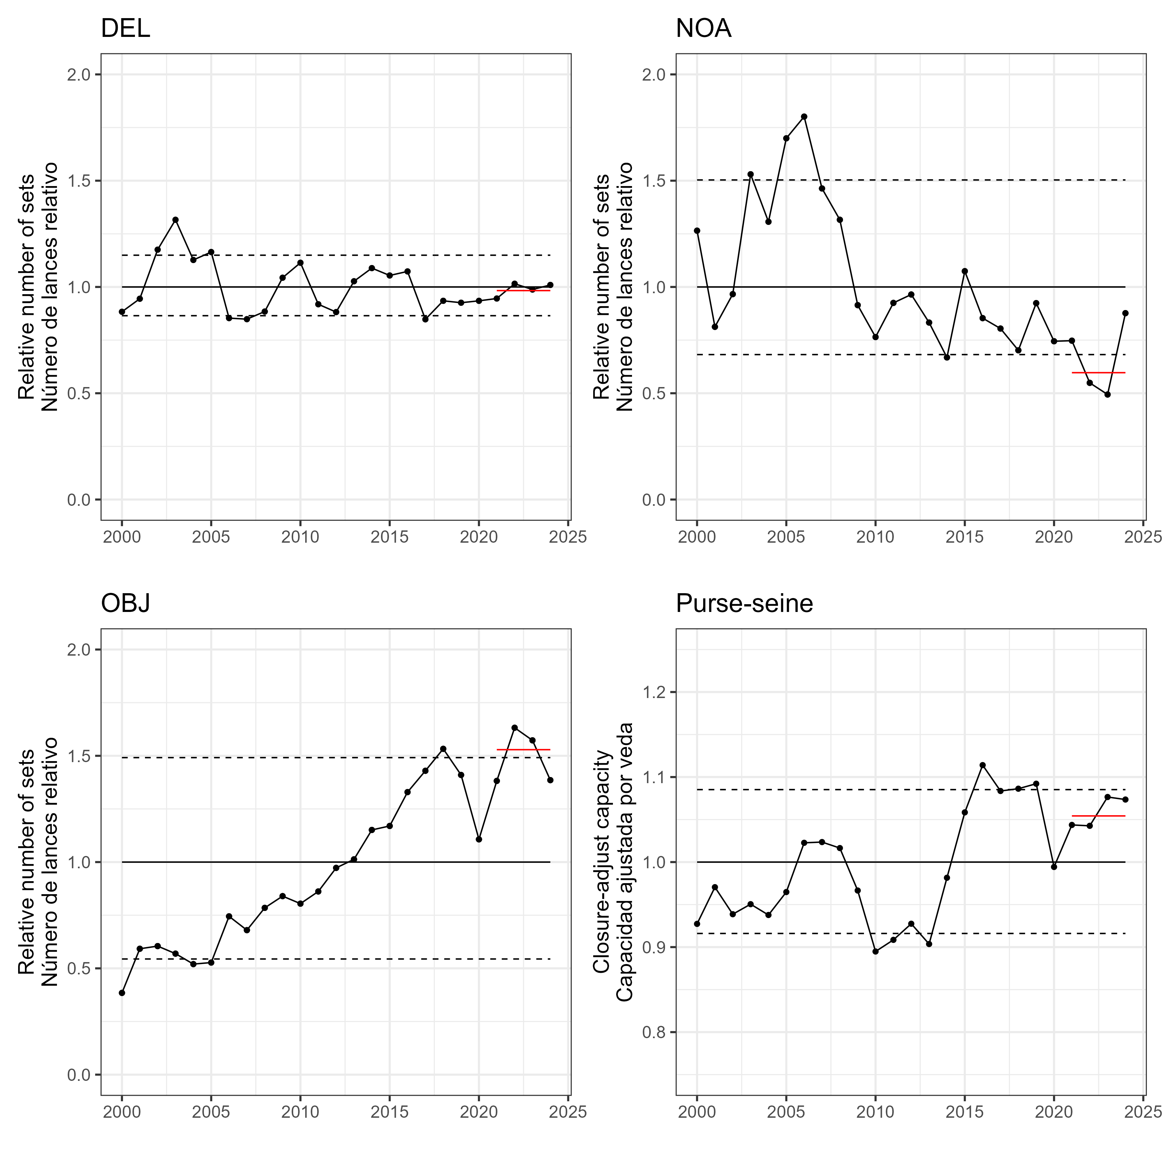   
Figure 1

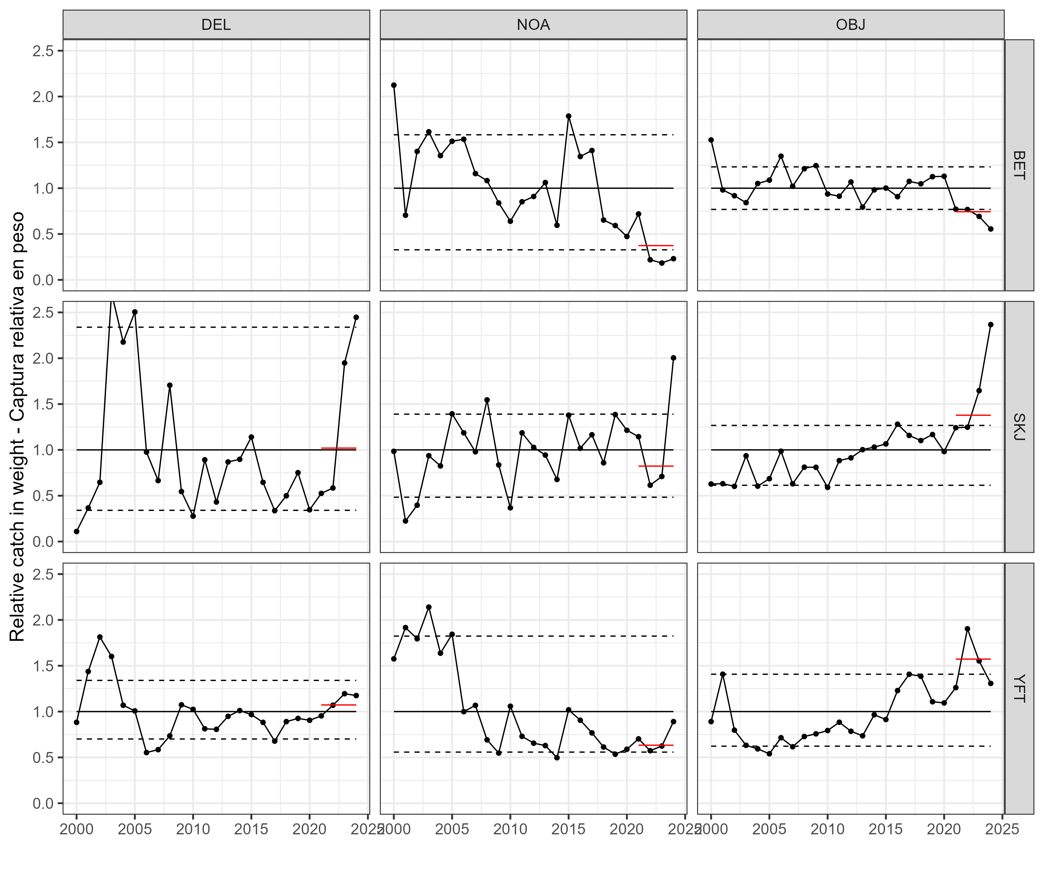   
Figure 2a

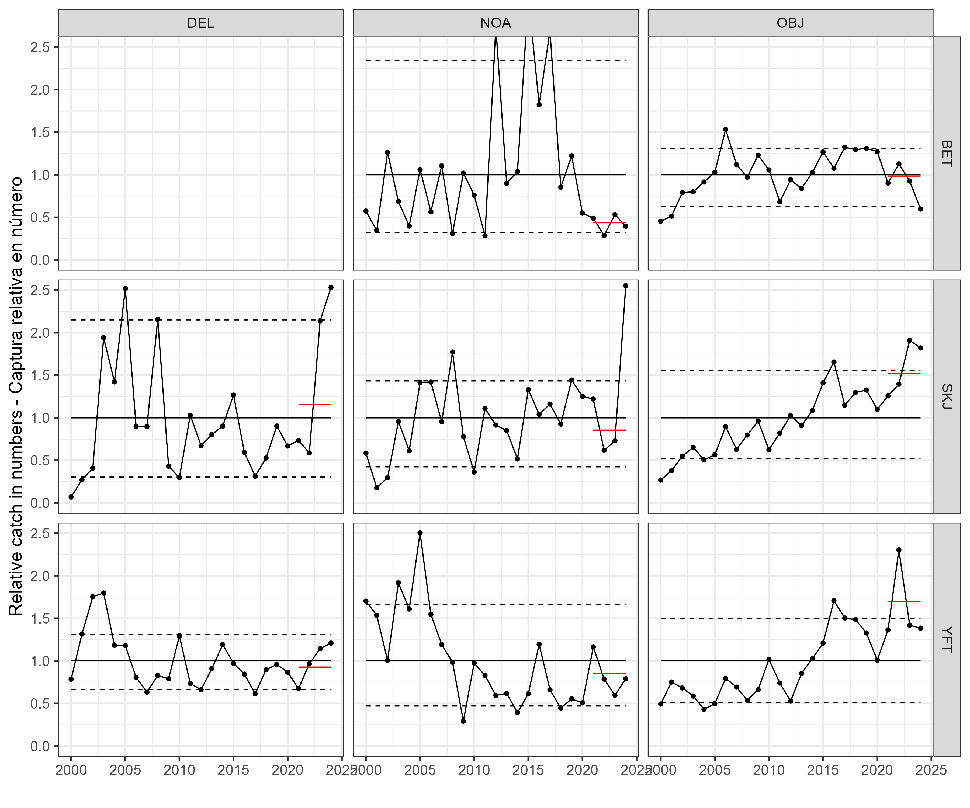   
Figure 2b

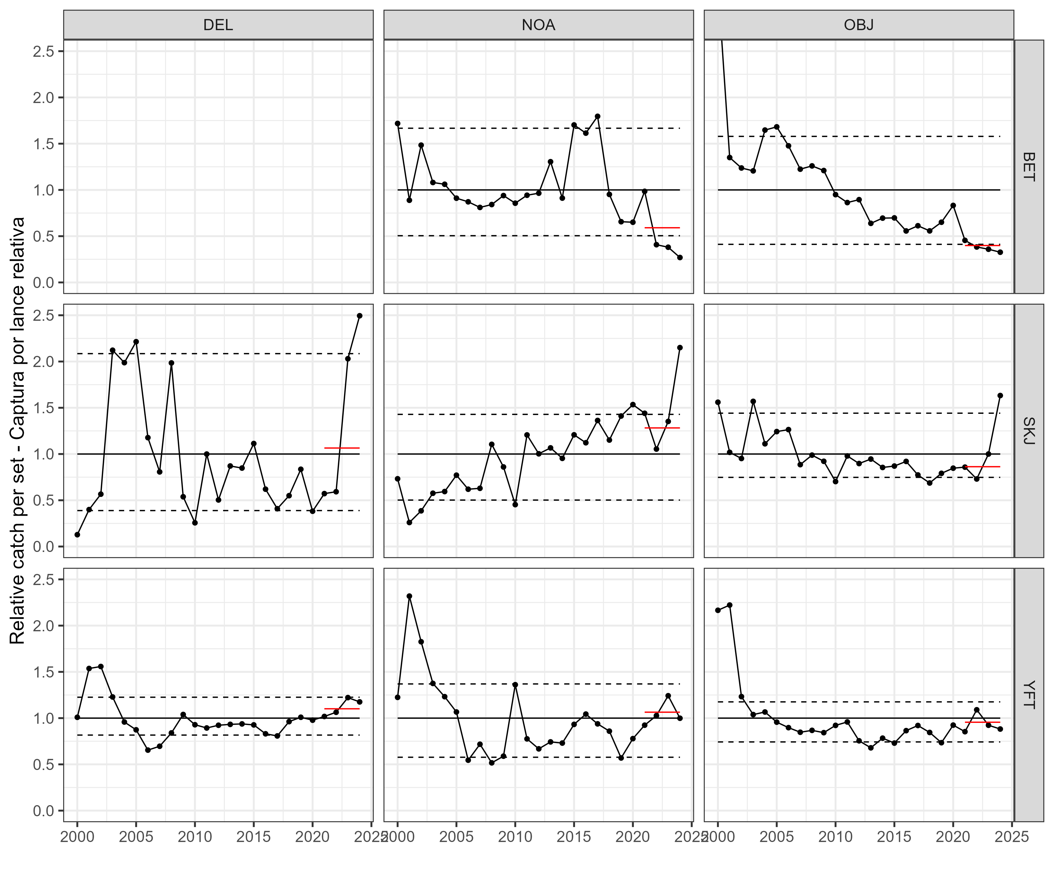   
Figure 3

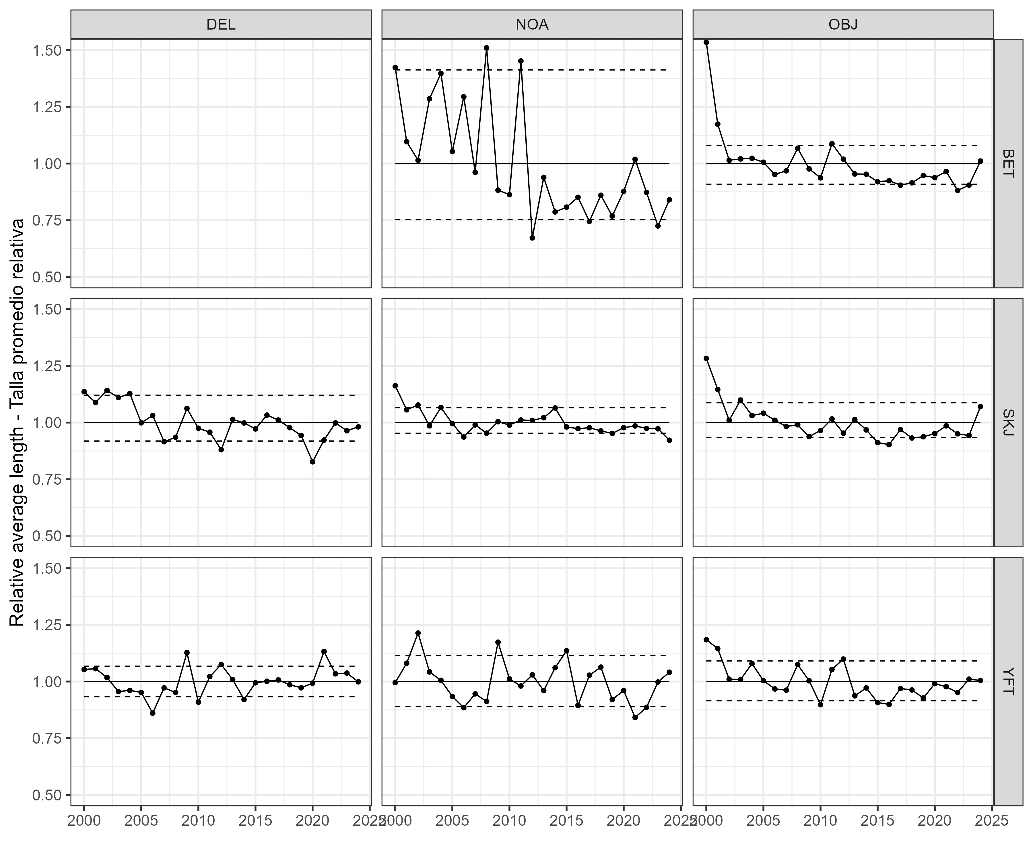   
Figure 4

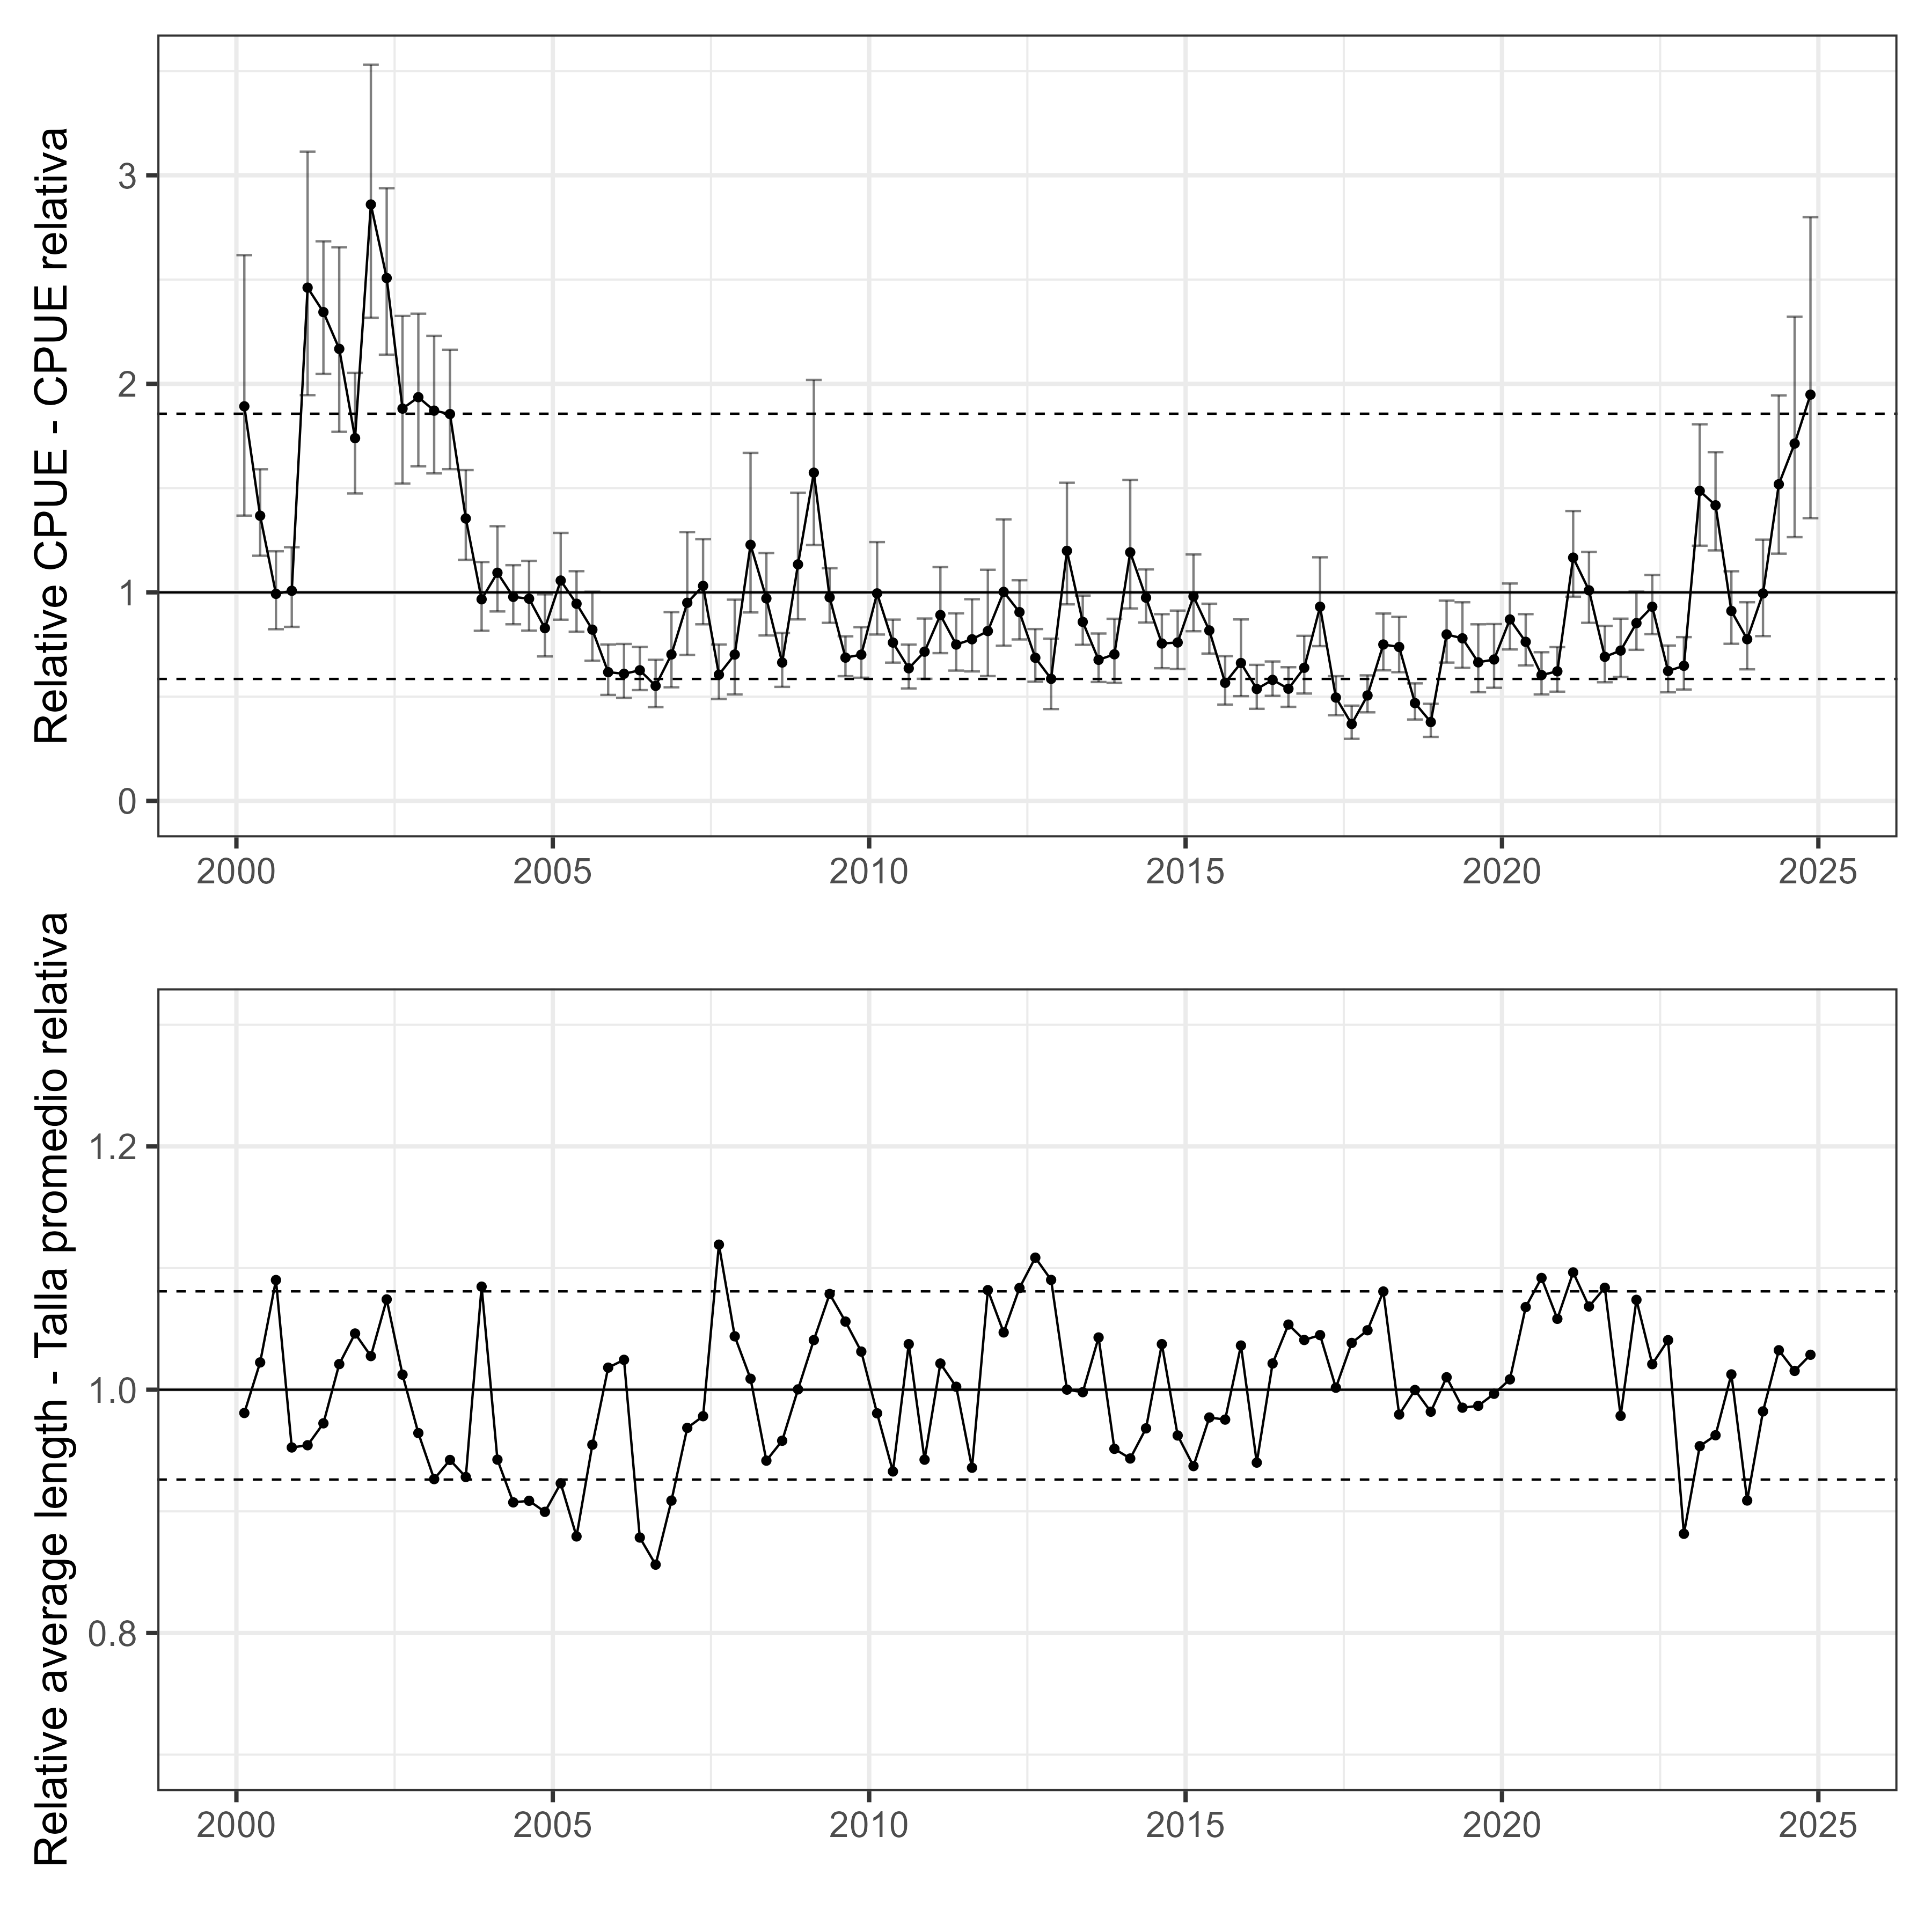   
Figure 5

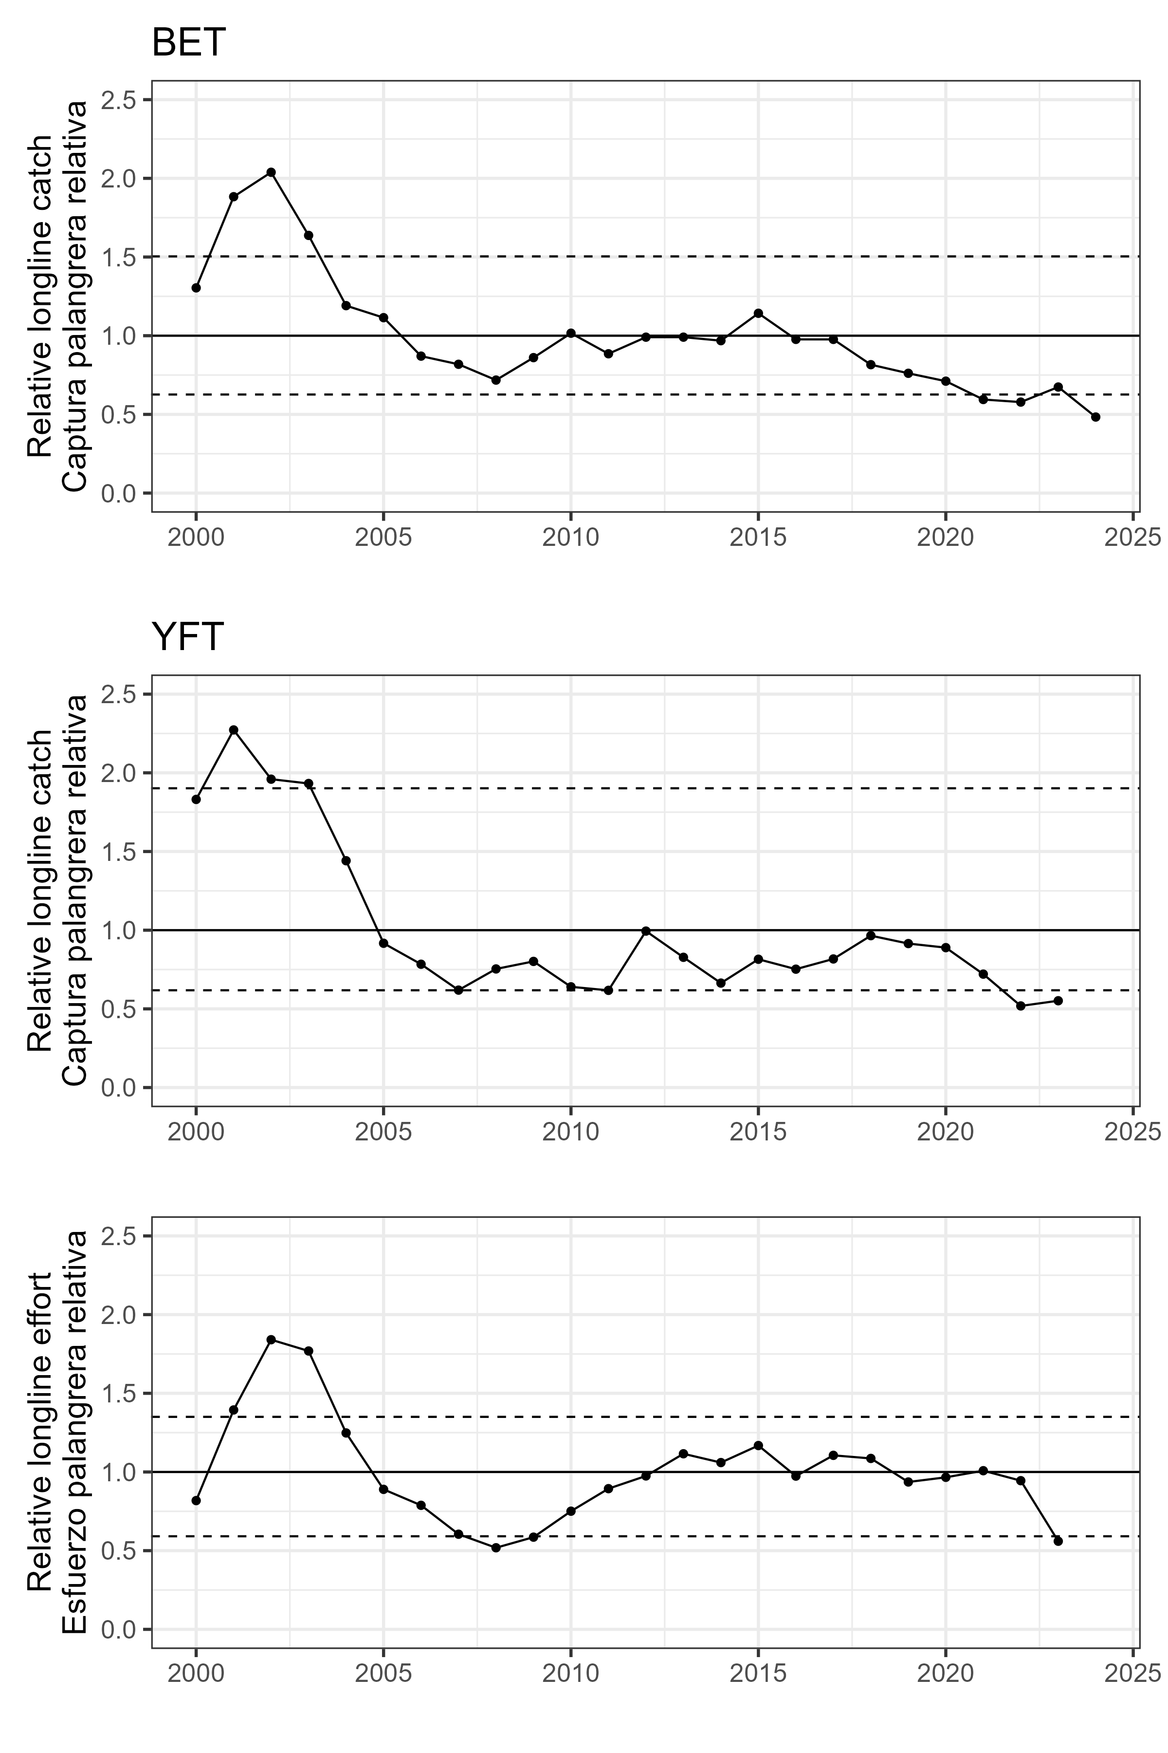   
Figure 6

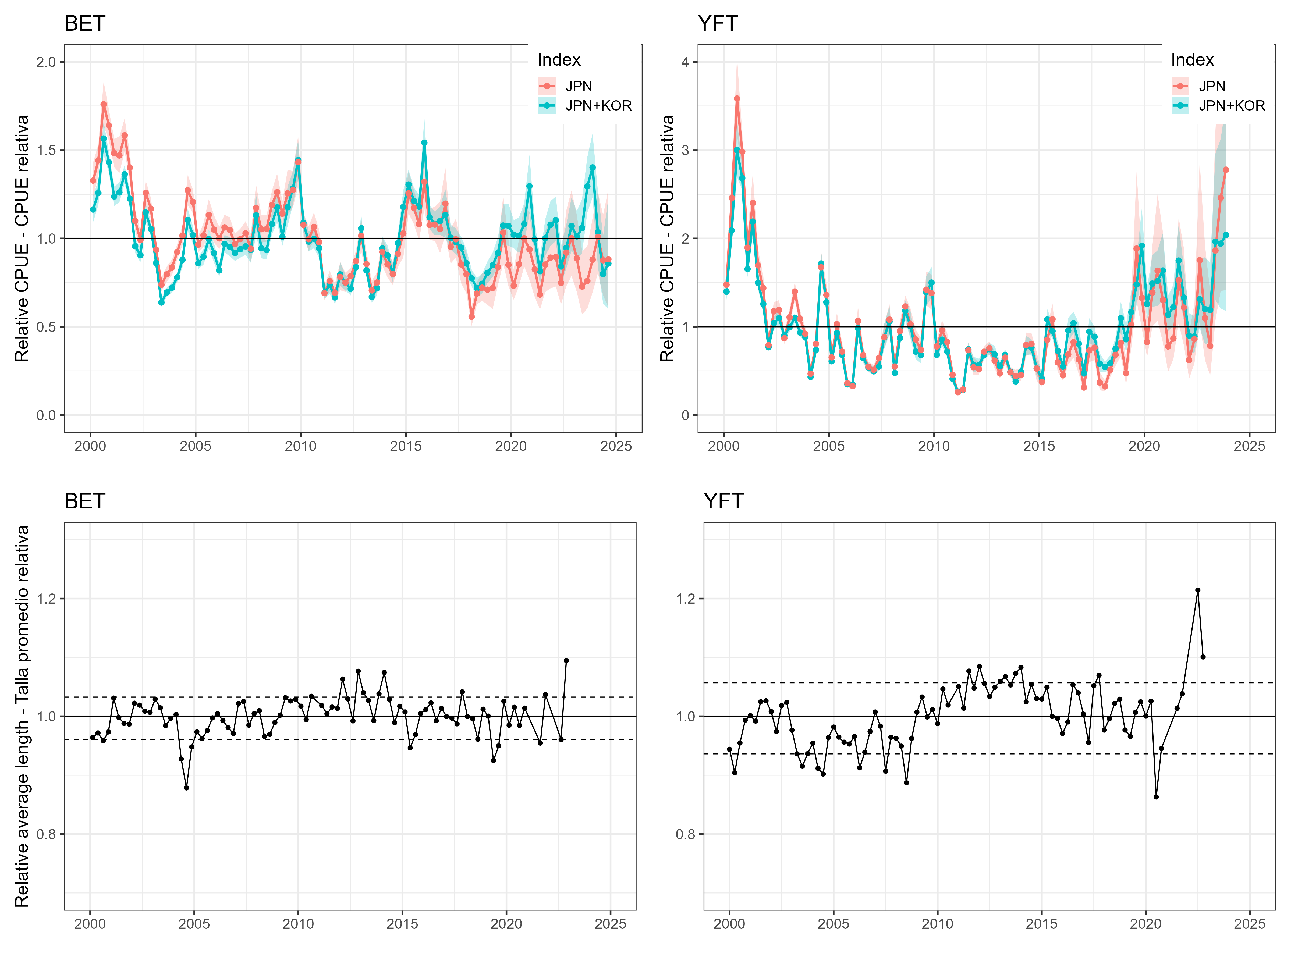   
Figure 7

# Tables

YFT DEL index

| Year | est | lwr | upr | log_est | se | CPUE | Low | High |
| --- | --- | --- | --- | --- | --- | --- | --- | --- |
| 2000.125 | 22368.134 | 16171.781 | 30938.671 | 10.015393 | 0.1654977 | 1.8921567 | 1.3679890 | 2.6171679 |
| 2000.375 | 16164.674 | 13897.386 | 18801.858 | 9.690584 | 0.0771073 | 1.3673960 | 1.1755992 | 1.5904840 |
| 2000.625 | 11736.715 | 9733.548 | 14152.135 | 9.370477 | 0.0954832 | 0.9928278 | 0.8233737 | 1.1971562 |
| 2000.875 | 11910.599 | 9865.684 | 14379.374 | 9.385184 | 0.0961069 | 1.0075369 | 0.8345513 | 1.2163787 |
| 2001.125 | 29094.685 | 23001.125 | 36802.578 | 10.278311 | 0.1199065 | 2.4611665 | 1.9456940 | 3.1132031 |
| 2001.375 | 27708.637 | 24201.749 | 31723.681 | 10.229499 | 0.0690417 | 2.3439185 | 2.0472601 | 2.6835642 |
| 2001.625 | 25624.725 | 20922.628 | 31383.560 | 10.151313 | 0.1034338 | 2.1676370 | 1.7698724 | 2.6547961 |
| 2001.875 | 20563.550 | 17429.086 | 24261.720 | 9.931275 | 0.0843789 | 1.7395040 | 1.4743501 | 2.0523444 |
| 2002.125 | 33808.767 | 27390.572 | 41730.883 | 10.428475 | 0.1074108 | 2.8599384 | 2.3170038 | 3.5300966 |
| 2002.375 | 29640.169 | 25295.457 | 34731.122 | 10.296886 | 0.0808717 | 2.5073099 | 2.1397775 | 2.9379705 |
| 2002.625 | 22237.431 | 17989.135 | 27489.001 | 10.009532 | 0.1081698 | 1.8811003 | 1.5217241 | 2.3253481 |
| 2002.875 | 22885.342 | 18965.392 | 27615.504 | 10.038252 | 0.0958593 | 1.9359081 | 1.6043077 | 2.3360482 |
| 2003.125 | 22122.168 | 18565.455 | 26360.265 | 10.004335 | 0.0894290 | 1.8713500 | 1.5704768 | 2.2298647 |
| 2003.375 | 21929.585 | 18806.047 | 25571.919 | 9.995592 | 0.0783985 | 1.8550591 | 1.5908295 | 2.1631762 |
| 2003.625 | 16009.548 | 13668.123 | 18752.071 | 9.680941 | 0.0806744 | 1.3542736 | 1.1562053 | 1.5862727 |
| 2003.875 | 11428.364 | 9643.959 | 13542.935 | 9.343854 | 0.0866172 | 0.9667439 | 0.8157956 | 1.1456224 |
| 2004.125 | 12932.515 | 10740.234 | 15572.280 | 9.467500 | 0.0947710 | 1.0939824 | 0.9085307 | 1.3172889 |
| 2004.375 | 11566.155 | 10011.796 | 13361.831 | 9.355838 | 0.0736335 | 0.9783997 | 0.8469118 | 1.1303019 |
| 2004.625 | 11461.026 | 9652.979 | 13607.728 | 9.346708 | 0.0875963 | 0.9695068 | 0.8165586 | 1.1511034 |
| 2004.875 | 9793.144 | 8189.023 | 11711.491 | 9.189438 | 0.0912710 | 0.8284179 | 0.6927205 | 0.9906972 |
| 2005.125 | 12491.094 | 10270.703 | 15191.505 | 9.432771 | 0.0998592 | 1.0566419 | 0.8688123 | 1.2850786 |
| 2005.375 | 11176.386 | 9591.938 | 13022.561 | 9.321558 | 0.0780015 | 0.9454286 | 0.8113953 | 1.1016026 |
| 2005.625 | 9706.553 | 7946.984 | 11855.715 | 9.180556 | 0.1020472 | 0.8210931 | 0.6722458 | 1.0028978 |
| 2005.875 | 7298.176 | 6007.153 | 8866.659 | 8.895380 | 0.0993251 | 0.6173645 | 0.5081530 | 0.7500477 |
| 2006.125 | 7205.729 | 5836.942 | 8895.502 | 8.882632 | 0.1074863 | 0.6095443 | 0.4937544 | 0.7524878 |
| 2006.375 | 7403.295 | 6280.406 | 8726.950 | 8.909681 | 0.0839254 | 0.6262567 | 0.5312681 | 0.7382290 |
| 2006.625 | 6520.663 | 5315.640 | 7998.857 | 8.782731 | 0.1042481 | 0.5515935 | 0.4496569 | 0.6766388 |
| 2006.875 | 8301.698 | 6439.888 | 10701.767 | 9.024215 | 0.1295681 | 0.7022540 | 0.5447580 | 0.9052841 |
| 2007.125 | 11231.860 | 8277.605 | 15240.481 | 9.326510 | 0.1557175 | 0.9501212 | 0.7002121 | 1.2892242 |
| 2007.375 | 12188.319 | 10011.266 | 14838.794 | 9.408233 | 0.1003932 | 1.0310296 | 0.8468661 | 1.2552422 |
| 2007.625 | 7156.506 | 5776.534 | 8866.142 | 8.875777 | 0.1092969 | 0.6053804 | 0.4886445 | 0.7500043 |
| 2007.875 | 8297.599 | 6035.675 | 11407.201 | 9.023722 | 0.1623900 | 0.7019074 | 0.5105645 | 0.9649592 |
| 2008.125 | 14516.778 | 10682.547 | 19727.209 | 9.583060 | 0.1564793 | 1.2279978 | 0.9036489 | 1.6687659 |
| 2008.375 | 11478.646 | 9376.751 | 14051.703 | 9.348244 | 0.1031933 | 0.9709973 | 0.7931916 | 1.1886607 |
| 2008.625 | 7844.490 | 6463.495 | 9520.550 | 8.967567 | 0.0987983 | 0.6635781 | 0.5467556 | 0.8053616 |
| 2008.875 | 13407.189 | 10289.556 | 17469.434 | 9.503546 | 0.1350339 | 1.1341358 | 0.8704060 | 1.4777749 |
| 2009.125 | 18604.813 | 14505.356 | 23862.844 | 9.831176 | 0.1269933 | 1.5738112 | 1.2270260 | 2.0186059 |
| 2009.375 | 11538.248 | 10094.000 | 13189.139 | 9.353423 | 0.0682289 | 0.9760391 | 0.8538657 | 1.1156934 |
| 2009.625 | 8121.515 | 7069.278 | 9330.375 | 9.002272 | 0.0707964 | 0.6870121 | 0.5980001 | 0.7892735 |
| 2009.875 | 8290.992 | 6980.926 | 9846.911 | 9.022925 | 0.0877507 | 0.7013485 | 0.5905259 | 0.8329688 |
| 2010.125 | 11762.825 | 9430.586 | 14671.841 | 9.372699 | 0.1127500 | 0.9950365 | 0.7977453 | 1.2411198 |
| 2010.375 | 8974.422 | 7837.865 | 10275.789 | 9.102134 | 0.0690891 | 0.7591609 | 0.6630161 | 0.8692478 |
| 2010.625 | 7515.198 | 6373.857 | 8860.914 | 8.924683 | 0.0840437 | 0.6357227 | 0.5391733 | 0.7495613 |
| 2010.875 | 8458.199 | 6920.279 | 10337.896 | 9.042891 | 0.1023897 | 0.7154927 | 0.5853955 | 0.8745026 |
| 2011.125 | 10535.651 | 8376.136 | 13251.926 | 9.262520 | 0.1170318 | 0.8912278 | 0.7085479 | 1.1210066 |
| 2011.375 | 8861.796 | 7386.316 | 10632.017 | 9.089505 | 0.0929203 | 0.7496337 | 0.6248183 | 0.8993826 |
| 2011.625 | 9161.324 | 7339.816 | 11434.872 | 9.122746 | 0.1131026 | 0.7749712 | 0.6208844 | 0.9672983 |
| 2011.875 | 9627.051 | 7074.476 | 13100.632 | 9.172332 | 0.1571884 | 0.8143678 | 0.5984380 | 1.1082099 |
| 2012.125 | 11849.121 | 8796.961 | 15960.248 | 9.380009 | 0.1519658 | 1.0023364 | 0.7441451 | 1.3501106 |
| 2012.375 | 10700.297 | 9152.828 | 12509.396 | 9.278027 | 0.0796997 | 0.9051554 | 0.7742504 | 1.0581931 |
| 2012.625 | 8113.535 | 6757.870 | 9741.154 | 9.001289 | 0.0932803 | 0.6863371 | 0.5716572 | 0.8240228 |
| 2012.875 | 6919.240 | 5206.136 | 9196.050 | 8.842061 | 0.1451394 | 0.5853098 | 0.4403932 | 0.7779128 |
| 2013.125 | 14174.877 | 11141.546 | 18034.045 | 9.559226 | 0.1228544 | 1.1990758 | 0.9424773 | 1.5255358 |
| 2013.375 | 10147.019 | 8847.424 | 11637.512 | 9.224935 | 0.0699266 | 0.8583528 | 0.7484160 | 0.9844385 |
| 2013.625 | 7996.078 | 6738.591 | 9488.224 | 8.986706 | 0.0872977 | 0.6764012 | 0.5700265 | 0.8026267 |
| 2013.875 | 8311.032 | 6690.775 | 10323.656 | 9.025339 | 0.1106419 | 0.7030437 | 0.5659812 | 0.8732983 |
| 2014.125 | 14090.987 | 10910.181 | 18199.141 | 9.553291 | 0.1305325 | 1.1919794 | 0.9229055 | 1.5395021 |
| 2014.375 | 11519.959 | 10112.674 | 13123.081 | 9.351836 | 0.0664765 | 0.9744919 | 0.8554454 | 1.1101053 |
| 2014.625 | 8922.477 | 7520.610 | 10585.656 | 9.096329 | 0.0872089 | 0.7547667 | 0.6361786 | 0.8954606 |
| 2014.875 | 8979.378 | 7474.141 | 10787.759 | 9.102686 | 0.0936147 | 0.7595801 | 0.6322476 | 0.9125570 |
| 2015.125 | 11591.297 | 9617.838 | 13969.686 | 9.358010 | 0.0952237 | 0.9805266 | 0.8135857 | 1.1817224 |
| 2015.375 | 9662.130 | 8352.571 | 11177.009 | 9.175969 | 0.0743099 | 0.8173352 | 0.7065556 | 0.9454838 |
| 2015.625 | 6693.614 | 5459.919 | 8206.067 | 8.808909 | 0.1039406 | 0.5662236 | 0.4618617 | 0.6941671 |
| 2015.875 | 7816.251 | 5938.914 | 10287.028 | 8.963960 | 0.1401448 | 0.6611893 | 0.5023798 | 0.8702008 |
| 2016.125 | 6343.673 | 5219.057 | 7710.624 | 8.755213 | 0.0995637 | 0.5366216 | 0.4414869 | 0.6522565 |
| 2016.375 | 6860.558 | 5955.517 | 7903.134 | 8.833544 | 0.0721803 | 0.5803457 | 0.5037855 | 0.6685407 |
| 2016.625 | 6356.825 | 5331.906 | 7578.757 | 8.757284 | 0.0897058 | 0.5377341 | 0.4510331 | 0.6411014 |
| 2016.875 | 7545.908 | 6085.665 | 9356.534 | 8.928761 | 0.1097313 | 0.6383206 | 0.5147942 | 0.7914875 |
| 2017.125 | 11006.585 | 8772.267 | 13809.991 | 9.306249 | 0.1157667 | 0.9310649 | 0.7420572 | 1.1682143 |
| 2017.375 | 5858.792 | 4855.182 | 7069.857 | 8.675699 | 0.0958675 | 0.4956047 | 0.4107063 | 0.5980528 |
| 2017.625 | 4359.232 | 3518.999 | 5400.087 | 8.380051 | 0.1092465 | 0.3687545 | 0.2976767 | 0.4568039 |
| 2017.875 | 5977.959 | 5021.433 | 7116.692 | 8.695834 | 0.0889628 | 0.5056852 | 0.4247698 | 0.6020144 |
| 2018.125 | 8866.719 | 7401.838 | 10621.511 | 9.090060 | 0.0921326 | 0.7500501 | 0.6261314 | 0.8984938 |
| 2018.375 | 8724.021 | 7295.711 | 10431.956 | 9.073835 | 0.0912229 | 0.7379790 | 0.6171539 | 0.8824590 |
| 2018.625 | 5544.858 | 4614.547 | 6662.724 | 8.620626 | 0.0937044 | 0.4690485 | 0.3903507 | 0.5636125 |
| 2018.875 | 4469.166 | 3628.975 | 5503.882 | 8.404957 | 0.1062528 | 0.3780540 | 0.3069797 | 0.4655841 |
| 2019.125 | 9434.614 | 7840.109 | 11353.407 | 9.152141 | 0.0944571 | 0.7980893 | 0.6632052 | 0.9604064 |
| 2019.375 | 9216.146 | 7542.733 | 11260.817 | 9.128712 | 0.1022326 | 0.7796087 | 0.6380497 | 0.9525743 |
| 2019.625 | 7853.924 | 6161.503 | 10011.213 | 8.968768 | 0.1238250 | 0.6643761 | 0.5212092 | 0.8468685 |
| 2019.875 | 8016.814 | 6411.839 | 10023.538 | 8.989296 | 0.1139792 | 0.6781553 | 0.5423856 | 0.8479108 |
| 2020.125 | 10285.540 | 8584.659 | 12323.417 | 9.238494 | 0.0922273 | 0.8700705 | 0.7261878 | 1.0424613 |
| 2020.375 | 9016.936 | 7679.255 | 10587.633 | 9.106860 | 0.0819311 | 0.7627572 | 0.6495987 | 0.8956277 |
| 2020.625 | 7132.869 | 6035.919 | 8429.176 | 8.872469 | 0.0851982 | 0.6033810 | 0.5105866 | 0.7130399 |
| 2020.875 | 7346.204 | 6190.726 | 8717.348 | 8.901939 | 0.0873135 | 0.6214273 | 0.5236819 | 0.7374169 |
| 2021.125 | 13791.594 | 11574.075 | 16433.975 | 9.531815 | 0.0894361 | 1.1666533 | 0.9790666 | 1.3901811 |
| 2021.375 | 11935.499 | 10094.749 | 14111.905 | 9.387272 | 0.0854616 | 1.0096432 | 0.8539286 | 1.1937526 |
| 2021.625 | 8169.075 | 6725.439 | 9922.591 | 9.008111 | 0.0992153 | 0.6910353 | 0.5689138 | 0.8393711 |
| 2021.875 | 8519.979 | 7027.198 | 10329.871 | 9.050169 | 0.0982803 | 0.7207189 | 0.5944399 | 0.8738236 |
| 2022.125 | 10079.526 | 8564.343 | 11862.773 | 9.218262 | 0.0831132 | 0.8526435 | 0.7244694 | 1.0034942 |
| 2022.375 | 11005.361 | 9453.852 | 12811.495 | 9.306138 | 0.0775322 | 0.9309613 | 0.7997144 | 1.0837481 |
| 2022.625 | 7363.593 | 6156.460 | 8807.416 | 8.904303 | 0.0913517 | 0.6228983 | 0.5207832 | 0.7450361 |
| 2022.875 | 7657.512 | 6315.065 | 9285.333 | 8.943442 | 0.0983431 | 0.6477613 | 0.5341997 | 0.7854641 |
| 2023.125 | 17574.093 | 14465.691 | 21350.432 | 9.774181 | 0.0993111 | 1.4866210 | 1.2236719 | 1.8060741 |
| 2023.375 | 16756.270 | 14201.064 | 19771.236 | 9.726528 | 0.0844177 | 1.4174400 | 1.2012874 | 1.6724859 |
| 2023.625 | 10767.507 | 8905.598 | 13018.688 | 9.284288 | 0.0968655 | 0.9108409 | 0.7533364 | 1.1012758 |
| 2023.875 | 9165.145 | 7459.017 | 11261.523 | 9.123163 | 0.1050959 | 0.7752945 | 0.6309680 | 0.9526340 |
| 2024.125 | 11760.929 | 9340.929 | 14807.890 | 9.372538 | 0.1175415 | 0.9948760 | 0.7901610 | 1.2526287 |
| 2024.375 | 17949.826 | 14015.198 | 22989.063 | 9.795336 | 0.1262463 | 1.5184049 | 1.1855629 | 1.9446909 |
| 2024.625 | 20257.097 | 14949.562 | 27448.964 | 9.916260 | 0.1550147 | 1.7135807 | 1.2646006 | 2.3219653 |
| 2024.875 | 23029.607 | 16027.807 | 33090.166 | 10.044536 | 0.1849297 | 1.9481117 | 1.3558091 | 2.7991694 |

BET LL index

| Category | Time | Stratum | Units | Estimate | Std..Error.for.Estimate | Std..Error.for.ln.Estimate. | Index | Year | CPUE | low | high | Low | High |
| --- | --- | --- | --- | --- | --- | --- | --- | --- | --- | --- | --- | --- | --- |
| 1 | 101 | Stratum_1 | [kg*km2/km2] | 18727539 | 609862.8 | 0.0329889 | JPN+KOR | 2000.125 | 1.1640464 | 0.7418245 | 1.264927 | 1.0911628 | 1.2417981 |
| 1 | 102 | Stratum_1 | [kg*km2/km2] | 20233476 | 561974.3 | 0.0281159 | JPN+KOR | 2000.375 | 1.2576508 | 0.7418245 | 1.264927 | 1.1902202 | 1.3289016 |
| 1 | 103 | Stratum_1 | [kg*km2/km2] | 25187495 | 764915.8 | 0.0307396 | JPN+KOR | 2000.625 | 1.5655775 | 0.7418245 | 1.264927 | 1.4740372 | 1.6628025 |
| 1 | 104 | Stratum_1 | [kg*km2/km2] | 23022516 | 466725.7 | 0.0204542 | JPN+KOR | 2000.875 | 1.4310090 | 0.7418245 | 1.264927 | 1.3747744 | 1.4895439 |
| 1 | 105 | Stratum_1 | [kg*km2/km2] | 19905084 | 445081.9 | 0.0225562 | JPN+KOR | 2001.125 | 1.2372389 | 0.7418245 | 1.264927 | 1.1837319 | 1.2931646 |
| 1 | 106 | Stratum_1 | [kg*km2/km2] | 20280015 | 458070.1 | 0.0227957 | JPN+KOR | 2001.375 | 1.2605436 | 0.7418245 | 1.264927 | 1.2054626 | 1.3181413 |
| 1 | 107 | Stratum_1 | [kg*km2/km2] | 21929302 | 414798.8 | 0.0190685 | JPN+KOR | 2001.625 | 1.3630581 | 0.7418245 | 1.264927 | 1.3130551 | 1.4149654 |
| 1 | 108 | Stratum_1 | [kg*km2/km2] | 19709242 | 353249.2 | 0.0180640 | JPN+KOR | 2001.875 | 1.2250660 | 0.7418245 | 1.264927 | 1.1824509 | 1.2692170 |
| 1 | 109 | Stratum_1 | [kg*km2/km2] | 15382486 | 314174.1 | 0.0206025 | JPN+KOR | 2002.125 | 0.9561282 | 0.7418245 | 1.264927 | 0.9182880 | 0.9955276 |
| 1 | 110 | Stratum_1 | [kg*km2/km2] | 14565844 | 335764.0 | 0.0232881 | JPN+KOR | 2002.375 | 0.9053682 | 0.7418245 | 1.264927 | 0.8649719 | 0.9476510 |
| 1 | 111 | Stratum_1 | [kg*km2/km2] | 18464895 | 397423.9 | 0.0217280 | JPN+KOR | 2002.625 | 1.1477213 | 0.7418245 | 1.264927 | 1.0998695 | 1.1976549 |
| 1 | 112 | Stratum_1 | [kg*km2/km2] | 16941750 | 344049.2 | 0.0204922 | JPN+KOR | 2002.875 | 1.0530472 | 0.7418245 | 1.264927 | 1.0115900 | 1.0962035 |
| 1 | 113 | Stratum_1 | [kg*km2/km2] | 13853395 | 281751.5 | 0.0205220 | JPN+KOR | 2003.125 | 0.8610845 | 0.7418245 | 1.264927 | 0.8271363 | 0.8964261 |
| 1 | 114 | Stratum_1 | [kg*km2/km2] | 10254024 | 188571.3 | 0.0185449 | JPN+KOR | 2003.375 | 0.6373587 | 0.7418245 | 1.264927 | 0.6146080 | 0.6609515 |
| 1 | 115 | Stratum_1 | [kg*km2/km2] | 11168385 | 205525.5 | 0.0185585 | JPN+KOR | 2003.625 | 0.6941925 | 0.7418245 | 1.264927 | 0.6693952 | 0.7199085 |
| 1 | 116 | Stratum_1 | [kg*km2/km2] | 11595795 | 227938.1 | 0.0198269 | JPN+KOR | 2003.875 | 0.7207590 | 0.7418245 | 1.264927 | 0.6932871 | 0.7493195 |
| 1 | 117 | Stratum_1 | [kg*km2/km2] | 12548106 | 217137.8 | 0.0174461 | JPN+KOR | 2004.125 | 0.7799518 | 0.7418245 | 1.264927 | 0.7537327 | 0.8070829 |
| 1 | 118 | Stratum_1 | [kg*km2/km2] | 14136408 | 348179.5 | 0.0248984 | JPN+KOR | 2004.375 | 0.8786757 | 0.7418245 | 1.264927 | 0.8368251 | 0.9226194 |
| 1 | 119 | Stratum_1 | [kg*km2/km2] | 17773455 | 515901.4 | 0.0293827 | JPN+KOR | 2004.625 | 1.1047434 | 0.7418245 | 1.264927 | 1.0429186 | 1.1702333 |
| 1 | 120 | Stratum_1 | [kg*km2/km2] | 16381301 | 399295.4 | 0.0246513 | JPN+KOR | 2004.875 | 1.0182114 | 0.7418245 | 1.264927 | 0.9701845 | 1.0686158 |
| 1 | 121 | Stratum_1 | [kg*km2/km2] | 13827083 | 280100.3 | 0.0204584 | JPN+KOR | 2005.125 | 0.8594491 | 0.7418245 | 1.264927 | 0.8256684 | 0.8946119 |
| 1 | 122 | Stratum_1 | [kg*km2/km2] | 14408068 | 362632.8 | 0.0254557 | JPN+KOR | 2005.375 | 0.8955613 | 0.7418245 | 1.264927 | 0.8519754 | 0.9413771 |
| 1 | 123 | Stratum_1 | [kg*km2/km2] | 16021599 | 438456.1 | 0.0277317 | JPN+KOR | 2005.625 | 0.9958534 | 0.7418245 | 1.264927 | 0.9431694 | 1.0514803 |
| 1 | 124 | Stratum_1 | [kg*km2/km2] | 14740426 | 438178.7 | 0.0301523 | JPN+KOR | 2005.875 | 0.9162197 | 0.7418245 | 1.264927 | 0.8636414 | 0.9719990 |
| 1 | 125 | Stratum_1 | [kg*km2/km2] | 13176172 | 302296.4 | 0.0232308 | JPN+KOR | 2006.125 | 0.8189905 | 0.7418245 | 1.264927 | 0.7825361 | 0.8571430 |
| 1 | 126 | Stratum_1 | [kg*km2/km2] | 15588845 | 394899.0 | 0.0256781 | JPN+KOR | 2006.375 | 0.9689548 | 0.7418245 | 1.264927 | 0.9213950 | 1.0189695 |
| 1 | 127 | Stratum_1 | [kg*km2/km2] | 15311742 | 440143.3 | 0.0291501 | JPN+KOR | 2006.625 | 0.9517309 | 0.7418245 | 1.264927 | 0.8988787 | 1.0076907 |
| 1 | 128 | Stratum_1 | [kg*km2/km2] | 14775497 | 380763.9 | 0.0261278 | JPN+KOR | 2006.875 | 0.9183996 | 0.7418245 | 1.264927 | 0.8725518 | 0.9666565 |
| 1 | 129 | Stratum_1 | [kg*km2/km2] | 15103397 | 392735.4 | 0.0263718 | JPN+KOR | 2007.125 | 0.9387808 | 0.7418245 | 1.264927 | 0.8914893 | 0.9885811 |
| 1 | 130 | Stratum_1 | [kg*km2/km2] | 15361032 | 387921.4 | 0.0256228 | JPN+KOR | 2007.375 | 0.9547946 | 0.7418245 | 1.264927 | 0.9080284 | 1.0039695 |
| 1 | 131 | Stratum_1 | [kg*km2/km2] | 15041775 | 615582.4 | 0.0416957 | JPN+KOR | 2007.625 | 0.9349506 | 0.7418245 | 1.264927 | 0.8615819 | 1.0145671 |
| 1 | 132 | Stratum_1 | [kg*km2/km2] | 18191336 | 949356.4 | 0.0532958 | JPN+KOR | 2007.875 | 1.1307177 | 0.7418245 | 1.264927 | 1.0185629 | 1.2552219 |
| 1 | 133 | Stratum_1 | [kg*km2/km2] | 15197439 | 478018.7 | 0.0320113 | JPN+KOR | 2008.125 | 0.9446262 | 0.7418245 | 1.264927 | 0.8871794 | 1.0057928 |
| 1 | 134 | Stratum_1 | [kg*km2/km2] | 15021712 | 423616.5 | 0.0286747 | JPN+KOR | 2008.375 | 0.9337035 | 0.7418245 | 1.264927 | 0.8826745 | 0.9876826 |
| 1 | 135 | Stratum_1 | [kg*km2/km2] | 17414170 | 510067.3 | 0.0297817 | JPN+KOR | 2008.625 | 1.0824114 | 0.7418245 | 1.264927 | 1.0210375 | 1.1474745 |
| 1 | 136 | Stratum_1 | [kg*km2/km2] | 18923337 | 718662.1 | 0.0386520 | JPN+KOR | 2008.875 | 1.1762166 | 0.7418245 | 1.264927 | 1.0904005 | 1.2687866 |
| 1 | 137 | Stratum_1 | [kg*km2/km2] | 16234286 | 421302.9 | 0.0263605 | JPN+KOR | 2009.125 | 1.0090734 | 0.7418245 | 1.264927 | 0.9582619 | 1.0625792 |
| 1 | 138 | Stratum_1 | [kg*km2/km2] | 18927939 | 900654.3 | 0.0486005 | JPN+KOR | 2009.375 | 1.1765026 | 0.7418245 | 1.264927 | 1.0696048 | 1.2940840 |
| 1 | 139 | Stratum_1 | [kg*km2/km2] | 20632665 | 763408.7 | 0.0376989 | JPN+KOR | 2009.625 | 1.2824632 | 0.7418245 | 1.264927 | 1.1911184 | 1.3808130 |
| 1 | 140 | Stratum_1 | [kg*km2/km2] | 23220574 | 895143.4 | 0.0392169 | JPN+KOR | 2009.875 | 1.4433197 | 0.7418245 | 1.264927 | 1.3365353 | 1.5586358 |
| 1 | 141 | Stratum_1 | [kg*km2/km2] | 17505451 | 461105.8 | 0.0267242 | JPN+KOR | 2010.125 | 1.0880851 | 0.7418245 | 1.264927 | 1.0325588 | 1.1465975 |
| 1 | 142 | Stratum_1 | [kg*km2/km2] | 15803411 | 467058.6 | 0.0299818 | JPN+KOR | 2010.375 | 0.9822915 | 0.7418245 | 1.264927 | 0.9262311 | 1.0417450 |
| 1 | 143 | Stratum_1 | [kg*km2/km2] | 16053106 | 444151.8 | 0.0280675 | JPN+KOR | 2010.625 | 0.9978118 | 0.7418245 | 1.264927 | 0.9444025 | 1.0542416 |
| 1 | 144 | Stratum_1 | [kg*km2/km2] | 15192827 | 454574.4 | 0.0303651 | JPN+KOR | 2010.875 | 0.9443395 | 0.7418245 | 1.264927 | 0.8897763 | 1.0022487 |
| 1 | 145 | Stratum_1 | [kg*km2/km2] | 11118385 | 265253.8 | 0.0241779 | JPN+KOR | 2011.125 | 0.6910847 | 0.7418245 | 1.264927 | 0.6590991 | 0.7246227 |
| 1 | 146 | Stratum_1 | [kg*km2/km2] | 11842451 | 416609.8 | 0.0357726 | JPN+KOR | 2011.375 | 0.7360904 | 0.7418245 | 1.264927 | 0.6862477 | 0.7895532 |
| 1 | 147 | Stratum_1 | [kg*km2/km2] | 10716866 | 319515.3 | 0.0303174 | JPN+KOR | 2011.625 | 0.6661275 | 0.7418245 | 1.264927 | 0.6276980 | 0.7069099 |
| 1 | 148 | Stratum_1 | [kg*km2/km2] | 12811285 | 526853.0 | 0.0419165 | JPN+KOR | 2011.875 | 0.7963102 | 0.7418245 | 1.264927 | 0.7335036 | 0.8644947 |
| 1 | 149 | Stratum_1 | [kg*km2/km2] | 12039990 | 360738.8 | 0.0304541 | JPN+KOR | 2012.125 | 0.7483689 | 0.7418245 | 1.264927 | 0.7050058 | 0.7943991 |
| 1 | 150 | Stratum_1 | [kg*km2/km2] | 11501413 | 312673.1 | 0.0276393 | JPN+KOR | 2012.375 | 0.7148925 | 0.7418245 | 1.264927 | 0.6771949 | 0.7546887 |
| 1 | 151 | Stratum_1 | [kg*km2/km2] | 13459184 | 371502.9 | 0.0280551 | JPN+KOR | 2012.625 | 0.8365816 | 0.7418245 | 1.264927 | 0.7918216 | 0.8838717 |
| 1 | 152 | Stratum_1 | [kg*km2/km2] | 17013149 | 614884.0 | 0.0367496 | JPN+KOR | 2012.875 | 1.0574851 | 0.7418245 | 1.264927 | 0.9839939 | 1.1364652 |
| 1 | 153 | Stratum_1 | [kg*km2/km2] | 13172033 | 322158.0 | 0.0248073 | JPN+KOR | 2013.125 | 0.8187332 | 0.7418245 | 1.264927 | 0.7798768 | 0.8595255 |
| 1 | 154 | Stratum_1 | [kg*km2/km2] | 10762324 | 282089.4 | 0.0266138 | JPN+KOR | 2013.375 | 0.6689531 | 0.7418245 | 1.264927 | 0.6349529 | 0.7047739 |
| 1 | 155 | Stratum_1 | [kg*km2/km2] | 11544822 | 335284.6 | 0.0295224 | JPN+KOR | 2013.625 | 0.7175907 | 0.7418245 | 1.264927 | 0.6772467 | 0.7603381 |
| 1 | 156 | Stratum_1 | [kg*km2/km2] | 15187444 | 536257.1 | 0.0359500 | JPN+KOR | 2013.875 | 0.9440049 | 0.7418245 | 1.264927 | 0.8797778 | 1.0129209 |
| 1 | 157 | Stratum_1 | [kg*km2/km2] | 14549649 | 433875.2 | 0.0303305 | JPN+KOR | 2014.125 | 0.9043615 | 0.7418245 | 1.264927 | 0.8521661 | 0.9597539 |
| 1 | 158 | Stratum_1 | [kg*km2/km2] | 12877764 | 414449.5 | 0.0327575 | JPN+KOR | 2014.375 | 0.8004423 | 0.7418245 | 1.264927 | 0.7506652 | 0.8535201 |
| 1 | 159 | Stratum_1 | [kg*km2/km2] | 15653243 | 462371.4 | 0.0300488 | JPN+KOR | 2014.625 | 0.9729576 | 0.7418245 | 1.264927 | 0.9173094 | 1.0319817 |
| 1 | 160 | Stratum_1 | [kg*km2/km2] | 18955067 | 740415.7 | 0.0397969 | JPN+KOR | 2014.875 | 1.1781888 | 0.7418245 | 1.264927 | 1.0897807 | 1.2737691 |
| 1 | 161 | Stratum_1 | [kg*km2/km2] | 20999463 | 659972.3 | 0.0319900 | JPN+KOR | 2015.125 | 1.3052622 | 0.7418245 | 1.264927 | 1.2259346 | 1.3897229 |
| 1 | 162 | Stratum_1 | [kg*km2/km2] | 19523744 | 583979.4 | 0.0304549 | JPN+KOR | 2015.375 | 1.2135360 | 0.7418245 | 1.264927 | 1.1432178 | 1.2881795 |
| 1 | 163 | Stratum_1 | [kg*km2/km2] | 18984212 | 533745.4 | 0.0286101 | JPN+KOR | 2015.625 | 1.1800004 | 0.7418245 | 1.264927 | 1.1156521 | 1.2480602 |
| 1 | 164 | Stratum_1 | [kg*km2/km2] | 24808552 | 1097553.0 | 0.0451443 | JPN+KOR | 2015.875 | 1.5420235 | 0.7418245 | 1.264927 | 1.4114431 | 1.6846846 |
| 1 | 165 | Stratum_1 | [kg*km2/km2] | 18007584 | 544450.0 | 0.0308062 | JPN+KOR | 2016.125 | 1.1192962 | 0.7418245 | 1.264927 | 1.0537129 | 1.1889615 |
| 1 | 166 | Stratum_1 | [kg*km2/km2] | 17414116 | 535382.0 | 0.0313638 | JPN+KOR | 2016.375 | 1.0824080 | 0.7418245 | 1.264927 | 1.0178730 | 1.1510347 |
| 1 | 167 | Stratum_1 | [kg*km2/km2] | 17666783 | 656001.7 | 0.0379800 | JPN+KOR | 2016.625 | 1.0981130 | 0.7418245 | 1.264927 | 1.0193370 | 1.1829770 |
| 1 | 168 | Stratum_1 | [kg*km2/km2] | 18229374 | 1101941.2 | 0.0620726 | JPN+KOR | 2016.875 | 1.1330820 | 0.7418245 | 1.264927 | 1.0032844 | 1.2796717 |
| 1 | 169 | Stratum_1 | [kg*km2/km2] | 16162470 | 560540.9 | 0.0354901 | JPN+KOR | 2017.125 | 1.0046096 | 0.7418245 | 1.264927 | 0.9371035 | 1.0769786 |
| 1 | 170 | Stratum_1 | [kg*km2/km2] | 15761466 | 590432.1 | 0.0383367 | JPN+KOR | 2017.375 | 0.9796844 | 0.7418245 | 1.264927 | 0.9087687 | 1.0561340 |
| 1 | 171 | Stratum_1 | [kg*km2/km2] | 15253723 | 482487.9 | 0.0323490 | JPN+KOR | 2017.625 | 0.9481247 | 0.7418245 | 1.264927 | 0.8898759 | 1.0101863 |
| 1 | 172 | Stratum_1 | [kg*km2/km2] | 13840377 | 610839.8 | 0.0452493 | JPN+KOR | 2017.875 | 0.8602754 | 0.7418245 | 1.264927 | 0.7872643 | 0.9400575 |
| 1 | 173 | Stratum_1 | [kg*km2/km2] | 12459363 | 380599.7 | 0.0312483 | JPN+KOR | 2018.125 | 0.7744358 | 0.7418245 | 1.264927 | 0.7284275 | 0.8233500 |
| 1 | 174 | Stratum_1 | [kg*km2/km2] | 11568724 | 437762.3 | 0.0388313 | JPN+KOR | 2018.375 | 0.7190764 | 0.7418245 | 1.264927 | 0.6663789 | 0.7759413 |
| 1 | 175 | Stratum_1 | [kg*km2/km2] | 11957765 | 444855.5 | 0.0382508 | JPN+KOR | 2018.625 | 0.7432580 | 0.7418245 | 1.264927 | 0.6895724 | 0.8011232 |
| 1 | 176 | Stratum_1 | [kg*km2/km2] | 12959668 | 488942.7 | 0.0387913 | JPN+KOR | 2018.875 | 0.8055332 | 0.7418245 | 1.264927 | 0.7465581 | 0.8691671 |
| 1 | 177 | Stratum_1 | [kg*km2/km2] | 13659837 | 545508.6 | 0.0411722 | JPN+KOR | 2019.125 | 0.8490536 | 0.7418245 | 1.264927 | 0.7832287 | 0.9204105 |
| 1 | 178 | Stratum_1 | [kg*km2/km2] | 14757920 | 668204.5 | 0.0468348 | JPN+KOR | 2019.375 | 0.9173070 | 0.7418245 | 1.264927 | 0.8368510 | 1.0054982 |
| 1 | 179 | Stratum_1 | [kg*km2/km2] | 17259804 | 918923.1 | 0.0551654 | JPN+KOR | 2019.625 | 1.0728165 | 0.7418245 | 1.264927 | 0.9628700 | 1.1953173 |
| 1 | 180 | Stratum_1 | [kg*km2/km2] | 17235133 | 945079.7 | 0.0568586 | JPN+KOR | 2019.875 | 1.0712830 | 0.7418245 | 1.264927 | 0.9583081 | 1.1975765 |
| 1 | 181 | Stratum_1 | [kg*km2/km2] | 16436622 | 627581.2 | 0.0395000 | JPN+KOR | 2020.125 | 1.0216500 | 0.7418245 | 1.264927 | 0.9455381 | 1.1038886 |
| 1 | 182 | Stratum_1 | [kg*km2/km2] | 16301246 | 790944.1 | 0.0504625 | JPN+KOR | 2020.375 | 1.0132355 | 0.7418245 | 1.264927 | 0.9178165 | 1.1185744 |
| 1 | 183 | Stratum_1 | [kg*km2/km2] | 17402531 | 901039.8 | 0.0538769 | JPN+KOR | 2020.625 | 1.0816879 | 0.7418245 | 1.264927 | 0.9732873 | 1.2021618 |
| 1 | 184 | Stratum_1 | [kg*km2/km2] | 20852382 | 1298261.1 | 0.0650030 | JPN+KOR | 2020.875 | 1.2961201 | 0.7418245 | 1.264927 | 1.1410733 | 1.4722343 |
| 1 | 185 | Stratum_1 | [kg*km2/km2] | 15995433 | 733544.5 | 0.0478078 | JPN+KOR | 2021.125 | 0.9942271 | 0.7418245 | 1.264927 | 0.9052963 | 1.0918939 |
| 1 | 186 | Stratum_1 | [kg*km2/km2] | 13102878 | 599720.4 | 0.0477688 | JPN+KOR | 2021.375 | 0.8144347 | 0.7418245 | 1.264927 | 0.7416426 | 0.8943714 |
| 1 | 187 | Stratum_1 | [kg*km2/km2] | 16108181 | 808225.7 | 0.0524721 | JPN+KOR | 2021.625 | 1.0012352 | 0.7418245 | 1.264927 | 0.9033810 | 1.1096889 |
| 1 | 188 | Stratum_1 | [kg*km2/km2] | 17333324 | 990060.5 | 0.0598755 | JPN+KOR | 2021.875 | 1.0773863 | 0.7418245 | 1.264927 | 0.9580857 | 1.2115420 |
| 1 | 189 | Stratum_1 | [kg*km2/km2] | 17756844 | 984069.2 | 0.0583413 | JPN+KOR | 2022.125 | 1.1037110 | 0.7418245 | 1.264927 | 0.9844513 | 1.2374182 |
| 1 | 190 | Stratum_1 | [kg*km2/km2] | 13537314 | 836050.5 | 0.0654546 | JPN+KOR | 2022.375 | 0.8414379 | 0.7418245 | 1.264927 | 0.7401266 | 0.9566171 |
| 1 | 191 | Stratum_1 | [kg*km2/km2] | 15228084 | 949664.3 | 0.0661352 | JPN+KOR | 2022.625 | 0.9465310 | 0.7418245 | 1.264927 | 0.8314562 | 1.0775322 |
| 1 | 192 | Stratum_1 | [kg*km2/km2] | 17225230 | 1169577.3 | 0.0721052 | JPN+KOR | 2022.875 | 1.0706675 | 0.7418245 | 1.264927 | 0.9295601 | 1.2331950 |
| 1 | 193 | Stratum_1 | [kg*km2/km2] | 16275464 | 1033939.6 | 0.0676194 | JPN+KOR | 2023.125 | 1.0116330 | 0.7418245 | 1.264927 | 0.8860621 | 1.1549994 |
| 1 | 194 | Stratum_1 | [kg*km2/km2] | 17037909 | 1177196.0 | 0.0736996 | JPN+KOR | 2023.375 | 1.0590242 | 0.7418245 | 1.264927 | 0.9165824 | 1.2236022 |
| 1 | 195 | Stratum_1 | [kg*km2/km2] | 20837279 | 1206476.3 | 0.0617008 | JPN+KOR | 2023.625 | 1.2951813 | 0.7418245 | 1.264927 | 1.1476509 | 1.4616769 |
| 1 | 196 | Stratum_1 | [kg*km2/km2] | 22552599 | 1383939.6 | 0.0656375 | JPN+KOR | 2023.875 | 1.4018004 | 0.7418245 | 1.264927 | 1.2325779 | 1.5942557 |
| 1 | 197 | Stratum_1 | [kg*km2/km2] | 16650907 | 1593243.0 | 0.1042790 | JPN+KOR | 2024.125 | 1.0349693 | 0.7418245 | 1.264927 | 0.8436521 | 1.2696721 |
| 1 | 198 | Stratum_1 | [kg*km2/km2] | 12855511 | 1413780.0 | 0.1209193 | JPN+KOR | 2024.375 | 0.7990591 | 0.7418245 | 1.264927 | 0.6304495 | 1.0127623 |
| 1 | 199 | Stratum_1 | [kg*km2/km2] | 13803393 | 2257710.3 | 0.1835895 | JPN+KOR | 2024.625 | 0.8579766 | 0.7418245 | 1.264927 | 0.5986885 | 1.2295606 |
| 1 | 101 | Stratum_1 | [kg*km2/km2] | 18815300 | 699349.9 | 0.0376914 | JPN | 2000.125 | 1.3278693 | 0.7316024 | 1.283006 | 1.2333086 | 1.4296802 |
| 1 | 102 | Stratum_1 | [kg*km2/km2] | 20426437 | 625990.6 | 0.0310611 | JPN | 2000.375 | 1.4415736 | 0.7316024 | 1.283006 | 1.3564291 | 1.5320627 |
| 1 | 103 | Stratum_1 | [kg*km2/km2] | 24938789 | 891313.2 | 0.0362386 | JPN | 2000.625 | 1.7600279 | 0.7316024 | 1.283006 | 1.6393535 | 1.8895853 |
| 1 | 104 | Stratum_1 | [kg*km2/km2] | 23233964 | 629055.6 | 0.0273939 | JPN | 2000.875 | 1.6397118 | 0.7316024 | 1.283006 | 1.5539940 | 1.7301577 |
| 1 | 105 | Stratum_1 | [kg*km2/km2] | 21007739 | 568771.3 | 0.0273960 | JPN | 2001.125 | 1.4825984 | 0.7316024 | 1.283006 | 1.4050881 | 1.5643843 |
| 1 | 106 | Stratum_1 | [kg*km2/km2] | 20826706 | 736304.9 | 0.0358468 | JPN | 2001.375 | 1.4698222 | 0.7316024 | 1.283006 | 1.3700973 | 1.5768056 |
| 1 | 107 | Stratum_1 | [kg*km2/km2] | 22437501 | 666175.7 | 0.0300509 | JPN | 2001.625 | 1.5835022 | 0.7316024 | 1.283006 | 1.4929279 | 1.6795716 |
| 1 | 108 | Stratum_1 | [kg*km2/km2] | 19851333 | 576697.2 | 0.0294008 | JPN | 2001.875 | 1.4009862 | 0.7316024 | 1.283006 | 1.3225357 | 1.4840903 |
| 1 | 109 | Stratum_1 | [kg*km2/km2] | 15580543 | 407808.2 | 0.0264792 | JPN | 2002.125 | 1.0995799 | 0.7316024 | 1.283006 | 1.0439680 | 1.1581542 |
| 1 | 110 | Stratum_1 | [kg*km2/km2] | 14041364 | 373749.8 | 0.0269365 | JPN | 2002.375 | 0.9909540 | 0.7316024 | 1.283006 | 0.9399931 | 1.0446777 |
| 1 | 111 | Stratum_1 | [kg*km2/km2] | 17827108 | 492870.6 | 0.0279794 | JPN | 2002.625 | 1.2581288 | 0.7316024 | 1.283006 | 1.1909911 | 1.3290511 |
| 1 | 112 | Stratum_1 | [kg*km2/km2] | 16559019 | 415529.5 | 0.0253789 | JPN | 2002.875 | 1.1686348 | 0.7316024 | 1.283006 | 1.1119259 | 1.2282358 |
| 1 | 113 | Stratum_1 | [kg*km2/km2] | 13265479 | 327464.7 | 0.0249607 | JPN | 2003.125 | 0.9361967 | 0.7316024 | 1.283006 | 0.8914976 | 0.9831371 |
| 1 | 114 | Stratum_1 | [kg*km2/km2] | 10458758 | 273542.0 | 0.0264622 | JPN | 2003.375 | 0.7381155 | 0.7316024 | 1.283006 | 0.7008083 | 0.7774087 |
| 1 | 115 | Stratum_1 | [kg*km2/km2] | 11284706 | 307713.2 | 0.0275970 | JPN | 2003.625 | 0.7964059 | 0.7316024 | 1.283006 | 0.7544725 | 0.8406700 |
| 1 | 116 | Stratum_1 | [kg*km2/km2] | 11843056 | 315396.6 | 0.0269411 | JPN | 2003.875 | 0.8358108 | 0.7316024 | 1.283006 | 0.7928213 | 0.8811314 |
| 1 | 117 | Stratum_1 | [kg*km2/km2] | 13082791 | 307370.2 | 0.0237508 | JPN | 2004.125 | 0.9233037 | 0.7316024 | 1.283006 | 0.8813075 | 0.9673012 |
| 1 | 118 | Stratum_1 | [kg*km2/km2] | 14397624 | 404780.3 | 0.0284672 | JPN | 2004.375 | 1.0160967 | 0.7316024 | 1.283006 | 0.9609555 | 1.0744019 |
| 1 | 119 | Stratum_1 | [kg*km2/km2] | 18036050 | 609980.7 | 0.0343061 | JPN | 2004.625 | 1.2728747 | 0.7316024 | 1.283006 | 1.1901008 | 1.3614056 |
| 1 | 120 | Stratum_1 | [kg*km2/km2] | 17093575 | 476517.1 | 0.0282428 | JPN | 2004.875 | 1.2063605 | 0.7316024 | 1.283006 | 1.1413960 | 1.2750224 |
| 1 | 121 | Stratum_1 | [kg*km2/km2] | 13673156 | 333886.7 | 0.0247193 | JPN | 2005.125 | 0.9649681 | 0.7316024 | 1.283006 | 0.9193301 | 1.0128717 |
| 1 | 122 | Stratum_1 | [kg*km2/km2] | 14412573 | 477568.4 | 0.0336381 | JPN | 2005.375 | 1.0171517 | 0.7316024 | 1.283006 | 0.9522531 | 1.0864732 |
| 1 | 123 | Stratum_1 | [kg*km2/km2] | 16053984 | 618536.2 | 0.0392115 | JPN | 2005.625 | 1.1329925 | 0.7316024 | 1.283006 | 1.0491788 | 1.2235016 |
| 1 | 124 | Stratum_1 | [kg*km2/km2] | 14878427 | 550118.7 | 0.0376419 | JPN | 2005.875 | 1.0500288 | 0.7316024 | 1.283006 | 0.9753484 | 1.1304273 |
| 1 | 125 | Stratum_1 | [kg*km2/km2] | 14174514 | 444619.6 | 0.0318845 | JPN | 2006.125 | 1.0003509 | 0.7316024 | 1.283006 | 0.9397487 | 1.0648612 |
| 1 | 126 | Stratum_1 | [kg*km2/km2] | 15052196 | 495026.1 | 0.0334393 | JPN | 2006.375 | 1.0622924 | 0.7316024 | 1.283006 | 0.9949013 | 1.1342484 |
| 1 | 127 | Stratum_1 | [kg*km2/km2] | 14844678 | 493757.9 | 0.0338064 | JPN | 2006.625 | 1.0476470 | 0.7316024 | 1.283006 | 0.9804793 | 1.1194161 |
| 1 | 128 | Stratum_1 | [kg*km2/km2] | 13734491 | 397130.2 | 0.0293502 | JPN | 2006.875 | 0.9692967 | 0.7316024 | 1.283006 | 0.9151102 | 1.0266919 |
| 1 | 129 | Stratum_1 | [kg*km2/km2] | 14113758 | 407314.0 | 0.0292908 | JPN | 2007.125 | 0.9960632 | 0.7316024 | 1.283006 | 0.9404897 | 1.0549204 |
| 1 | 130 | Stratum_1 | [kg*km2/km2] | 14584234 | 468563.6 | 0.0326504 | JPN | 2007.375 | 1.0292665 | 0.7316024 | 1.283006 | 0.9654621 | 1.0972875 |
| 1 | 131 | Stratum_1 | [kg*km2/km2] | 13346777 | 579778.4 | 0.0442552 | JPN | 2007.625 | 0.9419343 | 0.7316024 | 1.283006 | 0.8636739 | 1.0272861 |
| 1 | 132 | Stratum_1 | [kg*km2/km2] | 16630272 | 885656.2 | 0.0543391 | JPN | 2007.875 | 1.1736634 | 0.7316024 | 1.283006 | 1.0550892 | 1.3055633 |
| 1 | 133 | Stratum_1 | [kg*km2/km2] | 14911352 | 561577.5 | 0.0383540 | JPN | 2008.125 | 1.0523525 | 0.7316024 | 1.283006 | 0.9761435 | 1.1345112 |
| 1 | 134 | Stratum_1 | [kg*km2/km2] | 14932974 | 524980.3 | 0.0357649 | JPN | 2008.375 | 1.0538784 | 0.7316024 | 1.283006 | 0.9825323 | 1.1304053 |
| 1 | 135 | Stratum_1 | [kg*km2/km2] | 16845310 | 546390.2 | 0.0329793 | JPN | 2008.625 | 1.1888395 | 0.7316024 | 1.283006 | 1.1144246 | 1.2682233 |
| 1 | 136 | Stratum_1 | [kg*km2/km2] | 17878148 | 722817.3 | 0.0411281 | JPN | 2008.875 | 1.2617308 | 0.7316024 | 1.283006 | 1.1640129 | 1.3676522 |
| 1 | 137 | Stratum_1 | [kg*km2/km2] | 16156661 | 494480.3 | 0.0311083 | JPN | 2009.125 | 1.1402388 | 0.7316024 | 1.283006 | 1.0727930 | 1.2119249 |
| 1 | 138 | Stratum_1 | [kg*km2/km2] | 17788261 | 897509.1 | 0.0514995 | JPN | 2009.375 | 1.2553872 | 0.7316024 | 1.283006 | 1.1348552 | 1.3887207 |
| 1 | 139 | Stratum_1 | [kg*km2/km2] | 18048246 | 733911.0 | 0.0414467 | JPN | 2009.625 | 1.2737353 | 0.7316024 | 1.283006 | 1.1743541 | 1.3815268 |
| 1 | 140 | Stratum_1 | [kg*km2/km2] | 20292303 | 1013699.2 | 0.0509447 | JPN | 2009.875 | 1.4321072 | 0.7316024 | 1.283006 | 1.2960165 | 1.5824884 |
| 1 | 141 | Stratum_1 | [kg*km2/km2] | 15253204 | 473649.5 | 0.0315560 | JPN | 2010.125 | 1.0764783 | 0.7316024 | 1.283006 | 1.0119155 | 1.1451604 |
| 1 | 142 | Stratum_1 | [kg*km2/km2] | 14108204 | 495992.4 | 0.0357349 | JPN | 2010.375 | 0.9956712 | 0.7316024 | 1.283006 | 0.9283202 | 1.0679086 |
| 1 | 143 | Stratum_1 | [kg*km2/km2] | 15100758 | 555133.4 | 0.0373847 | JPN | 2010.625 | 1.0657196 | 0.7316024 | 1.283006 | 0.9904225 | 1.1467412 |
| 1 | 144 | Stratum_1 | [kg*km2/km2] | 13861340 | 477347.9 | 0.0350168 | JPN | 2010.875 | 0.9782490 | 0.7316024 | 1.283006 | 0.9133611 | 1.0477468 |
| 1 | 145 | Stratum_1 | [kg*km2/km2] | 9780629 | 291636.9 | 0.0303009 | JPN | 2011.125 | 0.6902573 | 0.7316024 | 1.283006 | 0.6504567 | 0.7324932 |
| 1 | 146 | Stratum_1 | [kg*km2/km2] | 10753286 | 397565.7 | 0.0376412 | JPN | 2011.375 | 0.7589015 | 0.7316024 | 1.283006 | 0.7049277 | 0.8170079 |
| 1 | 147 | Stratum_1 | [kg*km2/km2] | 9815654 | 359750.2 | 0.0373424 | JPN | 2011.625 | 0.6927291 | 0.7316024 | 1.283006 | 0.6438385 | 0.7453323 |
| 1 | 148 | Stratum_1 | [kg*km2/km2] | 11084755 | 560369.1 | 0.0515866 | JPN | 2011.875 | 0.7822946 | 0.7316024 | 1.283006 | 0.7070643 | 0.8655291 |
| 1 | 149 | Stratum_1 | [kg*km2/km2] | 10628077 | 388576.5 | 0.0372400 | JPN | 2012.125 | 0.7500650 | 0.7316024 | 1.283006 | 0.6972677 | 0.8068601 |
| 1 | 150 | Stratum_1 | [kg*km2/km2] | 11156847 | 328495.5 | 0.0299491 | JPN | 2012.375 | 0.7873823 | 0.7316024 | 1.283006 | 0.7424932 | 0.8349853 |
| 1 | 151 | Stratum_1 | [kg*km2/km2] | 12345920 | 404025.9 | 0.0333204 | JPN | 2012.625 | 0.8712999 | 0.7316024 | 1.283006 | 0.8162154 | 0.9301019 |
| 1 | 152 | Stratum_1 | [kg*km2/km2] | 14379012 | 650533.4 | 0.0461651 | JPN | 2012.875 | 1.0147832 | 0.7316024 | 1.283006 | 0.9269936 | 1.1108868 |
| 1 | 153 | Stratum_1 | [kg*km2/km2] | 12118934 | 484194.5 | 0.0407773 | JPN | 2013.125 | 0.8552806 | 0.7316024 | 1.283006 | 0.7895838 | 0.9264436 |
| 1 | 154 | Stratum_1 | [kg*km2/km2] | 10005299 | 366891.0 | 0.0374150 | JPN | 2013.375 | 0.7061131 | 0.7316024 | 1.283006 | 0.6561845 | 0.7598407 |
| 1 | 155 | Stratum_1 | [kg*km2/km2] | 10634912 | 388710.9 | 0.0373150 | JPN | 2013.625 | 0.7505474 | 0.7316024 | 1.283006 | 0.6976137 | 0.8074976 |
| 1 | 156 | Stratum_1 | [kg*km2/km2] | 13090349 | 559727.9 | 0.0437119 | JPN | 2013.875 | 0.9238371 | 0.7316024 | 1.283006 | 0.8479829 | 1.0064768 |
| 1 | 157 | Stratum_1 | [kg*km2/km2] | 12097788 | 560925.7 | 0.0474877 | JPN | 2014.125 | 0.8537882 | 0.7316024 | 1.283006 | 0.7779072 | 0.9370710 |
| 1 | 158 | Stratum_1 | [kg*km2/km2] | 11310374 | 458115.4 | 0.0414444 | JPN | 2014.375 | 0.7982174 | 0.7316024 | 1.283006 | 0.7359410 | 0.8657636 |
| 1 | 159 | Stratum_1 | [kg*km2/km2] | 12948922 | 541809.5 | 0.0428477 | JPN | 2014.625 | 0.9138561 | 0.7316024 | 1.283006 | 0.8402434 | 0.9939179 |
| 1 | 160 | Stratum_1 | [kg*km2/km2] | 14578633 | 1023720.0 | 0.0721752 | JPN | 2014.875 | 1.0288712 | 0.7316024 | 1.283006 | 0.8931496 | 1.1852168 |
| 1 | 161 | Stratum_1 | [kg*km2/km2] | 17791634 | 844642.8 | 0.0487404 | JPN | 2015.125 | 1.2556253 | 0.7316024 | 1.283006 | 1.1412253 | 1.3814930 |
| 1 | 162 | Stratum_1 | [kg*km2/km2] | 16633212 | 676848.5 | 0.0417474 | JPN | 2015.375 | 1.1738709 | 0.7316024 | 1.283006 | 1.0816436 | 1.2739620 |
| 1 | 163 | Stratum_1 | [kg*km2/km2] | 15330617 | 681090.8 | 0.0456239 | JPN | 2015.625 | 1.0819416 | 0.7316024 | 1.283006 | 0.9893910 | 1.1831496 |
| 1 | 164 | Stratum_1 | [kg*km2/km2] | 18705066 | 1134936.4 | 0.0624711 | JPN | 2015.875 | 1.3200897 | 0.7316024 | 1.283006 | 1.1679574 | 1.4920380 |
| 1 | 165 | Stratum_1 | [kg*km2/km2] | 15249109 | 624839.5 | 0.0421173 | JPN | 2016.125 | 1.0761893 | 0.7316024 | 1.283006 | 0.9909180 | 1.1687984 |
| 1 | 166 | Stratum_1 | [kg*km2/km2] | 15281650 | 675194.8 | 0.0454835 | JPN | 2016.375 | 1.0784859 | 0.7316024 | 1.283006 | 0.9865024 | 1.1790460 |
| 1 | 167 | Stratum_1 | [kg*km2/km2] | 14930793 | 1022526.7 | 0.0708735 | JPN | 2016.625 | 1.0537245 | 0.7316024 | 1.283006 | 0.9170612 | 1.2107538 |
| 1 | 168 | Stratum_1 | [kg*km2/km2] | 16961341 | 1318032.4 | 0.0805746 | JPN | 2016.875 | 1.1970282 | 0.7316024 | 1.283006 | 1.0221578 | 1.4018155 |
| 1 | 169 | Stratum_1 | [kg*km2/km2] | 13490014 | 693281.6 | 0.0531681 | JPN | 2017.125 | 0.9520430 | 0.7316024 | 1.283006 | 0.8578255 | 1.0566088 |
| 1 | 170 | Stratum_1 | [kg*km2/km2] | 14104049 | 768968.6 | 0.0564593 | JPN | 2017.375 | 0.9953780 | 0.7316024 | 1.283006 | 0.8911050 | 1.1118525 |
| 1 | 171 | Stratum_1 | [kg*km2/km2] | 12088598 | 788055.9 | 0.0677270 | JPN | 2017.625 | 0.8531397 | 0.7316024 | 1.283006 | 0.7470846 | 0.9742502 |
| 1 | 172 | Stratum_1 | [kg*km2/km2] | 11309971 | 816183.2 | 0.0749701 | JPN | 2017.875 | 0.7981889 | 0.7316024 | 1.283006 | 0.6891121 | 0.9245311 |
| 1 | 173 | Stratum_1 | [kg*km2/km2] | 7887939 | 385159.7 | 0.0505565 | JPN | 2018.125 | 0.5566827 | 0.7316024 | 1.283006 | 0.5041656 | 0.6146704 |
| 1 | 174 | Stratum_1 | [kg*km2/km2] | 9744348 | 450297.8 | 0.0478774 | JPN | 2018.375 | 0.6876968 | 0.7316024 | 1.283006 | 0.6260988 | 0.7553550 |
| 1 | 175 | Stratum_1 | [kg*km2/km2] | 10222479 | 540569.7 | 0.0549346 | JPN | 2018.625 | 0.7214404 | 0.7316024 | 1.283006 | 0.6477974 | 0.8034552 |
| 1 | 176 | Stratum_1 | [kg*km2/km2] | 10059958 | 631883.8 | 0.0654320 | JPN | 2018.875 | 0.7099706 | 0.7316024 | 1.283006 | 0.6245159 | 0.8071184 |
| 1 | 177 | Stratum_1 | [kg*km2/km2] | 10198561 | 905437.1 | 0.0930228 | JPN | 2019.125 | 0.7197524 | 0.7316024 | 1.283006 | 0.5997917 | 0.8637056 |
| 1 | 178 | Stratum_1 | [kg*km2/km2] | 11857764 | 746899.2 | 0.0660584 | JPN | 2019.375 | 0.8368488 | 0.7316024 | 1.283006 | 0.7352194 | 0.9525265 |
| 1 | 179 | Stratum_1 | [kg*km2/km2] | 14643130 | 1319499.0 | 0.0949129 | JPN | 2019.625 | 1.0334230 | 0.7316024 | 1.283006 | 0.8579987 | 1.2447140 |
| 1 | 180 | Stratum_1 | [kg*km2/km2] | 12057894 | 903603.8 | 0.0788267 | JPN | 2019.875 | 0.8509728 | 0.7316024 | 1.283006 | 0.7291502 | 0.9931488 |
| 1 | 181 | Stratum_1 | [kg*km2/km2] | 10381726 | 587161.9 | 0.0594020 | JPN | 2020.125 | 0.7326790 | 0.7316024 | 1.283006 | 0.6521534 | 0.8231476 |
| 1 | 182 | Stratum_1 | [kg*km2/km2] | 12086402 | 892042.4 | 0.0779921 | JPN | 2020.375 | 0.8529847 | 0.7316024 | 1.283006 | 0.7320707 | 0.9938697 |
| 1 | 183 | Stratum_1 | [kg*km2/km2] | 14174669 | 1179415.7 | 0.0882651 | JPN | 2020.625 | 1.0003618 | 0.7316024 | 1.283006 | 0.8414423 | 1.1892957 |
| 1 | 184 | Stratum_1 | [kg*km2/km2] | 13289201 | 1292316.0 | 0.1035686 | JPN | 2020.875 | 0.9378709 | 0.7316024 | 1.283006 | 0.7655678 | 1.1489535 |
| 1 | 185 | Stratum_1 | [kg*km2/km2] | 11687204 | 1179167.5 | 0.1075214 | JPN | 2021.125 | 0.8248117 | 0.7316024 | 1.283006 | 0.6680834 | 1.0183074 |
| 1 | 186 | Stratum_1 | [kg*km2/km2] | 9668713 | 619507.9 | 0.0680175 | JPN | 2021.375 | 0.6823589 | 0.7316024 | 1.283006 | 0.5971937 | 0.7796694 |
| 1 | 187 | Stratum_1 | [kg*km2/km2] | 12075744 | 1164536.9 | 0.1029860 | JPN | 2021.625 | 0.8522325 | 0.7316024 | 1.283006 | 0.6964576 | 1.0428492 |
| 1 | 188 | Stratum_1 | [kg*km2/km2] | 12630244 | 1305329.1 | 0.1106890 | JPN | 2021.875 | 0.8913658 | 0.7316024 | 1.283006 | 0.7175226 | 1.1073281 |
| 1 | 189 | Stratum_1 | [kg*km2/km2] | 12672953 | 1239113.6 | 0.1050362 | JPN | 2022.125 | 0.8943799 | 0.7316024 | 1.283006 | 0.7279699 | 1.0988304 |
| 1 | 190 | Stratum_1 | [kg*km2/km2] | 10613799 | 900014.0 | 0.0914866 | JPN | 2022.375 | 0.7490574 | 0.7316024 | 1.283006 | 0.6260948 | 0.8961693 |
| 1 | 191 | Stratum_1 | [kg*km2/km2] | 13033197 | 1414642.4 | 0.1178033 | JPN | 2022.625 | 0.9198037 | 0.7316024 | 1.283006 | 0.7301616 | 1.1587009 |
| 1 | 192 | Stratum_1 | [kg*km2/km2] | 14190324 | 1588445.4 | 0.1220628 | JPN | 2022.875 | 1.0014667 | 0.7316024 | 1.283006 | 0.7883781 | 1.2721505 |
| 1 | 193 | Stratum_1 | [kg*km2/km2] | 12580656 | 1413519.5 | 0.1232541 | JPN | 2023.125 | 0.8878661 | 0.7316024 | 1.283006 | 0.6973189 | 1.1304817 |
| 1 | 194 | Stratum_1 | [kg*km2/km2] | 10305447 | 1170055.0 | 0.1251978 | JPN | 2023.375 | 0.7272957 | 0.7316024 | 1.283006 | 0.5690370 | 0.9295688 |
| 1 | 195 | Stratum_1 | [kg*km2/km2] | 10762725 | 1143284.1 | 0.1170942 | JPN | 2023.625 | 0.7595676 | 0.7316024 | 1.283006 | 0.6038010 | 0.9555184 |
| 1 | 196 | Stratum_1 | [kg*km2/km2] | 12469335 | 1366181.5 | 0.1208739 | JPN | 2023.875 | 0.8800098 | 0.7316024 | 1.283006 | 0.6943806 | 1.1152633 |
| 1 | 197 | Stratum_1 | [kg*km2/km2] | 14286201 | 1485106.3 | 0.1157651 | JPN | 2024.125 | 1.0082331 | 0.7316024 | 1.283006 | 0.8035626 | 1.2650340 |
| 1 | 198 | Stratum_1 | [kg*km2/km2] | 12415594 | 1451222.7 | 0.1305969 | JPN | 2024.375 | 0.8762170 | 0.7316024 | 1.283006 | 0.6783368 | 1.1318217 |
| 1 | 199 | Stratum_1 | [kg*km2/km2] | 12499302 | 2082856.7 | 0.1894757 | JPN | 2024.625 | 0.8821246 | 0.7316024 | 1.283006 | 0.6084782 | 1.2788362 |

YFT LL index

| Category | Time | Stratum | Units | Estimate | Std..Error.for.Estimate | Std..Error.for.ln.Estimate. | Index | Year | CPUE | low | high | Low | High |
| --- | --- | --- | --- | --- | --- | --- | --- | --- | --- | --- | --- | --- | --- |
| 1 | 101 | Stratum_1 | [kg*km2/km2] | 10939422 | 373760.18 | 0.0346479 | JPN+KOR | 2000.125 | 1.3974789 | 0.482082 | 1.684805 | 1.3057269 | 1.4956782 |
| 1 | 102 | Stratum_1 | [kg*km2/km2] | 16365237 | 661524.96 | 0.0410112 | JPN+KOR | 2000.375 | 2.0906108 | 0.482082 | 1.684805 | 1.9291399 | 2.2655971 |
| 1 | 103 | Stratum_1 | [kg*km2/km2] | 23485762 | 1251792.26 | 0.0542738 | JPN+KOR | 2000.625 | 3.0002369 | 0.482082 | 1.684805 | 2.6974706 | 3.3369860 |
| 1 | 104 | Stratum_1 | [kg*km2/km2] | 21004729 | 568336.53 | 0.0273196 | JPN+KOR | 2000.875 | 2.6832923 | 0.482082 | 1.684805 | 2.5433906 | 2.8308894 |
| 1 | 105 | Stratum_1 | [kg*km2/km2] | 12946641 | 361711.08 | 0.0282154 | JPN+KOR | 2001.125 | 1.6538953 | 0.482082 | 1.684805 | 1.5649145 | 1.7479356 |
| 1 | 106 | Stratum_1 | [kg*km2/km2] | 17147872 | 669436.81 | 0.0395224 | JPN+KOR | 2001.375 | 2.1905902 | 0.482082 | 1.684805 | 2.0273046 | 2.3670274 |
| 1 | 107 | Stratum_1 | [kg*km2/km2] | 11722812 | 305773.08 | 0.0263069 | JPN+KOR | 2001.625 | 1.4975547 | 0.482082 | 1.684805 | 1.4222954 | 1.5767962 |
| 1 | 108 | Stratum_1 | [kg*km2/km2] | 9846720 | 227037.48 | 0.0232256 | JPN+KOR | 2001.875 | 1.2578895 | 0.482082 | 1.684805 | 1.2019115 | 1.3164747 |
| 1 | 109 | Stratum_1 | [kg*km2/km2] | 6013197 | 183354.60 | 0.0308044 | JPN+KOR | 2002.125 | 0.7681683 | 0.482082 | 1.684805 | 0.7231612 | 0.8159764 |
| 1 | 110 | Stratum_1 | [kg*km2/km2] | 8149646 | 280810.19 | 0.0348562 | JPN+KOR | 2002.375 | 1.0410933 | 0.482082 | 1.684805 | 0.9723429 | 1.1147047 |
| 1 | 111 | Stratum_1 | [kg*km2/km2] | 8586439 | 338192.11 | 0.0398943 | JPN+KOR | 2002.625 | 1.0968923 | 0.482082 | 1.684805 | 1.0143907 | 1.1861038 |
| 1 | 112 | Stratum_1 | [kg*km2/km2] | 7042253 | 199550.86 | 0.0286051 | JPN+KOR | 2002.875 | 0.8996271 | 0.482082 | 1.684805 | 0.8505765 | 0.9515063 |
| 1 | 113 | Stratum_1 | [kg*km2/km2] | 7787357 | 214277.94 | 0.0277558 | JPN+KOR | 2003.125 | 0.9948120 | 0.482082 | 1.684805 | 0.9421385 | 1.0504303 |
| 1 | 114 | Stratum_1 | [kg*km2/km2] | 8619104 | 205473.68 | 0.0240303 | JPN+KOR | 2003.375 | 1.1010651 | 0.482082 | 1.684805 | 1.0504079 | 1.1541653 |
| 1 | 115 | Stratum_1 | [kg*km2/km2] | 7308807 | 197068.61 | 0.0272126 | JPN+KOR | 2003.625 | 0.9336786 | 0.482082 | 1.684805 | 0.8851841 | 0.9848299 |
| 1 | 116 | Stratum_1 | [kg*km2/km2] | 6916533 | 192561.81 | 0.0280838 | JPN+KOR | 2003.875 | 0.8835668 | 0.482082 | 1.684805 | 0.8362458 | 0.9335655 |
| 1 | 117 | Stratum_1 | [kg*km2/km2] | 3382236 | 103373.46 | 0.0308883 | JPN+KOR | 2004.125 | 0.4320707 | 0.482082 | 1.684805 | 0.4066888 | 0.4590368 |
| 1 | 118 | Stratum_1 | [kg*km2/km2] | 5769547 | 262763.27 | 0.0462140 | JPN+KOR | 2004.375 | 0.7370427 | 0.482082 | 1.684805 | 0.6732160 | 0.8069206 |
| 1 | 119 | Stratum_1 | [kg*km2/km2] | 13430557 | 518932.34 | 0.0391883 | JPN+KOR | 2004.625 | 1.7157142 | 0.482082 | 1.684805 | 1.5888656 | 1.8526899 |
| 1 | 120 | Stratum_1 | [kg*km2/km2] | 10002605 | 353723.97 | 0.0358484 | JPN+KOR | 2004.875 | 1.2778033 | 0.482082 | 1.684805 | 1.1911027 | 1.3708149 |
| 1 | 121 | Stratum_1 | [kg*km2/km2] | 4767607 | 171304.32 | 0.0364197 | JPN+KOR | 2005.125 | 0.6090478 | 0.482082 | 1.684805 | 0.5670878 | 0.6541125 |
| 1 | 122 | Stratum_1 | [kg*km2/km2] | 7270287 | 319627.48 | 0.0446453 | JPN+KOR | 2005.375 | 0.9287578 | 0.482082 | 1.684805 | 0.8509413 | 1.0136904 |
| 1 | 123 | Stratum_1 | [kg*km2/km2] | 5344774 | 269004.89 | 0.0513340 | JPN+KOR | 2005.625 | 0.6827791 | 0.482082 | 1.684805 | 0.6174245 | 0.7550515 |
| 1 | 124 | Stratum_1 | [kg*km2/km2] | 2721214 | 142599.48 | 0.0535161 | JPN+KOR | 2005.875 | 0.3476270 | 0.482082 | 1.684805 | 0.3130111 | 0.3860712 |
| 1 | 125 | Stratum_1 | [kg*km2/km2] | 2691845 | 115195.09 | 0.0434768 | JPN+KOR | 2006.125 | 0.3438753 | 0.482082 | 1.684805 | 0.3157859 | 0.3744632 |
| 1 | 126 | Stratum_1 | [kg*km2/km2] | 7702492 | 308838.66 | 0.0406625 | JPN+KOR | 2006.375 | 0.9839707 | 0.482082 | 1.684805 | 0.9085933 | 1.0656013 |
| 1 | 127 | Stratum_1 | [kg*km2/km2] | 5066334 | 227626.17 | 0.0456993 | JPN+KOR | 2006.625 | 0.6472092 | 0.482082 | 1.684805 | 0.5917588 | 0.7078556 |
| 1 | 128 | Stratum_1 | [kg*km2/km2] | 4195743 | 193455.40 | 0.0469508 | JPN+KOR | 2006.875 | 0.5359938 | 0.482082 | 1.684805 | 0.4888712 | 0.5876587 |
| 1 | 129 | Stratum_1 | [kg*km2/km2] | 3879311 | 177801.27 | 0.0467368 | JPN+KOR | 2007.125 | 0.4955705 | 0.482082 | 1.684805 | 0.4521914 | 0.5431110 |
| 1 | 130 | Stratum_1 | [kg*km2/km2] | 4295876 | 184232.96 | 0.0437052 | JPN+KOR | 2007.375 | 0.5487855 | 0.482082 | 1.684805 | 0.5037326 | 0.5978678 |
| 1 | 131 | Stratum_1 | [kg*km2/km2] | 6874621 | 547261.91 | 0.0820868 | JPN+KOR | 2007.625 | 0.8782126 | 0.482082 | 1.684805 | 0.7476976 | 1.0315099 |
| 1 | 132 | Stratum_1 | [kg*km2/km2] | 8285496 | 622432.57 | 0.0774639 | JPN+KOR | 2007.875 | 1.0584477 | 0.482082 | 1.684805 | 0.9093495 | 1.2319922 |
| 1 | 133 | Stratum_1 | [kg*km2/km2] | 3733348 | 231392.07 | 0.0637421 | JPN+KOR | 2008.125 | 0.4769242 | 0.482082 | 1.684805 | 0.4209117 | 0.5403906 |
| 1 | 134 | Stratum_1 | [kg*km2/km2] | 6831015 | 327279.75 | 0.0489390 | JPN+KOR | 2008.375 | 0.8726421 | 0.482082 | 1.684805 | 0.7928271 | 0.9604923 |
| 1 | 135 | Stratum_1 | [kg*km2/km2] | 9240275 | 441293.38 | 0.0488227 | JPN+KOR | 2008.625 | 1.1804180 | 0.482082 | 1.684805 | 1.0726971 | 1.2989563 |
| 1 | 136 | Stratum_1 | [kg*km2/km2] | 7875307 | 604866.27 | 0.0791150 | JPN+KOR | 2008.875 | 1.0060473 | 0.482082 | 1.684805 | 0.8615378 | 1.1747960 |
| 1 | 137 | Stratum_1 | [kg*km2/km2] | 5623890 | 349164.16 | 0.0637223 | JPN+KOR | 2009.125 | 0.7184354 | 0.482082 | 1.684805 | 0.6340831 | 0.8140091 |
| 1 | 138 | Stratum_1 | [kg*km2/km2] | 5326006 | 406975.30 | 0.0788366 | JPN+KOR | 2009.375 | 0.6803815 | 0.482082 | 1.684805 | 0.5829689 | 0.7940715 |
| 1 | 139 | Stratum_1 | [kg*km2/km2] | 10886876 | 661656.78 | 0.0624028 | JPN+KOR | 2009.625 | 1.3907664 | 0.482082 | 1.684805 | 1.2306537 | 1.5717105 |
| 1 | 140 | Stratum_1 | [kg*km2/km2] | 11744525 | 663473.29 | 0.0578405 | JPN+KOR | 2009.875 | 1.5003285 | 0.482082 | 1.684805 | 1.3395273 | 1.6804329 |
| 1 | 141 | Stratum_1 | [kg*km2/km2] | 5340233 | 218767.61 | 0.0417231 | JPN+KOR | 2010.125 | 0.6821991 | 0.482082 | 1.684805 | 0.6286309 | 0.7403320 |
| 1 | 142 | Stratum_1 | [kg*km2/km2] | 6682958 | 303050.06 | 0.0462151 | JPN+KOR | 2010.375 | 0.8537282 | 0.482082 | 1.684805 | 0.7797952 | 0.9346710 |
| 1 | 143 | Stratum_1 | [kg*km2/km2] | 5611679 | 268644.52 | 0.0488521 | JPN+KOR | 2010.625 | 0.7168755 | 0.482082 | 1.684805 | 0.6514183 | 0.7889100 |
| 1 | 144 | Stratum_1 | [kg*km2/km2] | 3215589 | 194047.18 | 0.0619696 | JPN+KOR | 2010.875 | 0.4107820 | 0.482082 | 1.684805 | 0.3637993 | 0.4638323 |
| 1 | 145 | Stratum_1 | [kg*km2/km2] | 2081436 | 90899.03 | 0.0445829 | JPN+KOR | 2011.125 | 0.2658973 | 0.482082 | 1.684805 | 0.2436488 | 0.2901775 |
| 1 | 146 | Stratum_1 | [kg*km2/km2] | 2212405 | 149677.71 | 0.0695460 | JPN+KOR | 2011.375 | 0.2826283 | 0.482082 | 1.684805 | 0.2466135 | 0.3239026 |
| 1 | 147 | Stratum_1 | [kg*km2/km2] | 5829612 | 272679.79 | 0.0478070 | JPN+KOR | 2011.625 | 0.7447158 | 0.482082 | 1.684805 | 0.6781042 | 0.8178708 |
| 1 | 148 | Stratum_1 | [kg*km2/km2] | 4427067 | 334723.76 | 0.0779794 | JPN+KOR | 2011.875 | 0.5655447 | 0.482082 | 1.684805 | 0.4853886 | 0.6589377 |
| 1 | 149 | Stratum_1 | [kg*km2/km2] | 4450038 | 258869.60 | 0.0597555 | JPN+KOR | 2012.125 | 0.5684792 | 0.482082 | 1.684805 | 0.5056496 | 0.6391157 |
| 1 | 150 | Stratum_1 | [kg*km2/km2] | 5326453 | 208582.84 | 0.0398518 | JPN+KOR | 2012.375 | 0.6804387 | 0.482082 | 1.684805 | 0.6293127 | 0.7357182 |
| 1 | 151 | Stratum_1 | [kg*km2/km2] | 5836492 | 258905.20 | 0.0453137 | JPN+KOR | 2012.625 | 0.7455947 | 0.482082 | 1.684805 | 0.6822303 | 0.8148443 |
| 1 | 152 | Stratum_1 | [kg*km2/km2] | 5382774 | 356489.23 | 0.0680602 | JPN+KOR | 2012.875 | 0.6876335 | 0.482082 | 1.684805 | 0.6017596 | 0.7857620 |
| 1 | 153 | Stratum_1 | [kg*km2/km2] | 4333239 | 198729.97 | 0.0469183 | JPN+KOR | 2013.125 | 0.5535585 | 0.482082 | 1.684805 | 0.5049239 | 0.6068777 |
| 1 | 154 | Stratum_1 | [kg*km2/km2] | 5331243 | 249791.66 | 0.0478734 | JPN+KOR | 2013.375 | 0.6810506 | 0.482082 | 1.684805 | 0.6200529 | 0.7480489 |
| 1 | 155 | Stratum_1 | [kg*km2/km2] | 3840015 | 194238.41 | 0.0517961 | JPN+KOR | 2013.625 | 0.4905507 | 0.482082 | 1.684805 | 0.4431943 | 0.5429672 |
| 1 | 156 | Stratum_1 | [kg*km2/km2] | 2977249 | 201193.91 | 0.0696935 | JPN+KOR | 2013.875 | 0.3803348 | 0.482082 | 1.684805 | 0.3317736 | 0.4360039 |
| 1 | 157 | Stratum_1 | [kg*km2/km2] | 3814098 | 225672.93 | 0.0607824 | JPN+KOR | 2014.125 | 0.4872398 | 0.482082 | 1.684805 | 0.4325176 | 0.5488855 |
| 1 | 158 | Stratum_1 | [kg*km2/km2] | 6134571 | 414341.44 | 0.0693200 | JPN+KOR | 2014.375 | 0.7836734 | 0.482082 | 1.684805 | 0.6841144 | 0.8977212 |
| 1 | 159 | Stratum_1 | [kg*km2/km2] | 5977823 | 342418.12 | 0.0587942 | JPN+KOR | 2014.625 | 0.7636493 | 0.482082 | 1.684805 | 0.6805302 | 0.8569206 |
| 1 | 160 | Stratum_1 | [kg*km2/km2] | 4145762 | 378098.73 | 0.0946283 | JPN+KOR | 2014.875 | 0.5296088 | 0.482082 | 1.684805 | 0.4399527 | 0.6375356 |
| 1 | 161 | Stratum_1 | [kg*km2/km2] | 3236448 | 196132.97 | 0.0625757 | JPN+KOR | 2015.125 | 0.4134467 | 0.482082 | 1.684805 | 0.3657245 | 0.4673960 |
| 1 | 162 | Stratum_1 | [kg*km2/km2] | 8473192 | 441688.65 | 0.0534957 | JPN+KOR | 2015.375 | 1.0824254 | 0.482082 | 1.684805 | 0.9746789 | 1.2020828 |
| 1 | 163 | Stratum_1 | [kg*km2/km2] | 7440733 | 346374.20 | 0.0476666 | JPN+KOR | 2015.625 | 0.9505317 | 0.482082 | 1.684805 | 0.8657489 | 1.0436172 |
| 1 | 164 | Stratum_1 | [kg*km2/km2] | 5693084 | 383885.21 | 0.0694619 | JPN+KOR | 2015.875 | 0.7272747 | 0.482082 | 1.684805 | 0.6347042 | 0.8333465 |
| 1 | 165 | Stratum_1 | [kg*km2/km2] | 4298181 | 269887.56 | 0.0647063 | JPN+KOR | 2016.125 | 0.5490799 | 0.482082 | 1.684805 | 0.4836782 | 0.6233252 |
| 1 | 166 | Stratum_1 | [kg*km2/km2] | 7494020 | 506307.89 | 0.0695053 | JPN+KOR | 2016.375 | 0.9573391 | 0.482082 | 1.684805 | 0.8354139 | 1.0970586 |
| 1 | 167 | Stratum_1 | [kg*km2/km2] | 8156790 | 471614.15 | 0.0596029 | JPN+KOR | 2016.625 | 1.0420060 | 0.482082 | 1.684805 | 0.9271184 | 1.1711303 |
| 1 | 168 | Stratum_1 | [kg*km2/km2] | 6320733 | 782265.35 | 0.1299506 | JPN+KOR | 2016.875 | 0.8074550 | 0.482082 | 1.684805 | 0.6258960 | 1.0416804 |
| 1 | 169 | Stratum_1 | [kg*km2/km2] | 3692808 | 251091.76 | 0.0705953 | JPN+KOR | 2017.125 | 0.4717453 | 0.482082 | 1.684805 | 0.4107860 | 0.5417507 |
| 1 | 170 | Stratum_1 | [kg*km2/km2] | 7380609 | 544660.05 | 0.0768076 | JPN+KOR | 2017.375 | 0.9428511 | 0.482082 | 1.684805 | 0.8110790 | 1.0960317 |
| 1 | 171 | Stratum_1 | [kg*km2/km2] | 6942862 | 410164.08 | 0.0614115 | JPN+KOR | 2017.625 | 0.8869302 | 0.482082 | 1.684805 | 0.7863482 | 1.0003776 |
| 1 | 172 | Stratum_1 | [kg*km2/km2] | 4541963 | 407983.41 | 0.0943122 | JPN+KOR | 2017.875 | 0.5802224 | 0.482082 | 1.684805 | 0.4822967 | 0.6980309 |
| 1 | 173 | Stratum_1 | [kg*km2/km2] | 4259013 | 226134.27 | 0.0550846 | JPN+KOR | 2018.125 | 0.5440764 | 0.482082 | 1.684805 | 0.4883946 | 0.6061063 |
| 1 | 174 | Stratum_1 | [kg*km2/km2] | 4590117 | 321525.18 | 0.0736127 | JPN+KOR | 2018.375 | 0.5863739 | 0.482082 | 1.684805 | 0.5075914 | 0.6773842 |
| 1 | 175 | Stratum_1 | [kg*km2/km2] | 5880307 | 448844.45 | 0.0804807 | JPN+KOR | 2018.625 | 0.7511919 | 0.482082 | 1.684805 | 0.6415705 | 0.8795437 |
| 1 | 176 | Stratum_1 | [kg*km2/km2] | 8583618 | 667370.56 | 0.0824260 | JPN+KOR | 2018.875 | 1.0965320 | 0.482082 | 1.684805 | 0.9329511 | 1.2887946 |
| 1 | 177 | Stratum_1 | [kg*km2/km2] | 6716896 | 583125.18 | 0.0925885 | JPN+KOR | 2019.125 | 0.8580637 | 0.482082 | 1.684805 | 0.7156598 | 1.0288036 |
| 1 | 178 | Stratum_1 | [kg*km2/km2] | 9126343 | 830684.85 | 0.0969952 | JPN+KOR | 2019.375 | 1.1658635 | 0.482082 | 1.684805 | 0.9640149 | 1.4099758 |
| 1 | 179 | Stratum_1 | [kg*km2/km2] | 11577516 | 949494.90 | 0.0871494 | JPN+KOR | 2019.625 | 1.4789935 | 0.482082 | 1.684805 | 1.2467610 | 1.7544838 |
| 1 | 180 | Stratum_1 | [kg*km2/km2] | 15010334 | 1459511.74 | 0.1039093 | JPN+KOR | 2019.875 | 1.9175260 | 0.482082 | 1.684805 | 1.5641985 | 2.3506647 |
| 1 | 181 | Stratum_1 | [kg*km2/km2] | 9849677 | 677584.16 | 0.0729576 | JPN+KOR | 2020.125 | 1.2582673 | 0.482082 | 1.684805 | 1.0906116 | 1.4516960 |
| 1 | 182 | Stratum_1 | [kg*km2/km2] | 11653614 | 1072430.00 | 0.0993864 | JPN+KOR | 2020.375 | 1.4887149 | 0.482082 | 1.684805 | 1.2252145 | 1.8088849 |
| 1 | 183 | Stratum_1 | [kg*km2/km2] | 11888883 | 1151013.02 | 0.1047812 | JPN+KOR | 2020.625 | 1.5187698 | 0.482082 | 1.684805 | 1.2368027 | 1.8650199 |
| 1 | 184 | Stratum_1 | [kg*km2/km2] | 12809531 | 1396098.78 | 0.1181899 | JPN+KOR | 2020.875 | 1.6363798 | 0.482082 | 1.684805 | 1.2980124 | 2.0629532 |
| 1 | 185 | Stratum_1 | [kg*km2/km2] | 8890078 | 746357.56 | 0.0904156 | JPN+KOR | 2021.125 | 1.1356813 | 0.482082 | 1.684805 | 0.9512467 | 1.3558755 |
| 1 | 186 | Stratum_1 | [kg*km2/km2] | 9575262 | 852084.79 | 0.0957535 | JPN+KOR | 2021.375 | 1.2232116 | 0.482082 | 1.684805 | 1.0138986 | 1.4757359 |
| 1 | 187 | Stratum_1 | [kg*km2/km2] | 13692025 | 1336917.84 | 0.1072066 | JPN+KOR | 2021.625 | 1.7491158 | 0.482082 | 1.684805 | 1.4176286 | 2.1581155 |
| 1 | 188 | Stratum_1 | [kg*km2/km2] | 10413196 | 1091447.69 | 0.1157973 | JPN+KOR | 2021.875 | 1.3302552 | 0.482082 | 1.684805 | 1.0601476 | 1.6691816 |
| 1 | 189 | Stratum_1 | [kg*km2/km2] | 7042583 | 793440.41 | 0.1266048 | JPN+KOR | 2022.125 | 0.8996692 | 0.482082 | 1.684805 | 0.7019637 | 1.1530578 |
| 1 | 190 | Stratum_1 | [kg*km2/km2] | 6967567 | 732316.38 | 0.1176276 | JPN+KOR | 2022.375 | 0.8900862 | 0.482082 | 1.684805 | 0.7068145 | 1.1208789 |
| 1 | 191 | Stratum_1 | [kg*km2/km2] | 10274536 | 1301063.36 | 0.1458845 | JPN+KOR | 2022.625 | 1.3125417 | 0.482082 | 1.684805 | 0.9861290 | 1.7469983 |
| 1 | 192 | Stratum_1 | [kg*km2/km2] | 9384905 | 1599332.34 | 0.2038754 | JPN+KOR | 2022.875 | 1.1988940 | 0.482082 | 1.684805 | 0.8039676 | 1.7878170 |
| 1 | 193 | Stratum_1 | [kg*km2/km2] | 9317453 | 1467975.83 | 0.1893784 | JPN+KOR | 2023.125 | 1.1902772 | 0.482082 | 1.684805 | 0.8211945 | 1.7252428 |
| 1 | 194 | Stratum_1 | [kg*km2/km2] | 15366529 | 2596265.32 | 0.2098530 | JPN+KOR | 2023.375 | 1.9630289 | 0.482082 | 1.684805 | 1.3010566 | 2.9618100 |
| 1 | 195 | Stratum_1 | [kg*km2/km2] | 15198510 | 2872270.94 | 0.2431676 | JPN+KOR | 2023.625 | 1.9415649 | 0.482082 | 1.684805 | 1.2054897 | 3.1270896 |
| 1 | 196 | Stratum_1 | [kg*km2/km2] | 15970052 | 3341017.24 | 0.2802359 | JPN+KOR | 2023.875 | 2.0401271 | 0.482082 | 1.684805 | 1.1779196 | 3.5334488 |
| 1 | 101 | Stratum_1 | [kg*km2/km2] | 11103293 | 441962.53 | 0.0405012 | JPN | 2000.125 | 1.4765122 | 0.452198 | 1.724603 | 1.3638345 | 1.5984991 |
| 1 | 102 | Stratum_1 | [kg*km2/km2] | 18484050 | 816919.70 | 0.0449757 | JPN | 2000.375 | 2.4580029 | 0.452198 | 1.724603 | 2.2506000 | 2.6845189 |
| 1 | 103 | Stratum_1 | [kg*km2/km2] | 26958112 | 1655752.71 | 0.0628972 | JPN | 2000.625 | 3.5848810 | 0.452198 | 1.724603 | 3.1690974 | 4.0552151 |
| 1 | 104 | Stratum_1 | [kg*km2/km2] | 22435620 | 805797.86 | 0.0364399 | JPN | 2000.875 | 2.9834814 | 0.452198 | 1.724603 | 2.7778260 | 3.2043624 |
| 1 | 105 | Stratum_1 | [kg*km2/km2] | 14259716 | 494931.43 | 0.0352321 | JPN | 2001.125 | 1.8962524 | 0.452198 | 1.724603 | 1.7697257 | 2.0318251 |
| 1 | 106 | Stratum_1 | [kg*km2/km2] | 18062582 | 1178412.78 | 0.0668849 | JPN | 2001.375 | 2.4019563 | 0.452198 | 1.724603 | 2.1068399 | 2.7384111 |
| 1 | 107 | Stratum_1 | [kg*km2/km2] | 12745784 | 668643.44 | 0.0535122 | JPN | 2001.625 | 1.6949303 | 0.452198 | 1.724603 | 1.5261644 | 1.8823585 |
| 1 | 108 | Stratum_1 | [kg*km2/km2] | 10813492 | 497036.36 | 0.0467659 | JPN | 2001.875 | 1.4379747 | 0.452198 | 1.724603 | 1.3120286 | 1.5760108 |
| 1 | 109 | Stratum_1 | [kg*km2/km2] | 5956010 | 231162.66 | 0.0394260 | JPN | 2002.125 | 0.7920283 | 0.452198 | 1.724603 | 0.7331294 | 0.8556591 |
| 1 | 110 | Stratum_1 | [kg*km2/km2] | 8842082 | 370492.56 | 0.0425890 | JPN | 2002.375 | 1.1758171 | 0.452198 | 1.724603 | 1.0816513 | 1.2781808 |
| 1 | 111 | Stratum_1 | [kg*km2/km2] | 8948045 | 400842.59 | 0.0455583 | JPN | 2002.625 | 1.1899081 | 0.452198 | 1.724603 | 1.0882619 | 1.3010483 |
| 1 | 112 | Stratum_1 | [kg*km2/km2] | 6541628 | 255494.30 | 0.0396669 | JPN | 2002.875 | 0.8699035 | 0.452198 | 1.724603 | 0.8048332 | 0.9402347 |
| 1 | 113 | Stratum_1 | [kg*km2/km2] | 8321180 | 351637.95 | 0.0429297 | JPN | 2003.125 | 1.1065478 | 0.452198 | 1.724603 | 1.0172499 | 1.2036845 |
| 1 | 114 | Stratum_1 | [kg*km2/km2] | 10517015 | 397246.44 | 0.0383216 | JPN | 2003.375 | 1.3985492 | 0.452198 | 1.724603 | 1.2973516 | 1.5076405 |
| 1 | 115 | Stratum_1 | [kg*km2/km2] | 8192894 | 341418.83 | 0.0423488 | JPN | 2003.625 | 1.0894884 | 0.452198 | 1.724603 | 1.0027082 | 1.1837790 |
| 1 | 116 | Stratum_1 | [kg*km2/km2] | 6911503 | 266676.51 | 0.0391619 | JPN | 2003.875 | 0.9190894 | 0.452198 | 1.724603 | 0.8511821 | 0.9924143 |
| 1 | 117 | Stratum_1 | [kg*km2/km2] | 3522378 | 129301.08 | 0.0372519 | JPN | 2004.125 | 0.4684047 | 0.452198 | 1.724603 | 0.4354234 | 0.5038842 |
| 1 | 118 | Stratum_1 | [kg*km2/km2] | 6067171 | 313280.28 | 0.0525652 | JPN | 2004.375 | 0.8068104 | 0.452198 | 1.724603 | 0.7278252 | 0.8943674 |
| 1 | 119 | Stratum_1 | [kg*km2/km2] | 12586754 | 631000.14 | 0.0511796 | JPN | 2004.625 | 1.6737824 | 0.452198 | 1.724603 | 1.5140285 | 1.8503928 |
| 1 | 120 | Stratum_1 | [kg*km2/km2] | 10233423 | 462932.14 | 0.0461187 | JPN | 2004.875 | 1.3608372 | 0.452198 | 1.724603 | 1.2432233 | 1.4895779 |
| 1 | 121 | Stratum_1 | [kg*km2/km2] | 4913642 | 214960.05 | 0.0445905 | JPN | 2005.125 | 0.6534145 | 0.452198 | 1.724603 | 0.5987321 | 0.7130910 |
| 1 | 122 | Stratum_1 | [kg*km2/km2] | 7736252 | 477891.50 | 0.0633176 | JPN | 2005.375 | 1.0287642 | 0.452198 | 1.724603 | 0.9086964 | 1.1646968 |
| 1 | 123 | Stratum_1 | [kg*km2/km2] | 5401410 | 353831.86 | 0.0674644 | JPN | 2005.625 | 0.7182777 | 0.452198 | 1.724603 | 0.6293113 | 0.8198213 |
| 1 | 124 | Stratum_1 | [kg*km2/km2] | 2715339 | 162180.72 | 0.0613858 | JPN | 2005.875 | 0.3610849 | 0.452198 | 1.724603 | 0.3201523 | 0.4072508 |
| 1 | 125 | Stratum_1 | [kg*km2/km2] | 2468254 | 147308.62 | 0.0612234 | JPN | 2006.125 | 0.3282276 | 0.452198 | 1.724603 | 0.2911124 | 0.3700747 |
| 1 | 126 | Stratum_1 | [kg*km2/km2] | 8001619 | 602377.33 | 0.0774439 | JPN | 2006.375 | 1.0640527 | 0.452198 | 1.724603 | 0.9142007 | 1.2384678 |
| 1 | 127 | Stratum_1 | [kg*km2/km2] | 5099387 | 309385.08 | 0.0622912 | JPN | 2006.625 | 0.6781149 | 0.452198 | 1.724603 | 0.6001778 | 0.7661726 |
| 1 | 128 | Stratum_1 | [kg*km2/km2] | 4114719 | 208768.50 | 0.0518833 | JPN | 2006.875 | 0.5471740 | 0.452198 | 1.724603 | 0.4942669 | 0.6057443 |
| 1 | 129 | Stratum_1 | [kg*km2/km2] | 3857012 | 192412.58 | 0.0510690 | JPN | 2007.125 | 0.5129041 | 0.452198 | 1.724603 | 0.4640507 | 0.5669007 |
| 1 | 130 | Stratum_1 | [kg*km2/km2] | 4849845 | 262935.43 | 0.0555289 | JPN | 2007.375 | 0.6449308 | 0.452198 | 1.724603 | 0.5784236 | 0.7190850 |
| 1 | 131 | Stratum_1 | [kg*km2/km2] | 6619962 | 508984.97 | 0.0793459 | JPN | 2007.625 | 0.8803204 | 0.452198 | 1.724603 | 0.7535294 | 1.0284456 |
| 1 | 132 | Stratum_1 | [kg*km2/km2] | 8127529 | 605229.95 | 0.0767988 | JPN | 2007.875 | 1.0807961 | 0.452198 | 1.724603 | 0.9297609 | 1.2563662 |
| 1 | 133 | Stratum_1 | [kg*km2/km2] | 4130161 | 264632.09 | 0.0660341 | JPN | 2008.125 | 0.5492275 | 0.452198 | 1.724603 | 0.4825507 | 0.6251174 |
| 1 | 134 | Stratum_1 | [kg*km2/km2] | 7156665 | 396181.77 | 0.0566925 | JPN | 2008.375 | 0.9516910 | 0.452198 | 1.724603 | 0.8516052 | 1.0635394 |
| 1 | 135 | Stratum_1 | [kg*km2/km2] | 9244121 | 443902.69 | 0.0491245 | JPN | 2008.625 | 1.2292802 | 0.452198 | 1.724603 | 1.1164396 | 1.3535257 |
| 1 | 136 | Stratum_1 | [kg*km2/km2] | 7732688 | 609702.86 | 0.0812906 | JPN | 2008.875 | 1.0282904 | 0.452198 | 1.724603 | 0.8768390 | 1.2059011 |
| 1 | 137 | Stratum_1 | [kg*km2/km2] | 6435078 | 395146.49 | 0.0631117 | JPN | 2009.125 | 0.8557346 | 0.452198 | 1.724603 | 0.7561662 | 0.9684135 |
| 1 | 138 | Stratum_1 | [kg*km2/km2] | 5567181 | 442831.29 | 0.0822397 | JPN | 2009.375 | 0.7403219 | 0.452198 | 1.724603 | 0.6301105 | 0.8698101 |
| 1 | 139 | Stratum_1 | [kg*km2/km2] | 10675773 | 710233.74 | 0.0686132 | JPN | 2009.625 | 1.4196608 | 0.452198 | 1.724603 | 1.2410229 | 1.6240125 |
| 1 | 140 | Stratum_1 | [kg*km2/km2] | 10378843 | 733394.11 | 0.0728013 | JPN | 2009.875 | 1.3801751 | 0.452198 | 1.724603 | 1.1966427 | 1.5918565 |
| 1 | 141 | Stratum_1 | [kg*km2/km2] | 5840478 | 273954.45 | 0.0479815 | JPN | 2010.125 | 0.7766649 | 0.452198 | 1.724603 | 0.7069537 | 0.8532501 |
| 1 | 142 | Stratum_1 | [kg*km2/km2] | 7212602 | 400990.92 | 0.0570157 | JPN | 2010.375 | 0.9591295 | 0.452198 | 1.724603 | 0.8577179 | 1.0725313 |
| 1 | 143 | Stratum_1 | [kg*km2/km2] | 6218024 | 351956.04 | 0.0580524 | JPN | 2010.625 | 0.8268708 | 0.452198 | 1.724603 | 0.7379423 | 0.9265160 |
| 1 | 144 | Stratum_1 | [kg*km2/km2] | 3423281 | 223527.05 | 0.0673366 | JPN | 2010.875 | 0.4552268 | 0.452198 | 1.724603 | 0.3989420 | 0.5194526 |
| 1 | 145 | Stratum_1 | [kg*km2/km2] | 1946018 | 102196.46 | 0.0539643 | JPN | 2011.125 | 0.2587809 | 0.452198 | 1.724603 | 0.2328074 | 0.2876520 |
| 1 | 146 | Stratum_1 | [kg*km2/km2] | 2174542 | 146938.45 | 0.0696871 | JPN | 2011.375 | 0.2891698 | 0.452198 | 1.724603 | 0.2522517 | 0.3314911 |
| 1 | 147 | Stratum_1 | [kg*km2/km2] | 5519630 | 292521.03 | 0.0543825 | JPN | 2011.625 | 0.7339986 | 0.452198 | 1.724603 | 0.6597872 | 0.8165571 |
| 1 | 148 | Stratum_1 | [kg*km2/km2] | 4070254 | 366141.96 | 0.0933563 | JPN | 2011.875 | 0.5412610 | 0.452198 | 1.724603 | 0.4507547 | 0.6499399 |
| 1 | 149 | Stratum_1 | [kg*km2/km2] | 3922198 | 263331.78 | 0.0693559 | JPN | 2012.125 | 0.5215726 | 0.452198 | 1.724603 | 0.4552792 | 0.5975190 |
| 1 | 150 | Stratum_1 | [kg*km2/km2] | 5392731 | 215355.07 | 0.0407185 | JPN | 2012.375 | 0.7171236 | 0.452198 | 1.724603 | 0.6621155 | 0.7767018 |
| 1 | 151 | Stratum_1 | [kg*km2/km2] | 5692867 | 269736.75 | 0.0485330 | JPN | 2012.625 | 0.7570355 | 0.452198 | 1.724603 | 0.6883418 | 0.8325846 |
| 1 | 152 | Stratum_1 | [kg*km2/km2] | 4631322 | 360206.15 | 0.0806095 | JPN | 2012.875 | 0.6158717 | 0.452198 | 1.724603 | 0.5258648 | 0.7212842 |
| 1 | 153 | Stratum_1 | [kg*km2/km2] | 3544616 | 231448.10 | 0.0675388 | JPN | 2013.125 | 0.4713619 | 0.452198 | 1.724603 | 0.4129184 | 0.5380774 |
| 1 | 154 | Stratum_1 | [kg*km2/km2] | 4895133 | 286752.87 | 0.0603904 | JPN | 2013.375 | 0.6509531 | 0.452198 | 1.724603 | 0.5782882 | 0.7327487 |
| 1 | 155 | Stratum_1 | [kg*km2/km2] | 3635436 | 213012.90 | 0.0605023 | JPN | 2013.625 | 0.4834391 | 0.452198 | 1.724603 | 0.4293794 | 0.5443050 |
| 1 | 156 | Stratum_1 | [kg*km2/km2] | 3321289 | 242697.00 | 0.0758886 | JPN | 2013.875 | 0.4416639 | 0.452198 | 1.724603 | 0.3806223 | 0.5124949 |
| 1 | 157 | Stratum_1 | [kg*km2/km2] | 3414517 | 266493.89 | 0.0813446 | JPN | 2014.125 | 0.4540613 | 0.452198 | 1.724603 | 0.3871440 | 0.5325452 |
| 1 | 158 | Stratum_1 | [kg*km2/km2] | 5957970 | 482496.29 | 0.0840840 | JPN | 2014.375 | 0.7922889 | 0.452198 | 1.724603 | 0.6719079 | 0.9342375 |
| 1 | 159 | Stratum_1 | [kg*km2/km2] | 6051392 | 420492.68 | 0.0721980 | JPN | 2014.625 | 0.8047122 | 0.452198 | 1.724603 | 0.6985289 | 0.9270363 |
| 1 | 160 | Stratum_1 | [kg*km2/km2] | 3960971 | 586574.58 | 0.1568167 | JPN | 2014.875 | 0.5267286 | 0.452198 | 1.724603 | 0.3873484 | 0.7162621 |
| 1 | 161 | Stratum_1 | [kg*km2/km2] | 2836260 | 233633.10 | 0.0862966 | JPN | 2015.125 | 0.3771650 | 0.452198 | 1.724603 | 0.3184742 | 0.4466718 |
| 1 | 162 | Stratum_1 | [kg*km2/km2] | 6404630 | 451451.40 | 0.0734703 | JPN | 2015.375 | 0.8516857 | 0.452198 | 1.724603 | 0.7374629 | 0.9836000 |
| 1 | 163 | Stratum_1 | [kg*km2/km2] | 8164532 | 606620.96 | 0.0776987 | JPN | 2015.625 | 1.0857168 | 0.452198 | 1.724603 | 0.9323480 | 1.2643143 |
| 1 | 164 | Stratum_1 | [kg*km2/km2] | 4484697 | 443430.16 | 0.1040159 | JPN | 2015.875 | 0.5963735 | 0.452198 | 1.724603 | 0.4863828 | 0.7312376 |
| 1 | 165 | Stratum_1 | [kg*km2/km2] | 3386492 | 249937.79 | 0.0773046 | JPN | 2016.125 | 0.4503347 | 0.452198 | 1.724603 | 0.3870190 | 0.5240086 |
| 1 | 166 | Stratum_1 | [kg*km2/km2] | 5166273 | 454076.70 | 0.0922564 | JPN | 2016.375 | 0.6870093 | 0.452198 | 1.724603 | 0.5733667 | 0.8231762 |
| 1 | 167 | Stratum_1 | [kg*km2/km2] | 6210462 | 725044.46 | 0.1244794 | JPN | 2016.625 | 0.8258652 | 0.452198 | 1.724603 | 0.6470683 | 1.0540668 |
| 1 | 168 | Stratum_1 | [kg*km2/km2] | 4737324 | 674023.89 | 0.1531583 | JPN | 2016.875 | 0.6299677 | 0.452198 | 1.724603 | 0.4666028 | 0.8505293 |
| 1 | 169 | Stratum_1 | [kg*km2/km2] | 2349407 | 238861.28 | 0.1088170 | JPN | 2017.125 | 0.3124233 | 0.452198 | 1.724603 | 0.2524158 | 0.3866966 |
| 1 | 170 | Stratum_1 | [kg*km2/km2] | 5502867 | 521123.36 | 0.1008257 | JPN | 2017.375 | 0.7317695 | 0.452198 | 1.724603 | 0.6005508 | 0.8916592 |
| 1 | 171 | Stratum_1 | [kg*km2/km2] | 5741005 | 563464.45 | 0.1047987 | JPN | 2017.625 | 0.7634370 | 0.452198 | 1.724603 | 0.6216798 | 0.9375182 |
| 1 | 172 | Stratum_1 | [kg*km2/km2] | 2766254 | 349717.91 | 0.1362936 | JPN | 2017.875 | 0.3678555 | 0.452198 | 1.724603 | 0.2816189 | 0.4804993 |
| 1 | 173 | Stratum_1 | [kg*km2/km2] | 2441405 | 219378.68 | 0.0963085 | JPN | 2018.125 | 0.3246572 | 0.452198 | 1.724603 | 0.2688101 | 0.3921069 |
| 1 | 174 | Stratum_1 | [kg*km2/km2] | 3842456 | 310054.60 | 0.0859781 | JPN | 2018.375 | 0.5109686 | 0.452198 | 1.724603 | 0.4317260 | 0.6047561 |
| 1 | 175 | Stratum_1 | [kg*km2/km2] | 5133421 | 484853.42 | 0.1011442 | JPN | 2018.625 | 0.6826406 | 0.452198 | 1.724603 | 0.5598820 | 0.8323151 |
| 1 | 176 | Stratum_1 | [kg*km2/km2] | 6149042 | 598654.50 | 0.1048773 | JPN | 2018.875 | 0.8176976 | 0.452198 | 1.724603 | 0.6657626 | 1.0043061 |
| 1 | 177 | Stratum_1 | [kg*km2/km2] | 3559103 | 517375.60 | 0.1603499 | JPN | 2019.125 | 0.4732883 | 0.452198 | 1.724603 | 0.3456473 | 0.6480647 |
| 1 | 178 | Stratum_1 | [kg*km2/km2] | 7685978 | 1030250.80 | 0.1488746 | JPN | 2019.375 | 1.0220788 | 0.452198 | 1.724603 | 0.7634133 | 1.3683873 |
| 1 | 179 | Stratum_1 | [kg*km2/km2] | 14178310 | 2432767.84 | 0.1935189 | JPN | 2019.625 | 1.8854271 | 0.452198 | 1.724603 | 1.2902774 | 2.7550938 |
| 1 | 180 | Stratum_1 | [kg*km2/km2] | 9986506 | 1383510.40 | 0.1548055 | JPN | 2019.875 | 1.3280023 | 0.452198 | 1.724603 | 0.9804506 | 1.7987547 |
| 1 | 181 | Stratum_1 | [kg*km2/km2] | 6228211 | 662298.23 | 0.1182675 | JPN | 2020.125 | 0.8282255 | 0.452198 | 1.724603 | 0.6568668 | 1.0442871 |
| 1 | 182 | Stratum_1 | [kg*km2/km2] | 10432684 | 1508849.22 | 0.1650144 | JPN | 2020.375 | 1.3873349 | 0.452198 | 1.724603 | 1.0039641 | 1.9170984 |
| 1 | 183 | Stratum_1 | [kg*km2/km2] | 12292502 | 2289029.27 | 0.2175065 | JPN | 2020.625 | 1.6346529 | 0.452198 | 1.724603 | 1.0672848 | 2.5036336 |
| 1 | 184 | Stratum_1 | [kg*km2/km2] | 9794809 | 1971231.00 | 0.2362769 | JPN | 2020.875 | 1.3025106 | 0.452198 | 1.724603 | 0.8197063 | 2.0696849 |
| 1 | 185 | Stratum_1 | [kg*km2/km2] | 5840738 | 1174525.29 | 0.2361049 | JPN | 2021.125 | 0.7766994 | 0.452198 | 1.724603 | 0.4889635 | 1.2337567 |
| 1 | 186 | Stratum_1 | [kg*km2/km2] | 6516209 | 894966.10 | 0.1574808 | JPN | 2021.375 | 0.8665233 | 0.452198 | 1.724603 | 0.6363996 | 1.1798603 |
| 1 | 187 | Stratum_1 | [kg*km2/km2] | 11491534 | 1914955.28 | 0.1949754 | JPN | 2021.625 | 1.5281404 | 0.452198 | 1.724603 | 1.0427900 | 2.2393895 |
| 1 | 188 | Stratum_1 | [kg*km2/km2] | 9151436 | 1729152.18 | 0.2228373 | JPN | 2021.875 | 1.2169550 | 0.452198 | 1.724603 | 0.7863060 | 1.8834647 |
| 1 | 189 | Stratum_1 | [kg*km2/km2] | 4681267 | 818809.50 | 0.2095877 | JPN | 2022.125 | 0.6225133 | 0.452198 | 1.724603 | 0.4128041 | 0.9387572 |
| 1 | 190 | Stratum_1 | [kg*km2/km2] | 6470394 | 1039372.75 | 0.1943633 | JPN | 2022.375 | 0.8604309 | 0.452198 | 1.724603 | 0.5878556 | 1.2593933 |
| 1 | 191 | Stratum_1 | [kg*km2/km2] | 13192053 | 2670769.96 | 0.2519830 | JPN | 2022.625 | 1.7542748 | 0.452198 | 1.724603 | 1.0705461 | 2.8746824 |
| 1 | 192 | Stratum_1 | [kg*km2/km2] | 8248326 | 1835797.81 | 0.2868637 | JPN | 2022.875 | 1.0968598 | 0.452198 | 1.724603 | 0.6251263 | 1.9245733 |
| 1 | 193 | Stratum_1 | [kg*km2/km2] | 5890515 | 1307044.46 | 0.2925149 | JPN | 2023.125 | 0.7833187 | 0.452198 | 1.724603 | 0.4415143 | 1.3897357 |
| 1 | 194 | Stratum_1 | [kg*km2/km2] | 14012540 | 2922729.44 | 0.2808229 | JPN | 2023.375 | 1.8633830 | 0.452198 | 1.724603 | 1.0746347 | 3.2310478 |
| 1 | 195 | Stratum_1 | [kg*km2/km2] | 18496225 | 3827705.39 | 0.2849652 | JPN | 2023.625 | 2.4596219 | 0.452198 | 1.724603 | 1.4070228 | 4.2996747 |
| 1 | 196 | Stratum_1 | [kg*km2/km2] | 20895496 | 4998095.99 | 0.3446883 | JPN | 2023.875 | 2.7786762 | 0.452198 | 1.724603 | 1.4139476 | 5.4606277 |

BET LL length

| Year | L | Species | Mean_L |
| --- | --- | --- | --- |
| 2000.125 | 128.9796 | Bigeye | 0.9638477 |
| 2000.375 | 130.0314 | Bigeye | 0.9717079 |
| 2000.625 | 128.2748 | Bigeye | 0.9585814 |
| 2000.875 | 130.2640 | Bigeye | 0.9734459 |
| 2001.125 | 137.9628 | Bigeye | 1.0309780 |
| 2001.375 | 133.5625 | Bigeye | 0.9980956 |
| 2001.625 | 132.1889 | Bigeye | 0.9878305 |
| 2001.875 | 132.0297 | Bigeye | 0.9866414 |
| 2002.125 | 136.8078 | Bigeye | 1.0223472 |
| 2002.375 | 136.3584 | Bigeye | 1.0189891 |
| 2002.625 | 134.9739 | Bigeye | 1.0086429 |
| 2002.875 | 134.6973 | Bigeye | 1.0065756 |
| 2003.125 | 137.7200 | Bigeye | 1.0291642 |
| 2003.375 | 135.7363 | Bigeye | 1.0143401 |
| 2003.625 | 131.6944 | Bigeye | 0.9841357 |
| 2003.875 | 133.3831 | Bigeye | 0.9967548 |
| 2004.125 | 134.2276 | Bigeye | 1.0030660 |
| 2004.375 | 124.1076 | Bigeye | 0.9274403 |
| 2004.625 | 117.5399 | Bigeye | 0.8783608 |
| 2004.875 | 126.8579 | Bigeye | 0.9479929 |
| 2005.125 | 130.2812 | Bigeye | 0.9735746 |
| 2005.375 | 128.7710 | Bigeye | 0.9622893 |
| 2005.625 | 130.5807 | Bigeye | 0.9758132 |
| 2005.875 | 133.4592 | Bigeye | 0.9973233 |
| 2006.125 | 134.4404 | Bigeye | 1.0046558 |
| 2006.375 | 132.8725 | Bigeye | 0.9929393 |
| 2006.625 | 131.2413 | Bigeye | 0.9807495 |
| 2006.875 | 129.9104 | Bigeye | 0.9708038 |
| 2007.125 | 136.7500 | Bigeye | 1.0219154 |
| 2007.375 | 137.1825 | Bigeye | 1.0251471 |
| 2007.625 | 131.7884 | Bigeye | 0.9848378 |
| 2007.875 | 134.4355 | Bigeye | 1.0046195 |
| 2008.125 | 135.0919 | Bigeye | 1.0095247 |
| 2008.375 | 129.2314 | Bigeye | 0.9657298 |
| 2008.625 | 129.7323 | Bigeye | 0.9694731 |
| 2008.875 | 132.4042 | Bigeye | 0.9894397 |
| 2009.125 | 134.0497 | Bigeye | 1.0017362 |
| 2009.375 | 138.0412 | Bigeye | 1.0315643 |
| 2009.625 | 137.3013 | Bigeye | 1.0260353 |
| 2009.875 | 137.6724 | Bigeye | 1.0288080 |
| 2010.125 | 136.1232 | Bigeye | 1.0172313 |
| 2010.375 | 133.0718 | Bigeye | 0.9944285 |
| 2010.625 | 138.3799 | Bigeye | 1.0340950 |
| 2011.125 | 136.2697 | Bigeye | 1.0183263 |
| 2011.375 | 134.4003 | Bigeye | 1.0043565 |
| 2011.625 | 135.9153 | Bigeye | 1.0156773 |
| 2011.875 | 135.6381 | Bigeye | 1.0136063 |
| 2012.125 | 142.2822 | Bigeye | 1.0632566 |
| 2012.375 | 137.7615 | Bigeye | 1.0294739 |
| 2012.625 | 132.7750 | Bigeye | 0.9922108 |
| 2012.875 | 144.0597 | Bigeye | 1.0765398 |
| 2013.125 | 139.1890 | Bigeye | 1.0401417 |
| 2013.375 | 137.4395 | Bigeye | 1.0270678 |
| 2013.625 | 132.8331 | Bigeye | 0.9926450 |
| 2013.875 | 138.9405 | Bigeye | 1.0382849 |
| 2014.125 | 143.7758 | Bigeye | 1.0744182 |
| 2014.375 | 137.7024 | Bigeye | 1.0290323 |
| 2014.625 | 132.3344 | Bigeye | 0.9889184 |
| 2014.875 | 136.1070 | Bigeye | 1.0171104 |
| 2015.125 | 134.8044 | Bigeye | 1.0073757 |
| 2015.375 | 126.6357 | Bigeye | 0.9463324 |
| 2015.625 | 129.6595 | Bigeye | 0.9689290 |
| 2015.875 | 134.4557 | Bigeye | 1.0047701 |
| 2016.125 | 135.3406 | Bigeye | 1.0113830 |
| 2016.375 | 136.8897 | Bigeye | 1.0229596 |
| 2016.625 | 132.8244 | Bigeye | 0.9925798 |
| 2016.875 | 135.6319 | Bigeye | 1.0135601 |
| 2017.125 | 133.7834 | Bigeye | 0.9997465 |
| 2017.375 | 133.4057 | Bigeye | 0.9969234 |
| 2017.625 | 132.0920 | Bigeye | 0.9871064 |
| 2017.875 | 139.3876 | Bigeye | 1.0416257 |
| 2018.125 | 133.7855 | Bigeye | 0.9997622 |
| 2018.375 | 133.2260 | Bigeye | 0.9955806 |
| 2018.625 | 128.6032 | Bigeye | 0.9610350 |
| 2018.875 | 135.4458 | Bigeye | 1.0121694 |
| 2019.125 | 133.8654 | Bigeye | 1.0003593 |
| 2019.375 | 123.7353 | Bigeye | 0.9246577 |
| 2019.625 | 127.1013 | Bigeye | 0.9498120 |
| 2019.875 | 137.2273 | Bigeye | 1.0254818 |
| 2020.125 | 131.7735 | Bigeye | 0.9847266 |
| 2020.375 | 135.8773 | Bigeye | 1.0153941 |
| 2020.625 | 131.7721 | Bigeye | 0.9847163 |
| 2020.875 | 135.6813 | Bigeye | 1.0139288 |
| 2021.625 | 127.7358 | Bigeye | 0.9545533 |
| 2021.875 | 138.7175 | Bigeye | 1.0366182 |
| 2022.625 | 128.5495 | Bigeye | 0.9606341 |
| 2022.875 | 146.4684 | Bigeye | 1.0945400 |

YFT LL length

| Year | L | Species | Mean_L |
| --- | --- | --- | --- |
| 2000.00 | 120.5704 | Yellowfin | 0.9440504 |
| 2000.25 | 115.4769 | Yellowfin | 0.9041688 |
| 2000.50 | 121.9349 | Yellowfin | 0.9547338 |
| 2000.75 | 126.8646 | Yellowfin | 0.9933333 |
| 2001.00 | 127.8478 | Yellowfin | 1.0010311 |
| 2001.25 | 126.6857 | Yellowfin | 0.9919319 |
| 2001.50 | 130.8691 | Yellowfin | 1.0246877 |
| 2001.75 | 131.0706 | Yellowfin | 1.0262658 |
| 2002.00 | 128.7399 | Yellowfin | 1.0080163 |
| 2002.25 | 124.3939 | Yellowfin | 0.9739877 |
| 2002.50 | 130.0457 | Yellowfin | 1.0182406 |
| 2002.75 | 130.7318 | Yellowfin | 1.0236128 |
| 2003.00 | 124.6980 | Yellowfin | 0.9763684 |
| 2003.25 | 119.5621 | Yellowfin | 0.9361556 |
| 2003.50 | 116.8923 | Yellowfin | 0.9152513 |
| 2003.75 | 119.6021 | Yellowfin | 0.9364686 |
| 2004.00 | 121.8958 | Yellowfin | 0.9544281 |
| 2004.25 | 116.4135 | Yellowfin | 0.9115024 |
| 2004.50 | 115.1936 | Yellowfin | 0.9019505 |
| 2004.75 | 123.1412 | Yellowfin | 0.9641794 |
| 2005.00 | 125.3899 | Yellowfin | 0.9817864 |
| 2005.25 | 123.2033 | Yellowfin | 0.9646653 |
| 2005.50 | 122.1045 | Yellowfin | 0.9560618 |
| 2005.75 | 121.7047 | Yellowfin | 0.9529316 |
| 2006.00 | 123.3570 | Yellowfin | 0.9658693 |
| 2006.25 | 116.5413 | Yellowfin | 0.9125031 |
| 2006.50 | 119.9312 | Yellowfin | 0.9390456 |
| 2006.75 | 124.4212 | Yellowfin | 0.9742018 |
| 2007.00 | 128.6483 | Yellowfin | 1.0072987 |
| 2007.25 | 125.5873 | Yellowfin | 0.9833317 |
| 2007.50 | 115.8153 | Yellowfin | 0.9068182 |
| 2007.75 | 123.1704 | Yellowfin | 0.9644075 |
| 2008.00 | 122.9389 | Yellowfin | 0.9625954 |
| 2008.25 | 121.2521 | Yellowfin | 0.9493882 |
| 2008.50 | 113.2865 | Yellowfin | 0.8870182 |
| 2008.75 | 122.9037 | Yellowfin | 0.9623199 |
| 2009.00 | 128.5949 | Yellowfin | 1.0068810 |
| 2009.25 | 131.9006 | Yellowfin | 1.0327645 |
| 2009.50 | 127.5618 | Yellowfin | 0.9987916 |
| 2009.75 | 129.1793 | Yellowfin | 1.0114570 |
| 2010.00 | 126.1092 | Yellowfin | 0.9874185 |
| 2010.25 | 133.6317 | Yellowfin | 1.0463183 |
| 2010.50 | 130.1596 | Yellowfin | 1.0191326 |
| 2011.00 | 134.1516 | Yellowfin | 1.0503891 |
| 2011.25 | 129.4720 | Yellowfin | 1.0137486 |
| 2011.50 | 137.5227 | Yellowfin | 1.0767844 |
| 2011.75 | 133.8390 | Yellowfin | 1.0479420 |
| 2012.00 | 138.5172 | Yellowfin | 1.0845713 |
| 2012.25 | 134.7944 | Yellowfin | 1.0554225 |
| 2012.50 | 132.0174 | Yellowfin | 1.0336788 |
| 2012.75 | 133.9989 | Yellowfin | 1.0491936 |
| 2013.00 | 135.3200 | Yellowfin | 1.0595378 |
| 2013.25 | 136.3061 | Yellowfin | 1.0672588 |
| 2013.50 | 134.5071 | Yellowfin | 1.0531730 |
| 2013.75 | 137.0016 | Yellowfin | 1.0727045 |
| 2014.00 | 138.3500 | Yellowfin | 1.0832621 |
| 2014.25 | 130.8706 | Yellowfin | 1.0246994 |
| 2014.50 | 134.5973 | Yellowfin | 1.0538791 |
| 2014.75 | 131.6097 | Yellowfin | 1.0304868 |
| 2015.00 | 131.4610 | Yellowfin | 1.0293225 |
| 2015.25 | 134.0086 | Yellowfin | 1.0492695 |
| 2015.50 | 127.7048 | Yellowfin | 0.9999119 |
| 2015.75 | 127.2642 | Yellowfin | 0.9964619 |
| 2016.00 | 124.0102 | Yellowfin | 0.9709834 |
| 2016.25 | 126.4851 | Yellowfin | 0.9903613 |
| 2016.50 | 134.5708 | Yellowfin | 1.0536712 |
| 2016.75 | 132.8278 | Yellowfin | 1.0400238 |
| 2017.00 | 128.2026 | Yellowfin | 1.0038094 |
| 2017.25 | 122.0222 | Yellowfin | 0.9554180 |
| 2017.50 | 134.3694 | Yellowfin | 1.0520942 |
| 2017.75 | 136.5997 | Yellowfin | 1.0695578 |
| 2018.00 | 124.7329 | Yellowfin | 0.9766424 |
| 2018.25 | 127.1676 | Yellowfin | 0.9957051 |
| 2018.50 | 130.5355 | Yellowfin | 1.0220756 |
| 2018.75 | 131.4236 | Yellowfin | 1.0290295 |
| 2019.00 | 124.7372 | Yellowfin | 0.9766756 |
| 2019.25 | 123.3628 | Yellowfin | 0.9659141 |
| 2019.50 | 128.5958 | Yellowfin | 1.0068879 |
| 2019.75 | 130.8523 | Yellowfin | 1.0245563 |
| 2020.00 | 127.7644 | Yellowfin | 1.0003780 |
| 2020.25 | 130.9870 | Yellowfin | 1.0256111 |
| 2020.50 | 110.2273 | Yellowfin | 0.8630648 |
| 2020.75 | 120.7576 | Yellowfin | 0.9455162 |
| 2021.50 | 129.4328 | Yellowfin | 1.0134415 |
| 2021.75 | 132.6175 | Yellowfin | 1.0383770 |
| 2022.50 | 155.0898 | Yellowfin | 1.2143325 |
| 2022.75 | 140.5905 | Yellowfin | 1.1008049 |