Indicators for SAC15
Haikun Xu
2026-05-14

Figures
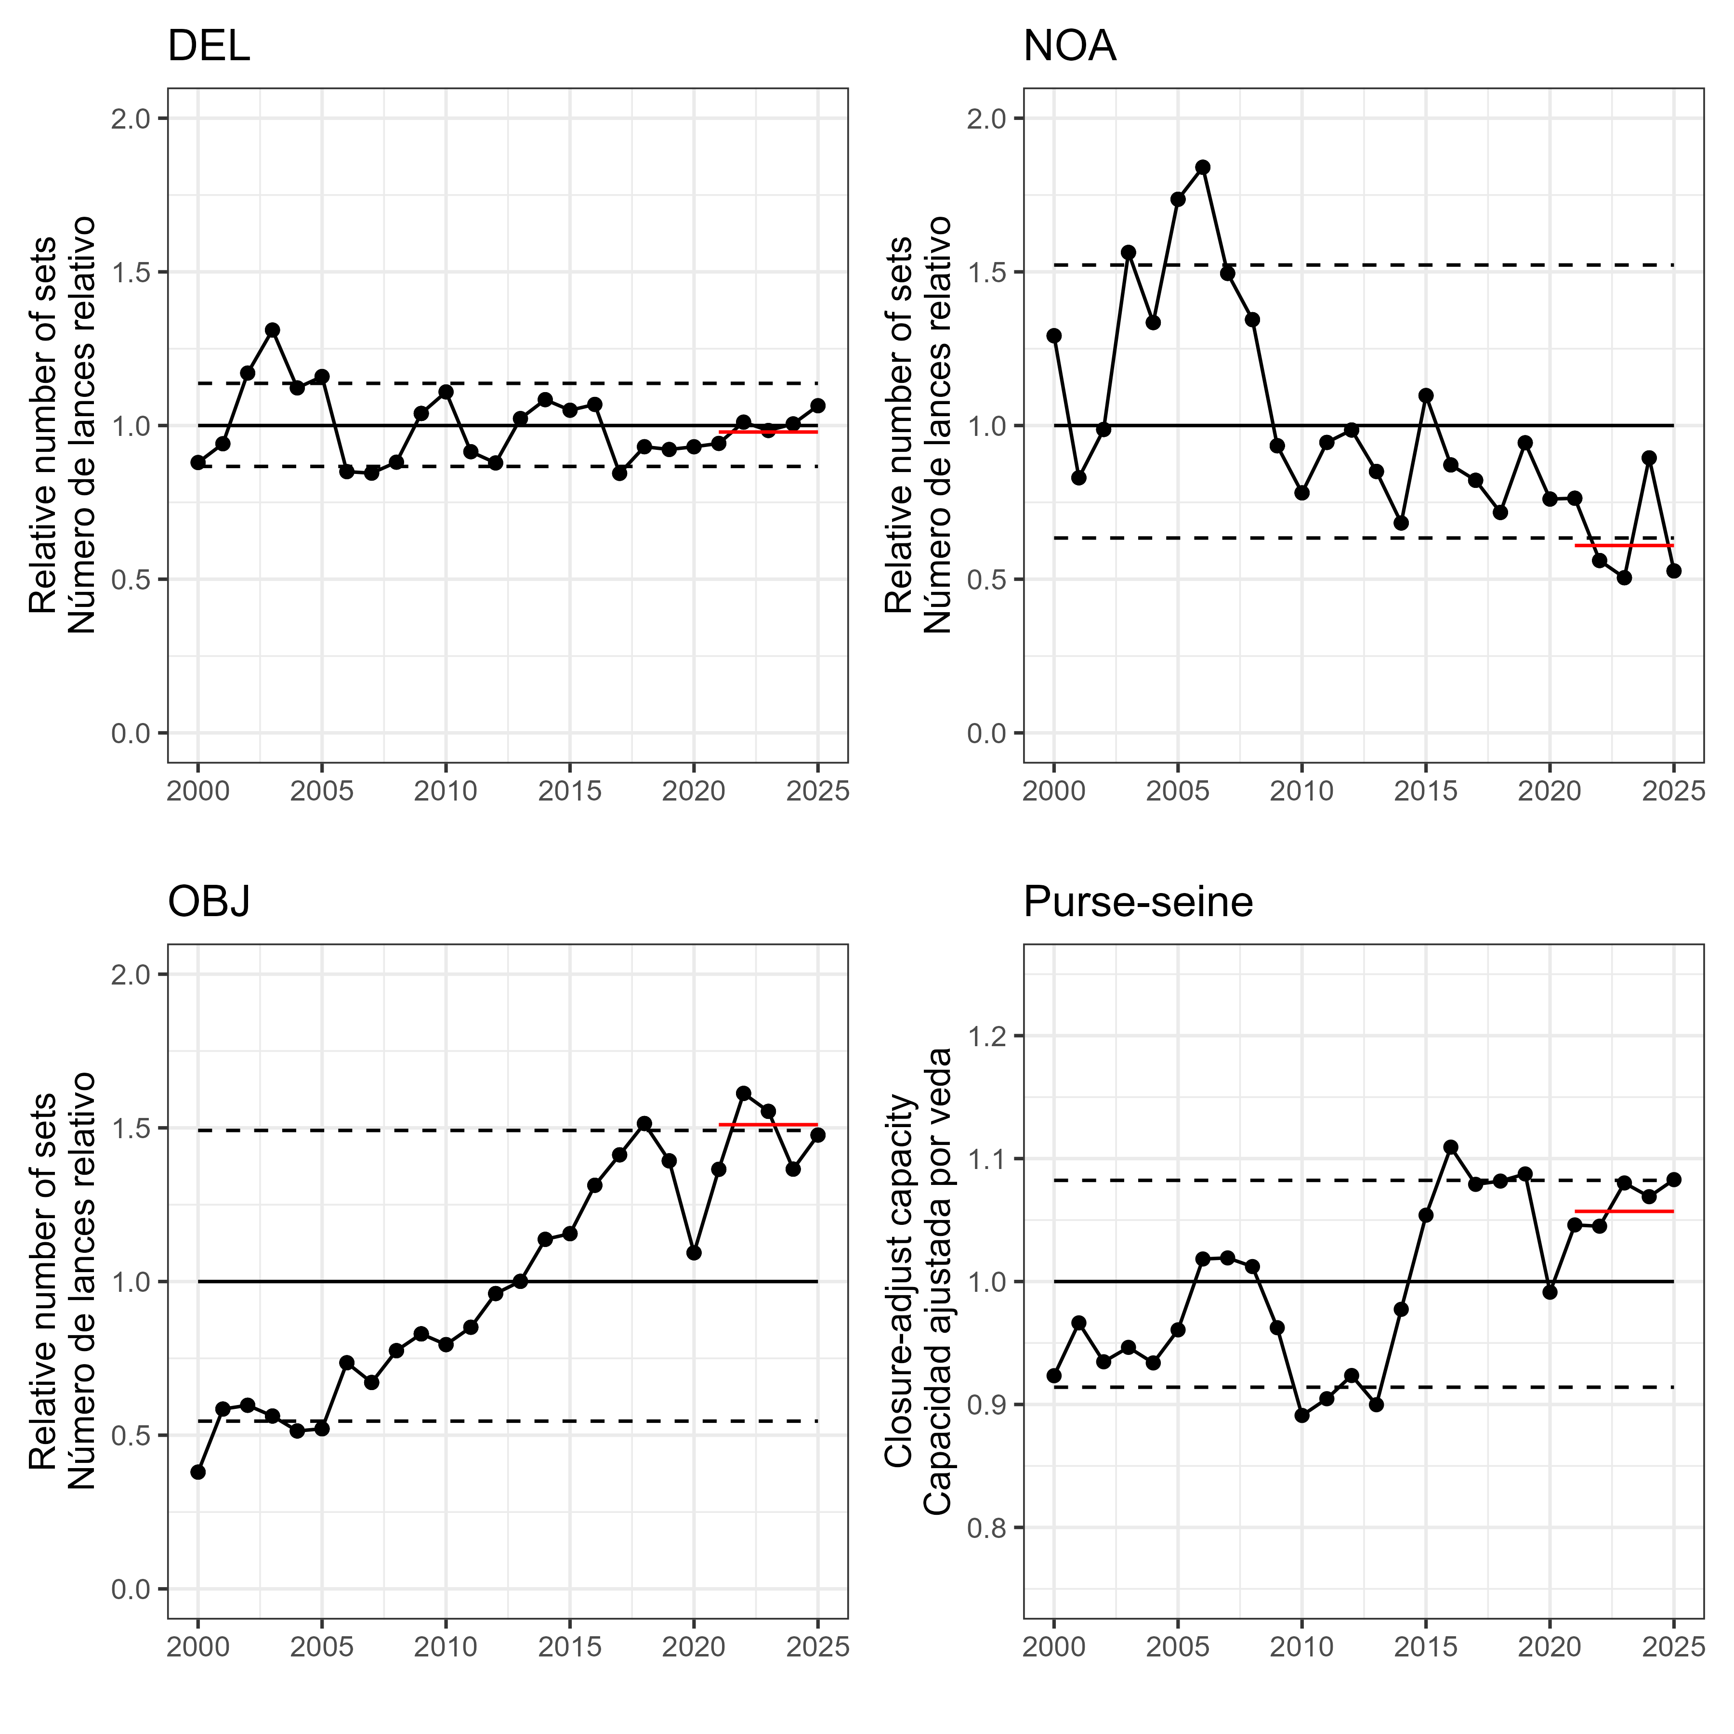
Figure 1
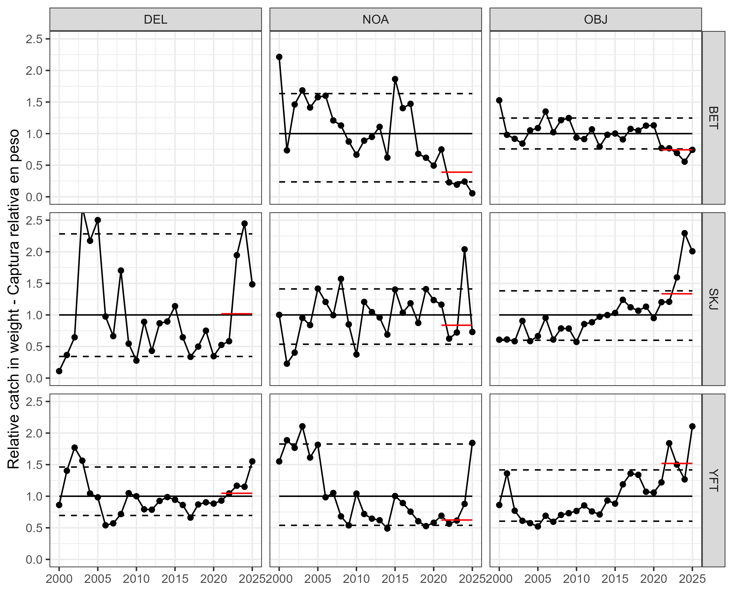
Figure 2a
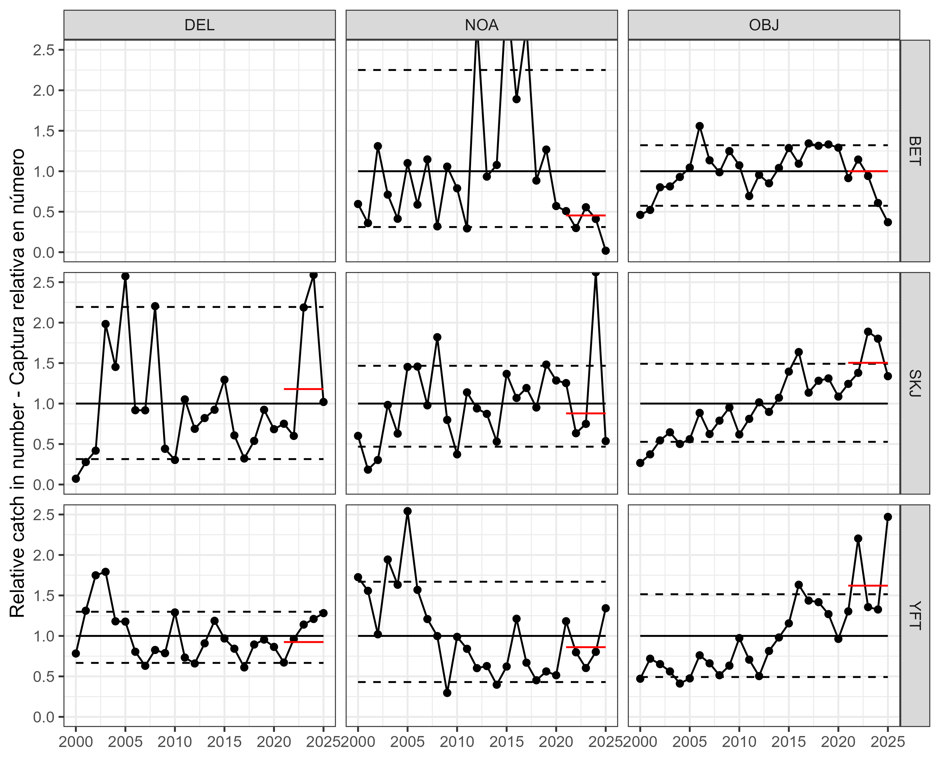
Figure 2b
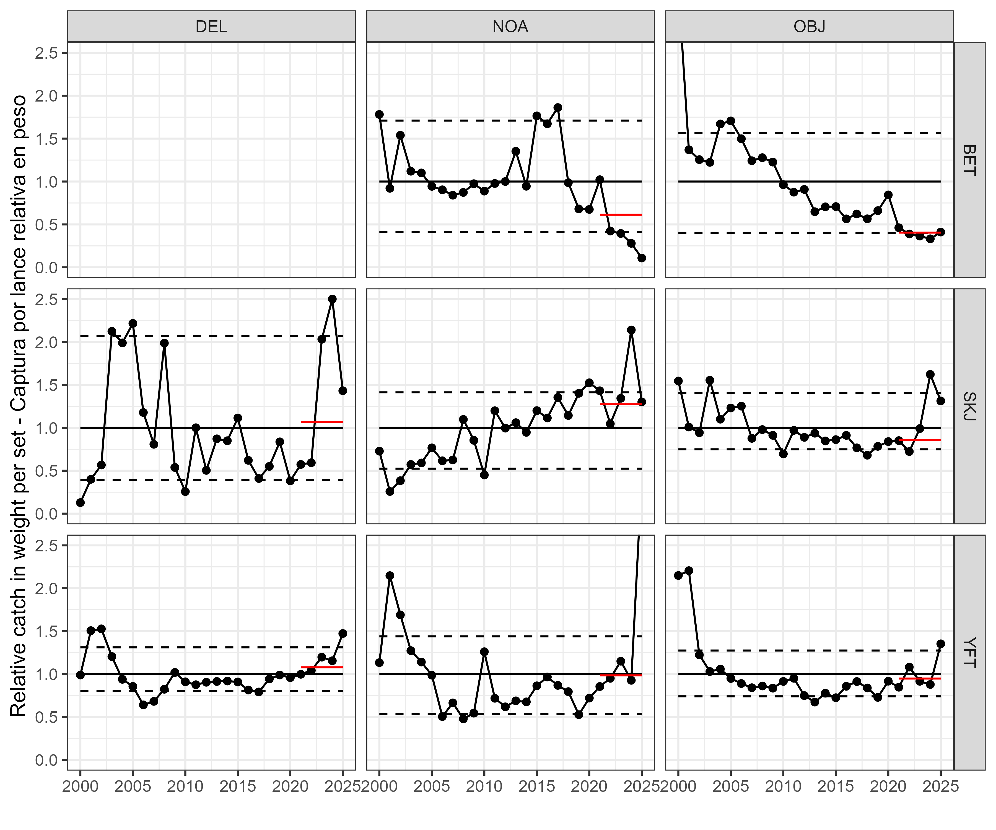
Figure 3
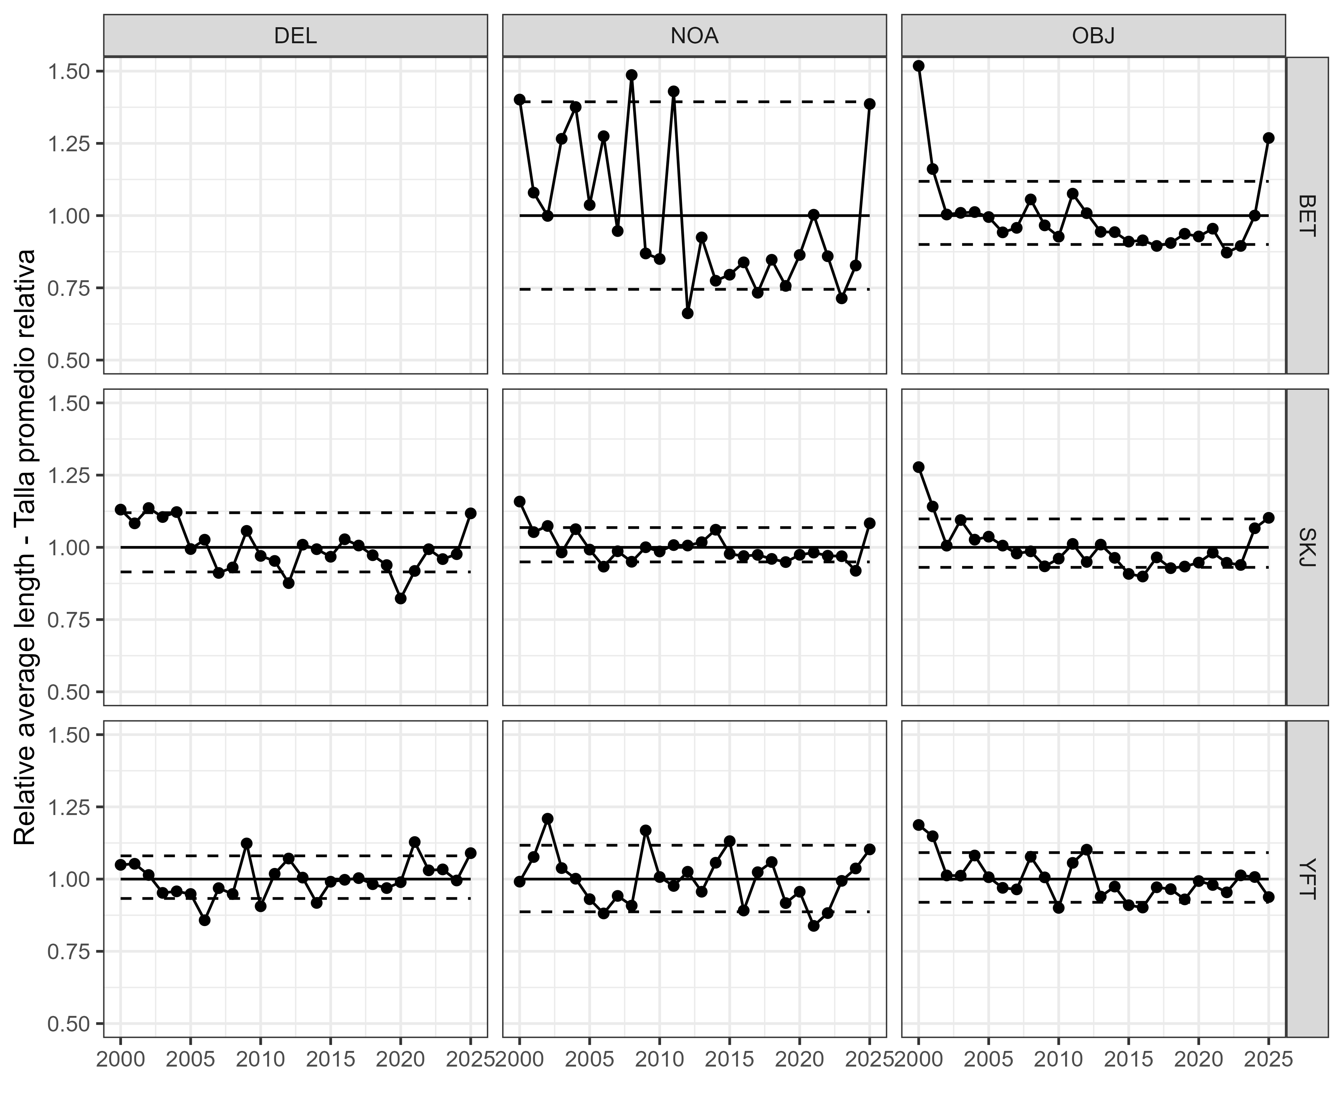
Figure 4
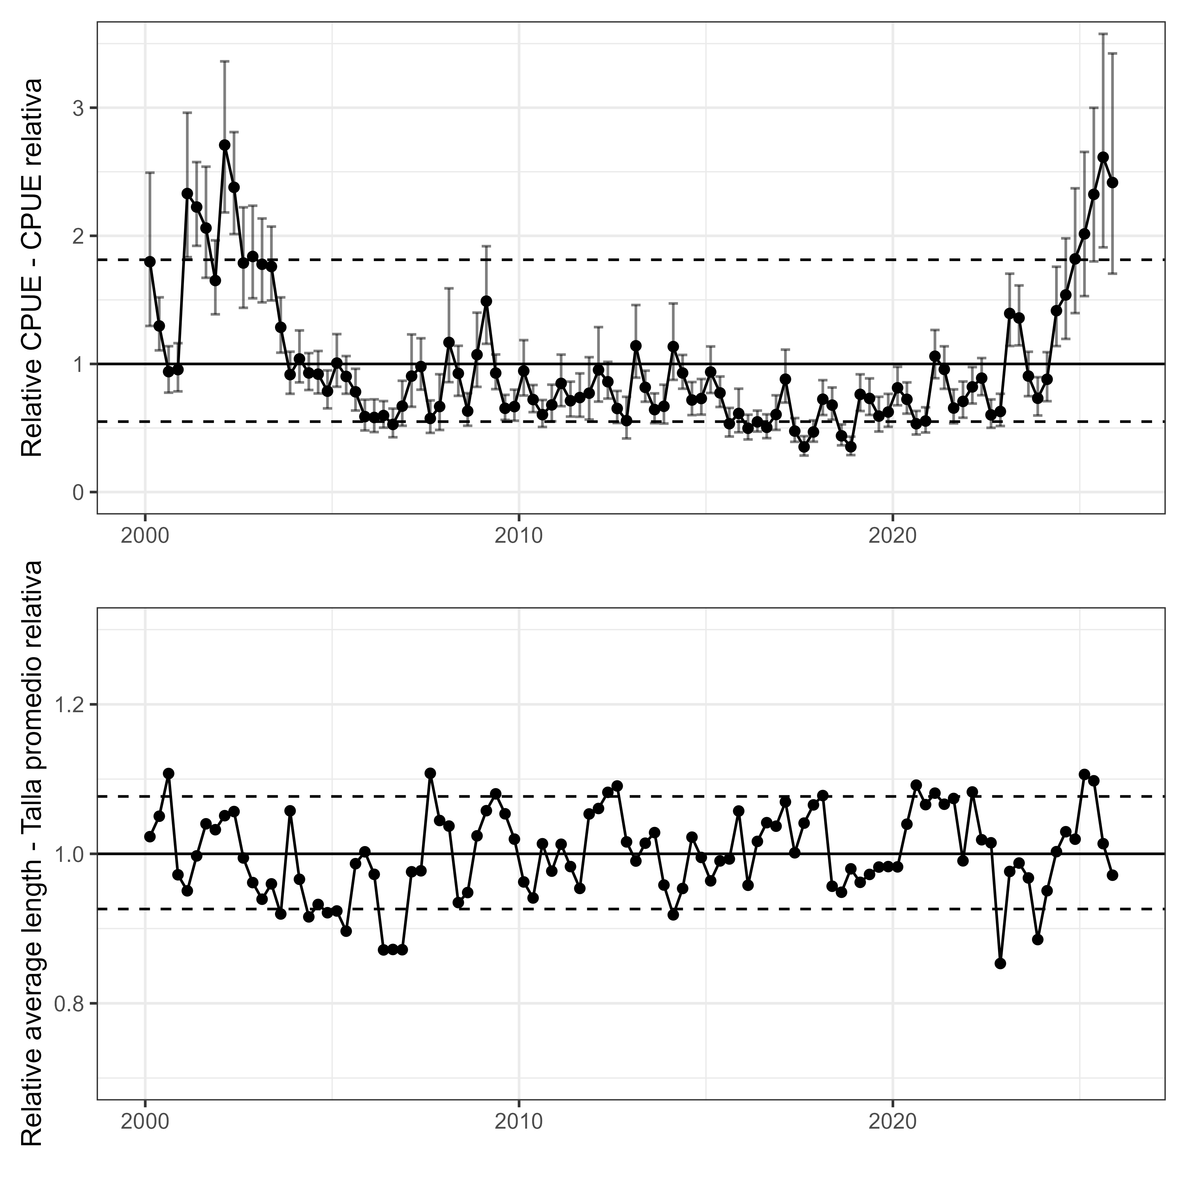
Figure 5
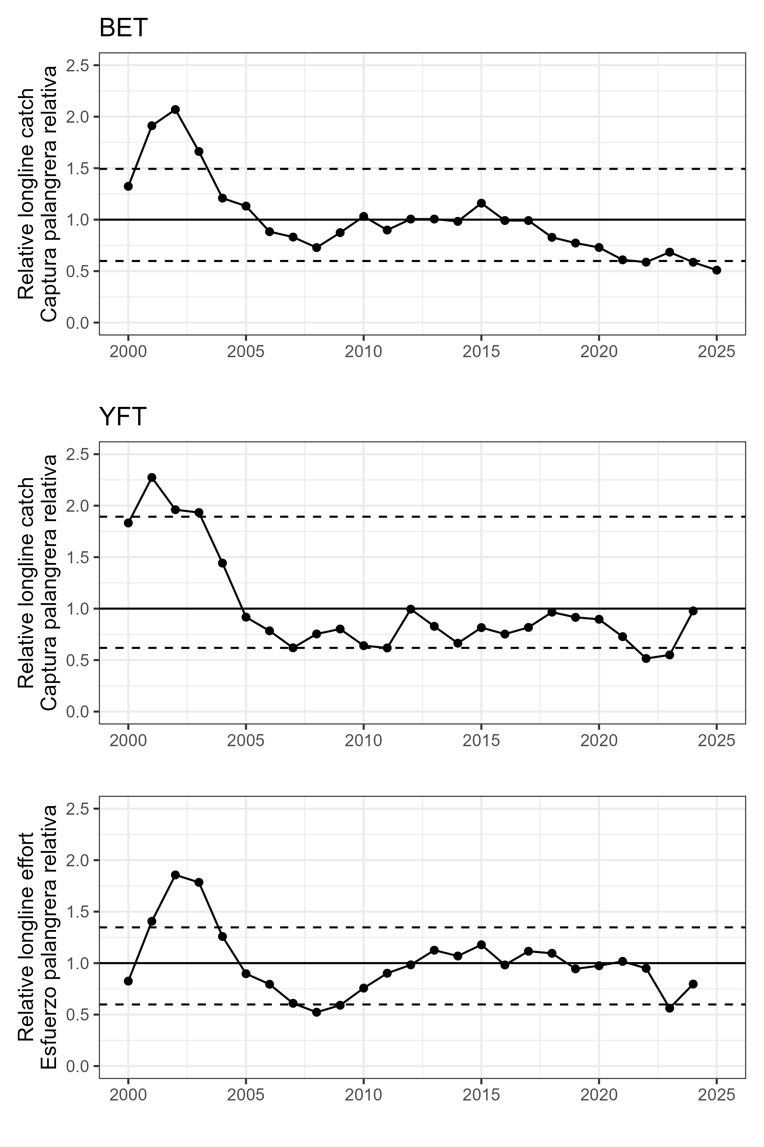
Figure 6
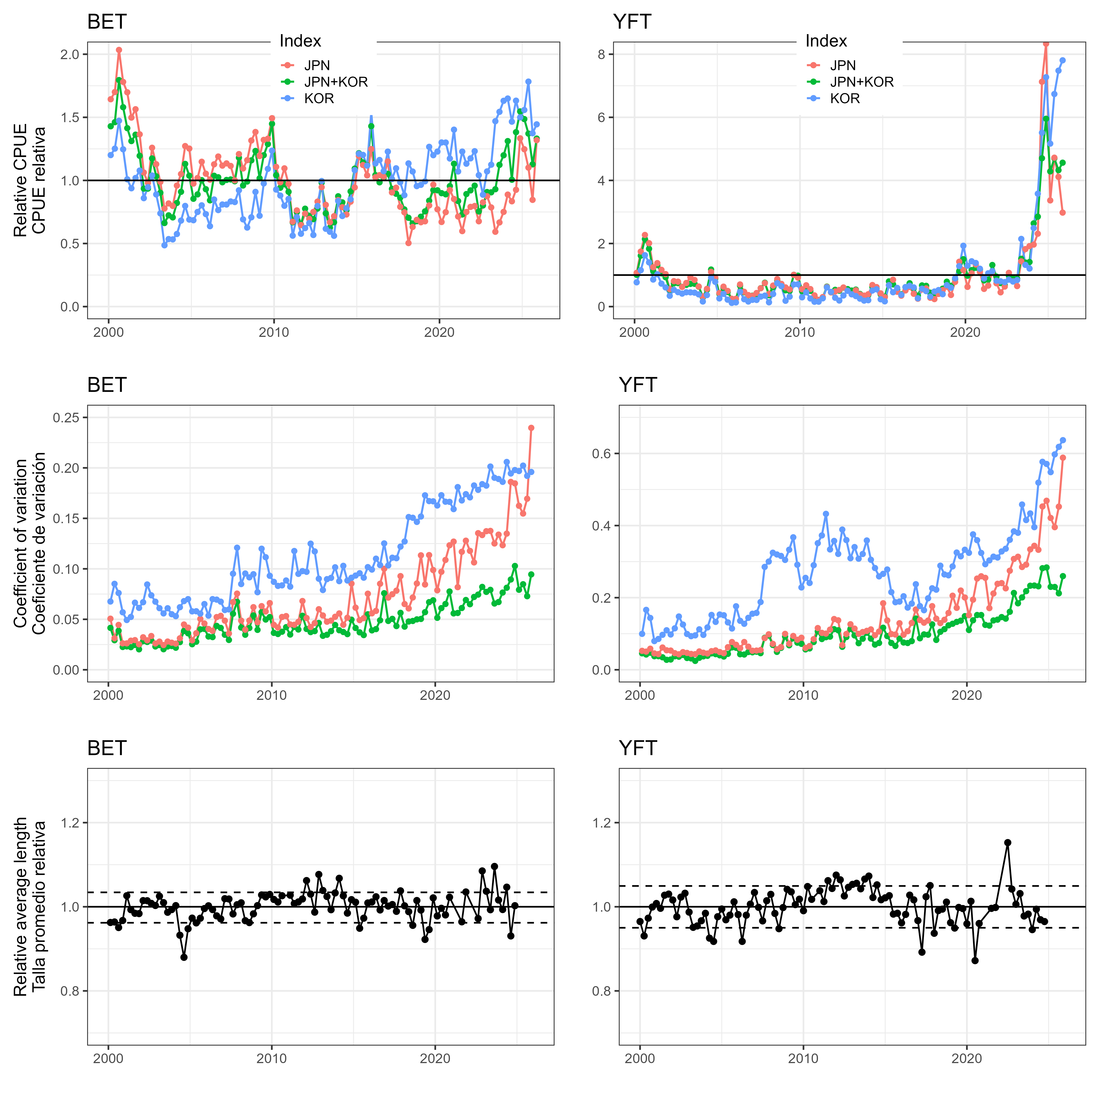
Figure 7

Tables
YFT DEL index
Year | est | lwr | upr | log_est | se | se_natural | type | CPUE | Low | High
2000.125 | 19859.637 | 14323.583 | 27535.371 | 9.896445 | 0.1667286 | 18374.750 | index | 1.7977807 | 1.2966253 | 2.4926365
2000.375 | 14322.902 | 12217.336 | 16791.347 | 9.569615 | 0.0811259 | 13782.067 | index | 1.2965714 | 1.1059632 | 1.5200302
2000.625 | 10383.034 | 8571.778 | 12577.017 | 9.247928 | 0.0978069 | 9933.193 | index | 0.9399174 | 0.7759519 | 1.1385303
2000.875 | 10556.145 | 8680.744 | 12836.710 | 9.264463 | 0.0997982 | 10077.606 | index | 0.9555881 | 0.7858159 | 1.1620390
2001.125 | 25737.474 | 20252.816 | 32707.429 | 10.155703 | 0.1222748 | 24253.392 | index | 2.3298680 | 1.8333649 | 2.9608318
2001.375 | 24576.838 | 21229.979 | 28451.322 | 10.109560 | 0.0746902 | 23772.556 | index | 2.2248023 | 1.9218248 | 2.5755444
2001.625 | 22765.616 | 18473.171 | 28055.459 | 10.033007 | 0.1065999 | 21678.747 | index | 2.0608426 | 1.6722653 | 2.5397119
2001.875 | 18239.218 | 15326.775 | 21705.094 | 9.811329 | 0.0887633 | 17452.432 | index | 1.6510933 | 1.3874419 | 1.9648458
2002.125 | 29920.505 | 24106.394 | 37136.894 | 10.306299 | 0.1102402 | 28208.177 | index | 2.7085342 | 2.1822070 | 3.3618065
2002.375 | 26275.423 | 22244.477 | 31036.820 | 10.176389 | 0.0849711 | 25052.236 | index | 2.3785655 | 2.0136607 | 2.8095965
2002.625 | 19749.288 | 15885.798 | 24552.393 | 9.890873 | 0.1110693 | 18588.243 | index | 1.7877914 | 1.4380458 | 2.2225983
2002.875 | 20312.182 | 16710.216 | 24690.569 | 9.918976 | 0.0995939 | 19233.042 | index | 1.8387471 | 1.5126760 | 2.2351057
2003.125 | 19642.281 | 16356.071 | 23588.746 | 9.885440 | 0.0934126 | 18657.966 | index | 1.7781047 | 1.4806177 | 2.1353631
2003.375 | 19445.441 | 16518.312 | 22891.272 | 9.875368 | 0.0832378 | 18578.954 | index | 1.7602859 | 1.4953050 | 2.0722237
2003.625 | 14204.394 | 12018.143 | 16788.352 | 9.561307 | 0.0852740 | 13605.466 | index | 1.2858435 | 1.0879312 | 1.5197593
2003.875 | 10126.664 | 8473.028 | 12103.030 | 9.222927 | 0.0909629 | 9697.625 | index | 0.9167096 | 0.7670129 | 1.0956225
2004.125 | 11479.722 | 9455.017 | 13937.999 | 9.348337 | 0.0990001 | 10967.023 | index | 1.0391943 | 0.8559062 | 1.2617328
2004.375 | 10269.037 | 8800.455 | 11982.690 | 9.236889 | 0.0787411 | 9939.083 | index | 0.9295979 | 0.7966532 | 1.0847283
2004.625 | 10166.524 | 8497.708 | 12163.070 | 9.226856 | 0.0914833 | 9756.395 | index | 0.9203180 | 0.7692470 | 1.1010576
2004.875 | 8699.530 | 7214.166 | 10490.723 | 9.071024 | 0.0955234 | 8312.723 | index | 0.7875193 | 0.6530555 | 0.9496692
2005.125 | 11119.781 | 9078.003 | 13620.787 | 9.316481 | 0.1035077 | 10589.841 | index | 1.0066110 | 0.8217772 | 1.2330174
2005.375 | 9968.732 | 8473.715 | 11727.515 | 9.207209 | 0.0829017 | 9631.883 | index | 0.9024130 | 0.7670753 | 1.0616288
2005.625 | 8643.450 | 7028.362 | 10629.679 | 9.064557 | 0.1055367 | 8269.701 | index | 0.7824427 | 0.6362354 | 0.9622484
2005.875 | 6505.457 | 5312.121 | 7966.869 | 8.780397 | 0.1033949 | 6228.046 | index | 0.5889023 | 0.4808745 | 0.7211984
2006.125 | 6431.076 | 5172.529 | 7995.845 | 8.768897 | 0.1111143 | 6130.123 | index | 0.5821690 | 0.4682380 | 0.7238215
2006.375 | 6597.517 | 5548.873 | 7844.337 | 8.794449 | 0.0883172 | 6369.719 | index | 0.5972359 | 0.5023065 | 0.7101057
2006.625 | 5832.357 | 4725.776 | 7198.053 | 8.671176 | 0.1073435 | 5560.766 | index | 0.5279703 | 0.4277962 | 0.6516016
2006.875 | 7407.487 | 5716.992 | 9597.857 | 8.910246 | 0.1321700 | 6941.488 | index | 0.6705580 | 0.5175245 | 0.8688439
2007.125 | 9995.921 | 7350.789 | 13592.886 | 9.209932 | 0.1568240 | 9251.586 | index | 0.9048743 | 0.6654217 | 1.2304941
2007.375 | 10818.459 | 8825.696 | 13261.171 | 9.289009 | 0.1038725 | 10279.044 | index | 0.9793340 | 0.7989374 | 1.2004633
2007.625 | 6349.428 | 5100.563 | 7904.074 | 8.756120 | 0.1117437 | 6004.271 | index | 0.5747778 | 0.4617233 | 0.7155140
2007.875 | 7374.006 | 5352.055 | 10159.831 | 8.905716 | 0.1635135 | 6773.465 | index | 0.6675271 | 0.4844884 | 0.9197175
2008.125 | 12901.530 | 9476.323 | 17564.773 | 9.465101 | 0.1574261 | 11872.018 | index | 1.1679026 | 0.8578331 | 1.5900487
2008.375 | 10229.291 | 8296.820 | 12611.866 | 9.233011 | 0.1068300 | 9713.699 | index | 0.9259999 | 0.7510614 | 1.1416854
2008.625 | 6982.767 | 5716.708 | 8529.217 | 8.851201 | 0.1020693 | 6688.122 | index | 0.6321105 | 0.5174994 | 0.7721046
2008.875 | 11844.002 | 9068.617 | 15468.773 | 9.379577 | 0.1362279 | 11134.354 | index | 1.0721705 | 0.8209266 | 1.4003075
2009.125 | 16459.927 | 12781.044 | 21197.738 | 9.708684 | 0.1290665 | 15558.419 | index | 1.4900242 | 1.1569903 | 1.9189203
2009.375 | 10260.816 | 8873.802 | 11864.628 | 9.236088 | 0.0740978 | 10047.186 | index | 0.9288537 | 0.8032930 | 1.0740406
2009.625 | 7220.842 | 6220.108 | 8382.583 | 8.884727 | 0.0761159 | 7081.023 | index | 0.6536621 | 0.5630696 | 0.7588299
2009.875 | 7368.592 | 6148.931 | 8830.176 | 8.904982 | 0.0923223 | 7144.448 | index | 0.6670370 | 0.5566261 | 0.7993486
2010.125 | 10440.567 | 8321.846 | 13098.708 | 9.253454 | 0.1157239 | 9978.801 | index | 0.9451255 | 0.7533265 | 1.1857570
2010.375 | 7975.688 | 6891.270 | 9230.751 | 8.984153 | 0.0745639 | 7774.543 | index | 0.7219940 | 0.6238261 | 0.8356100
2010.625 | 6674.813 | 5613.094 | 7937.358 | 8.806097 | 0.0883890 | 6433.461 | index | 0.6042331 | 0.5081200 | 0.7185264
2010.875 | 7515.685 | 6099.149 | 9261.212 | 8.924747 | 0.1065544 | 7138.857 | index | 0.6803525 | 0.5521194 | 0.8383684
2011.125 | 9368.817 | 7405.131 | 11853.231 | 9.145142 | 0.1200092 | 8831.147 | index | 0.8481060 | 0.6703418 | 1.0730106
2011.375 | 7871.303 | 6507.466 | 9520.973 | 8.970979 | 0.0970801 | 7498.160 | index | 0.7125446 | 0.5890821 | 0.8618829
2011.625 | 8148.352 | 6488.532 | 10232.768 | 9.005571 | 0.1162161 | 7684.404 | index | 0.7376243 | 0.5873676 | 0.9263186
2011.875 | 8524.942 | 6248.693 | 11630.373 | 9.050752 | 0.1584845 | 7865.323 | index | 0.7717148 | 0.5656557 | 1.0528380
2012.125 | 10530.110 | 7796.292 | 14222.559 | 9.261994 | 0.1533653 | 9802.105 | index | 0.9532314 | 0.7057504 | 1.2874950
2012.375 | 9510.744 | 8056.501 | 11227.487 | 9.160177 | 0.0846663 | 9204.061 | index | 0.8609539 | 0.7293072 | 1.0163641
2012.625 | 7205.213 | 5954.093 | 8719.229 | 8.882560 | 0.0973109 | 6931.882 | index | 0.6522472 | 0.5389885 | 0.7893053
2012.875 | 6160.079 | 4619.540 | 8214.362 | 8.725845 | 0.1468366 | 5784.101 | index | 0.5576372 | 0.4181787 | 0.7436037
2013.125 | 12610.737 | 9861.412 | 16126.564 | 9.442304 | 0.1254713 | 11922.819 | index | 1.1415788 | 0.8926939 | 1.4598533
2013.375 | 9027.811 | 7786.820 | 10466.578 | 9.108065 | 0.0754490 | 8796.396 | index | 0.8172367 | 0.7048949 | 0.9474828
2013.625 | 7109.673 | 5939.573 | 8510.283 | 8.869212 | 0.0917461 | 6863.509 | index | 0.6435985 | 0.5376742 | 0.7703904
2013.875 | 7394.941 | 5907.731 | 9256.540 | 8.908551 | 0.1145604 | 7020.322 | index | 0.6694222 | 0.5347913 | 0.8379457
2014.125 | 12541.817 | 9671.687 | 16263.674 | 9.436824 | 0.1325870 | 11855.553 | index | 1.1353398 | 0.8755190 | 1.4722656
2014.375 | 10263.613 | 8909.038 | 11824.145 | 9.236360 | 0.0722149 | 10036.083 | index | 0.9291069 | 0.8064828 | 1.0703758
2014.625 | 7935.338 | 6636.264 | 9488.709 | 8.979081 | 0.0912143 | 7681.654 | index | 0.7183413 | 0.6007415 | 0.8589621
2014.875 | 8066.169 | 6674.716 | 9747.693 | 8.995434 | 0.0966099 | 7755.055 | index | 0.7301847 | 0.6042222 | 0.8824067
2015.125 | 10354.843 | 8539.785 | 12555.676 | 9.245210 | 0.0983276 | 9947.007 | index | 0.9373654 | 0.7730557 | 1.1365984
2015.375 | 8550.340 | 7335.729 | 9966.060 | 9.053726 | 0.0781720 | 8298.635 | index | 0.7740140 | 0.6640603 | 0.9021736
2015.625 | 5893.529 | 4787.284 | 7255.406 | 8.681610 | 0.1060692 | 5621.077 | index | 0.5335079 | 0.4333641 | 0.6567934
2015.875 | 6777.171 | 5153.354 | 8912.653 | 8.821315 | 0.1397536 | 6381.846 | index | 0.6134990 | 0.4665016 | 0.8068162
2016.125 | 5499.963 | 4534.917 | 6670.374 | 8.612497 | 0.0984378 | 5277.289 | index | 0.4978806 | 0.4105190 | 0.6038334
2016.375 | 6052.483 | 5214.596 | 7025.004 | 8.708224 | 0.0760254 | 5874.160 | index | 0.5478971 | 0.4720466 | 0.6359356
2016.625 | 5582.542 | 4648.337 | 6704.499 | 8.627399 | 0.0934378 | 5348.542 | index | 0.5053559 | 0.4207863 | 0.6069224
2016.875 | 6686.286 | 5357.510 | 8344.627 | 8.807814 | 0.1130425 | 6313.311 | index | 0.6052717 | 0.4849831 | 0.7553950
2017.125 | 9731.652 | 7711.303 | 12281.328 | 9.183139 | 0.1187249 | 9130.616 | index | 0.8809514 | 0.6980577 | 1.1117640
2017.375 | 5257.368 | 4331.883 | 6380.579 | 8.567386 | 0.0987917 | 4982.761 | index | 0.4759199 | 0.3921395 | 0.5775998
2017.625 | 3895.327 | 3146.792 | 4821.918 | 8.267533 | 0.1088765 | 3685.580 | index | 0.3526219 | 0.2848602 | 0.4365027
2017.875 | 5181.836 | 4341.601 | 6184.681 | 8.552915 | 0.0902650 | 4944.660 | index | 0.4690823 | 0.3930194 | 0.5598661
2018.125 | 8004.965 | 6640.536 | 9649.743 | 8.987817 | 0.0953432 | 7597.521 | index | 0.7246443 | 0.6011282 | 0.8735397
2018.375 | 7497.624 | 6233.110 | 9018.672 | 8.922341 | 0.0942420 | 7122.532 | index | 0.6787176 | 0.5642463 | 0.8164122
2018.625 | 4849.919 | 4029.747 | 5837.019 | 8.486717 | 0.0945213 | 4616.033 | index | 0.4390357 | 0.3647890 | 0.5283941
2018.875 | 3902.562 | 3188.459 | 4776.600 | 8.269389 | 0.1031119 | 3700.909 | index | 0.3532769 | 0.2886321 | 0.4324002
2019.125 | 8422.999 | 6987.527 | 10153.363 | 9.038721 | 0.0953278 | 7969.802 | index | 0.7624865 | 0.6325392 | 0.9191298
2019.375 | 8072.583 | 6648.633 | 9801.504 | 8.996229 | 0.0990132 | 7637.668 | index | 0.7307653 | 0.6018610 | 0.8872779
2019.625 | 6547.847 | 5217.543 | 8217.334 | 8.786891 | 0.1158744 | 6138.167 | index | 0.5927395 | 0.4723127 | 0.7438719
2019.875 | 6900.561 | 5624.515 | 8466.107 | 8.839358 | 0.1043224 | 6517.478 | index | 0.6246688 | 0.5091536 | 0.7663917
2020.125 | 8988.559 | 7480.612 | 10800.480 | 9.103708 | 0.0936946 | 8512.402 | index | 0.8136835 | 0.6771752 | 0.9777097
2020.375 | 7995.621 | 6760.070 | 9456.997 | 8.986649 | 0.0856449 | 7621.850 | index | 0.7237984 | 0.6119490 | 0.8560912
2020.625 | 5890.175 | 4959.704 | 6995.208 | 8.681041 | 0.0877259 | 5614.314 | index | 0.5332042 | 0.4489725 | 0.6332387
2020.875 | 6125.524 | 5133.628 | 7309.068 | 8.720220 | 0.0901300 | 5818.443 | index | 0.5545090 | 0.4647169 | 0.6616508
2021.125 | 11710.601 | 9813.201 | 13974.865 | 9.368250 | 0.0901883 | 11053.445 | index | 1.0600945 | 0.8883308 | 1.2650697
2021.375 | 10575.439 | 8898.082 | 12568.990 | 9.266289 | 0.0881131 | 9988.810 | index | 0.9573347 | 0.8054905 | 1.1378033
2021.625 | 7244.515 | 5926.356 | 8855.863 | 8.888000 | 0.1024688 | 6776.045 | index | 0.6558050 | 0.5364776 | 0.8016742
2021.875 | 7815.406 | 6406.140 | 9534.693 | 8.963852 | 0.1014509 | 7299.095 | index | 0.7074846 | 0.5799095 | 0.8631250
2022.125 | 9068.335 | 7629.759 | 10778.152 | 9.112544 | 0.0881304 | 8524.009 | index | 0.8209051 | 0.6906768 | 0.9756883
2022.375 | 9822.182 | 8348.905 | 11555.438 | 9.192399 | 0.0829162 | 9268.986 | index | 0.8891466 | 0.7557770 | 1.0460516
2022.625 | 6653.389 | 5540.592 | 7989.683 | 8.802882 | 0.0933817 | 6229.529 | index | 0.6022937 | 0.5015568 | 0.7232633
2022.875 | 6948.582 | 5696.982 | 8475.153 | 8.846293 | 0.1013290 | 6474.653 | index | 0.6290159 | 0.5157137 | 0.7672105
2023.125 | 15399.397 | 12593.789 | 18830.029 | 9.642084 | 0.1026164 | 14269.125 | index | 1.3940203 | 1.1400404 | 1.7045824
2023.375 | 15008.813 | 12644.222 | 17815.605 | 9.616393 | 0.0874696 | 14015.082 | index | 1.3586630 | 1.1446063 | 1.6127511
2023.625 | 10000.740 | 8267.901 | 12096.758 | 9.210414 | 0.0970826 | 9294.797 | index | 0.9053105 | 0.7484437 | 1.0950550
2023.875 | 8087.335 | 6602.085 | 9906.717 | 8.998055 | 0.1035293 | 7469.846 | index | 0.7321007 | 0.5976472 | 0.8968024
2024.125 | 9723.135 | 7836.143 | 12064.526 | 9.182263 | 0.1100843 | 8824.420 | index | 0.8801805 | 0.7093590 | 1.0921377
2024.375 | 15637.356 | 12586.452 | 19427.787 | 9.657418 | 0.1107376 | 14030.429 | index | 1.4155615 | 1.1393758 | 1.7586948
2024.625 | 16997.318 | 13205.029 | 21878.697 | 9.740811 | 0.1288074 | 14952.428 | index | 1.5386711 | 1.1953711 | 1.9805640
2024.875 | 20102.854 | 15429.549 | 26191.609 | 9.908617 | 0.1349909 | 17347.574 | index | 1.8197977 | 1.3967431 | 2.3709899
2025.125 | 22259.928 | 16895.710 | 29327.230 | 10.010543 | 0.1406803 | 18892.139 | index | 2.0150655 | 1.5294654 | 2.6548419
2025.375 | 25668.180 | 19886.207 | 33131.278 | 10.153007 | 0.1302196 | 21734.305 | index | 2.3235952 | 1.8001775 | 2.9992014
2025.625 | 28869.948 | 21098.464 | 39504.008 | 10.270556 | 0.1600034 | 23442.016 | index | 2.6134332 | 1.9099137 | 3.5760952
2025.875 | 26686.731 | 18830.814 | 37820.013 | 10.191922 | 0.1778971 | 20843.076 | index | 2.4157990 | 1.7046362 | 3.4236540

BET LL index
Category | Time | Stratum | Units | Estimate | Std..Error.for.Estimate | Std..Error.for.ln.Estimate. | Index | Year | CPUE | low | high | Low | High
1 | 101 | Stratum_1 | [kg] | 28804468 | 1172760.5 | 0.0414965 | JPN+KOR | 2000.125 | 1.4291397 | 0.7144765 | 1.368459 | 1.3175045 | 1.5502339
1 | 102 | Stratum_1 | [kg] | 29454161 | 849098.5 | 0.0292795 | JPN+KOR | 2000.375 | 1.4613743 | 0.7144765 | 1.368459 | 1.3798703 | 1.5476925
1 | 103 | Stratum_1 | [kg] | 36180806 | 1377155.3 | 0.0386892 | JPN+KOR | 2000.625 | 1.7951182 | 0.7144765 | 1.368459 | 1.6640262 | 1.9365376
1 | 104 | Stratum_1 | [kg] | 31847907 | 710720.5 | 0.0225839 | JPN+KOR | 2000.875 | 1.5801405 | 0.7144765 | 1.368459 | 1.5117218 | 1.6516558
1 | 105 | Stratum_1 | [kg] | 28500355 | 652779.4 | 0.0231508 | JPN+KOR | 2001.125 | 1.4140510 | 0.7144765 | 1.368459 | 1.3513216 | 1.4796924
1 | 106 | Stratum_1 | [kg] | 26439088 | 586078.1 | 0.0224165 | JPN+KOR | 2001.375 | 1.3117809 | 0.7144765 | 1.368459 | 1.2553937 | 1.3707007
1 | 107 | Stratum_1 | [kg] | 27460717 | 666184.2 | 0.0245410 | JPN+KOR | 2001.625 | 1.3624692 | 0.7144765 | 1.368459 | 1.2984851 | 1.4296061
1 | 108 | Stratum_1 | [kg] | 24088478 | 482738.2 | 0.0202646 | JPN+KOR | 2001.875 | 1.1951548 | 0.7144765 | 1.368459 | 1.1486153 | 1.2435801
1 | 109 | Stratum_1 | [kg] | 18843521 | 526529.8 | 0.0283136 | JPN+KOR | 2002.125 | 0.9349252 | 0.7144765 | 1.368459 | 0.8844552 | 0.9882752
1 | 110 | Stratum_1 | [kg] | 18848271 | 511651.6 | 0.0275548 | JPN+KOR | 2002.375 | 0.9351609 | 0.7144765 | 1.368459 | 0.8859948 | 0.9870552
1 | 111 | Stratum_1 | [kg] | 23664937 | 674271.4 | 0.0289156 | JPN+KOR | 2002.625 | 1.1741408 | 0.7144765 | 1.368459 | 1.1094473 | 1.2426066
1 | 112 | Stratum_1 | [kg] | 20809614 | 474392.0 | 0.0230906 | JPN+KOR | 2002.875 | 1.0324733 | 0.7144765 | 1.368459 | 0.9867876 | 1.0802742
1 | 113 | Stratum_1 | [kg] | 18185859 | 438638.4 | 0.0244377 | JPN+KOR | 2003.125 | 0.9022952 | 0.7144765 | 1.368459 | 0.8600958 | 0.9465650
1 | 114 | Stratum_1 | [kg] | 13348654 | 268689.8 | 0.0203602 | JPN+KOR | 2003.375 | 0.6622962 | 0.7144765 | 1.368459 | 0.6363870 | 0.6892603
1 | 115 | Stratum_1 | [kg] | 14569392 | 331746.8 | 0.0230649 | JPN+KOR | 2003.625 | 0.7228634 | 0.7144765 | 1.368459 | 0.6909124 | 0.7562920
1 | 116 | Stratum_1 | [kg] | 14245314 | 330789.6 | 0.0235236 | JPN+KOR | 2003.875 | 0.7067842 | 0.7144765 | 1.368459 | 0.6749368 | 0.7401344
1 | 117 | Stratum_1 | [kg] | 16552313 | 356792.9 | 0.0218479 | JPN+KOR | 2004.125 | 0.8212464 | 0.7144765 | 1.368459 | 0.7868215 | 0.8571776
1 | 118 | Stratum_1 | [kg] | 18334232 | 494088.6 | 0.0273879 | JPN+KOR | 2004.375 | 0.9096568 | 0.7144765 | 1.368459 | 0.8621137 | 0.9598217
1 | 119 | Stratum_1 | [kg] | 22790153 | 857176.8 | 0.0383699 | JPN+KOR | 2004.625 | 1.1307382 | 0.7144765 | 1.368459 | 1.0488199 | 1.2190547
1 | 120 | Stratum_1 | [kg] | 20907407 | 740481.6 | 0.0361324 | JPN+KOR | 2004.875 | 1.0373253 | 0.7144765 | 1.368459 | 0.9664034 | 1.1134521
1 | 121 | Stratum_1 | [kg] | 17224503 | 428842.3 | 0.0253101 | JPN+KOR | 2005.125 | 0.8545973 | 0.7144765 | 1.368459 | 0.8132370 | 0.8980612
1 | 122 | Stratum_1 | [kg] | 17922262 | 489414.9 | 0.0277938 | JPN+KOR | 2005.375 | 0.8892167 | 0.7144765 | 1.368459 | 0.8420717 | 0.9390013
1 | 123 | Stratum_1 | [kg] | 20196374 | 790738.8 | 0.0400546 | JPN+KOR | 2005.625 | 1.0020473 | 0.7144765 | 1.368459 | 0.9263884 | 1.0838854
1 | 124 | Stratum_1 | [kg] | 18749154 | 740949.6 | 0.0404832 | JPN+KOR | 2005.875 | 0.9302432 | 0.7144765 | 1.368459 | 0.8592835 | 1.0070627
1 | 125 | Stratum_1 | [kg] | 16970484 | 546991.5 | 0.0329546 | JPN+KOR | 2006.125 | 0.8419941 | 0.7144765 | 1.368459 | 0.7893281 | 0.8981742
1 | 126 | Stratum_1 | [kg] | 20896046 | 661094.3 | 0.0323835 | JPN+KOR | 2006.375 | 1.0367617 | 0.7144765 | 1.368459 | 0.9730016 | 1.1047000
1 | 127 | Stratum_1 | [kg] | 20655177 | 874650.3 | 0.0434706 | JPN+KOR | 2006.625 | 1.0248109 | 0.7144765 | 1.368459 | 0.9411109 | 1.1159549
1 | 128 | Stratum_1 | [kg] | 19861552 | 802135.2 | 0.0414649 | JPN+KOR | 2006.875 | 0.9854350 | 0.7144765 | 1.368459 | 0.9085155 | 1.0688670
1 | 129 | Stratum_1 | [kg] | 20226205 | 684775.8 | 0.0346957 | JPN+KOR | 2007.125 | 1.0035274 | 0.7144765 | 1.368459 | 0.9375526 | 1.0741448
1 | 130 | Stratum_1 | [kg] | 20304516 | 585870.9 | 0.0295406 | JPN+KOR | 2007.375 | 1.0074128 | 0.7144765 | 1.368459 | 0.9507405 | 1.0674633
1 | 131 | Stratum_1 | [kg] | 20023732 | 1077615.9 | 0.0554905 | JPN+KOR | 2007.625 | 0.9934816 | 0.7144765 | 1.368459 | 0.8910978 | 1.1076290
1 | 132 | Stratum_1 | [kg] | 23787833 | 1547231.8 | 0.0673080 | JPN+KOR | 2007.875 | 1.1802383 | 0.7144765 | 1.368459 | 1.0343701 | 1.3466770
1 | 133 | Stratum_1 | [kg] | 19341974 | 785296.2 | 0.0418247 | JPN+KOR | 2008.125 | 0.9596561 | 0.7144765 | 1.368459 | 0.8841251 | 1.0416396
1 | 134 | Stratum_1 | [kg] | 19976650 | 673594.4 | 0.0347079 | JPN+KOR | 2008.375 | 0.9911456 | 0.7144765 | 1.368459 | 0.9259627 | 1.0609172
1 | 135 | Stratum_1 | [kg] | 23354544 | 936163.4 | 0.0413899 | JPN+KOR | 2008.625 | 1.1587406 | 0.7144765 | 1.368459 | 1.0684505 | 1.2566607
1 | 136 | Stratum_1 | [kg] | 24858763 | 1293311.8 | 0.0538280 | JPN+KOR | 2008.875 | 1.2333727 | 0.7144765 | 1.368459 | 1.1098775 | 1.3706091
1 | 137 | Stratum_1 | [kg] | 20493637 | 784893.0 | 0.0395297 | JPN+KOR | 2009.125 | 1.0167960 | 0.7144765 | 1.368459 | 0.9409910 | 1.0987078
1 | 138 | Stratum_1 | [kg] | 24179472 | 1328512.7 | 0.0570867 | JPN+KOR | 2009.375 | 1.1996695 | 0.7144765 | 1.368459 | 1.0726756 | 1.3416982
1 | 139 | Stratum_1 | [kg] | 25958362 | 1246184.3 | 0.0497660 | JPN+KOR | 2009.625 | 1.2879295 | 0.7144765 | 1.368459 | 1.1682355 | 1.4198871
1 | 140 | Stratum_1 | [kg] | 29197478 | 1473758.8 | 0.0522224 | JPN+KOR | 2009.875 | 1.4486390 | 0.7144765 | 1.368459 | 1.3076983 | 1.6047699
1 | 141 | Stratum_1 | [kg] | 20994147 | 745693.9 | 0.0365520 | JPN+KOR | 2010.125 | 1.0416289 | 0.7144765 | 1.368459 | 0.9696151 | 1.1189913
1 | 142 | Stratum_1 | [kg] | 18984444 | 654341.7 | 0.0354410 | JPN+KOR | 2010.375 | 0.9419171 | 0.7144765 | 1.368459 | 0.8787083 | 1.0096729
1 | 143 | Stratum_1 | [kg] | 19526986 | 715035.4 | 0.0377065 | JPN+KOR | 2010.625 | 0.9688355 | 0.7144765 | 1.368459 | 0.8998158 | 1.0431492
1 | 144 | Stratum_1 | [kg] | 18336265 | 750382.1 | 0.0422006 | JPN+KOR | 2010.875 | 0.9097576 | 0.7144765 | 1.368459 | 0.8375366 | 0.9882062
1 | 145 | Stratum_1 | [kg] | 13461133 | 456185.5 | 0.0348942 | JPN+KOR | 2011.125 | 0.6678769 | 0.7144765 | 1.368459 | 0.6237260 | 0.7151531
1 | 146 | Stratum_1 | [kg] | 15094112 | 619486.2 | 0.0424569 | JPN+KOR | 2011.375 | 0.7488975 | 0.7144765 | 1.368459 | 0.6891002 | 0.8138838
1 | 147 | Stratum_1 | [kg] | 13104590 | 505932.4 | 0.0398907 | JPN+KOR | 2011.625 | 0.6501870 | 0.7144765 | 1.368459 | 0.6012881 | 0.7030625
1 | 148 | Stratum_1 | [kg] | 15636330 | 806722.3 | 0.0535073 | JPN+KOR | 2011.875 | 0.7757998 | 0.7144765 | 1.368459 | 0.6985594 | 0.8615807
1 | 149 | Stratum_1 | [kg] | 14500422 | 567636.9 | 0.0404194 | JPN+KOR | 2012.125 | 0.7194414 | 0.7144765 | 1.368459 | 0.6646450 | 0.7787555
1 | 150 | Stratum_1 | [kg] | 13967011 | 504602.1 | 0.0373311 | JPN+KOR | 2012.375 | 0.6929762 | 0.7144765 | 1.368459 | 0.6440824 | 0.7455816
1 | 151 | Stratum_1 | [kg] | 15662251 | 580989.8 | 0.0383079 | JPN+KOR | 2012.625 | 0.7770858 | 0.7144765 | 1.368459 | 0.7208762 | 0.8376783
1 | 152 | Stratum_1 | [kg] | 19790186 | 887975.8 | 0.0463182 | JPN+KOR | 2012.875 | 0.9818942 | 0.7144765 | 1.368459 | 0.8966807 | 1.0752056
1 | 153 | Stratum_1 | [kg] | 14895063 | 487026.8 | 0.0336432 | JPN+KOR | 2013.125 | 0.7390216 | 0.7144765 | 1.368459 | 0.6918620 | 0.7893959
1 | 154 | Stratum_1 | [kg] | 12599962 | 424407.3 | 0.0346817 | JPN+KOR | 2013.375 | 0.6251497 | 0.7144765 | 1.368459 | 0.5840667 | 0.6691226
1 | 155 | Stratum_1 | [kg] | 13464115 | 499349.6 | 0.0382625 | JPN+KOR | 2013.625 | 0.6680249 | 0.7144765 | 1.368459 | 0.6197591 | 0.7200495
1 | 156 | Stratum_1 | [kg] | 17620340 | 756279.2 | 0.0443951 | JPN+KOR | 2013.875 | 0.8742368 | 0.7144765 | 1.368459 | 0.8013814 | 0.9537158
1 | 157 | Stratum_1 | [kg] | 16647015 | 631335.7 | 0.0391555 | JPN+KOR | 2014.125 | 0.8259451 | 0.7144765 | 1.368459 | 0.7649294 | 0.8918278
1 | 158 | Stratum_1 | [kg] | 15386774 | 558125.2 | 0.0374159 | JPN+KOR | 2014.375 | 0.7634180 | 0.7144765 | 1.368459 | 0.7094362 | 0.8215073
1 | 159 | Stratum_1 | [kg] | 18403327 | 630862.8 | 0.0353332 | JPN+KOR | 2014.625 | 0.9130849 | 0.7144765 | 1.368459 | 0.8519908 | 0.9785598
1 | 160 | Stratum_1 | [kg] | 22040790 | 1057366.5 | 0.0496140 | JPN+KOR | 2014.875 | 1.0935584 | 0.7144765 | 1.368459 | 0.9922240 | 1.2052419
1 | 161 | Stratum_1 | [kg] | 24502588 | 980372.4 | 0.0413852 | JPN+KOR | 2015.125 | 1.2157010 | 0.7144765 | 1.368459 | 1.1209829 | 1.3184224
1 | 162 | Stratum_1 | [kg] | 23016722 | 824727.0 | 0.0370746 | JPN+KOR | 2015.375 | 1.1419795 | 0.7144765 | 1.368459 | 1.0619394 | 1.2280522
1 | 163 | Stratum_1 | [kg] | 22586196 | 751404.6 | 0.0343753 | JPN+KOR | 2015.625 | 1.1206188 | 0.7144765 | 1.368459 | 1.0476038 | 1.1987228
1 | 164 | Stratum_1 | [kg] | 28818869 | 1527682.9 | 0.0549552 | JPN+KOR | 2015.875 | 1.4298542 | 0.7144765 | 1.368459 | 1.2838459 | 1.5924675
1 | 165 | Stratum_1 | [kg] | 21002459 | 790396.9 | 0.0390329 | JPN+KOR | 2016.125 | 1.0420414 | 0.7144765 | 1.368459 | 0.9652938 | 1.1248909
1 | 166 | Stratum_1 | [kg] | 19849702 | 770268.0 | 0.0402896 | JPN+KOR | 2016.375 | 0.9848471 | 0.7144765 | 1.368459 | 0.9100675 | 1.0657712
1 | 167 | Stratum_1 | [kg] | 20579950 | 966820.2 | 0.0490328 | JPN+KOR | 2016.625 | 1.0210785 | 0.7144765 | 1.368459 | 0.9275163 | 1.1240787
1 | 168 | Stratum_1 | [kg] | 21209449 | 1530316.3 | 0.0758397 | JPN+KOR | 2016.875 | 1.0523112 | 0.7144765 | 1.368459 | 0.9069601 | 1.2209566
1 | 169 | Stratum_1 | [kg] | 18805748 | 870445.0 | 0.0483856 | JPN+KOR | 2017.125 | 0.9330511 | 0.7144765 | 1.368459 | 0.8486308 | 1.0258693
1 | 170 | Stratum_1 | [kg] | 18023813 | 869410.0 | 0.0504324 | JPN+KOR | 2017.375 | 0.8942552 | 0.7144765 | 1.368459 | 0.8100887 | 0.9871666
1 | 171 | Stratum_1 | [kg] | 17393905 | 722114.6 | 0.0433045 | JPN+KOR | 2017.625 | 0.8630022 | 0.7144765 | 1.368459 | 0.7927758 | 0.9394494
1 | 172 | Stratum_1 | [kg] | 15524219 | 835518.6 | 0.0563774 | JPN+KOR | 2017.875 | 0.7702373 | 0.7144765 | 1.368459 | 0.6896602 | 0.8602288
1 | 173 | Stratum_1 | [kg] | 14184825 | 581696.8 | 0.0427418 | JPN+KOR | 2018.125 | 0.7037830 | 0.7144765 | 1.368459 | 0.6472264 | 0.7652817
1 | 174 | Stratum_1 | [kg] | 13288851 | 607976.9 | 0.0478100 | JPN+KOR | 2018.375 | 0.6593291 | 0.7144765 | 1.368459 | 0.6003515 | 0.7241006
1 | 175 | Stratum_1 | [kg] | 13642584 | 628963.1 | 0.0483576 | JPN+KOR | 2018.625 | 0.6768796 | 0.7144765 | 1.368459 | 0.6156709 | 0.7441736
1 | 176 | Stratum_1 | [kg] | 14357467 | 683904.6 | 0.0499197 | JPN+KOR | 2018.875 | 0.7123487 | 0.7144765 | 1.368459 | 0.6459518 | 0.7855705
1 | 177 | Stratum_1 | [kg] | 15210322 | 728645.4 | 0.0503627 | JPN+KOR | 2019.125 | 0.7546633 | 0.7144765 | 1.368459 | 0.6837284 | 0.8329575
1 | 178 | Stratum_1 | [kg] | 16913311 | 910459.7 | 0.0570540 | JPN+KOR | 2019.375 | 0.8391574 | 0.7144765 | 1.368459 | 0.7503746 | 0.9384449
1 | 179 | Stratum_1 | [kg] | 18606046 | 1176700.5 | 0.0669945 | JPN+KOR | 2019.625 | 0.9231429 | 0.7144765 | 1.368459 | 0.8095470 | 1.0526785
1 | 180 | Stratum_1 | [kg] | 18573250 | 1203917.0 | 0.0688395 | JPN+KOR | 2019.875 | 0.9215157 | 0.7144765 | 1.368459 | 0.8052029 | 1.0546300
1 | 181 | Stratum_1 | [kg] | 18116982 | 880718.5 | 0.0514728 | JPN+KOR | 2020.125 | 0.8988778 | 0.7144765 | 1.368459 | 0.8126174 | 0.9942948
1 | 182 | Stratum_1 | [kg] | 17936052 | 1027761.5 | 0.0610812 | JPN+KOR | 2020.375 | 0.8899009 | 0.7144765 | 1.368459 | 0.7894930 | 1.0030789
1 | 183 | Stratum_1 | [kg] | 19243122 | 1176262.1 | 0.0651626 | JPN+KOR | 2020.625 | 0.9547515 | 0.7144765 | 1.368459 | 0.8402776 | 1.0848205
1 | 184 | Stratum_1 | [kg] | 22817065 | 1654496.7 | 0.0775356 | JPN+KOR | 2020.875 | 1.1320734 | 0.7144765 | 1.368459 | 0.9724672 | 1.3178750
1 | 185 | Stratum_1 | [kg] | 16859813 | 885864.5 | 0.0558438 | JPN+KOR | 2021.125 | 0.8365031 | 0.7144765 | 1.368459 | 0.7497775 | 0.9332602
1 | 186 | Stratum_1 | [kg] | 14714593 | 775984.2 | 0.0562860 | JPN+KOR | 2021.375 | 0.7300676 | 0.7144765 | 1.368459 | 0.6538099 | 0.8152197
1 | 187 | Stratum_1 | [kg] | 17974738 | 1027631.9 | 0.0611812 | JPN+KOR | 2021.625 | 0.8918204 | 0.7144765 | 1.368459 | 0.7910409 | 1.0054392
1 | 188 | Stratum_1 | [kg] | 18560170 | 1198124.7 | 0.0691185 | JPN+KOR | 2021.875 | 0.9208667 | 0.7144765 | 1.368459 | 0.8041960 | 1.0544636
1 | 189 | Stratum_1 | [kg] | 19321149 | 1166176.0 | 0.0649407 | JPN+KOR | 2022.125 | 0.9586228 | 0.7144765 | 1.368459 | 0.8440519 | 1.0887455
1 | 190 | Stratum_1 | [kg] | 15198293 | 1007402.5 | 0.0721179 | JPN+KOR | 2022.375 | 0.7540665 | 0.7144765 | 1.368459 | 0.6546687 | 0.8685557
1 | 191 | Stratum_1 | [kg] | 16148798 | 1107704.7 | 0.0744781 | JPN+KOR | 2022.625 | 0.8012260 | 0.7144765 | 1.368459 | 0.6924014 | 0.9271545
1 | 192 | Stratum_1 | [kg] | 18296915 | 1381431.3 | 0.0820828 | JPN+KOR | 2022.875 | 0.9078052 | 0.7144765 | 1.368459 | 0.7728984 | 1.0662595
1 | 193 | Stratum_1 | [kg] | 18254117 | 1291114.2 | 0.0771639 | JPN+KOR | 2023.125 | 0.9056818 | 0.7144765 | 1.368459 | 0.7785606 | 1.0535589
1 | 194 | Stratum_1 | [kg] | 18748650 | 1360837.5 | 0.0791701 | JPN+KOR | 2023.375 | 0.9302182 | 0.7144765 | 1.368459 | 0.7965149 | 1.0863650
1 | 195 | Stratum_1 | [kg] | 22639727 | 1365343.9 | 0.0656440 | JPN+KOR | 2023.625 | 1.1232748 | 0.7144765 | 1.368459 | 0.9876628 | 1.2775071
1 | 196 | Stratum_1 | [kg] | 24167001 | 1492463.6 | 0.0671114 | JPN+KOR | 2023.875 | 1.1990508 | 0.7144765 | 1.368459 | 1.0512626 | 1.3676153
1 | 197 | Stratum_1 | [kg] | 26435188 | 1855074.1 | 0.0764840 | JPN+KOR | 2024.125 | 1.3115873 | 0.7144765 | 1.368459 | 1.1289967 | 1.5237080
1 | 198 | Stratum_1 | [kg] | 20264469 | 1499113.4 | 0.0812487 | JPN+KOR | 2024.375 | 1.0054259 | 0.7144765 | 1.368459 | 0.8574124 | 1.1789906
1 | 199 | Stratum_1 | [kg] | 27860378 | 2259717.3 | 0.0894410 | JPN+KOR | 2024.625 | 1.3822985 | 0.7144765 | 1.368459 | 1.1600271 | 1.6471589
1 | 200 | Stratum_1 | [kg] | 31171740 | 2884260.2 | 0.1028302 | JPN+KOR | 2024.875 | 1.5465924 | 0.7144765 | 1.368459 | 1.2642851 | 1.8919372
1 | 201 | Stratum_1 | [kg] | 29952667 | 2135701.0 | 0.0792526 | JPN+KOR | 2025.125 | 1.4861078 | 0.7144765 | 1.368459 | 1.2722988 | 1.7358472
1 | 202 | Stratum_1 | [kg] | 27633173 | 2105212.8 | 0.0847398 | JPN+KOR | 2025.375 | 1.3710256 | 0.7144765 | 1.368459 | 1.1612176 | 1.6187416
1 | 203 | Stratum_1 | [kg] | 22719057 | 1491678.3 | 0.0728890 | JPN+KOR | 2025.625 | 1.1272107 | 0.7144765 | 1.368459 | 0.9771488 | 1.3003178
1 | 204 | Stratum_1 | [kg] | 26837740 | 2251629.1 | 0.0944607 | JPN+KOR | 2025.875 | 1.3315601 | 0.7144765 | 1.368459 | 1.1065072 | 1.6023866
1 | 101 | Stratum_1 | [kg] | 27662267 | 1370039.6 | 0.0506079 | JPN | 2000.125 | 1.6432196 | 0.6759798 | 1.332768 | 1.4880491 | 1.8145709
1 | 102 | Stratum_1 | [kg] | 28623293 | 881089.7 | 0.0313099 | JPN | 2000.375 | 1.7003074 | 0.6759798 | 1.332768 | 1.5991011 | 1.8079190
1 | 103 | Stratum_1 | [kg] | 34243568 | 1494544.5 | 0.0444441 | JPN | 2000.625 | 2.0341682 | 0.6759798 | 1.332768 | 1.8644694 | 2.2193125
1 | 104 | Stratum_1 | [kg] | 29973803 | 774100.2 | 0.0261969 | JPN | 2000.875 | 1.7805316 | 0.6759798 | 1.332768 | 1.6914159 | 1.8743425
1 | 105 | Stratum_1 | [kg] | 28589420 | 737824.4 | 0.0261503 | JPN | 2001.125 | 1.6982952 | 0.6759798 | 1.332768 | 1.6134429 | 1.7876100
1 | 106 | Stratum_1 | [kg] | 25213848 | 715979.1 | 0.0288122 | JPN | 2001.375 | 1.4977764 | 0.6759798 | 1.332768 | 1.4155379 | 1.5847926
1 | 107 | Stratum_1 | [kg] | 26331444 | 762788.6 | 0.0293790 | JPN | 2001.625 | 1.5641648 | 0.6759798 | 1.332768 | 1.4766400 | 1.6568775
1 | 108 | Stratum_1 | [kg] | 22983390 | 572409.8 | 0.0252480 | JPN | 2001.875 | 1.3652806 | 0.6759798 | 1.332768 | 1.2993627 | 1.4345426
1 | 109 | Stratum_1 | [kg] | 17889806 | 567201.1 | 0.0321935 | JPN | 2002.125 | 1.0627068 | 0.6759798 | 1.332768 | 0.9977225 | 1.1319238
1 | 110 | Stratum_1 | [kg] | 16507278 | 474443.9 | 0.0292061 | JPN | 2002.375 | 0.9805806 | 0.6759798 | 1.332768 | 0.9260248 | 1.0383506
1 | 111 | Stratum_1 | [kg] | 21190825 | 696961.2 | 0.0334399 | JPN | 2002.625 | 1.2587970 | 0.6759798 | 1.332768 | 1.1789384 | 1.3440650
1 | 112 | Stratum_1 | [kg] | 18995141 | 487124.9 | 0.0260197 | JPN | 2002.875 | 1.1283670 | 0.6759798 | 1.332768 | 1.0722646 | 1.1874047
1 | 113 | Stratum_1 | [kg] | 16632514 | 457059.9 | 0.0279092 | JPN | 2003.125 | 0.9880200 | 0.6759798 | 1.332768 | 0.9354250 | 1.0435722
1 | 114 | Stratum_1 | [kg] | 13088614 | 316233.1 | 0.0245175 | JPN | 2003.375 | 0.7775020 | 0.6759798 | 1.332768 | 0.7410232 | 0.8157766
1 | 115 | Stratum_1 | [kg] | 13760827 | 378918.2 | 0.0279663 | JPN | 2003.625 | 0.8174334 | 0.6759798 | 1.332768 | 0.7738326 | 0.8634908
1 | 116 | Stratum_1 | [kg] | 13428090 | 354718.7 | 0.0268116 | JPN | 2003.875 | 0.7976678 | 0.6759798 | 1.332768 | 0.7568322 | 0.8407068
1 | 117 | Stratum_1 | [kg] | 16145990 | 411100.0 | 0.0258827 | JPN | 2004.125 | 0.9591190 | 0.6759798 | 1.332768 | 0.9116764 | 1.0090305
1 | 118 | Stratum_1 | [kg] | 17686422 | 541313.2 | 0.0311779 | JPN | 2004.375 | 1.0506252 | 0.6759798 | 1.332768 | 0.9883453 | 1.1168298
1 | 119 | Stratum_1 | [kg] | 21416535 | 939079.0 | 0.0448553 | JPN | 2004.625 | 1.2722048 | 0.6759798 | 1.332768 | 1.1651329 | 1.3891163
1 | 120 | Stratum_1 | [kg] | 21083235 | 860394.3 | 0.0417443 | JPN | 2004.875 | 1.2524059 | 0.6759798 | 1.332768 | 1.1540154 | 1.3591851
1 | 121 | Stratum_1 | [kg] | 16410819 | 468997.9 | 0.0291367 | JPN | 2005.125 | 0.9748507 | 0.6759798 | 1.332768 | 0.9207389 | 1.0321426
1 | 122 | Stratum_1 | [kg] | 17158154 | 606994.9 | 0.0361889 | JPN | 2005.375 | 1.0192446 | 0.6759798 | 1.332768 | 0.9494536 | 1.0941656
1 | 123 | Stratum_1 | [kg] | 19323637 | 947603.8 | 0.0504248 | JPN | 2005.625 | 1.1478806 | 0.6759798 | 1.332768 | 1.0398585 | 1.2671241
1 | 124 | Stratum_1 | [kg] | 17730286 | 790653.2 | 0.0458528 | JPN | 2005.875 | 1.0532309 | 0.6759798 | 1.332768 | 0.9627043 | 1.1522700
1 | 125 | Stratum_1 | [kg] | 16934301 | 666353.5 | 0.0404126 | JPN | 2006.125 | 1.0059470 | 0.6759798 | 1.332768 | 0.9293413 | 1.0888674
1 | 126 | Stratum_1 | [kg] | 18979945 | 711782.2 | 0.0385590 | JPN | 2006.375 | 1.1274642 | 0.6759798 | 1.332768 | 1.0453957 | 1.2159755
1 | 127 | Stratum_1 | [kg] | 20020337 | 1013656.3 | 0.0522087 | JPN | 2006.625 | 1.1892666 | 0.6759798 | 1.332768 | 1.0735896 | 1.3174075
1 | 128 | Stratum_1 | [kg] | 18806899 | 973881.6 | 0.0534289 | JPN | 2006.875 | 1.1171848 | 0.6759798 | 1.332768 | 1.0061099 | 1.2405225
1 | 129 | Stratum_1 | [kg] | 19103921 | 902420.2 | 0.0486694 | JPN | 2007.125 | 1.1348288 | 0.6759798 | 1.332768 | 1.0315780 | 1.2484139
1 | 130 | Stratum_1 | [kg] | 18765550 | 656371.0 | 0.0359597 | JPN | 2007.375 | 1.1147286 | 0.6759798 | 1.332768 | 1.0388662 | 1.1961307
1 | 131 | Stratum_1 | [kg] | 16841878 | 1091655.5 | 0.0670692 | JPN | 2007.625 | 1.0004569 | 0.6759798 | 1.332768 | 0.8772187 | 1.1410084
1 | 132 | Stratum_1 | [kg] | 20347305 | 1480098.1 | 0.0754675 | JPN | 2007.875 | 1.2086894 | 0.6759798 | 1.332768 | 1.0424985 | 1.4013738
1 | 133 | Stratum_1 | [kg] | 18426333 | 868452.2 | 0.0486950 | JPN | 2008.125 | 1.0945781 | 0.6759798 | 1.332768 | 0.9949397 | 1.2041949
1 | 134 | Stratum_1 | [kg] | 19533654 | 750242.5 | 0.0396601 | JPN | 2008.375 | 1.1603562 | 0.6759798 | 1.332768 | 1.0735739 | 1.2541535
1 | 135 | Stratum_1 | [kg] | 22155438 | 1044187.8 | 0.0487884 | JPN | 2008.625 | 1.3160978 | 0.6759798 | 1.332768 | 1.1960756 | 1.4481639
1 | 136 | Stratum_1 | [kg] | 23293625 | 1393279.5 | 0.0620196 | JPN | 2008.875 | 1.3837095 | 0.6759798 | 1.332768 | 1.2253291 | 1.5625614
1 | 137 | Stratum_1 | [kg] | 20088331 | 913449.8 | 0.0470623 | JPN | 2009.125 | 1.1933056 | 0.6759798 | 1.332768 | 1.0881566 | 1.3086152
1 | 138 | Stratum_1 | [kg] | 22240373 | 1346949.1 | 0.0630368 | JPN | 2009.375 | 1.3211432 | 0.6759798 | 1.332768 | 1.1675941 | 1.4948855
1 | 139 | Stratum_1 | [kg] | 22400202 | 1244739.1 | 0.0578017 | JPN | 2009.625 | 1.3306375 | 0.6759798 | 1.332768 | 1.1881136 | 1.4902583
1 | 140 | Stratum_1 | [kg] | 25133658 | 1596519.4 | 0.0660557 | JPN | 2009.875 | 1.4930128 | 0.6759798 | 1.332768 | 1.3117039 | 1.6993829
1 | 141 | Stratum_1 | [kg] | 18639064 | 801680.5 | 0.0444916 | JPN | 2010.125 | 1.1072149 | 0.6759798 | 1.332768 | 1.0147521 | 1.2081029
1 | 142 | Stratum_1 | [kg] | 16581485 | 673398.8 | 0.0419306 | JPN | 2010.375 | 0.9849887 | 0.6759798 | 1.332768 | 0.9072755 | 1.0693585
1 | 143 | Stratum_1 | [kg] | 18443492 | 930564.6 | 0.0523013 | JPN | 2010.625 | 1.0955974 | 0.6759798 | 1.332768 | 0.9888519 | 1.2138660
1 | 144 | Stratum_1 | [kg] | 16364503 | 839618.7 | 0.0531701 | JPN | 2010.875 | 0.9720993 | 0.6759798 | 1.332768 | 0.8758936 | 1.0788720
1 | 145 | Stratum_1 | [kg] | 11318928 | 491299.9 | 0.0449353 | JPN | 2011.125 | 0.6723774 | 0.6759798 | 1.332768 | 0.6156919 | 0.7342819
1 | 146 | Stratum_1 | [kg] | 12831343 | 551664.2 | 0.0445963 | JPN | 2011.375 | 0.7622193 | 0.6759798 | 1.332768 | 0.6984235 | 0.8318425
1 | 147 | Stratum_1 | [kg] | 10881664 | 498883.2 | 0.0475103 | JPN | 2011.625 | 0.6464027 | 0.6759798 | 1.332768 | 0.5889272 | 0.7094874
1 | 148 | Stratum_1 | [kg] | 12401615 | 811370.5 | 0.0681114 | JPN | 2011.875 | 0.7366922 | 0.6759798 | 1.332768 | 0.6446270 | 0.8419062
1 | 149 | Stratum_1 | [kg] | 11704370 | 578908.3 | 0.0512944 | JPN | 2012.125 | 0.6952738 | 0.6759798 | 1.332768 | 0.6287720 | 0.7688092
1 | 150 | Stratum_1 | [kg] | 12631117 | 516835.7 | 0.0423878 | JPN | 2012.375 | 0.7503253 | 0.6759798 | 1.332768 | 0.6905075 | 0.8153250
1 | 151 | Stratum_1 | [kg] | 14005643 | 623819.7 | 0.0461954 | JPN | 2012.625 | 0.8319762 | 0.6759798 | 1.332768 | 0.7599563 | 0.9108213
1 | 152 | Stratum_1 | [kg] | 15928314 | 920717.1 | 0.0599871 | JPN | 2012.875 | 0.9461885 | 0.6759798 | 1.332768 | 0.8412317 | 1.0642402
1 | 153 | Stratum_1 | [kg] | 13572933 | 702720.0 | 0.0537929 | JPN | 2013.125 | 0.8062720 | 0.6759798 | 1.332768 | 0.7255914 | 0.8959237
1 | 154 | Stratum_1 | [kg] | 11261093 | 516599.6 | 0.0476154 | JPN | 2013.375 | 0.6689419 | 0.6759798 | 1.332768 | 0.6093366 | 0.7343776
1 | 155 | Stratum_1 | [kg] | 12063760 | 565658.2 | 0.0486934 | JPN | 2013.625 | 0.7166226 | 0.6759798 | 1.332768 | 0.6513911 | 0.7883865
1 | 156 | Stratum_1 | [kg] | 14211834 | 717999.8 | 0.0525129 | JPN | 2013.875 | 0.8442245 | 0.6759798 | 1.332768 | 0.7616547 | 0.9357457
1 | 157 | Stratum_1 | [kg] | 13257446 | 709866.0 | 0.0558056 | JPN | 2014.125 | 0.7875311 | 0.6759798 | 1.332768 | 0.7059355 | 0.8785579
1 | 158 | Stratum_1 | [kg] | 12288632 | 527620.1 | 0.0445791 | JPN | 2014.375 | 0.7299807 | 0.6759798 | 1.332768 | 0.6689057 | 0.7966323
1 | 159 | Stratum_1 | [kg] | 13996314 | 693135.6 | 0.0515498 | JPN | 2014.625 | 0.8314220 | 0.6759798 | 1.332768 | 0.7515216 | 0.9198173
1 | 160 | Stratum_1 | [kg] | 15901750 | 1296919.3 | 0.0853870 | JPN | 2014.875 | 0.9446105 | 0.6759798 | 1.332768 | 0.7990425 | 1.1166978
1 | 161 | Stratum_1 | [kg] | 20083614 | 1180538.0 | 0.0615324 | JPN | 2015.125 | 1.1930254 | 0.6759798 | 1.332768 | 1.0574802 | 1.3459445
1 | 162 | Stratum_1 | [kg] | 18886442 | 888783.3 | 0.0491923 | JPN | 2015.375 | 1.1219099 | 0.6759798 | 1.332768 | 1.0187900 | 1.2354674
1 | 163 | Stratum_1 | [kg] | 17503786 | 855551.4 | 0.0511437 | JPN | 2015.625 | 1.0397761 | 0.6759798 | 1.332768 | 0.9406009 | 1.1494081
1 | 164 | Stratum_1 | [kg] | 21017916 | 1505839.5 | 0.0753761 | JPN | 2015.875 | 1.2485257 | 0.6759798 | 1.332768 | 1.0770505 | 1.4473012
1 | 165 | Stratum_1 | [kg] | 17245678 | 916004.4 | 0.0559160 | JPN | 2016.125 | 1.0244437 | 0.6759798 | 1.332768 | 0.9181032 | 1.1431013
1 | 166 | Stratum_1 | [kg] | 17538461 | 971028.6 | 0.0583086 | JPN | 2016.375 | 1.0418359 | 0.6759798 | 1.332768 | 0.9293216 | 1.1679724
1 | 167 | Stratum_1 | [kg] | 17331832 | 1390754.9 | 0.0852068 | JPN | 2016.625 | 1.0295615 | 0.6759798 | 1.332768 | 0.8712099 | 1.2166952
1 | 168 | Stratum_1 | [kg] | 19368977 | 1814737.9 | 0.1000810 | JPN | 2016.875 | 1.1505739 | 0.6759798 | 1.332768 | 0.9456356 | 1.3999264
1 | 169 | Stratum_1 | [kg] | 15230352 | 1024082.2 | 0.0714897 | JPN | 2017.125 | 0.9047275 | 0.6759798 | 1.332768 | 0.7864381 | 1.0408091
1 | 170 | Stratum_1 | [kg] | 15859173 | 1114778.0 | 0.0748372 | JPN | 2017.375 | 0.9420813 | 0.6759798 | 1.332768 | 0.8135526 | 1.0909155
1 | 171 | Stratum_1 | [kg] | 13317825 | 980056.0 | 0.0783723 | JPN | 2017.625 | 0.7911178 | 0.6759798 | 1.332768 | 0.6784679 | 0.9224716
1 | 172 | Stratum_1 | [kg] | 12579932 | 1092116.9 | 0.0927832 | JPN | 2017.875 | 0.7472848 | 0.6759798 | 1.332768 | 0.6230279 | 0.8963235
1 | 173 | Stratum_1 | [kg] | 8476196 | 520383.2 | 0.0651030 | JPN | 2018.125 | 0.5035108 | 0.6759798 | 1.332768 | 0.4431921 | 0.5720390
1 | 174 | Stratum_1 | [kg] | 10626783 | 608074.4 | 0.0607384 | JPN | 2018.375 | 0.6312620 | 0.6759798 | 1.332768 | 0.5604128 | 0.7110681
1 | 175 | Stratum_1 | [kg] | 11569635 | 773621.3 | 0.0715928 | JPN | 2018.625 | 0.6872702 | 0.6759798 | 1.332768 | 0.5972917 | 0.7908033
1 | 176 | Stratum_1 | [kg] | 11253379 | 896577.3 | 0.0855041 | JPN | 2018.875 | 0.6684836 | 0.6759798 | 1.332768 | 0.5653381 | 0.7904480
1 | 177 | Stratum_1 | [kg] | 11379039 | 1192183.2 | 0.1133836 | JPN | 2019.125 | 0.6759482 | 0.6759798 | 1.332768 | 0.5412518 | 0.8441653
1 | 178 | Stratum_1 | [kg] | 13494036 | 1048171.3 | 0.0844745 | JPN | 2019.375 | 0.8015852 | 0.6759798 | 1.332768 | 0.6792718 | 0.9459231
1 | 179 | Stratum_1 | [kg] | 16270878 | 1684919.9 | 0.1136108 | JPN | 2019.625 | 0.9665378 | 0.6759798 | 1.332768 | 0.7735910 | 1.2076088
1 | 180 | Stratum_1 | [kg] | 12980687 | 1176584.4 | 0.0987995 | JPN | 2019.875 | 0.7710908 | 0.6759798 | 1.332768 | 0.6353392 | 0.9358481
1 | 181 | Stratum_1 | [kg] | 11287704 | 818529.3 | 0.0787416 | JPN | 2020.125 | 0.6705226 | 0.6759798 | 1.332768 | 0.5746286 | 0.7824194
1 | 182 | Stratum_1 | [kg] | 12598784 | 1118054.6 | 0.0970636 | JPN | 2020.375 | 0.7484046 | 0.6759798 | 1.332768 | 0.6187486 | 0.9052295
1 | 183 | Stratum_1 | [kg] | 15552883 | 1536746.9 | 0.1087910 | JPN | 2020.625 | 0.9238867 | 0.6759798 | 1.332768 | 0.7464727 | 1.1434668
1 | 184 | Stratum_1 | [kg] | 14352153 | 1601783.1 | 0.1233132 | JPN | 2020.875 | 0.8525599 | 0.6759798 | 1.332768 | 0.6695124 | 1.0856534
1 | 185 | Stratum_1 | [kg] | 12018520 | 1387615.6 | 0.1269597 | JPN | 2021.125 | 0.7139352 | 0.6759798 | 1.332768 | 0.5566581 | 0.9156492
1 | 186 | Stratum_1 | [kg] | 10071377 | 753923.5 | 0.0818513 | JPN | 2021.375 | 0.5982692 | 0.6759798 | 1.332768 | 0.5095930 | 0.7023764
1 | 187 | Stratum_1 | [kg] | 12622767 | 1338587.3 | 0.1168528 | JPN | 2021.625 | 0.7498293 | 0.6759798 | 1.332768 | 0.5963418 | 0.9428216
1 | 188 | Stratum_1 | [kg] | 13302002 | 1541727.7 | 0.1278693 | JPN | 2021.875 | 0.7901778 | 0.6759798 | 1.332768 | 0.6150074 | 1.0152415
1 | 189 | Stratum_1 | [kg] | 13422385 | 1426275.0 | 0.1177860 | JPN | 2022.125 | 0.7973289 | 0.6759798 | 1.332768 | 0.6329596 | 1.0043823
1 | 190 | Stratum_1 | [kg] | 11380812 | 1081566.9 | 0.1063448 | JPN | 2022.375 | 0.6760536 | 0.6759798 | 1.332768 | 0.5488563 | 0.8327288
1 | 191 | Stratum_1 | [kg] | 13906135 | 1674310.9 | 0.1353301 | JPN | 2022.625 | 0.8260651 | 0.6759798 | 1.332768 | 0.6336056 | 1.0769848
1 | 192 | Stratum_1 | [kg] | 14721104 | 1746260.4 | 0.1334461 | JPN | 2022.875 | 0.8744767 | 0.6759798 | 1.332768 | 0.6732194 | 1.1358993
1 | 193 | Stratum_1 | [kg] | 13228604 | 1602479.1 | 0.1372735 | JPN | 2023.125 | 0.7858178 | 0.6759798 | 1.332768 | 0.6004437 | 1.0284221
1 | 194 | Stratum_1 | [kg] | 9982506 | 1208498.4 | 0.1375587 | JPN | 2023.375 | 0.5929900 | 0.6759798 | 1.332768 | 0.4528508 | 0.7764968
1 | 195 | Stratum_1 | [kg] | 11226983 | 1234758.7 | 0.1251019 | JPN | 2023.625 | 0.6669157 | 0.6759798 | 1.332768 | 0.5218936 | 0.8522359
1 | 196 | Stratum_1 | [kg] | 12635290 | 1493030.8 | 0.1338924 | JPN | 2023.875 | 0.7505732 | 0.6759798 | 1.332768 | 0.5773266 | 0.9758083
1 | 197 | Stratum_1 | [kg] | 14943209 | 1599653.0 | 0.1233767 | JPN | 2024.125 | 0.8876703 | 0.6759798 | 1.332768 | 0.6969977 | 1.1305038
1 | 198 | Stratum_1 | [kg] | 14047837 | 1656738.6 | 0.1348684 | JPN | 2024.375 | 0.8344826 | 0.6759798 | 1.332768 | 0.6406414 | 1.0869751
1 | 199 | Stratum_1 | [kg] | 15580903 | 2475741.6 | 0.1860856 | JPN | 2024.625 | 0.9255512 | 0.6759798 | 1.332768 | 0.6426895 | 1.3329067
1 | 200 | Stratum_1 | [kg] | 22451434 | 3509854.8 | 0.1846179 | JPN | 2024.875 | 1.3336809 | 0.6759798 | 1.332768 | 0.9287568 | 1.9151458
1 | 201 | Stratum_1 | [kg] | 20995378 | 2865427.2 | 0.1624826 | JPN | 2025.125 | 1.2471869 | 0.6759798 | 1.332768 | 0.9070339 | 1.7149030
1 | 202 | Stratum_1 | [kg] | 18543045 | 2383947.2 | 0.1547581 | JPN | 2025.375 | 1.1015111 | 0.6759798 | 1.332768 | 0.8133100 | 1.4918381
1 | 203 | Stratum_1 | [kg] | 14239207 | 2010215.4 | 0.1694436 | JPN | 2025.625 | 0.8458506 | 0.6759798 | 1.332768 | 0.6068207 | 1.1790356
1 | 204 | Stratum_1 | [kg] | 22203606 | 4285863.6 | 0.2396508 | JPN | 2025.875 | 1.3189592 | 0.6759798 | 1.332768 | 0.8245870 | 2.1097269
1 | 101 | Stratum_1 | [kg] | 30293355 | 1970902.5 | 0.0676277 | KOR | 2000.125 | 1.2006511 | 0.6233533 | 1.459191 | 1.0516010 | 1.3708270
1 | 102 | Stratum_1 | [kg] | 31585051 | 2580005.5 | 0.0851379 | KOR | 2000.375 | 1.2518464 | 0.6233533 | 1.459191 | 1.0594494 | 1.4791829
1 | 103 | Stratum_1 | [kg] | 37155717 | 2716967.9 | 0.0760582 | KOR | 2000.625 | 1.4726350 | 0.6233533 | 1.459191 | 1.2686828 | 1.7093743
1 | 104 | Stratum_1 | [kg] | 31453825 | 1733461.5 | 0.0569453 | KOR | 2000.875 | 1.2466453 | 0.6233533 | 1.459191 | 1.1149879 | 1.3938489
1 | 105 | Stratum_1 | [kg] | 25451620 | 1218922.8 | 0.0492993 | KOR | 2001.125 | 1.0087531 | 0.6233533 | 1.459191 | 0.9158418 | 1.1110902
1 | 106 | Stratum_1 | [kg] | 23659625 | 1202752.5 | 0.0523409 | KOR | 2001.375 | 0.9377289 | 0.6233533 | 1.459191 | 0.8462990 | 1.0390365
1 | 107 | Stratum_1 | [kg] | 25714813 | 1650915.8 | 0.0664839 | KOR | 2001.625 | 1.0191846 | 0.6233533 | 1.459191 | 0.8946653 | 1.1610344
1 | 108 | Stratum_1 | [kg] | 27197621 | 1607564.1 | 0.0613083 | KOR | 2001.875 | 1.0779544 | 0.6233533 | 1.459191 | 0.9559028 | 1.2155898
1 | 109 | Stratum_1 | [kg] | 21682904 | 1394843.2 | 0.0669209 | KOR | 2002.125 | 0.8593833 | 0.6233533 | 1.459191 | 0.7537419 | 0.9798309
1 | 110 | Stratum_1 | [kg] | 23873743 | 1931271.5 | 0.0845082 | KOR | 2002.375 | 0.9462153 | 0.6233533 | 1.459191 | 0.8017798 | 1.1166699
1 | 111 | Stratum_1 | [kg] | 26214136 | 1851744.6 | 0.0737708 | KOR | 2002.625 | 1.0389748 | 0.6233533 | 1.459191 | 0.8991042 | 1.2006046
1 | 112 | Stratum_1 | [kg] | 22424440 | 1453710.8 | 0.0674507 | KOR | 2002.875 | 0.8887734 | 0.6233533 | 1.459191 | 0.7787102 | 1.0143931
1 | 113 | Stratum_1 | [kg] | 18633741 | 1095323.8 | 0.0610384 | KOR | 2003.125 | 0.7385323 | 0.6233533 | 1.459191 | 0.6552583 | 0.8323893
1 | 114 | Stratum_1 | [kg] | 12257379 | 661426.4 | 0.0558288 | KOR | 2003.375 | 0.4858107 | 0.6233533 | 1.459191 | 0.4354564 | 0.5419878
1 | 115 | Stratum_1 | [kg] | 13501724 | 794192.9 | 0.0609617 | KOR | 2003.625 | 0.5351293 | 0.6233533 | 1.459191 | 0.4748616 | 0.6030459
1 | 116 | Stratum_1 | [kg] | 13438085 | 714776.8 | 0.0550400 | KOR | 2003.875 | 0.5326070 | 0.6233533 | 1.459191 | 0.4781409 | 0.5932774
1 | 117 | Stratum_1 | [kg] | 14515880 | 745903.3 | 0.0531314 | KOR | 2004.125 | 0.5753244 | 0.6233533 | 1.459191 | 0.5184256 | 0.6384681
1 | 118 | Stratum_1 | [kg] | 17197443 | 1028688.4 | 0.0619576 | KOR | 2004.375 | 0.6816059 | 0.6233533 | 1.459191 | 0.6036622 | 0.7696136
1 | 119 | Stratum_1 | [kg] | 20129050 | 1319034.6 | 0.0680159 | KOR | 2004.625 | 0.7977976 | 0.6233533 | 1.459191 | 0.6982267 | 0.9115679
1 | 120 | Stratum_1 | [kg] | 17398838 | 1172703.2 | 0.0699757 | KOR | 2004.875 | 0.6895880 | 0.6233533 | 1.459191 | 0.6012086 | 0.7909594
1 | 121 | Stratum_1 | [kg] | 17270009 | 965091.1 | 0.0578621 | KOR | 2005.125 | 0.6844820 | 0.6233533 | 1.459191 | 0.6110952 | 0.7666819
1 | 122 | Stratum_1 | [kg] | 18923665 | 1060789.5 | 0.0579755 | KOR | 2005.375 | 0.7500232 | 0.6233533 | 1.459191 | 0.6694605 | 0.8402808
1 | 123 | Stratum_1 | [kg] | 20249758 | 1088892.2 | 0.0556455 | KOR | 2005.625 | 0.8025818 | 0.6233533 | 1.459191 | 0.7196526 | 0.8950673
1 | 124 | Stratum_1 | [kg] | 18491597 | 1160268.4 | 0.0651129 | KOR | 2005.875 | 0.7328986 | 0.6233533 | 1.459191 | 0.6450876 | 0.8326626
1 | 125 | Stratum_1 | [kg] | 16081118 | 832243.3 | 0.0536523 | KOR | 2006.125 | 0.6373613 | 0.6233533 | 1.459191 | 0.5737410 | 0.7080363
1 | 126 | Stratum_1 | [kg] | 21412577 | 1438632.6 | 0.0699898 | KOR | 2006.375 | 0.8486691 | 0.6233533 | 1.459191 | 0.7398811 | 0.9734528
1 | 127 | Stratum_1 | [kg] | 19298315 | 1285189.1 | 0.0694895 | KOR | 2006.625 | 0.7648721 | 0.6233533 | 1.459191 | 0.6674799 | 0.8764749
1 | 128 | Stratum_1 | [kg] | 20416433 | 1317963.8 | 0.0674717 | KOR | 2006.875 | 0.8091878 | 0.6233533 | 1.459191 | 0.7089511 | 0.9235967
1 | 129 | Stratum_1 | [kg] | 20408782 | 1154920.1 | 0.0591695 | KOR | 2007.125 | 0.8088845 | 0.6233533 | 1.459191 | 0.7203116 | 0.9083488
1 | 130 | Stratum_1 | [kg] | 21022370 | 1201054.5 | 0.0597713 | KOR | 2007.375 | 0.8332036 | 0.6233533 | 1.459191 | 0.7410931 | 0.9367626
1 | 131 | Stratum_1 | [kg] | 20906213 | 1884373.3 | 0.0951723 | KOR | 2007.625 | 0.8285998 | 0.6233533 | 1.459191 | 0.6875947 | 0.9985208
1 | 132 | Stratum_1 | [kg] | 23258178 | 2646461.7 | 0.1208976 | KOR | 2007.875 | 0.9218179 | 0.6233533 | 1.459191 | 0.7273360 | 1.1683023
1 | 133 | Stratum_1 | [kg] | 17442155 | 1393355.3 | 0.0849168 | KOR | 2008.125 | 0.6913049 | 0.6233533 | 1.459191 | 0.5853114 | 0.8164926
1 | 134 | Stratum_1 | [kg] | 15800782 | 1412234.9 | 0.0953837 | KOR | 2008.375 | 0.6262504 | 0.6233533 | 1.459191 | 0.5194644 | 0.7549884
1 | 135 | Stratum_1 | [kg] | 17852983 | 1529736.2 | 0.0915510 | KOR | 2008.625 | 0.7075876 | 0.6233533 | 1.459191 | 0.5913580 | 0.8466619
1 | 136 | Stratum_1 | [kg] | 22933503 | 2030069.0 | 0.0946756 | KOR | 2008.875 | 0.9089497 | 0.6233533 | 1.459191 | 0.7550059 | 1.0942823
1 | 137 | Stratum_1 | [kg] | 18168761 | 1307723.6 | 0.0768229 | KOR | 2009.125 | 0.7201032 | 0.6233533 | 1.459191 | 0.6194436 | 0.8371200
1 | 138 | Stratum_1 | [kg] | 24624634 | 2747140.8 | 0.1199280 | KOR | 2009.375 | 0.9759762 | 0.6233533 | 1.459191 | 0.7715329 | 1.2345936
1 | 139 | Stratum_1 | [kg] | 27540194 | 2848411.6 | 0.1114963 | KOR | 2009.625 | 1.0915320 | 0.6233533 | 1.459191 | 0.8772611 | 1.3581384
1 | 140 | Stratum_1 | [kg] | 31183300 | 2691497.3 | 0.0931026 | KOR | 2009.875 | 1.2359233 | 0.6233533 | 1.459191 | 1.0297718 | 1.4833446
1 | 141 | Stratum_1 | [kg] | 23404754 | 1891142.4 | 0.0870976 | KOR | 2010.125 | 0.9276273 | 0.6233533 | 1.459191 | 0.7820500 | 1.1003036
1 | 142 | Stratum_1 | [kg] | 22202184 | 1712031.3 | 0.0830860 | KOR | 2010.375 | 0.8799645 | 0.6233533 | 1.459191 | 0.7477234 | 1.0355936
1 | 143 | Stratum_1 | [kg] | 20159651 | 1563519.1 | 0.0836258 | KOR | 2010.625 | 0.7990105 | 0.6233533 | 1.459191 | 0.6782171 | 0.9413176
1 | 144 | Stratum_1 | [kg] | 21530911 | 1763374.9 | 0.0884484 | KOR | 2010.875 | 0.8533592 | 0.6233533 | 1.459191 | 0.7175350 | 1.0148938
1 | 145 | Stratum_1 | [kg] | 14184595 | 1083357.7 | 0.0823577 | KOR | 2011.125 | 0.5621942 | 0.6233533 | 1.459191 | 0.4783900 | 0.6606792
1 | 146 | Stratum_1 | [kg] | 17902365 | 1936116.2 | 0.1176535 | KOR | 2011.375 | 0.7095449 | 0.6233533 | 1.459191 | 0.5634186 | 0.8935700
1 | 147 | Stratum_1 | [kg] | 14561878 | 1270204.2 | 0.0950166 | KOR | 2011.625 | 0.5771475 | 0.6233533 | 1.459191 | 0.4790789 | 0.6952910
1 | 148 | Stratum_1 | [kg] | 15696357 | 1406201.1 | 0.0977428 | KOR | 2011.875 | 0.6221116 | 0.6233533 | 1.459191 | 0.5136508 | 0.7534748
1 | 149 | Stratum_1 | [kg] | 16696570 | 1481094.6 | 0.0970307 | KOR | 2012.125 | 0.6617542 | 0.6233533 | 1.459191 | 0.5471451 | 0.8003702
1 | 150 | Stratum_1 | [kg] | 14317668 | 1626861.5 | 0.1249313 | KOR | 2012.375 | 0.5674685 | 0.6233533 | 1.459191 | 0.4442200 | 0.7249123
1 | 151 | Stratum_1 | [kg] | 20112574 | 2149067.7 | 0.1172409 | KOR | 2012.625 | 0.7971446 | 0.6233533 | 1.459191 | 0.6334898 | 1.0030777
1 | 152 | Stratum_1 | [kg] | 25103916 | 2076787.1 | 0.0902049 | KOR | 2012.875 | 0.9949722 | 0.6233533 | 1.459191 | 0.8337329 | 1.1873942
1 | 153 | Stratum_1 | [kg] | 15560999 | 1134334.9 | 0.0789898 | KOR | 2013.125 | 0.6167468 | 0.6233533 | 1.459191 | 0.5282864 | 0.7200198
1 | 154 | Stratum_1 | [kg] | 14961566 | 1235582.6 | 0.0897663 | KOR | 2013.375 | 0.5929888 | 0.6233533 | 1.459191 | 0.4973199 | 0.7070614
1 | 155 | Stratum_1 | [kg] | 14155856 | 1180768.4 | 0.0910561 | KOR | 2013.625 | 0.5610552 | 0.6233533 | 1.459191 | 0.4693503 | 0.6706781
1 | 156 | Stratum_1 | [kg] | 21107533 | 1950891.5 | 0.1015307 | KOR | 2013.875 | 0.8365790 | 0.6233533 | 1.459191 | 0.6856181 | 1.0207787
1 | 157 | Stratum_1 | [kg] | 18109896 | 1449121.7 | 0.0877944 | KOR | 2014.125 | 0.7177702 | 0.6233533 | 1.459191 | 0.6043010 | 0.8525455
1 | 158 | Stratum_1 | [kg] | 19667473 | 1836139.0 | 0.1029541 | KOR | 2014.375 | 0.7795034 | 0.6233533 | 1.459191 | 0.6370620 | 0.9537935
1 | 159 | Stratum_1 | [kg] | 21458445 | 1725599.2 | 0.0884320 | KOR | 2014.625 | 0.8504870 | 0.6233533 | 1.459191 | 0.7151430 | 1.0114455
1 | 160 | Stratum_1 | [kg] | 27280926 | 2249490.2 | 0.0911533 | KOR | 2014.875 | 1.0812561 | 0.6233533 | 1.459191 | 0.9043516 | 1.2927657
1 | 161 | Stratum_1 | [kg] | 30559810 | 2565784.0 | 0.0933220 | KOR | 2015.125 | 1.2112119 | 0.6233533 | 1.459191 | 1.0087483 | 1.4543113
1 | 162 | Stratum_1 | [kg] | 30327818 | 2605682.1 | 0.0956499 | KOR | 2015.375 | 1.2020170 | 0.6233533 | 1.459191 | 0.9965332 | 1.4498714
1 | 163 | Stratum_1 | [kg] | 28192879 | 2310108.1 | 0.0912148 | KOR | 2015.625 | 1.1174005 | 0.6233533 | 1.459191 | 0.9344699 | 1.3361415
1 | 164 | Stratum_1 | [kg] | 38903850 | 3537939.6 | 0.1016982 | KOR | 2015.875 | 1.5419207 | 0.6233533 | 1.459191 | 1.2632659 | 1.8820419
1 | 165 | Stratum_1 | [kg] | 28615088 | 2533451.6 | 0.0992531 | KOR | 2016.125 | 1.1341345 | 0.6233533 | 1.459191 | 0.9336382 | 1.3776868
1 | 166 | Stratum_1 | [kg] | 29311908 | 2861988.9 | 0.1100566 | KOR | 2016.375 | 1.1617523 | 0.6233533 | 1.459191 | 0.9363355 | 1.4414369
1 | 167 | Stratum_1 | [kg] | 27078034 | 2482907.2 | 0.1037347 | KOR | 2016.625 | 1.0732146 | 0.6233533 | 1.459191 | 0.8757614 | 1.3151866
1 | 168 | Stratum_1 | [kg] | 30989561 | 3409677.1 | 0.1251851 | KOR | 2016.875 | 1.2282446 | 0.6233533 | 1.459191 | 0.9610040 | 1.5698009
1 | 169 | Stratum_1 | [kg] | 25515052 | 2329356.2 | 0.1034118 | KOR | 2017.125 | 1.0112672 | 0.6233533 | 1.459191 | 0.8257337 | 1.2384881
1 | 170 | Stratum_1 | [kg] | 27654272 | 2696144.7 | 0.1110234 | KOR | 2017.375 | 1.0960533 | 0.6233533 | 1.459191 | 0.8817119 | 1.3625006
1 | 171 | Stratum_1 | [kg] | 24862725 | 2408191.8 | 0.1105264 | KOR | 2017.625 | 0.9854128 | 0.6233533 | 1.459191 | 0.7934804 | 1.2237711
1 | 172 | Stratum_1 | [kg] | 22279232 | 2361241.5 | 0.1220174 | KOR | 2017.875 | 0.8830183 | 0.6233533 | 1.459191 | 0.6951945 | 1.1215871
1 | 173 | Stratum_1 | [kg] | 28632384 | 3133806.0 | 0.1270868 | KOR | 2018.125 | 1.1348200 | 0.6233533 | 1.459191 | 0.8846032 | 1.4558125
1 | 174 | Stratum_1 | [kg] | 27007355 | 3486708.2 | 0.1513062 | KOR | 2018.375 | 1.0704133 | 0.6233533 | 1.459191 | 0.7957141 | 1.4399452
1 | 175 | Stratum_1 | [kg] | 24089397 | 3069527.6 | 0.1505774 | KOR | 2018.625 | 0.9547626 | 0.6233533 | 1.459191 | 0.7107572 | 1.2825358
1 | 176 | Stratum_1 | [kg] | 24343079 | 3008861.7 | 0.1464730 | KOR | 2018.875 | 0.9648170 | 0.6233533 | 1.459191 | 0.7240435 | 1.2856574
1 | 177 | Stratum_1 | [kg] | 25053332 | 3188551.7 | 0.1518315 | KOR | 2019.125 | 0.9929673 | 0.6233533 | 1.459191 | 0.7373834 | 1.3371390
1 | 178 | Stratum_1 | [kg] | 31945244 | 4575412.5 | 0.1728310 | KOR | 2019.375 | 1.2661223 | 0.6233533 | 1.459191 | 0.9023166 | 1.7766112
1 | 179 | Stratum_1 | [kg] | 30272823 | 4180112.6 | 0.1670897 | KOR | 2019.625 | 1.1998374 | 0.6233533 | 1.459191 | 0.8647544 | 1.6647613
1 | 180 | Stratum_1 | [kg] | 30996702 | 4248136.5 | 0.1668599 | KOR | 2019.875 | 1.2285277 | 0.6233533 | 1.459191 | 0.8858311 | 1.7038015
1 | 181 | Stratum_1 | [kg] | 32819251 | 4367715.2 | 0.1627407 | KOR | 2020.125 | 1.3007629 | 0.6233533 | 1.459191 | 0.9455194 | 1.7894758
1 | 182 | Stratum_1 | [kg] | 32803957 | 4614890.7 | 0.1729415 | KOR | 2020.375 | 1.3001567 | 0.6233533 | 1.459191 | 0.9263709 | 1.8247631
1 | 183 | Stratum_1 | [kg] | 29607603 | 4006020.4 | 0.1664918 | KOR | 2020.625 | 1.1734719 | 0.6233533 | 1.459191 | 0.8467439 | 1.6262726
1 | 184 | Stratum_1 | [kg] | 35376379 | 4778472.0 | 0.1663434 | KOR | 2020.875 | 1.4021124 | 0.6233533 | 1.459191 | 1.0120185 | 1.9425724
1 | 185 | Stratum_1 | [kg] | 27016124 | 3493019.5 | 0.1591503 | KOR | 2021.125 | 1.0707609 | 0.6233533 | 1.459191 | 0.7838284 | 1.4627294
1 | 186 | Stratum_1 | [kg] | 30996458 | 4521927.0 | 0.1809652 | KOR | 2021.375 | 1.2285180 | 0.6233533 | 1.459191 | 0.8616697 | 1.7515489
1 | 187 | Stratum_1 | [kg] | 28572168 | 3854673.9 | 0.1677279 | KOR | 2021.625 | 1.1324334 | 0.6233533 | 1.459191 | 0.8151542 | 1.5732057
1 | 188 | Stratum_1 | [kg] | 29639262 | 4120212.2 | 0.1739748 | KOR | 2021.875 | 1.1747267 | 0.6233533 | 1.459191 | 0.8353077 | 1.6520652
1 | 189 | Stratum_1 | [kg] | 31076650 | 4236016.3 | 0.1707707 | KOR | 2022.125 | 1.2316963 | 0.6233533 | 1.459191 | 0.8813344 | 1.7213397
1 | 190 | Stratum_1 | [kg] | 26284939 | 3811664.1 | 0.1825794 | KOR | 2022.375 | 1.0417810 | 0.6233533 | 1.459191 | 0.7283862 | 1.4900168
1 | 191 | Stratum_1 | [kg] | 22375751 | 3165292.2 | 0.1782613 | KOR | 2022.625 | 0.8868437 | 0.6233533 | 1.459191 | 0.6253281 | 1.2577264
1 | 192 | Stratum_1 | [kg] | 27028252 | 3910069.3 | 0.1838929 | KOR | 2022.875 | 1.0712416 | 0.6233533 | 1.459191 | 0.7470586 | 1.5361025
1 | 193 | Stratum_1 | [kg] | 28372411 | 4052426.2 | 0.1824151 | KOR | 2023.125 | 1.1245161 | 0.6233533 | 1.459191 | 0.7864857 | 1.6078317
1 | 194 | Stratum_1 | [kg] | 37074725 | 5793182.5 | 0.2013226 | KOR | 2023.375 | 1.4694249 | 0.6233533 | 1.459191 | 0.9903258 | 2.1803021
1 | 195 | Stratum_1 | [kg] | 38943233 | 5724931.2 | 0.1902007 | KOR | 2023.625 | 1.5434816 | 0.6233533 | 1.459191 | 1.0631617 | 2.2408026
1 | 196 | Stratum_1 | [kg] | 41149113 | 5995341.7 | 0.1889702 | KOR | 2023.875 | 1.6309098 | 0.6233533 | 1.459191 | 1.1260957 | 2.3620255
1 | 197 | Stratum_1 | [kg] | 41606150 | 5986335.3 | 0.1861562 | KOR | 2024.125 | 1.6490240 | 0.6233533 | 1.459191 | 1.1449002 | 2.3751242
1 | 198 | Stratum_1 | [kg] | 36977052 | 5835154.7 | 0.2058537 | KOR | 2024.375 | 1.4655537 | 0.6233533 | 1.459191 | 0.9789839 | 2.1939562
1 | 199 | Stratum_1 | [kg] | 41174429 | 6117604.6 | 0.1944247 | KOR | 2024.625 | 1.6319131 | 0.6233533 | 1.459191 | 1.1148063 | 2.3888818
1 | 200 | Stratum_1 | [kg] | 37832710 | 5692251.0 | 0.1978650 | KOR | 2024.875 | 1.4994670 | 0.6233533 | 1.459191 | 1.0174447 | 2.2098511
1 | 201 | Stratum_1 | [kg] | 39311374 | 5852397.1 | 0.1968666 | KOR | 2025.125 | 1.5580726 | 0.6233533 | 1.459191 | 1.0592817 | 2.2917324
1 | 202 | Stratum_1 | [kg] | 44986961 | 6925288.0 | 0.2022489 | KOR | 2025.375 | 1.7830196 | 0.6233533 | 1.459191 | 1.1994949 | 2.6504146
1 | 203 | Stratum_1 | [kg] | 34662441 | 5065041.1 | 0.1920693 | KOR | 2025.625 | 1.3738161 | 0.6233533 | 1.459191 | 0.9428354 | 2.0018028
1 | 204 | Stratum_1 | [kg] | 36441933 | 5372707.9 | 0.1959452 | KOR | 2025.875 | 1.4443447 | 0.6233533 | 1.459191 | 0.9837368 | 2.1206197

YFT LL index
Category | Time | Stratum | Units | Estimate | Std..Error.for.Estimate | Std..Error.for.ln.Estimate. | Index | Year | CPUE | low | high | Low | High
1 | 101 | Stratum_1 | [kg] | 13656666 | 601203.0 | 0.0456625 | JPN+KOR | 2000.125 | 1.0076619 | 0.3604393 | 1.585422 | 0.9213956 | 1.1020048
1 | 102 | Stratum_1 | [kg] | 21894529 | 897755.4 | 0.0423886 | JPN+KOR | 2000.375 | 1.6154955 | 0.3604393 | 1.585422 | 1.4867016 | 1.7554469
1 | 103 | Stratum_1 | [kg] | 28995752 | 1324396.8 | 0.0473260 | JPN+KOR | 2000.625 | 2.1394616 | 0.3604393 | 1.585422 | 1.9499335 | 2.3474114
1 | 104 | Stratum_1 | [kg] | 24855515 | 910249.2 | 0.0376391 | JPN+KOR | 2000.875 | 1.8339728 | 0.3604393 | 1.585422 | 1.7035458 | 1.9743855
1 | 105 | Stratum_1 | [kg] | 15277584 | 561790.9 | 0.0377191 | JPN+KOR | 2001.125 | 1.1272619 | 0.3604393 | 1.585422 | 1.0469300 | 1.2137577
1 | 106 | Stratum_1 | [kg] | 17848039 | 602721.1 | 0.0346603 | JPN+KOR | 2001.375 | 1.3169238 | 0.3604393 | 1.585422 | 1.2304309 | 1.4094966
1 | 107 | Stratum_1 | [kg] | 14286666 | 386651.2 | 0.0276630 | JPN+KOR | 2001.625 | 1.0541466 | 0.3604393 | 1.585422 | 0.9985132 | 1.1128797
1 | 108 | Stratum_1 | [kg] | 12630570 | 351876.9 | 0.0285129 | JPN+KOR | 2001.875 | 0.9319510 | 0.3604393 | 1.585422 | 0.8812972 | 0.9855162
1 | 109 | Stratum_1 | [kg] | 7218708 | 262980.1 | 0.0374750 | JPN+KOR | 2002.125 | 0.5326349 | 0.3604393 | 1.585422 | 0.4949146 | 0.5732301
1 | 110 | Stratum_1 | [kg] | 9979703 | 351748.7 | 0.0363316 | JPN+KOR | 2002.375 | 0.7363559 | 0.3604393 | 1.585422 | 0.6857435 | 0.7907039
1 | 111 | Stratum_1 | [kg] | 10089532 | 401825.4 | 0.0411415 | JPN+KOR | 2002.625 | 0.7444596 | 0.3604393 | 1.585422 | 0.6867849 | 0.8069777
1 | 112 | Stratum_1 | [kg] | 8496604 | 270612.7 | 0.0327018 | JPN+KOR | 2002.875 | 0.6269249 | 0.3604393 | 1.585422 | 0.5880025 | 0.6684237
1 | 113 | Stratum_1 | [kg] | 9336386 | 286614.2 | 0.0315006 | JPN+KOR | 2003.125 | 0.6888885 | 0.3604393 | 1.585422 | 0.6476421 | 0.7327618
1 | 114 | Stratum_1 | [kg] | 9765385 | 235601.9 | 0.0246570 | JPN+KOR | 2003.375 | 0.7205423 | 0.3604393 | 1.585422 | 0.6865482 | 0.7562197
1 | 115 | Stratum_1 | [kg] | 9784171 | 315214.9 | 0.0332208 | JPN+KOR | 2003.625 | 0.7219285 | 0.3604393 | 1.585422 | 0.6764195 | 0.7704993
1 | 116 | Stratum_1 | [kg] | 8558067 | 309554.4 | 0.0372803 | JPN+KOR | 2003.875 | 0.6314599 | 0.3604393 | 1.585422 | 0.5869650 | 0.6793279
1 | 117 | Stratum_1 | [kg] | 4098706 | 153653.7 | 0.0387515 | JPN+KOR | 2004.125 | 0.3024245 | 0.3604393 | 1.585422 | 0.2803051 | 0.3262893
1 | 118 | Stratum_1 | [kg] | 7214280 | 315942.9 | 0.0455170 | JPN+KOR | 2004.375 | 0.5323082 | 0.3604393 | 1.585422 | 0.4868760 | 0.5819799
1 | 119 | Stratum_1 | [kg] | 15914043 | 663597.2 | 0.0434055 | JPN+KOR | 2004.625 | 1.1742232 | 0.3604393 | 1.585422 | 1.0784578 | 1.2784925
1 | 120 | Stratum_1 | [kg] | 12094288 | 467000.5 | 0.0401138 | JPN+KOR | 2004.875 | 0.8923812 | 0.3604393 | 1.585422 | 0.8249068 | 0.9653749
1 | 121 | Stratum_1 | [kg] | 5486083 | 194719.6 | 0.0367181 | JPN+KOR | 2005.125 | 0.4047926 | 0.3604393 | 1.585422 | 0.3766842 | 0.4349984
1 | 122 | Stratum_1 | [kg] | 8052502 | 340958.2 | 0.0441388 | JPN+KOR | 2005.375 | 0.5941566 | 0.3604393 | 1.585422 | 0.5449156 | 0.6478474
1 | 123 | Stratum_1 | [kg] | 6271373 | 368968.8 | 0.0620975 | JPN+KOR | 2005.625 | 0.4627355 | 0.3604393 | 1.585422 | 0.4097079 | 0.5226263
1 | 124 | Stratum_1 | [kg] | 3310005 | 190982.5 | 0.0610209 | JPN+KOR | 2005.875 | 0.2442299 | 0.3604393 | 1.585422 | 0.2166989 | 0.2752585
1 | 125 | Stratum_1 | [kg] | 3336547 | 138137.1 | 0.0430911 | JPN+KOR | 2006.125 | 0.2461883 | 0.3604393 | 1.585422 | 0.2262494 | 0.2678843
1 | 126 | Stratum_1 | [kg] | 9008529 | 366397.8 | 0.0423403 | JPN+KOR | 2006.375 | 0.6646975 | 0.3604393 | 1.585422 | 0.6117630 | 0.7222122
1 | 127 | Stratum_1 | [kg] | 6164382 | 290099.7 | 0.0492441 | JPN+KOR | 2006.625 | 0.4548410 | 0.3604393 | 1.585422 | 0.4129926 | 0.5009300
1 | 128 | Stratum_1 | [kg] | 4871313 | 225684.1 | 0.0484433 | JPN+KOR | 2006.875 | 0.3594315 | 0.3604393 | 1.585422 | 0.3268740 | 0.3952318
1 | 129 | Stratum_1 | [kg] | 4692882 | 223306.3 | 0.0500594 | JPN+KOR | 2007.125 | 0.3462659 | 0.3604393 | 1.585422 | 0.3139051 | 0.3819629
1 | 130 | Stratum_1 | [kg] | 5153990 | 225633.7 | 0.0460547 | JPN+KOR | 2007.375 | 0.3802890 | 0.3604393 | 1.585422 | 0.3474651 | 0.4162136
1 | 131 | Stratum_1 | [kg] | 7917584 | 651727.9 | 0.0887193 | JPN+KOR | 2007.625 | 0.5842017 | 0.3604393 | 1.585422 | 0.4909570 | 0.6951558
1 | 132 | Stratum_1 | [kg] | 10264867 | 896571.8 | 0.0948947 | JPN+KOR | 2007.875 | 0.7573968 | 0.3604393 | 1.585422 | 0.6288505 | 0.9122198
1 | 133 | Stratum_1 | [kg] | 4916840 | 315204.3 | 0.0688458 | JPN+KOR | 2008.125 | 0.3627908 | 0.3604393 | 1.585422 | 0.3169958 | 0.4152015
1 | 134 | Stratum_1 | [kg] | 8362615 | 390948.1 | 0.0496754 | JPN+KOR | 2008.375 | 0.6170384 | 0.3604393 | 1.585422 | 0.5597933 | 0.6801375
1 | 135 | Stratum_1 | [kg] | 11288490 | 635507.3 | 0.0606705 | JPN+KOR | 2008.625 | 0.8329251 | 0.3604393 | 1.585422 | 0.7395410 | 0.9381012
1 | 136 | Stratum_1 | [kg] | 9459637 | 801433.8 | 0.0921972 | JPN+KOR | 2008.875 | 0.6979826 | 0.3604393 | 1.585422 | 0.5825923 | 0.8362275
1 | 137 | Stratum_1 | [kg] | 7004454 | 441030.5 | 0.0679343 | JPN+KOR | 2009.125 | 0.5168261 | 0.3604393 | 1.585422 | 0.4523948 | 0.5904340
1 | 138 | Stratum_1 | [kg] | 6738483 | 535706.3 | 0.0872194 | JPN+KOR | 2009.375 | 0.4972013 | 0.3604393 | 1.585422 | 0.4190729 | 0.5898953
1 | 139 | Stratum_1 | [kg] | 13648472 | 941519.5 | 0.0752148 | JPN+KOR | 2009.625 | 1.0070573 | 0.3604393 | 1.585422 | 0.8690206 | 1.1670200
1 | 140 | Stratum_1 | [kg] | 13277834 | 879829.0 | 0.0719566 | JPN+KOR | 2009.875 | 0.9797096 | 0.3604393 | 1.585422 | 0.8508375 | 1.1281013
1 | 141 | Stratum_1 | [kg] | 6653792 | 349724.9 | 0.0565360 | JPN+KOR | 2010.125 | 0.4909523 | 0.3604393 | 1.585422 | 0.4394555 | 0.5484837
1 | 142 | Stratum_1 | [kg] | 8293292 | 453564.4 | 0.0592519 | JPN+KOR | 2010.375 | 0.6119234 | 0.3604393 | 1.585422 | 0.5448298 | 0.6872794
1 | 143 | Stratum_1 | [kg] | 6766784 | 477247.0 | 0.0769911 | JPN+KOR | 2010.625 | 0.4992895 | 0.3604393 | 1.585422 | 0.4293548 | 0.5806154
1 | 144 | Stratum_1 | [kg] | 4250707 | 404065.3 | 0.1064290 | JPN+KOR | 2010.875 | 0.3136399 | 0.3604393 | 1.585422 | 0.2545875 | 0.3863896
1 | 145 | Stratum_1 | [kg] | 2800713 | 214267.9 | 0.0852981 | JPN+KOR | 2011.125 | 0.2066516 | 0.3604393 | 1.585422 | 0.1748362 | 0.2442564
1 | 146 | Stratum_1 | [kg] | 3754825 | 301789.4 | 0.0903671 | JPN+KOR | 2011.375 | 0.2770510 | 0.3604393 | 1.585422 | 0.2320800 | 0.3307363
1 | 147 | Stratum_1 | [kg] | 8583427 | 700356.0 | 0.0919340 | JPN+KOR | 2011.625 | 0.6333312 | 0.3604393 | 1.585422 | 0.5289018 | 0.7583796
1 | 148 | Stratum_1 | [kg] | 6118576 | 608673.0 | 0.1125315 | JPN+KOR | 2011.875 | 0.4514612 | 0.3604393 | 1.585422 | 0.3621027 | 0.5628714
1 | 149 | Stratum_1 | [kg] | 7207671 | 693111.6 | 0.1096594 | JPN+KOR | 2012.125 | 0.5318205 | 0.3604393 | 1.585422 | 0.4289643 | 0.6593394
1 | 150 | Stratum_1 | [kg] | 6828202 | 396469.2 | 0.0636985 | JPN+KOR | 2012.375 | 0.5038212 | 0.3604393 | 1.585422 | 0.4446878 | 0.5708181
1 | 151 | Stratum_1 | [kg] | 8135089 | 655867.1 | 0.0908408 | JPN+KOR | 2012.625 | 0.6002504 | 0.3604393 | 1.585422 | 0.5023509 | 0.7172288
1 | 152 | Stratum_1 | [kg] | 7515881 | 749803.1 | 0.1133284 | JPN+KOR | 2012.875 | 0.5545619 | 0.3604393 | 1.585422 | 0.4441022 | 0.6924957
1 | 153 | Stratum_1 | [kg] | 6880947 | 582253.7 | 0.0952800 | JPN+KOR | 2013.125 | 0.5077131 | 0.3604393 | 1.585422 | 0.4212252 | 0.6119590
1 | 154 | Stratum_1 | [kg] | 7291494 | 485863.7 | 0.0737095 | JPN+KOR | 2013.375 | 0.5380054 | 0.3604393 | 1.585422 | 0.4656331 | 0.6216264
1 | 155 | Stratum_1 | [kg] | 5433333 | 419016.1 | 0.0861066 | JPN+KOR | 2013.625 | 0.4009004 | 0.3604393 | 1.585422 | 0.3386422 | 0.4746046
1 | 156 | Stratum_1 | [kg] | 4394876 | 399320.7 | 0.1028412 | JPN+KOR | 2013.875 | 0.3242774 | 0.3604393 | 1.585422 | 0.2650798 | 0.3966951
1 | 157 | Stratum_1 | [kg] | 4964158 | 385986.5 | 0.0864581 | JPN+KOR | 2014.125 | 0.3662821 | 0.3604393 | 1.585422 | 0.3091869 | 0.4339207
1 | 158 | Stratum_1 | [kg] | 8450529 | 537737.9 | 0.0697888 | JPN+KOR | 2014.375 | 0.6235252 | 0.3604393 | 1.585422 | 0.5438118 | 0.7149233
1 | 159 | Stratum_1 | [kg] | 7787870 | 523649.5 | 0.0743424 | JPN+KOR | 2014.625 | 0.5746307 | 0.3604393 | 1.585422 | 0.4967150 | 0.6647683
1 | 160 | Stratum_1 | [kg] | 5299784 | 546167.3 | 0.1166344 | JPN+KOR | 2014.875 | 0.3910464 | 0.3604393 | 1.585422 | 0.3111337 | 0.4914841
1 | 161 | Stratum_1 | [kg] | 4293727 | 355879.4 | 0.0935392 | JPN+KOR | 2015.125 | 0.3168141 | 0.3604393 | 1.585422 | 0.2637439 | 0.3805631
1 | 162 | Stratum_1 | [kg] | 10814482 | 718582.9 | 0.0743970 | JPN+KOR | 2015.375 | 0.7979503 | 0.3604393 | 1.585422 | 0.6896804 | 0.9232171
1 | 163 | Stratum_1 | [kg] | 9548252 | 567078.0 | 0.0661259 | JPN+KOR | 2015.625 | 0.7045211 | 0.3604393 | 1.585422 | 0.6188801 | 0.8020131
1 | 164 | Stratum_1 | [kg] | 7331800 | 572459.6 | 0.0864572 | JPN+KOR | 2015.875 | 0.5409794 | 0.3604393 | 1.585422 | 0.4566536 | 0.6408769
1 | 165 | Stratum_1 | [kg] | 5291640 | 358450.1 | 0.0756380 | JPN+KOR | 2016.125 | 0.3904455 | 0.3604393 | 1.585422 | 0.3366480 | 0.4528400
1 | 166 | Stratum_1 | [kg] | 8366616 | 557996.3 | 0.0742625 | JPN+KOR | 2016.375 | 0.6173337 | 0.3604393 | 1.585422 | 0.5337114 | 0.7140580
1 | 167 | Stratum_1 | [kg] | 10027734 | 702433.5 | 0.0795209 | JPN+KOR | 2016.625 | 0.7398998 | 0.3604393 | 1.585422 | 0.6331161 | 0.8646941
1 | 168 | Stratum_1 | [kg] | 7883767 | 969866.6 | 0.1420675 | JPN+KOR | 2016.875 | 0.5817065 | 0.3604393 | 1.585422 | 0.4403253 | 0.7684828
1 | 169 | Stratum_1 | [kg] | 4688692 | 359267.5 | 0.0873282 | JPN+KOR | 2017.125 | 0.3459568 | 0.3604393 | 1.585422 | 0.2915322 | 0.4105416
1 | 170 | Stratum_1 | [kg] | 9100964 | 775634.6 | 0.0981340 | JPN+KOR | 2017.375 | 0.6715178 | 0.3604393 | 1.585422 | 0.5540184 | 0.8139372
1 | 171 | Stratum_1 | [kg] | 8915823 | 739903.6 | 0.0972567 | JPN+KOR | 2017.625 | 0.6578571 | 0.3604393 | 1.585422 | 0.5436820 | 0.7960093
1 | 172 | Stratum_1 | [kg] | 5967384 | 637602.3 | 0.1259449 | JPN+KOR | 2017.875 | 0.4403055 | 0.3604393 | 1.585422 | 0.3439914 | 0.5635865
1 | 173 | Stratum_1 | [kg] | 5741706 | 414783.2 | 0.0828185 | JPN+KOR | 2018.125 | 0.4236538 | 0.3604393 | 1.585422 | 0.3601758 | 0.4983192
1 | 174 | Stratum_1 | [kg] | 6665089 | 585687.4 | 0.1053716 | JPN+KOR | 2018.375 | 0.4917859 | 0.3604393 | 1.585422 | 0.4000202 | 0.6046029
1 | 175 | Stratum_1 | [kg] | 7688922 | 710099.3 | 0.1126593 | JPN+KOR | 2018.625 | 0.5673298 | 0.3604393 | 1.585422 | 0.4549232 | 0.7075108
1 | 176 | Stratum_1 | [kg] | 10695092 | 1058521.7 | 0.1232448 | JPN+KOR | 2018.875 | 0.7891411 | 0.3604393 | 1.585422 | 0.6197928 | 1.0047610
1 | 177 | Stratum_1 | [kg] | 8950773 | 922818.3 | 0.1276233 | JPN+KOR | 2019.125 | 0.6604359 | 0.3604393 | 1.585422 | 0.5142752 | 0.8481366
1 | 178 | Stratum_1 | [kg] | 11816526 | 1251613.0 | 0.1327263 | JPN+KOR | 2019.375 | 0.8718865 | 0.3604393 | 1.585422 | 0.6721729 | 1.1309382
1 | 179 | Stratum_1 | [kg] | 15227730 | 1631091.1 | 0.1362377 | JPN+KOR | 2019.625 | 1.1235834 | 0.3604393 | 1.585422 | 0.8602753 | 1.4674833
1 | 180 | Stratum_1 | [kg] | 20359941 | 2381019.1 | 0.1487392 | JPN+KOR | 2019.875 | 1.5022653 | 0.3604393 | 1.585422 | 1.1223733 | 2.0107403
1 | 181 | Stratum_1 | [kg] | 13267170 | 1190758.3 | 0.1103098 | JPN+KOR | 2020.125 | 0.9789227 | 0.3604393 | 1.585422 | 0.7885892 | 1.2151951
1 | 182 | Stratum_1 | [kg] | 15672785 | 1669128.0 | 0.1372254 | JPN+KOR | 2020.375 | 1.1564219 | 0.3604393 | 1.585422 | 0.8837057 | 1.5132997
1 | 183 | Stratum_1 | [kg] | 16698866 | 1932033.4 | 0.1518842 | JPN+KOR | 2020.625 | 1.2321317 | 0.3604393 | 1.585422 | 0.9148938 | 1.6593712
1 | 184 | Stratum_1 | [kg] | 15910455 | 1876339.1 | 0.1518404 | JPN+KOR | 2020.875 | 1.1739584 | 0.3604393 | 1.585422 | 0.8717733 | 1.5808908
1 | 185 | Stratum_1 | [kg] | 11249292 | 1098586.2 | 0.1245327 | JPN+KOR | 2021.125 | 0.8300329 | 0.3604393 | 1.585422 | 0.6502659 | 1.0594968
1 | 186 | Stratum_1 | [kg] | 11581327 | 1110362.8 | 0.1225194 | JPN+KOR | 2021.375 | 0.8545322 | 0.3604393 | 1.585422 | 0.6721061 | 1.0864734
1 | 187 | Stratum_1 | [kg] | 17868338 | 1851298.0 | 0.1368508 | JPN+KOR | 2021.625 | 1.3184215 | 0.3604393 | 1.585422 | 1.0082415 | 1.7240268
1 | 188 | Stratum_1 | [kg] | 12880777 | 1387241.3 | 0.1390822 | JPN+KOR | 2021.875 | 0.9504126 | 0.3604393 | 1.585422 | 0.7236408 | 1.2482494
1 | 189 | Stratum_1 | [kg] | 10095243 | 1126065.6 | 0.1461606 | JPN+KOR | 2022.125 | 0.7448810 | 0.3604393 | 1.585422 | 0.5593356 | 0.9919764
1 | 190 | Stratum_1 | [kg] | 9169396 | 984242.9 | 0.1418472 | JPN+KOR | 2022.375 | 0.6765671 | 0.3604393 | 1.585422 | 0.5123516 | 0.8934159
1 | 191 | Stratum_1 | [kg] | 13302334 | 1570335.3 | 0.1608890 | JPN+KOR | 2022.625 | 0.9815173 | 0.3604393 | 1.585422 | 0.7160552 | 1.3453938
1 | 192 | Stratum_1 | [kg] | 12110995 | 1835955.5 | 0.2130846 | JPN+KOR | 2022.875 | 0.8936140 | 0.3604393 | 1.585422 | 0.5885301 | 1.3568481
1 | 193 | Stratum_1 | [kg] | 11991327 | 1587751.3 | 0.1843471 | JPN+KOR | 2023.125 | 0.8847843 | 0.3604393 | 1.585422 | 0.6164786 | 1.2698628
1 | 194 | Stratum_1 | [kg] | 20535933 | 2816346.2 | 0.2007209 | JPN+KOR | 2023.375 | 1.5152510 | 0.3604393 | 1.585422 | 1.0224157 | 2.2456479
1 | 195 | Stratum_1 | [kg] | 18938649 | 2690658.3 | 0.2180879 | JPN+KOR | 2023.625 | 1.3973948 | 0.3604393 | 1.585422 | 0.9113369 | 2.1426899
1 | 196 | Stratum_1 | [kg] | 19161915 | 2854511.9 | 0.2331381 | JPN+KOR | 2023.875 | 1.4138686 | 0.3604393 | 1.585422 | 0.8952780 | 2.2328532
1 | 197 | Stratum_1 | [kg] | 35752479 | 5293902.9 | 0.2336605 | JPN+KOR | 2024.125 | 2.6380091 | 0.3604393 | 1.585422 | 1.6687085 | 4.1703463
1 | 198 | Stratum_1 | [kg] | 38640205 | 5632622.3 | 0.2315622 | JPN+KOR | 2024.375 | 2.8510810 | 0.3604393 | 1.585422 | 1.8109224 | 4.4886864
1 | 199 | Stratum_1 | [kg] | 63738131 | 10683705.4 | 0.2817022 | JPN+KOR | 2024.625 | 4.7029402 | 0.3604393 | 1.585422 | 2.7075699 | 8.1688182
1 | 200 | Stratum_1 | [kg] | 80700193 | 13772978.1 | 0.2837404 | JPN+KOR | 2024.875 | 5.9544918 | 0.3604393 | 1.585422 | 3.4144437 | 10.3841140
1 | 201 | Stratum_1 | [kg] | 58088486 | 8263122.7 | 0.2300834 | JPN+KOR | 2025.125 | 4.2860792 | 0.3604393 | 1.585422 | 2.7302927 | 6.7283903
1 | 202 | Stratum_1 | [kg] | 63695165 | 8851674.1 | 0.2296907 | JPN+KOR | 2025.375 | 4.6997699 | 0.3604393 | 1.585422 | 2.9961248 | 7.3721353
1 | 203 | Stratum_1 | [kg] | 58609037 | 7669941.7 | 0.2120651 | JPN+KOR | 2025.625 | 4.3244882 | 0.3604393 | 1.585422 | 2.8537848 | 6.5531214
1 | 204 | Stratum_1 | [kg] | 61824743 | 9709075.6 | 0.2597380 | JPN+KOR | 2025.875 | 4.5617602 | 0.3604393 | 1.585422 | 2.7418203 | 7.5897229
1 | 101 | Stratum_1 | [kg] | 14230452 | 711721.3 | 0.0525238 | JPN | 2000.125 | 1.0691146 | 0.3470638 | 1.889332 | 0.9645286 | 1.1850410
1 | 102 | Stratum_1 | [kg] | 23229586 | 1116454.5 | 0.0504290 | JPN | 2000.375 | 1.7452074 | 0.3470638 | 1.889332 | 1.5809603 | 1.9265181
1 | 103 | Stratum_1 | [kg] | 30225150 | 1682211.2 | 0.0584656 | JPN | 2000.625 | 2.2707746 | 0.3470638 | 1.889332 | 2.0249165 | 2.5464839
1 | 104 | Stratum_1 | [kg] | 26744234 | 1166251.8 | 0.0453730 | JPN | 2000.875 | 2.0092581 | 0.3470638 | 1.889332 | 1.8382875 | 2.1961298
1 | 105 | Stratum_1 | [kg] | 16603217 | 695893.9 | 0.0435128 | JPN | 2001.125 | 1.2473772 | 0.3470638 | 1.889332 | 1.1454046 | 1.3584282
1 | 106 | Stratum_1 | [kg] | 18344663 | 1080231.3 | 0.0617480 | JPN | 2001.375 | 1.3782097 | 0.3470638 | 1.889332 | 1.2211086 | 1.5555225
1 | 107 | Stratum_1 | [kg] | 15507854 | 802774.6 | 0.0540548 | JPN | 2001.625 | 1.1650841 | 0.3470638 | 1.889332 | 1.0479603 | 1.2952979
1 | 108 | Stratum_1 | [kg] | 13710253 | 698482.0 | 0.0532780 | JPN | 2001.875 | 1.0300327 | 0.3470638 | 1.889332 | 0.9278972 | 1.1434106
1 | 109 | Stratum_1 | [kg] | 7358586 | 325130.1 | 0.0460859 | JPN | 2002.125 | 0.5528406 | 0.3470638 | 1.889332 | 0.5050923 | 0.6051026
1 | 110 | Stratum_1 | [kg] | 10740331 | 442343.5 | 0.0429872 | JPN | 2002.375 | 0.8069066 | 0.3470638 | 1.889332 | 0.7417061 | 0.8778386
1 | 111 | Stratum_1 | [kg] | 10521504 | 493346.6 | 0.0489536 | JPN | 2002.625 | 0.7904663 | 0.3470638 | 1.889332 | 0.7181468 | 0.8700687
1 | 112 | Stratum_1 | [kg] | 8315384 | 372478.8 | 0.0467657 | JPN | 2002.875 | 0.6247235 | 0.3470638 | 1.889332 | 0.5700069 | 0.6846926
1 | 113 | Stratum_1 | [kg] | 9959764 | 418821.9 | 0.0438931 | JPN | 2003.125 | 0.7482636 | 0.3470638 | 1.889332 | 0.6865815 | 0.8154872
1 | 114 | Stratum_1 | [kg] | 12374754 | 514353.7 | 0.0433022 | JPN | 2003.375 | 0.9296985 | 0.3470638 | 1.889332 | 0.8540485 | 1.0120495
1 | 115 | Stratum_1 | [kg] | 11241826 | 543599.6 | 0.0508599 | JPN | 2003.625 | 0.8445832 | 0.3470638 | 1.889332 | 0.7644508 | 0.9331152
1 | 116 | Stratum_1 | [kg] | 8475276 | 383145.3 | 0.0472595 | JPN | 2003.875 | 0.6367360 | 0.3470638 | 1.889332 | 0.5804053 | 0.6985340
1 | 117 | Stratum_1 | [kg] | 4242736 | 183351.1 | 0.0451163 | JPN | 2004.125 | 0.3187510 | 0.3470638 | 1.889332 | 0.2917748 | 0.3482213
1 | 118 | Stratum_1 | [kg] | 7480006 | 368499.2 | 0.0516856 | JPN | 2004.375 | 0.5619628 | 0.3470638 | 1.889332 | 0.5078225 | 0.6218751
1 | 119 | Stratum_1 | [kg] | 14639943 | 745746.4 | 0.0537376 | JPN | 2004.625 | 1.0998791 | 0.3470638 | 1.889332 | 0.9899257 | 1.2220452
1 | 120 | Stratum_1 | [kg] | 12296050 | 573999.2 | 0.0492318 | JPN | 2004.875 | 0.9237856 | 0.3470638 | 1.889332 | 0.8388113 | 1.0173681
1 | 121 | Stratum_1 | [kg] | 5712088 | 249701.8 | 0.0459073 | JPN | 2005.125 | 0.4291415 | 0.3470638 | 1.889332 | 0.3922143 | 0.4695453
1 | 122 | Stratum_1 | [kg] | 8417685 | 496563.7 | 0.0626707 | JPN | 2005.375 | 0.6324093 | 0.3470638 | 1.889332 | 0.5593091 | 0.7150635
1 | 123 | Stratum_1 | [kg] | 6619539 | 475404.8 | 0.0769373 | JPN | 2005.625 | 0.4973170 | 0.3470638 | 1.889332 | 0.4277036 | 0.5782606
1 | 124 | Stratum_1 | [kg] | 3300313 | 213711.4 | 0.0693288 | JPN | 2005.875 | 0.2479481 | 0.3470638 | 1.889332 | 0.2164446 | 0.2840368
1 | 125 | Stratum_1 | [kg] | 3277540 | 185448.0 | 0.0600139 | JPN | 2006.125 | 0.2462371 | 0.3470638 | 1.889332 | 0.2189116 | 0.2769736
1 | 126 | Stratum_1 | [kg] | 9341997 | 673497.8 | 0.0769953 | JPN | 2006.375 | 0.7018516 | 0.3470638 | 1.889332 | 0.6035394 | 0.8161782
1 | 127 | Stratum_1 | [kg] | 6236226 | 376038.8 | 0.0641431 | JPN | 2006.625 | 0.4685192 | 0.3470638 | 1.889332 | 0.4131690 | 0.5312845
1 | 128 | Stratum_1 | [kg] | 4867261 | 243547.1 | 0.0528303 | JPN | 2006.875 | 0.3656707 | 0.3470638 | 1.889332 | 0.3297009 | 0.4055648
1 | 129 | Stratum_1 | [kg] | 4499629 | 226370.8 | 0.0532303 | JPN | 2007.125 | 0.3380510 | 0.3470638 | 1.889332 | 0.3045592 | 0.3752259
1 | 130 | Stratum_1 | [kg] | 5732122 | 295477.6 | 0.0546958 | JPN | 2007.375 | 0.4306466 | 0.3470638 | 1.889332 | 0.3868682 | 0.4793790
1 | 131 | Stratum_1 | [kg] | 7744218 | 628066.2 | 0.0876491 | JPN | 2007.625 | 0.5818126 | 0.3470638 | 1.889332 | 0.4899759 | 0.6908623
1 | 132 | Stratum_1 | [kg] | 9907504 | 895362.6 | 0.0984194 | JPN | 2007.875 | 0.7443373 | 0.3470638 | 1.889332 | 0.6137529 | 0.9027054
1 | 133 | Stratum_1 | [kg] | 5349189 | 356756.5 | 0.0719931 | JPN | 2008.125 | 0.4018773 | 0.3470638 | 1.889332 | 0.3489890 | 0.4627807
1 | 134 | Stratum_1 | [kg] | 8877570 | 472013.7 | 0.0568829 | JPN | 2008.375 | 0.6669598 | 0.3470638 | 1.889332 | 0.5965955 | 0.7456231
1 | 135 | Stratum_1 | [kg] | 11608575 | 674960.4 | 0.0629869 | JPN | 2008.625 | 0.8721365 | 0.3470638 | 1.889332 | 0.7708483 | 0.9867339
1 | 136 | Stratum_1 | [kg] | 9582041 | 871360.9 | 0.0996194 | JPN | 2008.875 | 0.7198857 | 0.3470638 | 1.889332 | 0.5921965 | 0.8751072
1 | 137 | Stratum_1 | [kg] | 8093559 | 538251.2 | 0.0722965 | JPN | 2009.125 | 0.6080581 | 0.3470638 | 1.889332 | 0.5277218 | 0.7006242
1 | 138 | Stratum_1 | [kg] | 7239110 | 613015.0 | 0.0937846 | JPN | 2009.375 | 0.5438645 | 0.3470638 | 1.889332 | 0.4525428 | 0.6536147
1 | 139 | Stratum_1 | [kg] | 13394997 | 1012301.8 | 0.0833326 | JPN | 2009.625 | 1.0063480 | 0.3470638 | 1.889332 | 0.8547006 | 1.1849018
1 | 140 | Stratum_1 | [kg] | 12227635 | 986736.1 | 0.0888266 | JPN | 2009.875 | 0.9186457 | 0.3470638 | 1.889332 | 0.7718578 | 1.0933490
1 | 141 | Stratum_1 | [kg] | 7335498 | 408648.3 | 0.0605297 | JPN | 2010.125 | 0.5511060 | 0.3470638 | 1.889332 | 0.4894533 | 0.6205247
1 | 142 | Stratum_1 | [kg] | 8996589 | 540222.9 | 0.0659132 | JPN | 2010.375 | 0.6759016 | 0.3470638 | 1.889332 | 0.5939870 | 0.7691126
1 | 143 | Stratum_1 | [kg] | 7400242 | 568462.0 | 0.0849070 | JPN | 2010.625 | 0.5559702 | 0.3470638 | 1.889332 | 0.4707357 | 0.6566377
1 | 144 | Stratum_1 | [kg] | 4724751 | 480507.8 | 0.1157030 | JPN | 2010.875 | 0.3549641 | 0.3470638 | 1.889332 | 0.2829411 | 0.4453207
1 | 145 | Stratum_1 | [kg] | 2862536 | 257282.9 | 0.1024267 | JPN | 2011.125 | 0.2150585 | 0.3470638 | 1.889332 | 0.1759419 | 0.2628718
1 | 146 | Stratum_1 | [kg] | 4011126 | 352142.0 | 0.1003297 | JPN | 2011.375 | 0.3013504 | 0.3470638 | 1.889332 | 0.2475537 | 0.3668379
1 | 147 | Stratum_1 | [kg] | 8279878 | 798809.0 | 0.1113929 | JPN | 2011.625 | 0.6220560 | 0.3470638 | 1.889332 | 0.5000460 | 0.7738362
1 | 148 | Stratum_1 | [kg] | 6011576 | 728282.1 | 0.1407454 | JPN | 2011.875 | 0.4516415 | 0.3470638 | 1.889332 | 0.3427591 | 0.5951121
1 | 149 | Stratum_1 | [kg] | 6386118 | 745389.2 | 0.1371905 | JPN | 2012.125 | 0.4797804 | 0.3470638 | 1.889332 | 0.3666600 | 0.6278002
1 | 150 | Stratum_1 | [kg] | 7014337 | 433867.5 | 0.0685950 | JPN | 2012.375 | 0.5269776 | 0.3470638 | 1.889332 | 0.4606838 | 0.6028114
1 | 151 | Stratum_1 | [kg] | 8065755 | 699981.5 | 0.0992411 | JPN | 2012.625 | 0.6059692 | 0.3470638 | 1.889332 | 0.4988556 | 0.7360822
1 | 152 | Stratum_1 | [kg] | 6655848 | 722209.9 | 0.1263144 | JPN | 2012.875 | 0.5000448 | 0.3470638 | 1.889332 | 0.3903804 | 0.6405159
1 | 153 | Stratum_1 | [kg] | 5175076 | 511289.6 | 0.1142022 | JPN | 2013.125 | 0.3887965 | 0.3470638 | 1.889332 | 0.3108218 | 0.4863324
1 | 154 | Stratum_1 | [kg] | 6887837 | 599419.0 | 0.0996587 | JPN | 2013.375 | 0.5174739 | 0.3470638 | 1.889332 | 0.4256545 | 0.6290998
1 | 155 | Stratum_1 | [kg] | 5110522 | 463735.0 | 0.1047109 | JPN | 2013.625 | 0.3839466 | 0.3470638 | 1.889332 | 0.3127080 | 0.4714141
1 | 156 | Stratum_1 | [kg] | 4632472 | 431810.4 | 0.1079852 | JPN | 2013.875 | 0.3480313 | 0.3470638 | 1.889332 | 0.2816433 | 0.4300681
1 | 157 | Stratum_1 | [kg] | 5215944 | 505447.7 | 0.1120159 | JPN | 2014.125 | 0.3918668 | 0.3470638 | 1.889332 | 0.3146217 | 0.4880770
1 | 158 | Stratum_1 | [kg] | 9099037 | 765008.3 | 0.0958315 | JPN | 2014.375 | 0.6835983 | 0.3470638 | 1.889332 | 0.5665361 | 0.8248489
1 | 159 | Stratum_1 | [kg] | 8234502 | 754260.8 | 0.1060711 | JPN | 2014.625 | 0.6186470 | 0.3470638 | 1.889332 | 0.5025200 | 0.7616097
1 | 160 | Stratum_1 | [kg] | 5578396 | 863226.8 | 0.1844920 | JPN | 2014.875 | 0.4190973 | 0.3470638 | 1.889332 | 0.2919255 | 0.6016690
1 | 161 | Stratum_1 | [kg] | 3980876 | 459619.6 | 0.1368473 | JPN | 2015.125 | 0.2990778 | 0.3470638 | 1.889332 | 0.2287165 | 0.3910848
1 | 162 | Stratum_1 | [kg] | 9042912 | 766242.9 | 0.0991733 | JPN | 2015.375 | 0.6793817 | 0.3470638 | 1.889332 | 0.5593657 | 0.8251480
1 | 163 | Stratum_1 | [kg] | 11320308 | 943595.2 | 0.0977085 | JPN | 2015.625 | 0.8504794 | 0.3470638 | 1.889332 | 0.7022515 | 1.0299946
1 | 164 | Stratum_1 | [kg] | 6245871 | 688654.6 | 0.1291233 | JPN | 2015.875 | 0.4692439 | 0.3470638 | 1.889332 | 0.3643231 | 0.6043807
1 | 165 | Stratum_1 | [kg] | 4614073 | 382826.1 | 0.0972171 | JPN | 2016.125 | 0.3466491 | 0.3470638 | 1.889332 | 0.2865083 | 0.4194140
1 | 166 | Stratum_1 | [kg] | 6811903 | 624353.8 | 0.1069151 | JPN | 2016.375 | 0.5117690 | 0.3470638 | 1.889332 | 0.4150172 | 0.6310764
1 | 167 | Stratum_1 | [kg] | 8267440 | 893530.5 | 0.1299054 | JPN | 2016.625 | 0.6211216 | 0.3470638 | 1.889332 | 0.4815029 | 0.8012246
1 | 168 | Stratum_1 | [kg] | 5407679 | 743087.5 | 0.1671658 | JPN | 2016.875 | 0.4062716 | 0.3470638 | 1.889332 | 0.2927670 | 0.5637816
1 | 169 | Stratum_1 | [kg] | 3330829 | 377622.2 | 0.1379538 | JPN | 2017.125 | 0.2502407 | 0.3470638 | 1.889332 | 0.1909542 | 0.3279341
1 | 170 | Stratum_1 | [kg] | 7228805 | 776448.7 | 0.1305922 | JPN | 2017.375 | 0.5430903 | 0.3470638 | 1.889332 | 0.4204455 | 0.7015109
1 | 171 | Stratum_1 | [kg] | 7666363 | 841968.5 | 0.1365221 | JPN | 2017.625 | 0.5759635 | 0.3470638 | 1.889332 | 0.4407426 | 0.7526705
1 | 172 | Stratum_1 | [kg] | 3736013 | 523296.9 | 0.1765152 | JPN | 2017.875 | 0.2806816 | 0.3470638 | 1.889332 | 0.1985917 | 0.3967041
1 | 173 | Stratum_1 | [kg] | 3170537 | 358464.0 | 0.1417264 | JPN | 2018.125 | 0.2381981 | 0.3470638 | 1.889332 | 0.1804257 | 0.3144693
1 | 174 | Stratum_1 | [kg] | 5349703 | 550607.8 | 0.1294339 | JPN | 2018.375 | 0.4019160 | 0.3470638 | 1.889332 | 0.3118595 | 0.5179783
1 | 175 | Stratum_1 | [kg] | 6943879 | 758254.7 | 0.1386685 | JPN | 2018.625 | 0.5216842 | 0.3470638 | 1.889332 | 0.3975307 | 0.6846123
1 | 176 | Stratum_1 | [kg] | 8386737 | 1019785.1 | 0.1576760 | JPN | 2018.875 | 0.6300842 | 0.3470638 | 1.889332 | 0.4625749 | 0.8582526
1 | 177 | Stratum_1 | [kg] | 4906425 | 764834.7 | 0.2054467 | JPN | 2019.125 | 0.3686131 | 0.3470638 | 1.889332 | 0.2464285 | 0.5513794
1 | 178 | Stratum_1 | [kg] | 10415429 | 1346396.4 | 0.1718003 | JPN | 2019.375 | 0.7824971 | 0.3470638 | 1.889332 | 0.5587833 | 1.0957768
1 | 179 | Stratum_1 | [kg] | 18929262 | 2998060.2 | 0.2197792 | JPN | 2019.625 | 1.4221298 | 0.3470638 | 1.889332 | 0.9243989 | 2.1878579
1 | 180 | Stratum_1 | [kg] | 15408211 | 2249705.6 | 0.2004117 | JPN | 2019.875 | 1.1575981 | 0.3470638 | 1.889332 | 0.7815629 | 1.7145559
1 | 181 | Stratum_1 | [kg] | 8325215 | 937573.7 | 0.1515015 | JPN | 2020.125 | 0.6254622 | 0.3470638 | 1.889332 | 0.4647725 | 0.8417084
1 | 182 | Stratum_1 | [kg] | 14035448 | 1946374.3 | 0.1944594 | JPN | 2020.375 | 1.0544642 | 0.3470638 | 1.889332 | 0.7202855 | 1.5436861
1 | 183 | Stratum_1 | [kg] | 17763018 | 3096318.4 | 0.2530015 | JPN | 2020.625 | 1.3345115 | 0.3470638 | 1.889332 | 0.8127615 | 2.1911974
1 | 184 | Stratum_1 | [kg] | 14613636 | 2615207.3 | 0.2593668 | JPN | 2020.875 | 1.0979027 | 0.3470638 | 1.889332 | 0.6603685 | 1.8253298
1 | 185 | Stratum_1 | [kg] | 7465908 | 1323929.7 | 0.2549212 | JPN | 2021.125 | 0.5609036 | 0.3470638 | 1.889332 | 0.3403258 | 0.9244460
1 | 186 | Stratum_1 | [kg] | 8846384 | 1074608.4 | 0.1710300 | JPN | 2021.375 | 0.6646169 | 0.3470638 | 1.889332 | 0.4753217 | 0.9292981
1 | 187 | Stratum_1 | [kg] | 14673316 | 2130727.7 | 0.2116050 | JPN | 2021.625 | 1.1023864 | 0.3470638 | 1.889332 | 0.7281352 | 1.6689972
1 | 188 | Stratum_1 | [kg] | 9836252 | 1630801.1 | 0.2384275 | JPN | 2021.875 | 0.7389843 | 0.3470638 | 1.889332 | 0.4631073 | 1.1792036
1 | 189 | Stratum_1 | [kg] | 6019749 | 980095.1 | 0.2403717 | JPN | 2022.125 | 0.4522556 | 0.3470638 | 1.889332 | 0.2823420 | 0.7244233
1 | 190 | Stratum_1 | [kg] | 8451753 | 1277417.4 | 0.2259138 | JPN | 2022.375 | 0.6349688 | 0.3470638 | 1.889332 | 0.4078033 | 0.9886762
1 | 191 | Stratum_1 | [kg] | 14234932 | 2525589.5 | 0.2747110 | JPN | 2022.625 | 1.0694511 | 0.3470638 | 1.889332 | 0.6241978 | 1.8323130
1 | 192 | Stratum_1 | [kg] | 10661546 | 2049086.2 | 0.3073848 | JPN | 2022.875 | 0.8009875 | 0.3470638 | 1.889332 | 0.4385050 | 1.4631098
1 | 193 | Stratum_1 | [kg] | 8659027 | 1669718.4 | 0.3134799 | JPN | 2023.125 | 0.6505410 | 0.3470638 | 1.889332 | 0.3519129 | 1.2025805
1 | 194 | Stratum_1 | [kg] | 19088127 | 3280838.0 | 0.2850666 | JPN | 2023.375 | 1.4340652 | 0.3470638 | 1.889332 | 0.8201916 | 2.5073934
1 | 195 | Stratum_1 | [kg] | 24254763 | 4093087.4 | 0.2916597 | JPN | 2023.625 | 1.8222275 | 0.3470638 | 1.889332 | 1.0288140 | 3.2275155
1 | 196 | Stratum_1 | [kg] | 25530749 | 4783425.0 | 0.3339125 | JPN | 2023.875 | 1.9180906 | 0.3470638 | 1.889332 | 0.9968667 | 3.6906356
1 | 197 | Stratum_1 | [kg] | 26163422 | 4987608.3 | 0.3438580 | JPN | 2024.125 | 1.9656225 | 0.3470638 | 1.889332 | 1.0018490 | 3.8565408
1 | 198 | Stratum_1 | [kg] | 30754995 | 5574540.1 | 0.3327743 | JPN | 2024.375 | 2.3105812 | 0.3470638 | 1.889332 | 1.2035330 | 4.4359276
1 | 199 | Stratum_1 | [kg] | 94854719 | 20754375.8 | 0.4529537 | JPN | 2024.625 | 7.1263066 | 0.3470638 | 1.889332 | 2.9329355 | 17.3151596
1 | 200 | Stratum_1 | [kg] | 110926637 | 24343140.7 | 0.4688072 | JPN | 2024.875 | 8.3337681 | 0.3470638 | 1.889332 | 3.3249462 | 20.8880642
1 | 201 | Stratum_1 | [kg] | 44803961 | 9227767.2 | 0.4211588 | JPN | 2025.125 | 3.3660610 | 0.3470638 | 1.889332 | 1.4744308 | 7.6845698
1 | 202 | Stratum_1 | [kg] | 62831780 | 11762841.9 | 0.3955273 | JPN | 2025.375 | 4.7204666 | 0.3470638 | 1.889332 | 2.1742293 | 10.2485995
1 | 203 | Stratum_1 | [kg] | 54731167 | 11645000.9 | 0.4524526 | JPN | 2025.625 | 4.1118785 | 0.3470638 | 1.889332 | 1.6939665 | 9.9810386
1 | 204 | Stratum_1 | [kg] | 39654048 | 10487604.5 | 0.5882638 | JPN | 2025.875 | 2.9791549 | 0.3470638 | 1.889332 | 0.9404871 | 9.4369867
1 | 101 | Stratum_1 | [kg] | 8041776 | 739434.6 | 0.0996441 | KOR | 2000.125 | 0.7697498 | 0.1953652 | 1.571091 | 0.6331853 | 0.9357684
1 | 102 | Stratum_1 | [kg] | 12046974 | 1811304.9 | 0.1661293 | KOR | 2000.375 | 1.1531229 | 0.1953652 | 1.571091 | 0.8326519 | 1.5969369
1 | 103 | Stratum_1 | [kg] | 17016838 | 2216118.3 | 0.1437906 | KOR | 2000.625 | 1.6288328 | 0.1953652 | 1.571091 | 1.2287952 | 2.1591038
1 | 104 | Stratum_1 | [kg] | 14646619 | 1076538.0 | 0.0795518 | KOR | 2000.875 | 1.4019580 | 0.1953652 | 1.571091 | 1.1995523 | 1.6385166
1 | 105 | Stratum_1 | [kg] | 8956892 | 710564.7 | 0.0855133 | KOR | 2001.125 | 0.8573437 | 0.1953652 | 1.571091 | 0.7250443 | 1.0137839
1 | 106 | Stratum_1 | [kg] | 10711900 | 961853.3 | 0.0969845 | KOR | 2001.375 | 1.0253311 | 0.1953652 | 1.571091 | 0.8478309 | 1.2399924
1 | 107 | Stratum_1 | [kg] | 7600690 | 763427.7 | 0.1096171 | KOR | 2001.625 | 0.7275295 | 0.1953652 | 1.571091 | 0.5868710 | 0.9019005
1 | 108 | Stratum_1 | [kg] | 6341724 | 570082.0 | 0.0978816 | KOR | 2001.875 | 0.6070228 | 0.1953652 | 1.571091 | 0.5010562 | 0.7353998
1 | 109 | Stratum_1 | [kg] | 3575794 | 371344.7 | 0.1149535 | KOR | 2002.125 | 0.3422710 | 0.1953652 | 1.571091 | 0.2732246 | 0.4287662
1 | 110 | Stratum_1 | [kg] | 5553409 | 733339.1 | 0.1478000 | KOR | 2002.375 | 0.5315661 | 0.1953652 | 1.571091 | 0.3978757 | 0.7101780
1 | 111 | Stratum_1 | [kg] | 4783566 | 538425.9 | 0.1254772 | KOR | 2002.625 | 0.4578776 | 0.1953652 | 1.571091 | 0.3580479 | 0.5855416
1 | 112 | Stratum_1 | [kg] | 4298442 | 391957.3 | 0.0992685 | KOR | 2002.875 | 0.4114421 | 0.1953652 | 1.571091 | 0.3386957 | 0.4998132
1 | 113 | Stratum_1 | [kg] | 4745814 | 407713.9 | 0.0932311 | KOR | 2003.125 | 0.4542640 | 0.1953652 | 1.571091 | 0.3783976 | 0.5453411
1 | 114 | Stratum_1 | [kg] | 4716683 | 410120.1 | 0.0954681 | KOR | 2003.375 | 0.4514757 | 0.1953652 | 1.571091 | 0.3744296 | 0.5443754
1 | 115 | Stratum_1 | [kg] | 4615044 | 470227.1 | 0.1122187 | KOR | 2003.625 | 0.4417469 | 0.1953652 | 1.571091 | 0.3545284 | 0.5504222
1 | 116 | Stratum_1 | [kg] | 4041846 | 360981.2 | 0.0967318 | KOR | 2003.875 | 0.3868810 | 0.1953652 | 1.571091 | 0.3200646 | 0.4676459
1 | 117 | Stratum_1 | [kg] | 1690459 | 179630.2 | 0.1174853 | KOR | 2004.125 | 0.1618089 | 0.1953652 | 1.571091 | 0.1285277 | 0.2037079
1 | 118 | Stratum_1 | [kg] | 3819406 | 516456.7 | 0.1521125 | KOR | 2004.375 | 0.3655893 | 0.1953652 | 1.571091 | 0.2713393 | 0.4925772
1 | 119 | Stratum_1 | [kg] | 9555979 | 1141225.8 | 0.1328353 | KOR | 2004.625 | 0.9146877 | 0.1953652 | 1.571091 | 0.7050195 | 1.1867097
1 | 120 | Stratum_1 | [kg] | 8199776 | 1114007.6 | 0.1532817 | KOR | 2004.875 | 0.7848734 | 0.1953652 | 1.571091 | 0.5811974 | 1.0599262
1 | 121 | Stratum_1 | [kg] | 2703238 | 365162.4 | 0.1512545 | KOR | 2005.125 | 0.2587509 | 0.1953652 | 1.571091 | 0.1923674 | 0.3480425
1 | 122 | Stratum_1 | [kg] | 4218770 | 501509.4 | 0.1314412 | KOR | 2005.375 | 0.4038160 | 0.1953652 | 1.571091 | 0.3121034 | 0.5224786
1 | 123 | Stratum_1 | [kg] | 2293659 | 237056.7 | 0.1144722 | KOR | 2005.625 | 0.2195465 | 0.1953652 | 1.571091 | 0.1754227 | 0.2747686
1 | 124 | Stratum_1 | [kg] | 1227932 | 187252.0 | 0.1761341 | KOR | 2005.875 | 0.1175363 | 0.1953652 | 1.571091 | 0.0832231 | 0.1659970
1 | 125 | Stratum_1 | [kg] | 1392191 | 168845.6 | 0.1358466 | KOR | 2006.125 | 0.1332590 | 0.1953652 | 1.571091 | 0.1021084 | 0.1739127
1 | 126 | Stratum_1 | [kg] | 4909873 | 564194.0 | 0.1275277 | KOR | 2006.375 | 0.4699676 | 0.1953652 | 1.571091 | 0.3660279 | 0.6034228
1 | 127 | Stratum_1 | [kg] | 2440716 | 310832.3 | 0.1441033 | KOR | 2006.625 | 0.2336226 | 0.1953652 | 1.571091 | 0.1761375 | 0.3098690
1 | 128 | Stratum_1 | [kg] | 1682925 | 227886.7 | 0.1553862 | KOR | 2006.875 | 0.1610877 | 0.1953652 | 1.571091 | 0.1187941 | 0.2184388
1 | 129 | Stratum_1 | [kg] | 2248013 | 298812.4 | 0.1577329 | KOR | 2007.125 | 0.2151773 | 0.1953652 | 1.571091 | 0.1579543 | 0.2931307
1 | 130 | Stratum_1 | [kg] | 2207839 | 337173.6 | 0.1879035 | KOR | 2007.375 | 0.2113319 | 0.1953652 | 1.571091 | 0.1462239 | 0.3054300
1 | 131 | Stratum_1 | [kg] | 3303403 | 739382.2 | 0.2853020 | KOR | 2007.625 | 0.3161981 | 0.1953652 | 1.571091 | 0.1807612 | 0.5531121
1 | 132 | Stratum_1 | [kg] | 3634882 | 837851.9 | 0.3001783 | KOR | 2007.875 | 0.3479268 | 0.1953652 | 1.571091 | 0.1931839 | 0.6266209
1 | 133 | Stratum_1 | [kg] | 1423220 | 338426.6 | 0.3247172 | KOR | 2008.125 | 0.1362290 | 0.1953652 | 1.571091 | 0.0720883 | 0.2574391
1 | 134 | Stratum_1 | [kg] | 4163265 | 993790.5 | 0.3198247 | KOR | 2008.375 | 0.3985030 | 0.1953652 | 1.571091 | 0.2129077 | 0.7458851
1 | 135 | Stratum_1 | [kg] | 7756229 | 1790192.1 | 0.3157669 | KOR | 2008.625 | 0.7424176 | 0.1953652 | 1.571091 | 0.3998177 | 1.3785878
1 | 136 | Stratum_1 | [kg] | 6780745 | 1505165.3 | 0.3047162 | KOR | 2008.875 | 0.6490454 | 0.1953652 | 1.571091 | 0.3571868 | 1.1793826
1 | 137 | Stratum_1 | [kg] | 1926534 | 447987.2 | 0.3330125 | KOR | 2009.125 | 0.1844057 | 0.1953652 | 1.571091 | 0.0960082 | 0.3541932
1 | 138 | Stratum_1 | [kg] | 3298339 | 859404.4 | 0.3674482 | KOR | 2009.375 | 0.3157133 | 0.1953652 | 1.571091 | 0.1536437 | 0.6487406
1 | 139 | Stratum_1 | [kg] | 7333399 | 1563529.4 | 0.2912813 | KOR | 2009.625 | 0.7019448 | 0.1953652 | 1.571091 | 0.3966060 | 1.2423577
1 | 140 | Stratum_1 | [kg] | 7397583 | 1257406.7 | 0.2283455 | KOR | 2009.875 | 0.7080885 | 0.1953652 | 1.571091 | 0.4526014 | 1.1077943
1 | 141 | Stratum_1 | [kg] | 3069942 | 566511.7 | 0.2548803 | KOR | 2010.125 | 0.2938515 | 0.1953652 | 1.571091 | 0.1783074 | 0.4842687
1 | 142 | Stratum_1 | [kg] | 4716939 | 827723.3 | 0.2407514 | KOR | 2010.375 | 0.4515001 | 0.1953652 | 1.571091 | 0.2816606 | 0.7237517
1 | 143 | Stratum_1 | [kg] | 2690093 | 547230.6 | 0.2900189 | KOR | 2010.625 | 0.2574927 | 0.1953652 | 1.571091 | 0.1458464 | 0.4546048
1 | 144 | Stratum_1 | [kg] | 1608120 | 374783.9 | 0.3511530 | KOR | 2010.875 | 0.1539275 | 0.1953652 | 1.571091 | 0.0773408 | 0.3063541
1 | 145 | Stratum_1 | [kg] | 1625536 | 391420.7 | 0.3726235 | KOR | 2011.125 | 0.1555945 | 0.1953652 | 1.571091 | 0.0749567 | 0.3229816
1 | 146 | Stratum_1 | [kg] | 2734157 | 749343.6 | 0.4324534 | KOR | 2011.375 | 0.2617105 | 0.1953652 | 1.571091 | 0.1121268 | 0.6108477
1 | 147 | Stratum_1 | [kg] | 6341116 | 1398029.7 | 0.3337571 | KOR | 2011.625 | 0.6069646 | 0.1953652 | 1.571091 | 0.3155466 | 1.1675167
1 | 148 | Stratum_1 | [kg] | 4875103 | 1112473.6 | 0.3573782 | KOR | 2011.875 | 0.4666394 | 0.1953652 | 1.571091 | 0.2316194 | 0.9401300
1 | 149 | Stratum_1 | [kg] | 2930426 | 627888.5 | 0.3213990 | KOR | 2012.125 | 0.2804971 | 0.1953652 | 1.571091 | 0.1493991 | 0.5266339
1 | 150 | Stratum_1 | [kg] | 2008898 | 501659.9 | 0.3888914 | KOR | 2012.375 | 0.1922894 | 0.1953652 | 1.571091 | 0.0897273 | 0.4120846
1 | 151 | Stratum_1 | [kg] | 3680991 | 861972.7 | 0.3597416 | KOR | 2012.625 | 0.3523404 | 0.1953652 | 1.571091 | 0.1740781 | 0.7131497
1 | 152 | Stratum_1 | [kg] | 5232968 | 1061078.2 | 0.3094298 | KOR | 2012.875 | 0.5008939 | 0.1953652 | 1.571091 | 0.2731202 | 0.9186238
1 | 153 | Stratum_1 | [kg] | 4079436 | 873249.2 | 0.3403518 | KOR | 2013.125 | 0.3904791 | 0.1953652 | 1.571091 | 0.2003939 | 0.7608710
1 | 154 | Stratum_1 | [kg] | 3487506 | 695601.5 | 0.3080824 | KOR | 2013.375 | 0.3338202 | 0.1953652 | 1.571091 | 0.1825020 | 0.6106013
1 | 155 | Stratum_1 | [kg] | 2633843 | 536370.2 | 0.3211847 | KOR | 2013.625 | 0.2521085 | 0.1953652 | 1.571091 | 0.1343351 | 0.4731354
1 | 156 | Stratum_1 | [kg] | 1984056 | 437157.3 | 0.3586321 | KOR | 2013.875 | 0.1899116 | 0.1953652 | 1.571091 | 0.0940325 | 0.3835530
1 | 157 | Stratum_1 | [kg] | 2116008 | 407206.7 | 0.3052133 | KOR | 2014.125 | 0.2025420 | 0.1953652 | 1.571091 | 0.1113556 | 0.3683984
1 | 158 | Stratum_1 | [kg] | 5318515 | 987109.1 | 0.2821939 | KOR | 2014.375 | 0.5090823 | 0.1953652 | 1.571091 | 0.2928058 | 0.8851081
1 | 159 | Stratum_1 | [kg] | 5732670 | 993864.7 | 0.2590792 | KOR | 2014.625 | 0.5487248 | 0.1953652 | 1.571091 | 0.3302341 | 0.9117741
1 | 160 | Stratum_1 | [kg] | 2423866 | 423225.7 | 0.2660103 | KOR | 2014.875 | 0.2320098 | 0.1953652 | 1.571091 | 0.1377443 | 0.3907858
1 | 161 | Stratum_1 | [kg] | 1741762 | 310701.7 | 0.2781770 | KOR | 2015.125 | 0.1667195 | 0.1953652 | 1.571091 | 0.0966490 | 0.2875911
1 | 162 | Stratum_1 | [kg] | 7072154 | 1062602.0 | 0.2153557 | KOR | 2015.375 | 0.6769387 | 0.1953652 | 1.571091 | 0.4438486 | 1.0324376
1 | 163 | Stratum_1 | [kg] | 4753724 | 632532.3 | 0.1873946 | KOR | 2015.625 | 0.4550212 | 0.1953652 | 1.571091 | 0.3151506 | 0.6569694
1 | 164 | Stratum_1 | [kg] | 6192753 | 844018.9 | 0.1891552 | KOR | 2015.875 | 0.5927634 | 0.1953652 | 1.571091 | 0.4091375 | 0.8588030
1 | 165 | Stratum_1 | [kg] | 3917591 | 568782.0 | 0.2039715 | KOR | 2016.125 | 0.3749874 | 0.1953652 | 1.571091 | 0.2514159 | 0.5592947
1 | 166 | Stratum_1 | [kg] | 6453743 | 827027.6 | 0.1724193 | KOR | 2016.375 | 0.6177451 | 0.1953652 | 1.571091 | 0.4405985 | 0.8661150
1 | 167 | Stratum_1 | [kg] | 6905943 | 895302.4 | 0.1835882 | KOR | 2016.625 | 0.6610292 | 0.1953652 | 1.571091 | 0.4612615 | 0.9473141
1 | 168 | Stratum_1 | [kg] | 6355139 | 1050691.2 | 0.2373394 | KOR | 2016.875 | 0.6083068 | 0.1953652 | 1.571091 | 0.3820281 | 0.9686126
1 | 169 | Stratum_1 | [kg] | 2770183 | 356179.2 | 0.1767139 | KOR | 2017.125 | 0.2651589 | 0.1953652 | 1.571091 | 0.1875359 | 0.3749109
1 | 170 | Stratum_1 | [kg] | 5931058 | 727344.9 | 0.1652322 | KOR | 2017.375 | 0.5677143 | 0.1953652 | 1.571091 | 0.4106590 | 0.7848349
1 | 171 | Stratum_1 | [kg] | 5119228 | 702740.1 | 0.1982799 | KOR | 2017.625 | 0.4900068 | 0.1953652 | 1.571091 | 0.3322177 | 0.7227388
1 | 172 | Stratum_1 | [kg] | 3290645 | 501203.6 | 0.2260599 | KOR | 2017.875 | 0.3149769 | 0.1953652 | 1.571091 | 0.2022333 | 0.4905742
1 | 173 | Stratum_1 | [kg] | 4988599 | 745906.5 | 0.2221849 | KOR | 2018.125 | 0.4775032 | 0.1953652 | 1.571091 | 0.3089219 | 0.7380808
1 | 174 | Stratum_1 | [kg] | 5474232 | 1007466.1 | 0.2887317 | KOR | 2018.375 | 0.5239874 | 0.1953652 | 1.571091 | 0.2975414 | 0.9227715
1 | 175 | Stratum_1 | [kg] | 4110863 | 698042.9 | 0.2644496 | KOR | 2018.625 | 0.3934873 | 0.1953652 | 1.571091 | 0.2343293 | 0.6607463
1 | 176 | Stratum_1 | [kg] | 7105259 | 1168897.4 | 0.2619708 | KOR | 2018.875 | 0.6801075 | 0.1953652 | 1.571091 | 0.4069898 | 1.1365058
1 | 177 | Stratum_1 | [kg] | 6253189 | 1098696.5 | 0.2867117 | KOR | 2019.125 | 0.5985482 | 0.1953652 | 1.571091 | 0.3412285 | 1.0499124
1 | 178 | Stratum_1 | [kg] | 9373562 | 1846084.1 | 0.3251683 | KOR | 2019.375 | 0.8972270 | 0.1953652 | 1.571091 | 0.4743659 | 1.6970365
1 | 179 | Stratum_1 | [kg] | 13409330 | 2474593.4 | 0.3147074 | KOR | 2019.625 | 1.2835261 | 0.1953652 | 1.571091 | 0.6926604 | 2.3784228
1 | 180 | Stratum_1 | [kg] | 20150787 | 3778207.3 | 0.3329197 | KOR | 2019.875 | 1.9288109 | 0.1953652 | 1.571091 | 1.0043907 | 3.7040482
1 | 181 | Stratum_1 | [kg] | 13536029 | 2493232.9 | 0.3243647 | KOR | 2020.125 | 1.2956536 | 0.1953652 | 1.571091 | 0.6860948 | 2.4467731
1 | 182 | Stratum_1 | [kg] | 15006032 | 3031720.1 | 0.3756476 | KOR | 2020.375 | 1.4363607 | 0.1953652 | 1.571091 | 0.6878691 | 2.9993091
1 | 183 | Stratum_1 | [kg] | 14446446 | 2785252.4 | 0.3594406 | KOR | 2020.625 | 1.3827977 | 0.1953652 | 1.571091 | 0.6835914 | 2.7971819
1 | 184 | Stratum_1 | [kg] | 12544569 | 2291479.3 | 0.3240616 | KOR | 2020.875 | 1.2007522 | 0.1953652 | 1.571091 | 0.6362190 | 2.2662100
1 | 185 | Stratum_1 | [kg] | 9305614 | 1564232.8 | 0.2927967 | KOR | 2021.125 | 0.8907230 | 0.1953652 | 1.571091 | 0.5017751 | 1.5811614
1 | 186 | Stratum_1 | [kg] | 11019765 | 1965159.1 | 0.3032959 | KOR | 2021.375 | 1.0547996 | 0.1953652 | 1.571091 | 0.5821022 | 1.9113520
1 | 187 | Stratum_1 | [kg] | 11768217 | 2077336.1 | 0.3137754 | KOR | 2021.625 | 1.1264406 | 0.1953652 | 1.571091 | 0.6090000 | 2.0835280
1 | 188 | Stratum_1 | [kg] | 8579861 | 1511932.3 | 0.3112692 | KOR | 2021.875 | 0.8212548 | 0.1953652 | 1.571091 | 0.4461904 | 1.5115954
1 | 189 | Stratum_1 | [kg] | 8376112 | 1507512.1 | 0.3282126 | KOR | 2022.125 | 0.8017521 | 0.1953652 | 1.571091 | 0.4213664 | 1.5255285
1 | 190 | Stratum_1 | [kg] | 8109664 | 1492419.8 | 0.3356956 | KOR | 2022.375 | 0.7762480 | 0.1953652 | 1.571091 | 0.4020228 | 1.4988230
1 | 191 | Stratum_1 | [kg] | 8925613 | 1687971.3 | 0.3605162 | KOR | 2022.625 | 0.8543498 | 0.1953652 | 1.571091 | 0.4214617 | 1.7318620
1 | 192 | Stratum_1 | [kg] | 8297474 | 1631229.2 | 0.3839893 | KOR | 2022.875 | 0.7942250 | 0.1953652 | 1.571091 | 0.3741841 | 1.6857836
1 | 193 | Stratum_1 | [kg] | 8789393 | 1699758.2 | 0.3799551 | KOR | 2023.125 | 0.8413109 | 0.1953652 | 1.571091 | 0.3995142 | 1.7716619
1 | 194 | Stratum_1 | [kg] | 22413827 | 4844845.9 | 0.4583895 | KOR | 2023.375 | 2.1454265 | 0.1953652 | 1.571091 | 0.8736241 | 5.2686904
1 | 195 | Stratum_1 | [kg] | 13812220 | 2750260.5 | 0.4152815 | KOR | 2023.625 | 1.3220903 | 0.1953652 | 1.571091 | 0.5858229 | 2.9837052
1 | 196 | Stratum_1 | [kg] | 12602962 | 2544236.2 | 0.4336651 | KOR | 2023.875 | 1.2063415 | 0.1953652 | 1.571091 | 0.5156168 | 2.8223666
1 | 197 | Stratum_1 | [kg] | 26010502 | 5031087.4 | 0.3955462 | KOR | 2024.125 | 2.4896963 | 0.1953652 | 1.571091 | 1.1467021 | 5.4055780
1 | 198 | Stratum_1 | [kg] | 37385172 | 8320362.8 | 0.5191164 | KOR | 2024.375 | 3.5784671 | 0.1953652 | 1.571091 | 1.2936483 | 9.8986922
1 | 199 | Stratum_1 | [kg] | 57583659 | 13164225.4 | 0.5768280 | KOR | 2024.625 | 5.5118437 | 0.1953652 | 1.571091 | 1.7794713 | 17.0727231
1 | 200 | Stratum_1 | [kg] | 75970882 | 17459012.0 | 0.5708979 | KOR | 2024.875 | 7.2718482 | 0.1953652 | 1.571091 | 2.3751263 | 22.2639846
1 | 201 | Stratum_1 | [kg] | 53971562 | 12151132.0 | 0.5481762 | KOR | 2025.125 | 5.1660978 | 0.1953652 | 1.571091 | 1.7641910 | 15.1279352
1 | 202 | Stratum_1 | [kg] | 70394575 | 16210415.1 | 0.5974334 | KOR | 2025.375 | 6.7380903 | 0.1953652 | 1.571091 | 2.0892542 | 21.7311328
1 | 203 | Stratum_1 | [kg] | 78138502 | 17704327.7 | 0.6183276 | KOR | 2025.625 | 7.4793304 | 0.1953652 | 1.571091 | 2.2260330 | 25.1300779
1 | 204 | Stratum_1 | [kg] | 81563966 | 19000742.3 | 0.6368731 | KOR | 2025.875 | 7.8072120 | 0.1953652 | 1.571091 | 2.2406739 | 27.2027797

BET LL length
Year | L | Species | Mean_L
2000.125 | 133.8271 | Bigeye | 0.9626351
2000.375 | 133.9906 | Bigeye | 0.9638112
2000.625 | 132.1575 | Bigeye | 0.9506250
2000.875 | 134.4829 | Bigeye | 0.9673519
2001.125 | 142.6683 | Bigeye | 1.0262305
2001.375 | 138.0611 | Bigeye | 0.9930902
2001.625 | 136.8622 | Bigeye | 0.9844669
2001.875 | 136.7633 | Bigeye | 0.9837554
2002.125 | 141.0523 | Bigeye | 1.0146067
2002.375 | 141.0145 | Bigeye | 1.0143347
2002.625 | 140.1394 | Bigeye | 1.0080402
2002.875 | 139.4470 | Bigeye | 1.0030594
2003.125 | 142.5167 | Bigeye | 1.0251401
2003.375 | 140.3872 | Bigeye | 1.0098227
2003.625 | 137.2076 | Bigeye | 0.9869508
2003.875 | 138.0925 | Bigeye | 0.9933167
2004.125 | 139.4003 | Bigeye | 1.0027237
2004.375 | 129.6142 | Bigeye | 0.9323305
2004.625 | 122.3128 | Bigeye | 0.8798111
2004.875 | 131.7524 | Bigeye | 0.9477115
2005.125 | 135.2679 | Bigeye | 0.9729989
2005.375 | 133.6919 | Bigeye | 0.9616620
2005.625 | 135.2344 | Bigeye | 0.9727574
2005.875 | 138.4283 | Bigeye | 0.9957321
2006.125 | 139.3392 | Bigeye | 1.0022837
2006.375 | 138.0964 | Bigeye | 0.9933441
2006.625 | 136.0125 | Bigeye | 0.9783545
2006.875 | 135.0079 | Bigeye | 0.9711285
2007.125 | 141.6861 | Bigeye | 1.0191658
2007.375 | 141.5830 | Bigeye | 1.0184242
2007.625 | 136.6457 | Bigeye | 0.9829092
2007.875 | 139.6997 | Bigeye | 1.0048770
2008.125 | 140.3314 | Bigeye | 1.0094212
2008.375 | 134.4217 | Bigeye | 0.9669117
2008.625 | 133.7903 | Bigeye | 0.9623701
2008.875 | 136.6784 | Bigeye | 0.9831443
2009.125 | 139.4038 | Bigeye | 1.0027489
2009.375 | 142.9314 | Bigeye | 1.0281232
2009.625 | 142.2873 | Bigeye | 1.0234903
2009.875 | 143.0921 | Bigeye | 1.0292790
2010.125 | 141.4457 | Bigeye | 1.0174363
2010.375 | 140.6006 | Bigeye | 1.0113574
2010.625 | 142.6766 | Bigeye | 1.0262902
2011.125 | 142.8420 | Bigeye | 1.0274804
2011.375 | 140.0870 | Bigeye | 1.0076632
2011.625 | 140.6189 | Bigeye | 1.0114894
2011.875 | 141.5968 | Bigeye | 1.0185230
2012.125 | 147.6751 | Bigeye | 1.0622449
2012.375 | 143.2031 | Bigeye | 1.0300776
2012.625 | 137.2419 | Bigeye | 0.9871981
2012.875 | 149.6967 | Bigeye | 1.0767870
2013.125 | 144.4019 | Bigeye | 1.0387006
2013.375 | 142.4119 | Bigeye | 1.0243865
2013.625 | 138.0500 | Bigeye | 0.9930109
2013.875 | 143.5929 | Bigeye | 1.0328813
2014.125 | 148.4306 | Bigeye | 1.0676795
2014.375 | 142.6378 | Bigeye | 1.0260109
2014.625 | 136.9214 | Bigeye | 0.9848923
2014.875 | 141.3746 | Bigeye | 1.0169247
2015.125 | 140.5238 | Bigeye | 1.0108051
2015.375 | 131.9161 | Bigeye | 0.9488888
2015.625 | 135.2480 | Bigeye | 0.9728553
2015.875 | 140.2883 | Bigeye | 1.0091112
2016.125 | 140.6107 | Bigeye | 1.0114298
2016.375 | 142.3253 | Bigeye | 1.0237633
2016.625 | 137.9668 | Bigeye | 0.9924119
2016.875 | 141.0905 | Bigeye | 1.0148814
2017.125 | 139.2502 | Bigeye | 1.0016435
2017.375 | 139.7565 | Bigeye | 1.0052860
2017.625 | 137.5121 | Bigeye | 0.9891412
2017.875 | 144.2809 | Bigeye | 1.0378305
2018.125 | 139.3273 | Bigeye | 1.0021987
2018.375 | 137.4088 | Bigeye | 0.9883982
2018.625 | 132.8822 | Bigeye | 0.9558380
2018.875 | 141.0811 | Bigeye | 1.0148135
2019.125 | 137.9220 | Bigeye | 0.9920900
2019.375 | 128.2315 | Bigeye | 0.9223851
2019.625 | 131.4775 | Bigeye | 0.9457341
2019.875 | 141.9569 | Bigeye | 1.0211136
2020.125 | 135.9869 | Bigeye | 0.9781703
2020.375 | 138.5153 | Bigeye | 0.9963578
2020.625 | 136.3297 | Bigeye | 0.9806360
2020.875 | 142.1831 | Bigeye | 1.0227402
2021.625 | 134.0468 | Bigeye | 0.9642148
2021.875 | 143.9126 | Bigeye | 1.0351811
2022.625 | 135.1345 | Bigeye | 0.9720389
2022.875 | 150.8633 | Bigeye | 1.0851781
2023.125 | 144.1492 | Bigeye | 1.0368830
2023.375 | 138.0406 | Bigeye | 0.9929431
2023.625 | 152.3472 | Bigeye | 1.0958520
2023.875 | 141.2459 | Bigeye | 1.0159990
2024.125 | 138.1099 | Bigeye | 0.9934415
2024.375 | 145.4959 | Bigeye | 1.0465703
2024.625 | 129.3807 | Bigeye | 0.9306515
2024.875 | 139.3760 | Bigeye | 1.0025486

YFT LL length
Year | L | Species | Mean_L
2000.00 | 127.9628 | Yellowfin | 0.9648993
2000.25 | 123.4240 | Yellowfin | 0.9306753
2000.50 | 129.0220 | Yellowfin | 0.9728867
2000.75 | 132.5363 | Yellowfin | 0.9993858
2001.00 | 133.6447 | Yellowfin | 1.0077436
2001.25 | 132.1332 | Yellowfin | 0.9963467
2001.50 | 136.2600 | Yellowfin | 1.0274646
2001.75 | 136.6134 | Yellowfin | 1.0301289
2002.00 | 134.7559 | Yellowfin | 1.0161230
2002.25 | 129.4675 | Yellowfin | 0.9762460
2002.50 | 135.6639 | Yellowfin | 1.0229694
2002.75 | 136.8800 | Yellowfin | 1.0321397
2003.00 | 130.9340 | Yellowfin | 0.9873040
2003.25 | 126.1304 | Yellowfin | 0.9510822
2003.50 | 126.5767 | Yellowfin | 0.9544479
2003.75 | 128.2006 | Yellowfin | 0.9666927
2004.00 | 130.5572 | Yellowfin | 0.9844628
2004.25 | 122.7231 | Yellowfin | 0.9253901
2004.50 | 121.6960 | Yellowfin | 0.9176451
2004.75 | 129.4787 | Yellowfin | 0.9763301
2005.00 | 131.9123 | Yellowfin | 0.9946804
2005.25 | 128.5157 | Yellowfin | 0.9690690
2005.50 | 129.9802 | Yellowfin | 0.9801118
2005.75 | 134.1754 | Yellowfin | 1.0117455
2006.00 | 130.1623 | Yellowfin | 0.9814850
2006.25 | 121.6980 | Yellowfin | 0.9176603
2006.50 | 129.9641 | Yellowfin | 0.9799906
2006.75 | 133.4474 | Yellowfin | 1.0062561
2007.00 | 137.1204 | Yellowfin | 1.0339520
2007.25 | 132.4467 | Yellowfin | 0.9987104
2007.50 | 128.1659 | Yellowfin | 0.9664314
2007.75 | 134.5171 | Yellowfin | 1.0143219
2008.00 | 136.5299 | Yellowfin | 1.0294994
2008.25 | 130.5139 | Yellowfin | 0.9841359
2008.50 | 125.7006 | Yellowfin | 0.9478416
2008.75 | 132.3673 | Yellowfin | 0.9981116
2009.00 | 138.1137 | Yellowfin | 1.0414425
2009.25 | 137.3176 | Yellowfin | 1.0354390
2009.50 | 133.2996 | Yellowfin | 1.0051416
2009.75 | 135.0115 | Yellowfin | 1.0180499
2010.00 | 131.3773 | Yellowfin | 0.9906464
2010.25 | 138.9927 | Yellowfin | 1.0480704
2010.50 | 134.9593 | Yellowfin | 1.0176566
2011.00 | 137.6819 | Yellowfin | 1.0381863
2011.25 | 134.2549 | Yellowfin | 1.0123448
2011.50 | 140.8519 | Yellowfin | 1.0620897
2011.75 | 138.3884 | Yellowfin | 1.0435133
2012.00 | 142.6016 | Yellowfin | 1.0752829
2012.25 | 141.1172 | Yellowfin | 1.0640899
2012.50 | 136.0268 | Yellowfin | 1.0257058
2012.75 | 138.7533 | Yellowfin | 1.0462651
2013.00 | 139.6748 | Yellowfin | 1.0532135
2013.25 | 140.0213 | Yellowfin | 1.0558263
2013.50 | 138.2813 | Yellowfin | 1.0427058
2013.75 | 141.3471 | Yellowfin | 1.0658237
2014.00 | 142.2979 | Yellowfin | 1.0729929
2014.25 | 135.5408 | Yellowfin | 1.0220411
2014.50 | 139.5294 | Yellowfin | 1.0521173
2014.75 | 134.8294 | Yellowfin | 1.0166768
2015.00 | 135.4372 | Yellowfin | 1.0212604
2015.25 | 136.1212 | Yellowfin | 1.0264179
2015.50 | 130.3083 | Yellowfin | 0.9825856
2015.75 | 130.5741 | Yellowfin | 0.9845900
2016.00 | 127.5389 | Yellowfin | 0.9617035
2016.25 | 130.2031 | Yellowfin | 0.9817926
2016.50 | 136.2847 | Yellowfin | 1.0276508
2016.75 | 134.7983 | Yellowfin | 1.0164423
2017.00 | 128.2572 | Yellowfin | 0.9671195
2017.25 | 118.3009 | Yellowfin | 0.8920445
2017.50 | 135.7807 | Yellowfin | 1.0238501
2017.75 | 139.3042 | Yellowfin | 1.0504188
2018.00 | 124.2597 | Yellowfin | 0.9369767
2018.25 | 131.4025 | Yellowfin | 0.9908366
2018.50 | 131.8746 | Yellowfin | 0.9943961
2018.75 | 134.0855 | Yellowfin | 1.0110679
2019.00 | 127.5984 | Yellowfin | 0.9621517
2019.25 | 125.9025 | Yellowfin | 0.9493642
2019.50 | 132.4081 | Yellowfin | 0.9984195
2019.75 | 132.0467 | Yellowfin | 0.9956941
2020.00 | 127.2586 | Yellowfin | 0.9595895
2020.25 | 134.3437 | Yellowfin | 1.0130147
2020.50 | 115.6397 | Yellowfin | 0.8719777
2020.75 | 127.3496 | Yellowfin | 0.9602756
2021.50 | 132.1162 | Yellowfin | 0.9962185
2021.75 | 132.3947 | Yellowfin | 0.9983181
2022.50 | 152.8438 | Yellowfin | 1.1525142
2022.75 | 138.1855 | Yellowfin | 1.0419834
2023.00 | 133.3913 | Yellowfin | 1.0058329
2023.25 | 136.7794 | Yellowfin | 1.0313810
2023.50 | 129.7047 | Yellowfin | 0.9780347
2023.75 | 130.3012 | Yellowfin | 0.9825325
2024.00 | 125.4118 | Yellowfin | 0.9456637
2024.25 | 131.8406 | Yellowfin | 0.9941398
2024.50 | 128.5318 | Yellowfin | 0.9691898
2024.75 | 127.9579 | Yellowfin | 0.9648624

