Full Stack Developer Requirements

Initial Setup:

* Use a dev instance of supabase
* Use Next.js, supabase and the makerkit.dev boilerplate to create a multi-tenant webapp  
  https://makerkit.dev/docs/next-supabase-turbo/introduction
* A figma design to be supplied – small number of design elements will need to be created by you such as displaying backup items
* Enable multi-tenant (called Organaizations in makerkit)
* Enable superadmin  
  https://makerkit.dev/docs/next-supabase-turbo/adding-super-admin
* Enable email using nodemailer  
  https://makerkit.dev/docs/next-supabase-turbo/email-configuration
* Landing pages/Marketing pages will be created in the 2nd phase  
  https://makerkit.dev/docs/next-supabase-turbo/marketing-pages
* Authentication – must use makerkit authentication which has already built – email signup only  
  https://makerkit.dev/docs/next-supabase-turbo/authentication-configuration
* Enable MFA using makerkit and supabase (can not find doco – will need to ask for support from makerkit.dev)
* Configure baselime monitoring  
  <https://makerkit.dev/docs/next-supabase-turbo/baselime>

Webapp

* Create database schema based on input from me – approx. 60 tables that will share the same structure
* Create row level security policies to ensure only tenant user have access to their own data
* User interface to be a replica of Microsoft Intune (access will be granted so you can see)
* Enable billing for 3 products using stripe  
  <https://makerkit.dev/docs/next-supabase-turbo/billing-schema>
* Create edge functions – python code will be supplied to help convert to typescript
  + Lookup tenant ID (part of signup flow) – difficulty – easy
    - Python code supplied
    - Triggered when a new user signs up to verify M365 tenant
    - Write to DB with tenant guid
  + Connect to tenant and backup all data to postgresDB as jsonb – difficulty – easy
    - Python code supplied
    - Triggered once signup has been completed
  + Monitor for modifications – difficulty – hard
    - Python code supplied
    - Difficulty is monitoring multiple M365 tenants and edge function timeout limits
    - Must be run on a schedule and needs to run as fast as possible and called on a schedule as fast as possible
    - Write to database when a modification has been detected
  + Backup modifications – difficulty – easy
    - Python code supplied
    - Triggered when a modification has been written to the DB
    - Check if modification is a new intune configuration or a modification to an existing intune configuration and write the configuration to the database
  + Restore data – difficulty – easy
    - Python code to be supplied
    - Triggered from user request in webapp – will have 3 restore variations based on user request
* Create new customer sign up flow
  + Authentication using email/password only
  + Must setup MFA
  + Screen 1 – What is your M365 domain name? – eg businessname.com or businessname.onmicrosoft.com
    - Calls edge function ‘Lookup tenant ID’ to verify domain and return the tenant guid. Return an error if no tenant ID is returned and ask user to check the domain name
  + Screen 2 – Register Azure AD App  
    Text:  
    A global administrator or an account with permissions to register an EntraID application. The EntraID application is required to access your Intune environment. This will grant read access to your Intune configuration using application permissions and write access using delegated permissions. This is done to enforce your organizations EntraID security roles and only users with the required EntraID security role can restore Intune configurations. Please see this link for details on the security model.  
      
    Not ready to approve the EntraID app? Proceed without approving – no backup will occur until this has been configured.  
      
    Button <Text ‘Register this Application to Process’ https://login.microsoftonline.com/common/adminconsent?client_id=c9c04287-9a54-4493-bcb2-190cd8b403ba>  
    Button<Text ‘Proceed without approving’>  
      
    ** The URL above will have a redirect once registration has been completed. The URL will return success or failure. On success, proceed to next success screen. On failure or skip, proceed to failure screen
  + Screen 3 (success)  
    Text:  
    Intune Shield has been setup and is now doing an initial backup which will take several minutes. Any new changes to Intune will detected and automatically backed up. To view changes, navigate to the Intune object and view changes.  
      
    Button <Ok> - navigates to home page and calls edge function ‘Connect to tenant and backup all data to postgresDB as jsonb’
  + Screen 3(failure)  
    Text:  
    The registration of the EntraID application has not been completed. Backup and restore can not proceed until this step has been completed successfully. To complete EntraID application, view the home page and click on the ‘Complete EntraID Application Registration’  
      
    Button <Ok> - navigates to home page  
      
    ** A tile on the home screen needs to be created with the title ‘Complete EntraID Application Registration’. This tile will display the same content from screen 2
* Create a view for each page that lists each backup – most backup items share the same structure but will require approx. 15 different views – example view for the Configuration Profile View:
  + List each Intune configuration:  
    A screenshot of a computer

    Description automatically generated
  + User clicks on the Item to view backups”  
    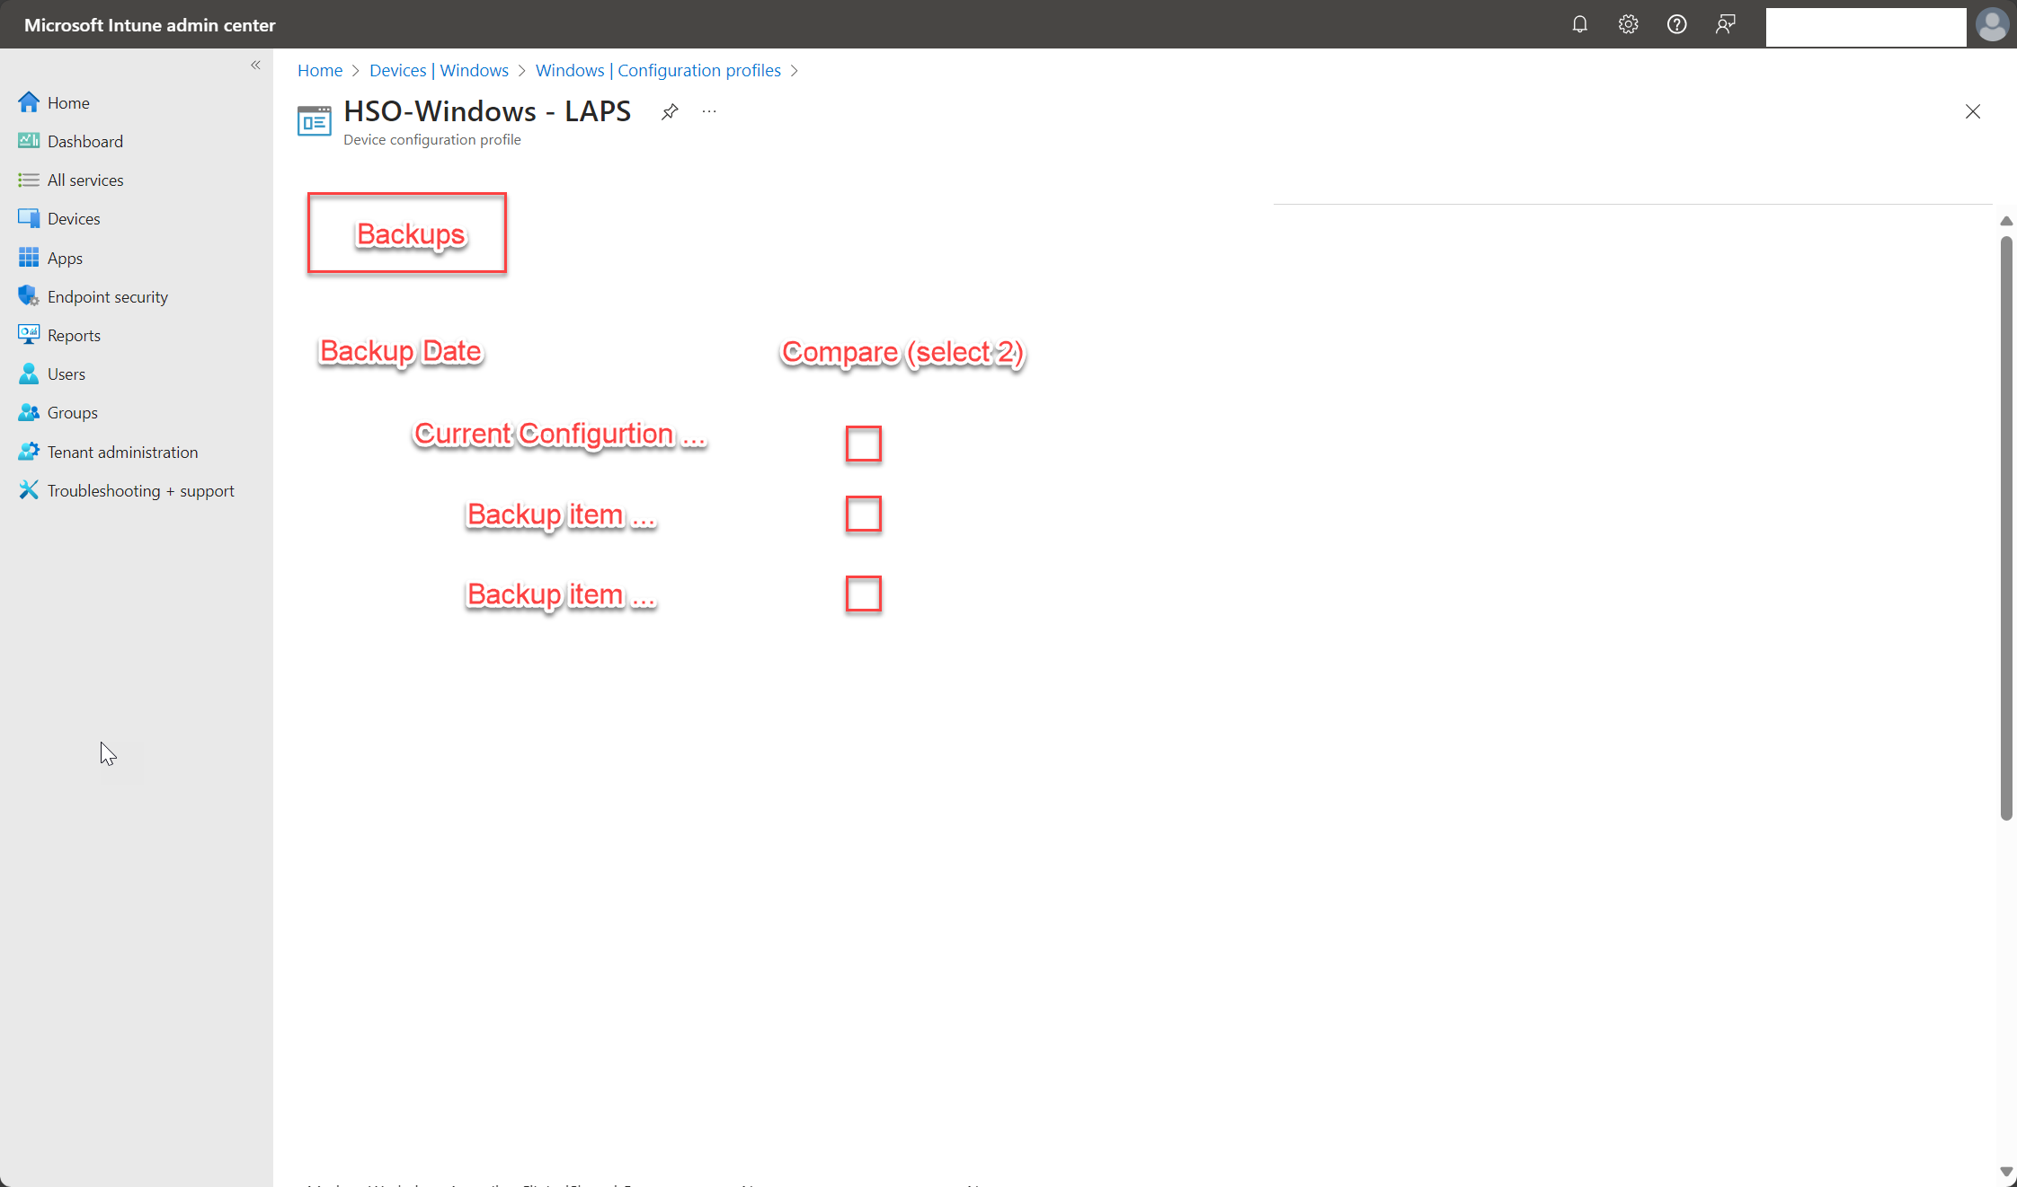
  + User can click on a backup item or current configuration to view the details or compare 2 backups
  + Backup Item view (the information displayed is the backup jsonb information stored in the database)   
    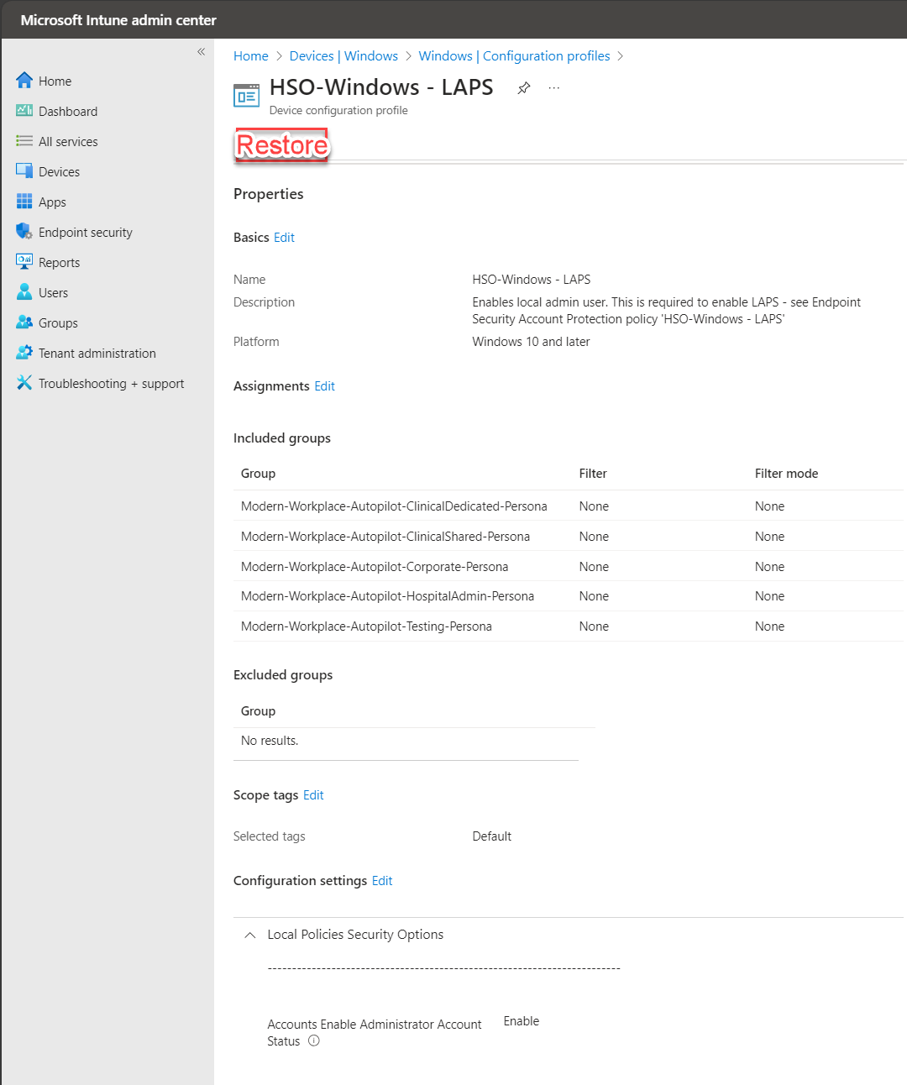
  + Compare item view  
    This will be similar to the above view but list the settings of each item side by side in 2 columns and highlight in yellow the different values
  + Restore wizard view screen 1  
    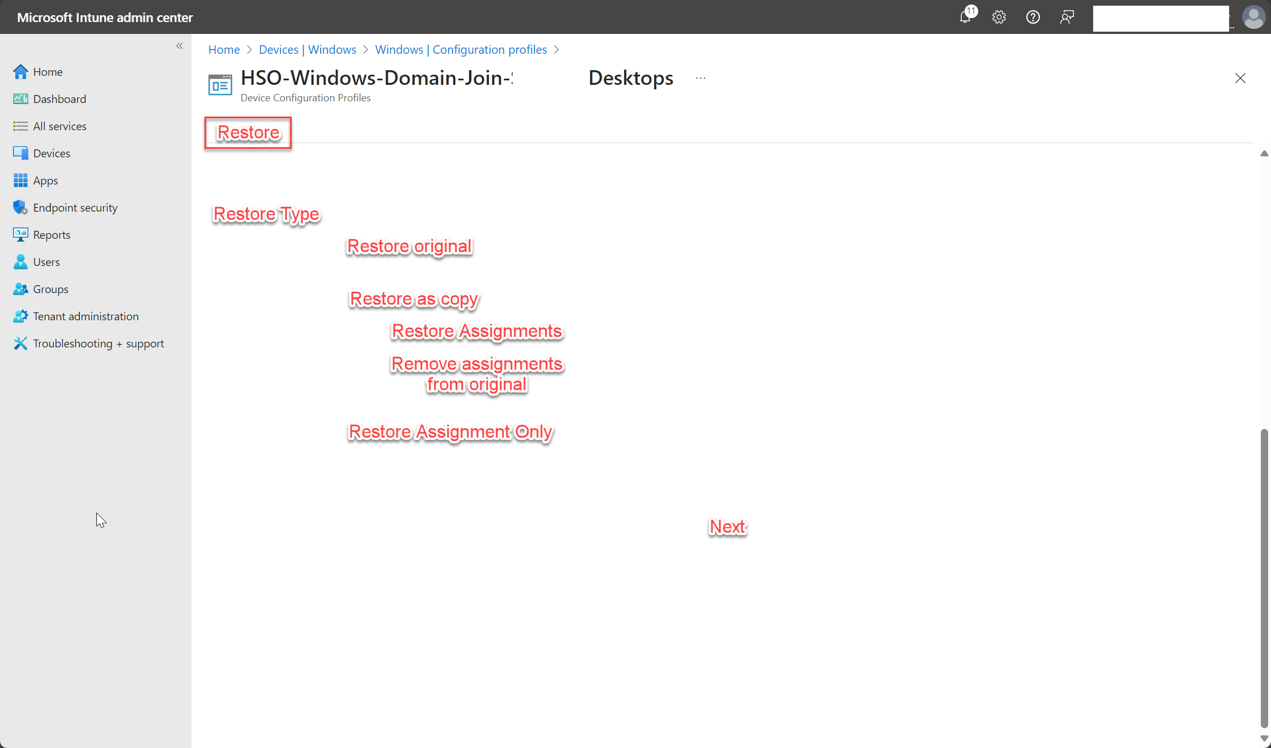  
    Can select 1 or 3 options (Restore original, Restore as copy or Restore assignment only – Restore as copy will have restore assignment and remove assignment from original as checkboxes as one or both can be selected)
  + Restore wizard view screen 2  
    This is just a confirmation screen – show the item that will be restored and ask user to confirm
  + Restore wizard view screen 3  
    When confirm button is clicked from previous screen, they will be redirected to the EntraID app for authentication – this still needs to be worked out by me – once authenticated run the edge function ‘restore data’.