COS20001 –User Centre Design

Task 7.3 Usability Evaluation & Usability Requirements

Lecturer:   Mrs. Nguyen Thuy Linh

Hai Hoang Le | s103542974 | Leader

Group 5

Members: Hai Hoang Le | s103542974

      Bui Quang Danh Than | s104068879

      Nguyen Quoc Bao Huynh | s103804535

                  Tho Cao Hoang Long | s104046037

Part 1. Usability Tasks

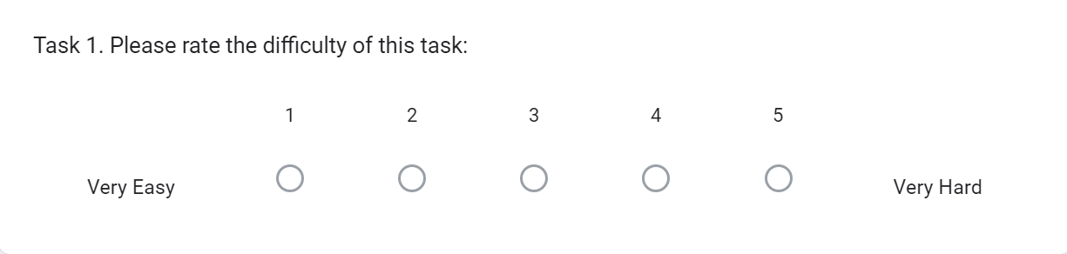Task 1: Create a simple account as the student profile.

Task 2: Login to an account that you just created on task 1

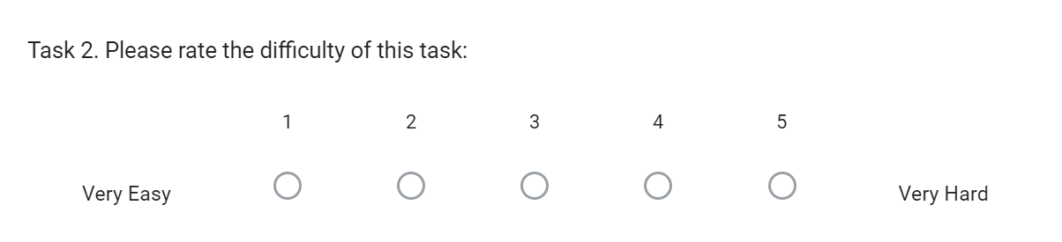

Task 3: Use teacher account to create a quiz about "Mathematics".

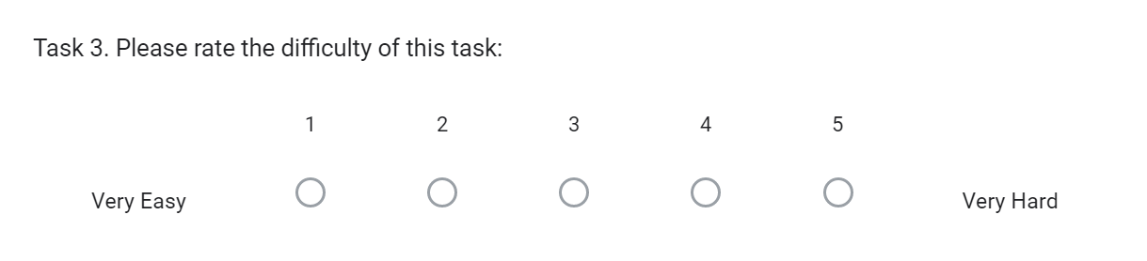

Task 4: Use student account to enter any quizzes from teacher.

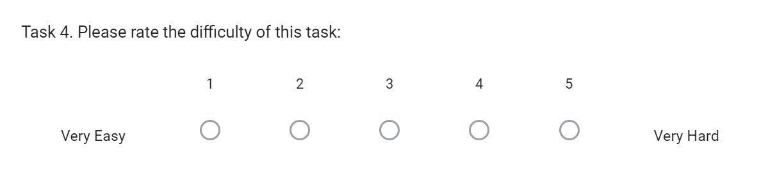

Task 5: Use teacher account to create a classroom named UCD.

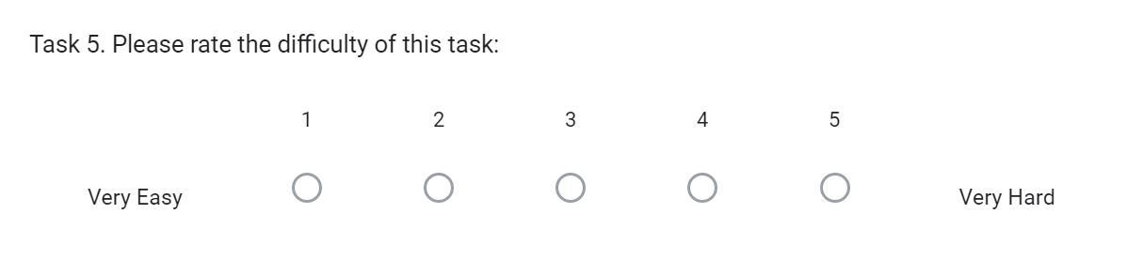

Part 2. Usability Requirements

|  |  |  |  |  |
| --- | --- | --- | --- | --- |
| User role | Usability Goal | Measuring Intrument | Metric | Target |
| Student | Effective | Task 1: Create a simple account as the student profile. | Average time to complete | 4 minutes |
| Student | Effectiveness | Task 1: Create a simple account as the student profile. | Rate for the complete successfully | 80% |
| Student | Satisfaction | Task 1: Create a simple account as the student profile. | Average rating in task difficulty | 3 or less |
| Student | Effective | Task 2: Login to an account that you just created on task 1 | Average time to complete | 30 seconds |
| Student | Effectiveness | Task 2: Login to an account that you just created on task 2 | Rate for the complete successfully | 90% |
| Student | Satisfaction | Task 2: Login to an account that you just created on task 3 | Average rating in task difficulty | 2 or less |
| Teacher | Effective | Task 3: Use teacher account to create a quiz about "Mathematics". | Average time to complete about 10 questions | 10 minutes |
| Teacher | Effectiveness | Task 3: Use teacher account to create a quiz about "Mathematics". | Rate for the complete successfully about 10 questions | 70% |
| Teacher | Satisfaction | Task 3: Use teacher account to create a quiz about "Mathematics". | Average rating in task difficulty about 10 questions | 4 or less |
| Student | Effective | Task 4: Use student account to enter any quizzes from teacher. | Average time to complete | 5 seconds |
| Student | Effectiveness | Task 4: Use student account to enter any quizzes from teacher. | Rate for the complete successfully | 80% |
| Student | Satisfaction | Task 4: Use student account to enter any quizzes from teacher. | Average rating in task difficulty | 2 or less |
| Teacher | Effective | Use teacher account to create a classroom named UCD. | Average time to complete | 2 minutes |
| Teacher | Effectiveness | Use teacher account to create a classroom named UCD. | Rate for the complete successfully | 80% |
| Teacher | Satisfaction | Use teacher account to create a classroom named UCD. | Average rating in task difficulty | 3 or less |
| Teacher | Satisfaction | System Usability Scale (SUS) | Average SUS score | 60 or higher |
| Student | Satisfaction | System Usability Scale (SUS) | Average SUS score | 70 or higher |