# COS20007

# Task 1.1P

# Hai Hoang Le

# student id: 103542974

1. Explain the terminal instructions **cd**, **ls**, and **pwd**. Provide a screenshot showing these in- structions being used correctly.

cd is change directory command to change the directory

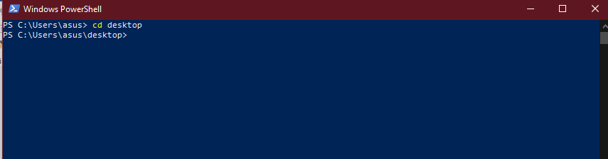

ls is command to list all the document in a directory

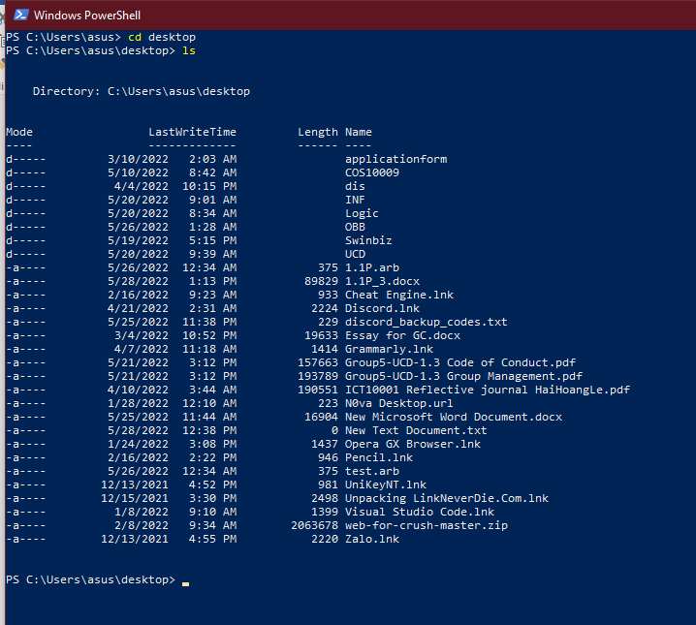

Pwd is a command to show the current directory

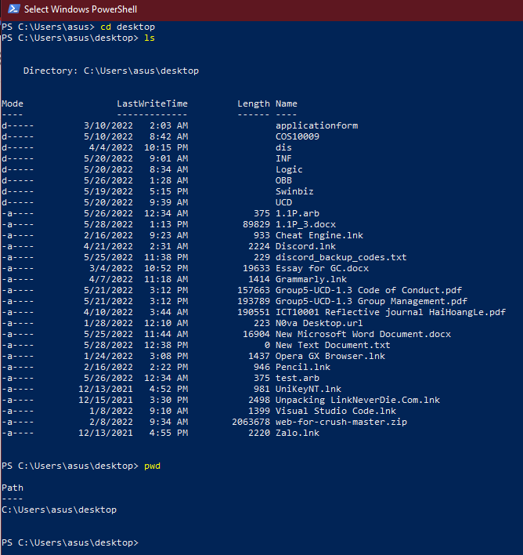

1. Consider the following kinds of information, and suggest the most appropriate data type to store or represent each:

|  |  |
| --- | --- |
| A person’s name | String |
| A person’s age in years | integer |
| A phone number | integer |
| A temperature in Celsius | double |
| The average age of a group of people | double |
| Whether a person has eaten lunch | boolean |

1. Aside from the examples already given, come up with an example of information that could be stored as:

|  |  |
| --- | --- |
| A string data type | School name |
| An integer data type | Number of player |
| A float data type | Amount of money I used |
| A boolean data type | Whether I absent the class |

1. Fill out the following table, evaluating the value of each expression and identifying the data type the value is most likely to be.

|  |  |  |  |
| --- | --- | --- | --- |
| **Expression** | **Given** | **Value** | **Data Type** |
| 5 |  | 5 | integer |
| TRUE |  | true | boolean |
| a | a = 2.5 | 2.5 | double |
| 1 + 2 * 3 |  | 7 | integer |
| a and FALSE | a = TRUE | Fasle | boolean |
| a or FALSE | a = TRUE | True | boolean |
| a + b | a = 1 and b = 2 | 3 | integer |
| 2 * a | a = 3 | 6 | integer |
| a * 2 + b | a = 1.5 and b = 2 | 5 | integer |
| a + 2 * b | a = 1.5 and b = 2 | 5.5 | double |
| (a + b) * c | a = 1, b = 1, and  c = 5 | 10 | integer |
| “Fred” + “ Smith” |  | “Fred Smith” | String |
| a + “ Smith” | a = “Wilma” | “Smith Wilma” | string |
|  |  |  |  |

1. Explain the difference between **declaring** and **initialising** a variable.

* Declaring is giving a variable a name and a space for memory to store, but not a value.
* Initializing is giving a variable a name, a memory and a value.

1. Explain the term **parameter**. Write some code that demonstrates a simple use of a para- meter.

* Parameter is a variable in coding to pass information between function and method.

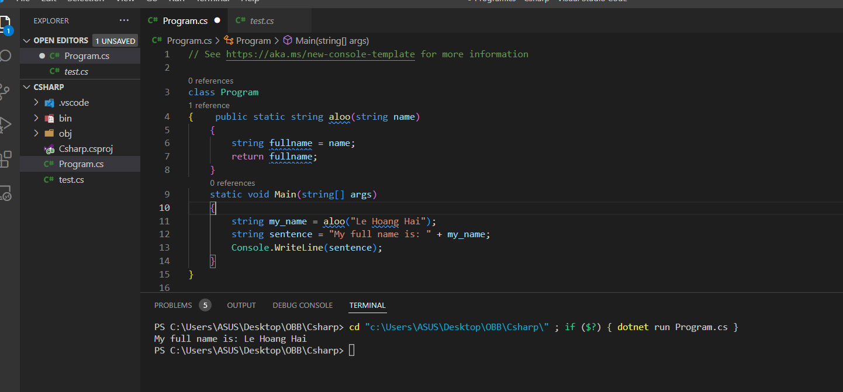

1. Using an example, describe the term **scope**.

* Scope can be seen as a concept that determines a variable which can be accessed or referenced outside a method.

1. In any procedural language you like, write a function called Average, which accepts an ar- ray of integers and returns the average of those integers.

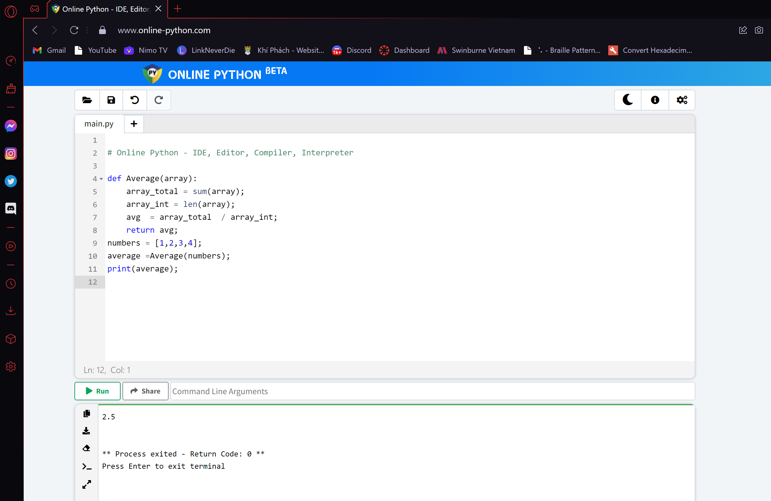

1. In the same language, write the code you would need to call that function and print out the result.



1. To the code from 6, add code to print the message “Double digits” if the average is above

Otherwise, print the message “Single digits”.

