

# Task 1 – Credit Submission

Student Number: 103542974   
Student Name: Hai Hoang Le

### Credit 1a

Paste your screen capture(s) for this task here.

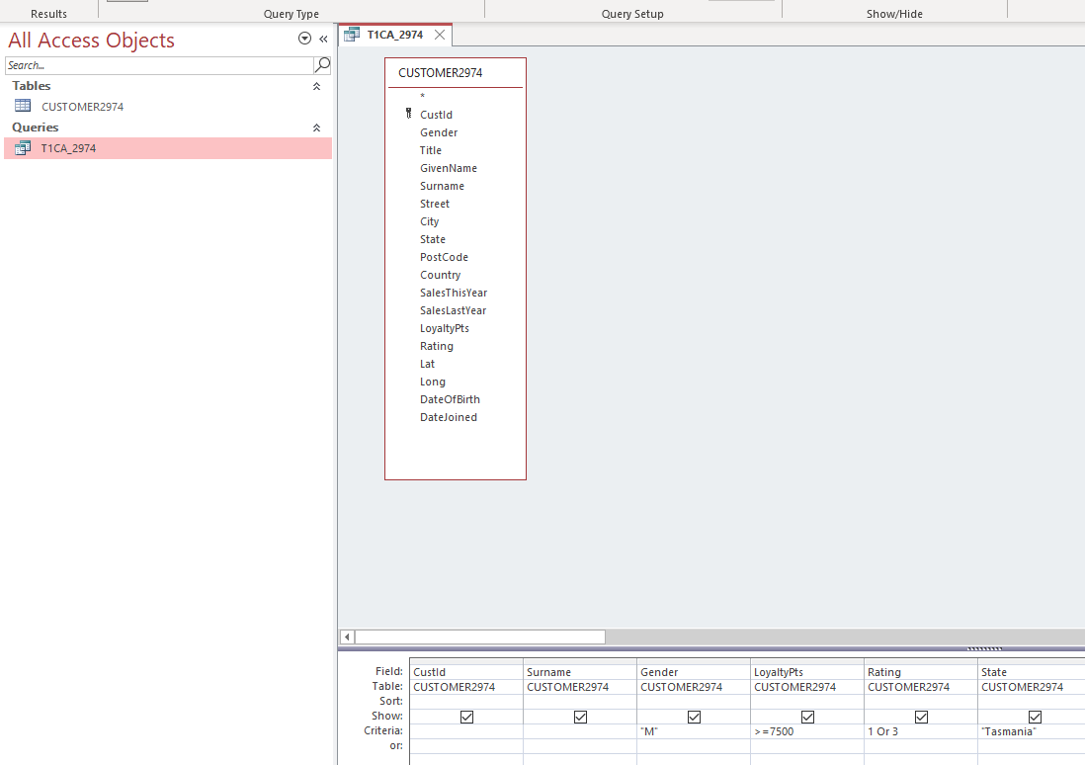

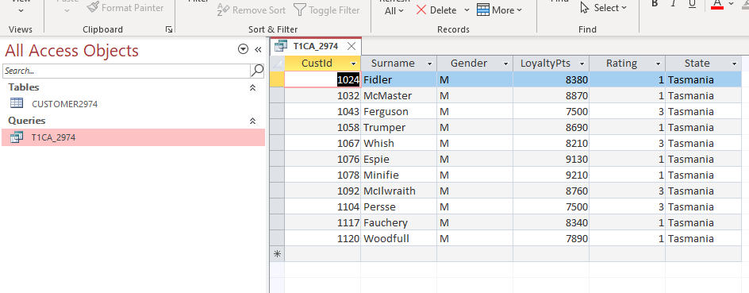

### Credit 1b

Paste your screen capture(s) for this task here.

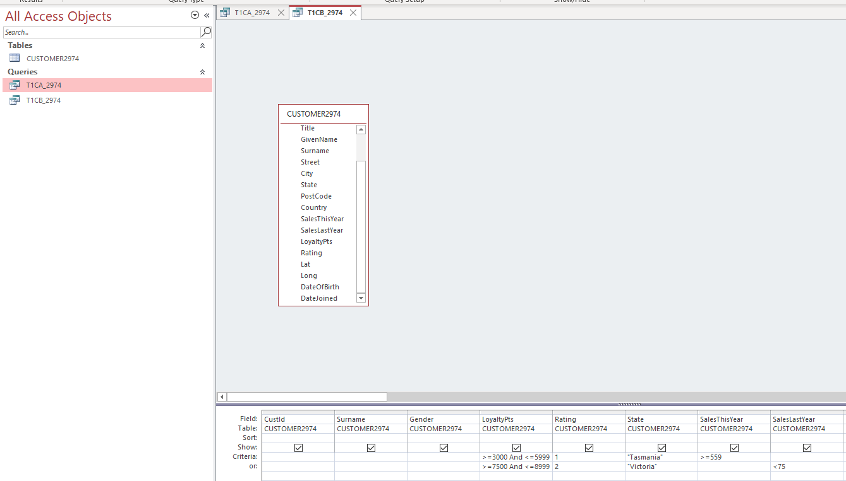

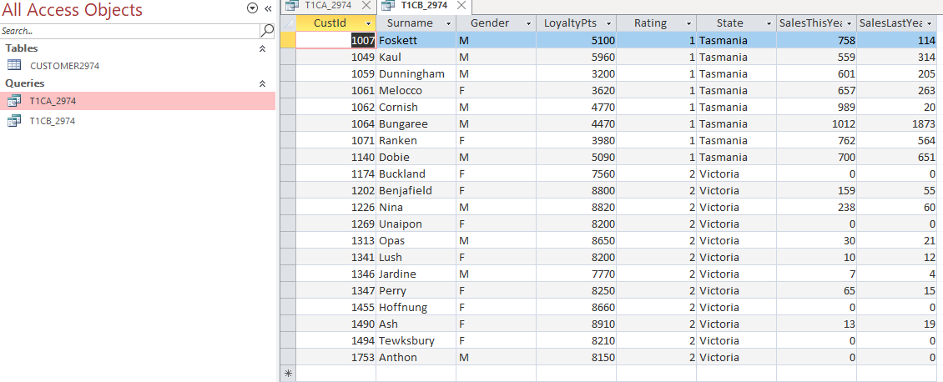

### Credit 1c

Paste your screen capture(s) for this task here.

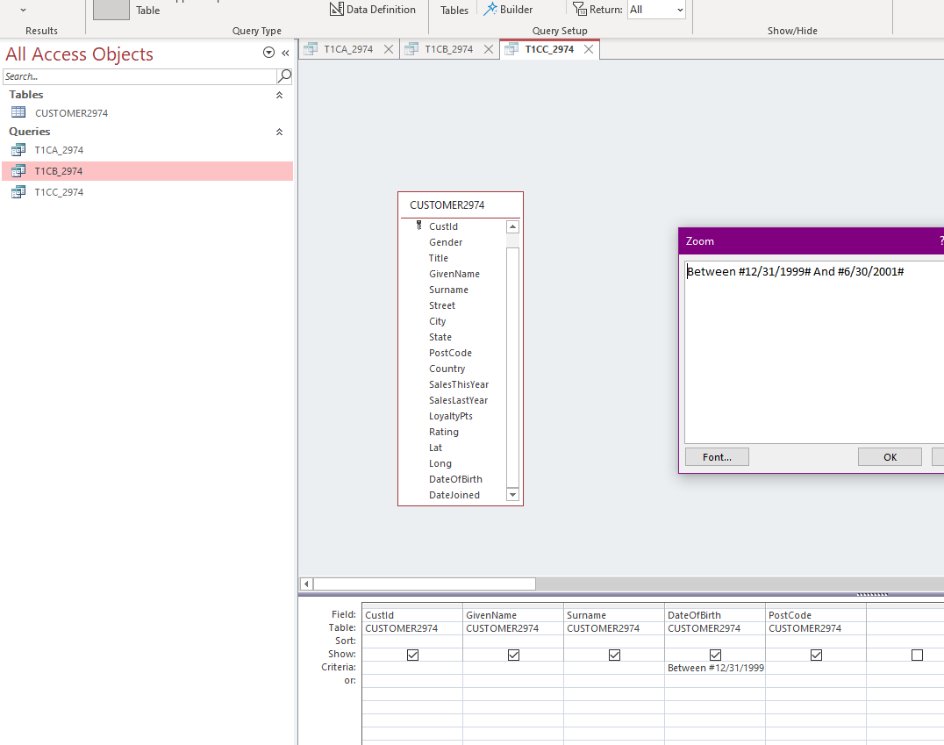

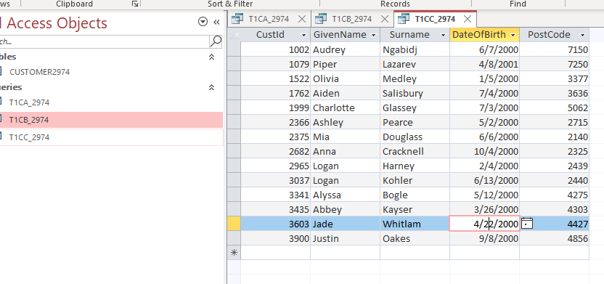

### Credit 1d

Paste your screen capture(s) for this task here.

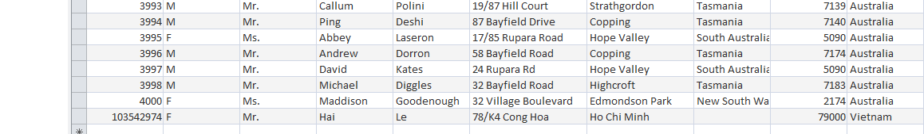

### Credit 1e

Paste your screen capture(s) for this task here.

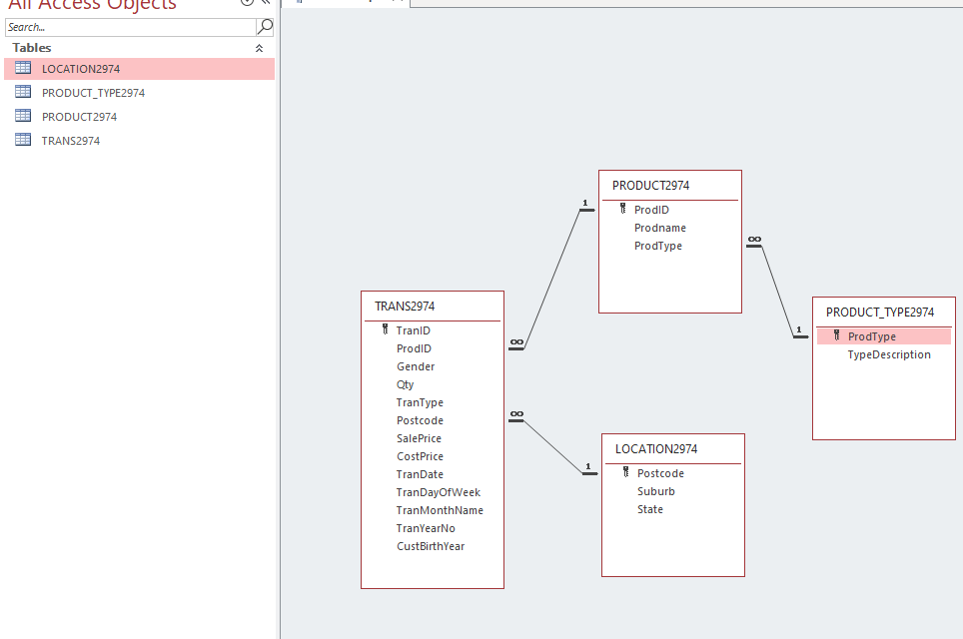

### Credit 1f

Paste your screen capture(s) for this task here.

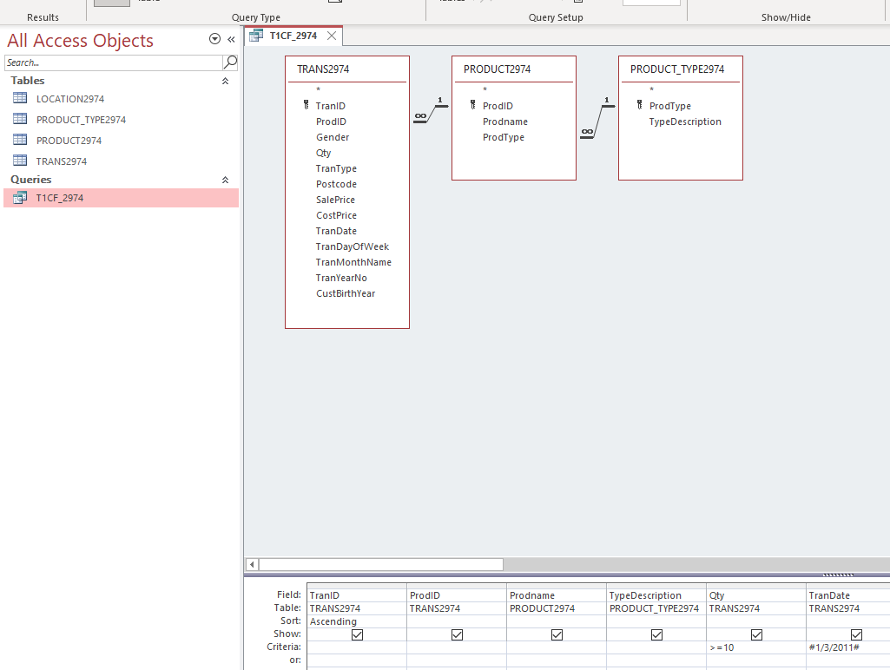

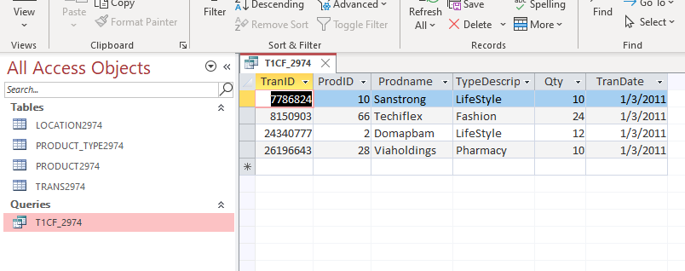

### Credit 1g

Paste your screen capture(s) for this task here.

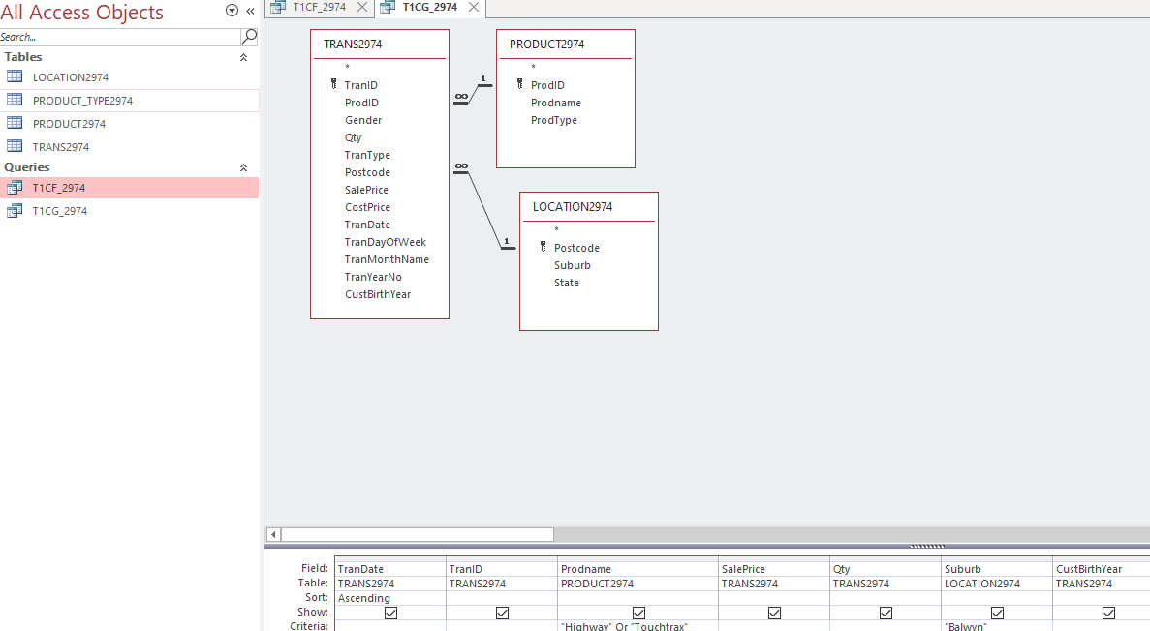

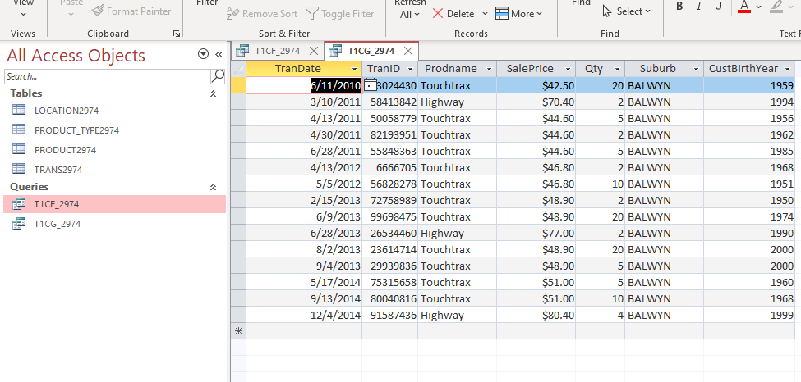

### Credit 1h

Paste your screen capture(s) for this task here.

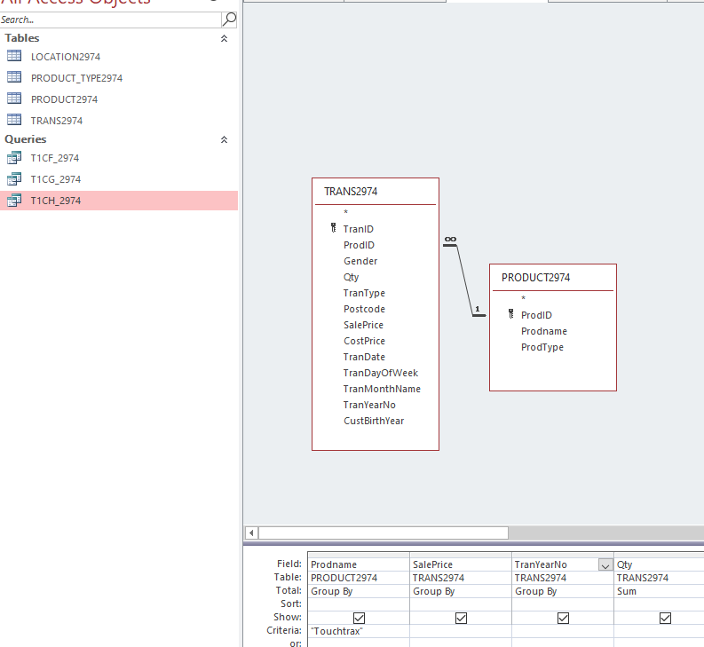

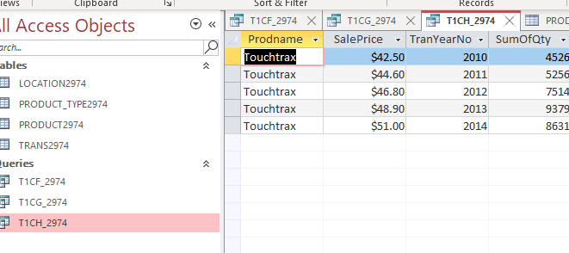

Touchtrax had been sold (4526 +5256+7514+9379+8631 = 35036 times over 4 years

There were 5 prices: $42.50, $44.60, $46.80, $48.90, $51.00

The price of Touchtrax had been increasing over the years

### Credit 1i

Paste your screen capture(s) for this task here.

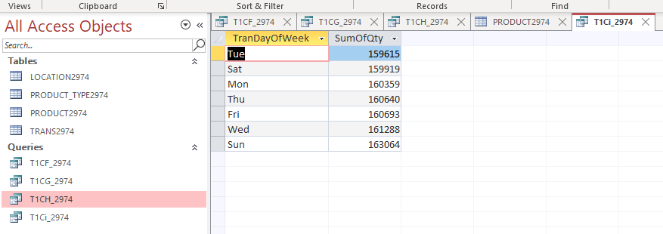

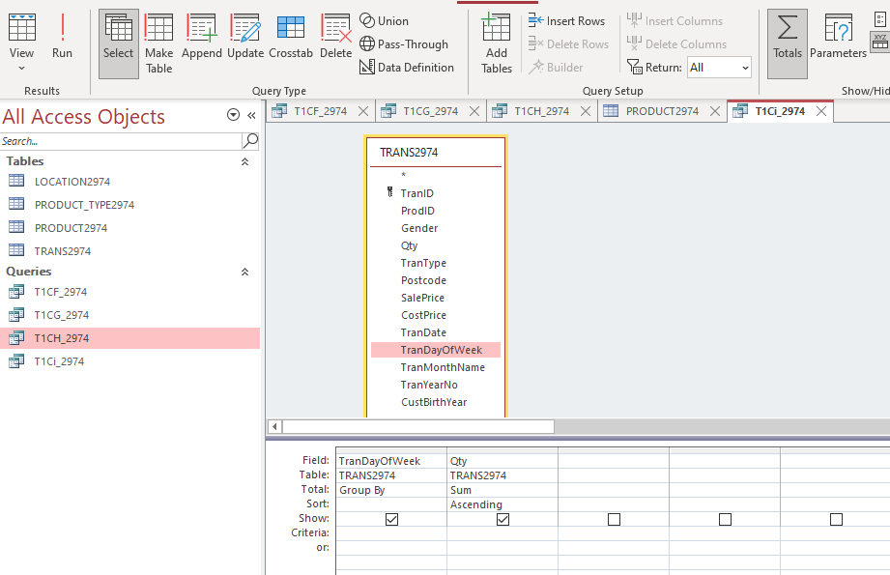

### Credit 1j

Paste your screen capture(s) for this task here.

### 