

# Task 1 – Pass Submission

Student Number: 103542974   
Student Name: Hai Hoang Le

### Pass 1a

Paste text describing advantages here.

* Queries can produce non- boolean data’s values while using filters can produce boolean values.
* When user uses a query, user can save, whereas, a filter cannot be saved
* Using queries can help user to view various of data in a table that user selected

### Pass 1b

Paste your screen capture(s) for this task here.

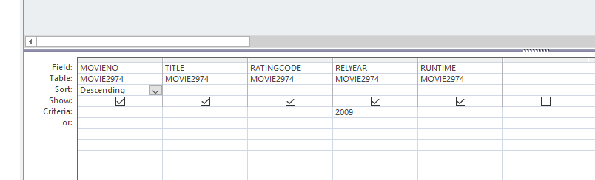

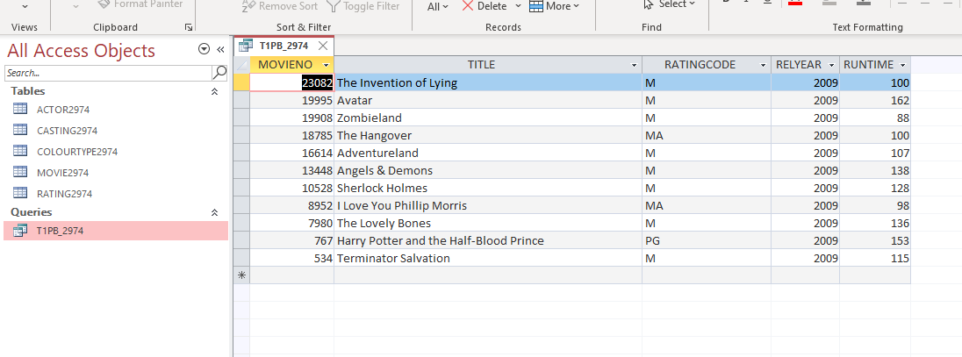

### Pass 1c

Paste your screen capture(s) for this task here.

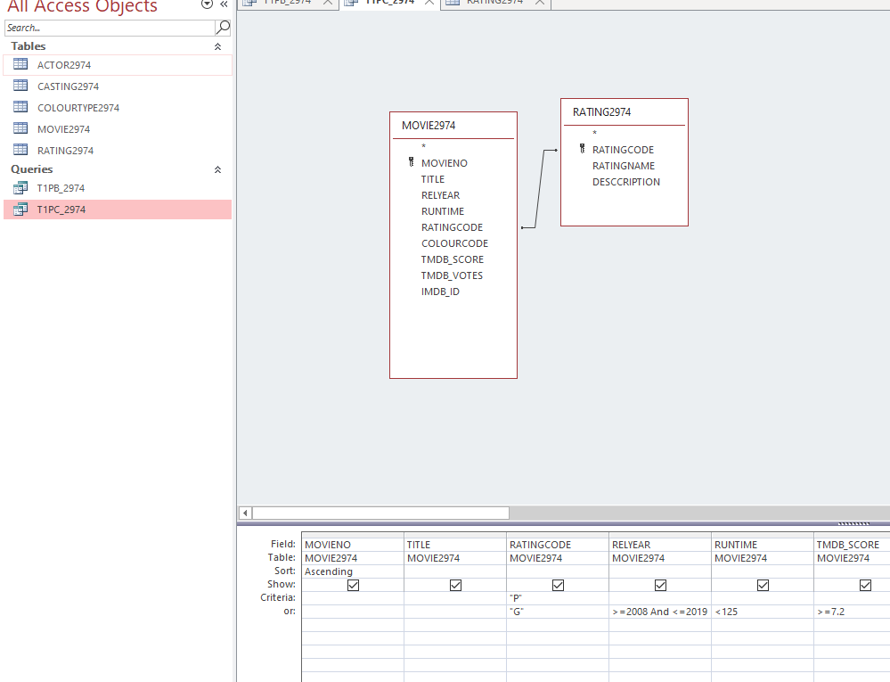

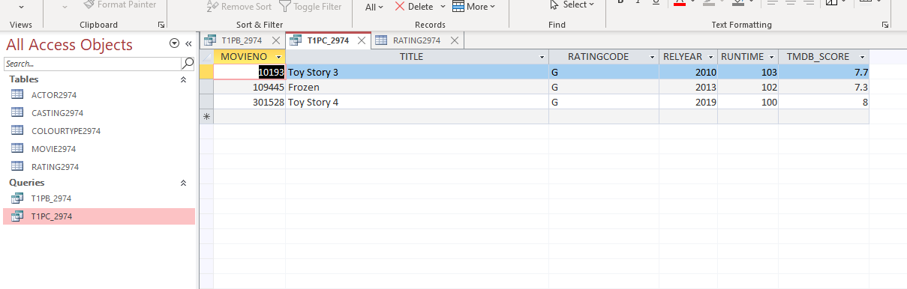

### Pass 1d

Paste your screen capture(s) for this task here.

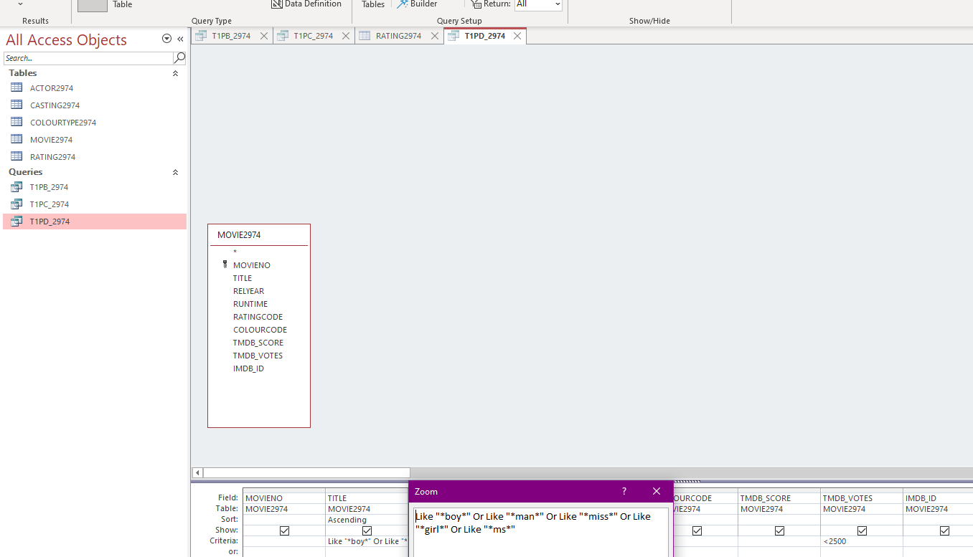

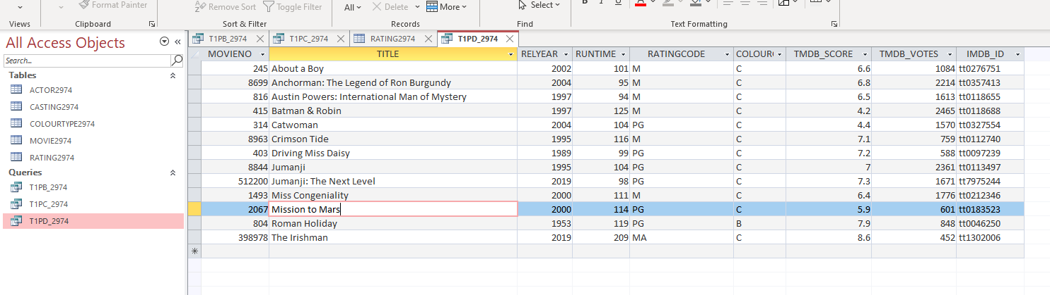

### Pass 1e

Paste your screen capture(s) for this task here.

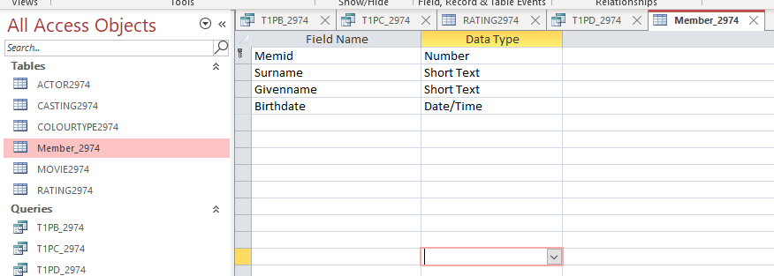

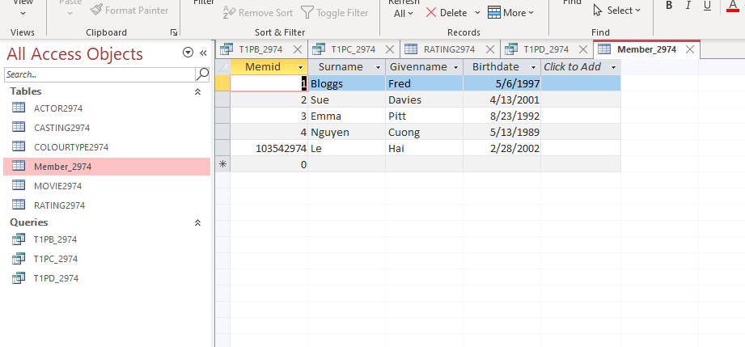

### Pass 1f

Paste your screen capture(s) for this task here.

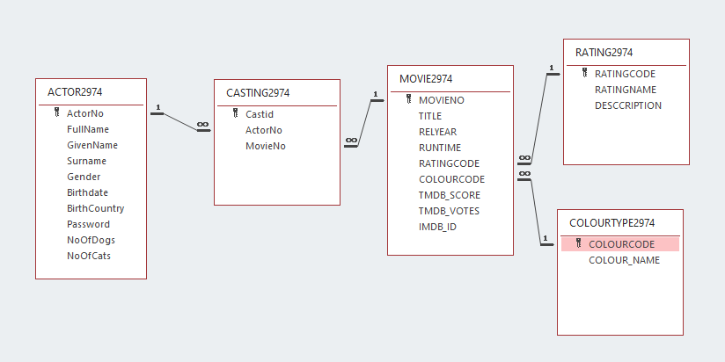

### Pass 1g

Paste your screen capture(s) for this task here.

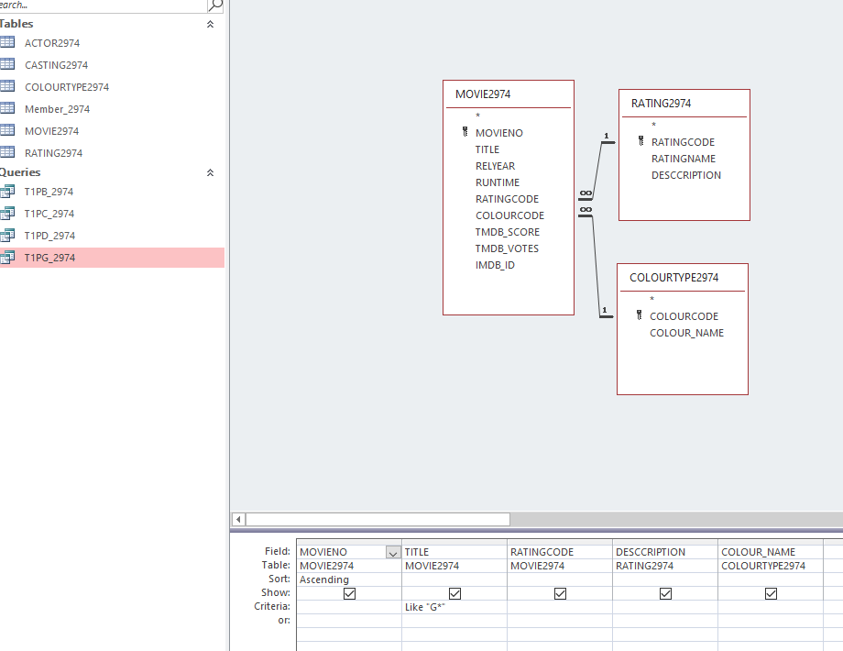

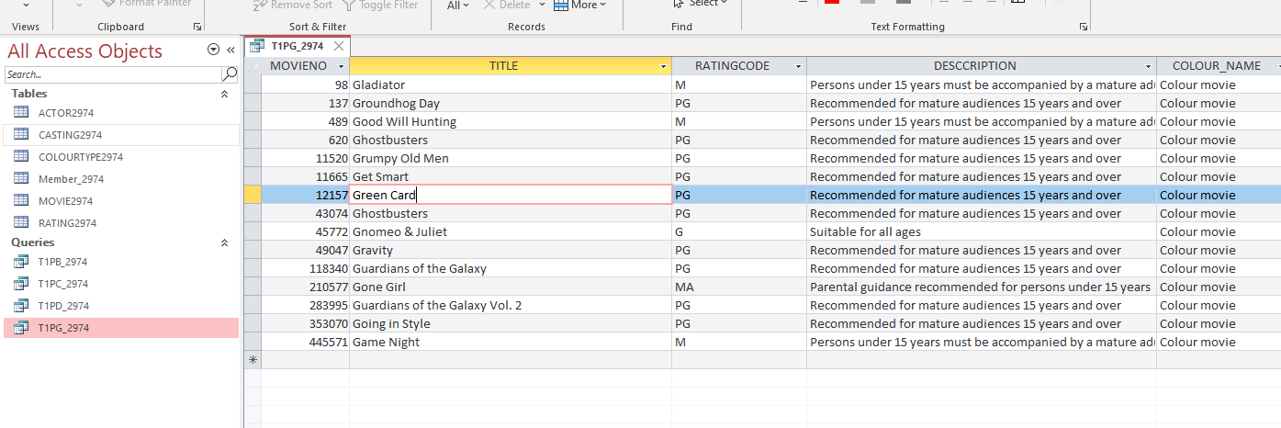

### Pass 1h

Paste your screen capture(s) for this task here.

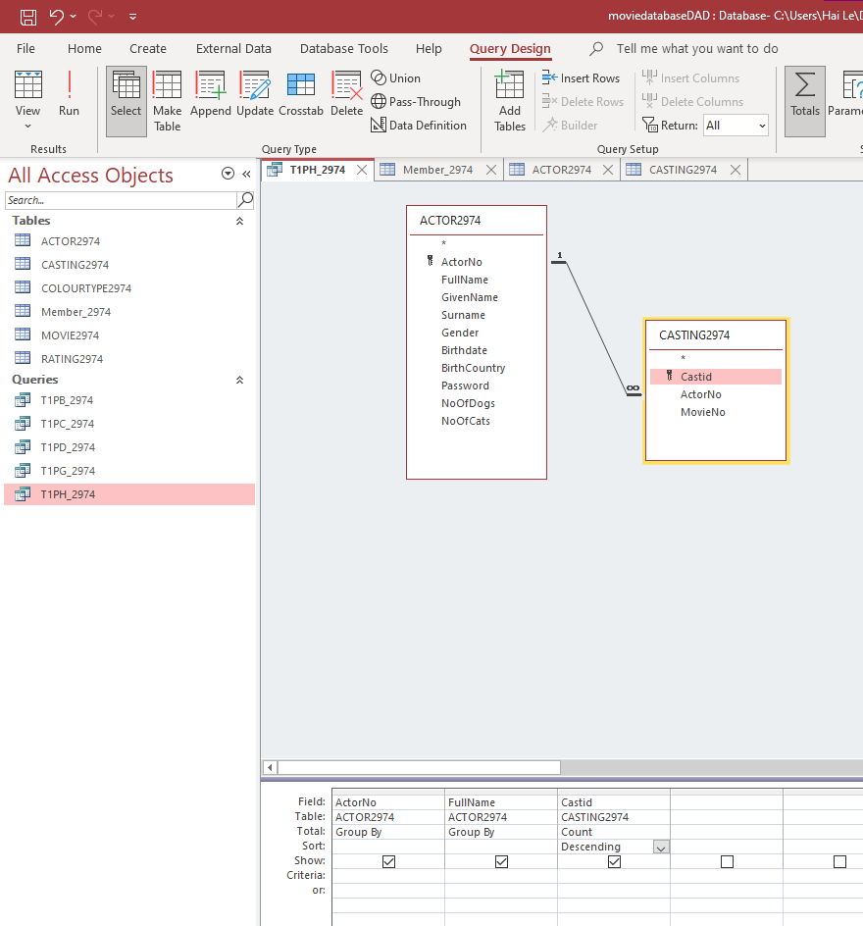

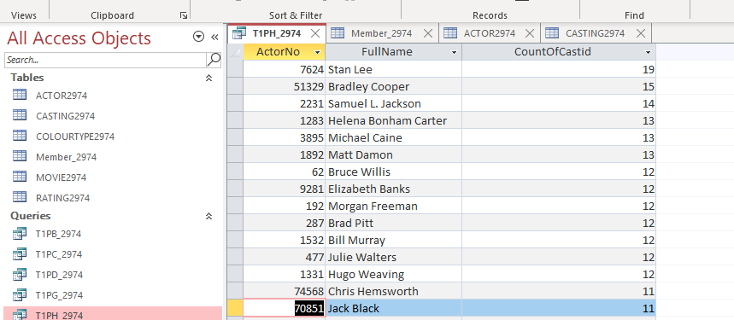

### Pass 1i

Paste your screen capture(s) for this task here.

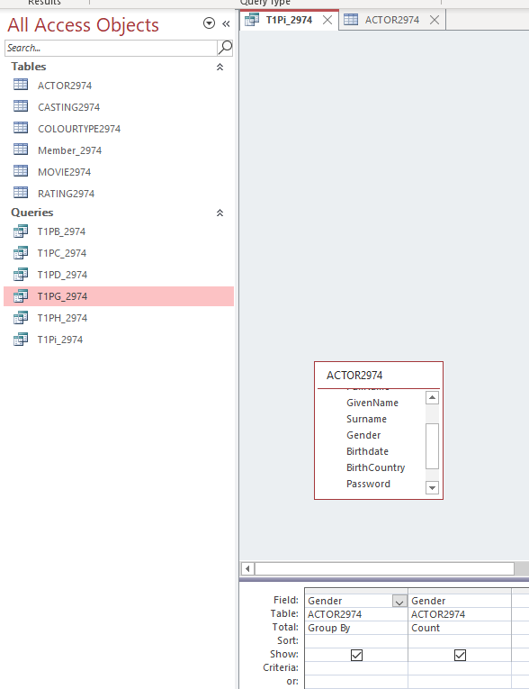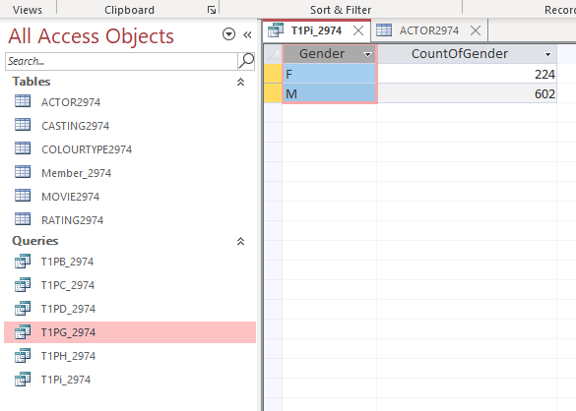

### Pass 1j

Paste your screen capture(s) for this task here.

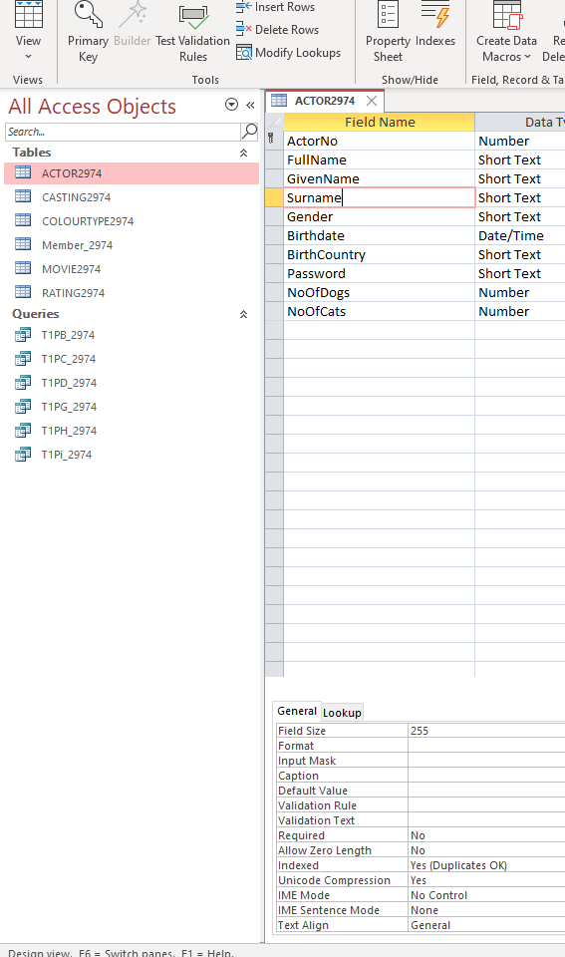

### Pass 1k

Paste your screen capture(s) for this task here.

### 