

# Task 2 – Pass Submission

Student Number: 103542974   
Student Name: Hai Hoang Le

### Pass 2a

Paste your screen capture(s) for this task here.

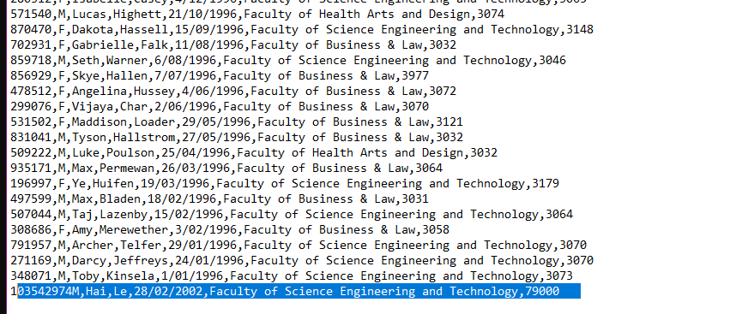

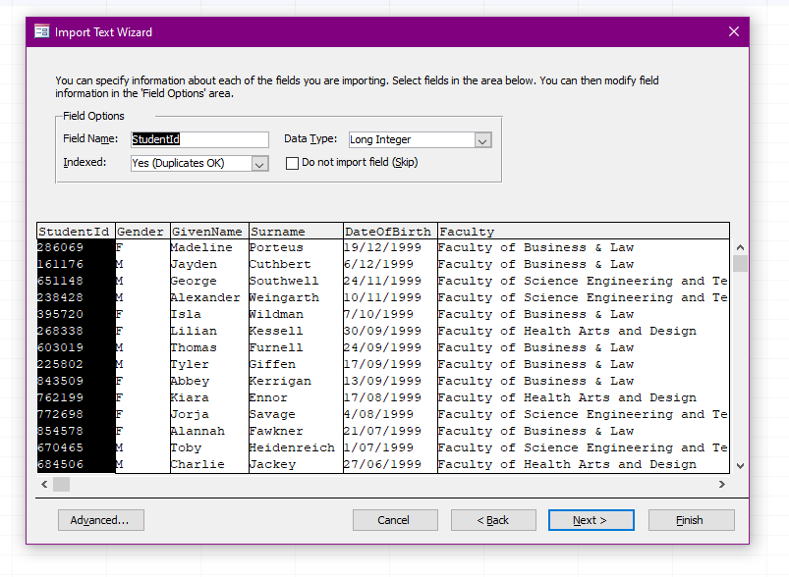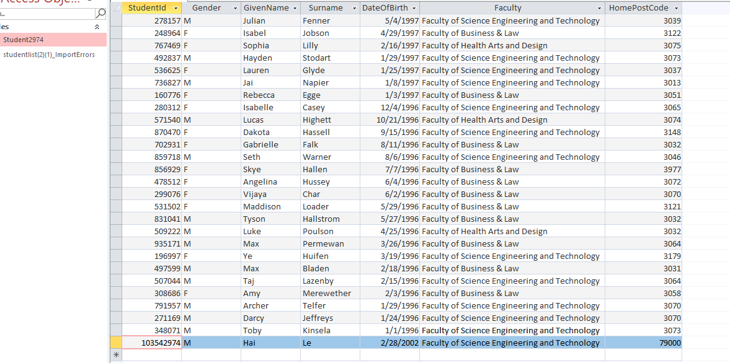

### Pass 2b

Paste your screen capture(s) for this task here.

1. Because the original .csv is Excel. By default of Window, the extension .csv are opened by Excel
   1. Right click to the extension .csv file
   2. Choose open with
   3. Select Notepad or Notepad++
   4. Check the box “Always use this app to open .csv files”
   5. Click Ok

### Pass 2c

Paste your screen capture(s) for this task here.

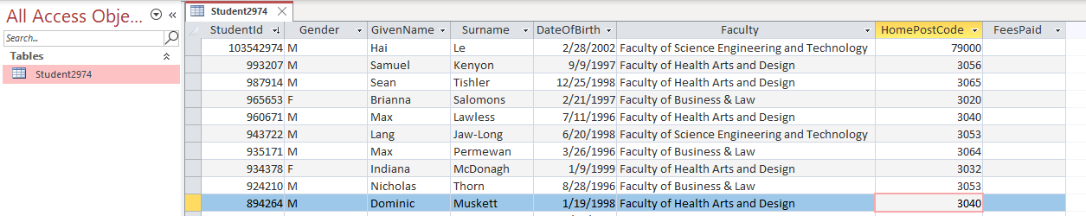

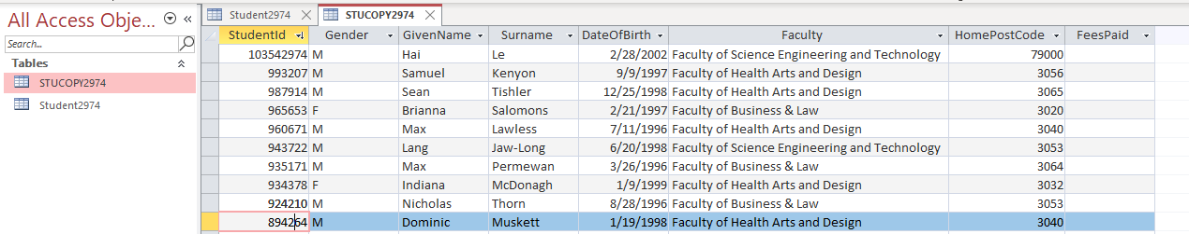

### Pass 2d

Paste your screen capture(s) for this task here.

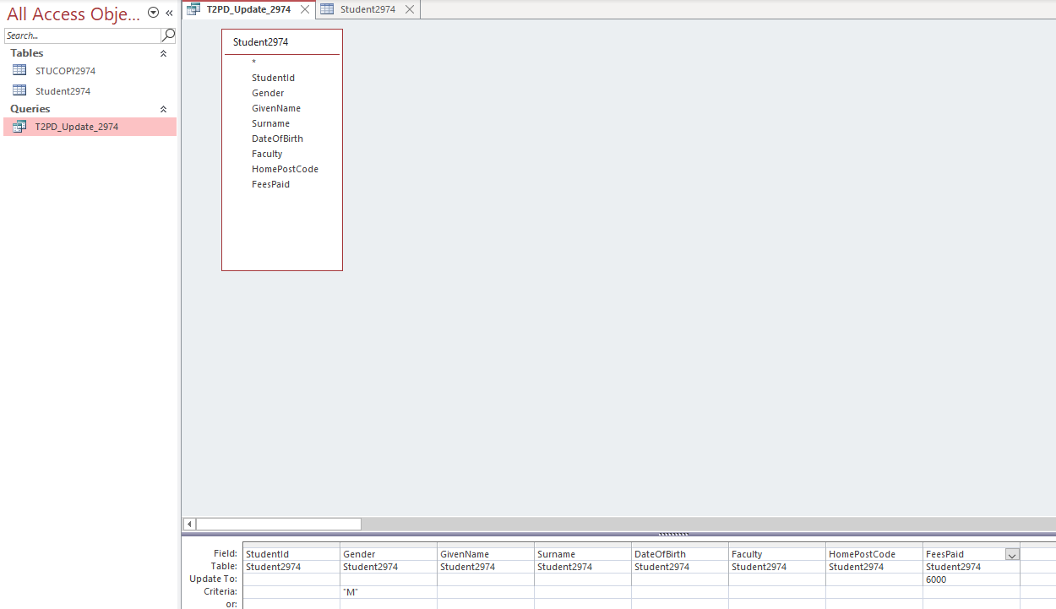

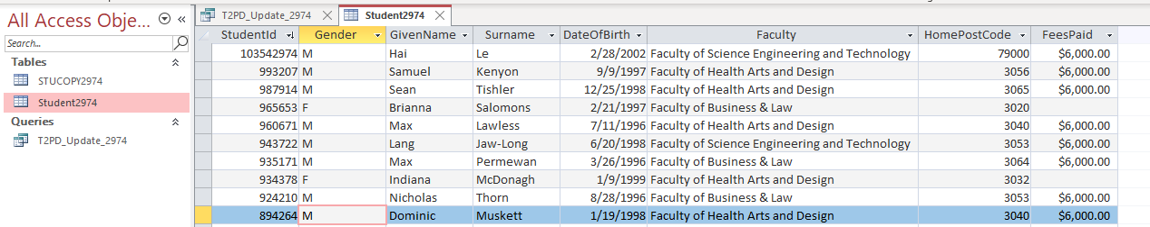

### Pass 2e

Paste your screen capture(s) for this task here.

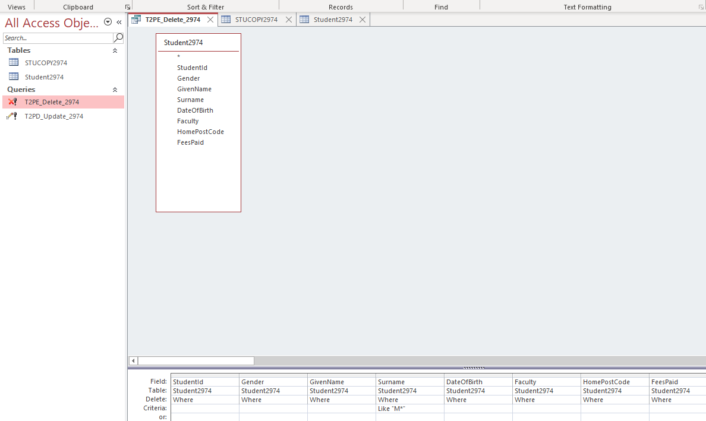

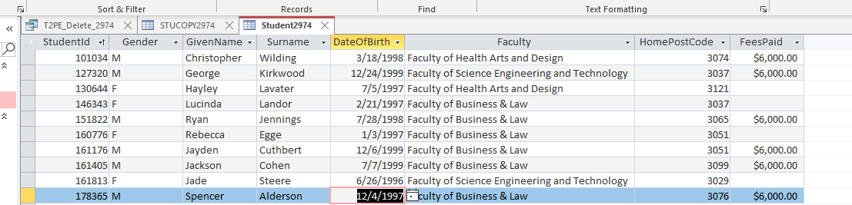

### Pass 2f

Paste your screen capture(s) for this task here.

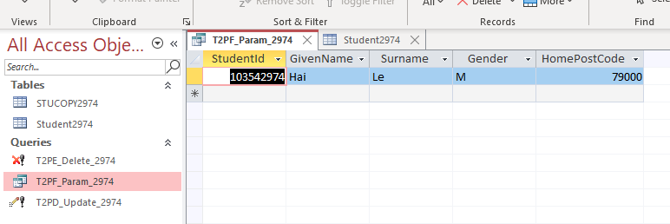

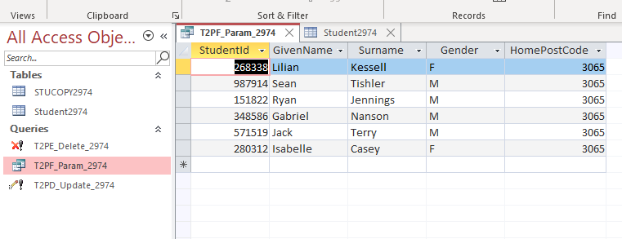

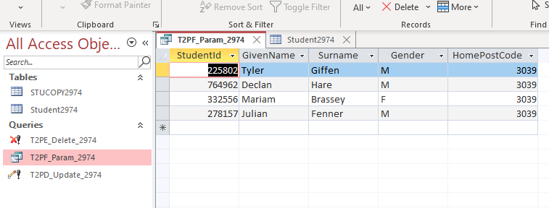

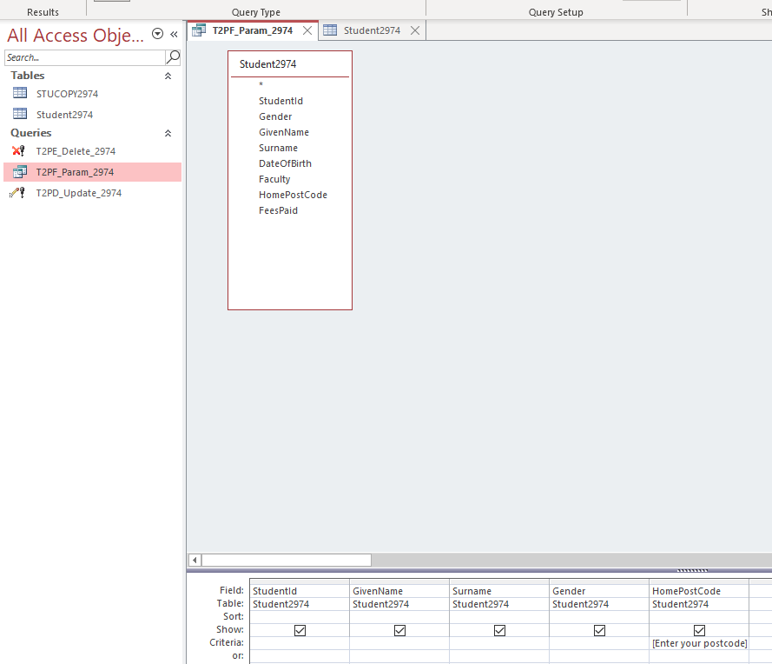

### Pass 2g

Paste your screen capture(s) for this task here.

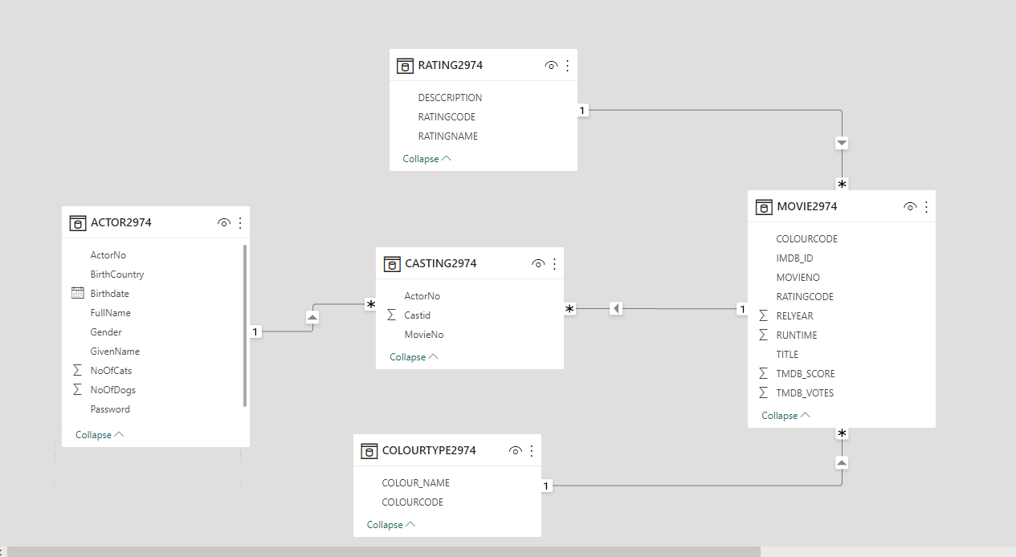

### Pass 2h

Paste your screen capture(s) for this task here.

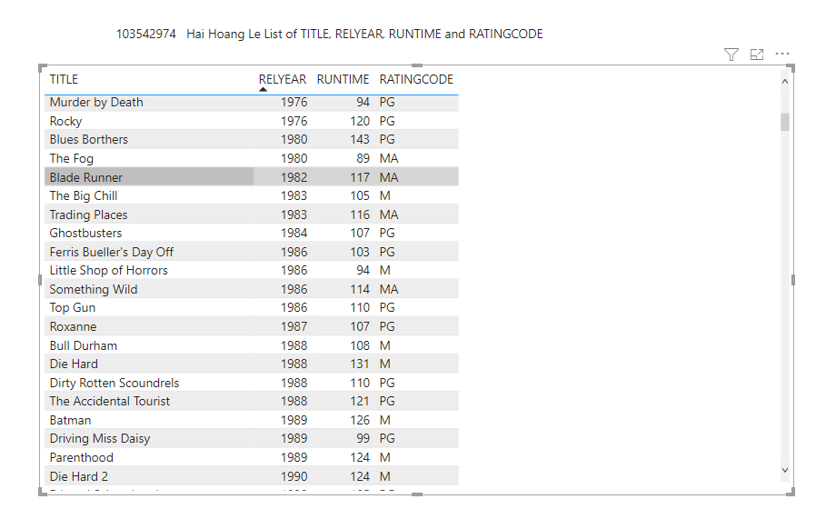

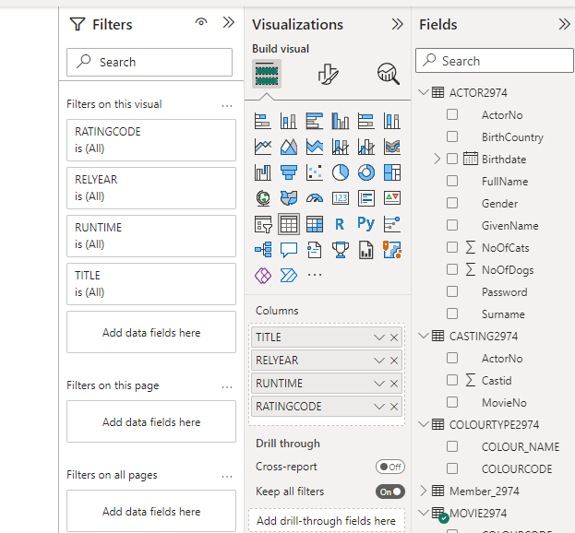

### Pass 2i

Paste your screen capture(s) for this task here.1



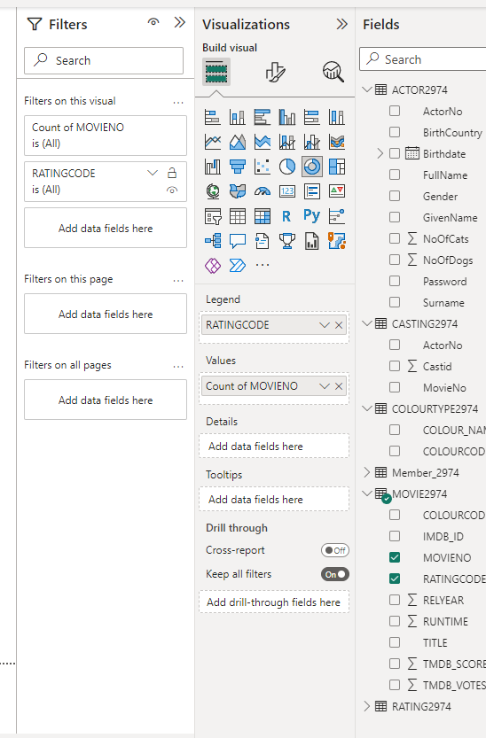

### Pass 2j

Paste your screen capture(s) for this task here.

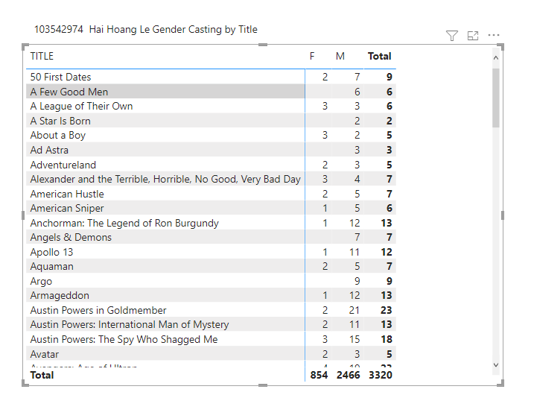

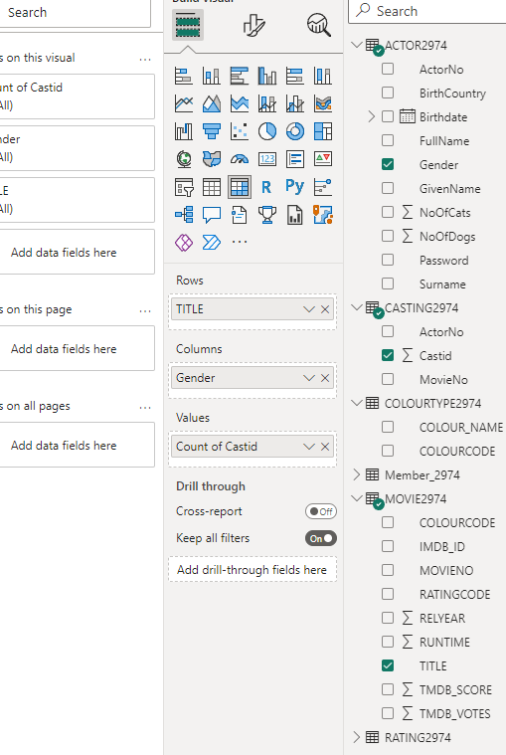

### Pass 2k

Paste your screen capture(s) for this task here.

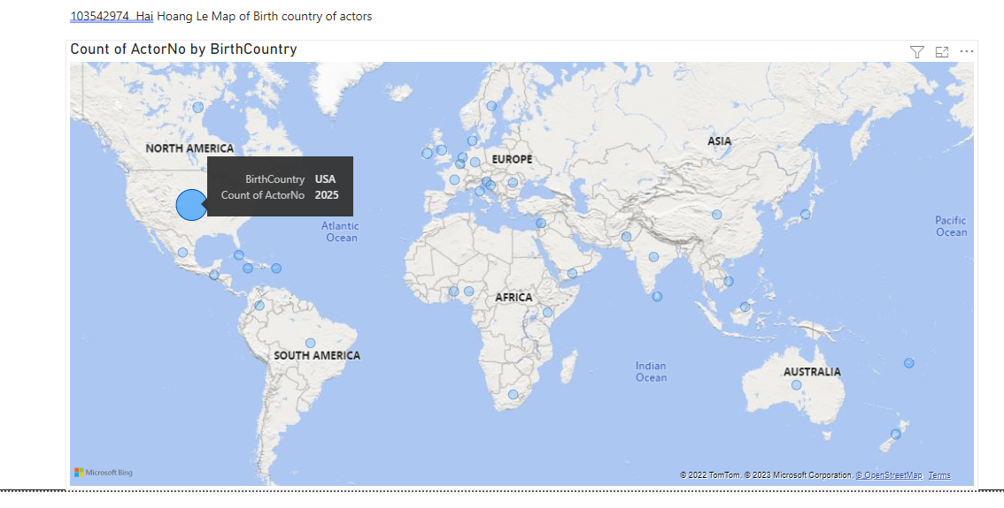

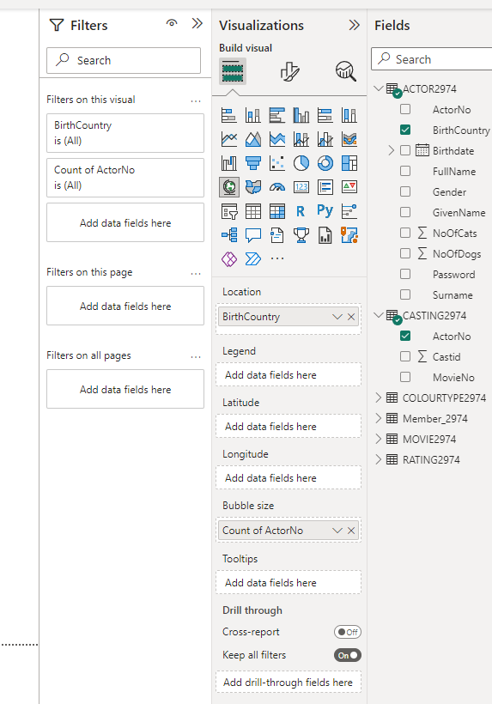

### Pass 2l

Paste your screen capture(s) for this task here.

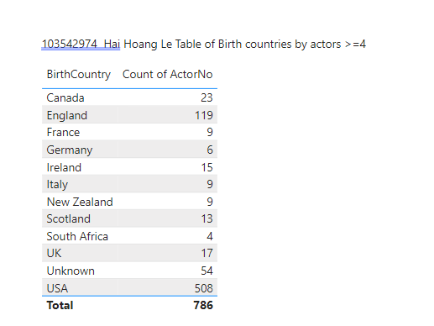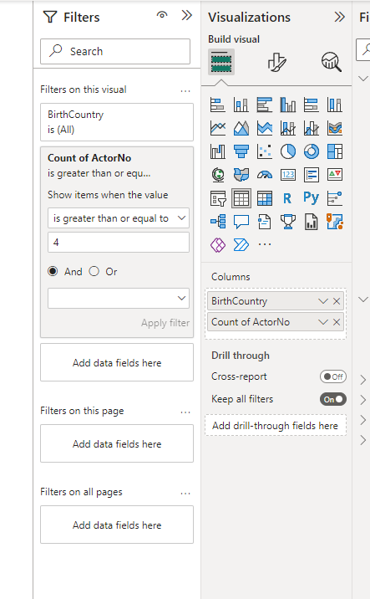

### Pass 2m

Paste your screen capture(s) for this task here.

