

# Task 3 – Credit Submission

Student Number: 103542974  
Student Name: Hai Hoang Le

### Credit 3a

Paste your screen capture(s) for this task here.

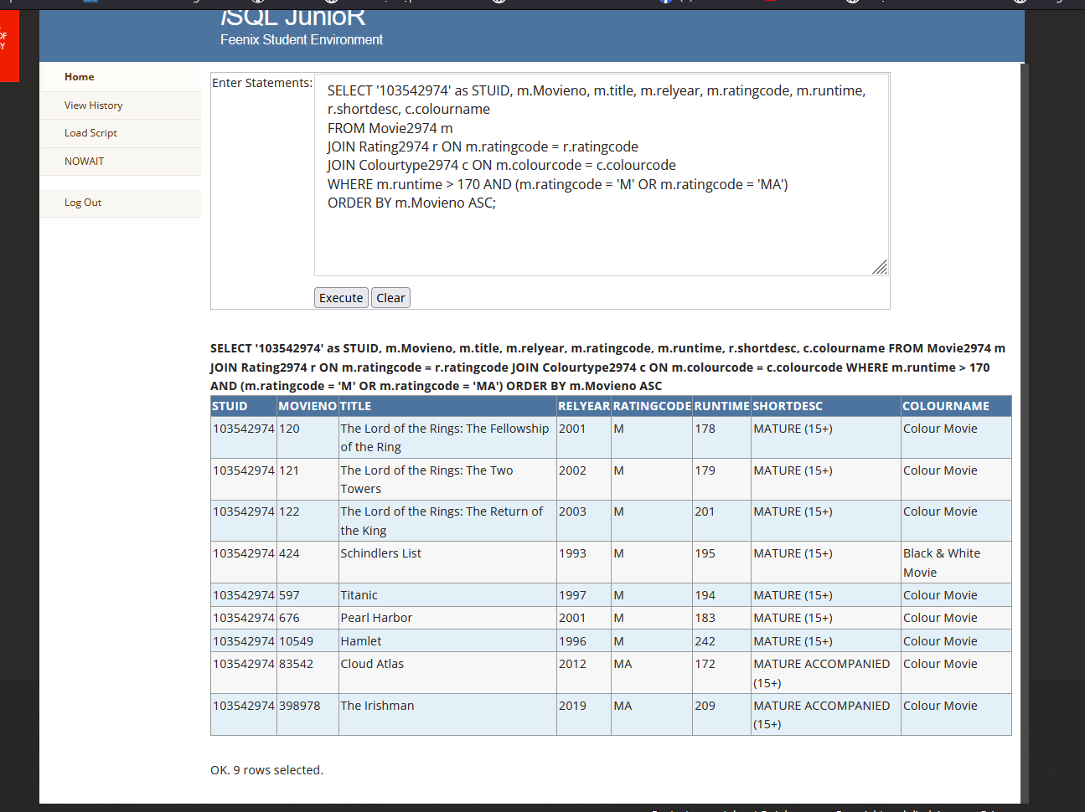

### Credit 3b

Paste your screen capture(s) for this task here.

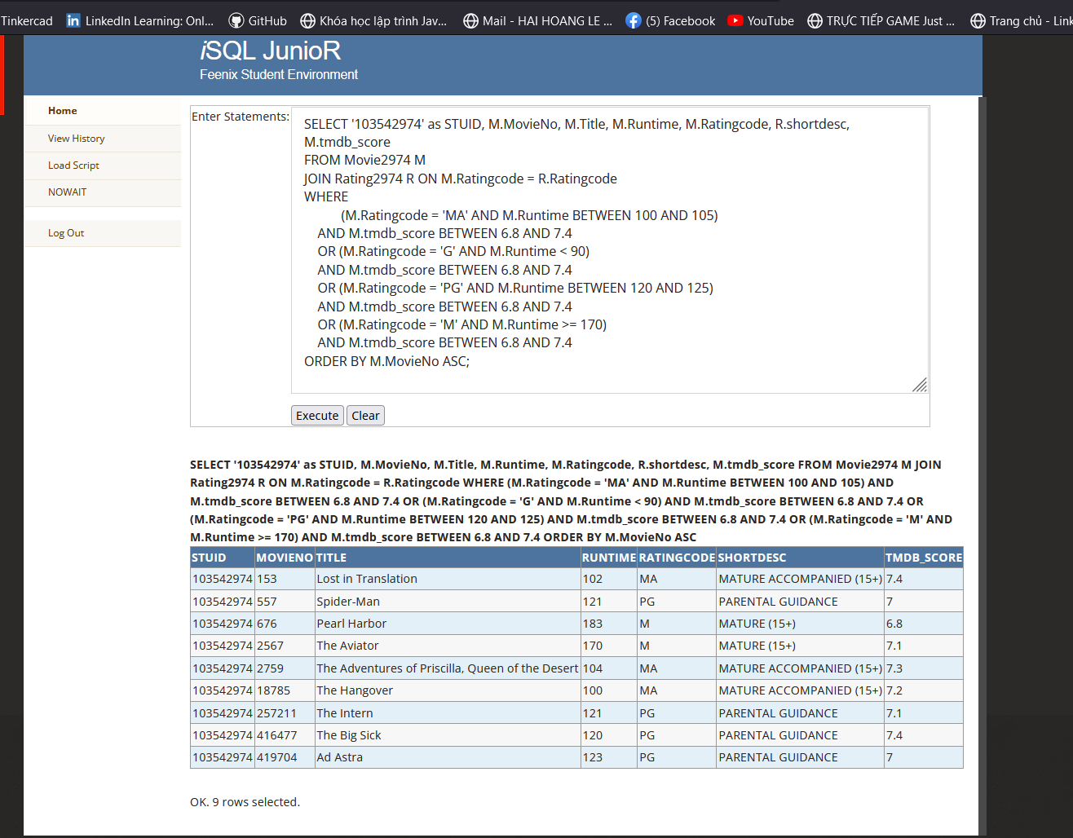

### Credit 3c

Paste your screen capture(s) for this task here.

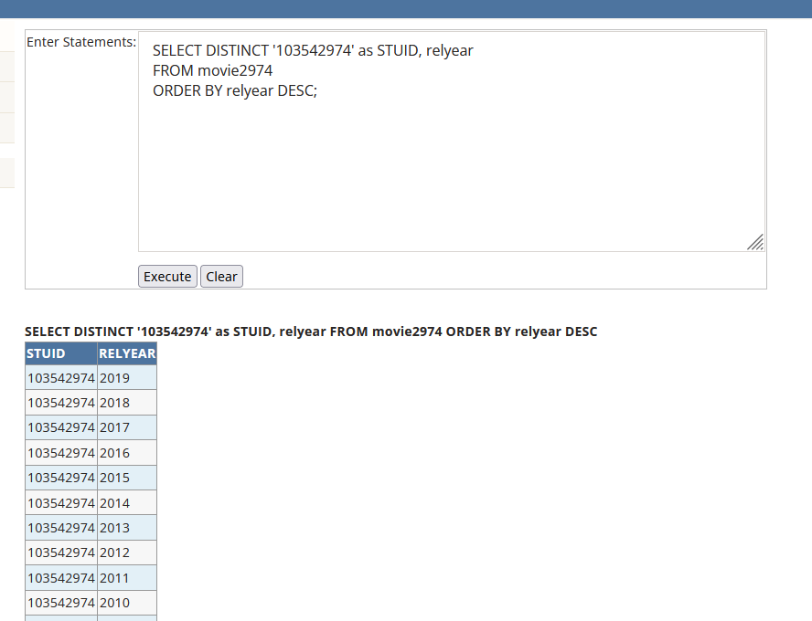

### Credit 3d

Paste your screen capture(s) for this task here.

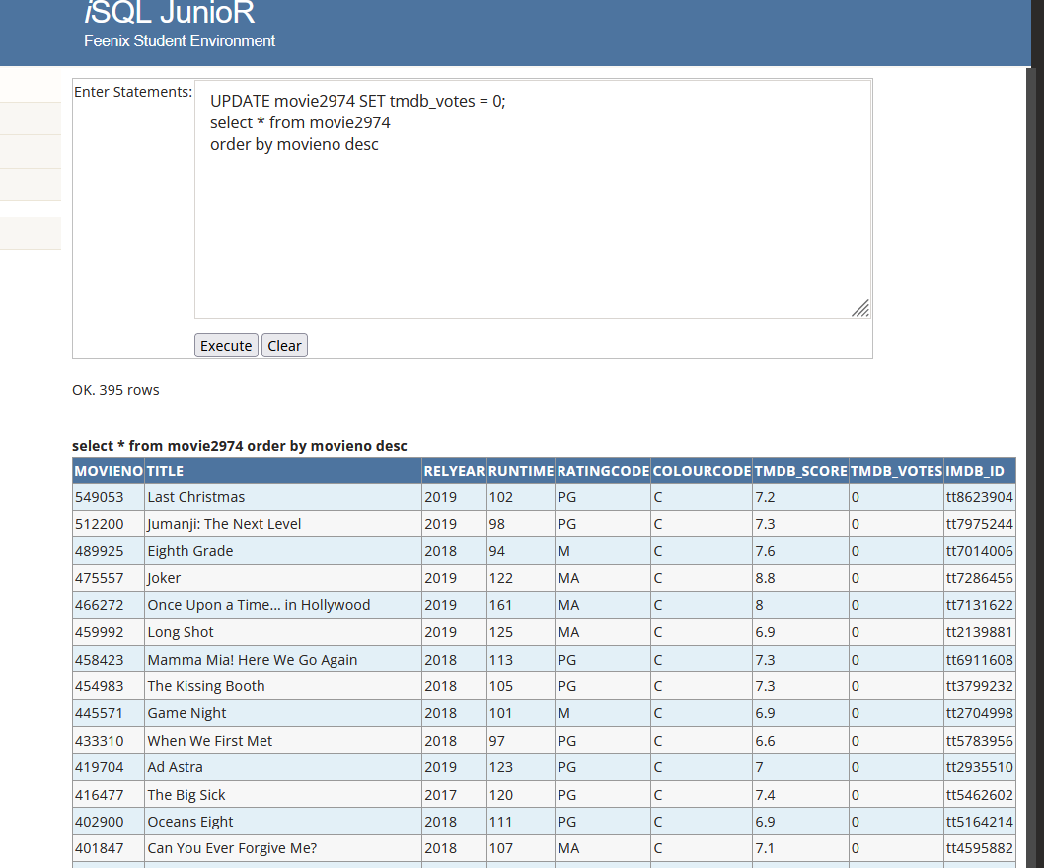

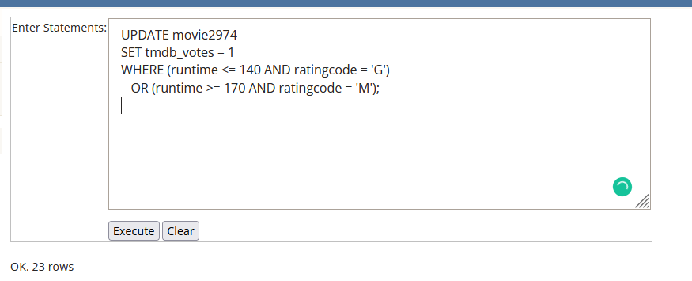

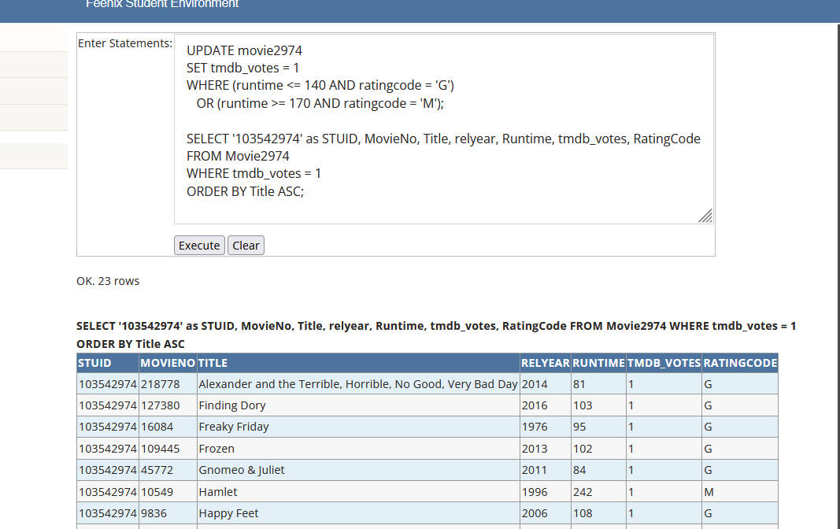

### Credit 3e

Paste your screen capture(s) for this task here.

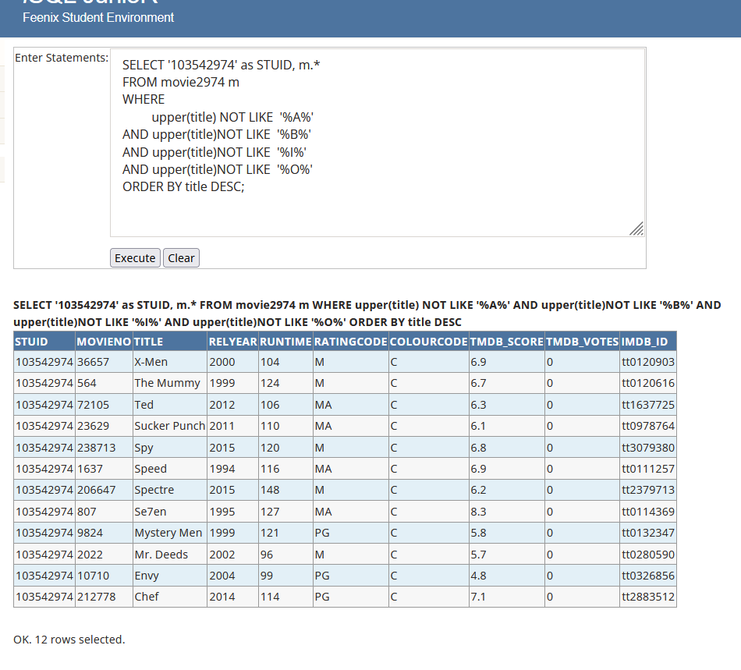

### Credit 3f

Paste your screen capture(s) for this task here.

DROP TABLE CAR2974;

CREATE TABLE CAR2974 (

RegNo VARCHAR(10)

PRIMARY KEY,

Make VARCHAR(50),

Model VARCHAR(50),

OdometerReading NUMERIC(10,2),

SaleDate DATE );

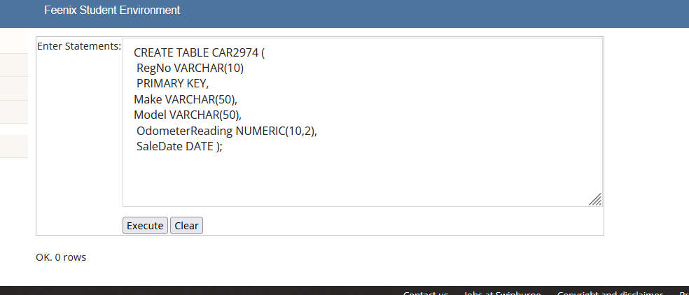

### Credit 3g

Paste your screen capture(s) for this task here.

INSERT INTO CAR2974 (RegNo, Make, Model, SaleDate, OdometerReading) VALUES ('1AMT7U', 'Aston Martin', 'Vantage', TO_DATE('2022-03-12','yyyy/mm/dd'), 5300);

INSERT INTO CAR2974 (RegNo, Make, Model, SaleDate, OdometerReading) VALUES ('SWS129', 'Hai Le', 'Pound',TO_DATE('2002-02-28','yyyy/mm/dd'), 2802);

INSERT INTO CAR2974 (RegNo, Make, Model, SaleDate, OdometerReading) VALUES ('POCOF3', 'Xiaomi', 'Smartphone',TO_DATE('2021-08-12','yyyy/mm/dd'), 9000);

INSERT INTO CAR2974 (RegNo, Make, Model, SaleDate, OdometerReading) VALUES ('39070', 'Honda', 'AirBlade', TO_DATE('2021-01-12','yyyy/mm/dd'), 500);

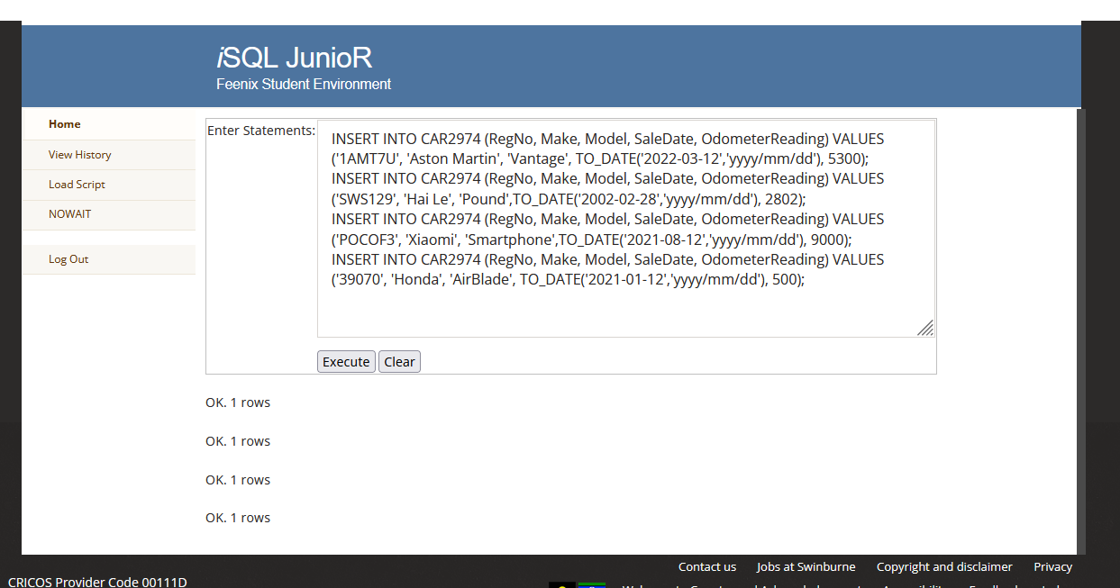

### Credit 3h

Paste your screen capture(s) for this task here.

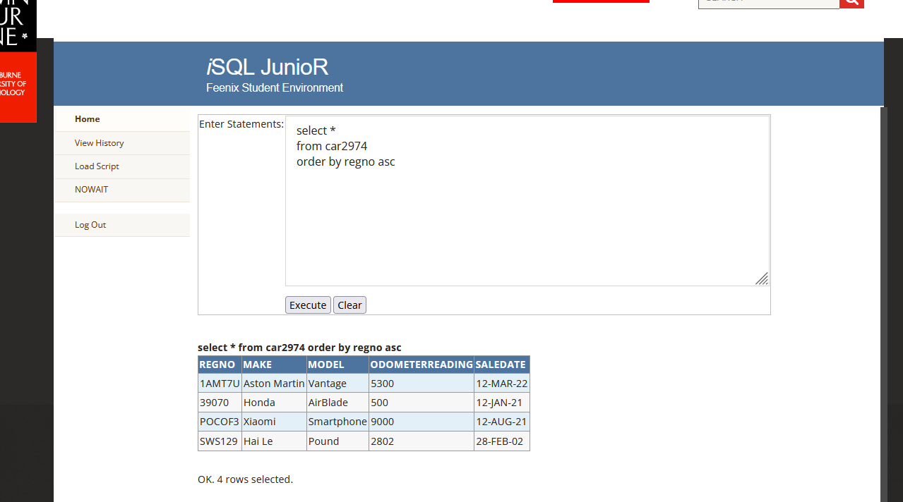

### Credit 3i

Paste your screen capture(s) for this task here.

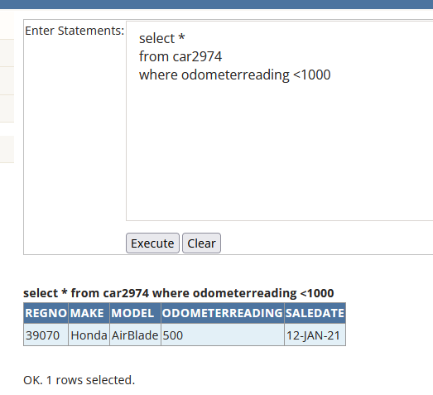

### Credit 3j

Paste your screen capture(s) for this task here.

