

# Task 3 – Pass Submission

Student Number: 103542974  
Student Name: Hai Hoang Le

### Pass 3a

Paste your screen capture(s) for this task here.

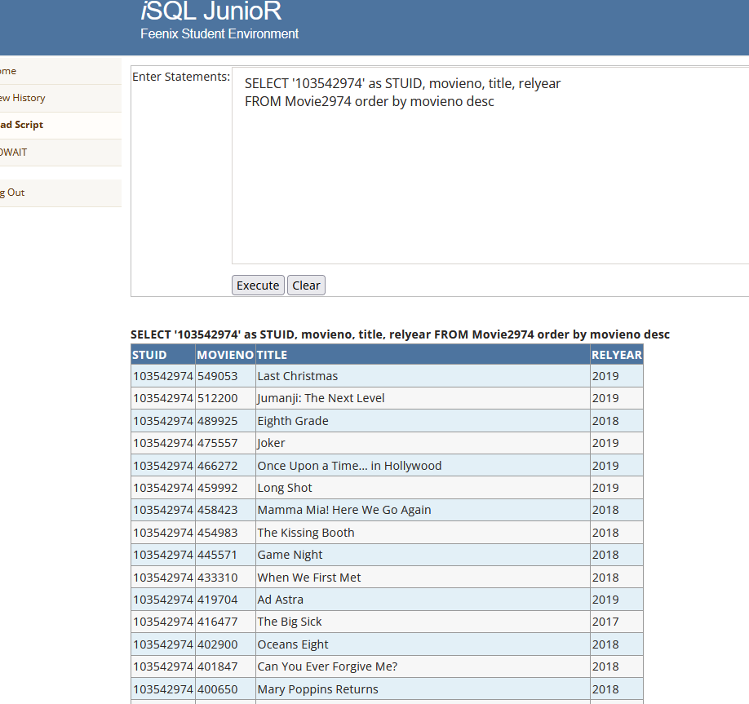

### Pass 3b

Paste your screen capture(s) for this task here.

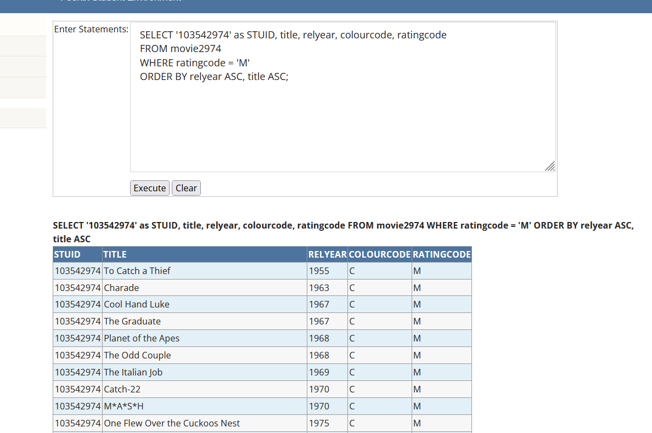

### Pass 3c

Paste your screen capture(s) for this task here.

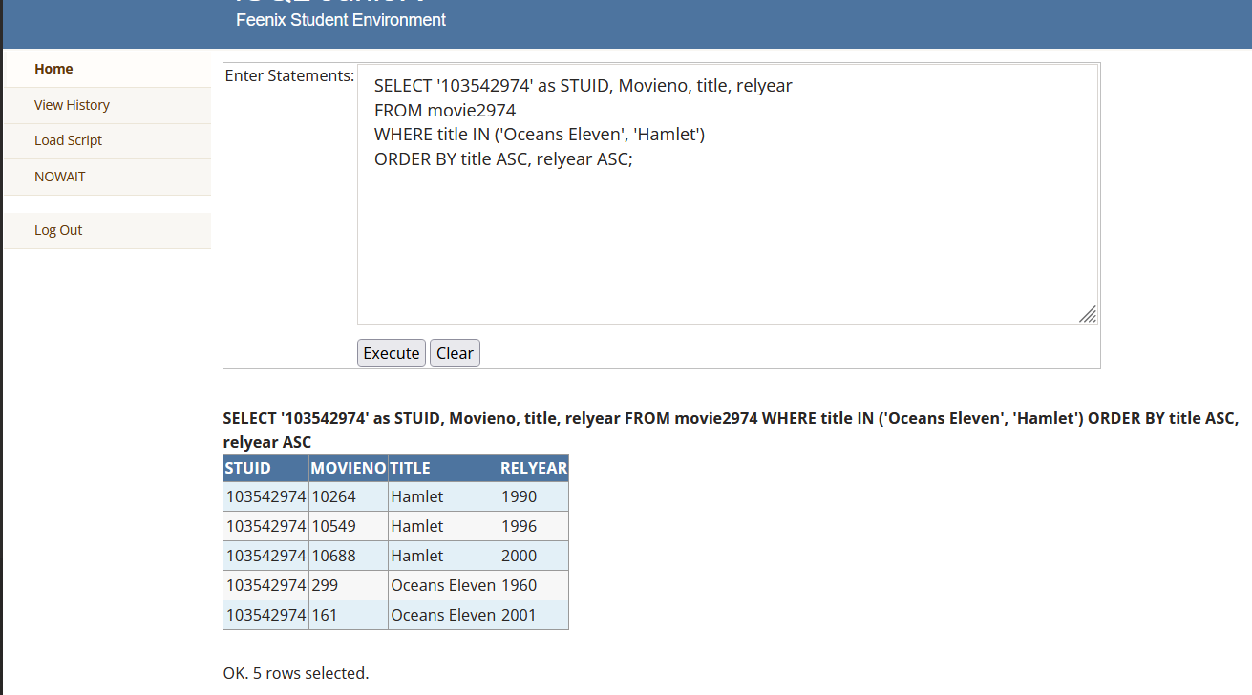

### Pass 3d

Paste your screen capture(s) for this task here.

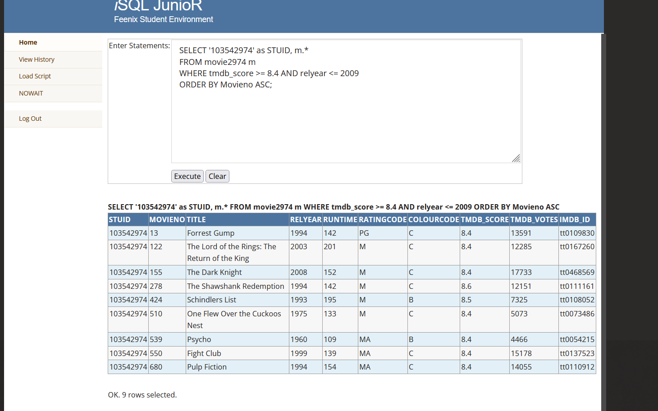

### Pass 3e

Paste your screen capture(s) for this task here.

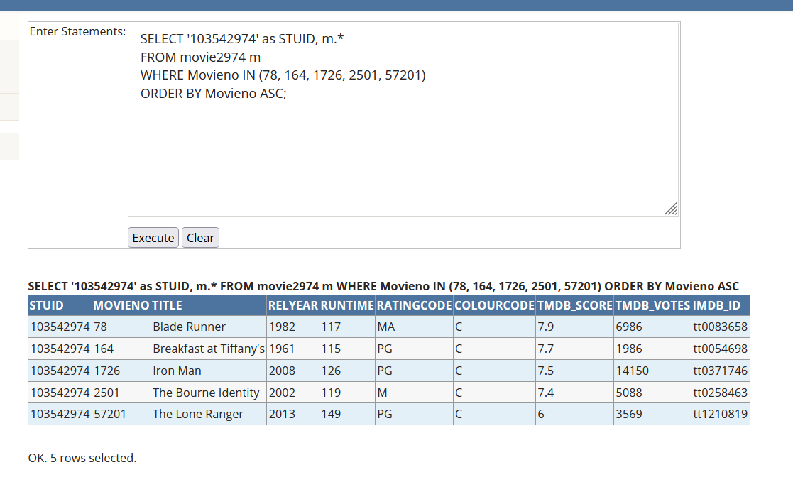

### Pass 3f

Paste your screen capture(s) for this task here.\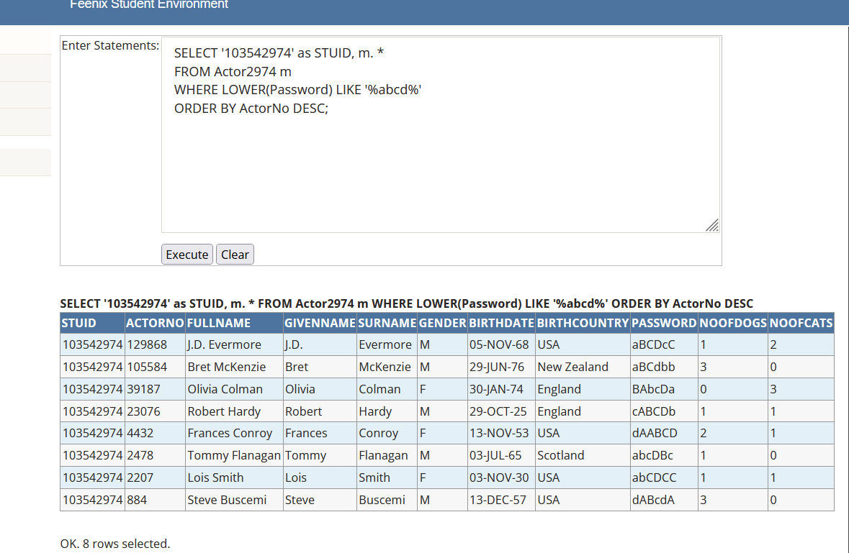

### Pass 3g

Paste your screen capture(s) for this task here.

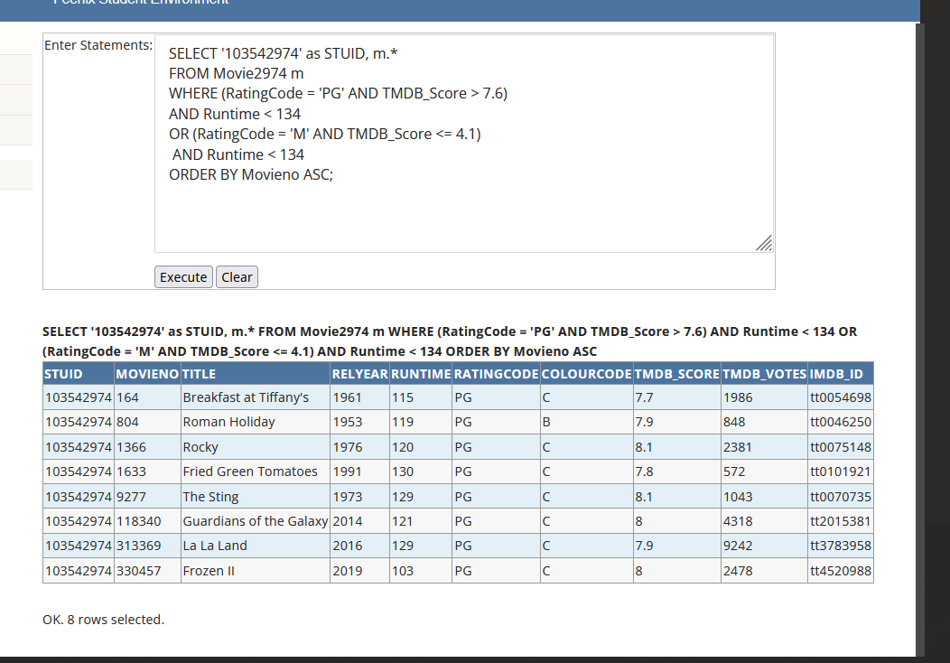

### Pass 3h

Paste your screen capture(s) for this task here.

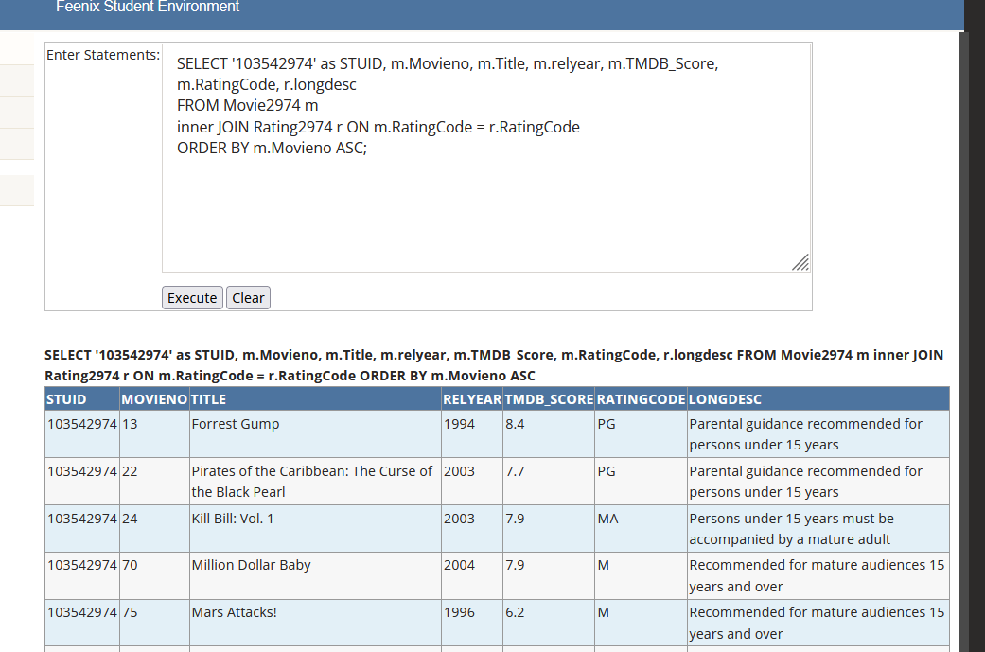

### Pass 3i

Paste your screen capture(s) for this task here.

