

Task 4 – Credit Submission

Student Number: 103542974
Student Name: Hai Hoang Le

Credit 4a
Paste your screen capture(s) for this task here.
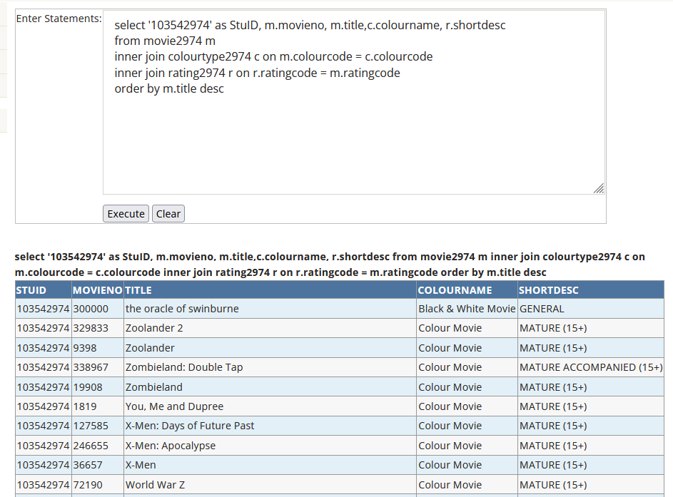

Credit 4b
Paste your screen capture(s) for this task here.
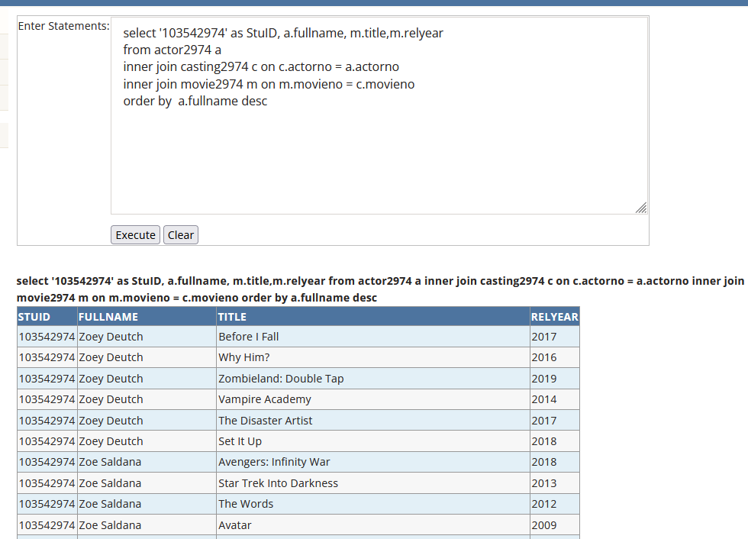

Credit 4c
Paste your screen capture(s) for this task here.
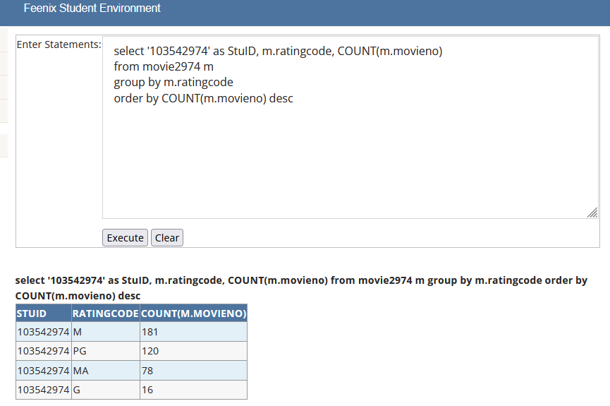

Credit 4d
Paste your screen capture(s) for this task here.
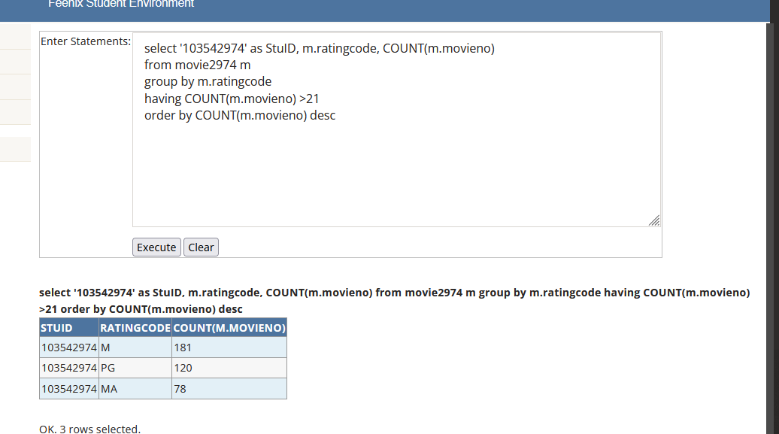

Credit 4e
Paste your screen capture(s) for this task here.
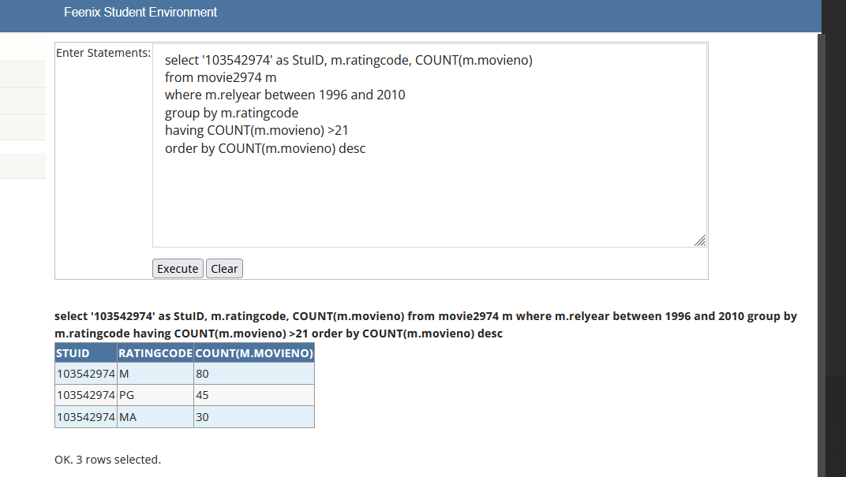

Credit 4f
Paste your screen capture(s) for this task here.
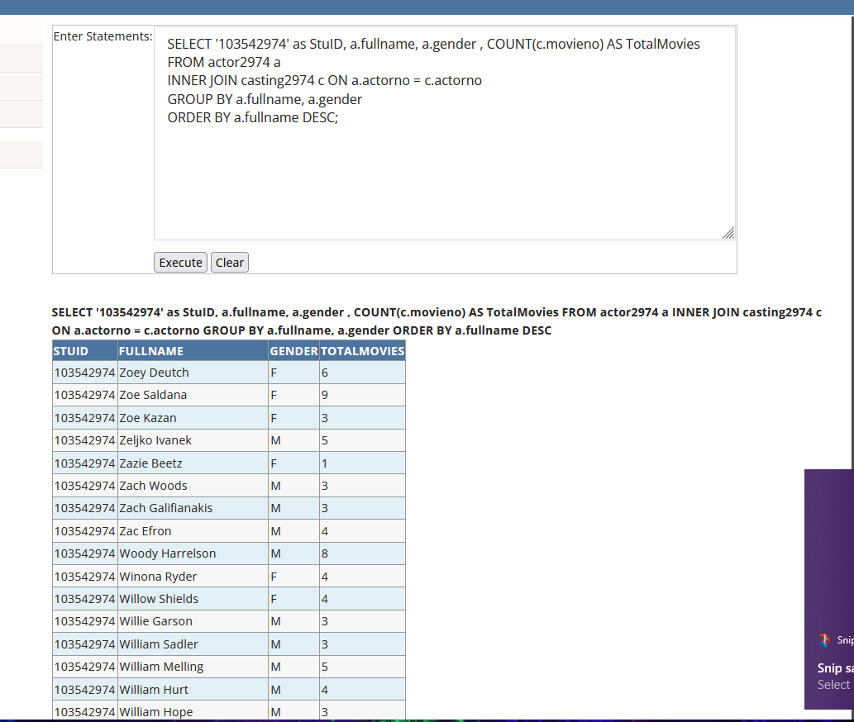

Credit 4g
Paste your screen capture(s) for this task here.
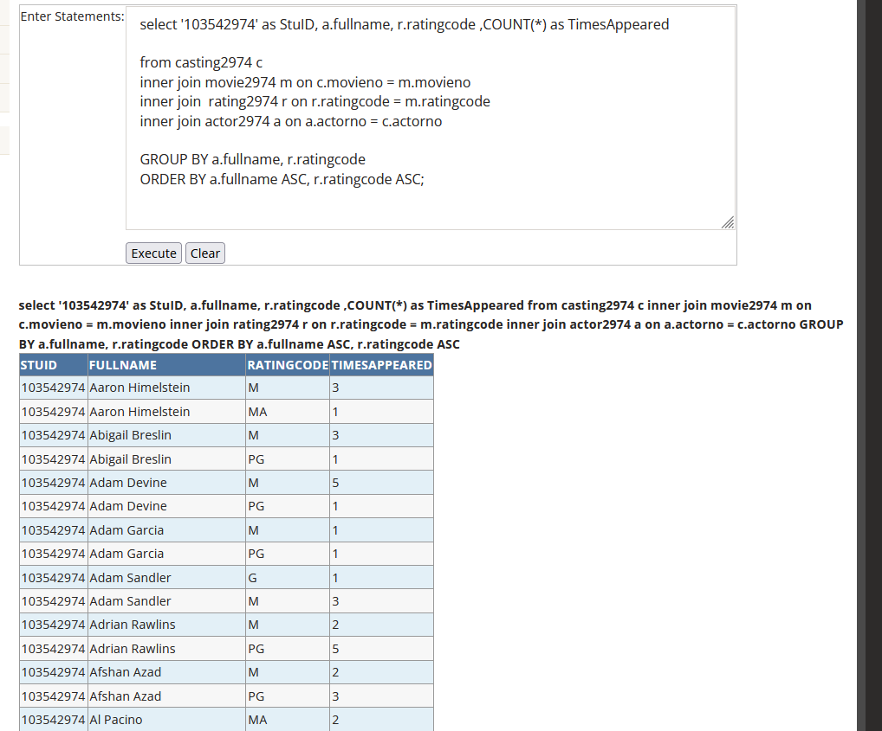

Credit 4h
Paste your screen capture(s) for this task here.
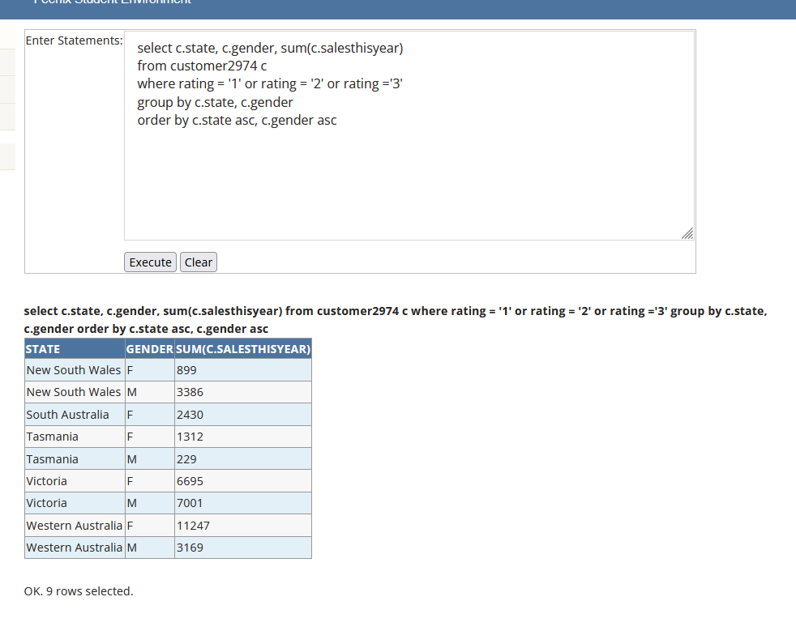
/* From the query above it seem that female the most state in Australia has more sales than man.*/

