

Task 4 – Pass Submission

Student Number: 103542974
Student Name: Hai Hoang Le

Pass 4a
Paste your screen capture(s) for this task here.
CAMPAIGN(CampaignCode, CampaignTitle)
PK CampaignCode

PLAYER(Pid, PName, Gender)
PK (Pid)
FK (CampaignCode) references CAMPAIGN ( CampaginCode)

Pass 4b
Paste your screen capture(s) for this task here.
CREATE TABLE CAMPAIGN2974 (
campaigncode VARCHAR(6) NULL,
campaigntitle VARCHAR(100) NULL,
PRIMARY KEY (campaigncode)
);

CREATE TABLE Player2974 (
pid INT NULL,
pname VARCHAR(25) NULL,
gender VARCHAR(1),
Campaigncode VARCHAR(6),
PRIMARY KEY (pid),
FOREIGN KEY (Campaigncode) REFERENCES CAMPAIGN2974(campaigncode)
);

Pass 4c
Paste your screen capture(s) for this task here.
INSERT INTO Campaign2974 (campaigncode, campaigntitle) VALUES (1, 'Campaign One');
INSERT INTO Campaign2974 (campaigncode, campaigntitle) VALUES (2, 'Campaign Two');
INSERT INTO Campaign2974 (campaigncode, campaigntitle) VALUES (3, 'Campaign Three');

INSERT INTO Player2974 (pid, pname, gender, campaigncode) VALUES (21, 'Ali Aien', 'M', 2);
INSERT INTO Player2974 (pid, pname, gender, campaigncode) VALUES (22, 'Peter Ymer', 'M', 1);
INSERT INTO Player2974 (pid, pname, gender, campaigncode) VALUES (23, 'Sarah Rogers', 'F', 1);
INSERT INTO Player2974 (pid, pname, gender, campaigncode) VALUES (24, 'Sheelan Aien', 'F', 2);
INSERT INTO Player2974 (pid, pname, gender, campaigncode) VALUES (25, 'Hai Hoang Le, 'M', 3);
INSERT INTO Player2974 (pid, pname, gender, campaigncode) VALUES (26, 'Emma Watson', 'F', 3);

Pass 4d
Paste your screen capture(s) for this task here.
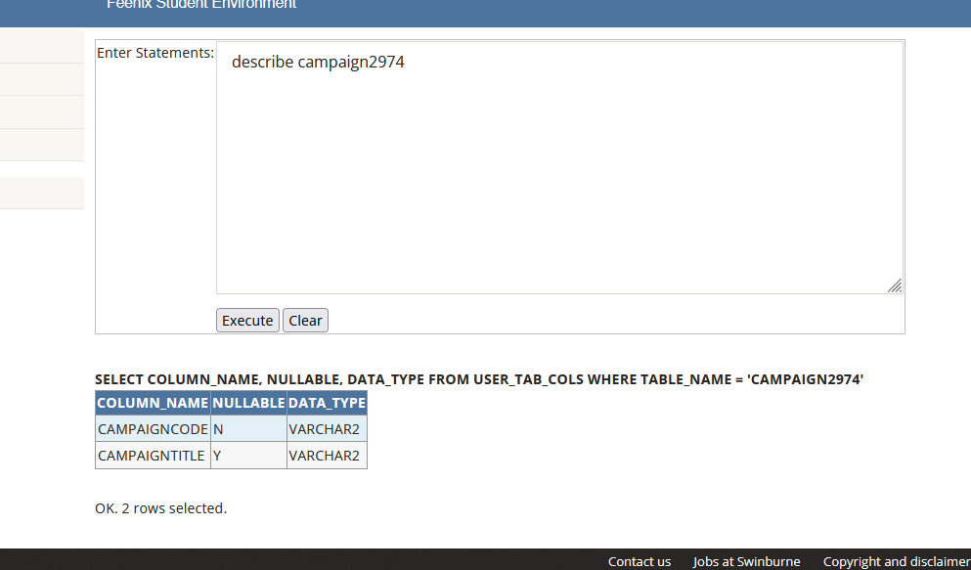
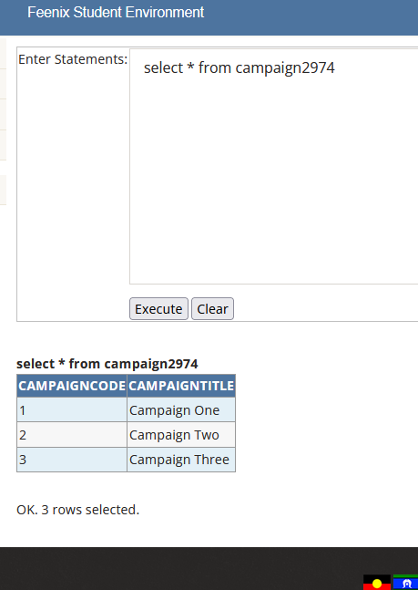
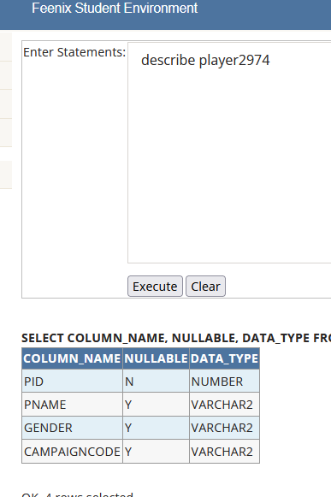
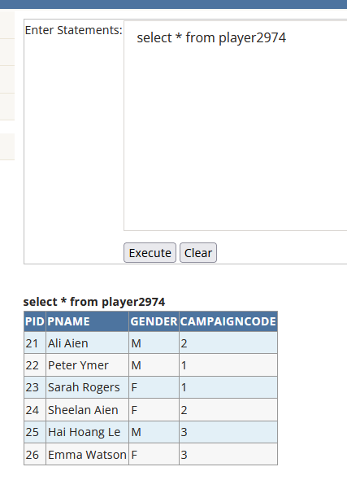

Pass 4e
Paste your screen capture(s) for this task here.
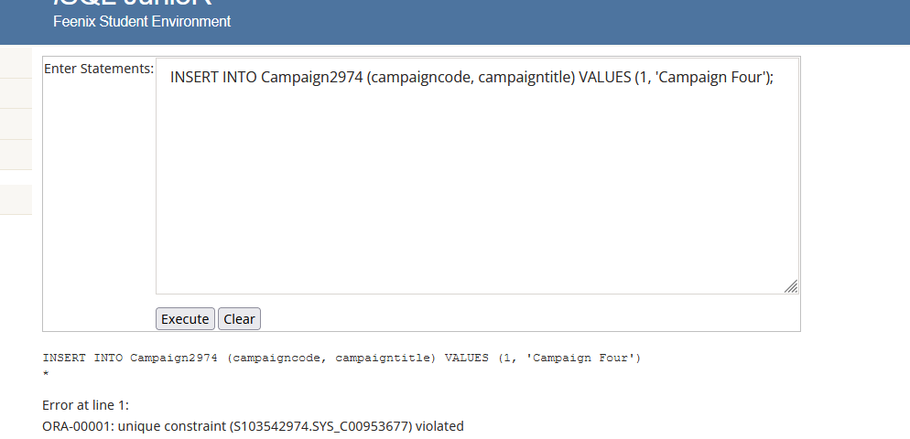
This state is fail because the values is being inserted and exists in the tables and violates the constraint.

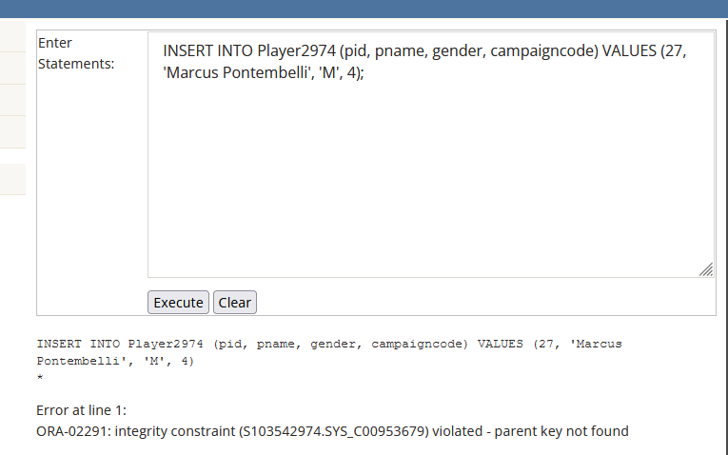
This Insert statement will cause error because it create a campaign code 4 which is non-existent in the Campaign2974 which is the parent record.

Pass 4f
Paste your screen capture(s) for this task here.
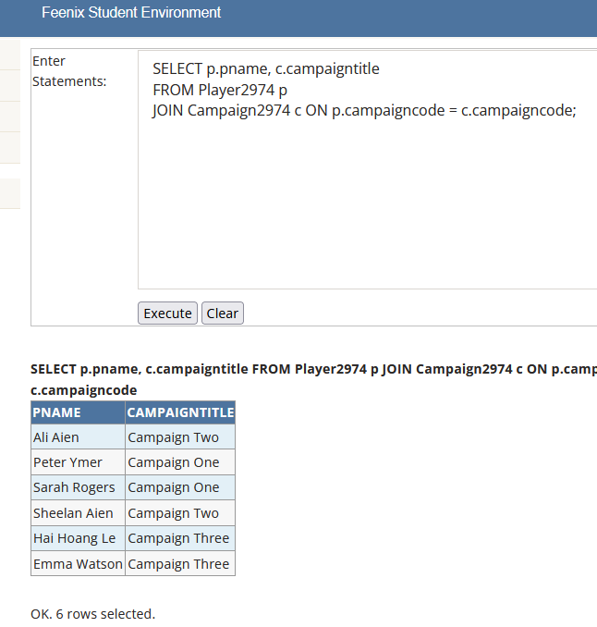

Pass 4g
Paste your screen capture(s) for this task here.
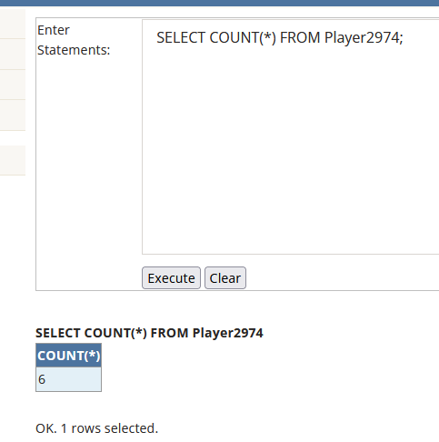
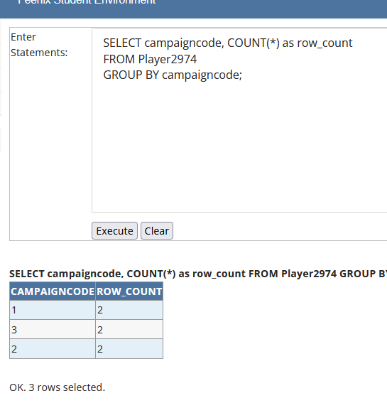

Pass 4h
Paste your screen capture(s) for this task here.
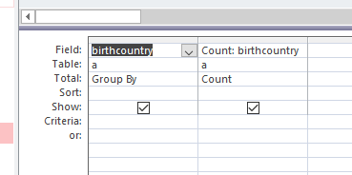
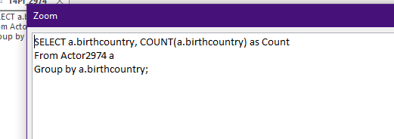
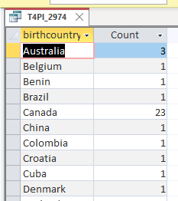

Pass 4i
Paste your screen capture(s) for this task here.
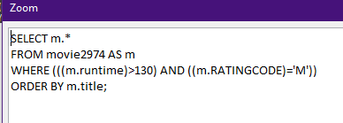
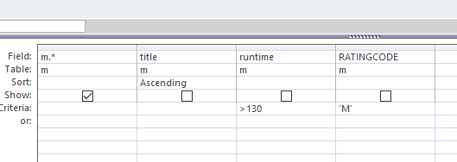
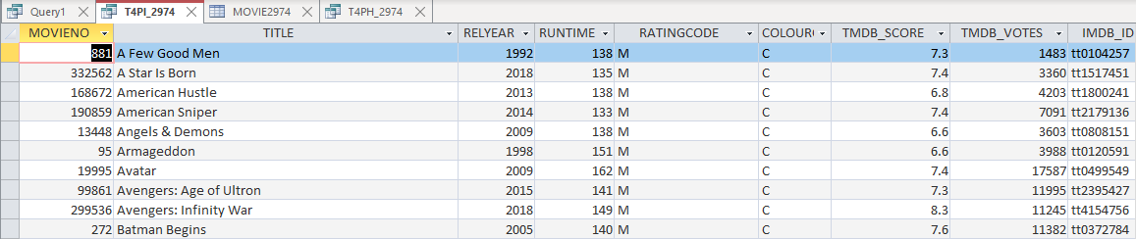

Pass 4j
Paste your screen capture(s) for this task here.
ERD:
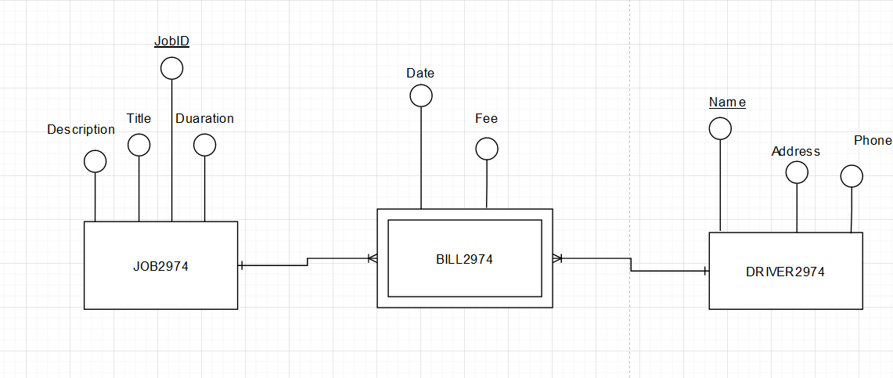
Relational Schema:
JOB2974 (JobID, Title, Description, Duaration)
PK (JobID)

DRIVER2974 (Name, Address, Phone)
PK (Name)

BILL2974 (Date, Fee, JobID, Name)
PK (JobID, Name)
FK1 (JobID) references JOB (JobID)
FK2 (Name) references DRIVER (Name)

Test Data:
INSERT INTO JOB2974 (JobID, Title, Description, Duaration)
VALUES (50, 'Deliver', 'Pizza', 1);
INSERT INTO JOB2974 (JobID, Title, Description, Duaration)
VALUES (51, 'Deliver', 'Sandwich', 2);

INSERT INTO DRIVER2974 (Name, Address, Phone)
VALUES ('Hai Le', 'Cong Hoa Street', '0702917344');

INSERT INTO DRIVER2974 (Name, Address, Phone)
VALUES ('Tuan Minh', 'Le Loi Street', '123456788');

INSERT INTO BILL2974 (Date, Fee, JobID, Name)
VALUES ('2023-03-21', 100.00, 50, 'Hai Le');

INSERT INTO BILL2974 (Date, Fee, JobID, Name)
VALUES ('2022-03-15', 200.00, 51, 'Tuan MInh');

Pass 4k
Paste your screen capture(s) for this task here.
ERD:
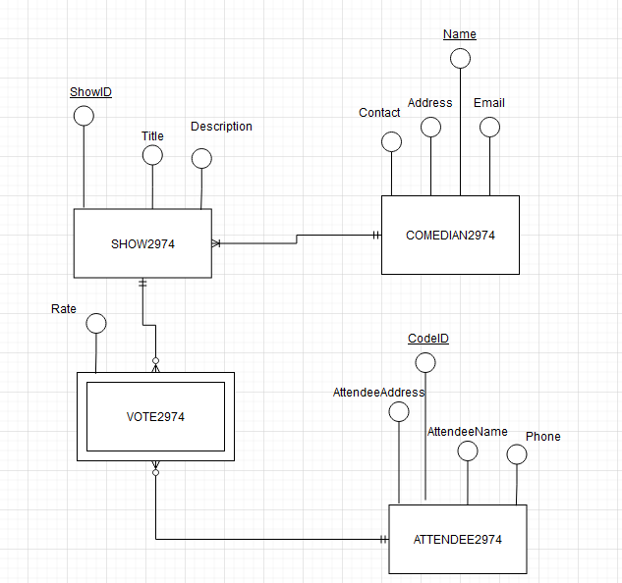
Relational Schema:
COMEDIAN2974 (Name, Contact, Address, Email)
PK (Name)

SHOW2974 (ShowID, Title, Description, Name)
PK (ShowID)
FK (Name) referencse COMEDIAN2974 (Name)

ATTENDEE2974 (CodeID, AttendeeName, AttendeeAdress, Phone)
PK (CodeID)

VOTE2974 (Rate, CodeID, ShowID)
PK (CodeID, ShowID)
FK1 (CodeID) references ATTENDEE2974(CodeID)
FK2 (ShowID) references SHOW2974(ShowID)

Test Data:
INSERT INTO COMEDIAN2974 (Name, Contact, Address, Email)
VALUES ('Hai Le', '0702917344', '123 Cong Hoa Street', 'hai28022002@gmail.com');

INSERT INTO COMEDIAN2974 (Name, Contact, Address, Email)
VALUES ('Quoc Huy', '0702873562', '128 Xo Viet Nghe Tinh Street', 'wochuyhaha@huhu.com');

INSERT INTO ATTENDEE2974 (CodeID, AttendeeName, AttendeeAdress, Phone)
VALUES ('A001', 'Trung Pham', '789 Bach Dang St', ‘232323132');

INSERT INTO ATTENDEE2974 (CodeID, AttendeeName, AttendeeAdress, Phone)
VALUES ('A002', 'Thanh Dat', '23 Dia Nguc St', '666666666');

INSERT INTO SHOW2974 (ShowID, Title, Description, Name)
VALUES (123, 'Sketch Comedy', 'Hilarious sketches with Hai Le ', 'Hai Le');

INSERT INTO SHOW2974 (ShowID, Title, Description, Name)
VALUES (321, 'Stand-up Comedy', 'A night of laughs with Woc Huy', 'Woc Huy');

INSERT INTO VOTE2974 (Rate, CodeID, ShowID)
VALUES (8, 'A001', 123);

INSERT INTO VOTE2974 (Rate, CodeID, ShowID)
VALUES (7, 'A002', 321);

