Hailemariam Teshome

Introduction to Biochemistry

Dec 17, 2023

**Ceramides**

Ceramides are a class of lipids that are a fundamental molecule to numerous cellular functions which include but are not limited to cell membrane structure, signaling, apoptosis, protecting our epidermis against environmental damage. A ceramide’s structure consists of a sphingosine base attached to a fatty acid that is linked by an amide bond [1,2]. Typically, the sphingosine base has an 18-carbon chain with an unsaturated hydrocarbon tail, while the fatty acid component varies in chain length from 12 on the low end to greater than 20 carbons at the high end [2]. This range allows ceramides flexibility in their biochemical properties including the degree of hydrophobicity, stability, and barrier functionality for the control of moisture in the skin barrier [1]. The structure of various sphingolipid molecules can be depicted in Figure 1 which showcases a lengthy hydrocarbon chain characterized by an amino group on one end and a hydroxyl group on the opposite end. On the far-right end, we can visualize a molecule that is created by adding a fatty acid residue to Sphingosine utilizing an amide bond [3].

Figure 1: Chemical structures of various Sphingolipids [3]

Expanding on its structure, the tertiary structure can be visualized in Figure 2, showcasing its folding and coiling patterns, which are primarily represented by the alpha-helices and sheets that connect the loops. Its specifically taken from a human model created using X-ray diffraction.

Figure 2: Crystal structure of human Ceramide-1-Phosphate Transfer Protein (CPTP) in complex [4]

Ceramides are primarily undergo chemical synthesis or recycling in the Cytosol or endoplasmic reticulum of the cell as shown in Figure 3. This image visualizes the biochemical reactions that occur within the cell that involve the synthesis of ceramides and their substrate preferences. It defines various commonly occurring Ceramide Synthases which range from CerS1 to CerS6 and their associated substrate preferences that are derived from a fatty Acyl-CoA of varying chain lengths. These molecules can be synthesized in a few different pathways, two of which are the salvage pathway and de novo synthesis pathways [5]. The salvage pathway hydrolyzes Sphingolipids such as Glucosylceramide and Sphingomyelin in the lysosome to produce Sphingosine that can be re-acetylated to regenerate a Ceramide molecule. An alternative mode of synthesis is the de novo synthesis pathway that depicts the conversion of the amino acids Serine and Palmitoyl-CoA into Ceramides within the endoplasmic reticulum [5,6]. These biomolecules are converted utilizing the enzyme Serine Palmitoyl Transferase (SPT) to form 3-Keto-Sphinganine first in the cytosol. Then, this intermediate step converts the 3-Keto-Sphinganine into Sphinganine by using the Ceramide-activated protein Kinase Suppressor RAS (KSR) which further reacts with a fatty Acyl-CoA, driven by Ceramide Synthases (CerS1-6), to yield Dihydroceramide. The final product in this pathway creates a Ceramide by desaturating the Dihydroceramide using the enzyme Dihydroceramide Desaturase 1 (DES1). These steps can be followed in the reaction depicted in Figure 4 [5,6].

Figure 3: Illustration of the different species of Ceramides generated through de novo synthesis or salvage pathway [5]

$$Serine+Palmitoyl-CoA→3-Ketosphinganine→Sphinganine$$

$$Sphinganine+Fatty Acyl-CoA→Ceramide+CoA$$

Figure 4: Chemical reactions producing Ceramide from amino acids

We can further understand these biochemical reactions by observing the larger pathways involved as show in Figure 5 which depicts the synthesis of various ceramides and their specific metabolism roles. At the outset, the elongation cycle of fatty extends acyl-CoA precursors which is essential for fatty acids and oleic acid to be transformed into their corresponding acyl-CoA forms that are further elongated. The figure also showcases the next step which is the amalgamation of Sphingoid bases with various Acyl-CoA molecules that are mediated by their respective Ceramide Synthases to develop distinct Ceramide species. This diagram also takes it a step further as the Ceramides can be transformed into other lipids like Glucosylceramides (GlcCer) by utilizing the GCS enzyme and sphingomyelins (SM) through the SMS enzyme. There are even a small few Ceramides that undergo post-translation modifications by integrating Linoleic acid into their structure or by binding to other proteins [7,8,9,10].

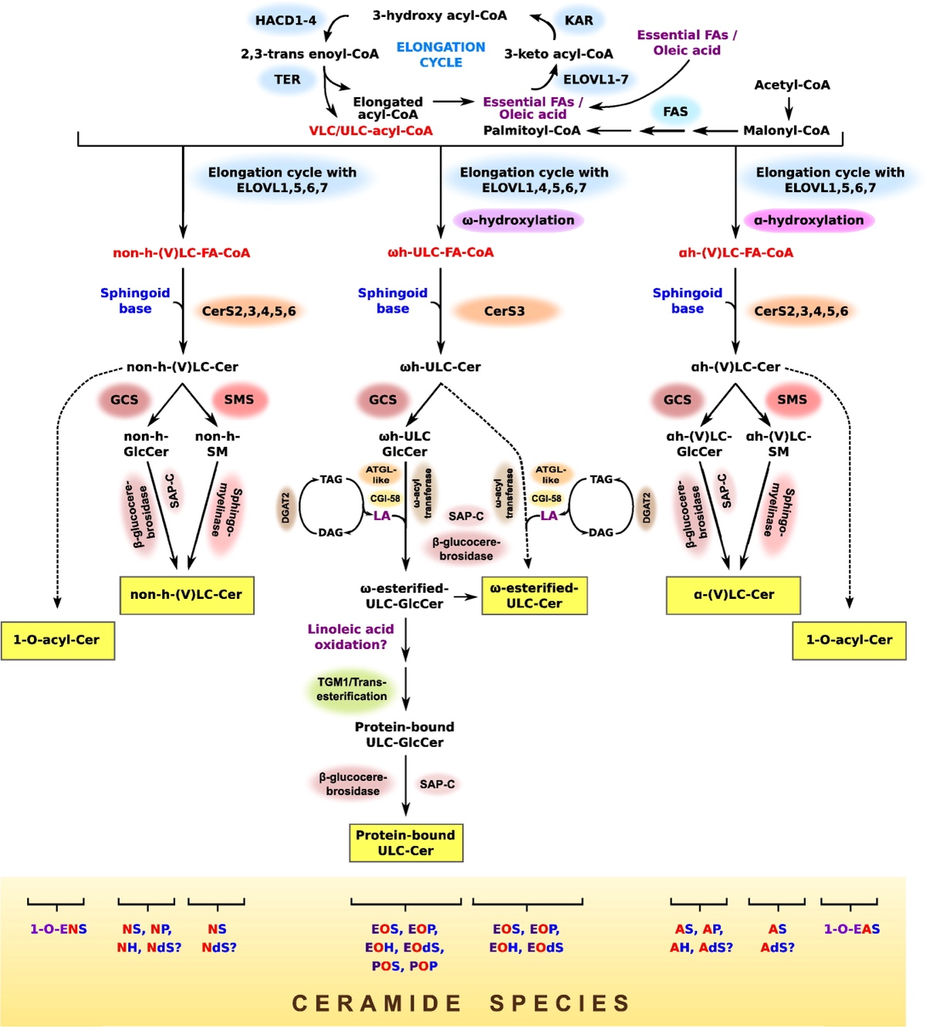

Figure 5: Biosynthetic pathways that elucidate the generation of different Ceramide species [10]

Particularly concerning the epidermis, Ceramides contribute to the structural integrity and form a protective barrier against environmental aggressors. Ceramides accomplish this by being interwoven within a lipid matrix with cholesterol and other free fatty acids in the stratum corneum. Their amphipathic nature is derived from a Sphingosine base linked to a fatty acid and facilitates their organization to aggregate into highly ordered and compact lipid layers. These layers form a barrier that resists both water-soluble and fat-soluble foreign particulates that can provide the best skin protection. Additionally, ceramides play a key role as a regulator of skin moisture by curtailing trans epidermal water loss (TEWL) [7,8]. TEWL is a phenomenon where water from the skin's deeper layers evaporates into the surrounding environment, which when retained ensures that the skin remains supple and elastic, but also prevents the formation of cracks within the skin that might permit environmental contaminants to enter. Another facet of ceramides is that they mitigate the penetration of environmental pollutants such as bacterial and fungal pathogens through their dense Ceramide-rich lipid layers, which prevents them from breaching the skin and causing oxidative stress [7]. Although not directly, Ceramides also combat harsh UV radiation by regulating skin structure which intrinsically contains antioxidant defenses that neutralize UV-induced oxidative stress. In instances of environmental stress or oxidative damage, Ceramides are a game changer in the skin's repair mechanisms as the skin barrier triggers an enzymatic conversion of stored lipids into Ceramides when compromised which facilitates a swift and effective barrier reconstruction [7,10]. Their multimolecular interaction with other lipids like cholesterol and free fatty acids allow for the formation of lipid rafts which enhance the barrier function by amplifying the protective attributes of each other.

Overall, Ceramides are a key biomolecule in the formation, repair, and maintenance of the skin that dictate the structural components of cell membranes. They’re dynamic molecule that integrates themselves into various cellular processes and disease mechanisms and can showcase promise in being utilized for novel therapeutic approaches for a range of diseases and use cases including metabolic disorders like insulin resistance and obesity, the formation of the myelin sheath around neurons, facilitating efficient nerve signal transmission, skin disorders like psoriasis and eczema, as well as inducing apoptosis in cancer cells [11,12,13].

Citations:

1. Motta S, Monti M, Sesana S, Caputo R, Carelli S, Ghidoni R. Ceramide composition of the psoriatic scale. Biochim Biophys Acta. 1993 Sep 8;1182(2):147-51. doi: 10.1016/0925-4439(93)90135-n. PMID: 8357845.

2. Maula T, Artetxe I, Grandell PM, Slotte JP. Importance of the sphingoid base length for the membrane properties of ceramides. Biophys J. 2012 Nov 7;103(9):1870-9. doi: 10.1016/j.bpj.2012.09.018. PMID: 23199915; PMCID: PMC3491676.

3. Wikimedia Foundation. (2023, December 11). Sphingolipid. Wikipedia. https://en.wikipedia.org/wiki/Sphingolipid

4. Bank, R. P. D. (n.d.). 4K84: Crystal structure of human ceramide-1-phosphate transfer protein (CPTP) in complex with 16:0 ceramide-1-phosphate (16:0-c1p). RCSB PDB. https://www.rcsb.org/structure/4k84

5. Ho, Qing Wei Calvin & Zheng, Xiaofeng & Ali, Yusuf. (2022). Ceramide Acyl Chain Length and Its Relevance to Intracellular Lipid Regulation. International Journal of Molecular Sciences. 23. 9697. 10.3390/ijms23179697.

6. Hannun, Y. A., & Obeid, L. M. (2008). "Principles of bioactive lipid signalling: lessons from sphingolipids." *Nature Reviews Molecular Cell Biology*, 9(2), 139-150.

7. Merrill, A. H., Sullards, M. C., Wang, E., Voss, K. A., & Riley, R. T. (2001). Sphingolipid Metabolism: Roles in Signal Transduction and Disruption by Fumonisins. *Environmental Health Perspectives*, *109*, 283–289. https://doi.org/10.2307/3435020

8. Quinville BM, Deschenes NM, Ryckman AE, Walia JS. A Comprehensive Review: Sphingolipid Metabolism and Implications of Disruption in Sphingolipid Homeostasis. Int J Mol Sci. 2021 May 28;22(11):5793. doi: 10.3390/ijms22115793. PMID: 34071409; PMCID: PMC8198874.

9. Green CD, Maceyka M, Cowart LA, Spiegel S. Sphingolipids in metabolic disease: The good, the bad, and the unknown. Cell Metab. 2021 Jul 6;33(7):1293-1306. doi: 10.1016/j.cmet.2021.06.006. PMID: 34233172; PMCID: PMC8269961.

10. Rabionet M, Gorgas K, Sandhoff R. Ceramide synthesis in the epidermis. Biochim Biophys Acta. 2014 Mar;1841(3):422-34. doi: 10.1016/j.bbalip.2013.08.011. Epub 2013 Aug 27. PMID: 23988654.

11. Ogretmen, B., & Hannun, Y. A. (2004). "Biologically active sphingolipids in cancer pathogenesis and treatment." *Nature Reviews Cancer*, 4(8), 604-616.

12. Stith JL, Velazquez FN, Obeid LM. Advances in determining signaling mechanisms of ceramide and role in disease. J Lipid Res. 2019 May;60(5):913-918. doi: 10.1194/jlr.S092874. Epub 2019 Mar 7. PMID: 30846529; PMCID: PMC6495170.

13. Arana L, Gangoiti P, Ouro A, Trueba M, Gómez-Muñoz A. Ceramide and ceramide 1-phosphate in health and disease. Lipids Health Dis. 2010 Feb 5;9:15. doi: 10.1186/1476-511X-9-15. PMID: 20137073; PMCID: PMC2828451.