
Addis Ababa University
College of Technology and Built Environment (CTBE)
Section 1

SE4801 – Enterprise Application Development
Lab 1 & Lab 2 Report

Name ID.No
Hailemichale Lijalem (ATE/1051/14)

College of Technology and Built Environment (CTBE)

April 25, 2026
Mr. Abel.
Table of Contents
1. Introduction 3
2. Architecture and Technologies 3
3. Implementation Details 3
3.1 Entity and Repository 3
3.2 Data Transfer Objects (DTOs) 3
3.3 Service Layer 3
3.4 REST Controller 4
3.5 Global Exception Handling 4
4. Testing and CI/CD 4
5. Reflection Questions 4
6. Conclusion 5
7.Tests on postman 6
8.Test on swagger 7

1. Introduction
The objective of these labs is to design and develop a production-ready RESTful Product Catalogue API using Spring Boot. The project evolved from a basic Spring Boot setup in Lab 1 to a fully functional enterprise-grade application in Lab 2. The enhancements included introducing Data Transfer Objects (DTOs), robust validation, global exception handling based on RFC standards, comprehensive API documentation, and integration testing.

2. Architecture and Technologies
The application is built upon a modern Java tech stack:
- Java 21 & Spring Boot 3
- Spring Data JPA with H2 In-Memory Database
- Spring Validation (@Valid, @NotBlank, etc.)
- SpringDoc OpenAPI for Swagger UI documentation
- JUnit 5 & MockMvc for isolated Integration Testing
- GitHub Actions for automated CI/CD pipelines

3. Implementation Details

3.1 Entity and Repository
The core domain model is the Product entity, mapped to the database using JPA annotations (@Entity, @Table, @Id, @GeneratedValue). Database operations are handled by the ProductRepository which extends JpaRepository, abstracting away the boilerplate CRUD operations.

3.2 Data Transfer Objects (DTOs)
To decouple the API exposure from the persistence layer, ProductRequest and ProductResponse DTOs were created. The ProductRequest DTO carries validation constraints (e.g., @NotBlank, @Positive) to ensure data integrity before it reaches the service layer.

3.3 Service Layer
The ProductService handles business logic, acting as an intermediary between the Controller and the Repository. It translates incoming DTOs into entities and throws a custom ResourceNotFoundException if a requested product ID does not exist.

3.4 REST Controller
The ProductController exposes standard RESTful endpoints (GET, POST, PUT, DELETE). It strictly follows REST HTTP semantics, such as returning a 201 Created status with a Location header pointing to the newly created resource on a POST request.

3.5 Global Exception Handling
A @ControllerAdvice class (GlobalExceptionHandler) centrally processes exceptions thrown across all controllers. It transforms exceptions like ResourceNotFoundException and validation failures into standard RFC 9457 ProblemDetail JSON responses.

4. Testing and CI/CD
Quality assurance is maintained through comprehensive integration testing using MockMvc. The ProductControllerTest verifies all API endpoints, serialization, HTTP status codes, and validation rules. The @Transactional annotation ensures that the in-memory database is rolled back after each test execution, maintaining a clean state and preventing test interference.
A GitHub Actions CI pipeline is configured (.github/workflows/ci.yml) to trigger "mvn test" automatically on pushes and pull requests to the master branch.

5. Reflection Questions
- Q: Why should the ProductRequest DTO carry the @Valid annotations instead of the Product entity itself?
A: Keeping validation annotations on the DTO decouples the API layer from the persistence layer. This ensures that validation specific to incoming HTTP requests doesn't pollute the domain model, allowing the entity to simply reflect the database schema while the DTO strictly enforces API-level constraints. It also enables us to expose only the required fields to the client, keeping fields like 'id' safe from manipulation.
- Q: What is the purpose of the Location header returned on a POST 201 Created response, and which HTTP specification mandates it?
A: The Location header provides the exact URI where the newly created resource can be retrieved. This follows REST conventions (and RFC 7231, HTTP/1.1 Semantics and Content), which states that returning a 201 Created should include a Location header identifying the location of the newly created resource.
- Q: Explain the difference between @ControllerAdvice and @ExceptionHandler. When would you use each?
A: @ExceptionHandler is used at the controller level to handle specific exceptions thrown by methods in that exact controller. @ControllerAdvice is a global interceptor that handles exceptions across the entire application. You use @ControllerAdvice for common logic, like transforming standard exceptions into ProblemDetail responses globally instead of duplicating code.
- Q: In your MockMvc tests you used @Transactional on the test class. What would happen to the database state between tests if you removed this annotation?
A: Without @Transactional, database changes (like saving or deleting a product) would persist across test executions, causing test state to leak. This would lead to tests interfering with each other and randomly failing due to unexpected pre-existing database states. Running tests in a transaction ensures that the database is rolled back to a clean state after every test.
- Q: What does RFC 9457 define, and why does following it produce better APIs than returning a generic error message?
A: RFC 9457 (Problem Details for HTTP APIs) provides a standardized JSON format for reporting errors back to HTTP clients. This standardized schema structure (containing type, title, status, detail, instance) allows developers and clients to uniformly identify the errors, making the API far easier to integrate and handle programmatically.
- Q: What is the difference between an integration test (MockMvc) and a unit test (Mockito)? When is each approach preferable?
A: Integration tests (MockMvc) bring up the Spring application context and test the synergy between multiple layers (controller > service > repo). A unit test (Mockito) isolates a single class by mocking its dependencies, running rapidly without starting the Spring context. Unit tests are preferable for testing complex business logic in isolation quickly, whereas integration tests are essential for ensuring the framework wiring, routing, and JSON serialization function as expected.

6. Conclusion
The labs successfully guided the implementation of a robust, scalable Spring Boot application. By adopting best practices such as separating concerns with DTOs, following strict REST principles, standardizing error outputs with RFC 9457, and isolating testing databases with transactions, the resulting API is structurally sound and production-ready.

7.Tests on postman
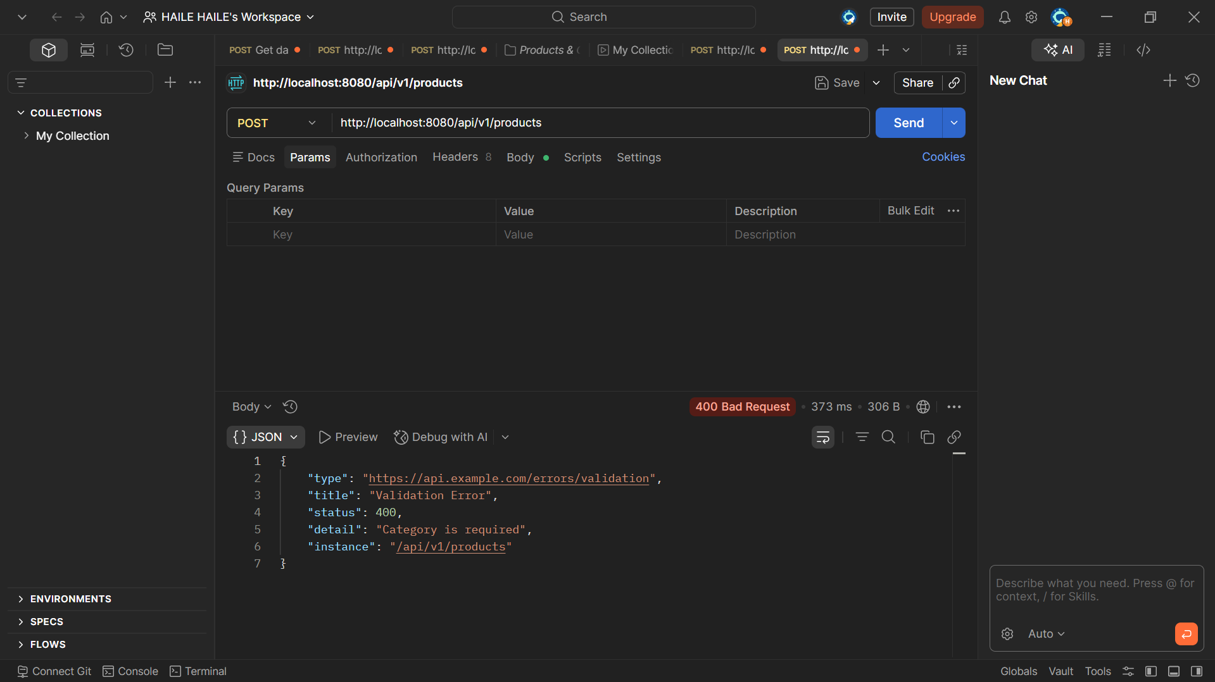
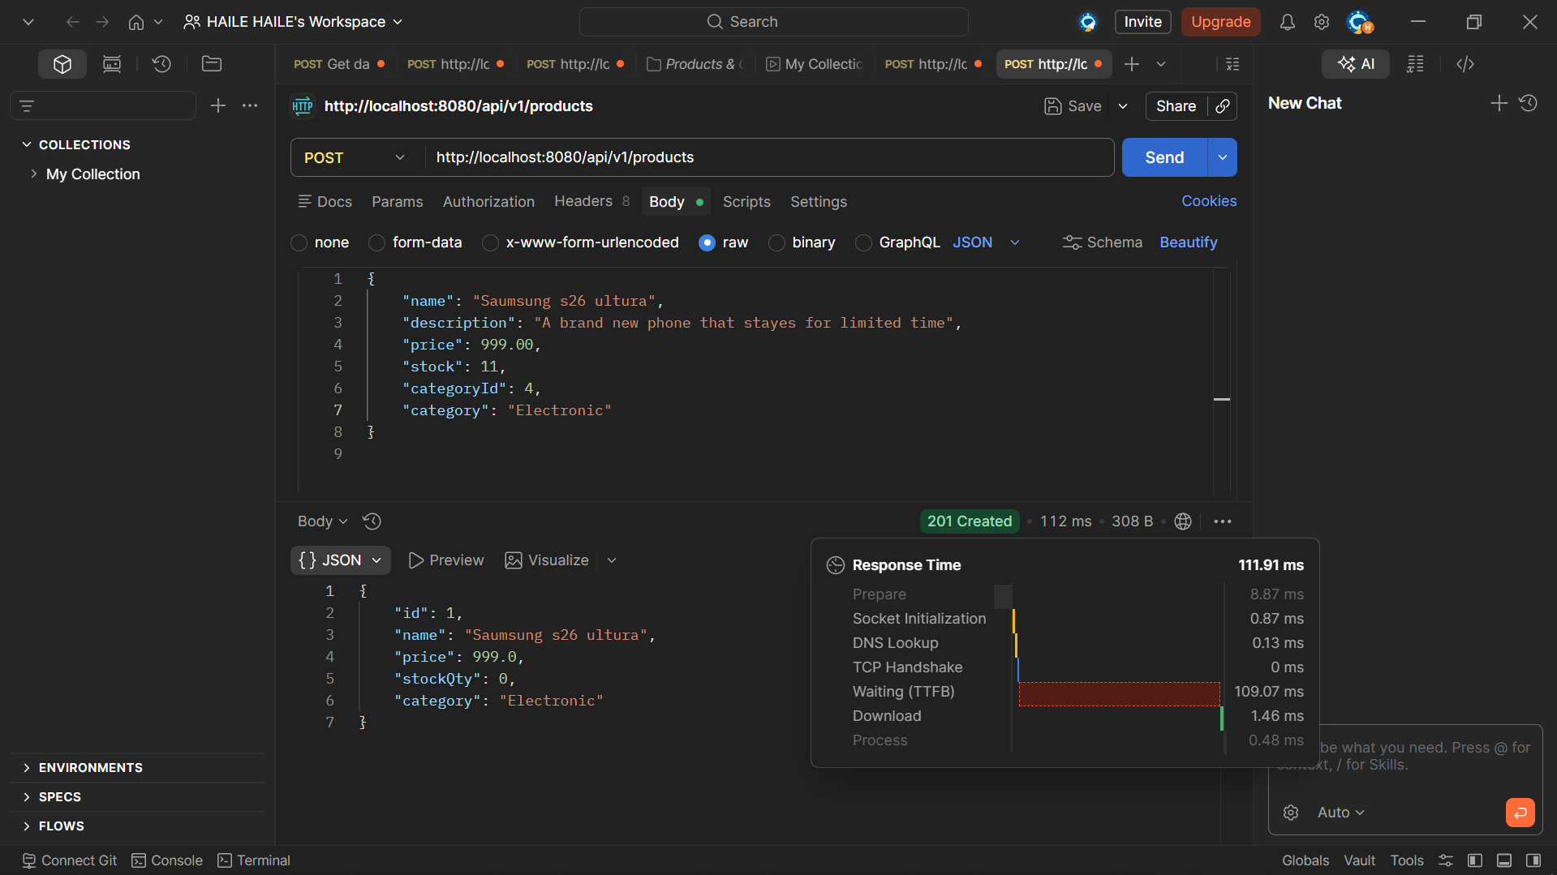

8.Test on swagger
