

Functional Safety Concept Lane Assistance

**Document Version: [Version]**

**Template Version 1.0, Released on 2017-06-21**



# Document history

**[Instructions: Fill in the date, version and description fields. You can fill out the Editor field with your name if you want to do so. Keep track of your editing as if this were a real world project.**

**For example, if this were your first draft or first submission, you might say version 1.0. If this is a second submission attempt, then you'd add a second line with a new date and version 2.0]**

|  |  |  |  |
| --- | --- | --- | --- |
| Date | Version | Editor | Description |
|  |  |  |  |
|  |  |  |  |
|  |  |  |  |
|  |  |  |  |
|  |  |  |  |

# Table of Contents

**[Instructions: We have provided a table of contents. If you change the document structure, please update the table of contents accordingly. The table of contents should show each section of the document and page numbers or links. Most word processors can do this for you. In** [**Google Docs**](https://support.google.com/docs/answer/116338?co=GENIE.Platform%3DDesktop&hl=en)**, you can use headings for each section and then go to Insert > Table of Contents.** [**Microsoft Word**](https://support.microsoft.com/en-us/help/285059/how-to-create-a-table-of-contents-by-marking-text-in-word) **has similar capabilities]**

Document history

Table of Contents

Purpose of the Functional Safety Concept

Inputs to the Functional Safety Analysis

Safety goals from the Hazard Analysis and Risk Assessment

Preliminary Architecture

Description of architecture elements

Functional Safety Concept

Functional Safety Analysis

Functional Safety Requirements

Refinement of the System Architecture

Allocation of Functional Safety Requirements to Architecture Elements

Warning and Degradation Concept

# Purpose of the Functional Safety Concept

**[Instructions: Answer what is the purpose of a functional safety concept?]**

1. Turning safety goal into functional safety requirements.

2. Allocating functional safety requirements to the item architecture.

# Inputs to the Functional Safety Concept

## Safety goals from the Hazard Analysis and Risk Assessment

**[Instructions:**

**REQUIRED:**

**Provide the lane departure warning and lane keeping assistance safety goals as discussed in the lessons and derived in the hazard analysis and risk assessment.**

**OPTIONAL:**

**If you expanded the hazard analysis and risk assessment to include other safety goals, include them here.**

**]**

|  |  |
| --- | --- |
| **ID** | **Safety Goal** |
| Safety_Goal_01 | The oscillating steering torque from the lane departure warning function shall be limited. |
| Safety_Goal_02 | The lane keeping assistance function shall be time limited and addtional steering torque shall end after a given timer interval so that the driver cannot misuse the system for autonomous driving. |

## Preliminary Architecture

**[Instructions: Provide a preliminary architecture for the lane assistance item. Hint: See Lesson 3: Item Definition]**

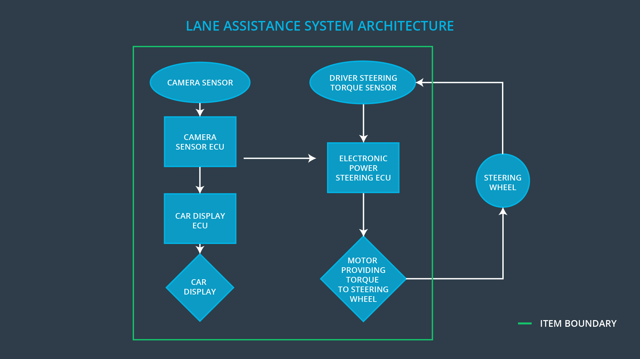

### Description of architecture elements

**[Instructions: Provide a description for each of the item elements; what is each element's purpose in the lane assistance item? ]**

|  |  |
| --- | --- |
| **Element** | **Description** |
| Camera Sensor | Senses that the vehicle is leaving the lane |
| Camera Sensor ECU | Detects the lane and provides the vibrational steering torque |
| Car Display | Shows a warning light to warn the driver |
| Car Display ECU | Controls a light to tell the driver that the function is activated |
| Driver Steering Torque Sensor | Detects how much the driver is already turning |
| Electronic Power Steering ECU | Provides a final torque to the motor based on the steering torque the driver has applied, and vibrational torque request from the camera subsystem |
| Motor | Applies the extra torque to the steering wheel |

# Functional Safety Concept

The functional safety concept consists of:

* Functional safety analysis
* Functional safety requirements
* Functional safety architecture
* Warning and degradation concept

## Functional Safety Analysis

**[Instructions: Fill in the functional safety analysis table below.]**

|  |  |  |  |
| --- | --- | --- | --- |
| **Malfunction ID** | **Main Function of the Item Related to Safety Goal Violations** | **Guidewords (NO, WRONG, EARLY, LATE, MORE, LESS)** | **Resulting Malfunction** |
| Malfunction_01 | Lane Departure Warning (LDW) function shall apply an oscillating steering torque to provide the driver a haptic feedback | more | The lane departure warning function applies an oscillating torque with very high torque amplitude (above limit) |
| Malfunction_02 | Lane Departure Warning (LDW) function shall apply an oscillating steering torque to provide the driver a haptic feedback | more | The lane departure warning function applies an oscillating torque with very high torque frequency (above limit) |
| Malfunction_03 | Lane Keeping Assistance (LKA) function shall apply the steering torque when active in order to stay in ego lane | no | The lane keeping assistance function is not limited in time duration which leads to misuse as autonomous driving function |

## Functional Safety Requirements

**[Instructions: Fill in the functional safety requirements for the lane departure warning ]**

Lane Departure Warning (LDW) Requirements:

|  |  |  |  |  |
| --- | --- | --- | --- | --- |
| **ID** | **Functional Safety Requirement** | **ASIL** | **Fault Tolerant Time Interval** | **Safe State** |
| Functional  Safety  Requirement  01-01 | The lane departure warning item shall ensure that the lane departure oscillating torque amplitude is below Max_Torque_Amplitude. | C | 50 ms | The amplitude and frequency of lane departure warning torque are set to zero. |
| Functional  Safety  Requirement  01-02 | The lane departure warning item shall ensure that the lane departure oscillating torque frequency is below Max_Torque_Frequency. | C | 50 ms | The amplitude and frequency of lane departure warning torque is set to zero. |

Lane Departure Warning (LDW) Verification and Validation Acceptance Criteria:

|  |  |  |
| --- | --- | --- |
| **ID** | **Validation Acceptance**  **Criteria and Method** | **Verification Acceptance**  **Criteria and Method** |
| Functional  Safety  Requirement  01-01 | If the chosen oscillating torque amplitude is below Max_Torque_Amplitude, the driver will not lose control and can feel the vibration. | when the torque amplitude crosses the limit, the lane assistance output is set to zero within the 50 ms fault tolerant time interval. |
| Functional  Safety  Requirement  01-02 | If the chosen oscillating torque amplitude is below Max_Torque_Frequency, the driver will not lose control and can feel the vibration. | when the torque frequency crosses the limit, the lane assistance output is set to zero within the 50 ms fault tolerant time interval. |

**[Instructions: Fill in the functional safety requirements for the lane keeping assistance]**

Lane Keeping Assistance (LKA) Requirements:

|  |  |  |  |  |
| --- | --- | --- | --- | --- |
| **ID** | **Functional Safety Requirement** | **ASIL** | **Fault Tolerant Time Interval** | **Safe State** |
| Functional  Safety  Requirement  02-01 | The lane keeping assistance function can not be activated for more than max_duration. | B | 500 ms | The lane keeping assistance torque is set to 0. |

Lane Keeping Assistance (LKA) Verification and Validation Acceptance Criteria:

|  |  |  |
| --- | --- | --- |
| **ID** | **Validation Acceptance**  **Criteria and Method** | **Verification Acceptance**  **Criteria and Method** |
| Functional  Safety  Requirement  02-01 | If the duration of the lane keeping assistance doesn’t exceed the max_duration, then the driver will not take their hands off the wheel. | The system really does turn off if the lane keeping assistance exceeded max_duration. |

## Refinement of the System Architecture

**[Instructions: Include the refined system architecture. Hint: The refined system architecture should include the system architecture from the end of the functional safety lesson including all of the ASIL labels.]**

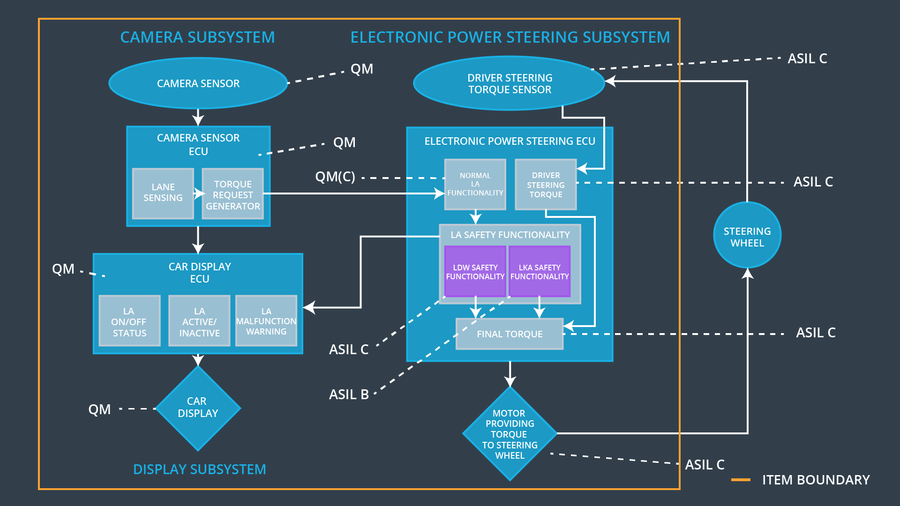

## Allocation of Functional Safety Requirements to Architecture Elements

**[Instructions: Mark which element or elements are responsible for meeting the functional safety requirement. Hint: Only one ECU is responsible for meeting all of the requirements.]**

|  |  |  |  |  |
| --- | --- | --- | --- | --- |
| **ID** | **Functional Safety Requirement** | **Electronic Power Steering ECU** | **Camera ECU** | **Car Display ECU** |
| Functional  Safety  Requirement  01-01 | The lane departure item shall ensure that the lane departure oscillating torque amplitude is below Max_Torque_Amplitude. | **x** |  |  |
| Functional  Safety  Requirement  01-02 | The lane departure item shall ensure that the lane departure oscillating torque frequency is below Max_Torque_Frequency. | **x** |  |  |
| Functional  Safety  Requirement  02-01 | The lane keeping assistance function can not be activated for more than max_duration. | **X** |  |  |

## Warning and Degradation Concept

**[Instructions: Fill in the warning and degradation concept.]**

|  |  |  |  |  |
| --- | --- | --- | --- | --- |
| **ID** | **Degradation Mode** | **Trigger for Degradation Mode** | **Safe State invoked?** | **Driver Warning** |
| WDC-01 | Turn off the lane departure warning off | Malfunction_01, Malfunction_02 | yes | Warning on car display |
| WDC-02 | Turn off the lane keeping assistance off | Malfunction_03 | yes | Warning on car display |