COSC578 Database Management Systems I

Normalize following table up to BCNF.

In this example we extend the PropertyInspection database to include property inspection by members of staff. When staffs are required to undertake the inspections, they are allocated a company car for use on the day of the inspections. However, a car may be allocated to several members of staff as required throughout the working day. A member of staff may inspect several properties on a given date, but a property is only inspected once on a given date.

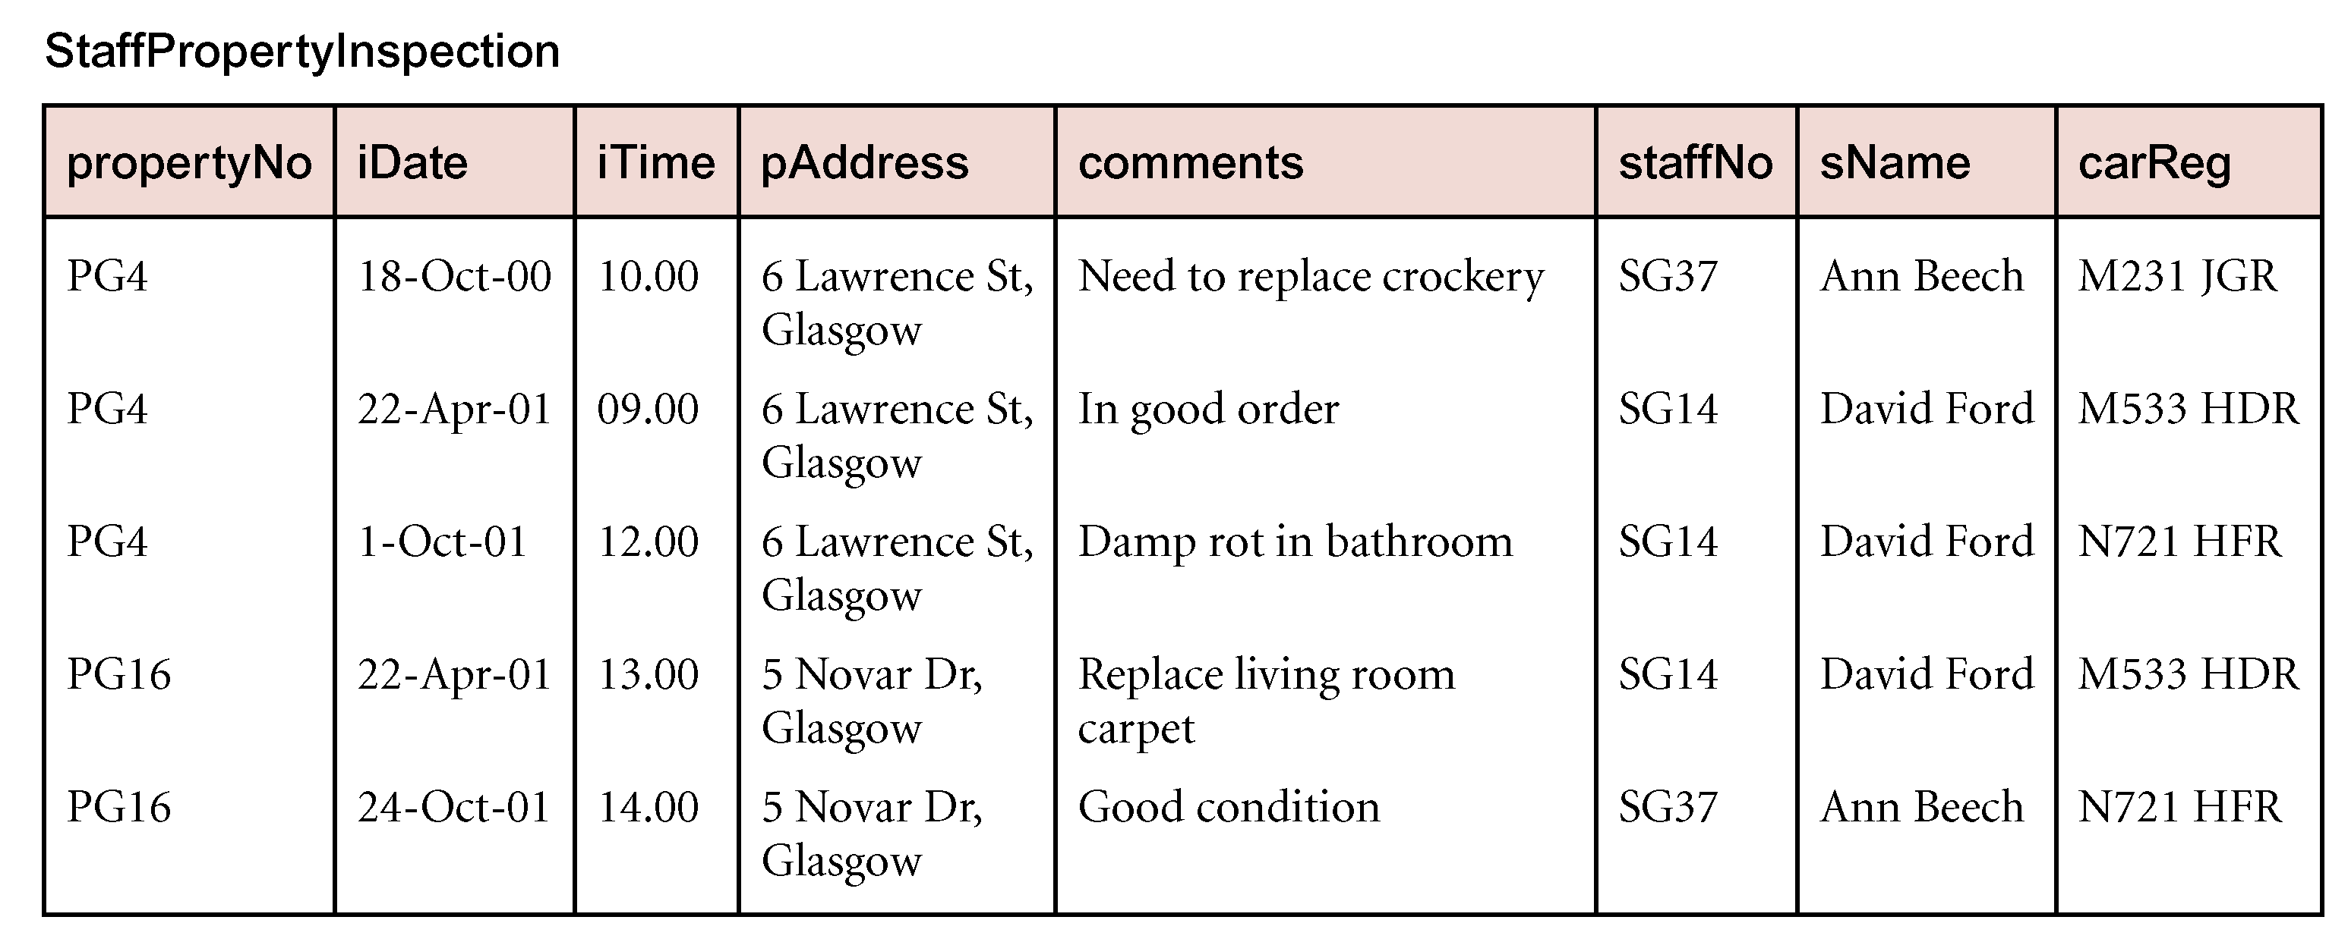

1. **Find all the candidate keys.**

{propertyNo, iDate} , { carReg, iDate, iTime} , { staffNo, iDate, iTime }

1. **Determine the primary key**

{propertyNo, iDate}

1. **Find all the functional dependencies.**

FD1: { propertyNo, iDate } 🡺 { iTime, pAddress, comments, staffNo, sName, carReg } (**Primary Key**)

FD2: propertyNo 🡺 pAddress ( **partial dependency** )

FD3: staffNo🡺sName( **transitive dependency** )

FD4: {staffNo, iDate} 🡺carReg **(BCNF)**

1. **Get the first normal form**

|  |  |  |  |  |  |  |  |
| --- | --- | --- | --- | --- | --- | --- | --- |
| **propertyNo** | **iDate** | **iTime** | **pAddress** | **Comments** | **staffNo** | **sName** | **carReg** |

1. **Get the second normal form**

|  |  |  |  |  |  |  |
| --- | --- | --- | --- | --- | --- | --- |
| **propertyNo** | **iDate** | **iTime** | **Comments** | **staffNo** | **sName** | **carReg** |

|  |  |
| --- | --- |
| **propertyNo** | **pAddress** |

1. **Get the third normal form**

|  |  |  |  |  |  |
| --- | --- | --- | --- | --- | --- |
| **propertyNo** | **iDate** | **iTime** | **Comments** | **staffNo** | **carReg** |

|  |  |
| --- | --- |
| **propertyNo** | **pAddress** |

|  |  |
| --- | --- |
| **staffNo** | **sName** |

1. **Gent the BCNF normal form.**

|  |  |  |  |  |
| --- | --- | --- | --- | --- |
| **propertyNo** | **iDate** | **iTime** | **Comments** | **staffNo** |

|  |  |
| --- | --- |
| **propertyNo** | **pAddress** |

|  |  |
| --- | --- |
| **staffNo** | **sName** |

|  |  |  |
| --- | --- | --- |
| **iDate** | **staffNo** | **carReg** |

[2]

|  |  |  |  |  |  |  |  |  |
| --- | --- | --- | --- | --- | --- | --- | --- | --- |
| StdSSN | StdCity | StdClass | OfferNo | OffTerm | OffYear | CourseNo | Crsdesc | EnrGrade |
| S1 | SEATTLE | JUN | O1 | FALL | 2003 | C1 | DB | 3.5 |
| S1 | SEATTLE | JUN | O2 | FALL | 2003 | C2 | VB | 3.3 |
| S2 | BOTHELL | JUN | O3 | WINTER | 2003 | C3 | OO | 3.1 |
| S2 | BOTHELL | JUN | O2 | FALL | 2003 | C2 | VB | 3.4 |
| S3 | BALTIMORE | SEN | O4 | SPRING | 2004 | C2 | VB | 3.2 |

**[2.1] Please find out all the candidate keys and then choose the primary key. (The primary key could be a composite key)**

{StfSSN, OffTerm, OffYear, CourseNo}

{ StdSSN, OfferNo} **( PK)**

**[2.2] Please find all the functional dependencies.**

**fd1**: StdSSN 🡺 { StdCity, StdClass } (**Partial dependency** )

**fd2**: OfferNo 🡺 { OffTerm, OffYear, CourseNo, Crsdesc } (**Partial dependency** )

**fd3**: CourseNo 🡺 Crsdesc (**Transitive dependency** )

**fd4**: { StdSSN, OfferNo} 🡺 { StdCity, StdClass, OffTerm, OffYear, CourseNo, Crsdesc, EnrGrade} (**Primary Key** )

**[2.3] Please find out the second normal form (in the format of relational schema).**

|  |  |  |
| --- | --- | --- |
| **StdSSN** | **OfferNo** | EnrGrade |

|  |  |  |  |  |
| --- | --- | --- | --- | --- |
| **OfferNo** | OffTerm | OffYear | CourseNo | Crsdesc |

|  |  |  |
| --- | --- | --- |
| **StdSSN** | StdCity | StdClass |

**[2.4] Please find out the third normal form.**

|  |  |  |
| --- | --- | --- |
| **StdSSN** | **OfferNo** | EnrGrade |

|  |  |  |  |
| --- | --- | --- | --- |
| **OfferNo** | OffTerm | OffYear | CourseNo |

|  |  |  |
| --- | --- | --- |
| **StdSSN** | StdCity | StdClass |

|  |  |
| --- | --- |
| **CourseNo** | Crsdesc |

[3] Functional Dependency Exercise

PROJECT/EMPLOYEE

|  |  |  |  |  |  |  |
| --- | --- | --- | --- | --- | --- | --- |
| PROJ_NUM | PRJ_NAME | EMP_NUM | EMP_NAME | JOB_CLASS | CHR_HOUR | HOURS |

**note: The charge_hour attribute represents the employee’s hourly charge and it can be decided by the employee’s job class. Employees can work for different projects and each project-work hour is traced. A project needs many employees.**

**[a] Find out the primary key(s)**

{ PROJ_NUM, EMP_NUM}

**[b] Define the modification anomalies. And give one example from above table.**

The modification anomalies can be described as updating one fact in a relation ( table ) requires to update multiple tuples. For example, When updating a project name (e.g.PRJ_NAME= ProductX) into a new name, this modification leads to update all the records for all the employees who work on “ProductX” .

**[c] Define the insertion anomalies. And give one example from above table.**

The insertion anomalies can be defined as an independent piece of information cannot be inserted into a table unless an irrelevant information is inserted together at the same time.

For instance, when inserting an employee data ( EMP_NUM and EMP_NAME), this cannot be done unless an he/she is assigned to a project (PROJ_NUM,PRJ_NAME).

**[d] Define the deletion anomalies. And give one example from above table.**

The deletion anomalies is described as the deletion of a piece of information unintentionally removed other information. For example, When deleting a project (e.g. PROJ_NUM = 20), it will result in deleting all the employees who work on that project .

**[e] Find out all the functional dependencies.**

FD1: {PROJ_NUM, EMP_NUM} 🡺 {PRJ_NAME, EMP_NAME, JOB_CLASS,CHR_HOUR, HOURS } **(Primary Key)**

FD2: PROJ_NUM 🡺 PRJ_NAME **(** **Partial dependency** **)**

FD3: EMP_NUM 🡺{ EMP_NAME, JOB_CLASS,CHR_HOUR} **( Partial dependency )**

FD4: JOB_CLASS 🡺 CHR_HOUR **( transitive dependency )**

**[f] Please normalize above table to the first normal form.**

|  |  |  |  |  |  |  |
| --- | --- | --- | --- | --- | --- | --- |
| PROJ_NUM | PRJ_NAME | EMP_NUM | EMP_NAME | JOB_CLASS | CHR_HOUR | HOURS |

**[g] Please normalize [f] table to the second normal form.**

|  |  |  |
| --- | --- | --- |
| PROJ_NUM | EMP_NUM | HOURS |

|  |  |
| --- | --- |
| PROJ_NUM | PRJ_NAME |

|  |  |  |  |
| --- | --- | --- | --- |
| EMP_NUM | EMP_NAME | JOB_CLASS | CHR_HOUR |

**[h] Please normalize [g] table to the third normal form.**

|  |  |  |
| --- | --- | --- |
| PROJ_NUM | EMP_NUM | HOURS |

|  |  |
| --- | --- |
| PROJ_NUM | PRJ_NAME |

|  |  |  |
| --- | --- | --- |
| EMP_NUM | EMP_NAME | JOB_CLASS |

|  |  |
| --- | --- |
| JOB_CLASS | CHR_HOUR |