Normalize following table up to 3rd NF.

In this example we extend the PropertyInspection database to include property inspection by members of staff. When staffs are required to undertake the inspections, they are allocated a company car for use on the day of the inspections. However, a car may be allocated to several members of staff as required throughout the working day. A member of staff may inspect several properties on a given date, but a property is only inspected once on a given date.

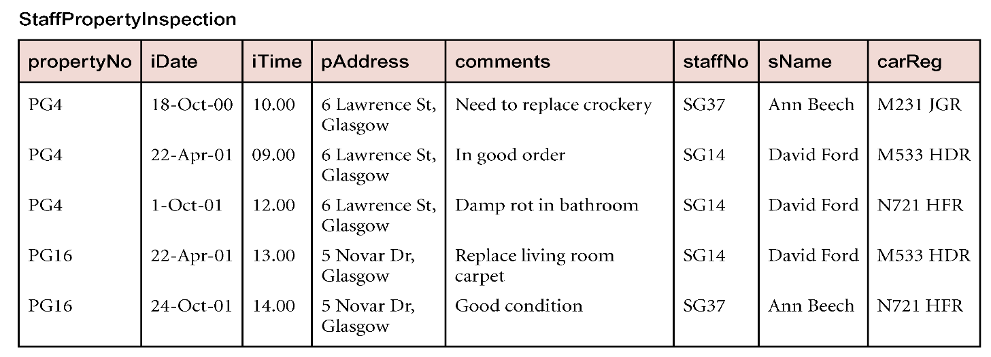

**The candidate keys:**

{propertyNo, iDate} , { carReg, iDate, iTime} , { staffNo, iDate, iTime }

**The primary key**

{propertyNo, iDate}

**Find all the functional dependencies.**

staffNo 🡪 sName

propertyNo 🡪 iTime, comments, staffNo, sName, carReg

propertyNo 🡪 pAddress

**Get the second normal form**

|  |  |
| --- | --- |
| propertyNO | pAddress |

|  |  |  |  |  |  |  |
| --- | --- | --- | --- | --- | --- | --- |
| propertyNO | iDate | iTime | comments | staffNO | sName | carReg |

**Get the third normal form**

|  |  |
| --- | --- |
| propertyNO | pAddress |

|  |  |
| --- | --- |
| staffNO | sName |

|  |  |  |  |  |  |
| --- | --- | --- | --- | --- | --- |
| propertyNO | iDate | iTime | comments | staffNO | carReg |

[2]

|  |  |  |  |  |  |  |  |  |
| --- | --- | --- | --- | --- | --- | --- | --- | --- |
| StdSSN | StdCity | StdClass | OfferNo | OffTerm | OffYear | CourseNo | Crsdesc | EnrGrade |
| S1 | SEATTLE | JUN | O1 | FALL | 2003 | C1 | DB | 3.5 |
| S1 | SEATTLE | JUN | O2 | FALL | 2003 | C2 | VB | 3.3 |
| S2 | BOTHELL | JUN | O3 | WINTER | 2003 | C3 | OO | 3.1 |
| S2 | BOTHELL | JUN | O2 | FALL | 2003 | C2 | VB | 3.4 |
| S3 | BALTIMORE | SEN | O4 | SPRING | 2004 | C2 | VB | 3.2 |

**[2.1] Please find out all the candidate keys and then choose the primary key. (The primary key could be a composite key)**

**CK {** StdSSN, OfferNo, StdCity, EnrGrade **}**

**PK {** StdSSN, OfferNo **}**

**[2.2] Please find all the functional dependencies.**

StdSSN 🡪 StdCity

CourseNo 🡪Crsdesc

**[2.3] Please find out the second normal form (in the format of relational schema).**

**Std_Info {StdSSN, StdCity, StdClass}**

|  |  |  |
| --- | --- | --- |
| StdSSN | StdCity | StdClass |

**Std_Offer_Course {StdSSN, OfferNo, OffTerm, OffYear, CourseNo, Crsdesc, EnrGrade}**

|  |  |  |  |  |  |  |
| --- | --- | --- | --- | --- | --- | --- |
| StdSSN | OfferNo | OffTerm | OffYear | CourseNo | Crsdesc | EnrGrade |

**[2.4] Please find out the third normal form.**

|  |  |  |
| --- | --- | --- |
| StdSSN | StdCity | StdClass |

|  |  |  |  |  |  |
| --- | --- | --- | --- | --- | --- |
| StdSSN | OfferNo | OffTerm | OffYear | CourseNo | EnrGrade |

|  |  |
| --- | --- |
| CourseNo | Crsdesc |

[3] Functional Dependency Exercise

PROJECT/EMPLOYEE

|  |  |  |  |  |  |  |
| --- | --- | --- | --- | --- | --- | --- |
| PROJ_NUM | PRJ_NAME | EMP_NUM | EMP_NAME | JOB_CLASS | CHR_HOUR | HOURS |

**note: The charge_hour attribute represents the employee’s hourly charge and it can be decided by the employee’s job class. Employees can work for different projects and each project-work hour is traced. A project needs many employees.**

**[a] Find out the primary key(s)**

**PK {PROJ_NUM, EMP_NUM}**

**[b] Define the modification anomalies. And give one example from above table.**

An modification anomaly occurs when one or more instances of duplicated data is trying to be updated.

Modification of a project number meant for only one employee will result in a change to all employees working on that project.

**[c] Define the insertion anomalies. And give one example from above table.**

An insert anomaly occurs when certain attributes cannot be inserted into the database without the presence of other attributes.

A person will not be able to insert data (X) unless it has been assigned an employee number and project number. Also a person will not be able to insert an employee without said employee being assigned to a project.

**[d] Define the deletion anomalies. And give one example from above table.**

A Delete Anomaly exists when certain attributes are lost because of the deletion of other attributes

When a project is deleted, then all the employees associated with that project will also be deleted.

**[e] Find out all the functional dependencies.**

**[f] Please normalize above table to the first normal form.**

|  |  |  |  |
| --- | --- | --- | --- |
| EMP_NUM | EMP_NAME | JOB_CLASS | CHR_HOUR |

|  |  |  |  |
| --- | --- | --- | --- |
| PROJ_NUM | EMP_NUM | PRJ_NAME | HOURS |

**[g] Please normalize [f] table to the second normal form.**

|  |  |
| --- | --- |
| EMP_NUM | EMP_NAME |

|  |  |  |
| --- | --- | --- |
| PROJ_NUM | PRJ_NAME | HOURS |

|  |  |  |
| --- | --- | --- |
| EMP_NUM | PROJ_NUM | HOURS |

**[h] Please normalize [g] table to the third normal form.**

|  |  |  |
| --- | --- | --- |
| EMP_NUM | EMP_NAME | PROJ_NUM |

|  |  |
| --- | --- |
| PROJ_NUM | HOURS |