J | SPJ
  j_num | jname | city
  j1 | Sorter | Paris
  j2 | Punch | Rome
  j3 | Reader | Athens
  j4 | Console | Athens
  j5 | Collator | London
  j6 | Terminal | Oslo
  j7 | Tape | London
  s_num | p_num | j_num | qty
  s1 | p1 | j1 | 200
  s1 | p1 | j4 | 700
  s2 | p3 | j1 | 400
  s2 | p3 | j2 | 200
  s2 | p3 | j3 | 200
  s2 | p3 | j4 | 500
  s2 | p3 | j5 | 600
  s2 | p3 | j6 | 400
  s2 | p3 | j7 | 800
  s2 | p5 | j2 | 100
  s3 | p3 | j1 | 200
  s3 | p4 | j2 | 500
  s4 | p6 | j3 | 300
  s4 | p6 | j7 | 300
  s5 | p1 | j4 | 100
  s5 | p2 | j2 | 200
  s5 | p2 | j4 | 100
  s5 | p3 | j4 | 200
  s5 | p4 | j4 | 800
  s5 | p5 | j4 | 400
  s5 | p5 | j5 | 500
  s5 | p5 | j7 | 100
  s5 | p6 | j2 | 200
  s5 | p6 | j4 | 500
P
p_num | pname | color | weight | city
p1 | Nut | Red | 12 | London
p2 | Bolt | Green | 17 | Paris
p3 | Screw | Blue | 17 | Rome
p4 | Screw | Red | 14 | London
p5 | Cam | Blue | 12 | Paris
p6 | Cog | Red | 19 | London

S
s_num | s_name | status | city
s1 | Smith | 20 | London
s2 | Jones | 10 | Paris
s3 | Blake | 30 | Paris
s4 | Clark | 20 | London
s5 | Adams | 30 | Athens

Note: Qty, status, and weight are numbers.

Exercises

- Get supplier names and numbers for all suppliers who supplied part P3 and whose name begins with letter A.
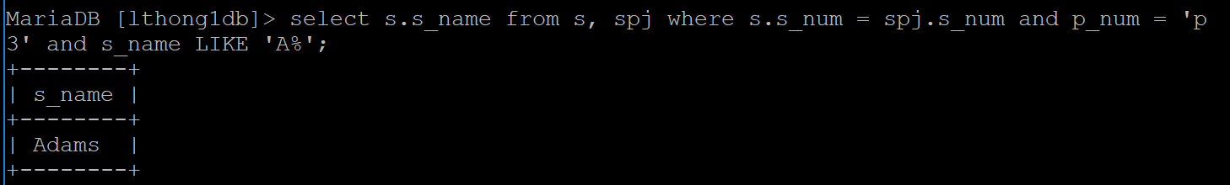

2. Get supplier names and numbers for all suppliers whose name begins with letter A and who supplied parts whose name begins with setter S.
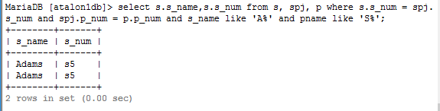

3. Get supplier names for suppliers who supplied for job J2. (Use a sub query)

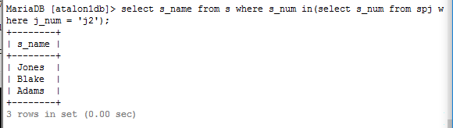

4. Get supplier names for suppliers who supplied for jobs in Athens. (Use sub query)
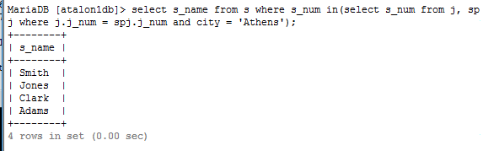

5. Get part names for parts that are not supplied for job J3. (Use a sub query)
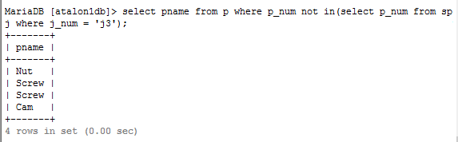

6. Get supplier numbers for suppliers with status lower than that of supplier S1.
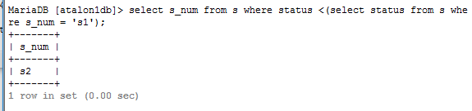

7. Get supplier numbers and names for suppliers whose status is greater than status values of all suppliers in located Paris.
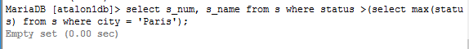

8. Calculate each supplier’s sales quantity and get the sales person’s name if the sales person supplies parts more than 1000 units in total.
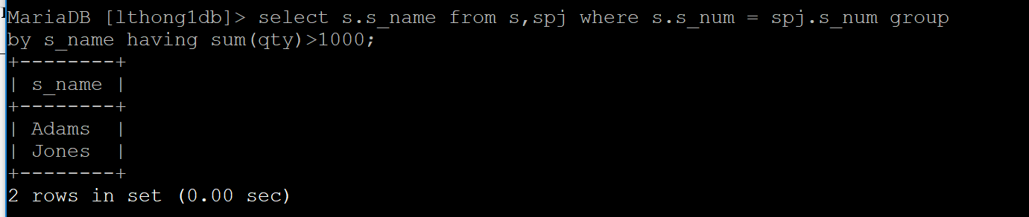

9. Get job numbers for jobs whose city is first in the alphabetical list of the job cities.
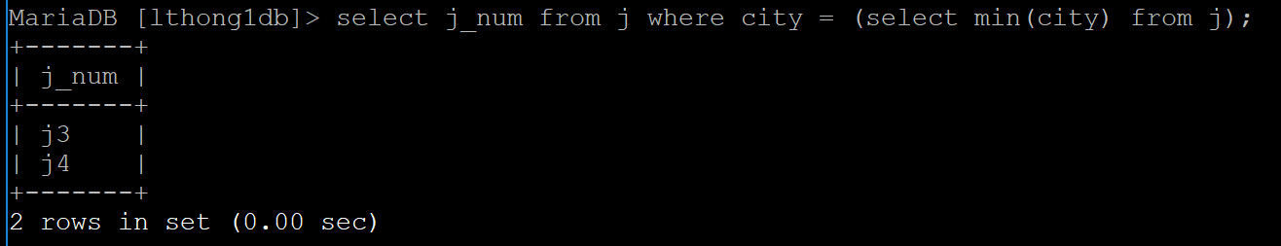
10. Increase the status values of suppliers by 5 who are located in Paris.
Please hand in the modified table and the query.
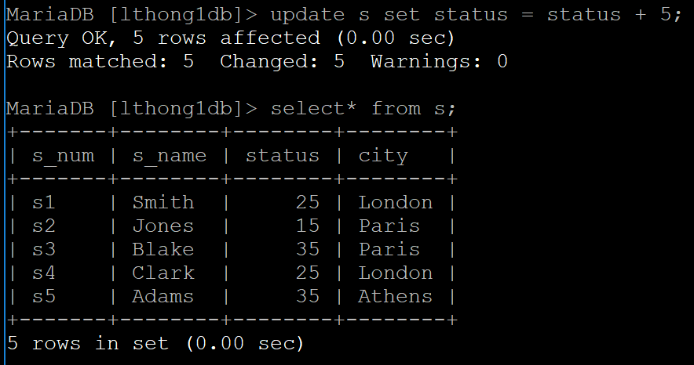
11. Change the name to ‘Hammer’ of parts that are Red and located in London and whose name was Screw.
Please hand in the modified table and the query.
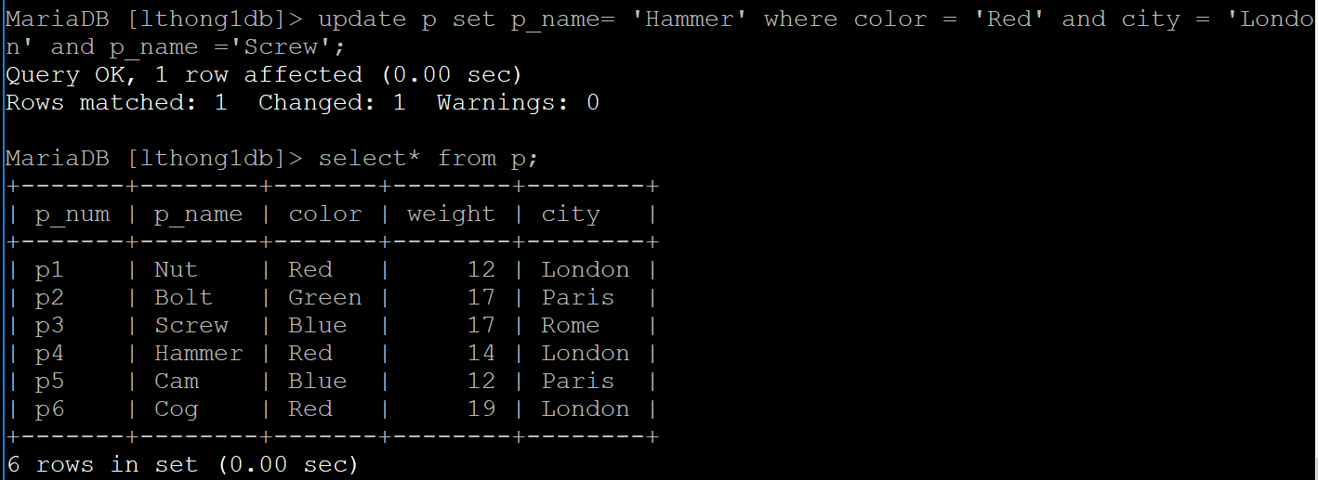

12. Delete all jobs in Rome and all corresponding part shipments. (Please use 2 queries)
Please hand in the modified table and the query.
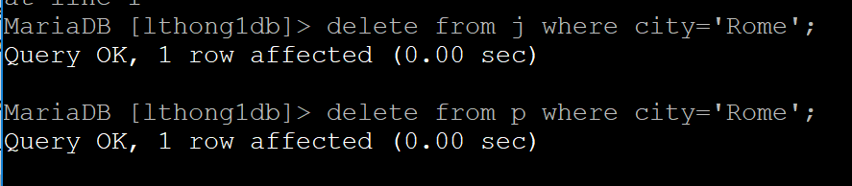
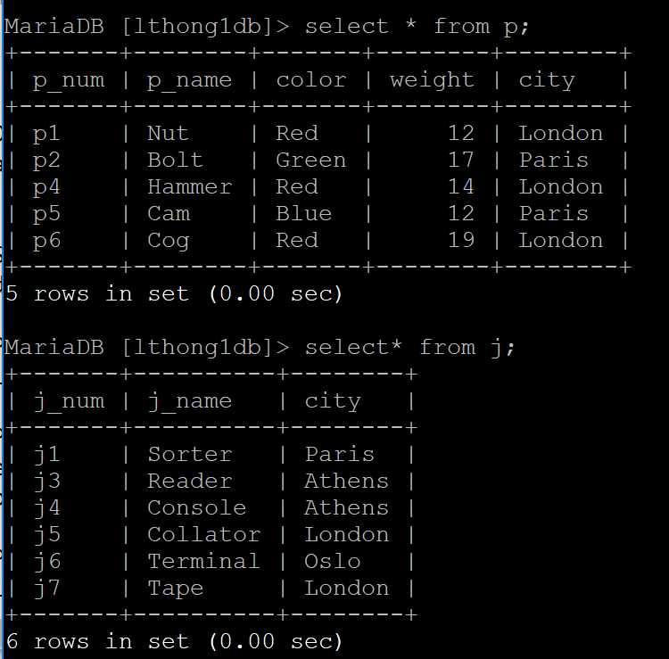

13. Smith moved to Adam’s location. Please update Smith’s city but do not use the city name directly.
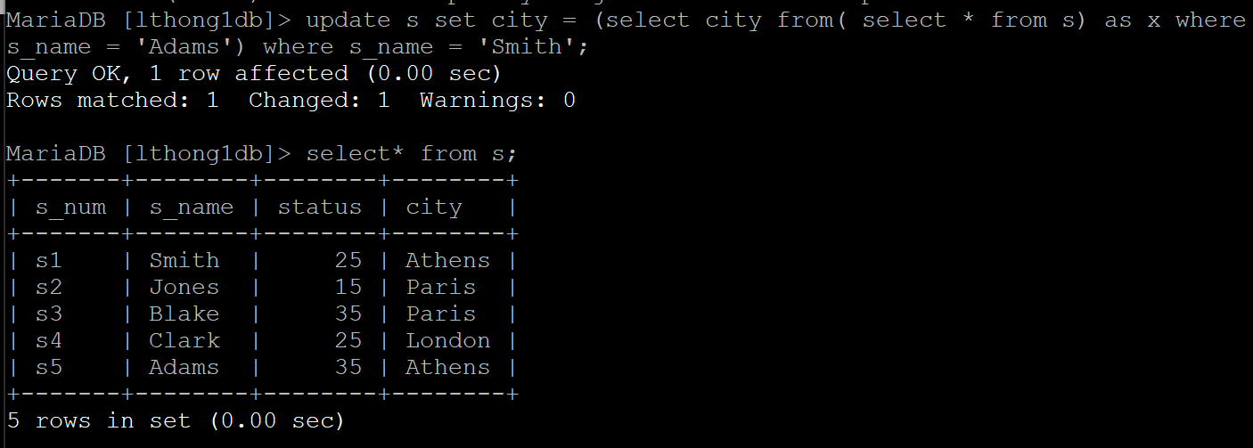
14. Please create a “view table” supplier_shipment that shows each supplier and its total shipment quantity.
15. Please try to increase Smith’s total shipment by 100 in the view table you created in question 14. Then discuss what happens when you try to update the view table.
Describe
16. Please create a base table supplier_shipment that shows each supplier and its total shipments from S and SPJ tables.
17. Please repeat question 15 on the base table supplier_shipment and discuss the result.

SET SQL_SAFE_UPDATES = 0;

