Data Analysis for a Winery

Dataset Attributes: Dataset contains various physiochemical properties of wine and how it affects quality ratings

Goal of Analysis: Provide detailed answer to the CEO’s questions including visualizations, statistical summaries, and actionable insights

Question 1

Attributes: Alcohol, pH, Chlorides, Fixed Acidity, Residual Sugar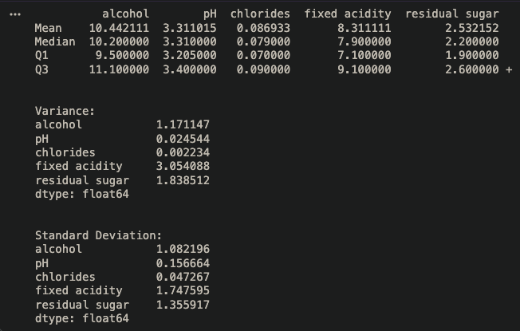

Define central tendencies and spread of these attributes:
- Alcohol: Variance = 1.171, std = 1.08, indicates moderate variability, with data points reasonably spread around the mean.
- pH: Variance = 0.025, std = 0.156, indicates very low variability, with values tightly clustered around the mean.
- Chlorides: Variance = 0.002, std = 0.047, indicates extremely low variability, with minimal deviation from the mean.
- Fixed Acidity: Variance = 3.054, std = 1.748, indicates relatively high variability, with observations showing a wider but still moderate spread around the mean.
- Residual Sugar: Variance = 1.839, std = 1.356, indicates moderate variability in residual sugar values.

Question 2

Outlier Calculation:

Attribute: Fixed Acidity

Q1 = 7.1
Q3 = 9.1
IQR = 9.1 - 7.1 = 2

Lower = 7.1 - (2 * 1.5) = 4.1
Upper = 9.1 + (2 * 1.5) = 12.1

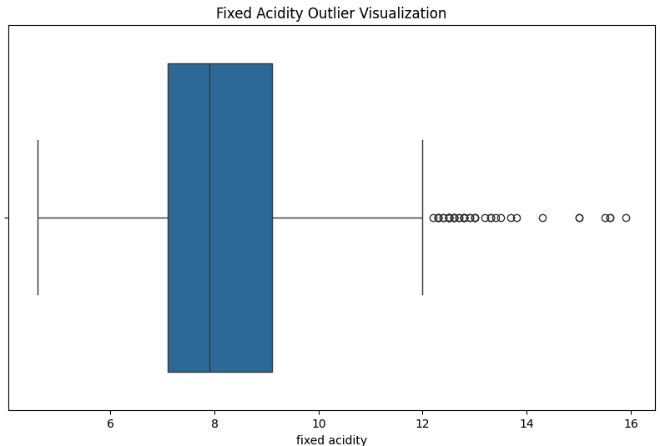

Question 3

Attributes: Alcohol, Fixed Acidity, Sulphates

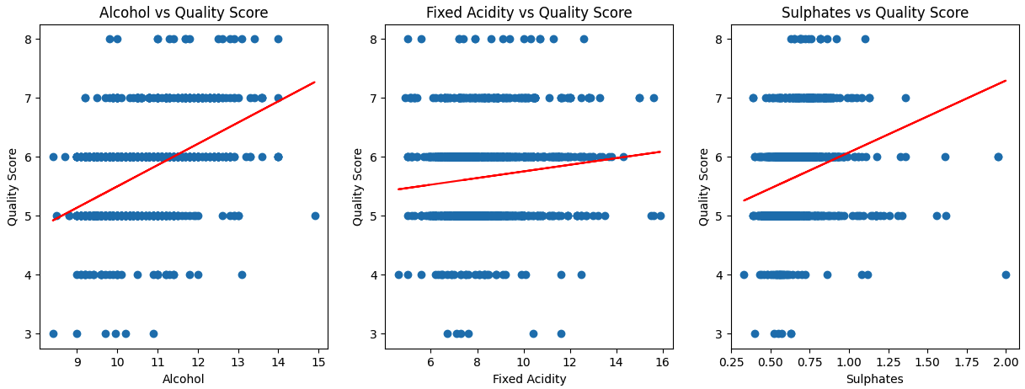

Alcohol vs Quality Score:
- Correlation: Positive correlation with higher alcohol concentrations
Fixed Acidity vs Quality Score:
- Correlation: Slightly positive correlation with higher fixed acidity levels
Sulphates vs Quality Score:
- Correlation: Positive correlation with higher sulphate concentrations

Actional Insights to Increase Wine Quality:
According to the above observations, a wine with a higher alcohol content, higher fixed acidity, and higher sulphate content, will receive a higher quality score. This could increase profit and quality rating making the product more attractive to consumers and help to create more recurrent customers

Question 4

Attributes: Alcohol, Sulphates, Fixed Acidity

Compare and contrast the box plots of these attributes

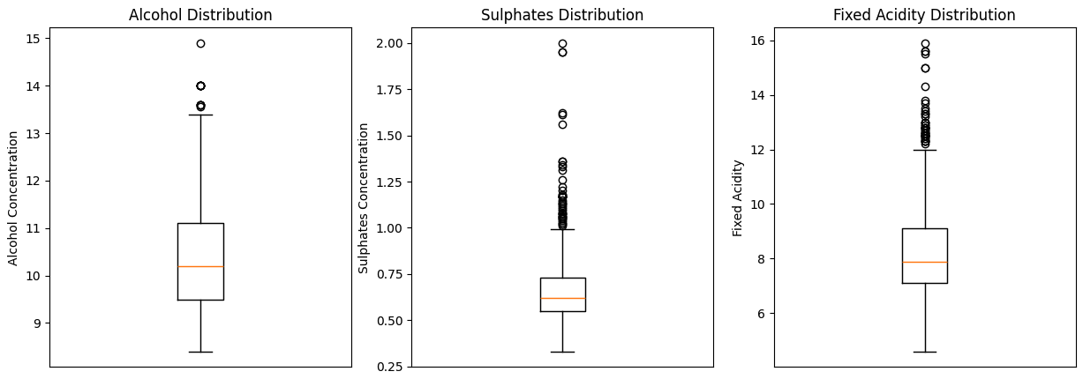

Similarities:
- All the boxplots only have high-valued outliers
- All have a median slightly lower than the center value between Q1 and Q3

Differences:
- Alcohol has the largest distribution of all the attributes
- Sulphates and Fixed Acidity have an abnormally large amount of outliers compared to Alcohol

Question 5

Key recommendations for improving wine quality

Based on these findings, wine quality score can be positively correlated with three tested attributes; higher alcohol concentration, higher fixed acidity, and higher sulphate concentration. This means that if those attributes were to be modified to be higher than average, the wine quality score is likely to increase. However, it’s important to note that the sulphates should not exceed 1.25 according to the graph as the outlier points greater than that tend to actually lead to a decrease in quality score. Alcohol content and fixed acidity seems to have less of that affect as you get into outlier values.

