BIO 620 Week 8 Assignments
Haille Bright
2026-10-21

Assignment 1: Downloading Phylogenetic Trees
Downloaded 100 phylogenetic trees from BirdTree.org for 50 bird species to use in the consensus tree analysis.

Assignment 2: Downloading AVONET Trait Data
Downloaded the AVONET supplementary dataset containing morphological and ecological traits for bird species. The AVONET3_BirdTree worksheet was used for the analysis.

Assignment 3: Consensus Phylogenetic Tree
library(phangorn)
## Loading required package: ape
trees <- read.nexus("/Users/haillebright/Downloads/tree-pruner-d3e061e9-25c5-45cd-952b-b1f175bd99c0/output.nex")
consensus_tree <- ape::consensus(trees, p = 0.5)
plot(consensus_tree, cex = 0.4, no.margin = TRUE)
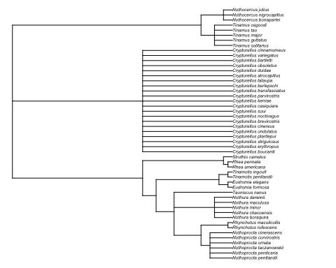

Assignment 4: Merging Phylogeny with Trait Data
library(readxl)
library(geiger)
## Loading required package: phytools
## Loading required package: maps
trait_data <- read_excel(
"/Users/haillebright/Downloads/AVONET Supplementary dataset 1.xlsx",
sheet = "AVONET3_BirdTree"
)
trait_data <- as.data.frame(trait_data)
trait_data$Species3 <- gsub(" ", "_", trait_data$Species3)
rownames(trait_data) <- trait_data$Species3
name_check <- name.check(consensus_tree, trait_data)
length(name_check$tree_not_data)
## [1] 0
length(name_check$data_not_tree)
## [1] 9943
matched_traits <- trait_data[
consensus_tree$tip.label, ,
drop = FALSE
]
dim(matched_traits)
## [1] 50 36

Assignment 5: PGLS Analysis
pgls_data <- matched_traits[, c("Mass", "Wing.Length")]
pgls_data$Mass <- as.numeric(pgls_data$Mass)
pgls_data$Wing.Length <- as.numeric(pgls_data$Wing.Length)
summary(pgls_data)
## Mass Wing.Length
## Min. : 43.0 Min. : 76.6
## 1st Qu.: 287.4 1st Qu.:141.0
## Median : 471.5 Median :163.8
## Mean : 3658.6 Mean :196.1
## 3rd Qu.: 700.4 3rd Qu.:211.2
## Max. :111000.0 Max. :625.0
colSums(is.na(pgls_data))
## Mass Wing.Length
## 0 0
pgls_data$logMass <- log10(pgls_data$Mass)
pgls_data$logWing <- log10(pgls_data$Wing.Length)
summary(pgls_data[, c("logMass", "logWing")])
## logMass logWing
## Min. :1.633 Min. :1.884
## 1st Qu.:2.458 1st Qu.:2.149
## Median :2.673 Median :2.214
## Mean :2.766 Mean :2.252
## 3rd Qu.:2.845 3rd Qu.:2.325
## Max. :5.045 Max. :2.796
library(ape)
library(phytools)
# Check whether the tree has branch lengths
is.null(consensus_tree$edge.length)
## [1] TRUE
# Check whether the tree is fully resolved
is.binary(consensus_tree)
## [1] FALSE
# Create a consensus tree with branch lengths
pgls_tree <- consensus_tree
# Calculate mean branch lengths using the original trees
pgls_tree <- phytools::consensus.edges(
trees,
consensus.tree = pgls_tree
)
# Check branch lengths
is.null(pgls_tree$edge.length)
## [1] FALSE
# Check for zero or negative branch lengths
sum(pgls_tree$edge.length <= 0)
## [1] 2
# Identify nonpositive branch lengths
pgls_tree$edge.length[pgls_tree$edge.length <= 0] <- 1e-6
# Check that all branch lengths are positive
sum(pgls_tree$edge.length <= 0)
## [1] 0
# Check whether the tree is ultrametric
is.ultrametric(pgls_tree)
## [1] FALSE
library(nlme)
library(ape)
# Create a phylogenetic correlation structure
phylo_cor <- corBrownian(
phy = pgls_tree,
form = ~ Species3
)
# Add species names as a column
pgls_data$Species3 <- rownames(pgls_data)
# Fit the PGLS model
pgls_model <- gls(
logWing ~ logMass,
data = pgls_data,
correlation = phylo_cor,
method = "ML"
)
# View results
summary(pgls_model)
## Generalized least squares fit by maximum likelihood
## Model: logWing ~ logMass
## Data: pgls_data
## AIC BIC logLik
## -184.1591 -178.423 95.07953
##
## Correlation Structure: corBrownian
## Formula: ~Species3
## Parameter estimate(s):
## numeric(0)
##
## Coefficients:
## Value Std.Error t-value p-value
## (Intercept) 1.4845717 0.05257779 28.23572 0
## logMass 0.2802305 0.01626307 17.23110 0
##
## Correlation:
## (Intr)
## logMass -0.949
##
## Standardized residuals:
## Min Q1 Med Q3 Max
## -3.1731783 -0.6831962 -0.1942959 0.2742518 2.7128558
##
## Residual standard error: 0.04827783
## Degrees of freedom: 50 total; 48 residual
PGLS Results and Interpretation: The PGLS analysis showed a significant positive relationship between body mass and wing length across the 50 bird species (β = 0.2802, p < 0.001). This suggests to me that larger birds tend to have longer wings, even when accounting for their evolutionary relationships. One limitation of this analysis is that the consensus tree contained unresolved branches, and two branch lengths had to be adjusted before running the model. These adjustments could definitely influence the results.

