Fixation frame extraction and object brand annotation

The code (in Python) is shared on Github and can be downloaded using the following command:

git clone https://github.com/HaiminZhang/shoppervideoanalysis.git

or through the link: <https://github.com/HaiminZhang/shoppervideoanalysis/archive/master.zip>

***Fixation frame extraction***

1. Open *shoppervideoanalysis/myextract.py* and set shopper video path and raw fixation file path.



1. Use the following command to extract fixation frames from the video.

python myextract.py

The fixation frames are extracted to *shoppervideoanalysis/fixation_frames/Recording001_Participant001_00.00.00-00.45.16.mp4*

***Object brand annotation***

1. Install the tool *labelme* in Anaconda using the following command:

pip install labelme

More information on installing *labelme* and using the tool can be found at <https://github.com/wkentaro/labelme>

1. Copy the extracted fixation frames from *shoppervideoanalysis/fixation_frames/Recording001* to *shoppervideoanalysis/annotation/Recording001*
2. Change directory to *shoppervideoanalysis/annotation* and add brand names to the *shoppervideoanalysis/annotation/labels.txt* file.
3. Open the labelme tool using the following command:

labelme Recording001 --labels labels.txt --nodata –autosave

1. Click Edit --> Create Rectangle

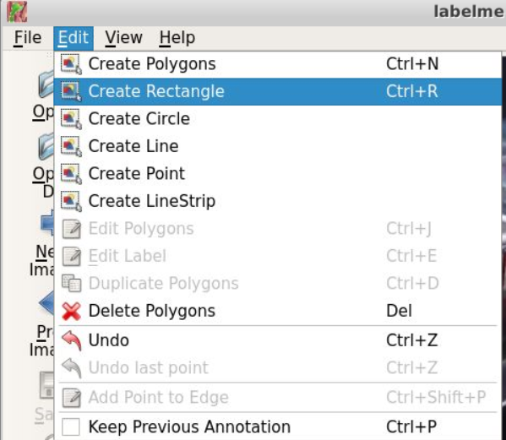

1. Draw a rectangle in the image and select a brand name:

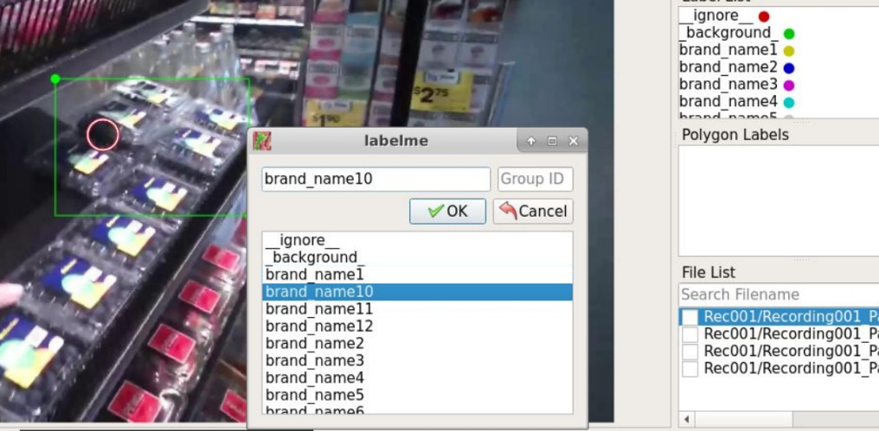

The annotations are automatically saved in a json file in the folder as the fixation frame image.

For a fixation frame, multiple brand objects can be labeled.

Contacts: Haimin Zhang [Haimin.zhang@uts.edu.au](mailto:Haimin.zhang@uts.edu.au) Mobile: 0410860066

A/Prof. Min Xu [Min.Xu@uts.edu.au](mailto:Min.Xu@uts.edu.au)