HANOI UNIVERSITY OF SCIENCE AND TECHNOLOGY
School of Information and Communications Technology
Object-Oriented Programming — IT3100
CAPSTONE PROJECT REPORT
SMART FARM SIMULATOR
A 2D Tile-Based Farming Simulation Game in Java
Field | Information
Group | OOP.20252 - Group 5
Repository | https://github.com/HaimoihocIT/OOP.20252-05
Team Member | Le Anh Duc, Trinh Hoang Dai Hai, Bui Minh Hai, Vu Nguyen Trung Kien
Team leader | Nguyen Quoc Cuong
Instructor | Nguyen Thi Thu Trang
Semester | 20252

Hanoi, June 2026

Table of Contents
1. Project Description
2. Assignment of Members
3. Use Case Analysis
4. Design
5. Object-Oriented Techniques Applied
6. External Sources, Libraries and Tools
7. Build, Run and Test Instructions
8. Conclusion

1. Project Description

1.1 Overview
Smart Farm Simulator is a 2D tile-based farm-management game written entirely in Java with a complete graphical user interface. The player takes the role of a farmer who must plant, water, fertilize, protect, and harvest crops on a grid of farmland while reacting to a constantly changing environment (weather and pest outbreaks). The objective is to keep the farm economically alive: every action costs money or yields money, and the game ends when the player goes bankrupt with no living crops left to harvest.
The project was chosen because it naturally exercises every core object-oriented principle taught in the course: a family of crops modelled by inheritance, a family of weather behaviours modelled by polymorphism, strict encapsulation of cell and crop state, and a clean Model–View–Controller (MVC) separation across packages. The rendering engine is a custom software rasterizer written from scratch on top of java.awt.Canvas, with no external game engine.

1.2 Project Requirement
Simulation & Gameplay Mechanics
Farm Grid Management: The farm operates on a 25×14 grid of cells loaded from a text map file. Each cell is designated as either grass ('G') or farmland soil ('S'). Crops can only be planted on soil cells.
Crop Lifecycle & Diversity: The game features 10 distinct crops (Rice, Cabbage, Corn, Carrot, Radish, Tomato, Pumpkin, Eggplant, Chili, and Pepper), each with unique costs, growth times, resource requirements, and harvest values. Crops progress through a defined lifecycle (SEED → STAGE1 → STAGE2 → STAGE3 → MATURE) based on accumulated days and available resources. If neglected, crops enter a DEAD state.
Resource Tracking: Each soil cell tracks moisture and nutrient levels on a scale of 0–100. Crops consume water and nutrients daily; insufficient water causes stress that can ultimately kill the crop. The player begins with an economic balance of $100, which is spent to buy seeds and fertilizer, and earned by harvesting mature crops.
Environment & Events: The weather system includes Sunny, Rainy, and Drought. Pests spawn pseudo-randomly on soil cells after a randomized number of days, halting crop growth until the player clears them.
Player Actions & Controls
Players interact with the grid by selecting tools to Plant seeds, Water, Fertilize, Clear pests (using the Sword tool), and Harvest. Tools are selectable via keyboard (keys 1–5) or by clicking GUI icons. The simulation also provides controls to advance time, apply weather events, or trigger pest attacks for demonstration purposes.
Graphical User Interface (GUI)
Menus: The Main Menu displays the application title with options to Start a new simulation, Continue, access Help, or Quit. A "Back" button is always available to return to the main menu.
Farm Screen: Features the interactive grid where clicking a cell executes the selected tool. The screen includes a live HUD/dashboard that automatically updates resources (e.g., water decreasing, money increasing) and a paginated Seed Shop.
Game Over Screen: Triggers automatically if the player's balance drops below the cheapest seed cost and no living crop remains, reporting the total number of days the player survived.
Technical & Non-Functional Requirements
Deterministic Logic: The simulation must update at a fixed 60 logic ticks per second so gameplay behaves identically across different hardware, while the rendering runs as fast as the hardware allows.
Maintainability: All layout and gameplay magic numbers must be centralized in a GameConstants class. Subsystems must communicate through a single, shared GameContext object.
Portability: The game must be developed in pure Java and built with Maven, configured to run as a single shaded JAR file.

2. Assignment of Members
Work was divided along the MVC architecture so that each member owns a coherent, well-bounded set of classes. The table below lists each member, their responsibility area, the concrete classes/methods they implemented, and their estimated contribution.
Member | Role | Classes / Files Owned | %
Cuong  (Leader) | Core engine, input, rendering core, integration | Game, GameLauncher, GameContext, GameConstants, GameState, StateHandler, Screen, Keyboard, Mouse, InputManager, Tool, pom.xml | 24
Duc | Crop model & catalog | Crop (abstract), GrowthStage, CropData, Rice, Carrot, Corn, Tomato, Pepper, Cabbage, Eggplant, Pumpkin, Chili, Radish | 19
Kien | Weather & farm grid model | Weather (interface), BaseWeather, Sunny, Rainy, Drought, FarmGrid, FarmCell, game.model.trigger, farm_map.txt | 19
Bui Hai | View / rendering layer | StateRenderer, GameRenderer, MenuRenderer, ShopRenderer, HelpRenderer, GameOverRenderer, Sprite, SpriteSheet, BitmapFont | 19
Dai Hai | Controller layer | StateUpdater, GameController, MenuController, ShopController, HelpController, GameOverController | 19

2.1 Source / Originality Claim
In accordance with the guidelines, all third-party material is declared here. All game logic, the MVC architecture, the software renderer, the crop/weather model and all controllers were written by the team members themselves.
- Gson 2.10.1 (library, used as-is). Google's JSON library is used only by BitmapFont to parse the bitmap-font definition file (/font maps/monogram-bitmap.json). It is declared as a Maven dependency and is not modified. See Section 6.
- monogram bitmap font (asset). The pixel font glyph data is based on the free 'monogram' font; only the rendering code is ours.
- Pixel-art sprite sheets (assets). The PNG textures under /textures are original; all sprite-extraction and rendering code is original.
- Java Standard Library only otherwise. java.awt (Canvas, BufferStrategy, BufferedImage), javax.swing.JFrame and java.util collections. No game engine or GUI builder was used.

3. Use Case Analysis

3.1 Actor
The system has a single human actor — the Player. There are no external systems or databases. The Player interacts with the game exclusively through the keyboard and the mouse; every use case below is therefore initiated by the Player.

3.2 Use Case Diagram
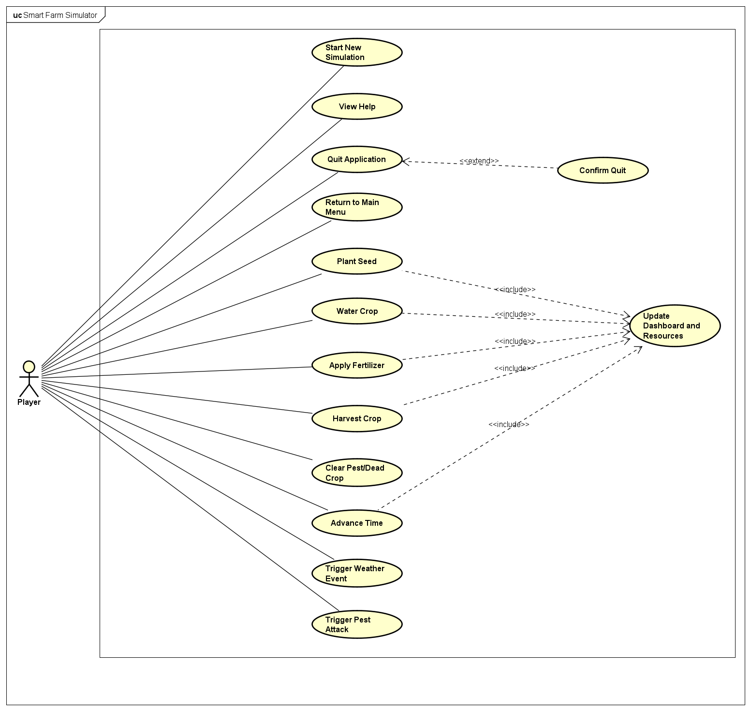
Figure 1 — Use case diagram of Smart Farm Simulator.
The Player can navigate the menu, start or continue a game, view help, and quit. Inside a running game the Player can manage the farm (plant, water, fertilize, clear pests, harvest), browse and buy from the seed shop, advance the day, change the weather, adjust the window scale, and return to the menu. Several gameplay use cases «include» the common Select Cell behaviour, and Advance Day «includes» the automatic Check Game Over behaviour.

3.3 Use Case Descriptions
The most important use cases are detailed below.

UC-01 Plant a Crop
Field | Description
Actor | Player
Pre-condition | A game is running; the Seed tool is selected; a seed type is chosen.
Main flow | 1. Player selects a soil cell (click or arrow keys + Space).  2. System checks the cell is soil ('S') and empty.  3. System checks the balance covers the seed cost.  4. System creates a new Crop via the factory and plants it.  5. System deducts the cost and shows a confirmation message.
Alternative | If the cell is occupied/non-soil, or money is insufficient, no crop is planted and an explanatory message is shown.
Post-condition | A SEED-stage crop occupies the cell; balance is reduced.

UC-02 Advance Day
Field | Description
Actor | Player
Pre-condition | A game is running.
Main flow | 1. Player presses Enter or clicks the ADV DAY button.  2. System increments the day counter.  3. FarmGrid.advanceDay(GameContext) fires triggers, applies current weather to every cell, lets each crop consume resources and grow (or be attacked by pests), rolls the next day's weather, and may spawn new pests.  4. System runs the Game-Over check.
Post-condition | Crops, moisture, nutrients, pests and weather are updated for the new day; the game may transition to GAME OVER.

UC-03 Harvest a Crop
Field | Description
Actor | Player
Pre-condition | Harvest tool selected; target cell contains a crop.
Main flow | 1. Player applies the Harvest tool to the cell.  2. If the crop is MATURE, system adds its value to the balance and removes it.  3. If the crop is DEAD, system removes it for no reward.
Post-condition | Cell is empty; balance increased if the crop was mature.

UC-04 Buy / Equip Seed from Shop
Field | Description
Actor | Player
Pre-condition | A game is running.
Main flow | 1. Player presses P to open the Seed Shop.  2. System shows three crop cards per page with cost, growth days, water need and sell value.  3. Player navigates pages (arrows) and clicks a crop card.  4. System equips that seed and returns to the game.
Post-condition | selectedTool = SEED_SHOP and seedIndex points to the chosen crop.

UC-05 Other Gameplay Use Cases (summary)
Use Case | Trigger | Effect
Water cell | Watering Can + cell | Increase moisture
Fertilize cell | Fertilizer + cell | Increase nutrients
Clear pests | Sword + cell | Cell pest flag cleared
Change weather | R/D/S keys or weather buttons | Toggles Sunny/Rainy/Drought via TriggerManager (toggle off to restore natural weather)
Trigger pests | L key or pest button | Spawns a pest outbreak via TriggerManager
Navigate grid | Arrow keys | Moves the selected cell
Change scale | [ and ] keys | Window scale 1×–6×
Continue game | Menu CONTINUE | Resumes without reset
Return to menu | Esc | Switches to MENU, state preserved

4. Design

4.1 General Class Diagram
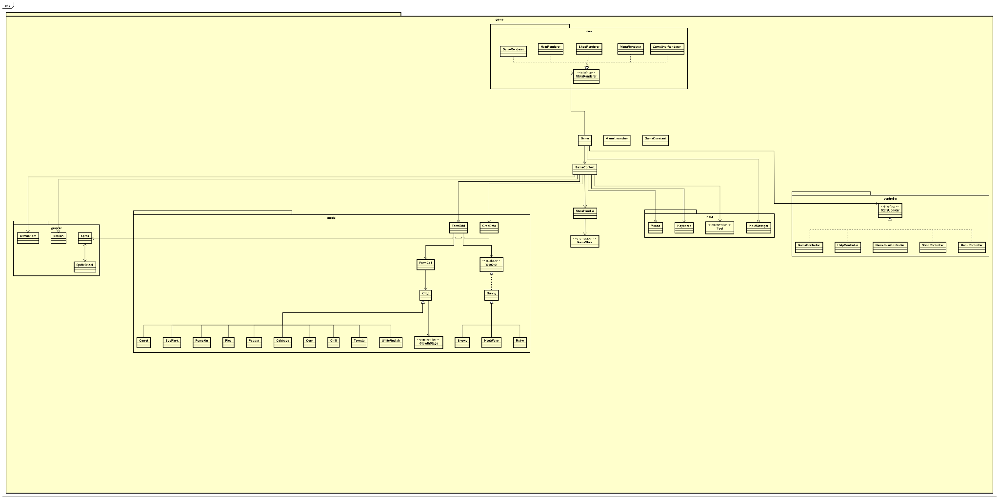
Figure 2 — General class diagram (packages and classes, without attributes/operations).
The system is organized into packages that map directly onto the MVC pattern plus a small core. The root game package owns the application lifecycle and the shared GameContext; model holds all domain logic; view renders that state; controller translates input into model changes; graphics and input provide low-level services.
Package | Responsibility | Main Classes
game (root) | Bootstrap, game loop, shared state, state machine | GameLauncher, Game, GameContext, GameConstants, GameState, StateHandler
game.model | Farm domain — grid & cells | FarmGrid, FarmCell
game.model.crop | Crop hierarchy + catalog/factory | Crop (abstract), GrowthStage, CropData, 10 crop subclasses
game.model.weather | Weather behaviours | Weather (interface), BaseWeather (abstract), Sunny, Rainy, Drought
game.model.trigger | Event-driven triggers — weather overrides and pest outbreaks | TriggerManager, GameTrigger (interface), WeatherTrigger, PestTrigger, TriggerCategory
game.view | Read-only rendering of each state | StateRenderer, BaseRenderer, GameRenderer, MenuRenderer, ShopRenderer, HelpRenderer, GameOverRenderer, WeatherSpriteMapper, CropSpriteMapper
game.controller | Input → model updates per state | StateUpdater, Game/Menu/Shop/Help/GameOver Controller
game.graphics | Software rasterizer & sprites | Screen, Sprite, SpriteSheet
game.graphics.text | Bitmap font rendering | BitmapFont
game.input | Input abstraction | Keyboard, Mouse, InputManager, Tool

4.2 Detailed Class Diagrams by Package

4.2.1 Core Package (game)
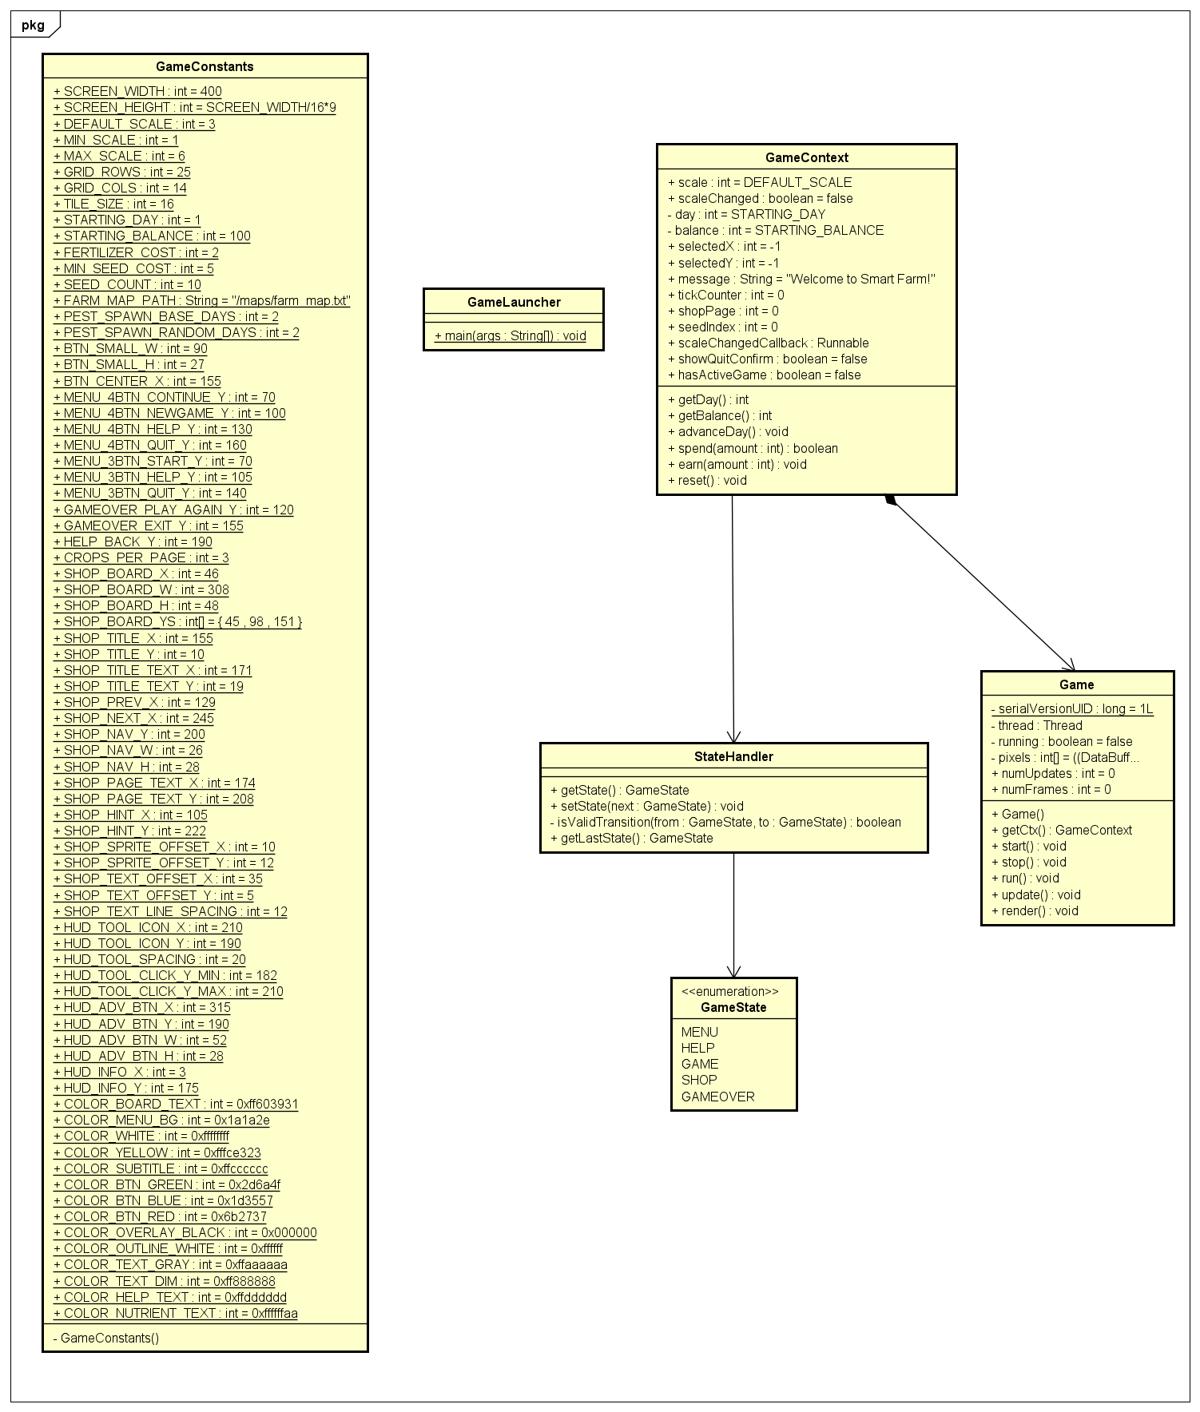
GameContext is the central data object shared by all layers. Key members:
Class | Key Attributes | Key Operations
Game | ctx: GameContext; inputManager; updaters: Map<GameState,StateUpdater>; renderers: Map<GameState,StateRenderer>; image; pixels[] | start(); stop(); run(); update(); render()
GameLauncher | — | main(String[])
GameContext | screen; handler; mouse; keyboard; guiFont; grid; scale; scaleChanged; day (private); balance (private); selectedX/Y; selectedTool; message; tickCounter; shopPage; seedIndex; cropCatalog; hasActiveGame; showQuitConfirm | reset(); getDay(); getBalance(); advanceDay(); spend(int); earn(int)
StateHandler | currentState: GameState; lastState: GameState | getState(); setState(); getLastState()
GameState | «enum» MENU, HELP, GAME, SHOP, GAMEOVER | —
GameConstants | «final» SCREEN_WIDTH, GRID_ROWS, TILE_SIZE, STARTING_BALANCE, FERTILIZER_COST, colours, HUD layout… | —

4.2.2 Farm Model (game.model)
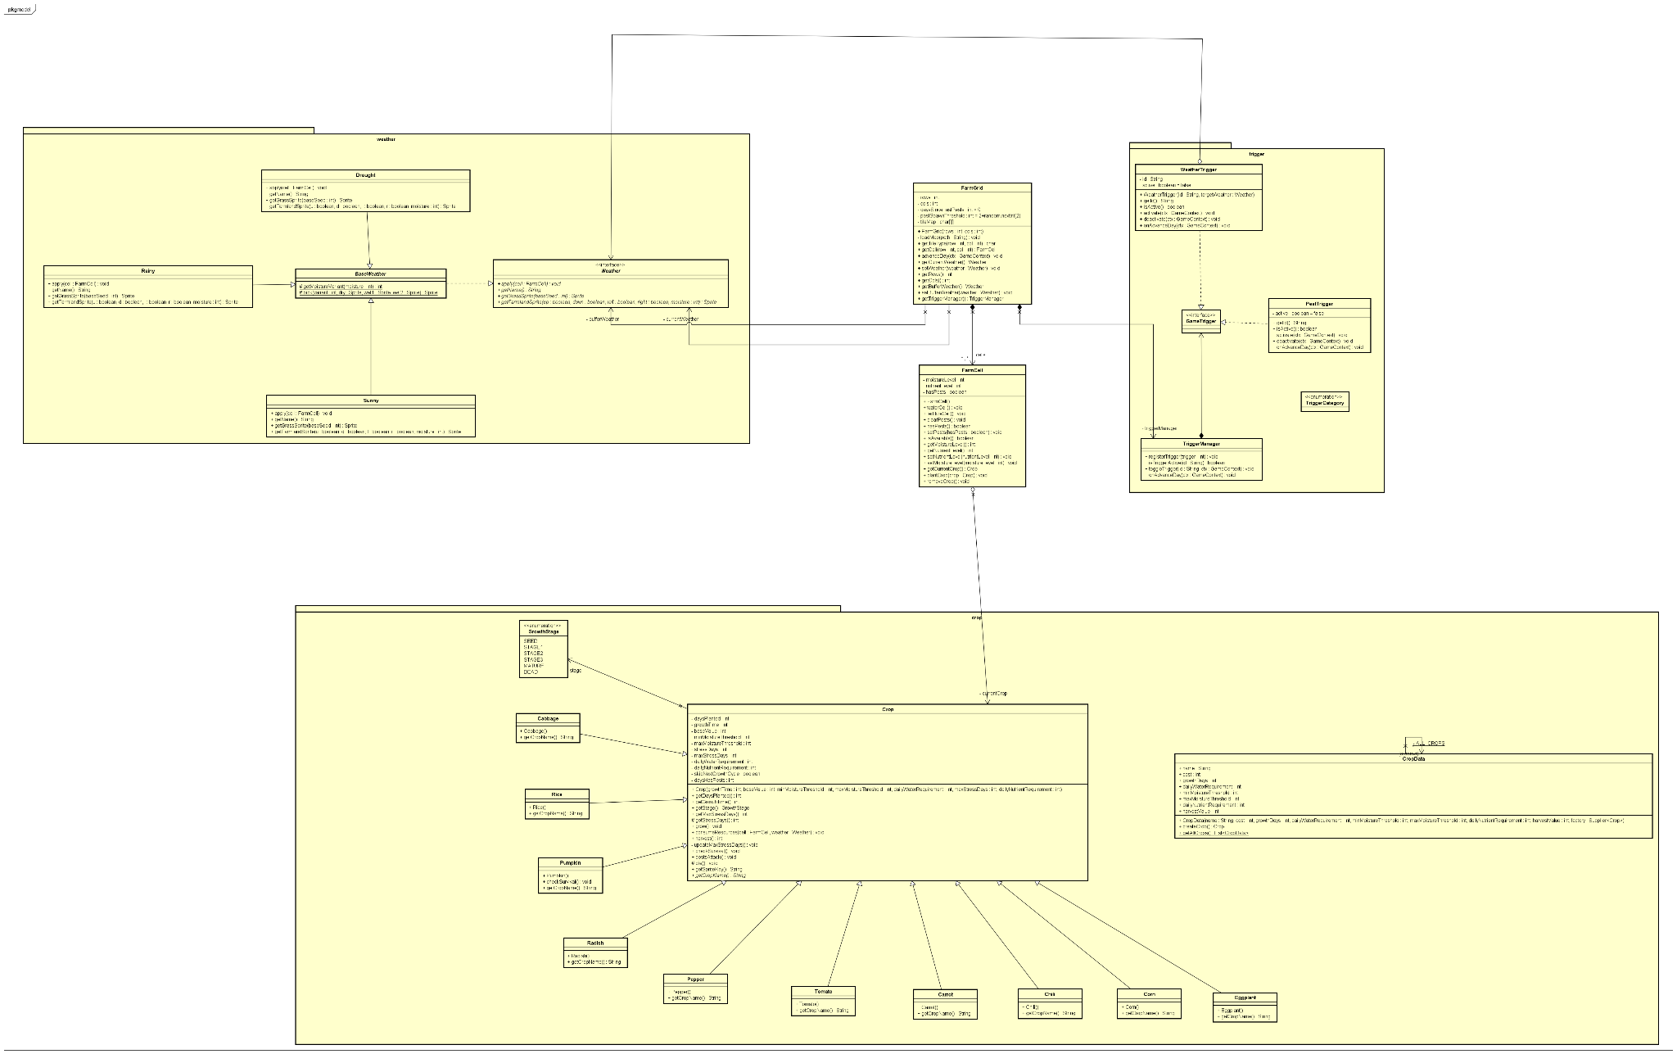
Class | Key Attributes | Key Operations
FarmGrid | -rows, -cols: int; -cells: FarmCell[][]; -tileMap: char[][]; -currentWeather: Weather; -bufferWeather: Weather; -triggerManager: TriggerManager; -random: Random; -pestSpawnThreshold | +advanceDay(GameContext); -loadMap(path); +getCell(r,c); +getTileType(r,c); +setWeather(w); +getBufferWeather(); +setBufferWeather(Weather); +getTriggerManager()
FarmCell | -moistureLevel: int; -nutrientLevel: int; -hasPests: boolean; -currentCrop: Crop | +waterCell(); +fertilizeCell(); +clearPests(); +plantCrop(c); +removeCrop(); +isAvailable(); getters/setters (clamped 0–100)

4.2.3 Crop Hierarchy (game.model.crop)
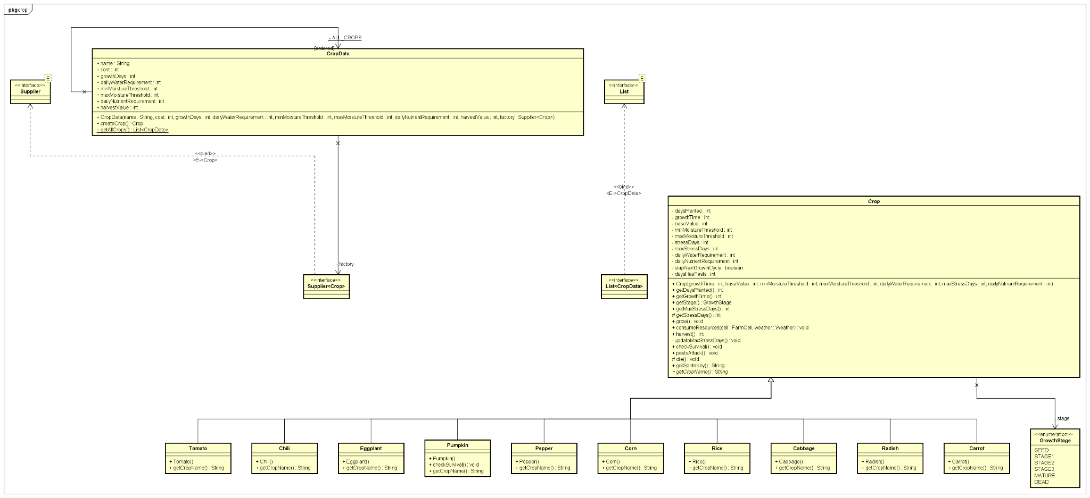
Class | Key Attributes | Key Operations
Crop «abstract» | -stage: GrowthStage; -daysPlanted; -growthTime; -baseValue; -minMoistureThreshold; -maxMoistureThreshold; -dailyWaterRequirement; -dailyNutrientRequirement; -stressDays; -maxStressDays; -skipNextGrowthCycle; -daysHasPests | +grow(); +consumeResources(cell,weather); +harvest(); +checkSurvival(); +pestsAttack(); +getStage(); +getSpriteKey(); +getCropName() «abstract»
GrowthStage «enum» | SEED, STAGE1, STAGE2, STAGE3, MATURE, DEAD | —
CropData | +name; +cost; +growthDays; +dailyWaterRequirement; +minMoistureThreshold; +maxMoistureThreshold; +dailyNutrientRequirement; +harvestValue; -factory: Supplier<Crop> | +createCrop(); +getAllCrops() «static»
Rice, Cabbage, Corn,  Carrot, Radish,  Tomato, Pumpkin,  Eggplant, Chili, Pepper | (constructor passes its own growth/water/value parameters to super) | +getSprite() — maps GrowthStage to the crop's sprite frames

In-game crop parameters (from CropData.getAllCrops()):
Crop | Cost | Growth (days) | Daily water | Moisture min–max | Nutrient/day | Sell
Rice | 20 | 6 | 20 | 50–80 | 20 | 65
Cabbage | 12 | 5 | 10 | 30–60 | 20 | 40
Corn | 28 | 6 | 20 | 40–70 | 20 | 80
Carrot | 8 | 4 | 10 | 20–50 | 10 | 30
Radish | 5 | 4 | 10 | 20–50 | 10 | 20
Tomato | 16 | 6 | 20 | 30–60 | 20 | 50
Pumpkin | 50 | 9 | 30 | 50–80 | 30 | 140
Eggplant | 32 | 7 | 20 | 40–70 | 30 | 90
Chilli | 24 | 6 | 20 | 30–60 | 30 | 70
Pepper | 20 | 6 | 20 | 30–60 | 20 | 60

4.2.4 Weather Behaviours (game.model.weather)
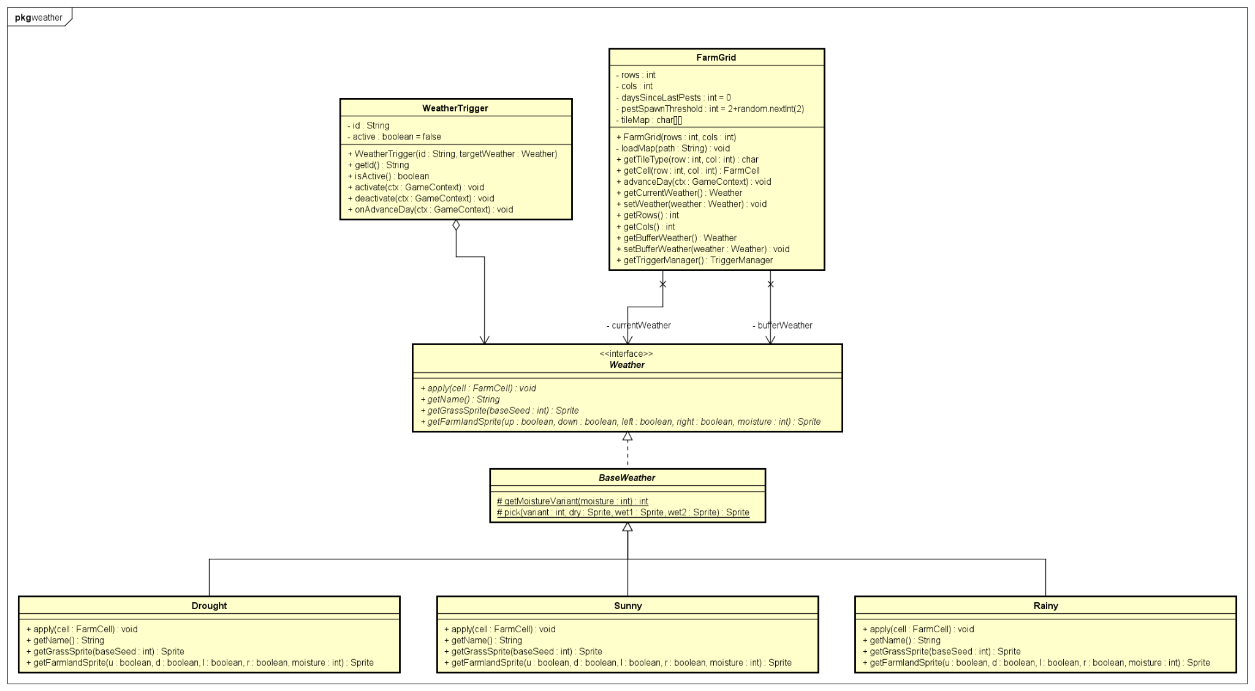
Class | Relationship | Operations / Effect
Weather «interface» | — | apply(cell); getName(); getWaterRequirement(); getPestSpawnMultiplier(); getGrassAppearance(seed); getFarmlandAppearance(u,d,l,r,moisture)
BaseWeather «abstract» | implements Weather | getMoistureVariant(moisture); pick(variant, dry, wet1, wet2) — shared tile-appearance helpers
Sunny | extends BaseWeather | apply: moisture −5; pest multiplier ×1.0; normal grass/soil sprites
Rainy | extends BaseWeather | apply: moisture +20; pest multiplier ×0.5; wet grass/soil sprites
Drought | extends BaseWeather | apply: moisture −20; getWaterRequirement(): 10; pest multiplier ×1.5; cracked dry tile sprites

4.2.5 View and Controller Packages
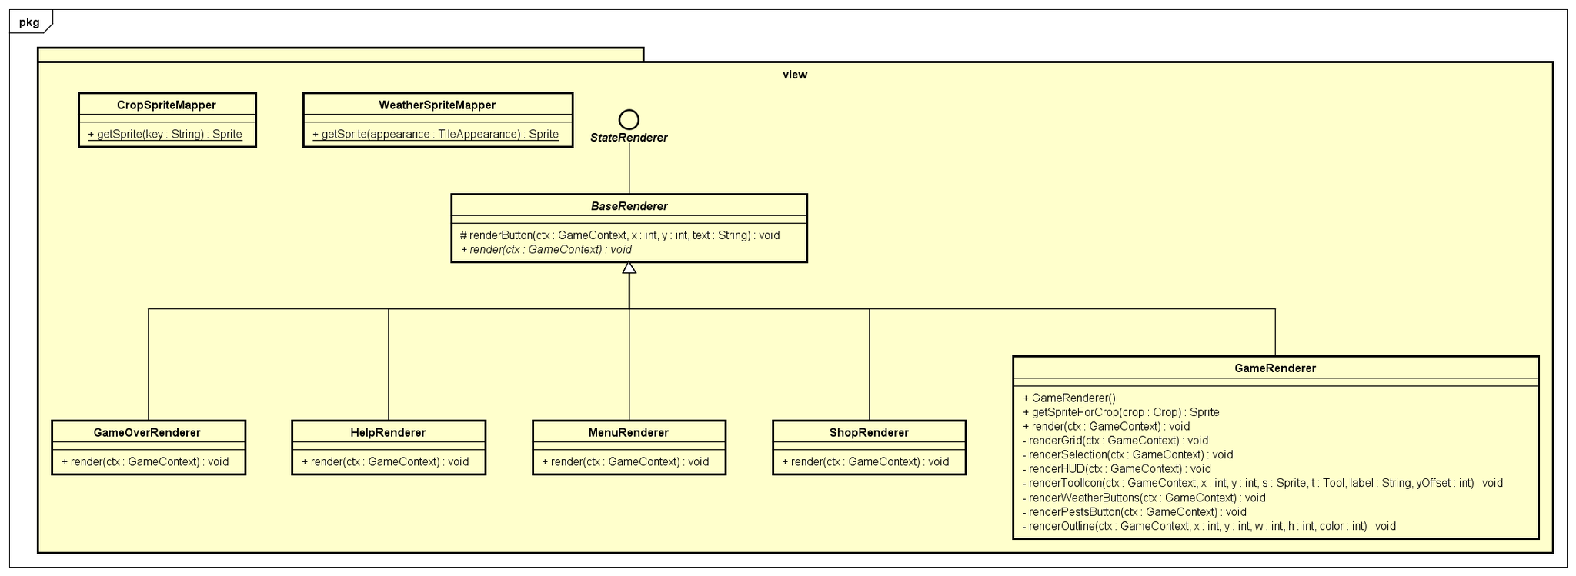
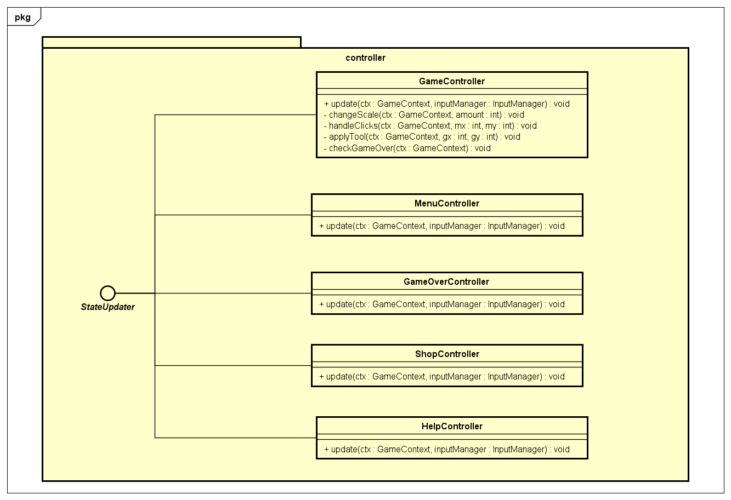
Both layers are built on a single-method interface so the Game loop can treat every state uniformly. StateRenderer.render(ctx) draws a state; StateUpdater.update(ctx, inputManager) updates a state. There is exactly one renderer and one controller per GameState value.

Interface | Method | Implementations
StateRenderer | render(GameContext) | GameRenderer, MenuRenderer, ShopRenderer, HelpRenderer, GameOverRenderer
StateUpdater | update(GameContext, InputManager) | GameController, MenuController, ShopController, HelpController, GameOverController

4.2.6 Graphics and Input Packages
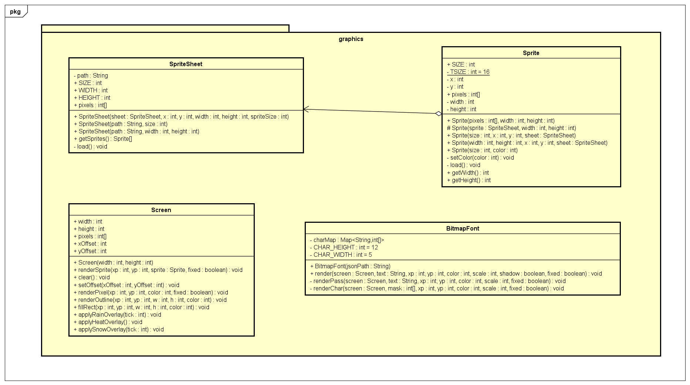
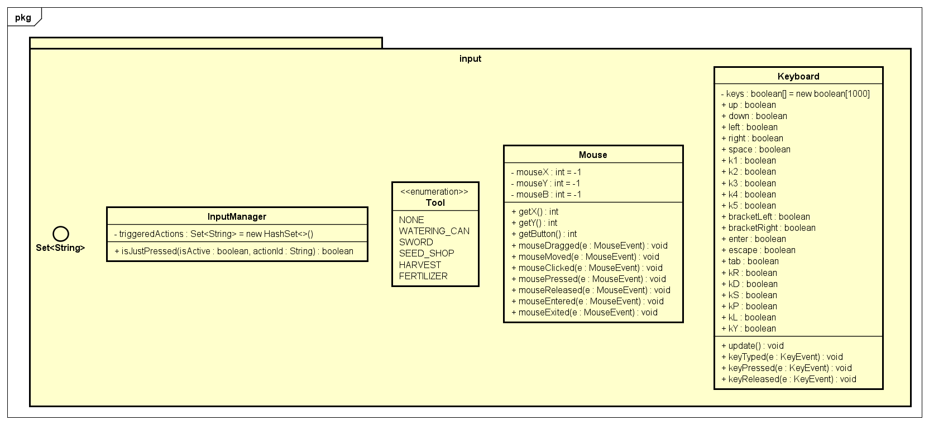
Class | Key Attributes | Key Operations
Screen | +pixels: int[]; width; height | clear(); renderSprite(); fillRect(); applyRainOverlay(); applySnowOverlay()
Sprite | +pixels: int[]; width; height (many static sprite constants) | load(); getters
SpriteSheet | +pixels: int[]; size | (loads PNG via ImageIO)
BitmapFont | -charMap: Map<String,int[]> | render(screen,text,x,y,scale,colour) — parses JSON via Gson
Keyboard | +keys: boolean[]; named fields (up, enter, k1…k5, tab, …) | keyPressed(); keyReleased(); update()
Mouse | mouseX; mouseY; mouseB | mousePressed/Released/Moved; getX/getY/getButton
InputManager | -triggeredActions: Set<String> | isJustPressed(active, id)
Tool «enum» | NONE, WATERING_CAN, SWORD, SEED_SHOP, HARVEST, FERTILIZER | —

4.3 Explanation of the Design — Relationships
- Inheritance (generalization). Crop is the abstract superclass of 10 concrete crops; Snowy extends Sunny to reuse its sprite-picking helpers.
- Realization (interface implementation). Sunny, Rainy and Drought extend BaseWeather which realizes the Weather interface; the five controllers realize StateUpdater and the five renderers realize StateRenderer.
- Composition (strong ownership). FarmGrid owns its FarmCell[][] — the cells are created in the FarmGrid constructor and cannot exist without it. Game owns its GameContext.
- Aggregation (weak ownership). A FarmCell holds a Crop reference that comes and goes (planted/harvested) and outlives individual day ticks; GameContext aggregates the shared services (Screen, Keyboard, Mouse, FarmGrid, BitmapFont).
- Association / dependency. Controllers and renderers depend on GameContext passed as a parameter; Crop.consumeResources(FarmCell, Weather) depends transiently on both; CropData holds a Supplier<Crop> association to a crop constructor.
The MVC discipline is enforced by these directions: the View only reads GameContext, the Controller only writes to the Model through GameContext, and the Model classes (FarmGrid, FarmCell, Crop, Weather) contain no AWT or rendering code at all.

4.4 Implementation of Important Methods

4.4.1 Fixed-timestep game loop — Game.run()
The loop separates logic from rendering. Logic (update()) runs a fixed 60 times per second using a nanosecond accumulator, while render() runs every iteration. This keeps the simulation deterministic across machines.
final double ns = 1_000_000_000.0 / 60.0; // one logic tick = 1/60 s
double delta = 0;
while (running) {
long now = System.nanoTime();
delta += (now - lastTime) / ns;
lastTime = now;
while (delta >= 1) { update(); delta--; } // catch up logic
render(); // draw as fast as possible
}

4.4.2 One-shot input — InputManager.isJustPressed()
Raw key states stay true while a key is held. isJustPressed() converts a continuous state into a single edge-triggered event using a Set of action ids, so e.g. pressing Enter advances exactly one day.
public boolean isJustPressed(boolean isActive, String actionId) {
if (isActive) {
if (!triggeredActions.contains(actionId)) {
triggeredActions.add(actionId); // first frame -> fire once
return true;
}
return false; // still held -> ignore
} else {
triggeredActions.remove(actionId); // released -> re-arm
return false;
}
}

4.4.3 Daily simulation — FarmGrid.advanceDay(GameContext)
This is the heart of the model. It first fires triggerManager.onAdvanceDay(ctx) to resolve any active weather or pest triggers, then for every cell applies the current weather, lets the crop consume resources and either grow or suffer a pest attack, and checks survival. After all cells are updated it rolls the next day's weather. Finally it may spawn pests on random soil cells, scaled by the weather's pest multiplier.
// 1. resolve triggers (weather overrides, pest events)
triggerManager.onAdvanceDay(ctx);
// 2. apply current weather + grow crops
for (int i = 0; i < rows; i++)
for (int j = 0; j < cols; j++) {
FarmCell cell = cells[i][j];
currentWeather.apply(cell); // polymorphic call
Crop crop = cell.getCurrentCrop();
if (crop != null) {
crop.consumeResources(cell, currentWeather);
if (!cell.hasPests()) crop.grow();
else crop.pestsAttack();
crop.checkSurvival();
}
}
// 3. roll next day's weather
double roll = random.nextDouble();
if (roll < 0.2) currentWeather = new Rainy();
else if (roll < 0.4) currentWeather = new Drought();
else currentWeather = new Sunny();

4.4.4 Resource consumption & growth — Crop
consumeResources() subtracts water (extra under a Drought) and nutrients; if water is outside the [minMoistureThreshold, maxMoistureThreshold] band it records a stress day. If the crop is stressed or starved, the next growth cycle is skipped. grow() advances the stage based on the ratio daysPlanted / growthTime, and checkSurvival() kills the crop once stressDays reaches maxStressDays.
double progress = (double) daysPlanted / growthTime;
if (progress >= 1.00) stage = GrowthStage.MATURE;
else if (progress >= 0.75) stage = GrowthStage.STAGE3;
else if (progress >= 0.50) stage = GrowthStage.STAGE2;
else if (progress >= 0.25) stage = GrowthStage.STAGE1;

4.4.5 Factory pattern — CropData.createCrop()
Each CropData stores a Supplier<Crop> constructor reference (e.g. Rice::new). createCrop() invokes it, so the controller plants a crop without a hard-coded switch on the seed index — adding a new crop only requires one new catalog entry.
// catalog entry holds a constructor reference
new CropData("Rice", 20, 6, 20, 50, 80, 20, 65, Rice::new)
public Crop createCrop() { return factory.get(); } // calls Rice::new

4.4.6 Tool application — GameController.applyTool()
A switch on the selected Tool routes each player action to the right model mutation, validating money and cell state. Note the harvest value is read once into a local variable to avoid calling harvest() twice.
case HARVEST -> {
Crop crop = cell.getCurrentCrop();
if (crop != null && crop.getStage() == GrowthStage.MATURE) {
int value = crop.harvest(); // cached - single call
ctx.earn(value);
cell.removeCrop();
ctx.message = "Harvested (+$" + value + ")";
} else if (crop != null && crop.getStage() == GrowthStage.DEAD) {
cell.removeCrop();
ctx.message = "Cleared dead crop";
}
}

6. External Sources, Libraries and Tools
Item | Type | Version | Used for | Modified?
Gson | Library | 2.10.1 | Parsing the bitmap-font JSON in BitmapFont | No
Java AWT / Swing | Standard library | JDK 21+ | Canvas, BufferStrategy, BufferedImage, JFrame | No
Apache Maven | Build tool | 3.8+ | Build, dependency management, shaded JAR | —
monogram font | Asset | — | Bitmap glyph data | Rendering code original
Pixel sprite sheets | Asset | — | Tiles, crops, UI | Extraction code original
Astah UML | Tool | — | Use case & class diagrams | —

7. Conclusion
Smart Farm Simulator delivers a complete, playable farming game built from scratch in Java with a custom software renderer and a clean MVC architecture. It demonstrates all four pillars of object-oriented programming — encapsulation, abstraction, inheritance and polymorphism — together with association, aggregation and composition, and applies modern Java idioms such as functional interfaces, method references and switch expressions. The package structure keeps the model independent of the UI, which made the system easy to divide among five members and straightforward to extend: adding a new crop or weather type requires only a new subclass and a catalog entry, with no change to the controllers or renderers.

