Point_process_June9

Hainan Xu

09/06/2022

## Point process

Problems:

2.too much data point, only computing border correlation;

I converted the orginal dataset to the dataset with 4 variables: x position, y position, roi_scource,size of the rectangle.

Here is the size distribution of all the points. It shows a right-skewed distribution.

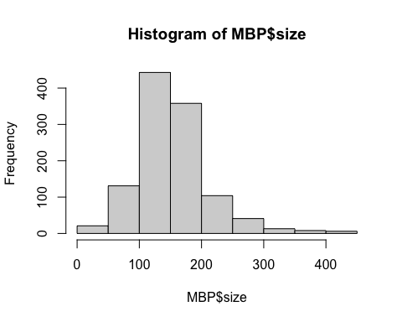

I plot the points based on thier position and the with marginal distributions of the points. More formatting need to be adjusted.

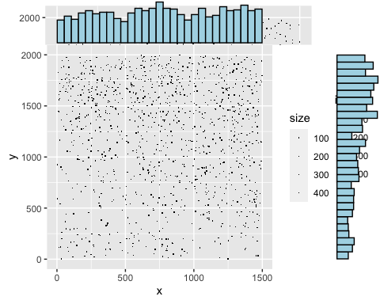

#### Shape

Then, I converted the data as a marked point process. The mark I use is the size of the rectangle. After that, I extracted the shape of the visual cortex based on the points provided. Here plot(ln) can plot the whole marked point process, the size of the circle indicate the size of the original rectangle size.

## Marked planar point pattern: 1125 points  
## marks are numeric, of storage type 'double'  
## window: rectangle = [2, 1498] x [3, 1998] units

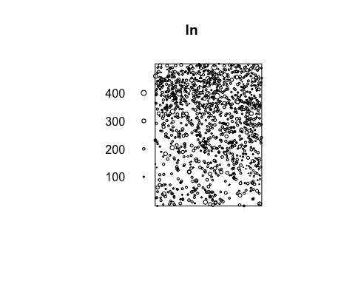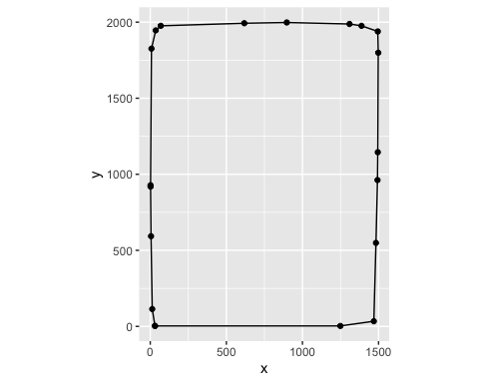

## Marked planar point pattern: 1125 points  
## marks are of storage type 'character'  
## window: polygonal boundary  
## enclosing rectangle: [2, 1498] x [3, 1998] units

#### Voronoi Tessilation

This is the Voronoi tessilation using deldir package.

library(deldir)

## deldir 1.0-6 Nickname: "Mendacious Cosmonaut"

##   
## The syntax of deldir() has had an important change.   
## The arguments have been re-ordered (the first three   
## are now "x, y, z") and some arguments have been   
## eliminated. The handling of the z ("tags")   
## argument has been improved.  
##   
## The "dummy points" facility has been removed.   
## This facility was a historical artefact, was really   
## of no use to anyone, and had hung around much too   
## long. Since there are no longer any "dummy points",   
## the structure of the value returned by deldir() has   
## changed slightly. The arguments of plot.deldir()   
## have been adjusted accordingly; e.g. the character   
## string "wpoints" ("which points") has been   
## replaced by the logical scalar "showpoints".   
## The user should consult the help files.

# Data  
  
x <- MBP$x  
y <- MBP$y  
  
# Calculate Voronoi Tesselation and tiles  
tesselation <- deldir(x, y)  
tiles <- tile.list(tesselation)  
  
plot(tiles,pch=10,showpoints = FALSE)

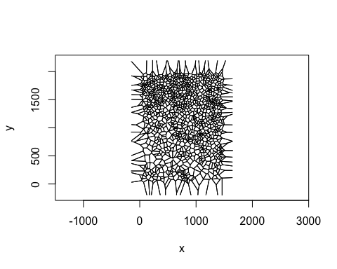

plot(tiles, pch = 1,  
 col.pts = "white",  
 border = "white",  
 fillcol = hcl.colors(50, "viridis"),  
 showpoints = FALSE  
 )

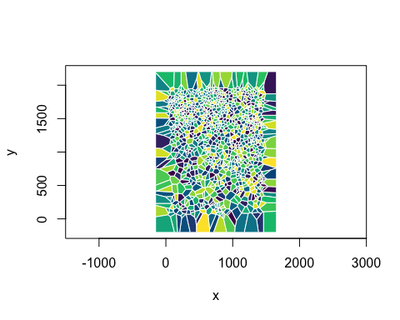

#### First order effect: estimation of the intensity.

This is the estimation of the intensity of the MBP cells.

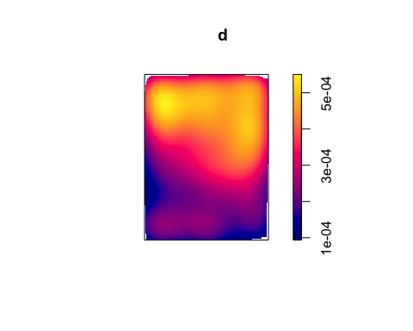 #### Second order effect: distance to it’s nearest neighbor.

Used 3 different edge effect correction. Here, only the correlation of margin is calculated since there are too much point.

G(r) is the cumulative distance, r is the distance.

## Function value object (class 'fv')  
## for the function r -> G(r)  
## .....................................................................  
## Math.label Description   
## r r distance argument r   
## theo G[pois](r) theoretical Poisson G(r)   
## han hat(G)[han](r) Hanisch estimate of G(r)   
## rs hat(G)[bord](r) border corrected estimate of G(r)   
## km hat(G)[km](r) Kaplan-Meier estimate of G(r)   
## hazard hat(h)[km](r) Kaplan-Meier estimate of hazard function h(r)  
## theohaz h[pois](r) theoretical Poisson hazard function h(r)   
## .....................................................................  
## Default plot formula: .~r  
## where "." stands for 'km', 'rs', 'han', 'theo'  
## Recommended range of argument r: [0, 44.48]  
## Available range of argument r: [0, 97.741]

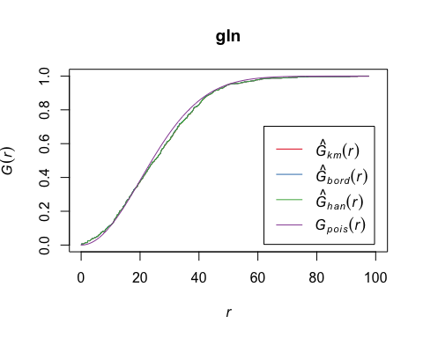 Paired correlation function

## Function value object (class 'fv')  
## for the function r -> L[inhom](r)  
## ................................................................................  
## Math.label   
## r r   
## theo {L[inhom]^{pois}}(r)   
## border {hat(L)[inhom]^{bord}}(r)   
## bord.modif {hat(L)[inhom]^{bordm}}(r)  
## trans {hat(L)[inhom]^{trans}}(r)  
## iso {hat(L)[inhom]^{iso}}(r)   
## Description   
## r distance argument r   
## theo theoretical Poisson L[inhom](r)   
## border border-corrected estimate of L[inhom](r)   
## bord.modif modified border-corrected estimate of L[inhom](r)   
## trans translation-correction estimate of L[inhom](r)   
## iso Ripley isotropic correction estimate of L[inhom](r)  
## ................................................................................  
## Default plot formula: .~.x  
## where "." stands for 'iso', 'trans', 'bord.modif', 'border', 'theo'  
## Recommended range of argument r: [0, 374]  
## Available range of argument r: [0, 374]

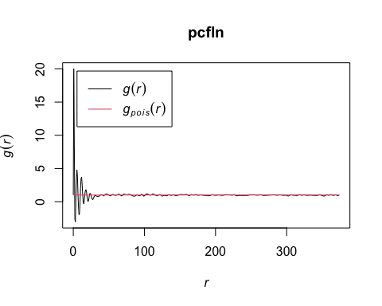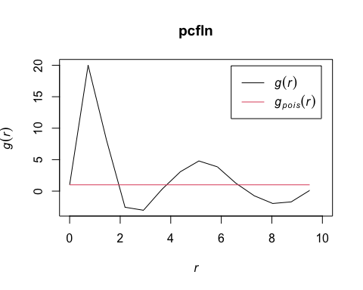

## Similar Analyais for a different pic:

MBP2<-read_csv(file.path("..", "data","H07-0500_79205589_179_2_MBP._analysis_results.csv"))%>%  
 transmute(x=com_x,  
 y=com_y,  
 class="MBP")

## Rows: 1393 Columns: 16  
## ── Column specification ────────────────────────────────────────────────────────  
## Delimiter: ","  
## chr (5): roi_id, roi_source, roi_type, filename, analysis_date  
## dbl (11): cell_number, com_x, com_y, pixel_area, background, mean_intensity,...  
##   
## ℹ Use `spec()` to retrieve the full column specification for this data.  
## ℹ Specify the column types or set `show_col_types = FALSE` to quiet this message.

MBP2

## # A tibble: 1,393 × 3  
## x y class  
## <dbl> <dbl> <chr>  
## 1 1345 1354 MBP   
## 2 739 313 MBP   
## 3 1245 1883 MBP   
## 4 698 771 MBP   
## 5 819 1306 MBP   
## 6 911 701 MBP   
## 7 439 642 MBP   
## 8 730 746 MBP   
## 9 552 1100 MBP   
## 10 323 94 MBP   
## # … with 1,383 more rows

ln2 = with(MBP2,  
 ppp(x = x, y = y, marks = class, xrange = range(x), yrange = range(y)))

## Warning: data contain duplicated points

ln2

## Marked planar point pattern: 1393 points  
## marks are of storage type 'character'  
## window: rectangle = [2, 1497] x [6, 1987] units

ggplot(MBP2,  
 aes(x = x, y = y, col = class)) + geom_point(shape = ".") +  
 facet_grid( . ~ class) + guides(col =FALSE)

## Warning: `guides(<scale> = FALSE)` is deprecated. Please use `guides(<scale> =  
## "none")` instead.

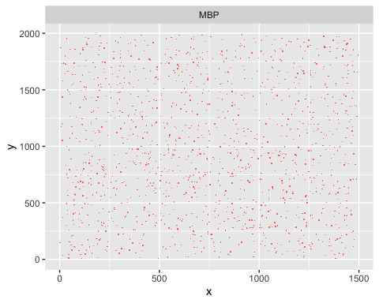

d2 = density(subset(ln2, marks == "MBP"), edge=TRUE, diggle=TRUE)  
plot(d2)

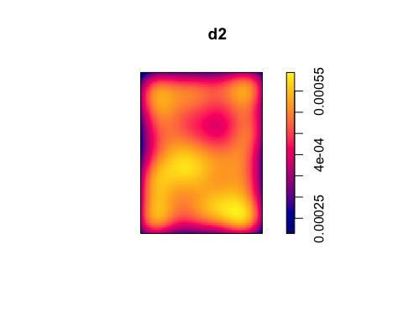

gln2 = Gest(ln2)  
  
  
library("RColorBrewer")  
plot(gln2, xlim = c(0, 10), lty = 1, col = brewer.pal(4, "Set1"))

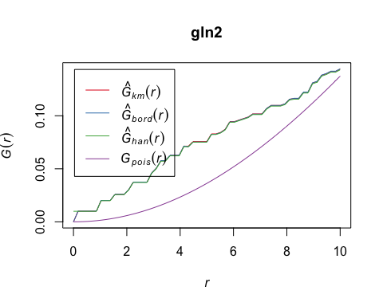

pcfln2 = pcf(Kinhom(subset(ln2, marks == "MBP")))

## number of data points exceeds 1000 - computing border correction estimate only

plot(pcfln2, lty = 1)

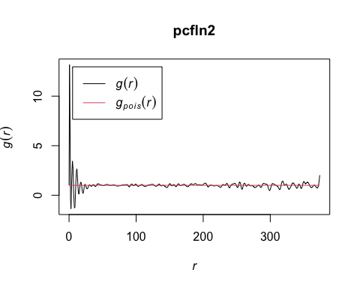

plot(pcfln2, lty = 1, xlim = c(0, 10))

