- Deploy a Ec2 instance using of t2. micro instance in Mumbai Region in Zone ap-south-1a,Configure web server on it and make it live. and attach a 5gb ebs volume. where create 10 files. like training.txt
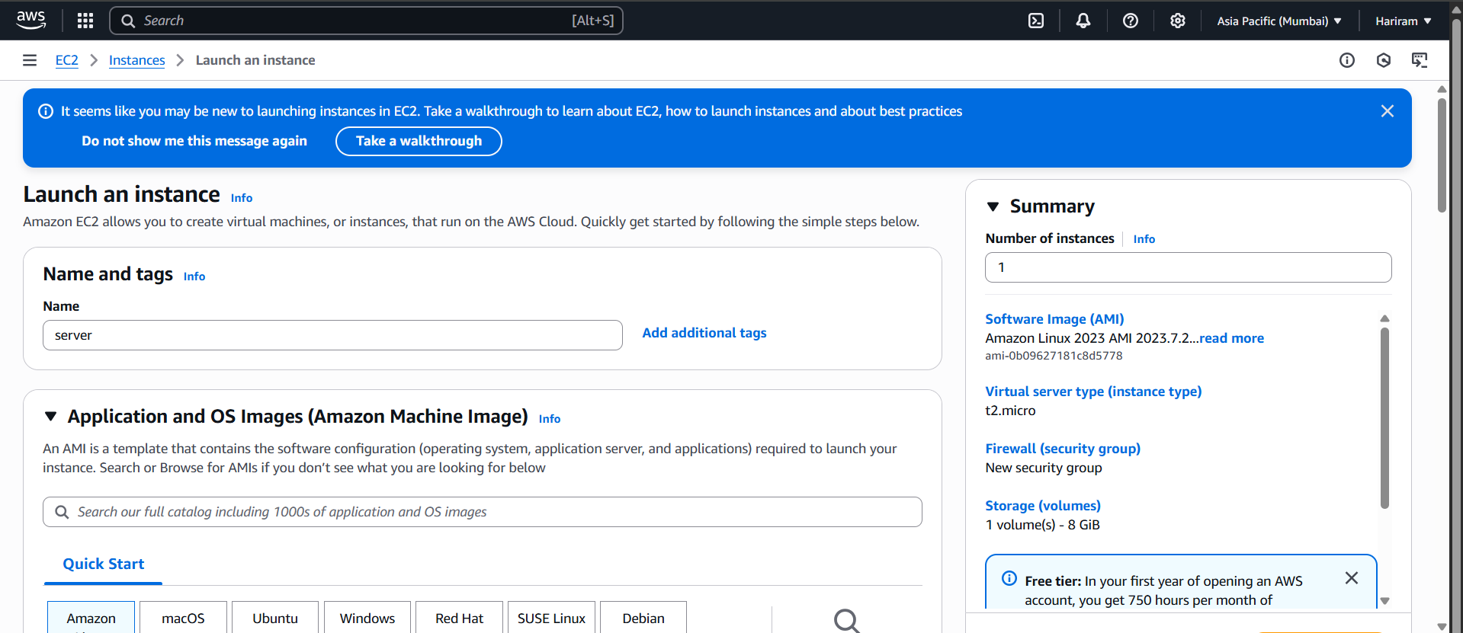
EC2 instance is created with name server.
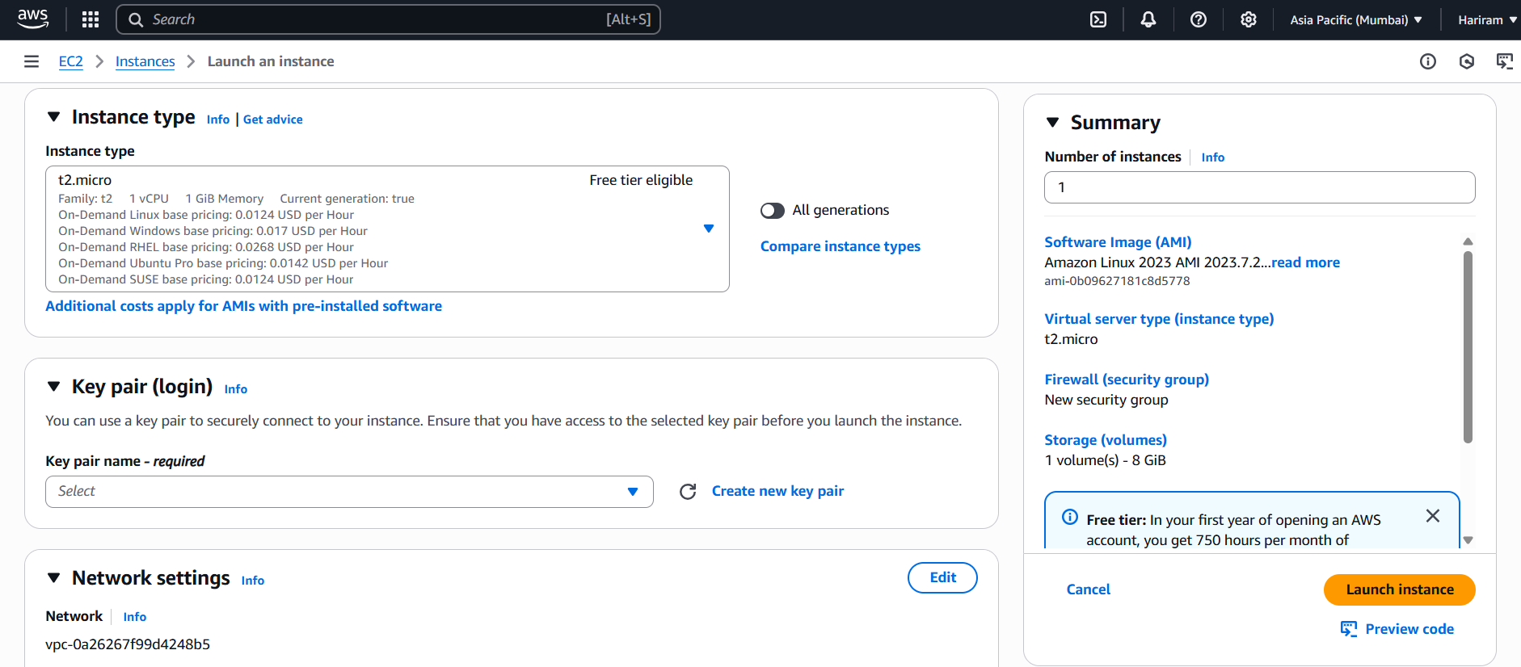
New key is created .
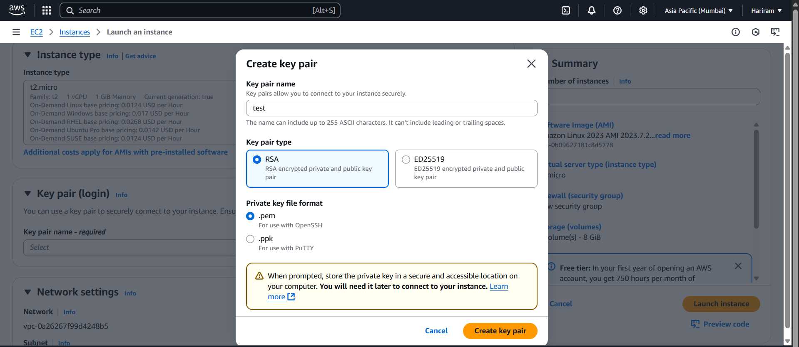
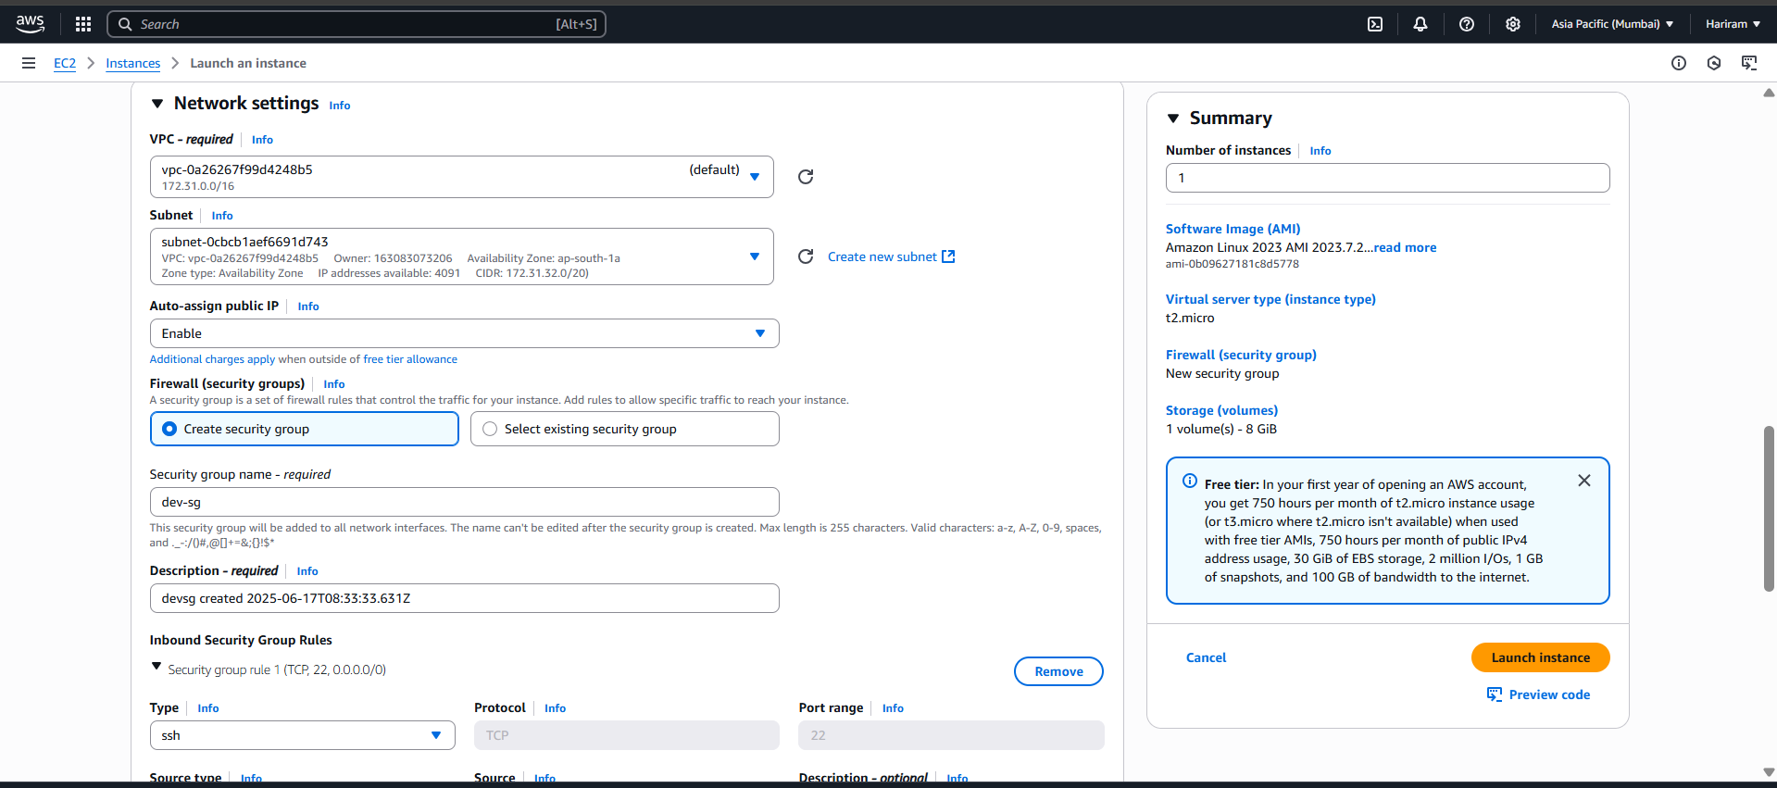
New security group is created.
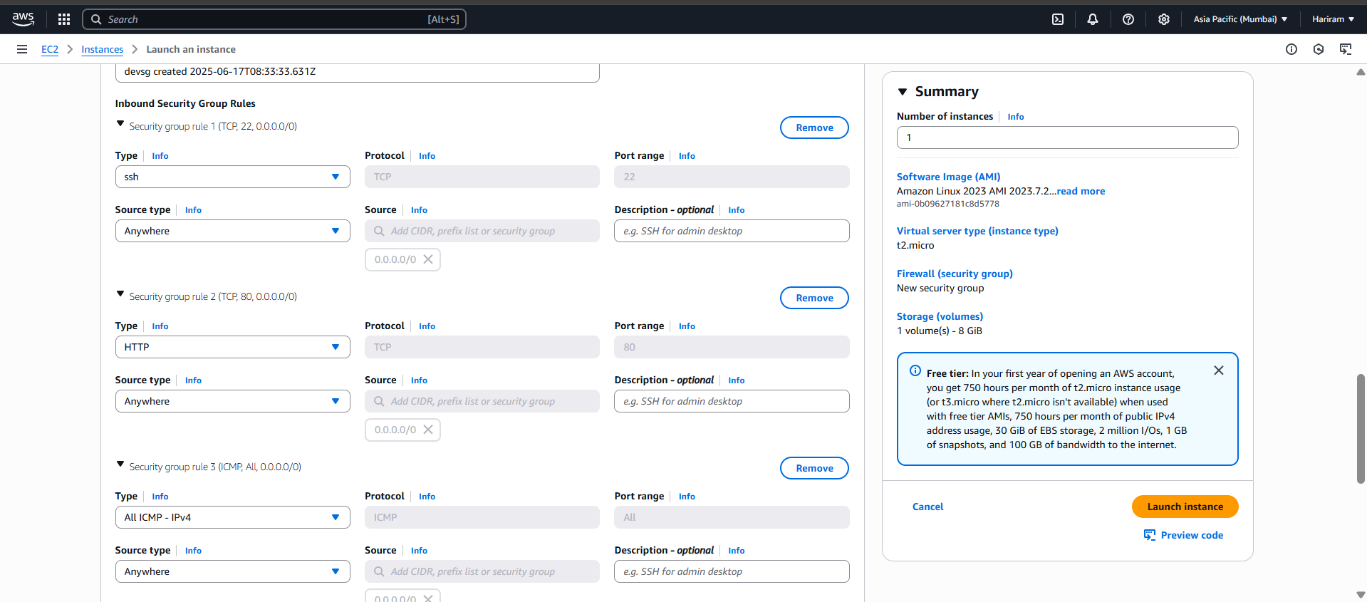
Necessary networks are allowed.
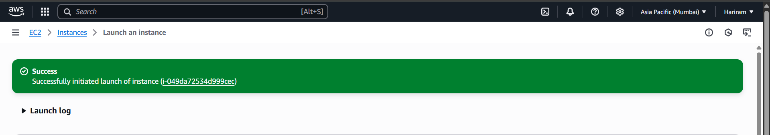
Instances is created successfully.
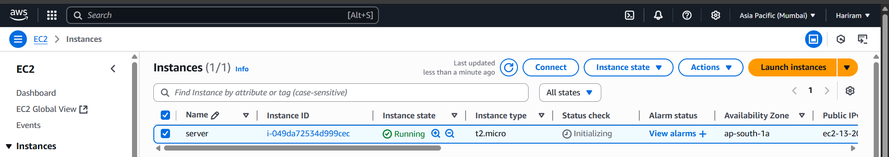
Instances running successfully.
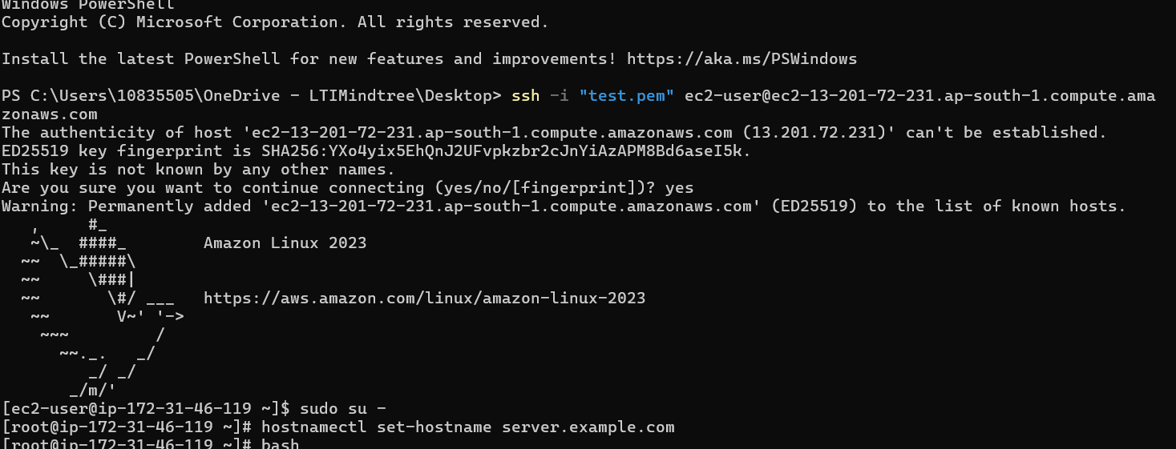
Go into the root and hostname is set.
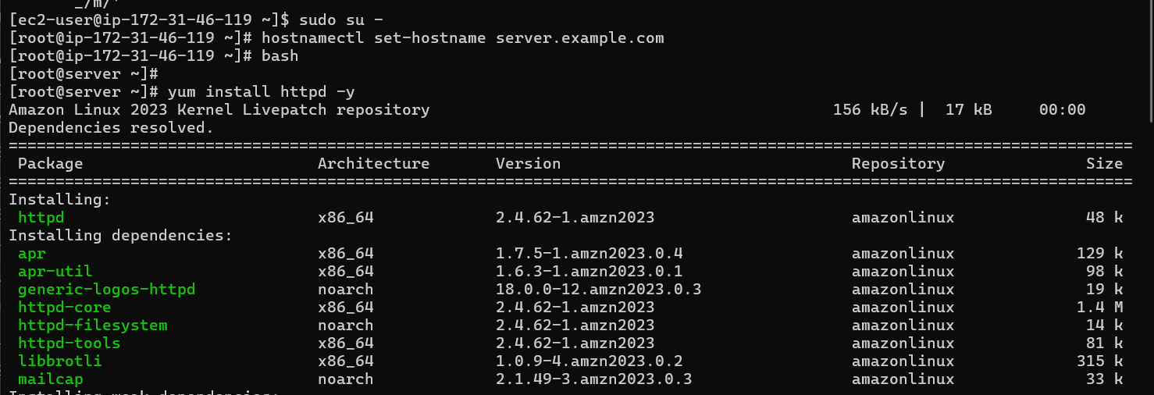
Httpd is installed .
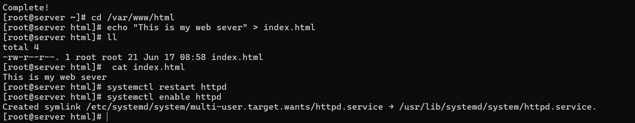
HTTPD is restarted and enabled.
Created a html file to host in server.
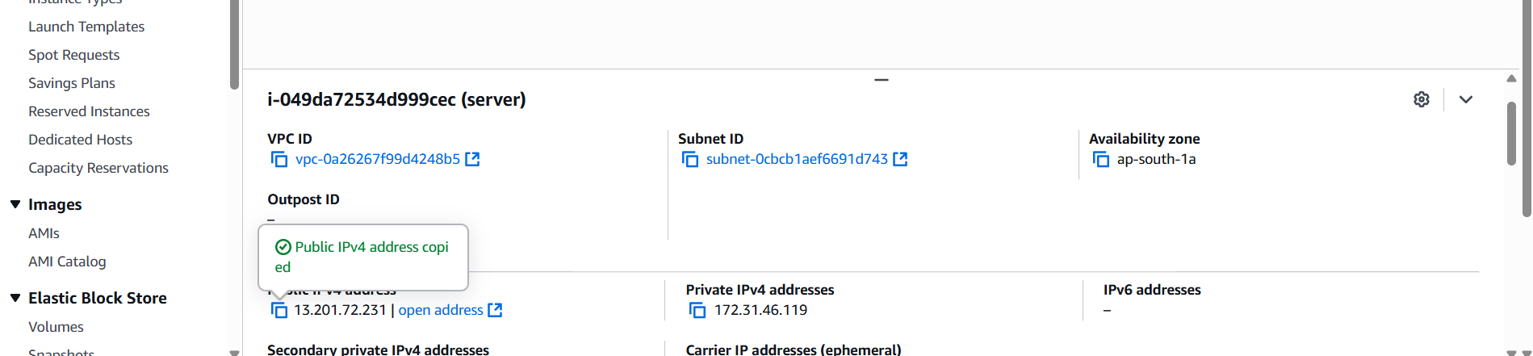
Copied the public ip.

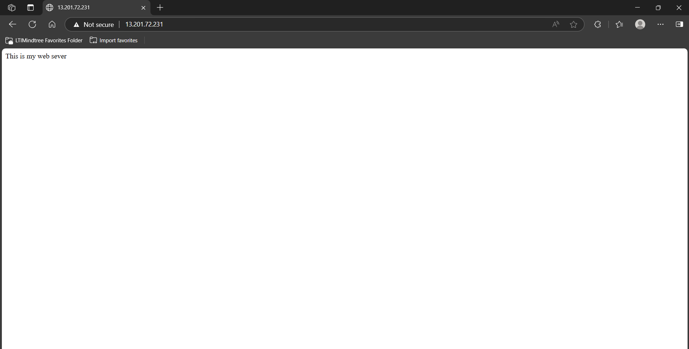
Web server is live now .
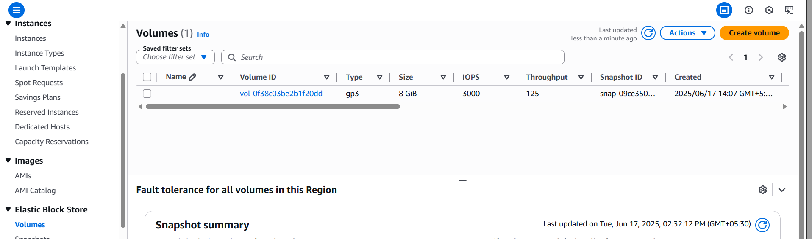
New EBS volume is created.
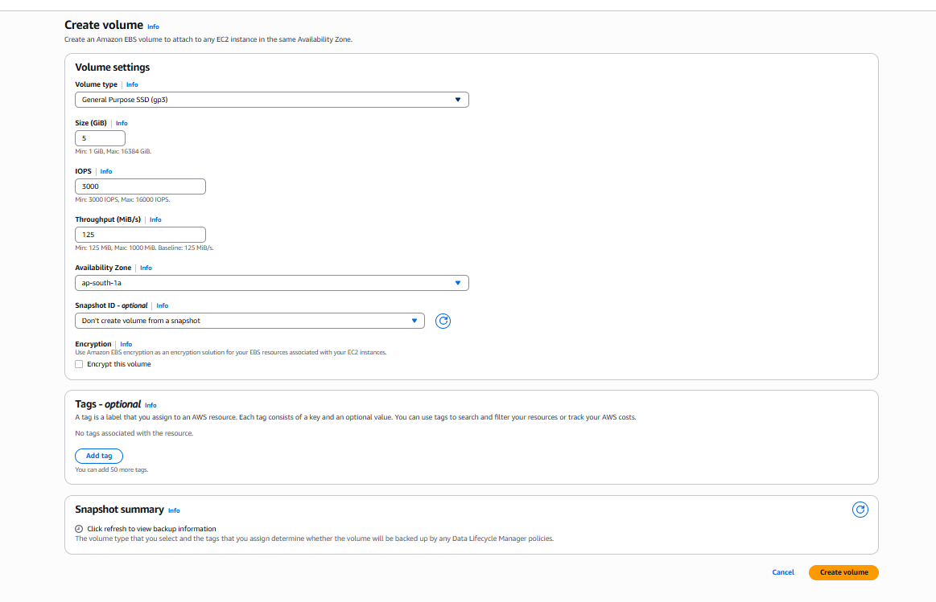
Volume setting is updated as 5gb .
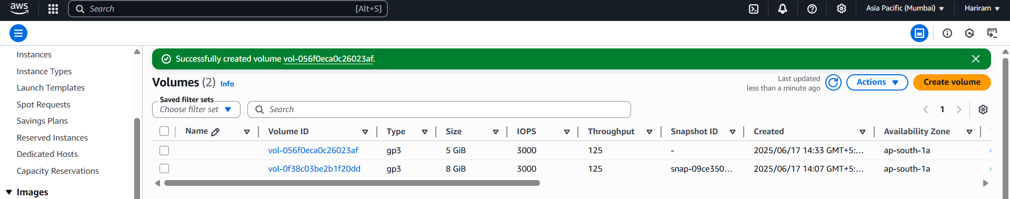
Volume is created successfully.
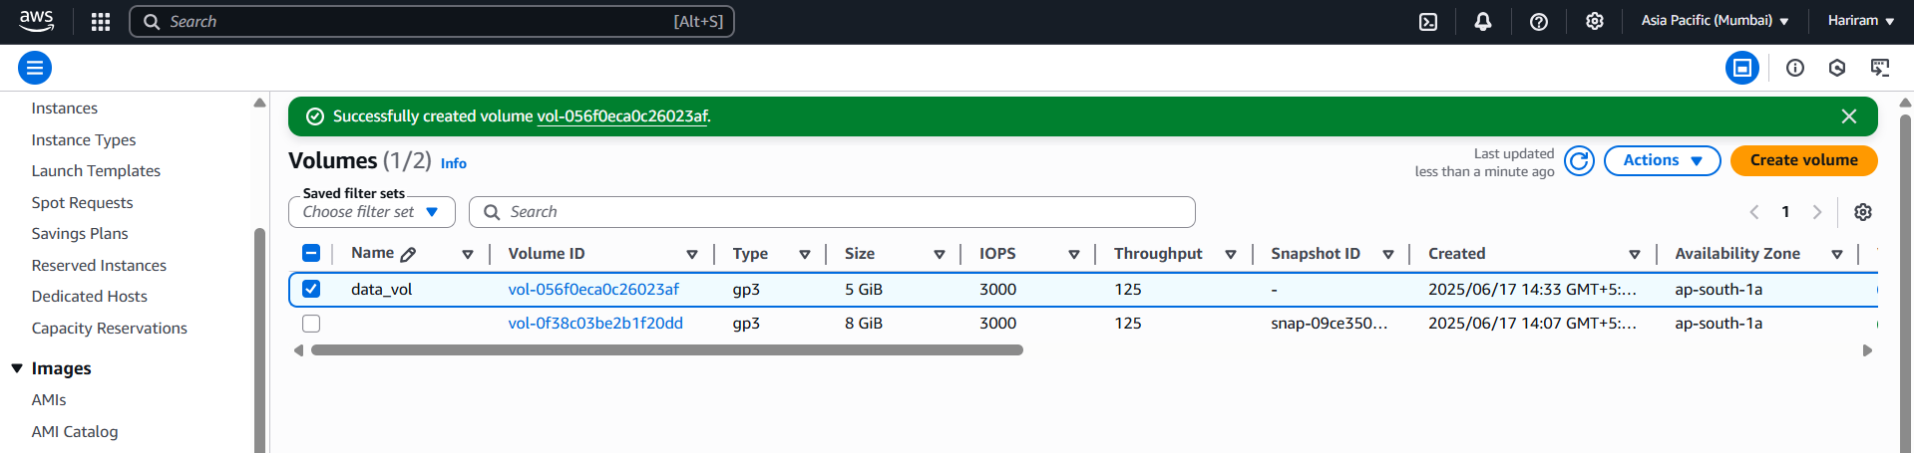

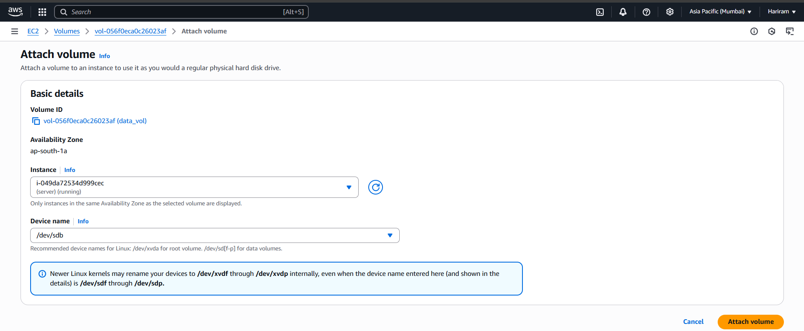
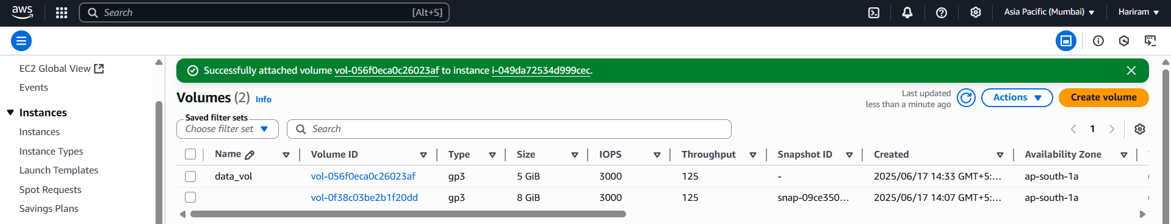
Volume is connected to the Instance successfully.
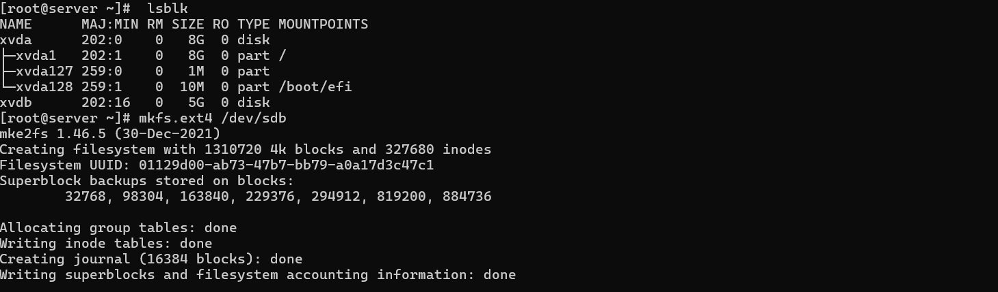
Volume is formatted and file system is created.
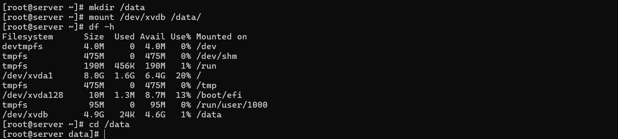
Data directory is created and mounted with the volume.
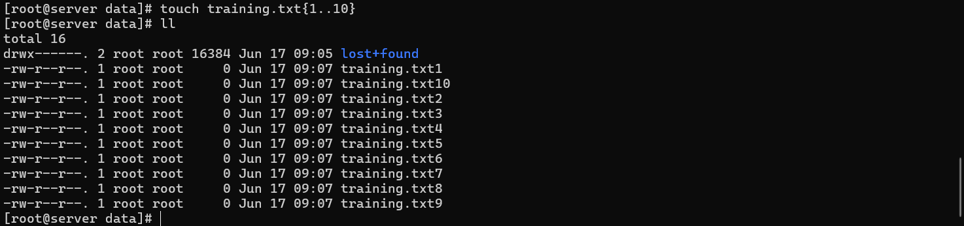
Text file is created inside the data volume.

2) We people are working on a common project in a same region. But my servers are in different zones. So, I want to share project information with everyone simultaneously. Configure efs storage it should be mount on every server.
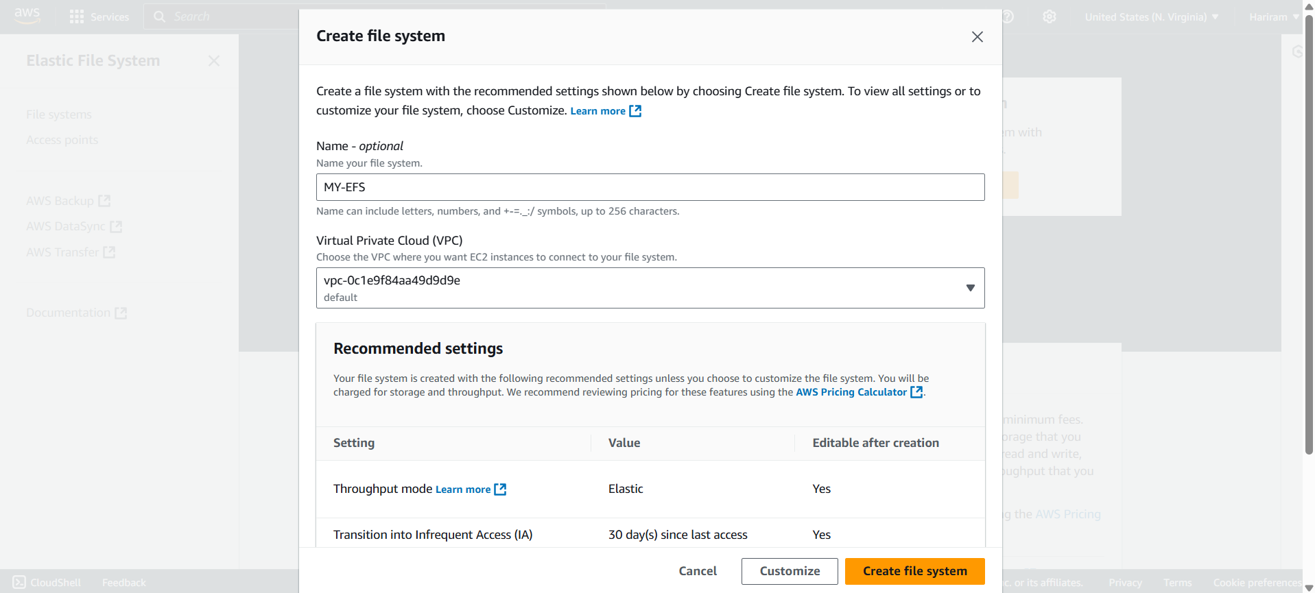
EFS file system is created.
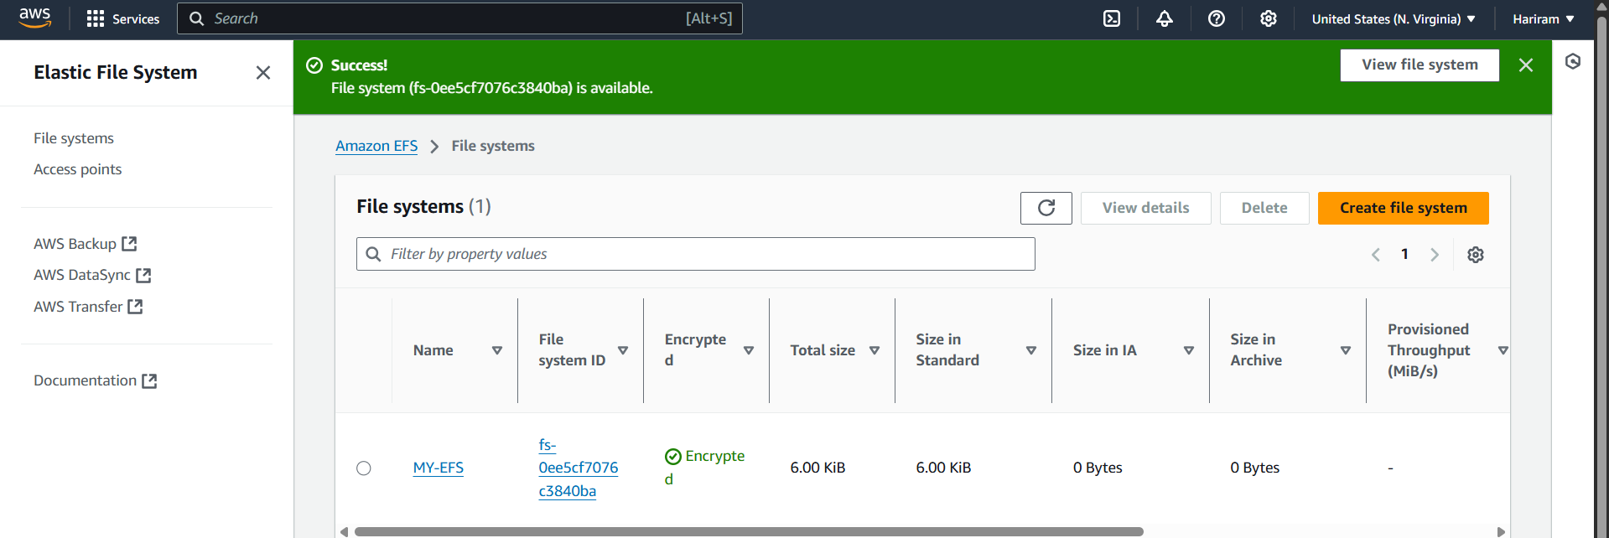
Successfully EFS is created.
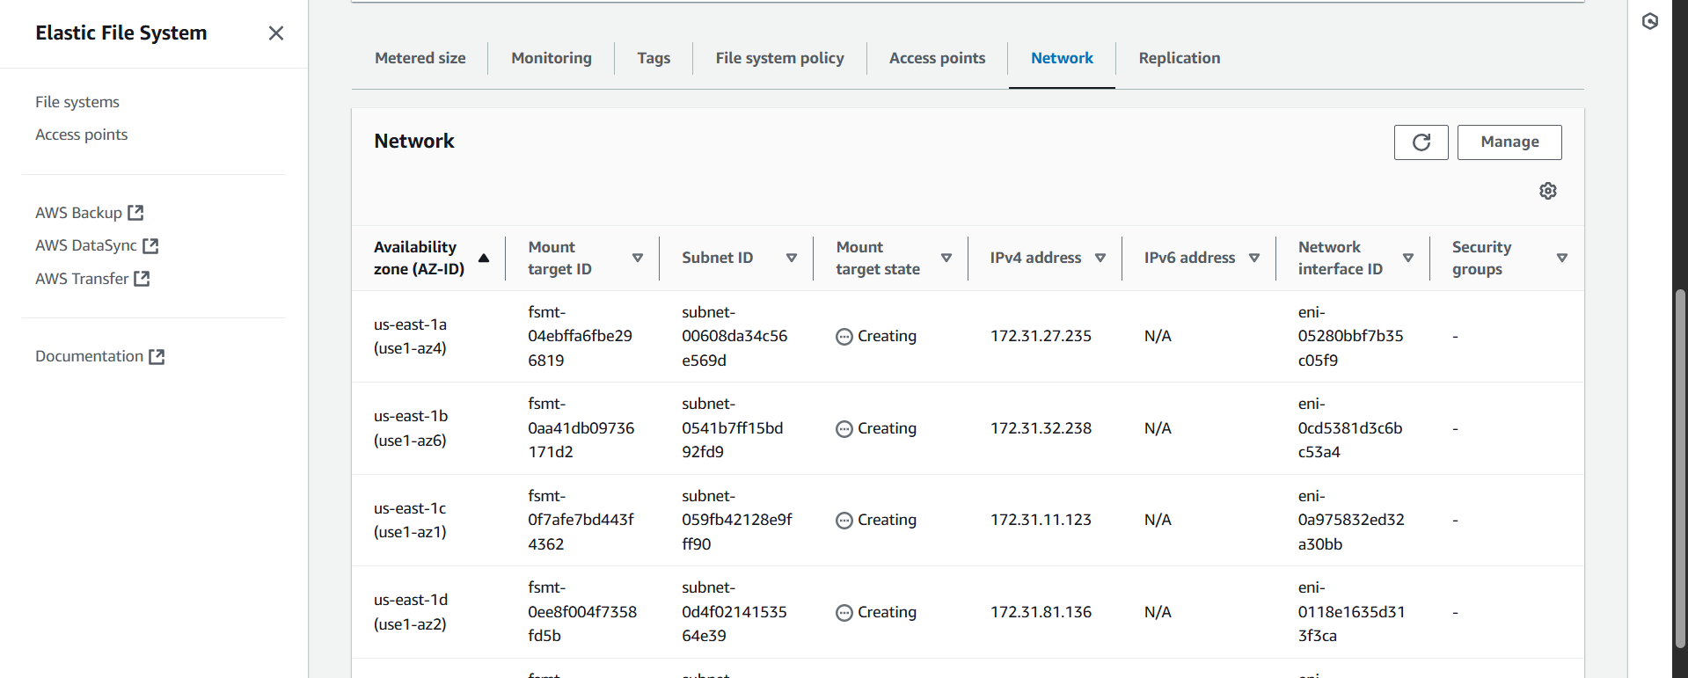
Waiting for EFS to create file system in every zone.

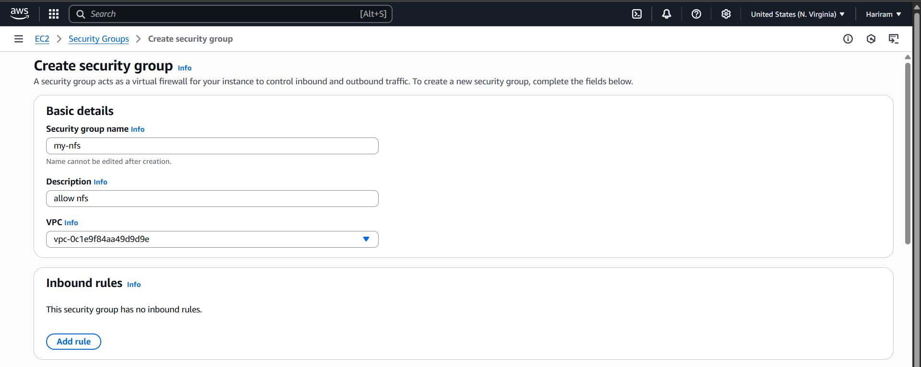
New security group is created as my-nfs.
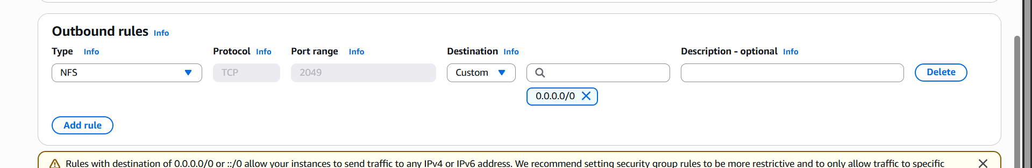
Outbound rules is updated with NFS.
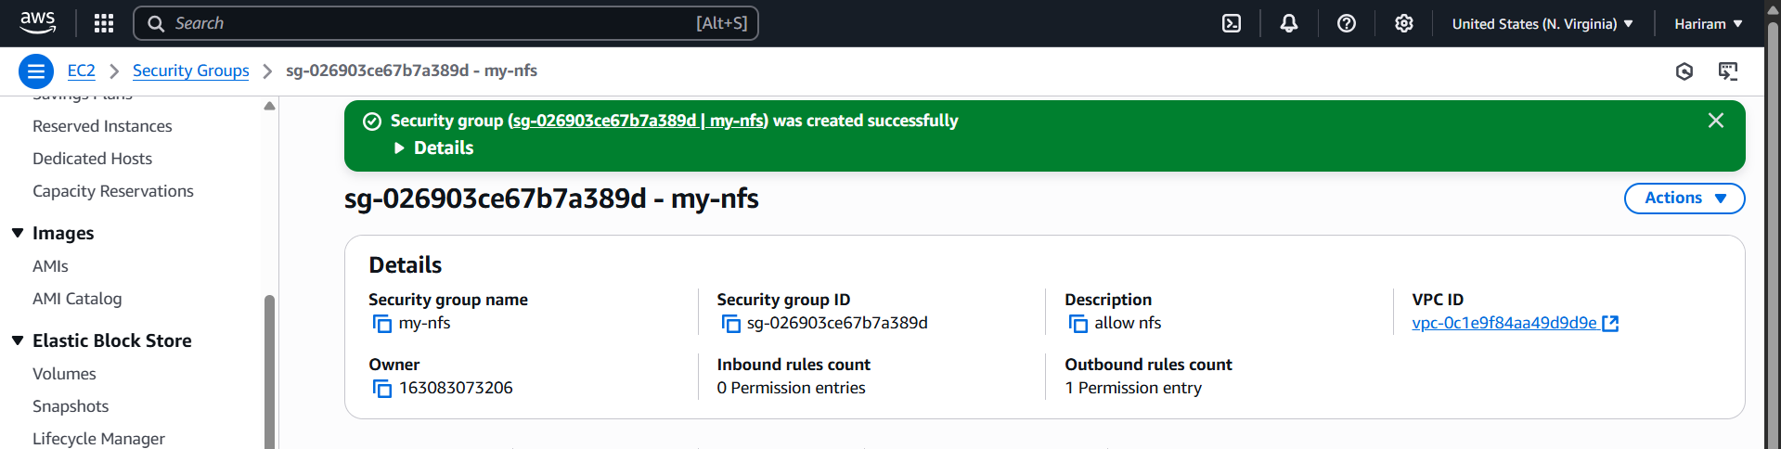
Security group created successfully.
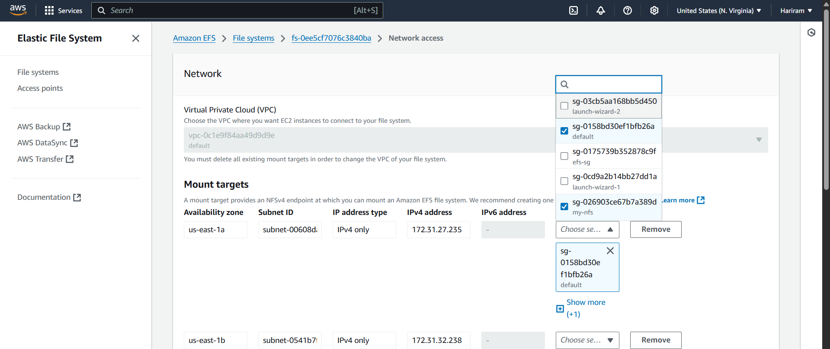
Security group is add to every zone .

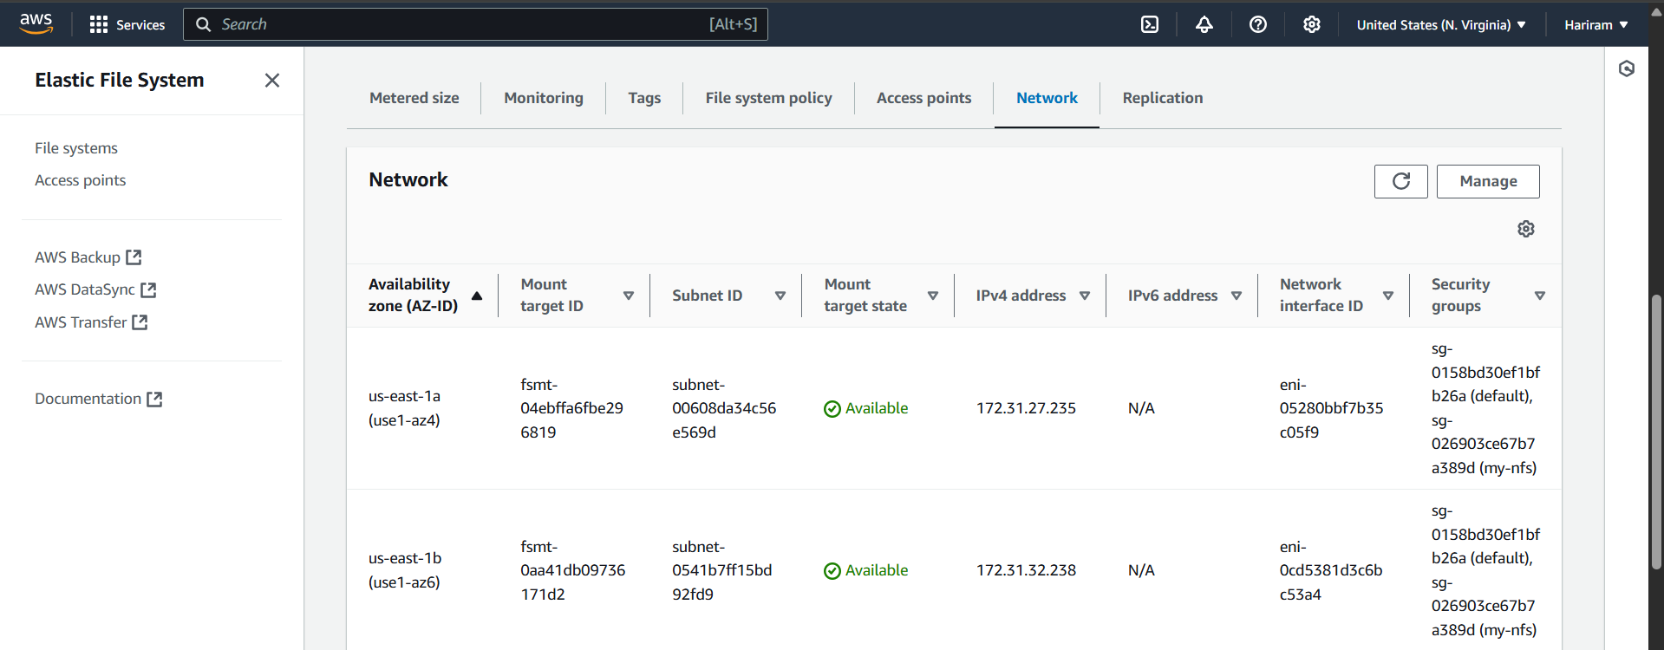

EFS is successfully created to share project information with everyone simultaneously.
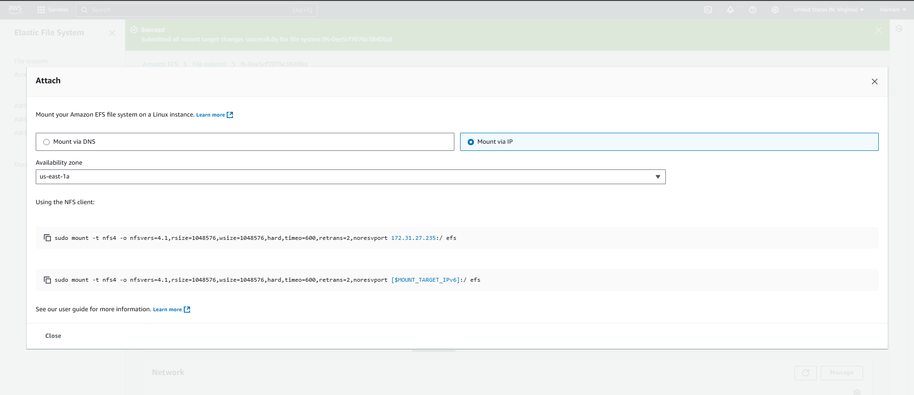
Using this EFS can be attached.

3) Create a Custom VPC. Where you need to create two subnets like Private subnet and Public subnet.in the public subnet. I want to host my web server. Where my website is running and Private subnet my database is running. Data base should not be reachable publically.
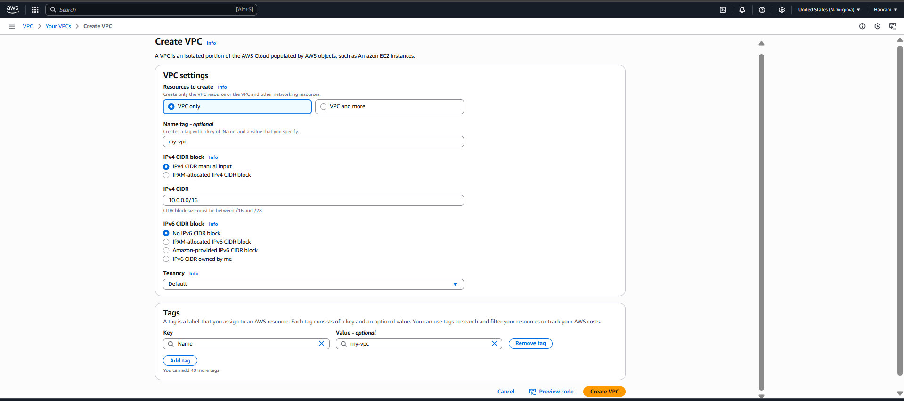
VPC is created with necessary settings. CIDR as 10.0.0.0.16
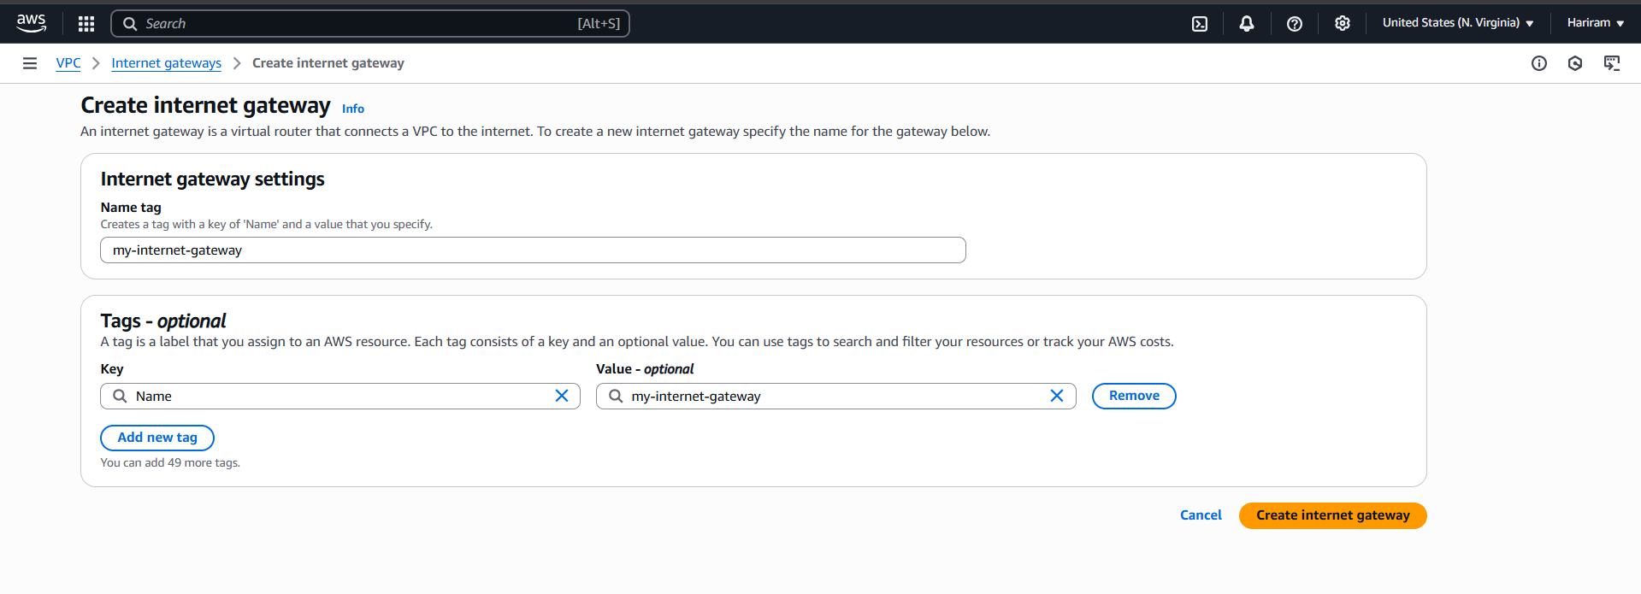
Internet gateway is created .
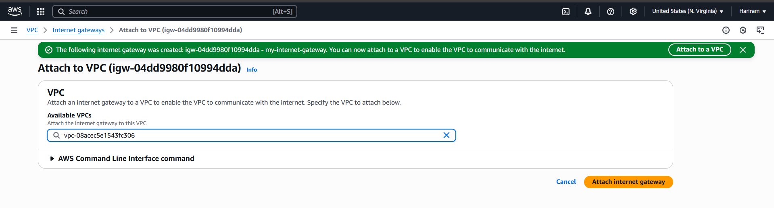
Internet gateway is attached with the VPC.
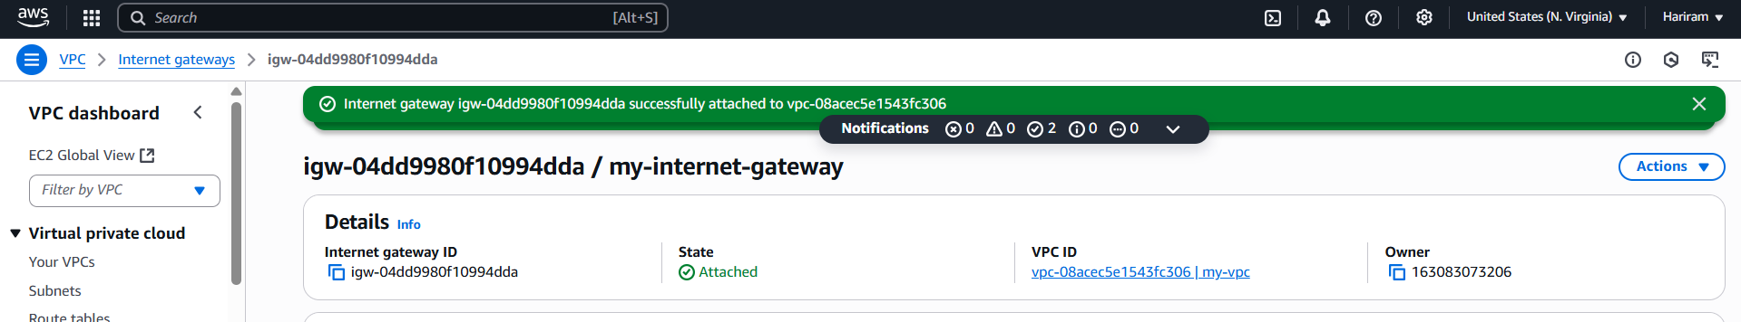
Successfully attached.
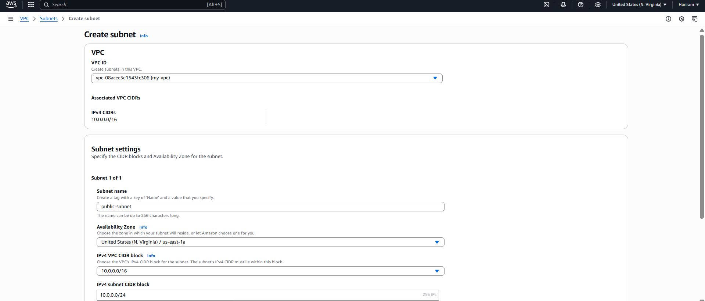
Public subnet is created with necessary settings. For public subnet CIDR : 10.0.0.0/24
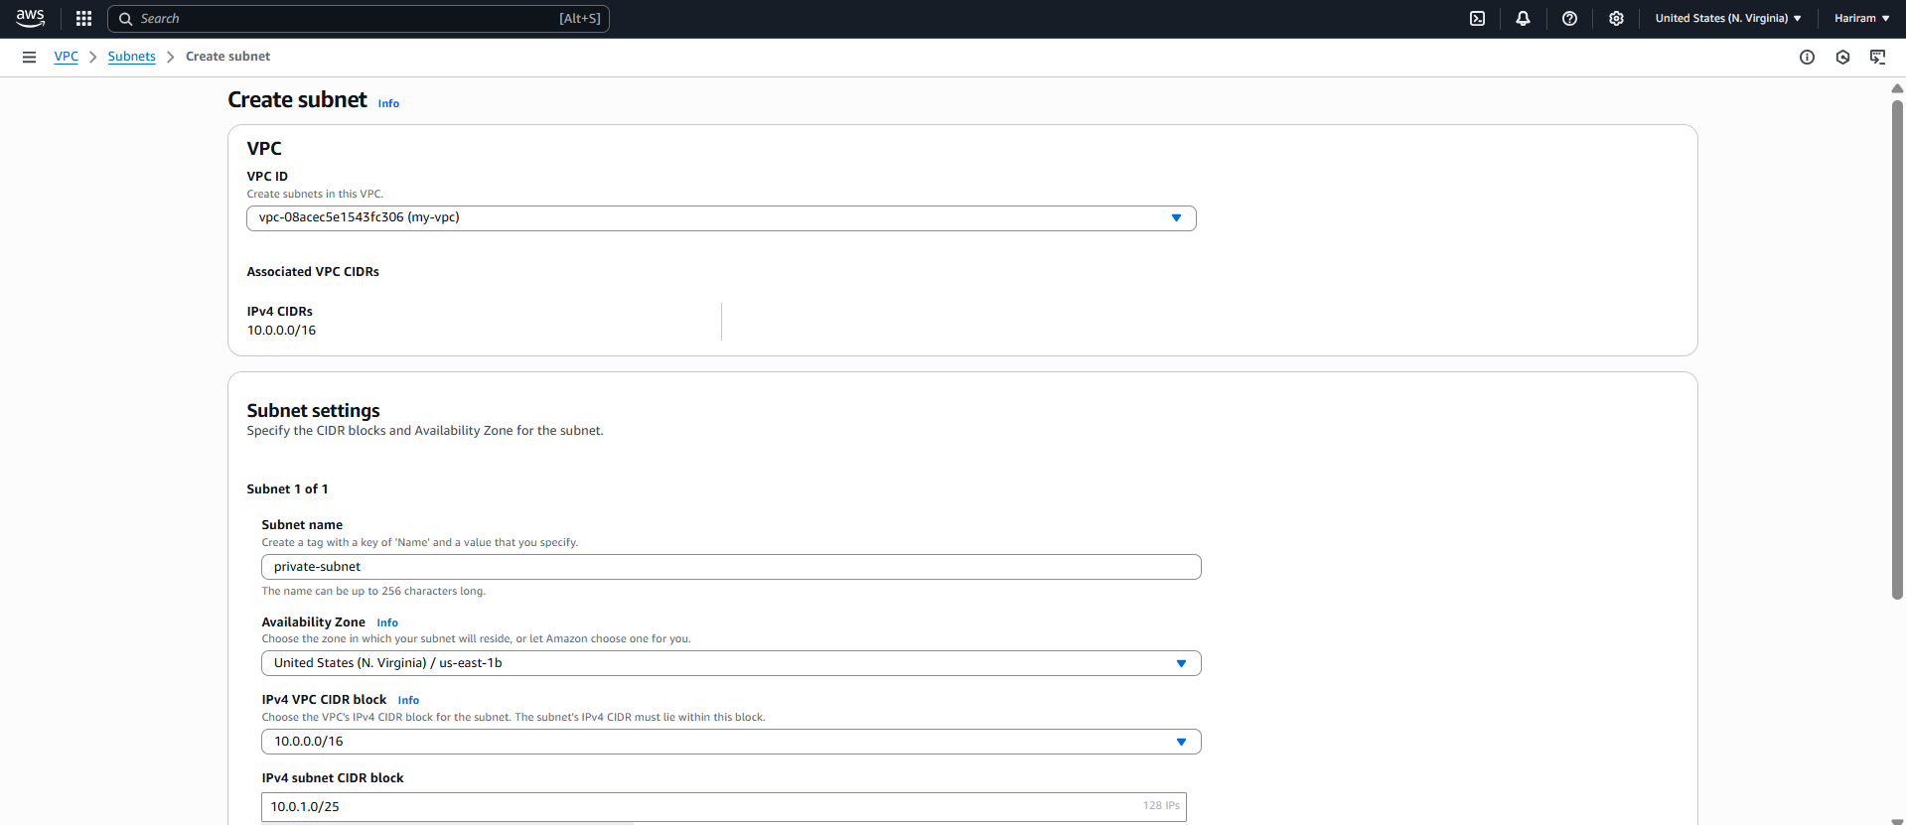
Private subnet is created with necessary settings. For private subnet CIDR : 10.0.1.0/25
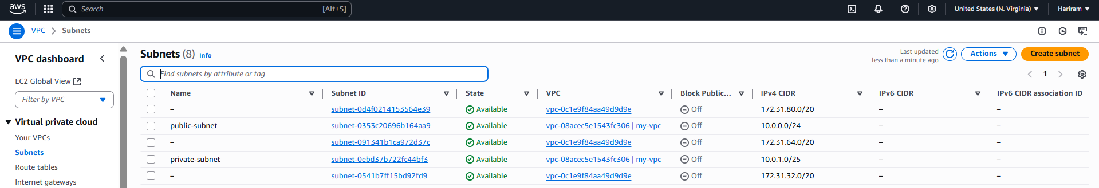
Public and private subnet are created successfully.
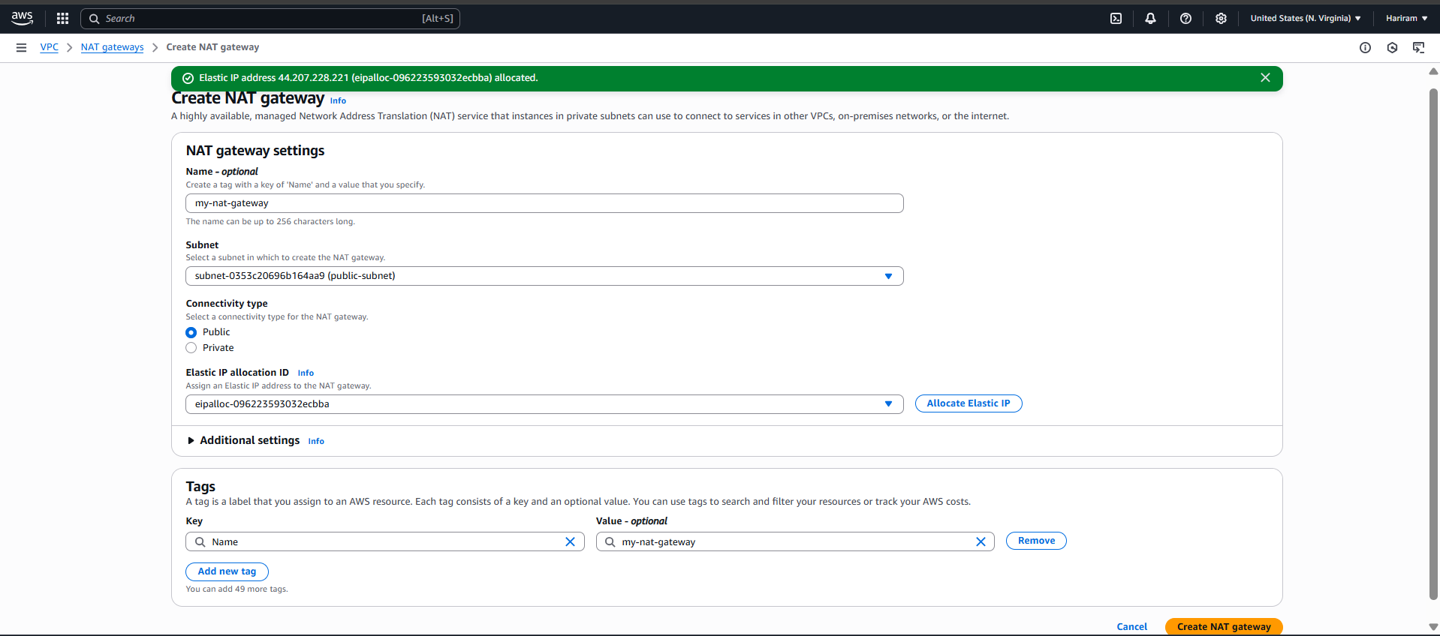
NAT gateway is created .
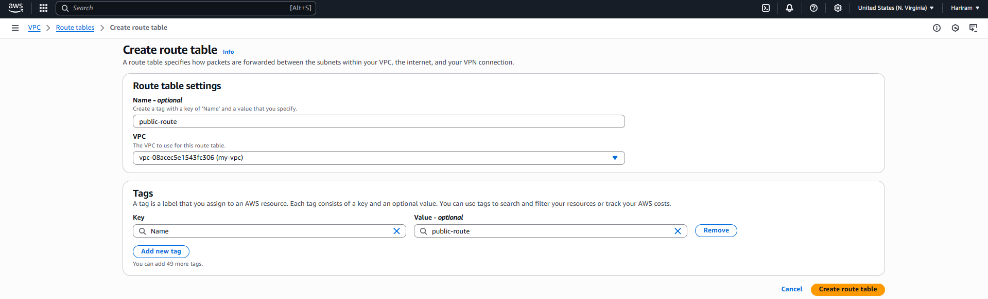
Public route table is created.
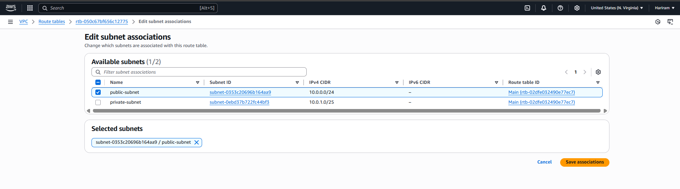
Public association is added.
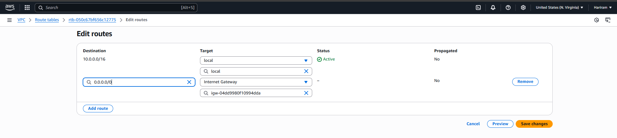
Internet gateway is added.
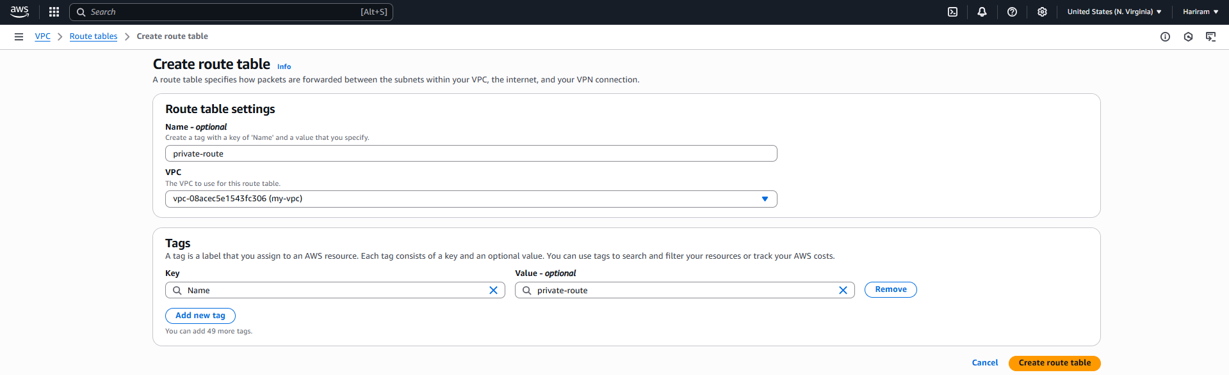
Private route table is created.
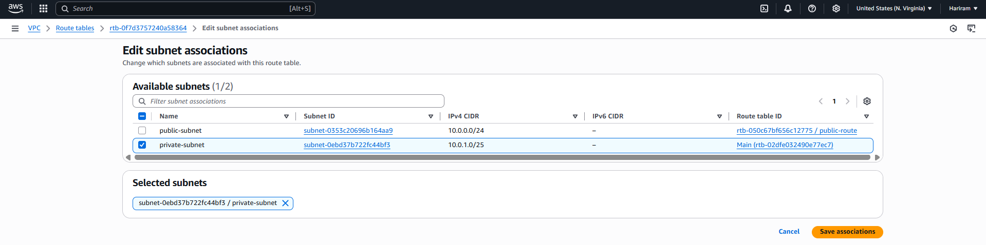

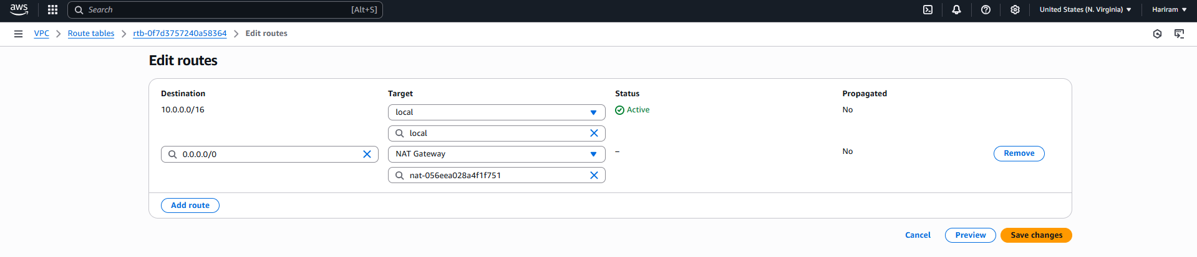
NAT gate way is added to private.
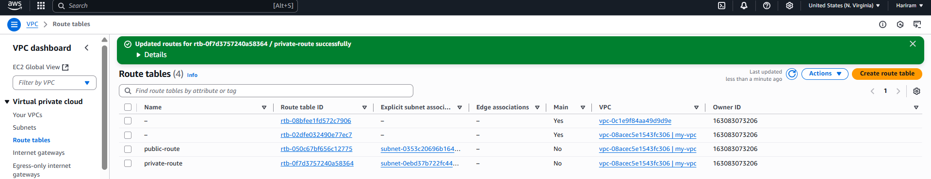
Both public and private route table are added.
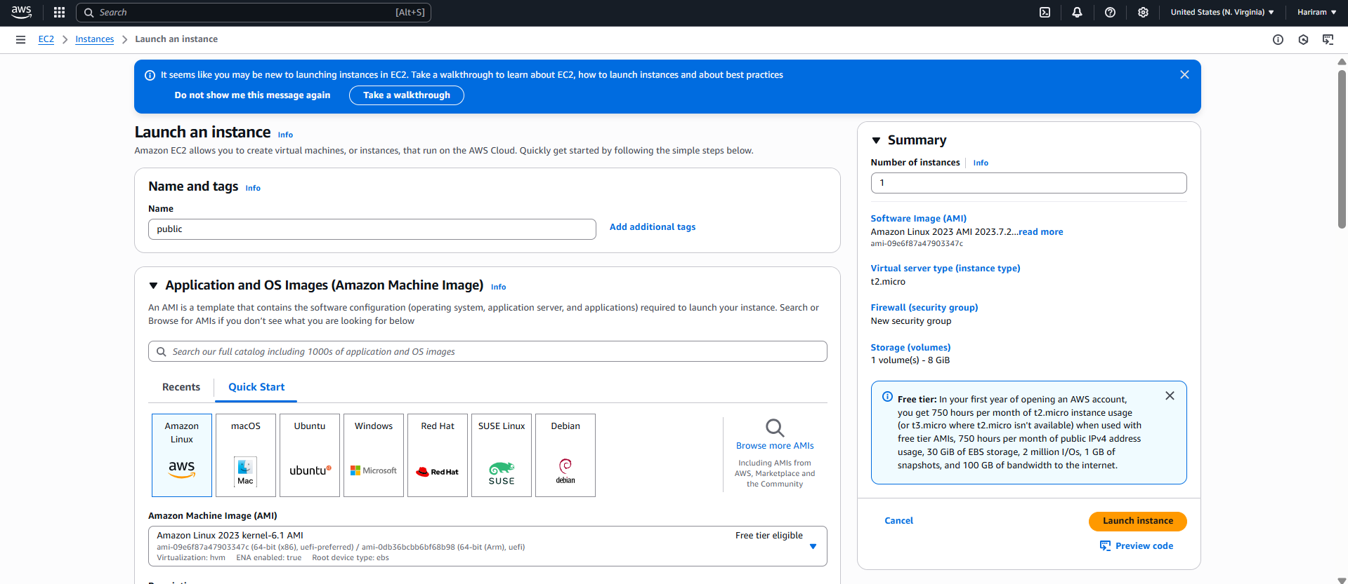
Public instance is created.
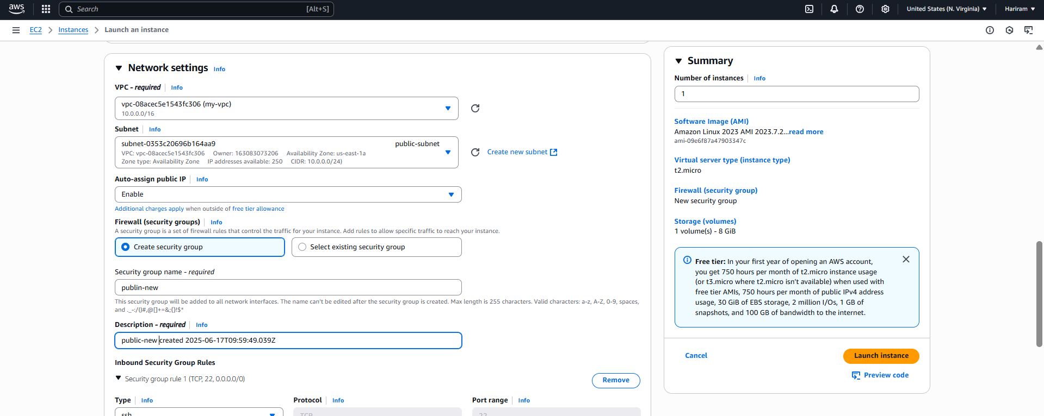
Necessary Network setting is updated.
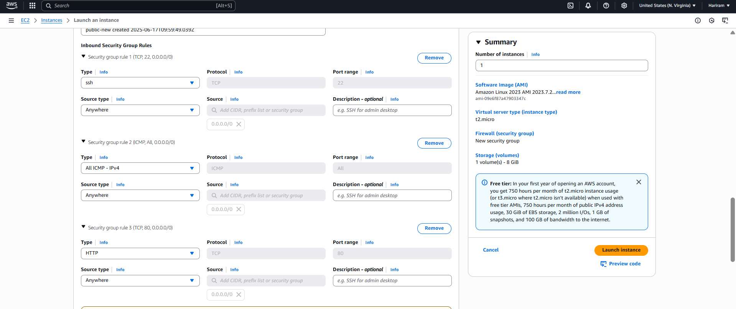
Necessary ports are added in security group.
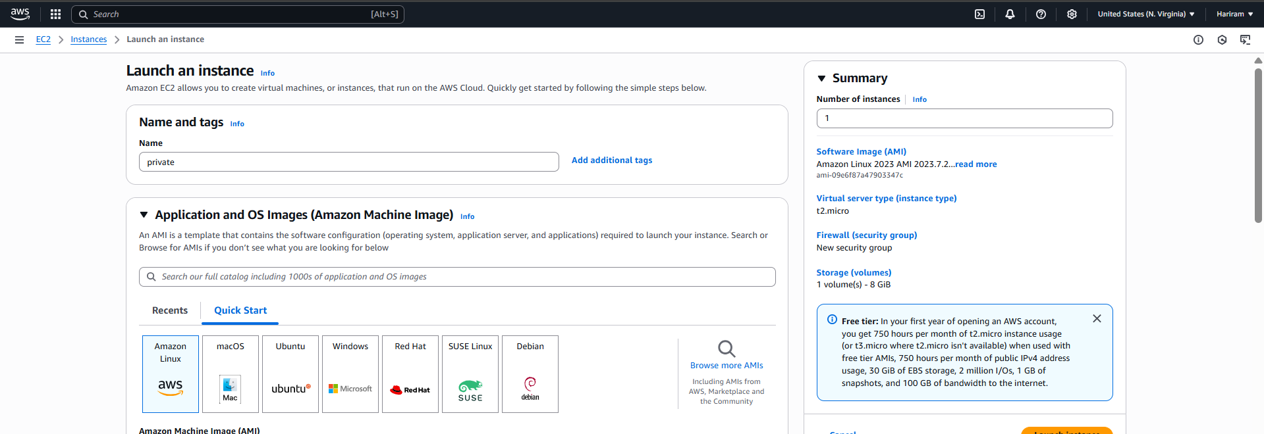
Private instance is created.
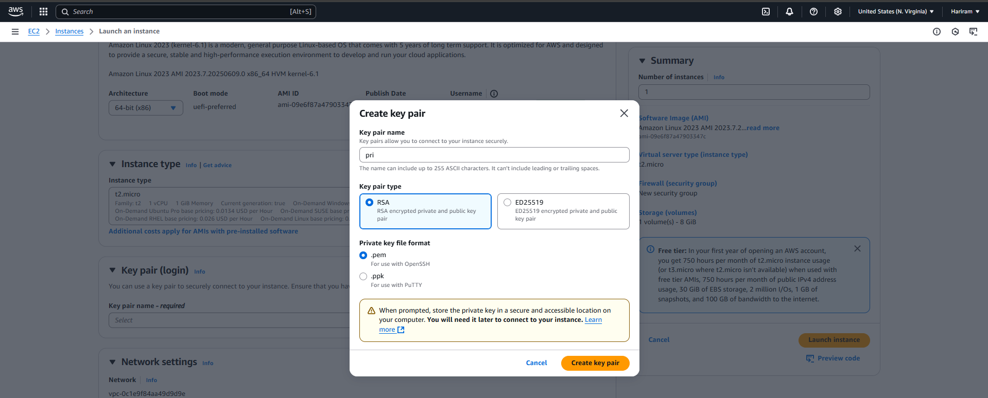
New key is created for private.
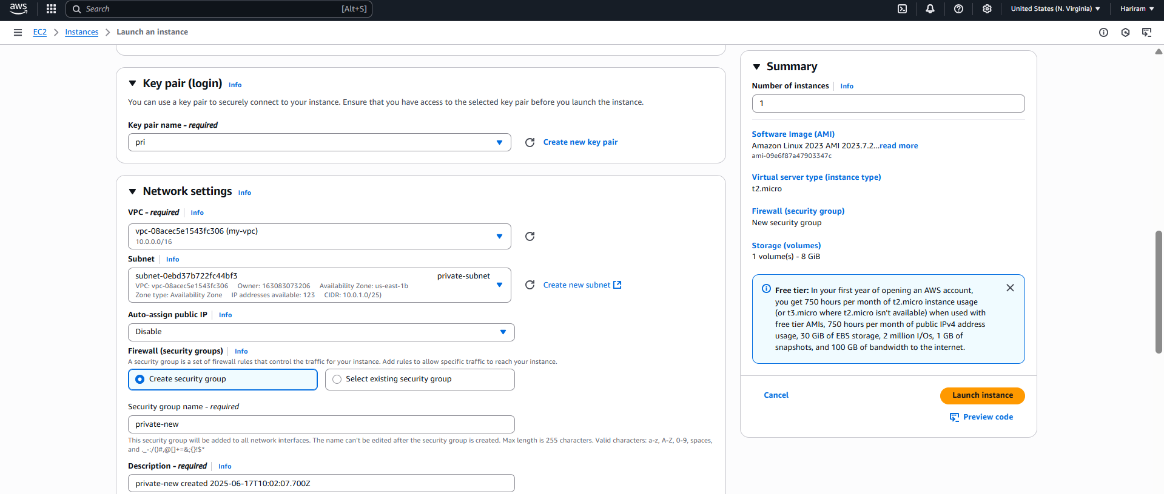
Security is created.
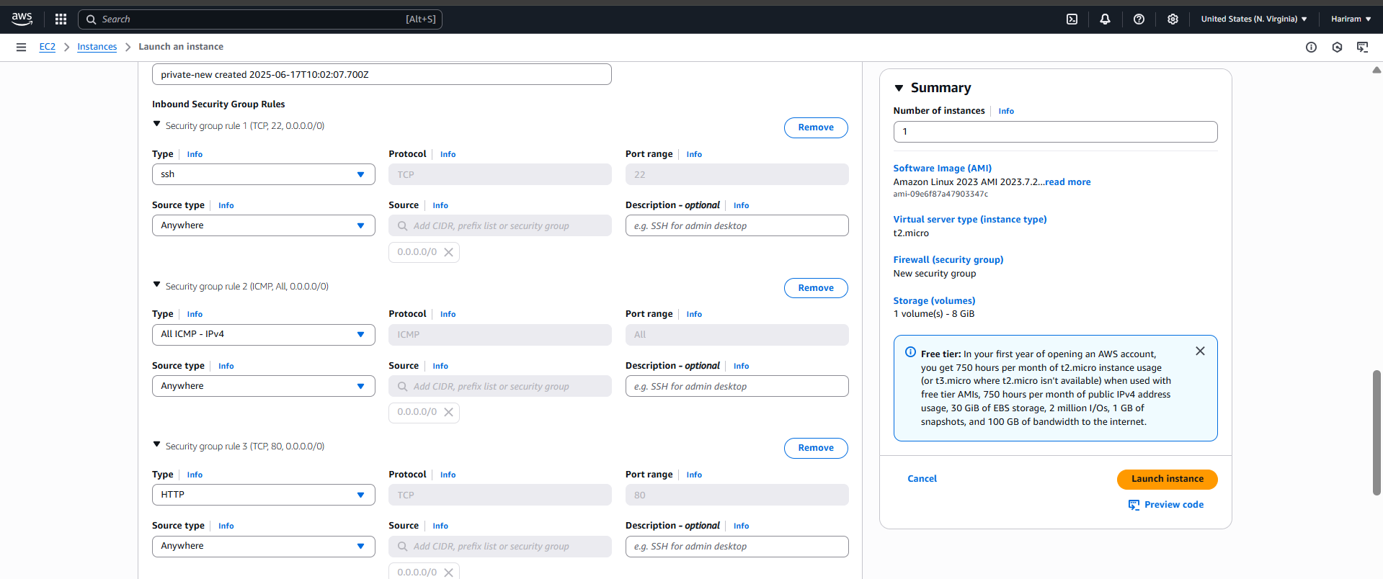
Necessary ports are added.
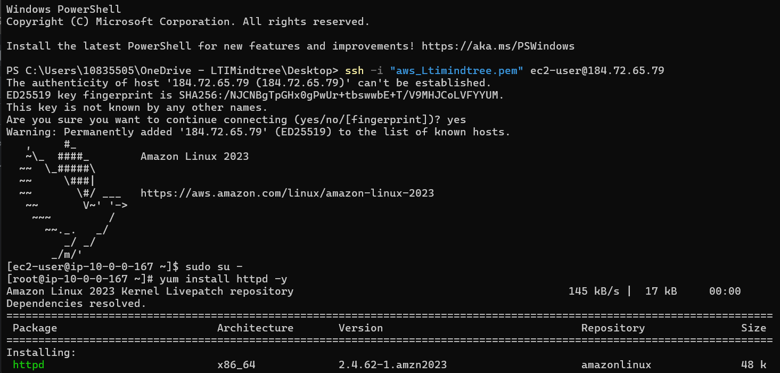
Httpd is installed.
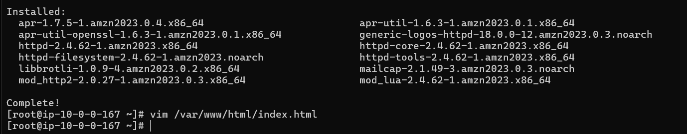
Directed to var/www/html .
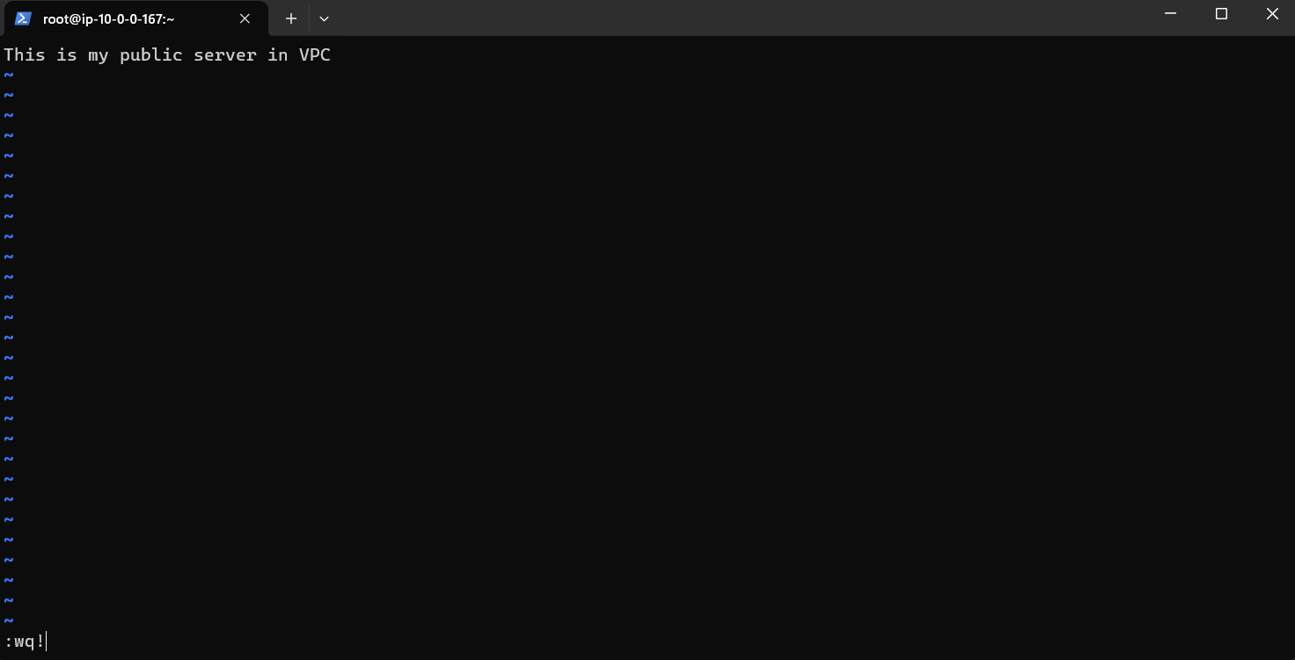
Index.html file is edited
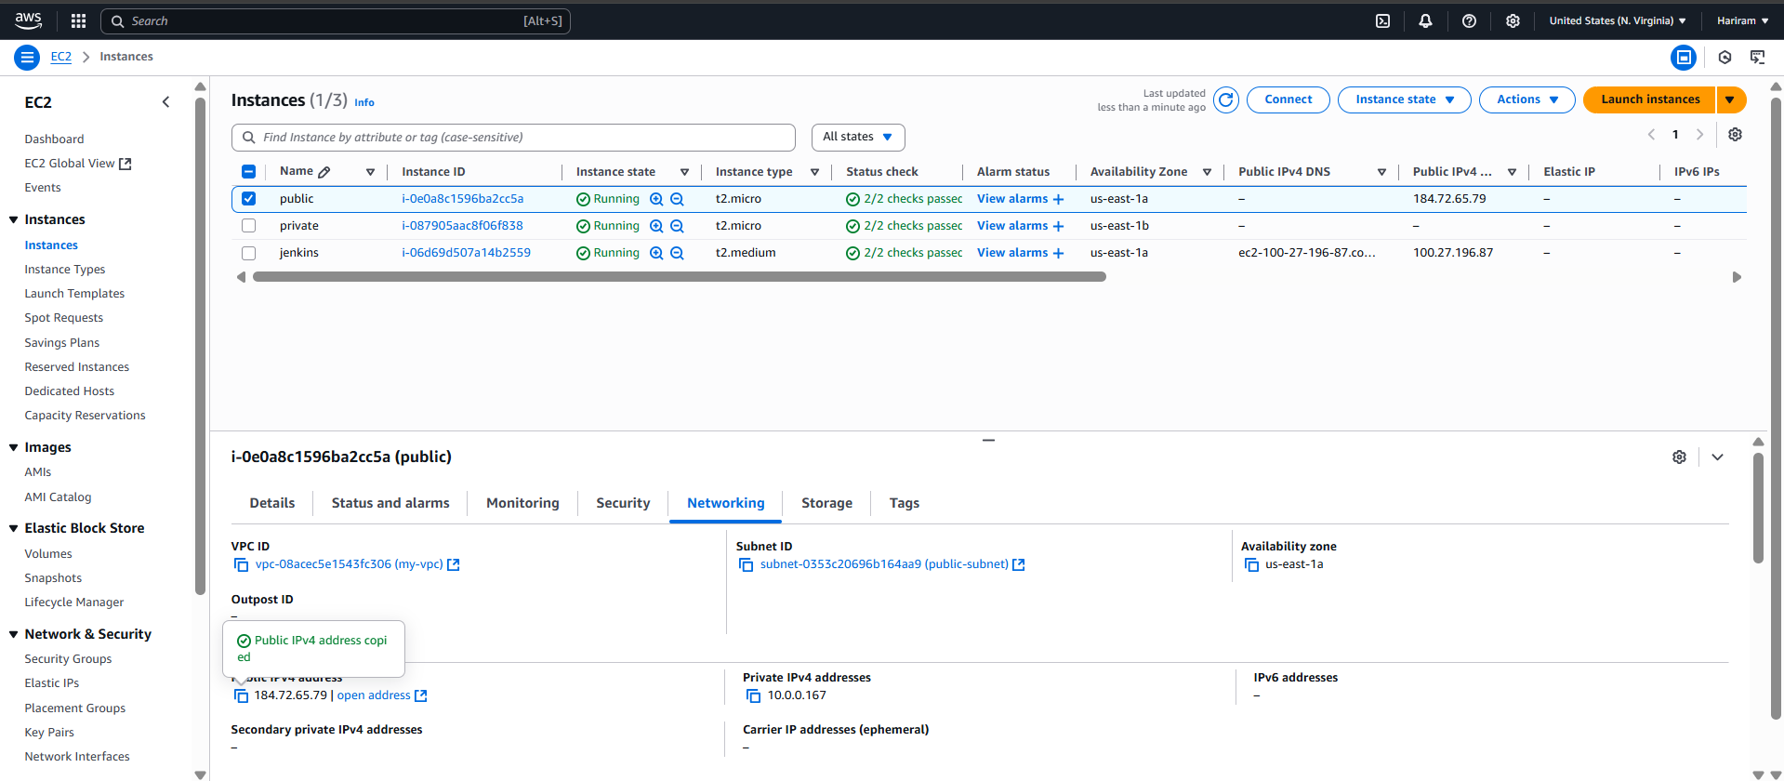
Public ip is copied.
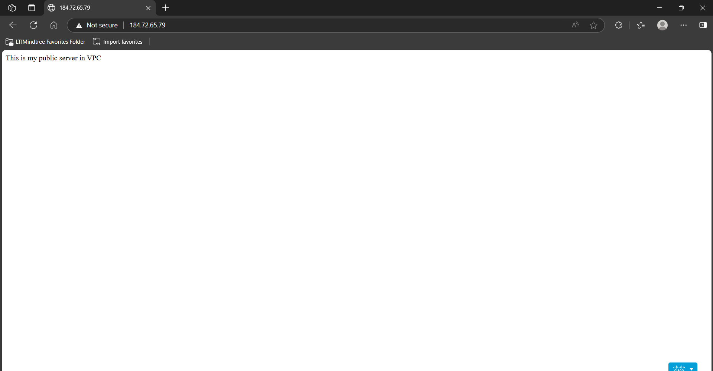
Web server is live.

Private key is add inside the public instance to give internet access to private instance through NAT gateway.
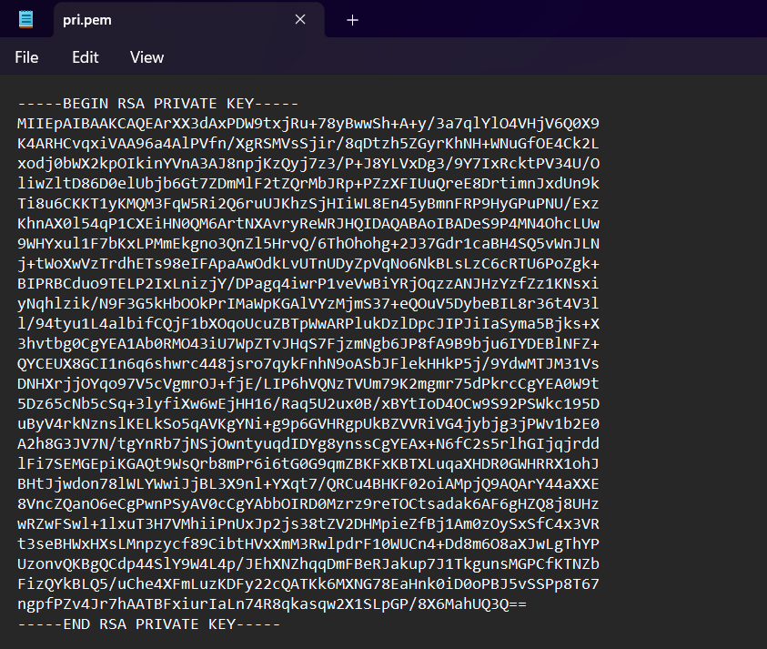
This is the private key.
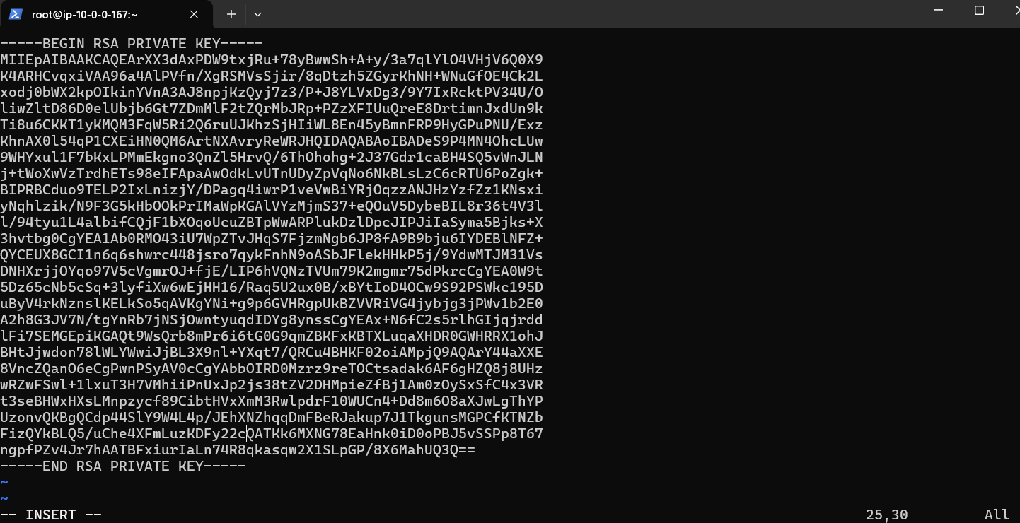
Pasted the key.
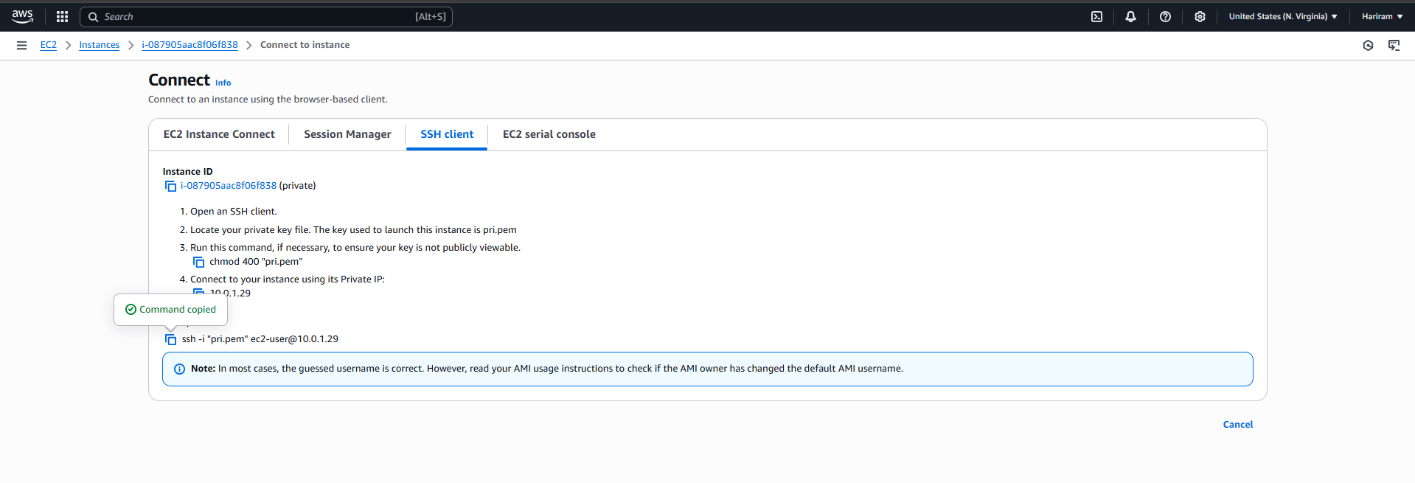
Run the private instance is Public Instance to provide internet access.
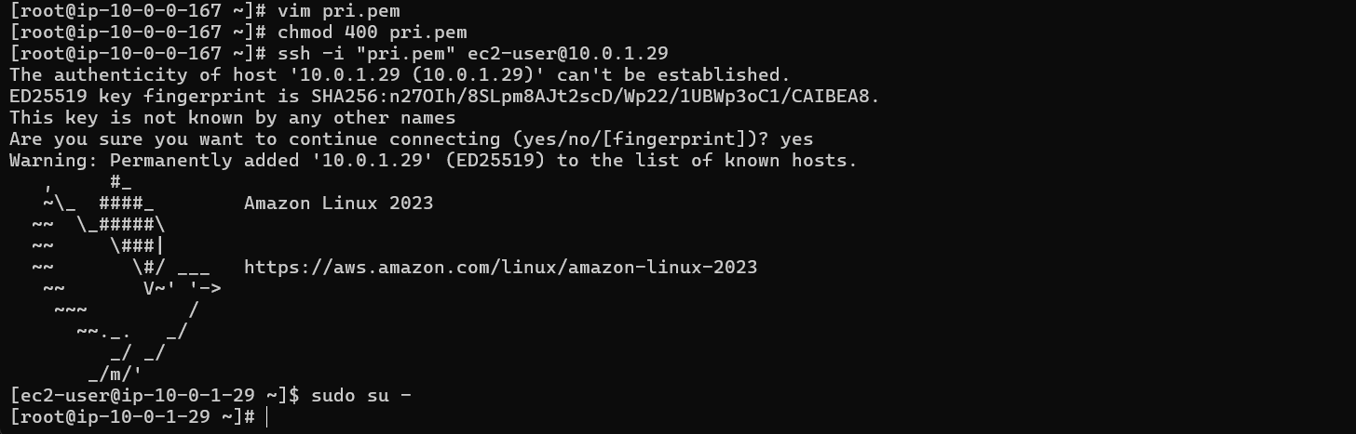

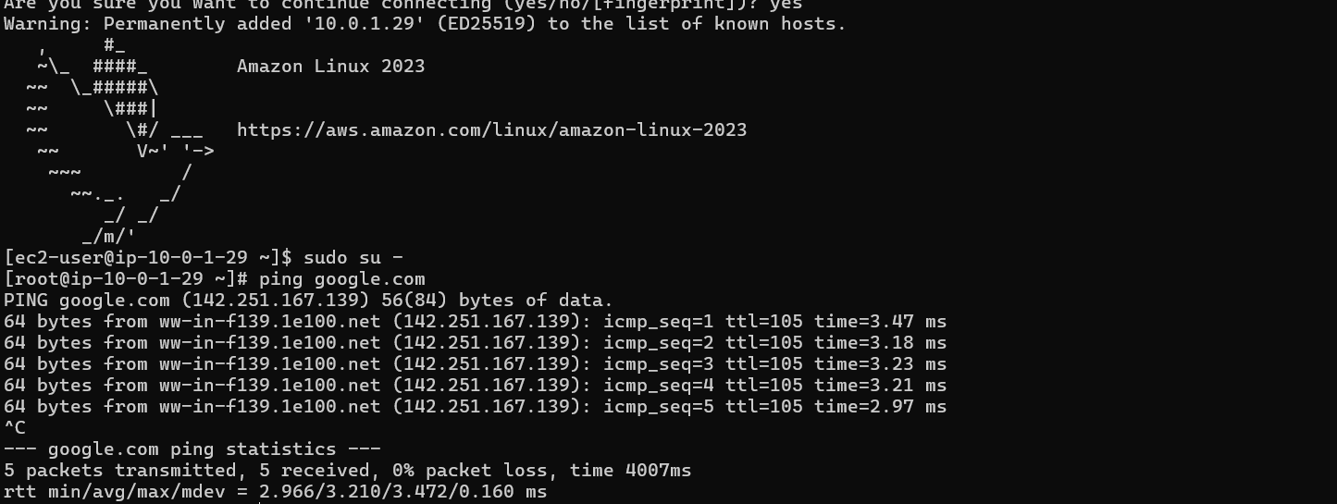
Internet access is provided.

Hence data is private instance Data base will not be reachable publically. But public Web page will be accessible to public.

4) Install and configure Jenkins on Linux server and create a webhook with GitHub repository. Then build a Java base application using build tool maven. Save out put into pipeline
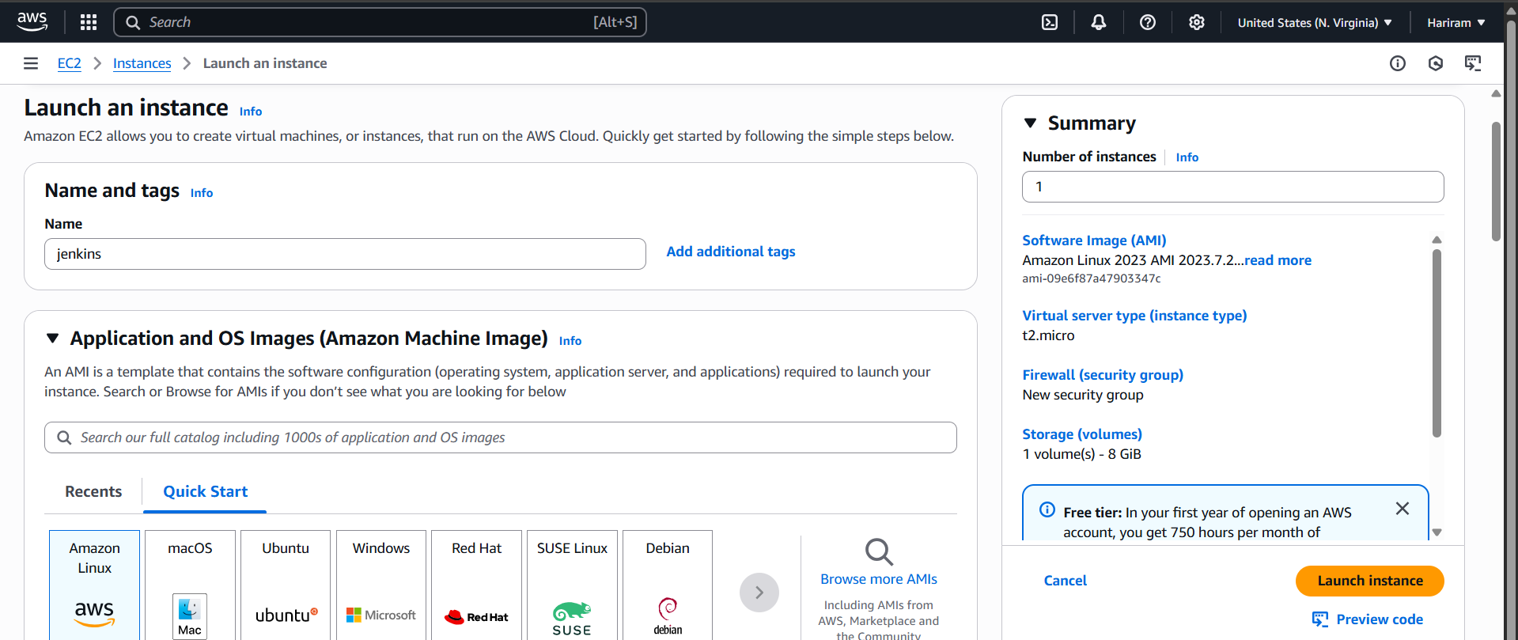
Jenkins instance is created.
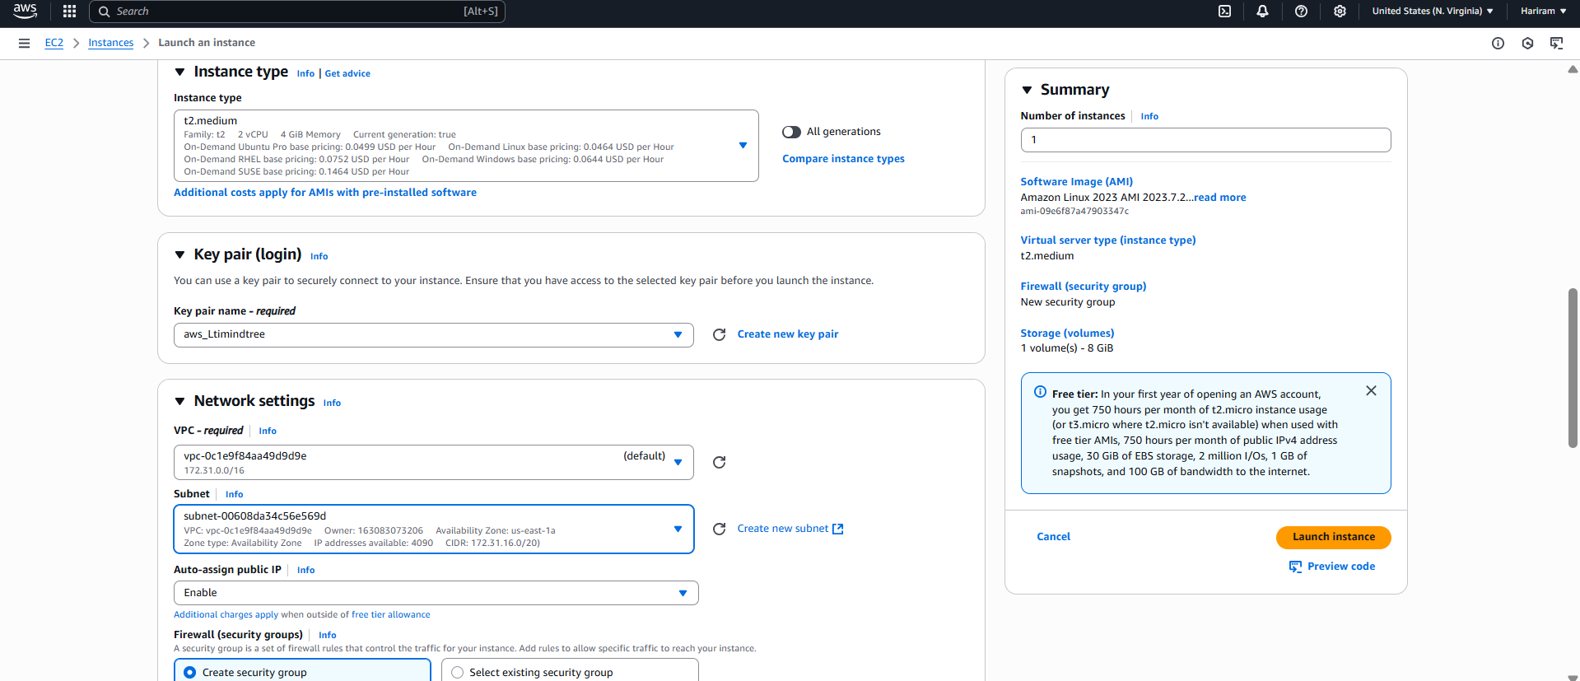
T2.medium is selected .
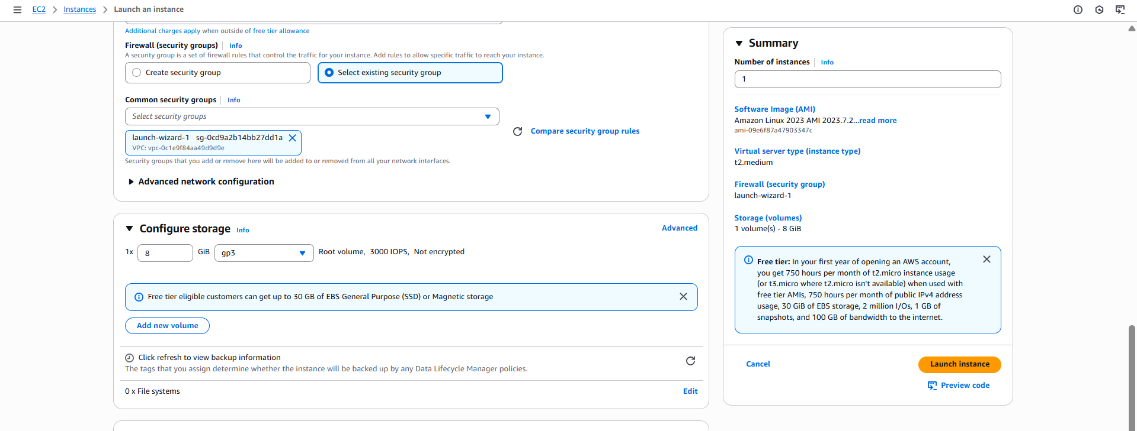
Existing security group is selected.
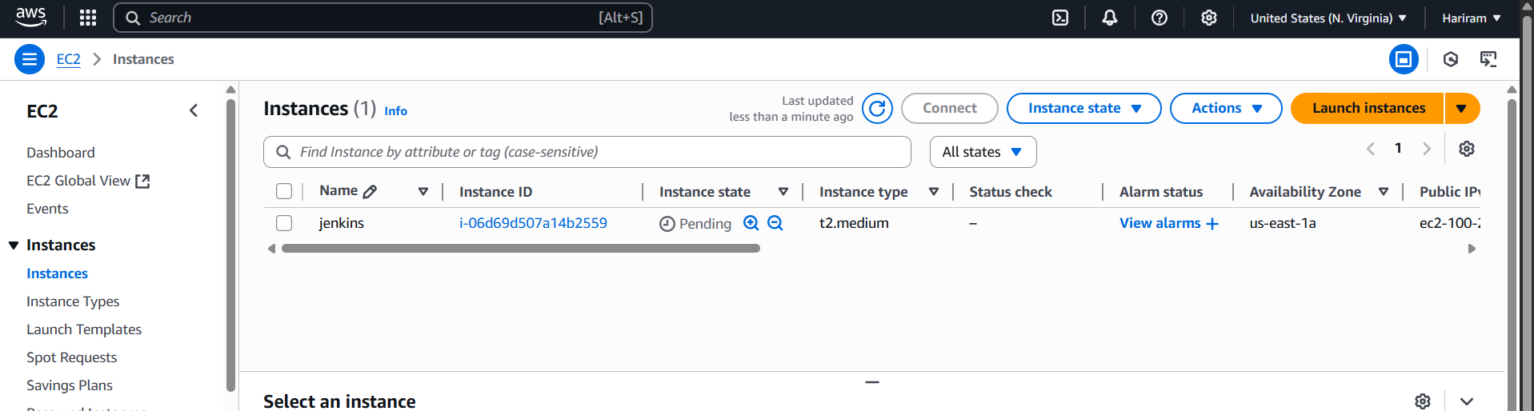
Jenkisn EC2 created.
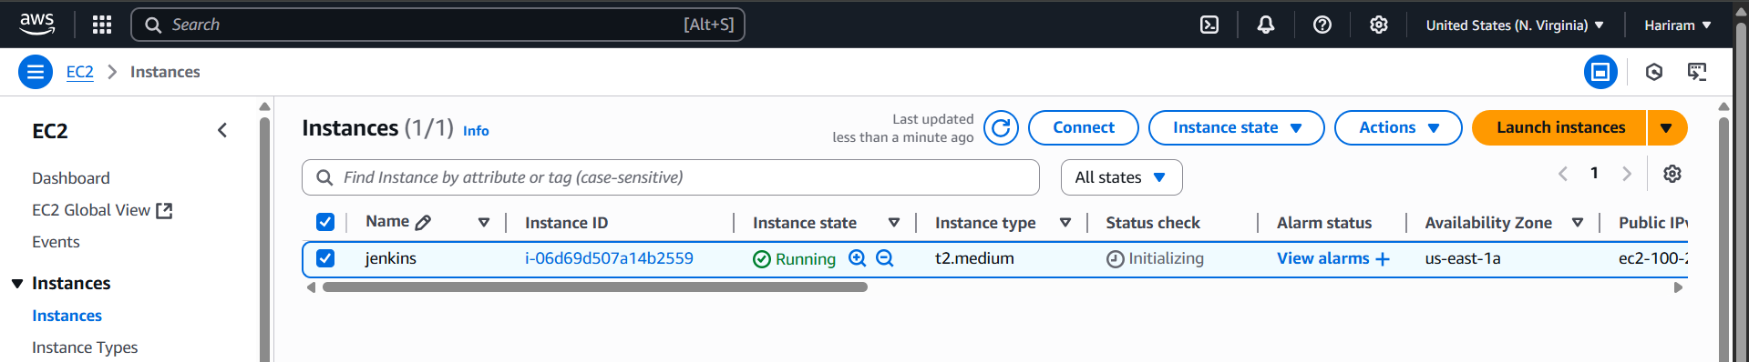
Jenkins Instance is running successfully.
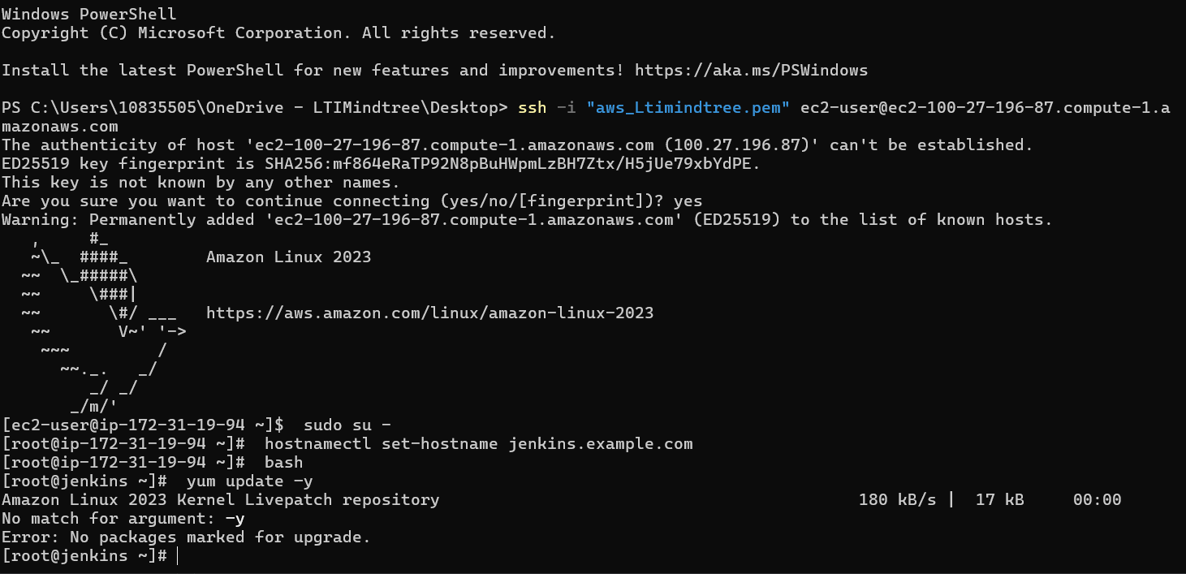
Yum update is done.
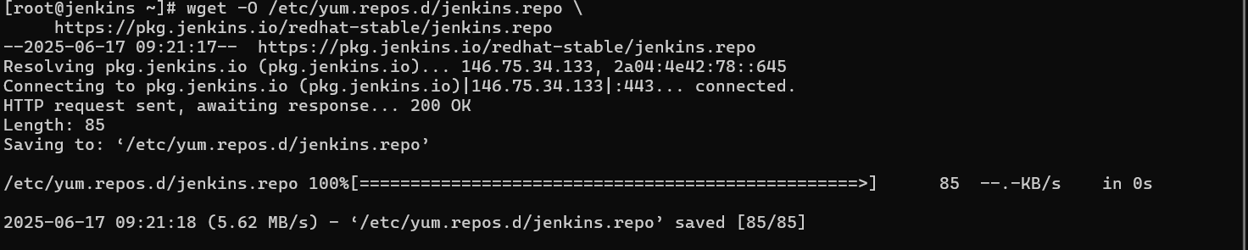
Necessary things to run Jenkins are installed.
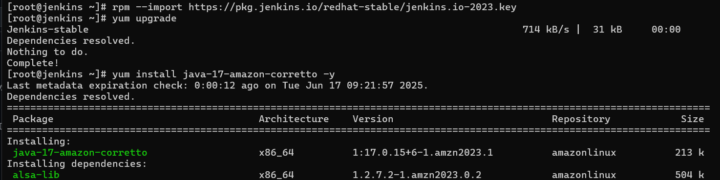

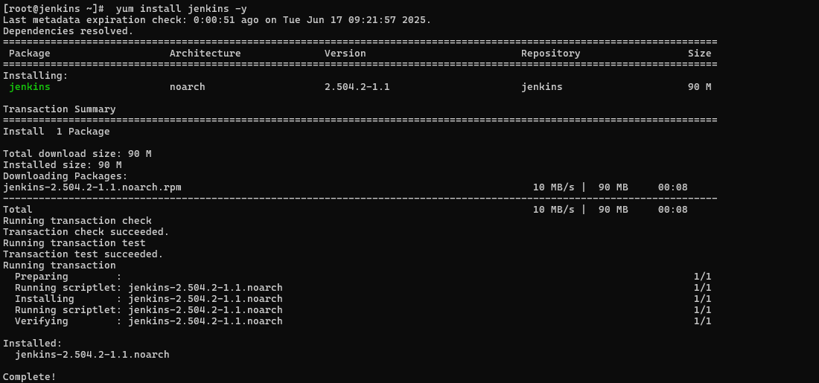
Jenkis is installed
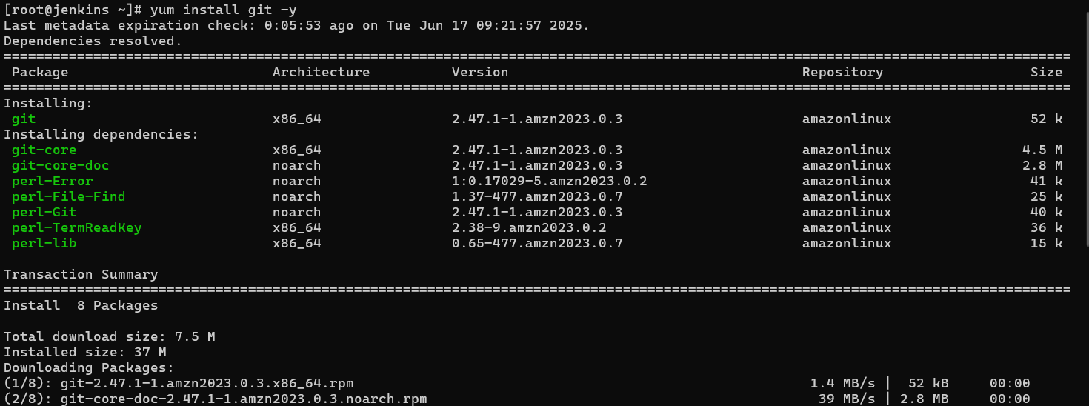
Git is installed.
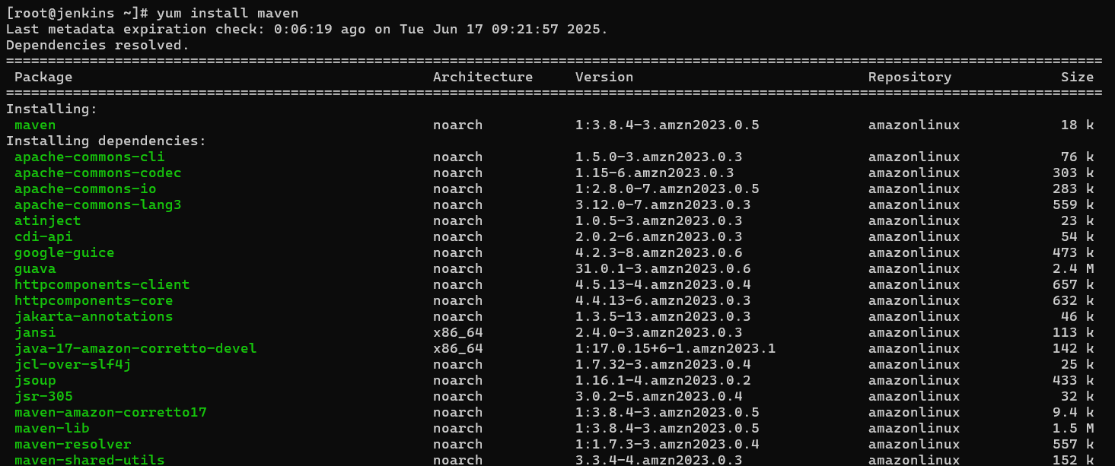
Maven is installed.
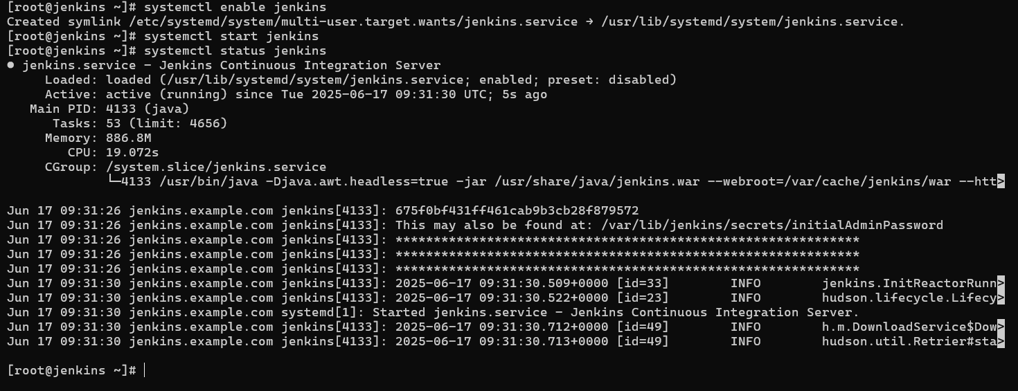
Jenkins is started.
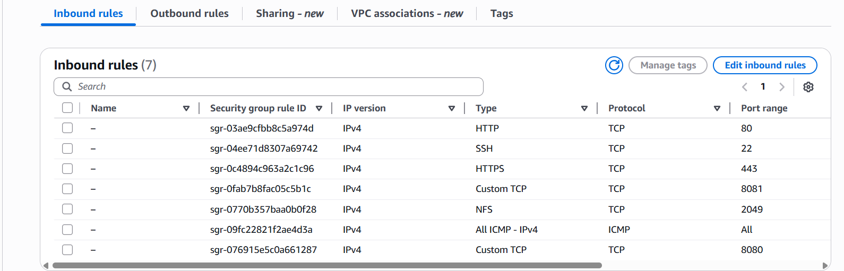
8080 port is added to Inbound.
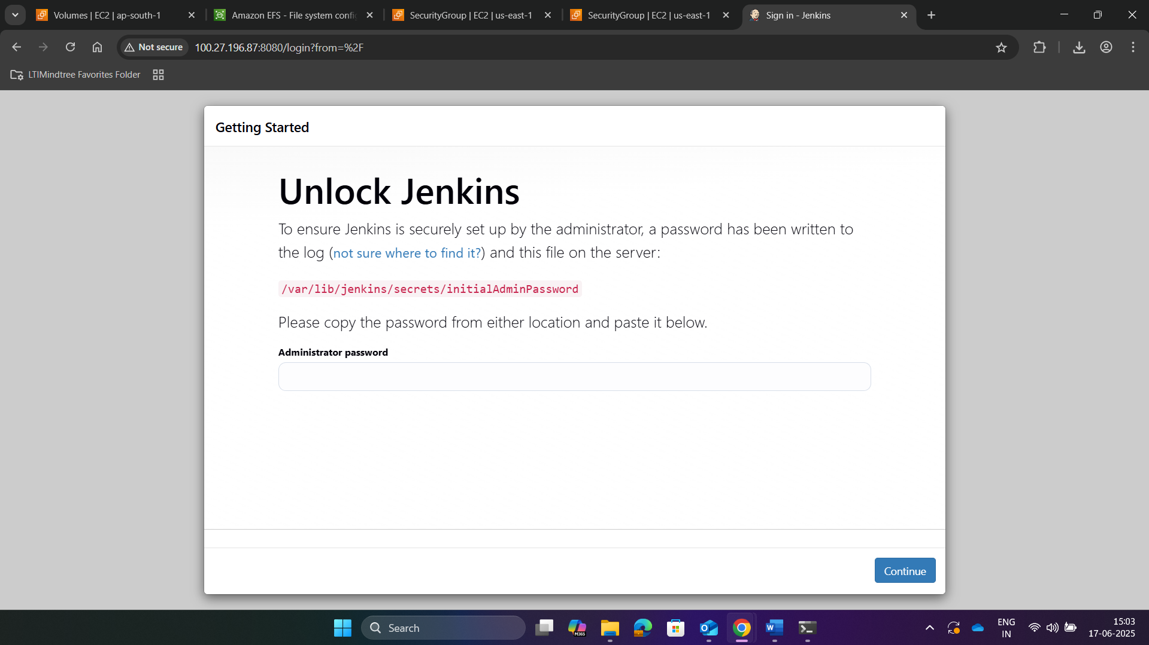
Jenkins is accessible.
Key is generated.
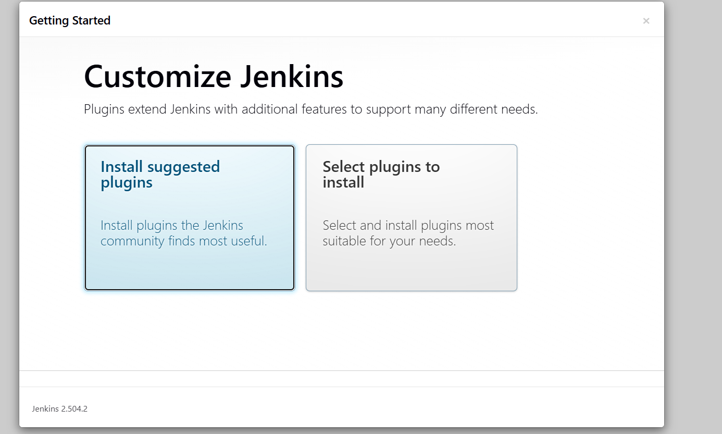

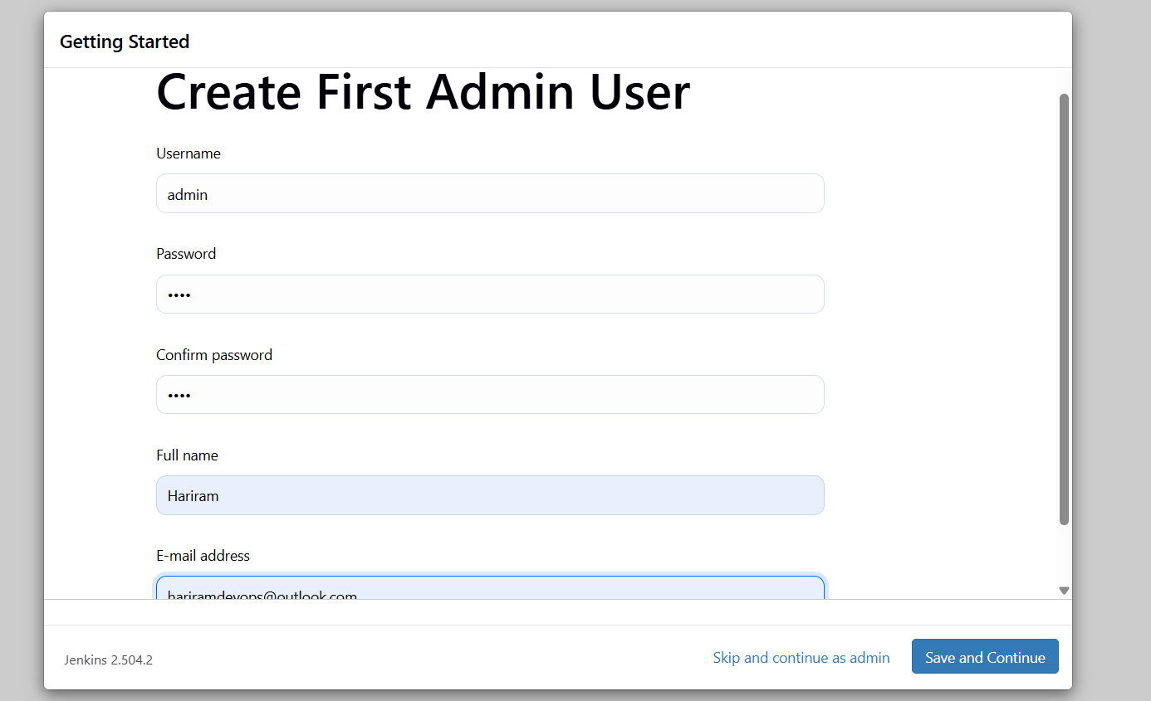
Jenkins’s admin is done.
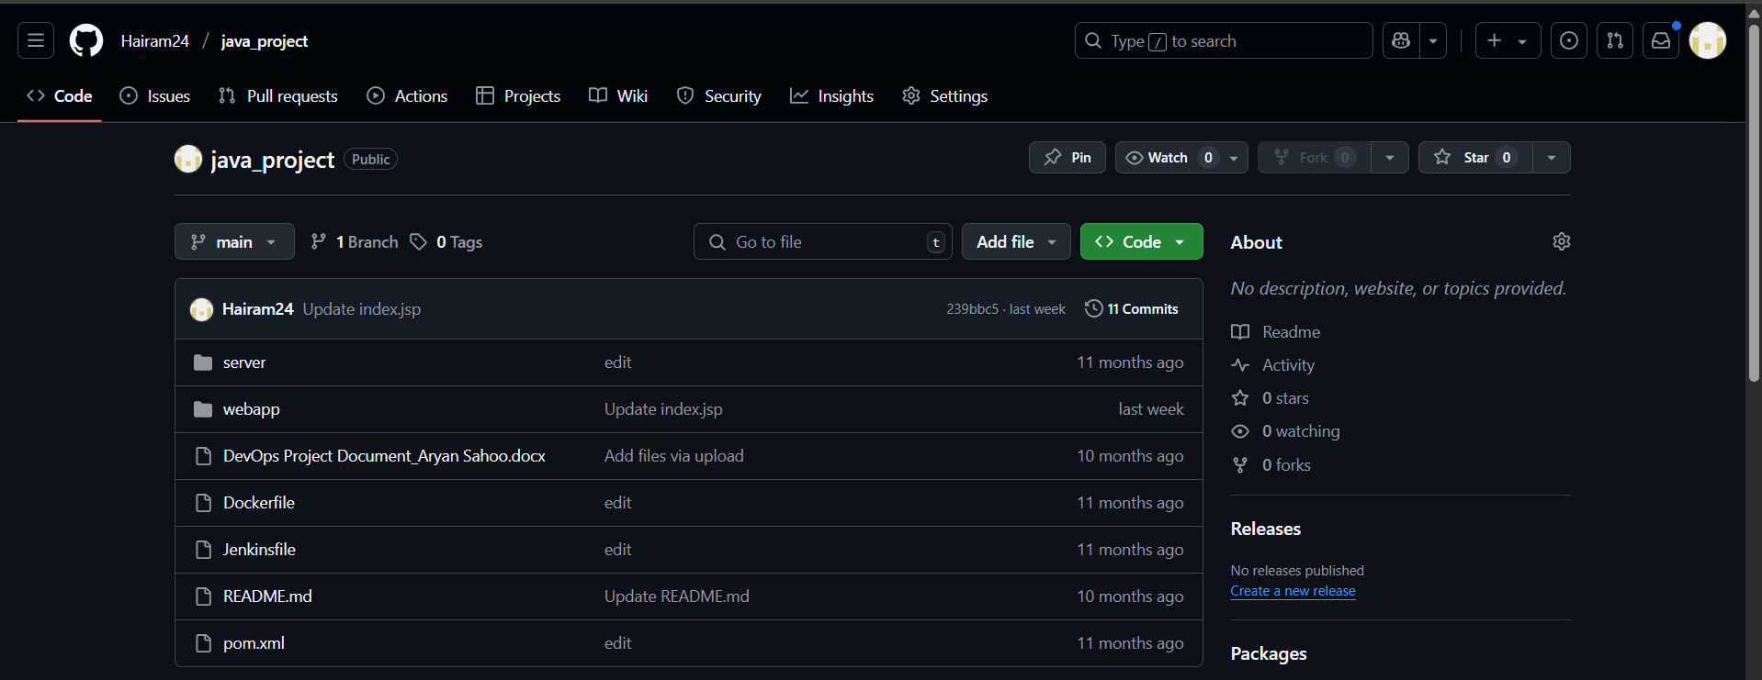
Java project in git hub.
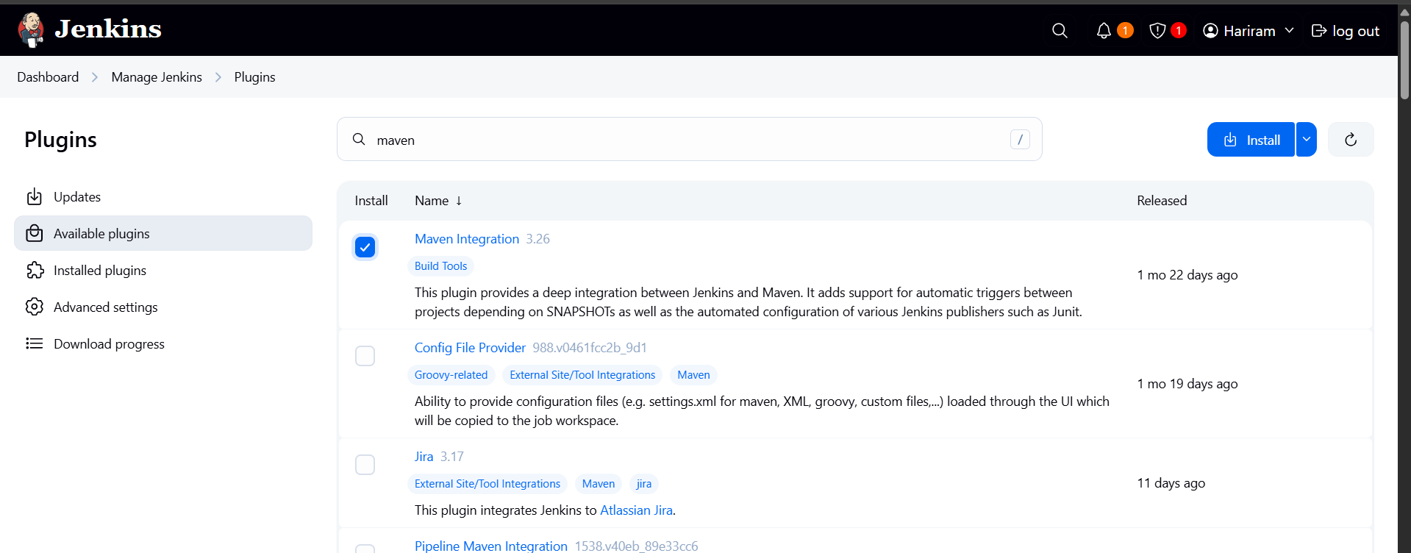
Maven plugin is installed.
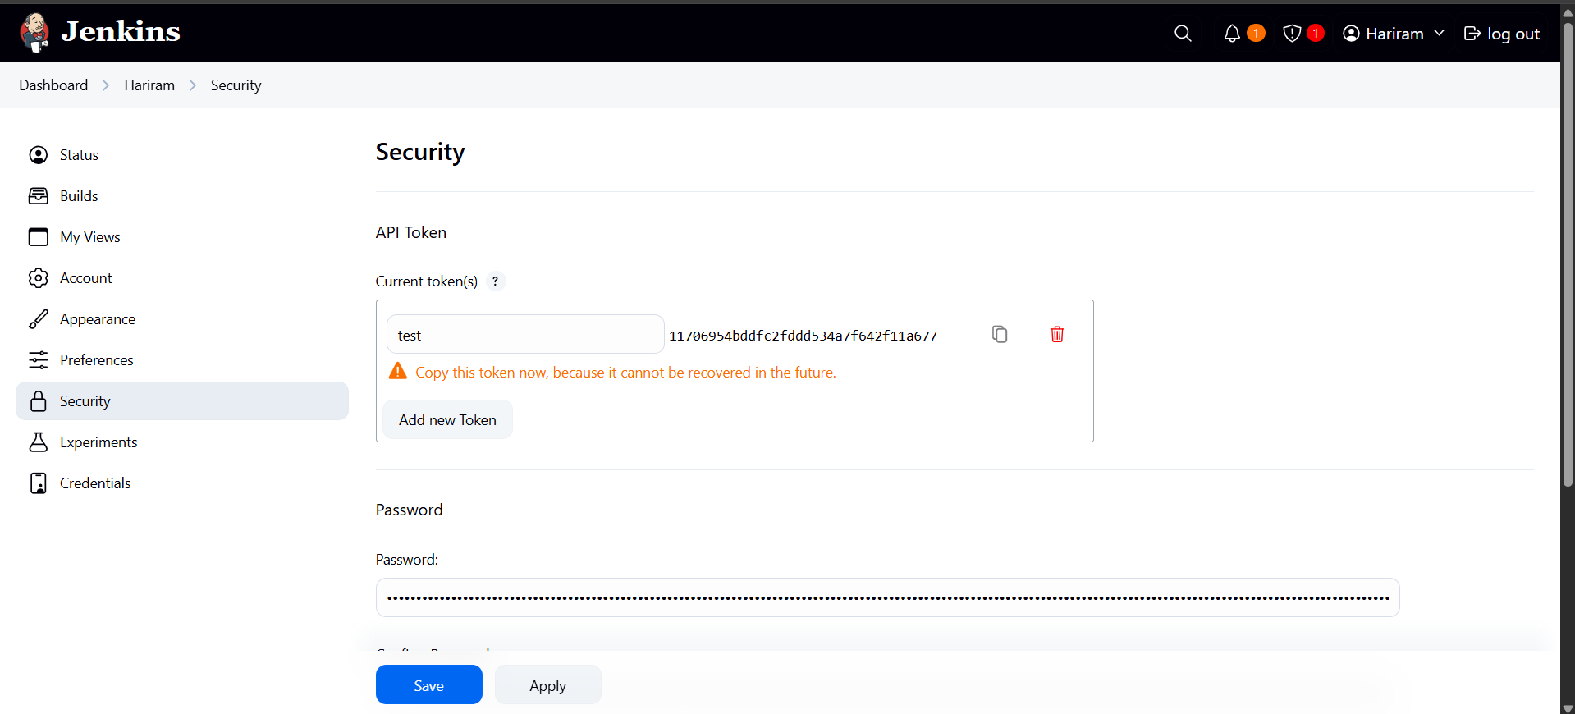
Token is generated for webhook.
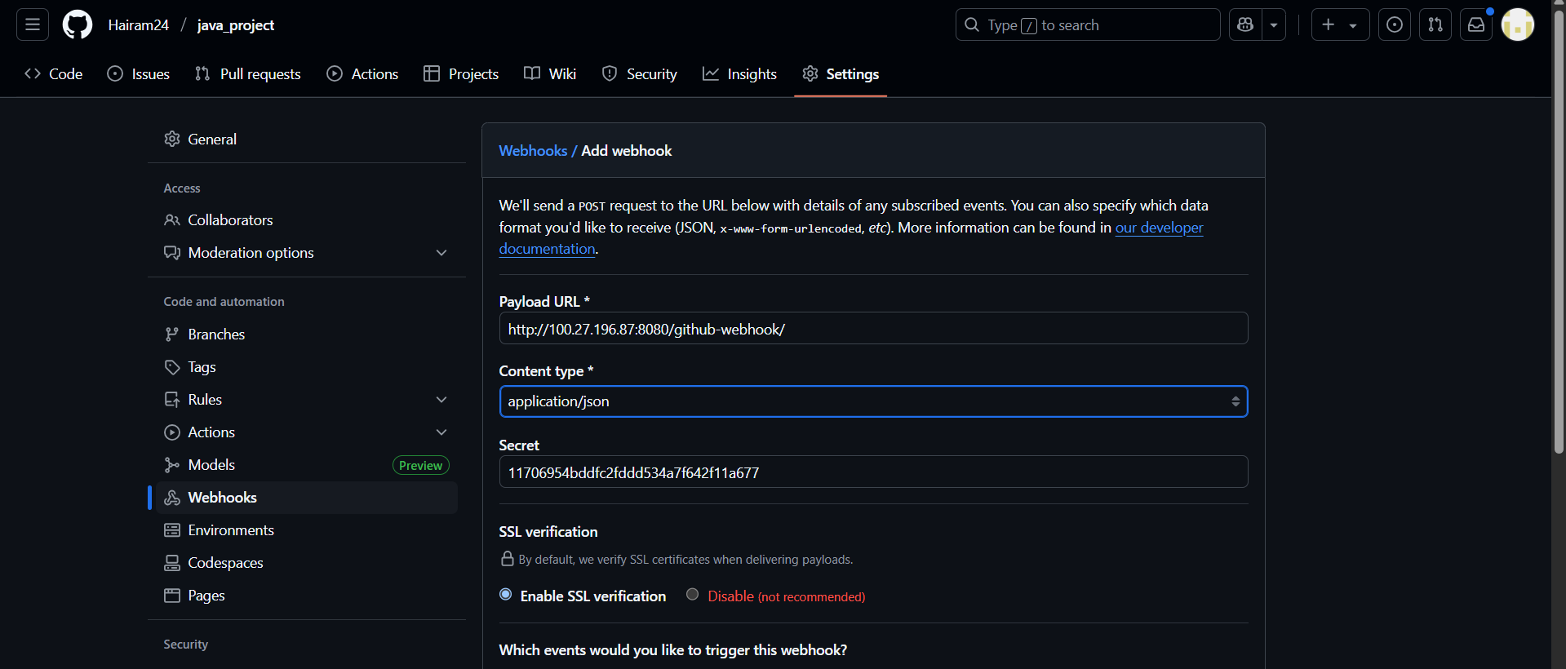
Webhook is created .
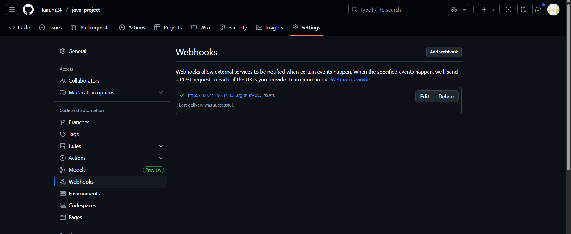
Webhook set up is done.

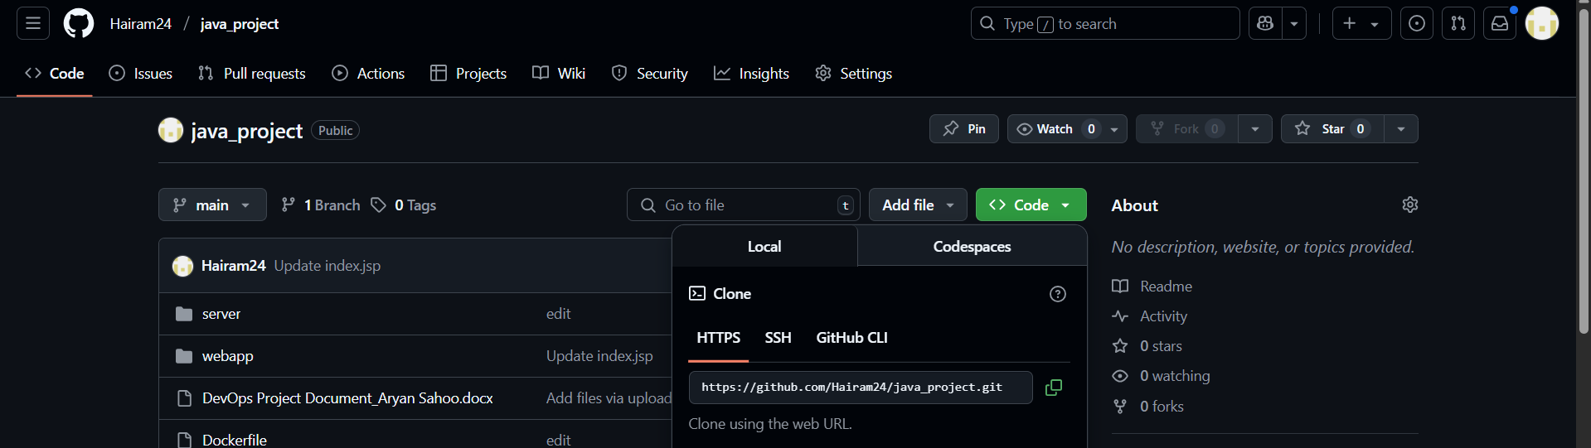

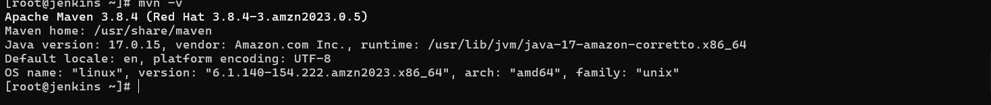

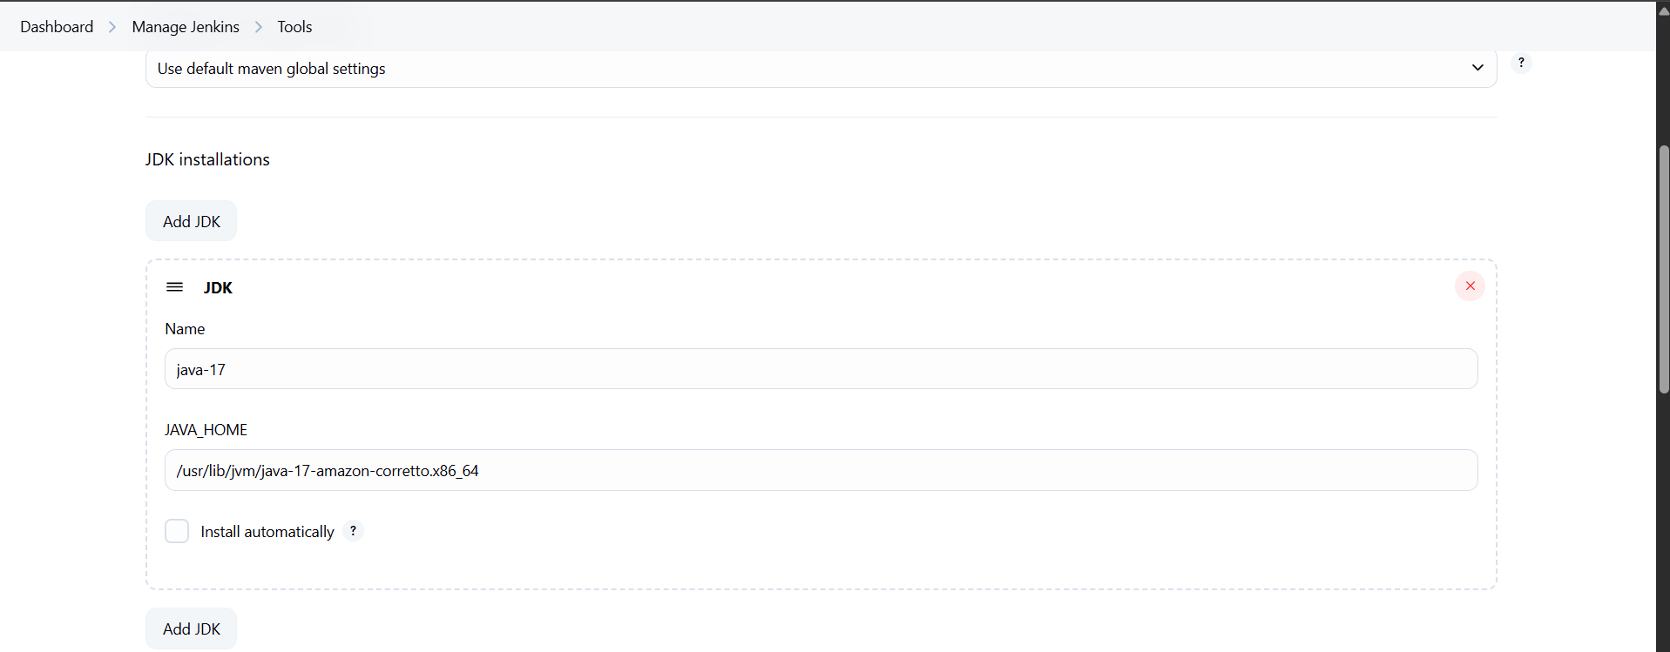
Java path is added.
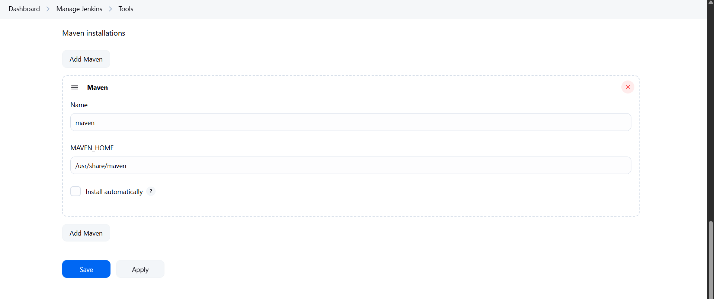
Maven path is added.
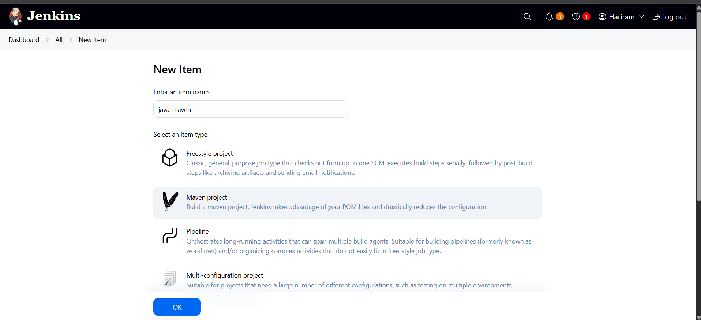
New item is created as maven project.
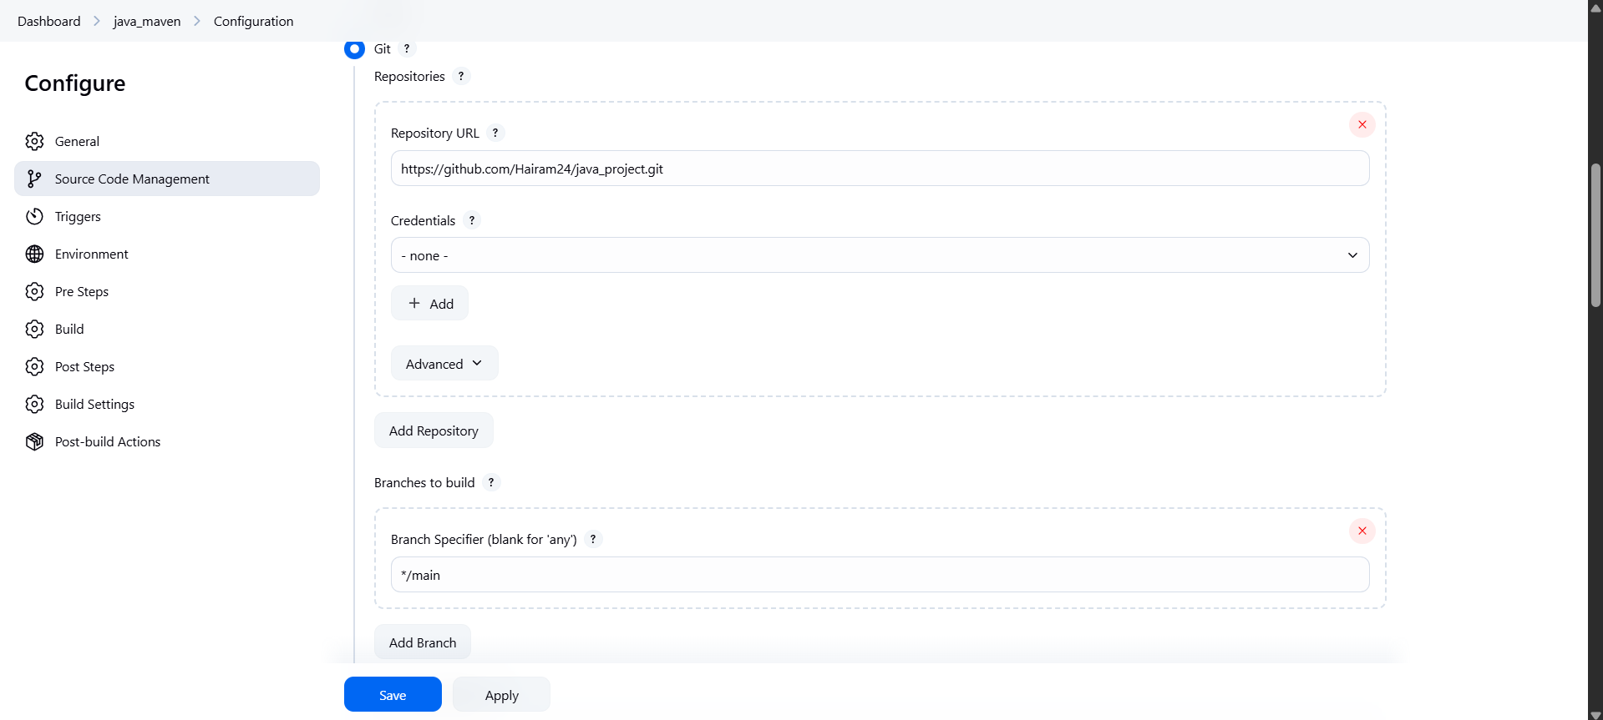
Git is connected.
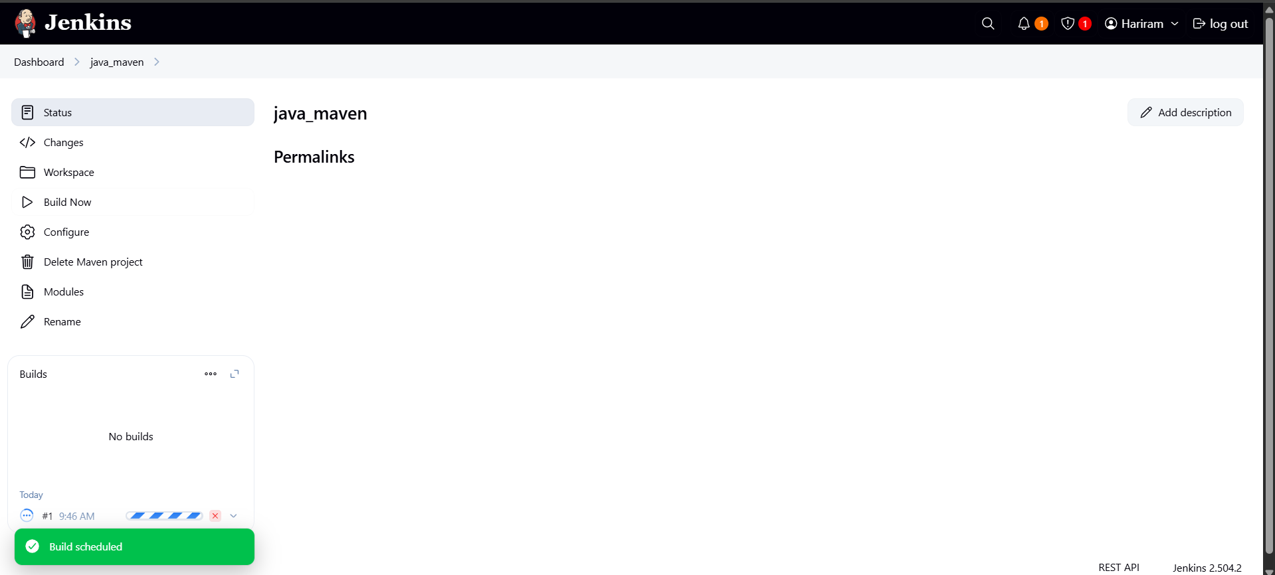
Build successfully.
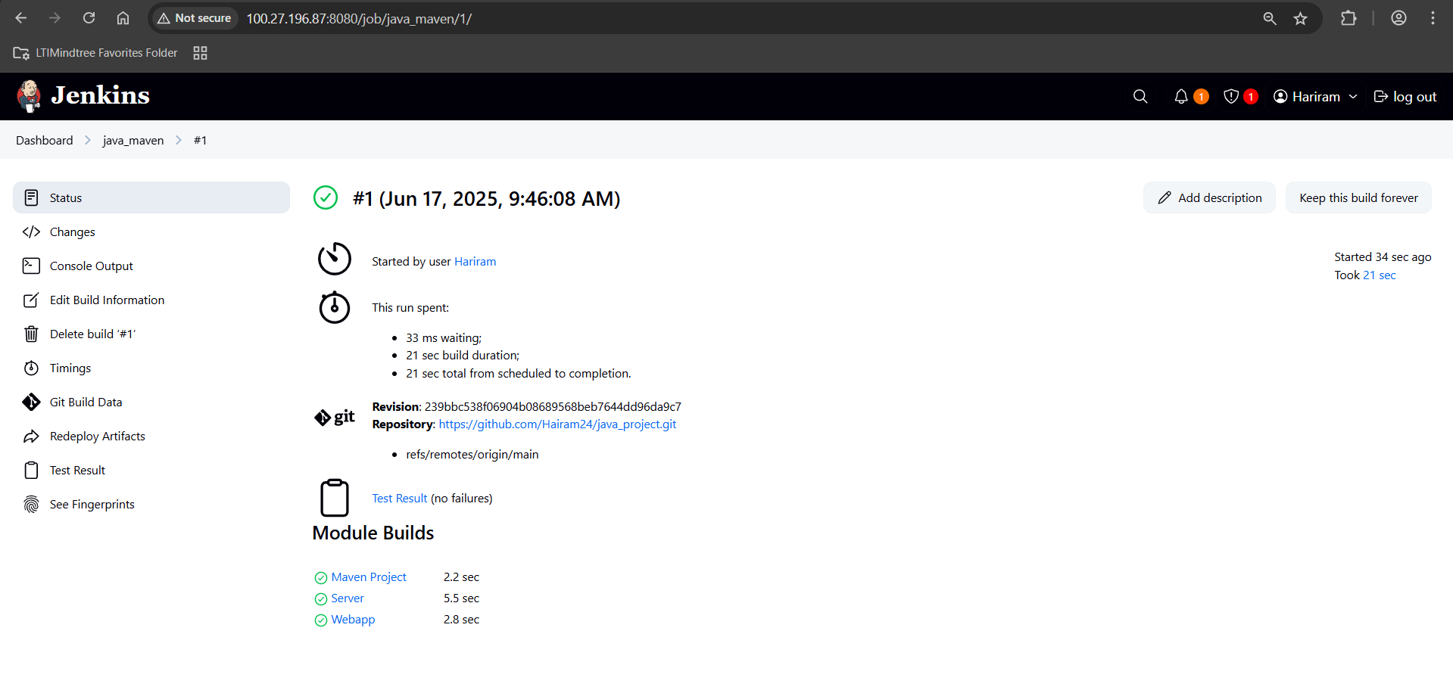

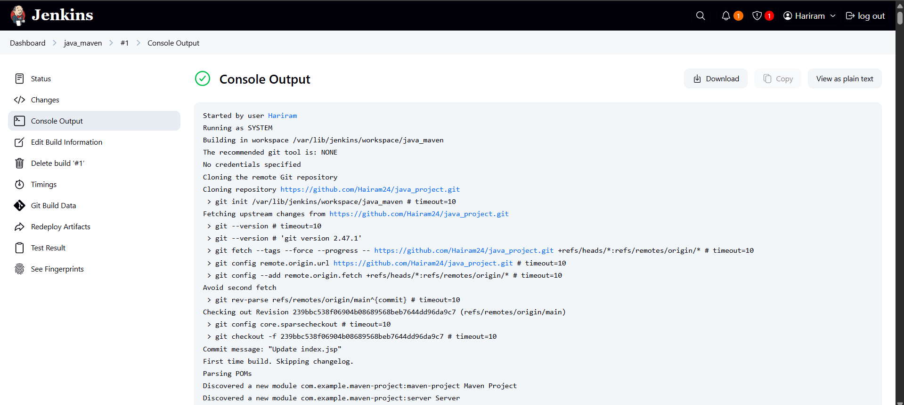
Var file is created successfully.

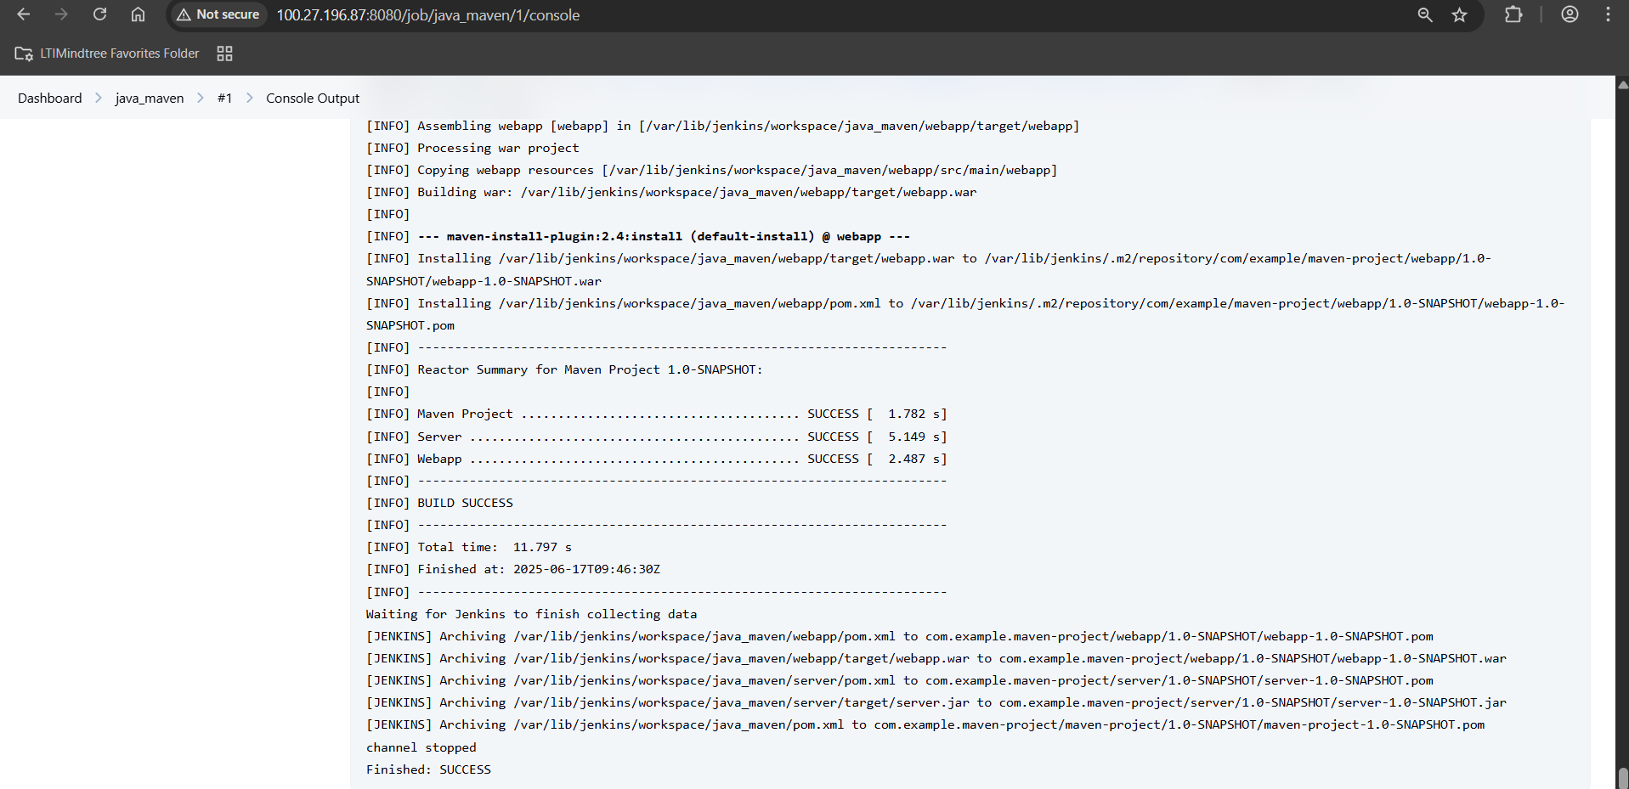
Build run successful.
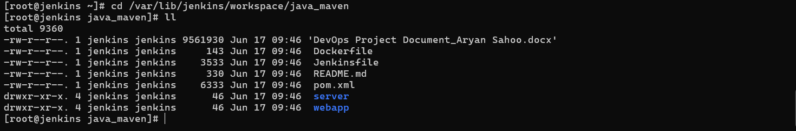
output is saved into pipeline.

