- Easy
Deploy a Ngnix application on your kubernetes cluster. and it should be available across of the cluster on port NO. 80.

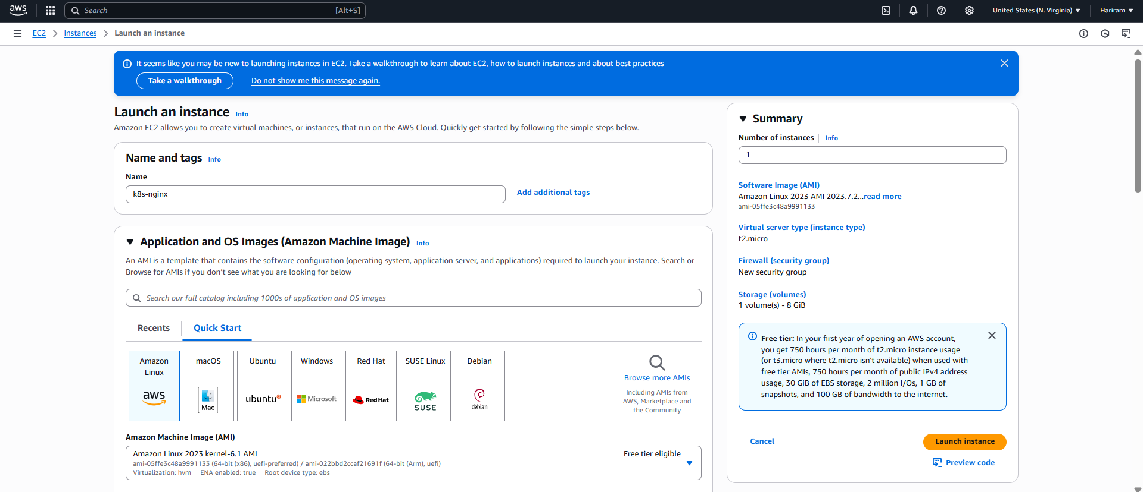
Created a instance with “k8s-nginx” name. Amazon Linux is chosen.
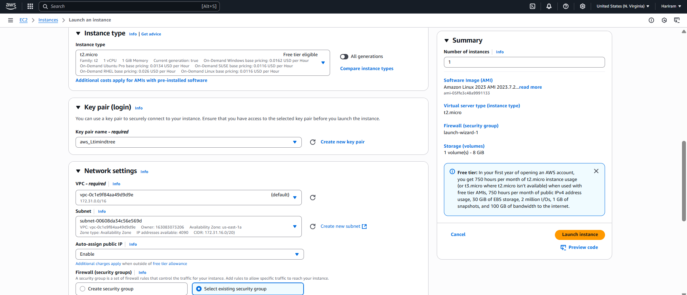
T2.micro selected. Existing key is added. Subnet us-east-1a is chosen.
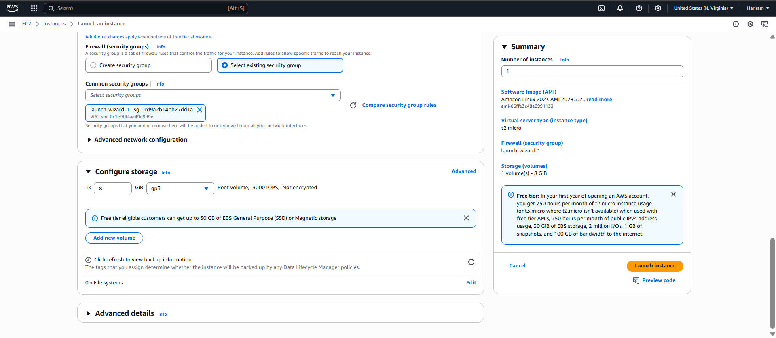
Existing security group is created. 8GB size is selected.
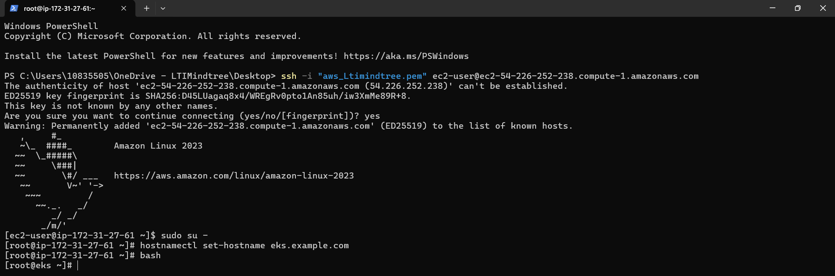
Machine run successfully.
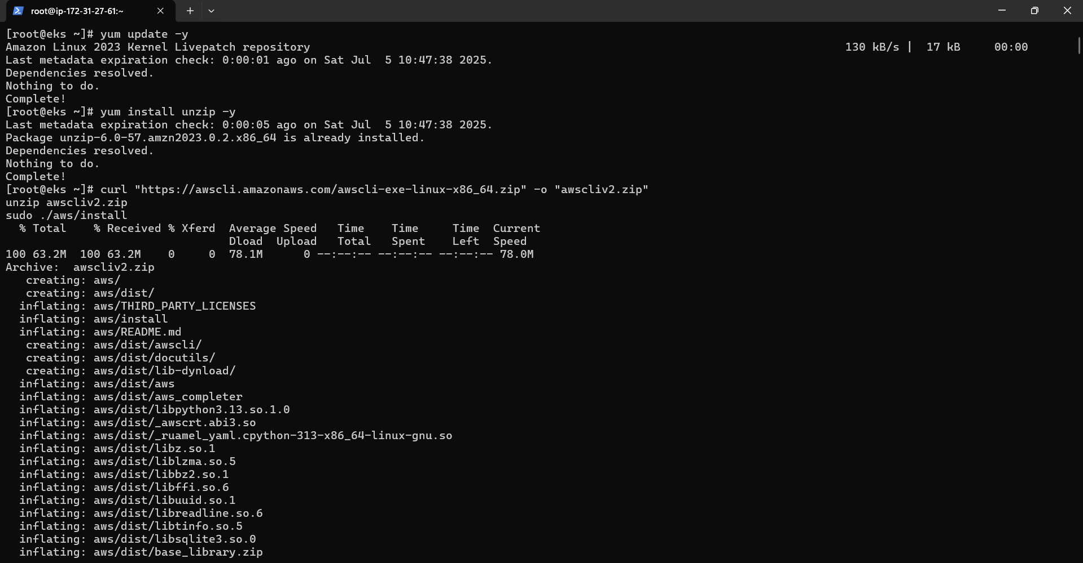
AWS CLI is installed.
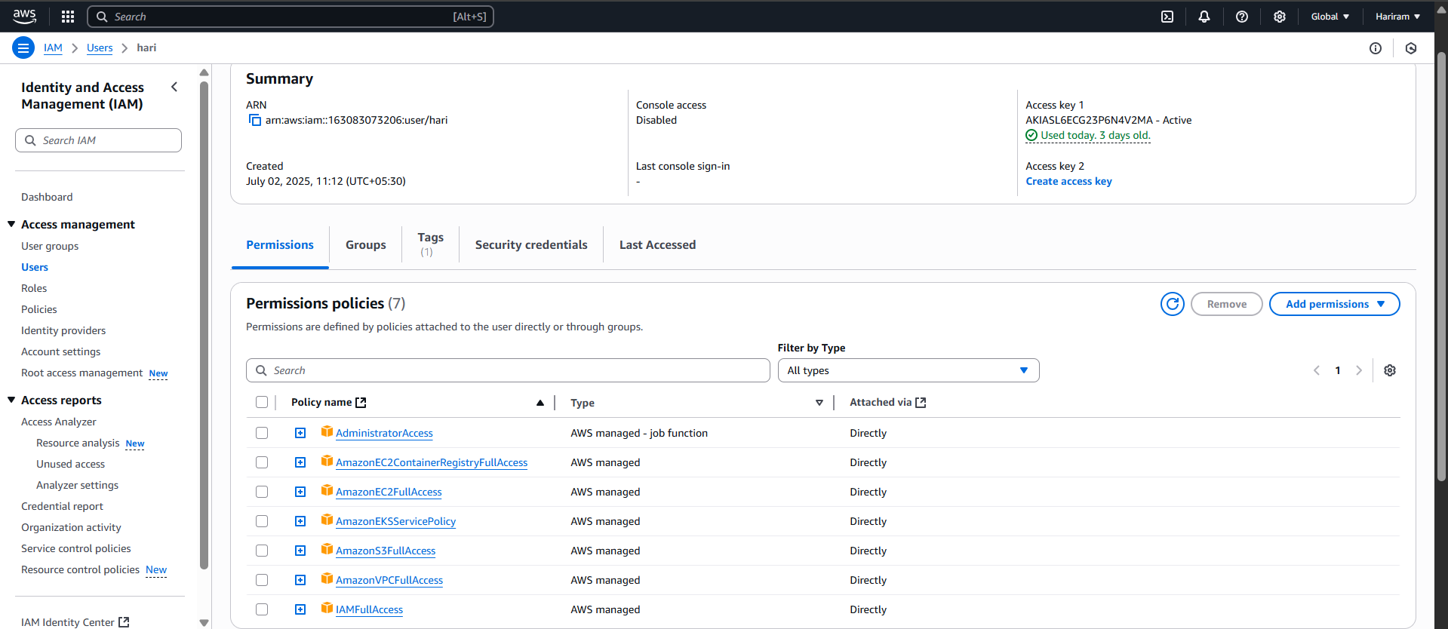
IAM is created with necessary permissions.
AWS cli is configured.
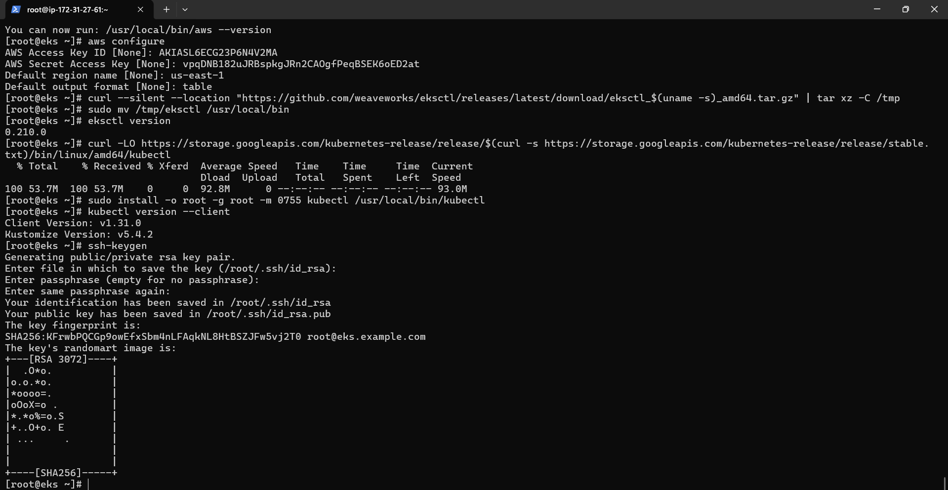
Kubernetes is installed and ssh key is generated.
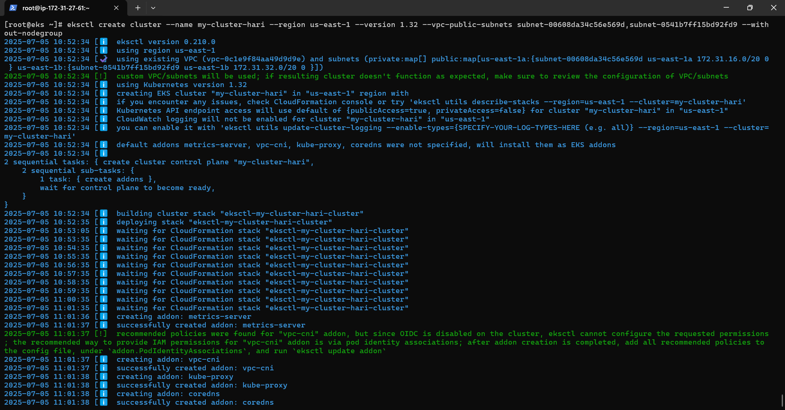
Cluster is created successfully.
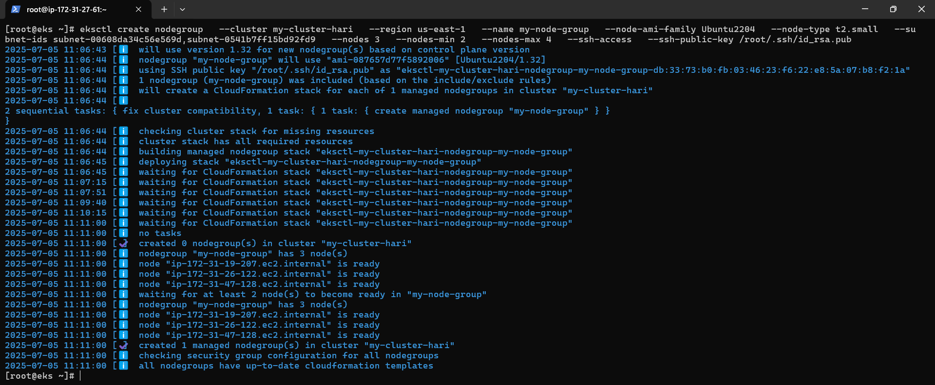
Node group is created successfully.
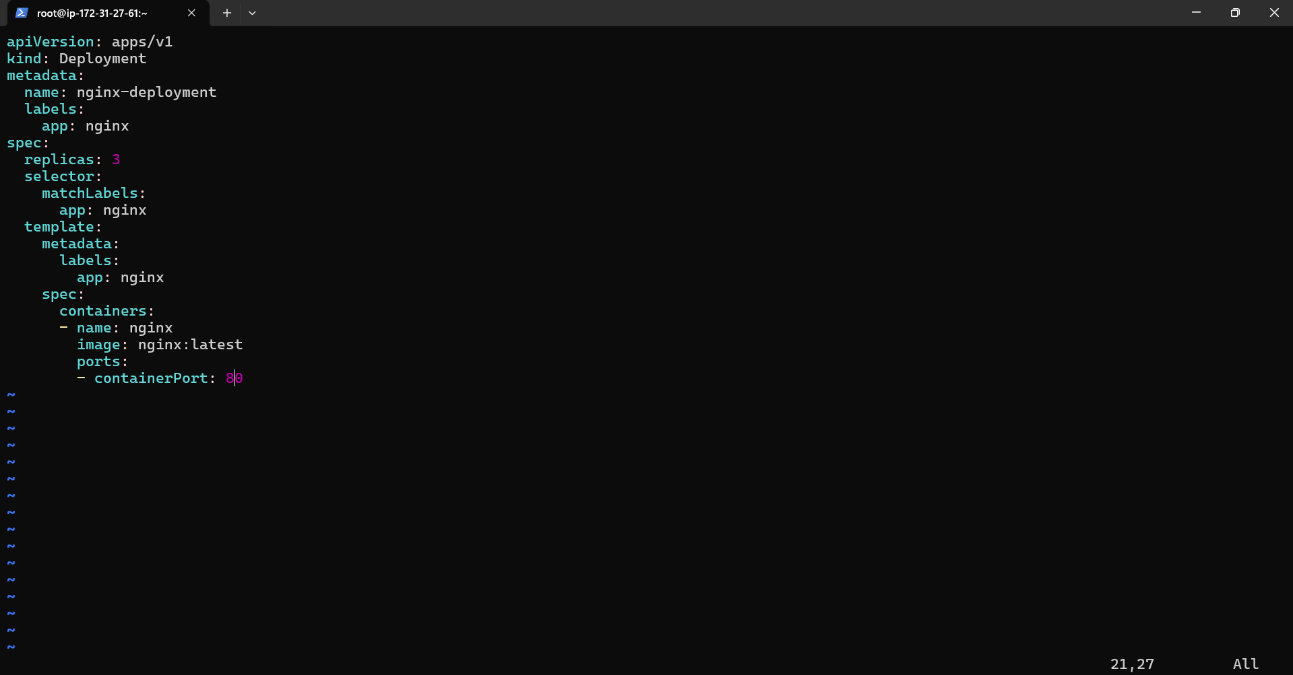
nginx.yaml file is created with nginx installation setup with container port as 80.
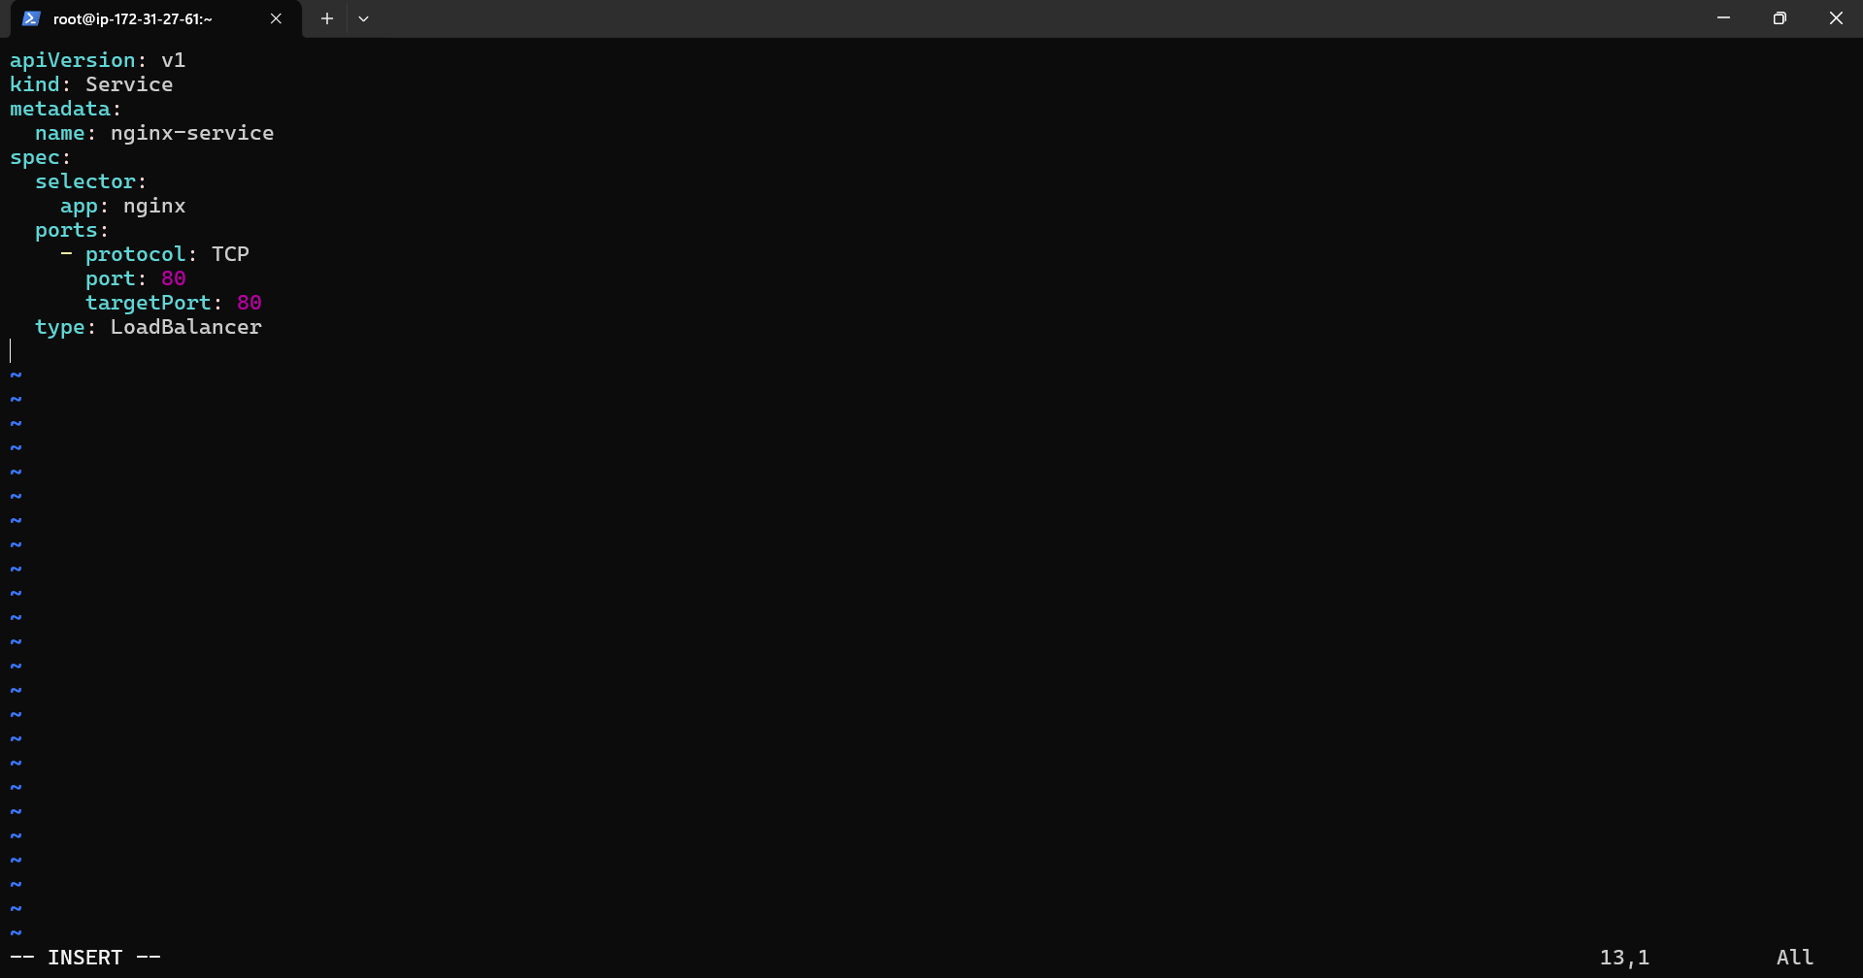
Nginx-service.yaml fileis created.
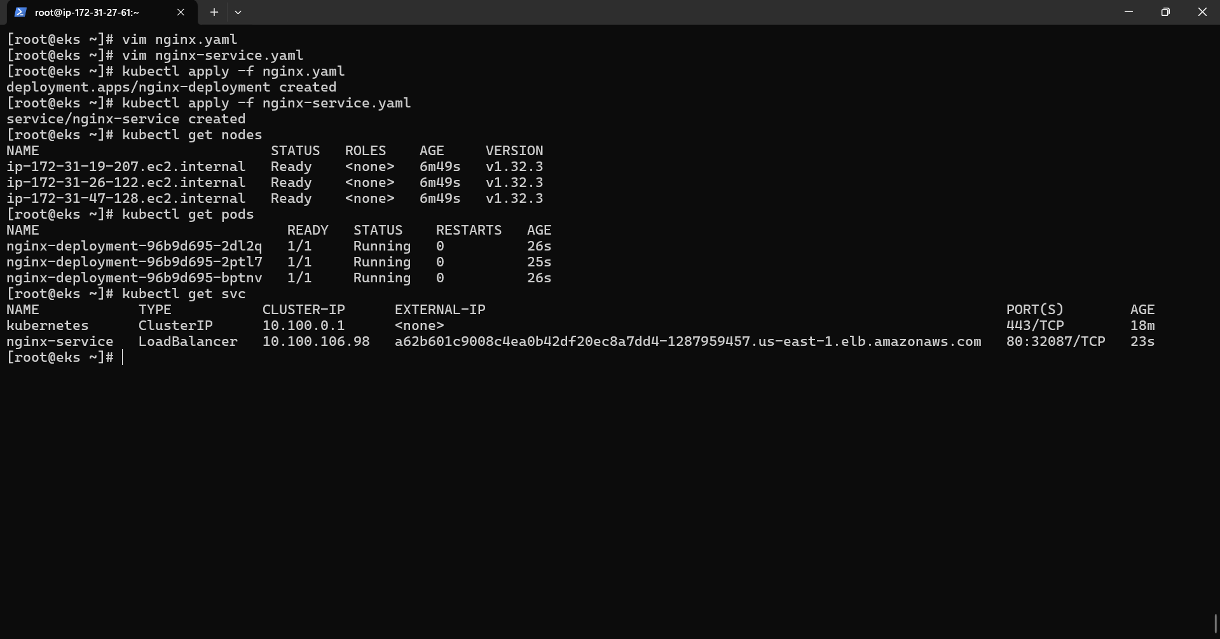
Both yaml is applied using kubectl apply -f command. Pods and nodes are running. Using kubectl get svc command external ip is taken.
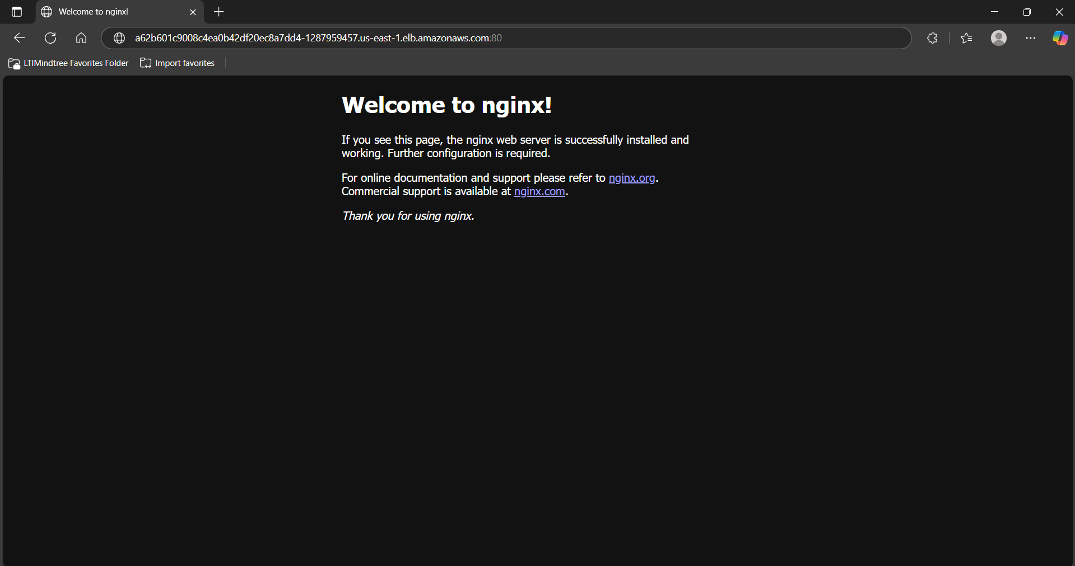

External ip with port 80 is pasted in the web-browser , Finally nginx web-page is available.

2) Medium
Create an EC2 instance using of terraform us-east-1a zone in North Virginia region. And create of your security group which name is web_access and allow port 22 and 80 in the ingress. This security group should be attached with your EC2 instance via Terraform.
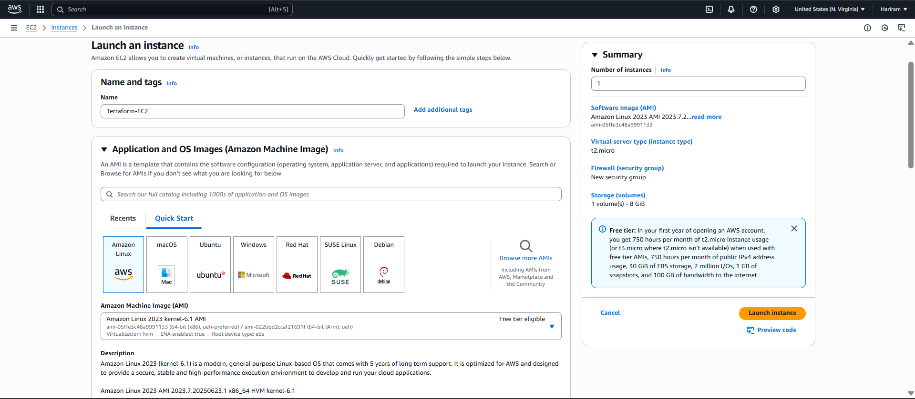
Created instance with name as “Terraform-EC2”. Amazon Linux is chosen.
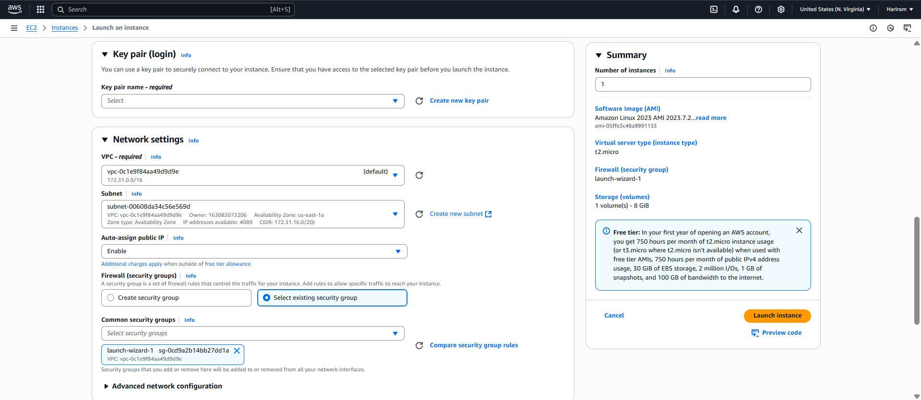
Existing key is selected. Subnet is selected. Existing security group is selected.
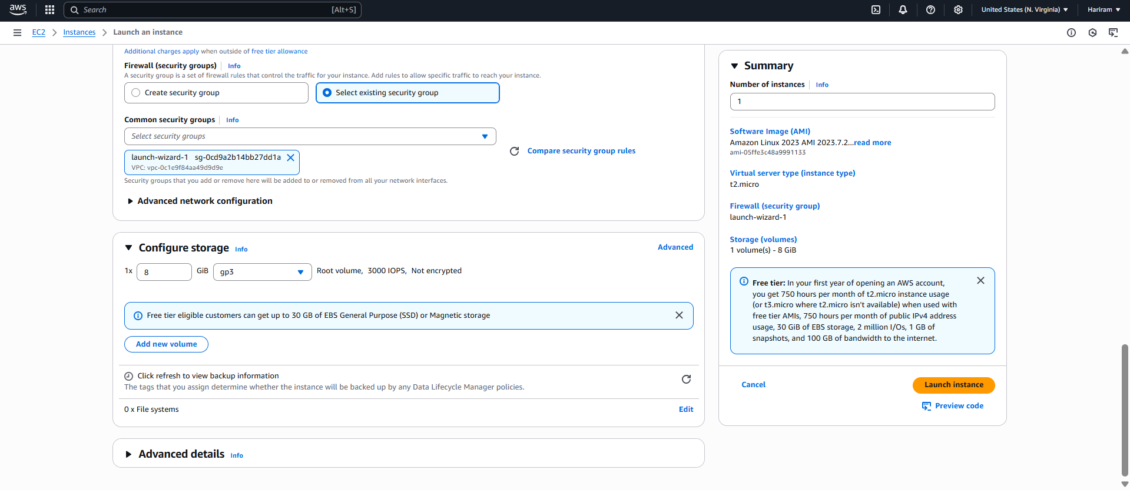
8GB size is selected and gp3 is selected.
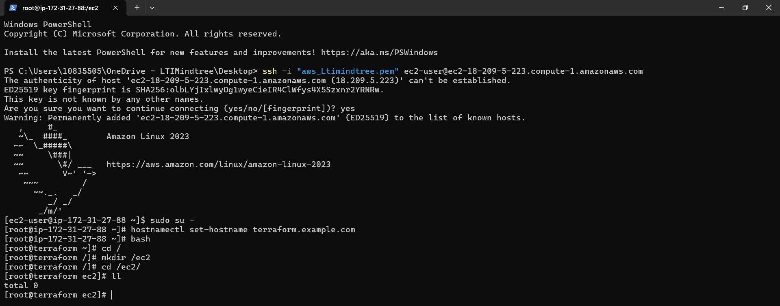
Machine is running successfully. Inside root folder ec2 directory is created.
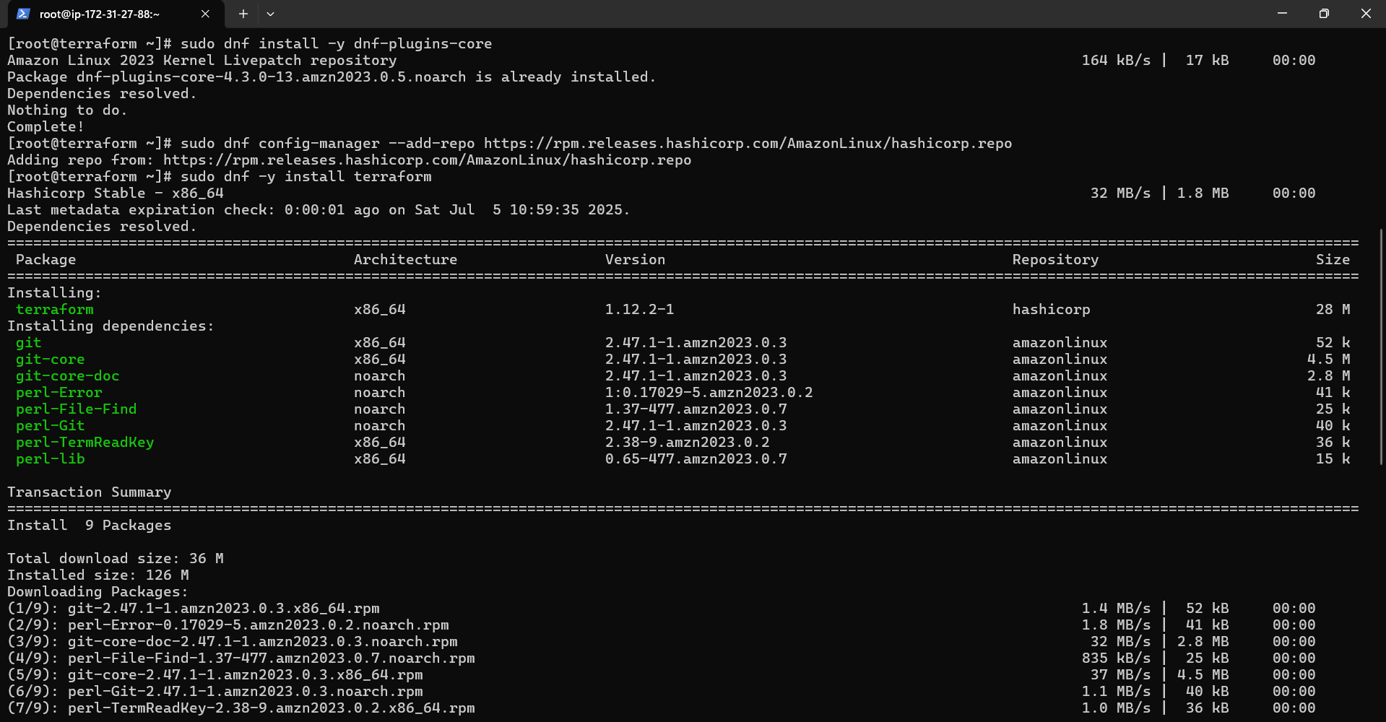
Terraform is installed successfully.

IAM user is created with necessary permissions.
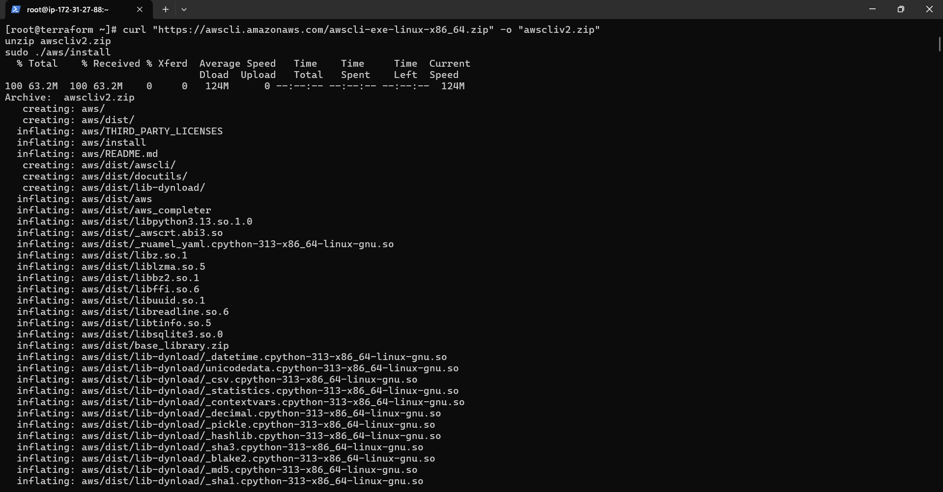
AWS cli is installed.
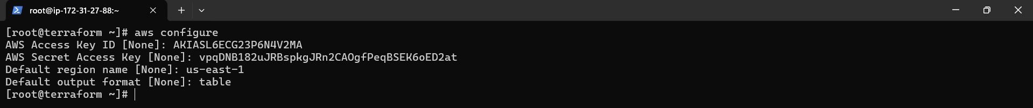
AWS cli is configured successfully.
Ec2.tf file is created.

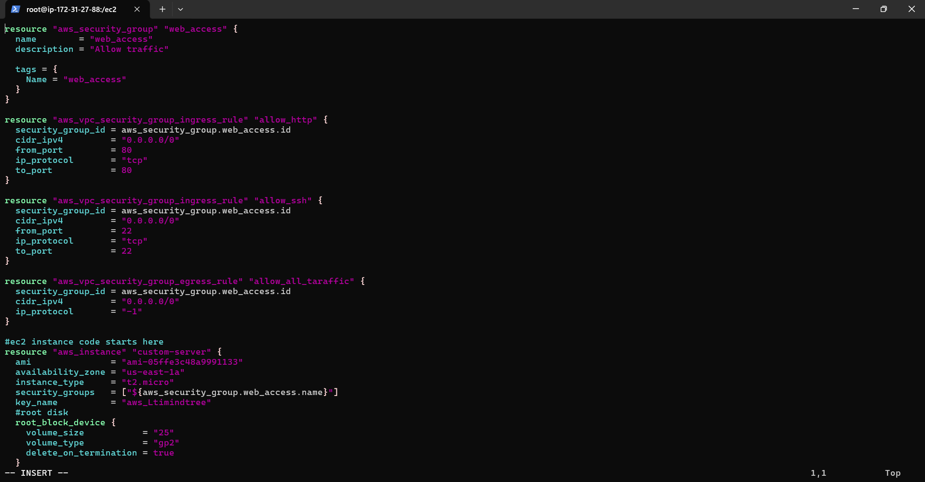
Yaml code is written such that EC2 instance will be created and a new security group will be created with port 80 ,22 allowed and finally the security group will be attached to the instance.
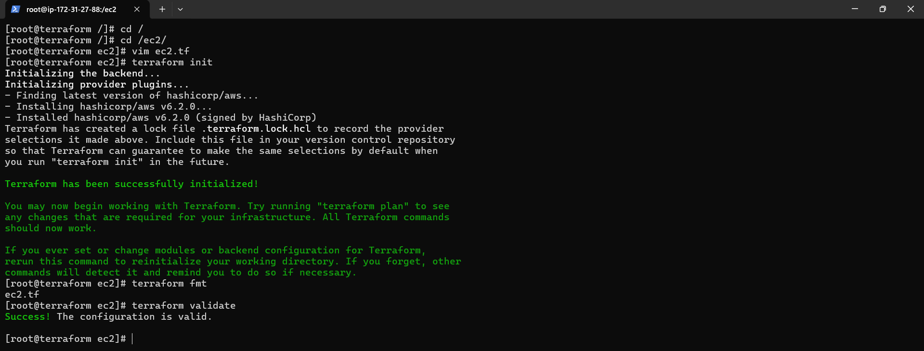
Terraform is initiated successfully inside the ec2 directory. Terraform fmt is done.
Terraform validate is successfully.
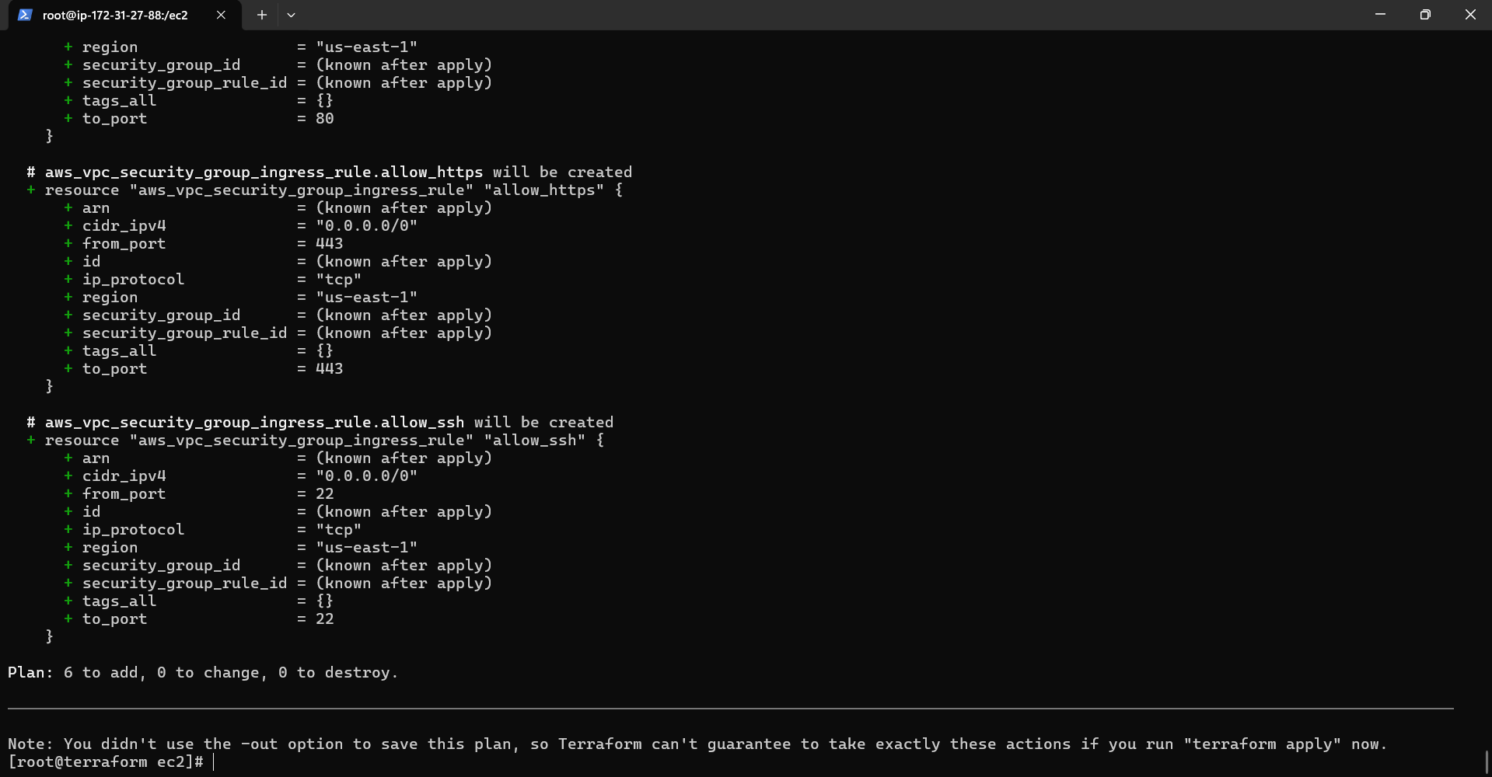
Terraform plan is successfully.
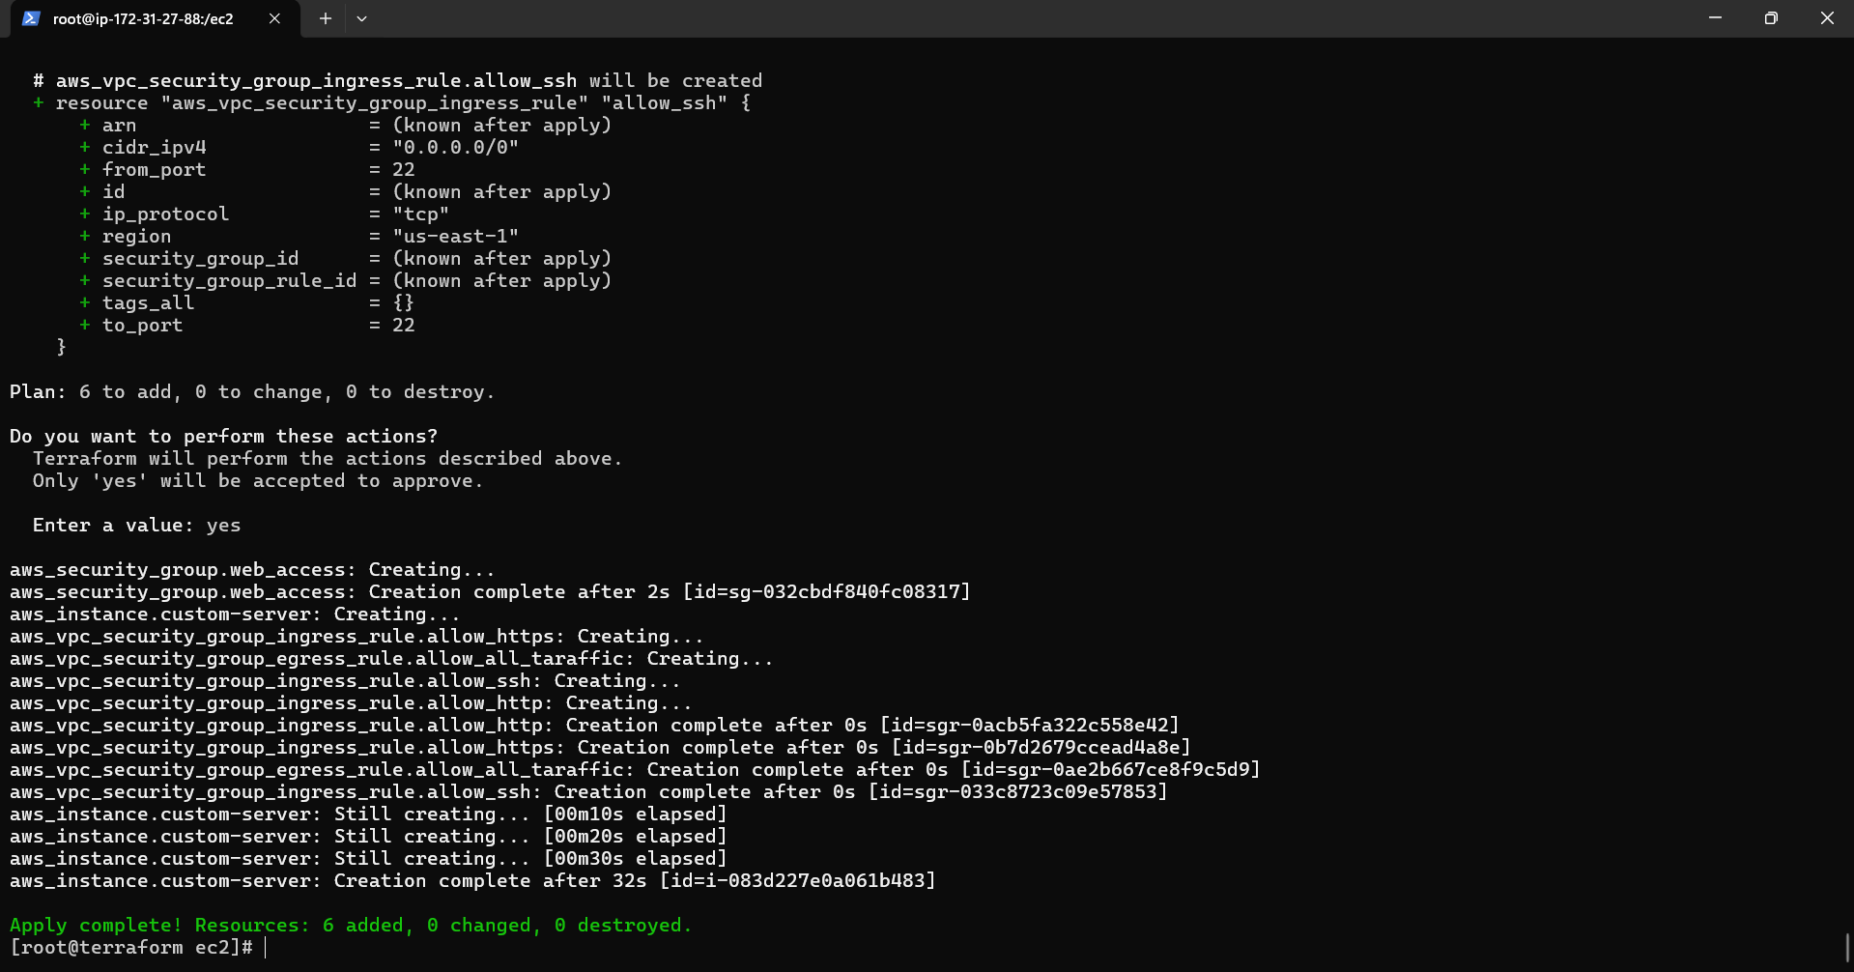
Terraform apply is successfully and new instance , security group is created and attached with the instance.
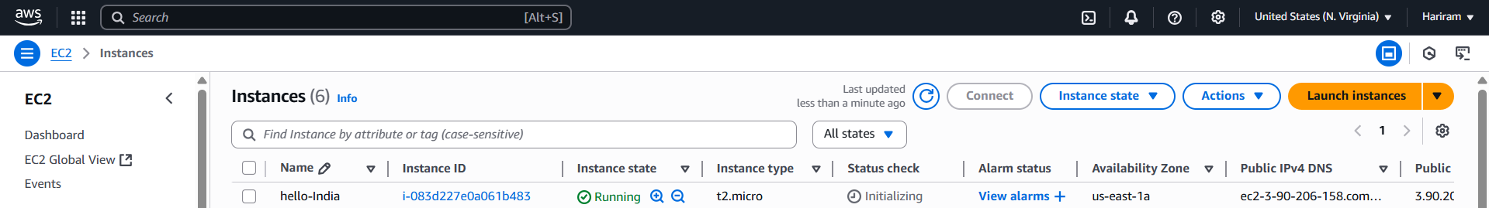
Instance is created successfully as hello-india.
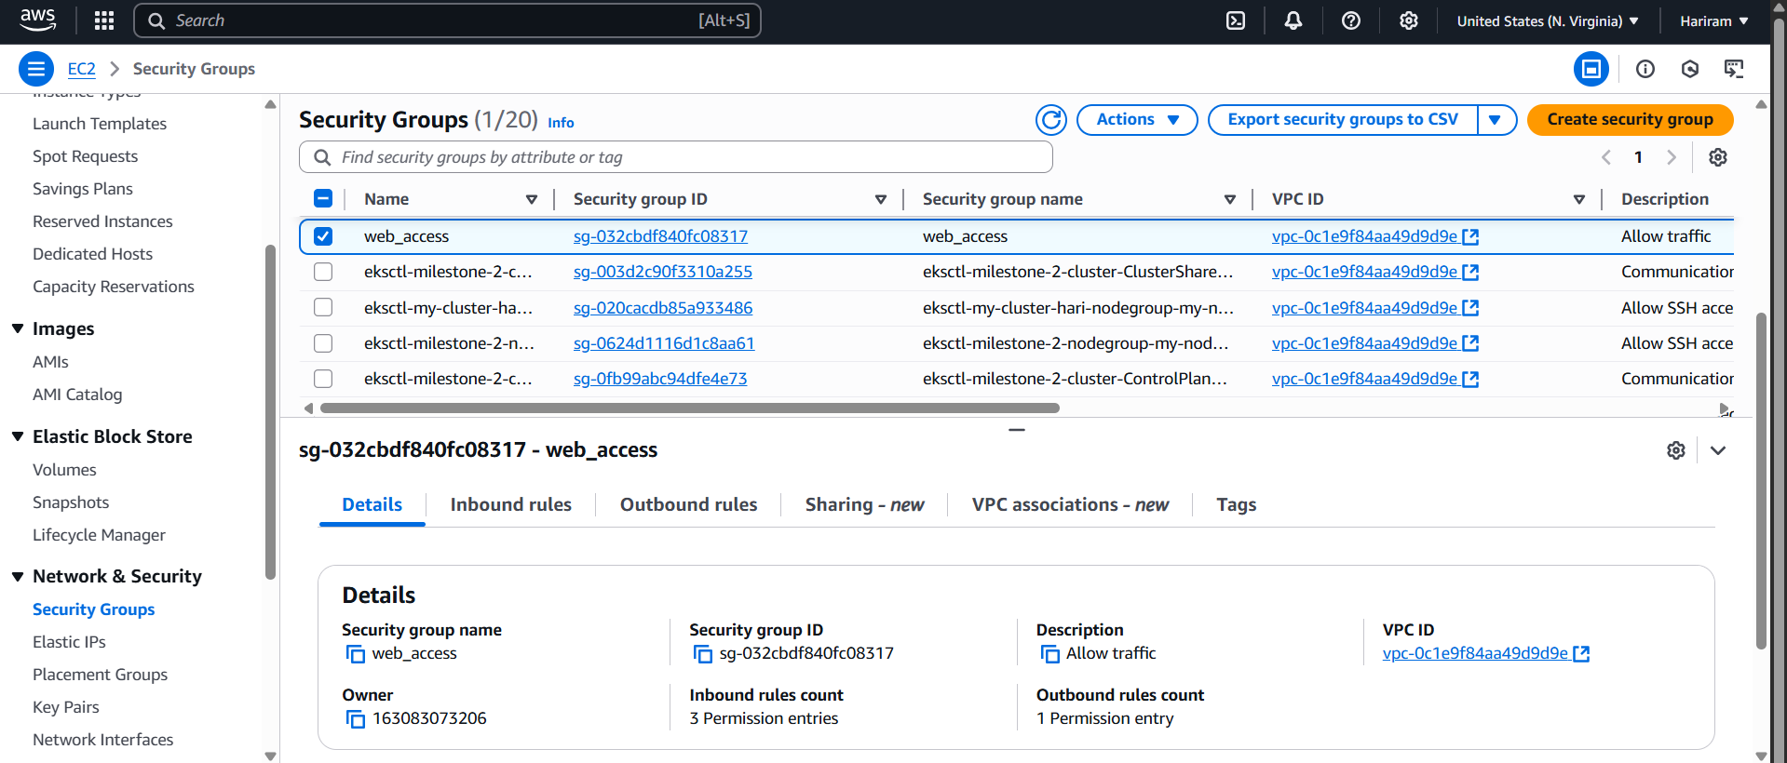
Security group is created with name as “web_access”.
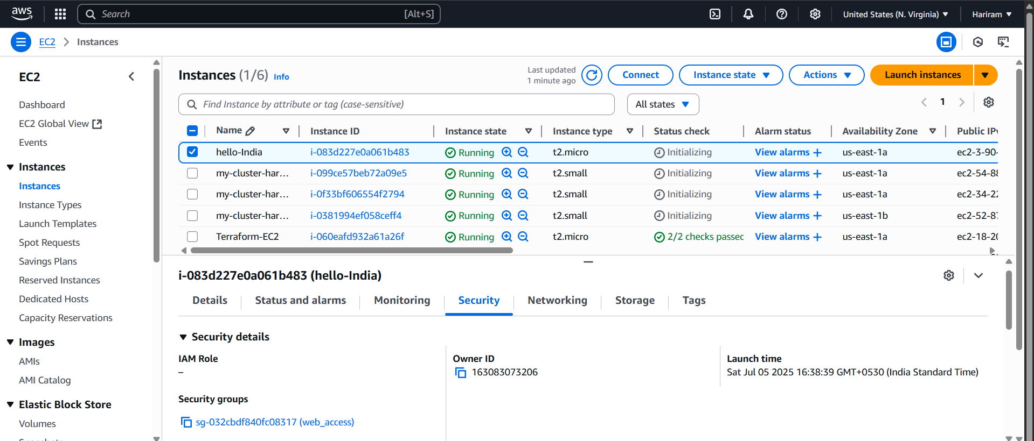
Security group is attached with the instance.
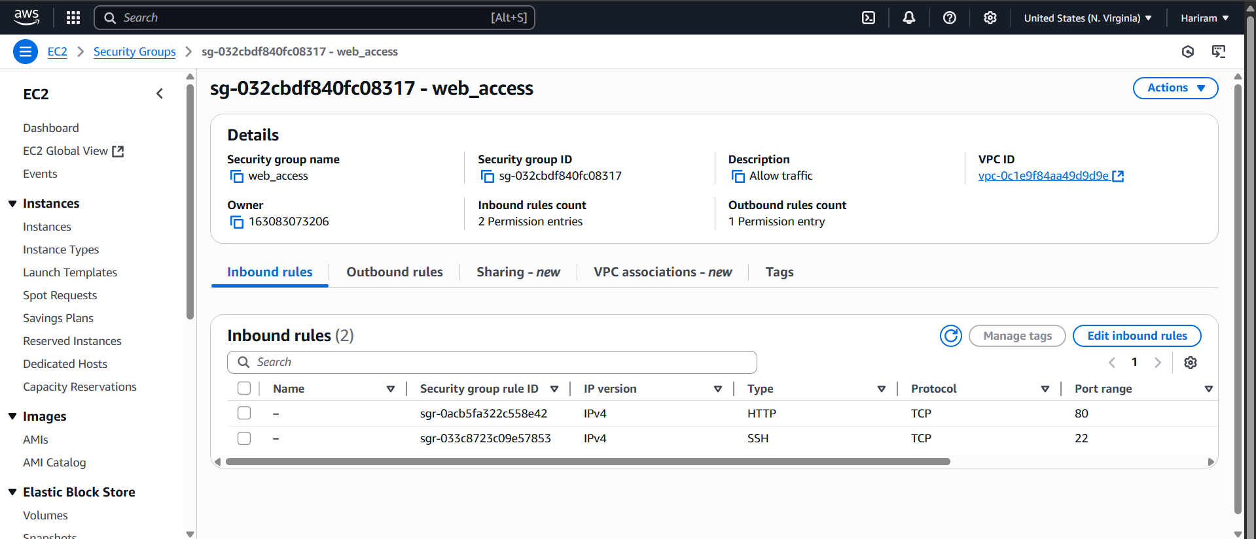
In the security group ports 80 and 22 are allowed.
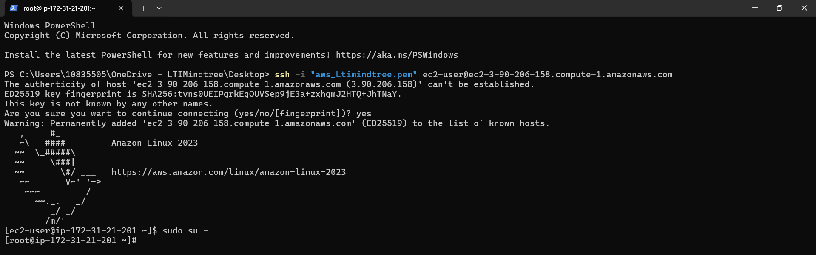
Machine is running successfully.
All the creations and attachments are done via terraform.

