This document outlines the various functions of UI elements found on each Admin page

HairDressing project

ADMIN FUNCTIONS

Table of Contents

1. Sign up 2

2. Sign in 4

3. Forgot Password 6

4. New Password 8

5. Dashboard 10

6. Databases 12

7. Traffic 14

8. Permissions 16

9. Pictures 18

# Sign up

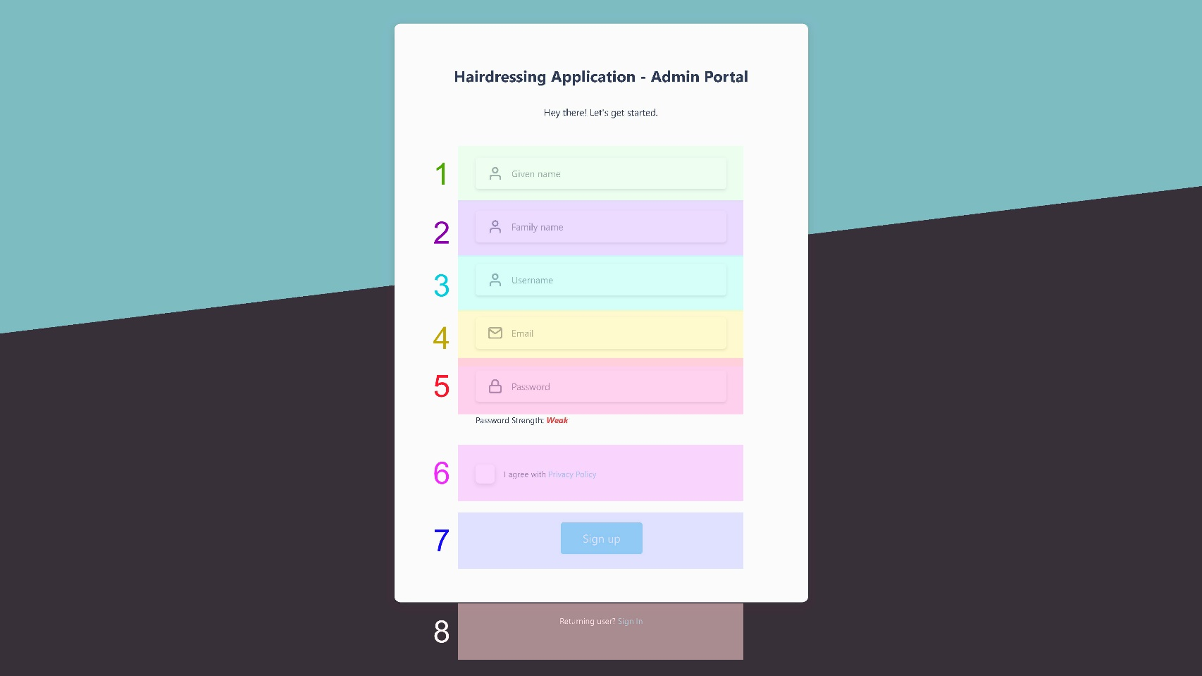

|  |  |  |
| --- | --- | --- |
| Function | Details | Fields |
| Sign up form | Every new user must enter the details outlined above to register in the admin portal | (1) Given name input (**required**)  (2) Family name input  (3) Username input (**required**)  (4) Email input (**required**)  (5) Password input (**required**)  (6) Privacy policy checkbox (**required**)  (7) Sign up button (submit form)  (8) Sign in link |
| Basic password validation will make accounts slightly more secure |
| A privacy policy might be written for the application itself rather than the admin portal |
| The “Sign up” button should be greyed out if a required field is invalid |
| The “Sign In” link conveniently redirects existing users to the sign in page |

# 2. Sign in

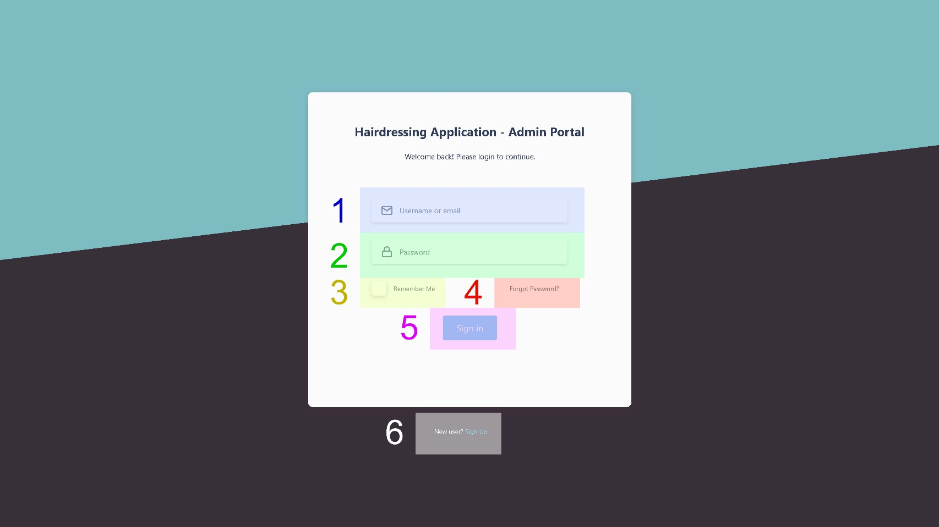

|  |  |  |
| --- | --- | --- |
| Function | Details | Fields |
| Sign in form | Users have the option to enter either their username or email to sign in | (1) Username or email input (**required**)  (2) Password input (**required**)  (3) Remember me checkbox  (4) Forgot password link  (5) Sign in button (submit form)  (6) Sign up link |
| A pop-up message should be displayed if either field is incorrect |
| Checking the “remember me” checkbox stores a token in the user’s browser that identifies them next time they access the admin portal |
| The “forgot password” link should redirect users to the forgot password page |
| The “forgot password” link should redirect new users to the sign up page |

# 3. Forgot Password

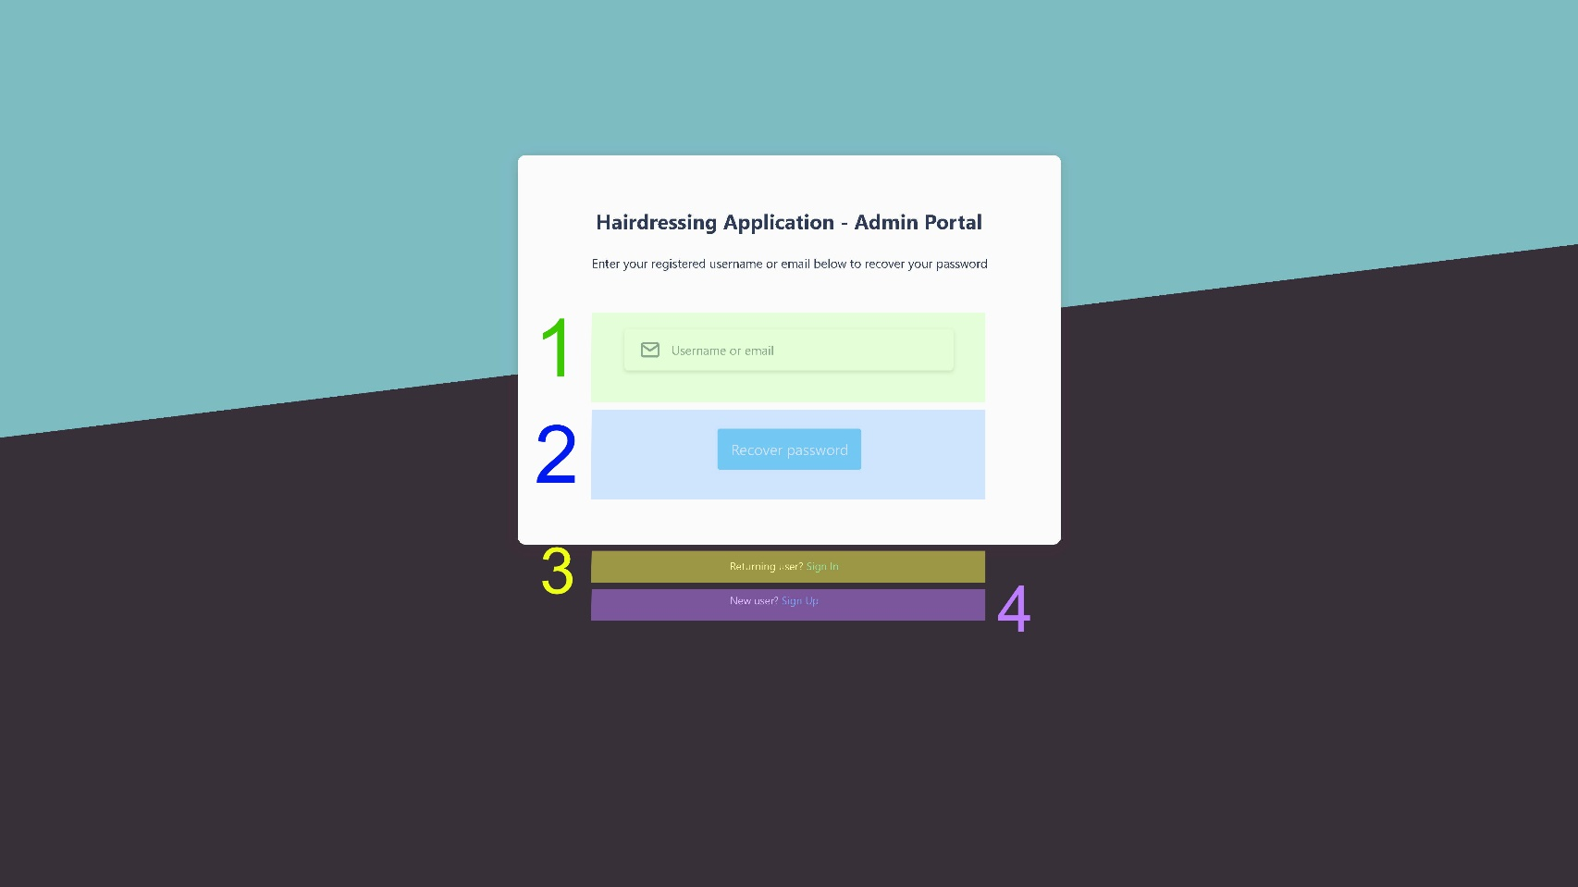





|  |  |  |
| --- | --- | --- |
| Function | Details | Fields |
| Forgot password form | Users can enter either username or email to recover their account | (1) Username or email input (**required**)  (2) Recover password button (submit form)  (3) Sign in link  (4) Sign up link |
| If an account associated with the information entered is found, an email will be sent to the user with instructions on how to create a new password. Additionally, a success message should pop up at the top of the window to let the user know. |
| If no account is found, an error message should pop up at the top of the window to inform the user. |
| If the username/email input field is invalid or empty, the “recover password” button should be inactive. |
| The sign in/ sign up links below the form should redirect users to the corresponding pages. |

# 4. New Password

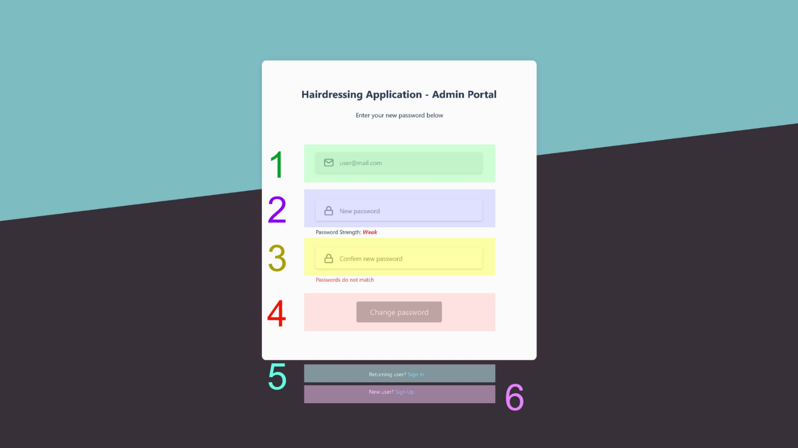

|  |  |  |
| --- | --- | --- |
| Function | Details | Fields |
| New password form | The “email” field is read-only and lets users be aware of which email is associated with the account that they wish to recover. | (1) Email (read-only)  (2) New password input (**required**)  (3) Confirm new password input (**required**)  (4) Change password button (submit form)  (5) Sign in link  (6) Sign up link |
| Both the “new password” and “confirm new password” input fields have basic validation and must match. |
| If any of the fields is invalid, empty or the passwords do not match, the “change password” button should be inactive. |
| If all inputs are valid, clicking on the “change password” button should redirect users to the dashboard page, with a success message at the top of the window informing them that their password has changed (possibly along with an email). |
| The sign in/ sign up links below the form should redirect users to the corresponding pages. |

# 5. Dashboard

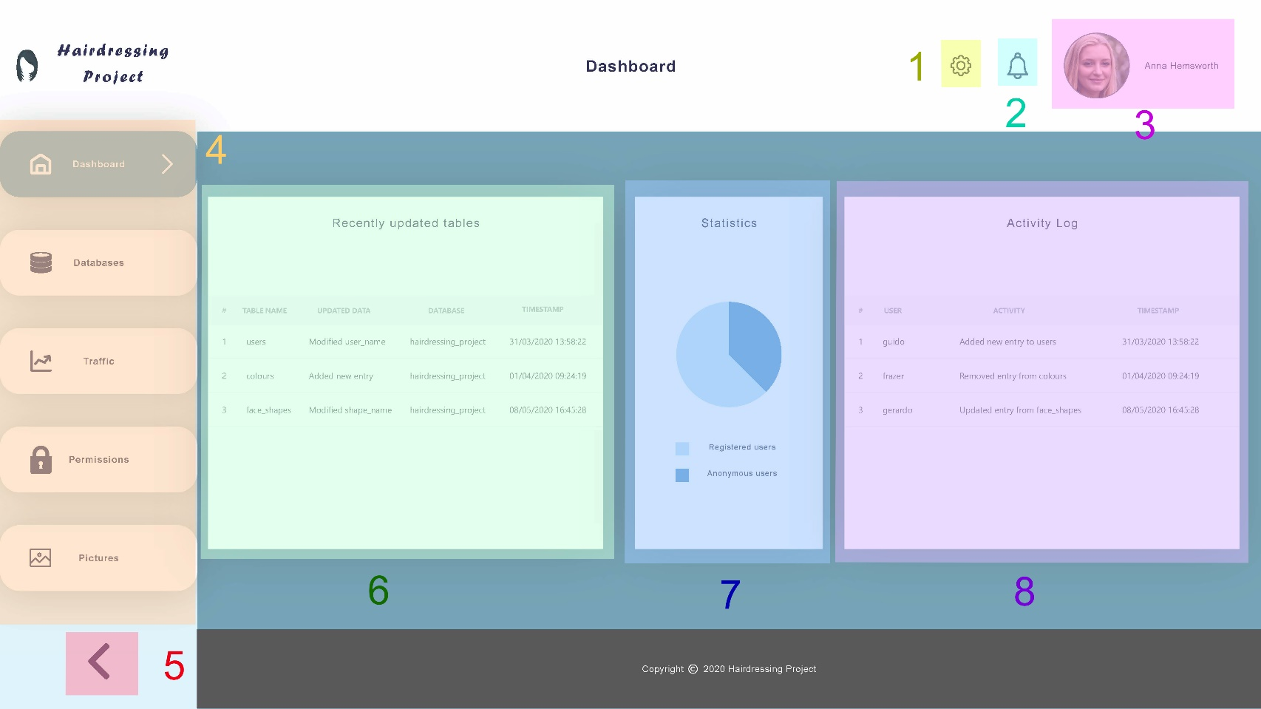

|  |  |  |
| --- | --- | --- |
| Function | Details | Fields |
| Dashboard (home) page | The dashboard is the home page of the admin portal. It is the first page that users see after signing in. | (1) Settings button  (2) Notifications button  (3) Profile picture and name  (4) Sidebar with links  (5) Collapse sidebar button  (6) Recently updated tables  (7) Statistics pie chart  (8) Activity log table |
| The settings button exposes a menu containing links for account information, logout and more. |
| Clicking on the notifications button should show a small panel with the latest (important) changes in the databases or in the current user’s account, such as password or permissions. It should also display a switch button with the option to disable such notifications. |
| The sidebar is the main navigation element of the admin portal. Clicking on each button should redirect users to the respective page. |
| Recently updated tables should show which column/row has been modified, with the name of the respective table and database and a timestamp. |
| The statistics section should display a simple pie chart or graph with useful data about users. |
| Activity log refers to the latest changes specifically made by registered users of the application, with a timestamp. |

# 6. Databases

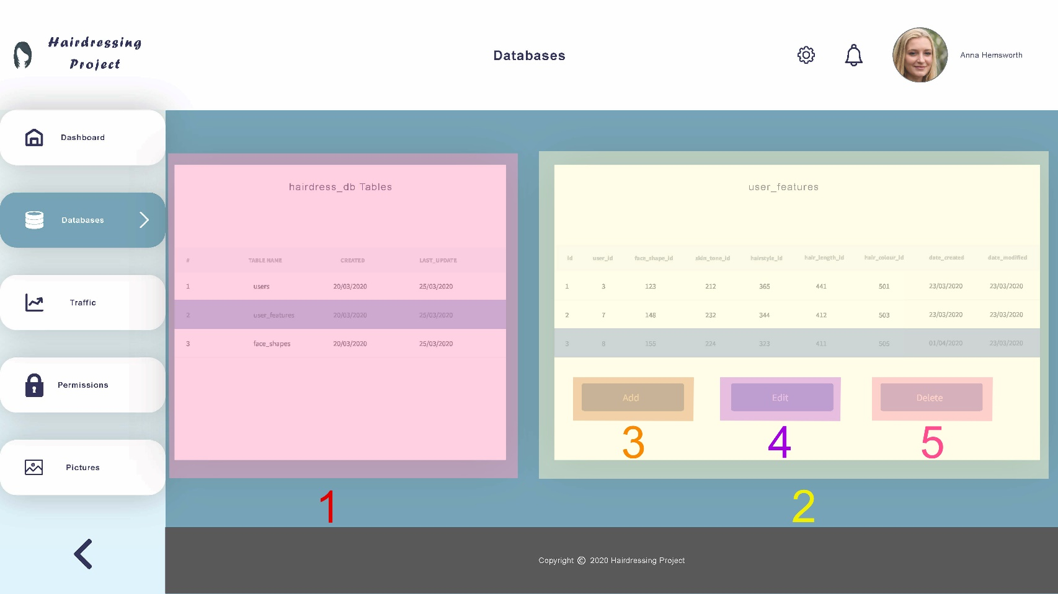

|  |  |  |
| --- | --- | --- |
| Function | Details | Fields |
| Databases page | The databases page should show all tables contained in each database (highlighted by (1)), with timestamps for created at and last updated dates. | (1) Tables section (for each database)  (2) Selected table section  (3) Add new entry button  (4) Edit entry button  (5) Delete entry button |
| When users select a row in the tables section, a new section should pop up at the right (2), showing all entries of the table selected. If no row in the latter is selected, the “edit” and “delete” buttons should remain inactive. |
| The “add” button allows users to create new entries in the selected table and the “edit” and “delete” buttons enable modification of the selected entry. |
| **TODO:**   * Add modals for add, edit and delete entries * Add search entry input field |
| All other UI elements not outlined in the previous picture have already been covered. |

# 7. Traffic

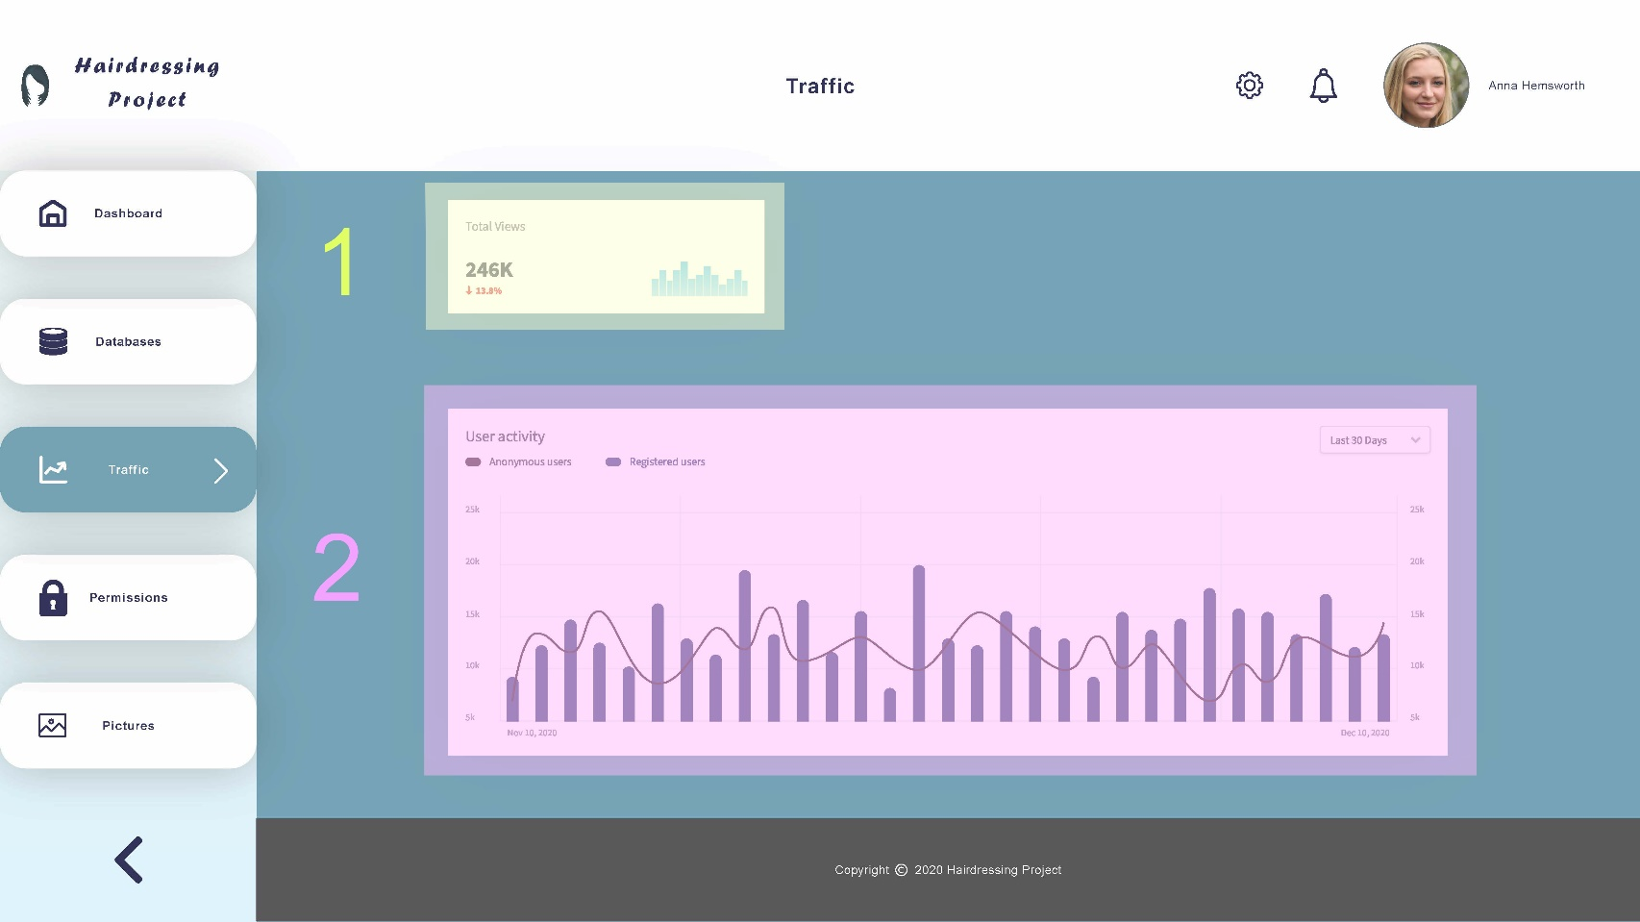

|  |  |  |
| --- | --- | --- |
| Function | Details | Fields |
| Traffic page | The traffic page should show relevant data regarding usage of the Hairdressing application. | (1) Total views data  (2) User activity data |
| The first section (1) should display the number of times that the application has been browsed so far. The total views could optionally count only unique users. |
| The second section (2) should present a graph that summarises user activity in the Hairdressing application by date, which could distinguish registered users from anonymous ones. |
| Ideally, a well-supported JavaScript library would be used to handle data visualisation for this page, so that users would be able to hover or click on specific points in the graph to see more details about the corresponding dates. |
| All other UI elements not outlined in the previous picture have already been covered. |

# 8. Permissions

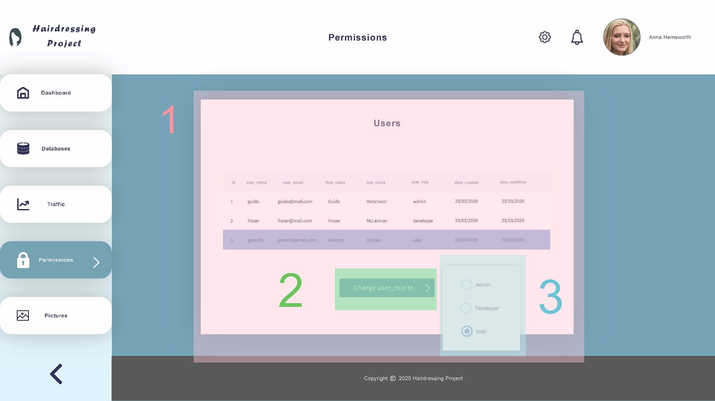

|  |  |  |
| --- | --- | --- |
| Function | Details | Fields |
| Permissions page | The permissions page allows admins to change the role of any registered user. As such, it can only be viewed by users with “admin” as their user_role | (1) Users table (main section)  (2) Change user_role to button  (3) User role drop-right |
| The main section of the page (1) shows all entries of the “users” table. If there is no entry currently selected, the “change user_role to” button (2) should be disabled. |
| Once a user is selected, clicking on the “change user_role to” button (2) should open a small drop-right with all the available user roles as radio buttons (3). |
| After a user role is chosen, the “users” table should be automatically updated. A feedback message should be displayed at the top of the page. |
| All other UI elements not outlined in the previous picture have already been covered. |

# 9. Pictures

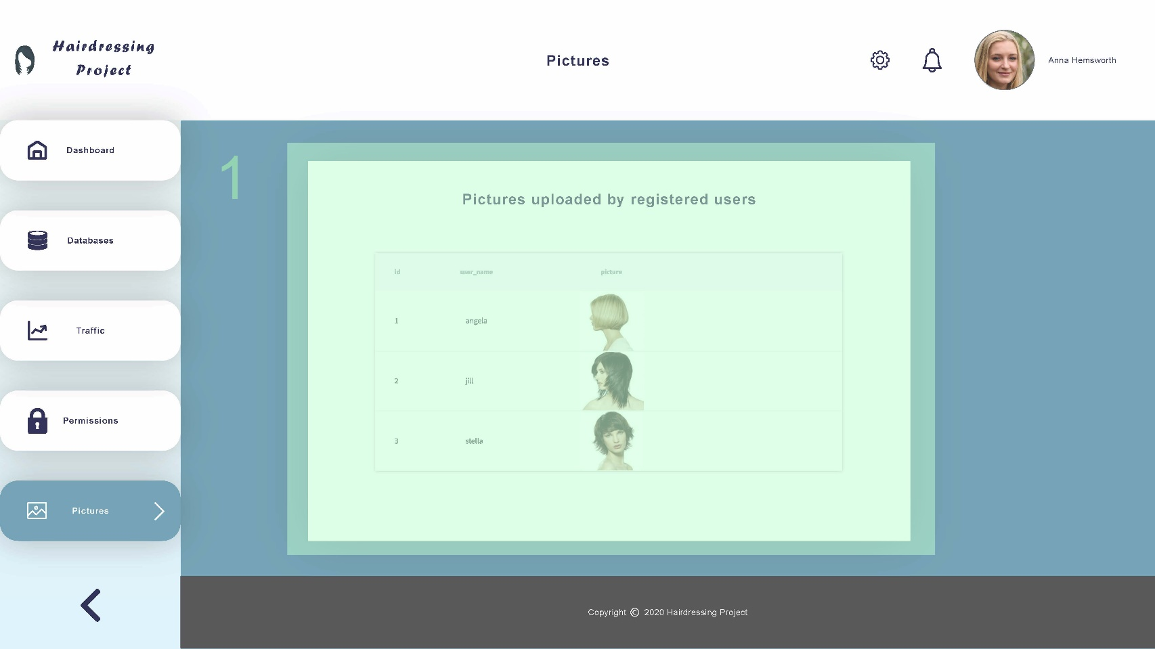

|  |  |  |
| --- | --- | --- |
| Function | Details | Fields |
| Pictures page | The pictures page should display user-submitted pictures from the Hairdressing application. Those pictures are not present in the databases, they are stored in a separate cloud instance (possibly AWS S3), which is why this page is needed. | (1) Pictures uploaded (main section) |
| The main section of this page (1) should show all pictures available in the cloud storage in a table, sorted by user/user id. |
| Double-clicking on a row should bring users to the URL where pictures submitted by that particular user is stored in the cloud. |
| **Note:** See the project specification document for more info about how pictures are handled in this project. |
| All other UI elements not outlined in the previous picture have already been covered. |