hairdressing PROJECT  
project specification

30/03/2020

# Version control

|  |  |  |
| --- | --- | --- |
| Author | Changes | Date |
| Diego C. | Initial release | 30/03/2020 |
| Diego C. | Added mock-ups and diagrams | 31/03/2020 |
| Diego C. | Added more mock-ups | 03/04/2020 |
|  |  |  |
|  |  |  |

Table of Contents

Version control 1

Project Overview 3

1. Background and Description 3

2. General Requirements 3

3. User Story 3

4. Stakeholders 4

Deliverables 5

1. Overview 5

2. Functional Requirements 6

2.1. Admin Portal 6

2.2. Hairdressing Application 6

3. Non-functional Requirements 7

3.1. Admin Portal 7

3.2. Hairdressing Application 7

4. Design 8

4.1. Admin Portal 8

4.2. Database 13

4.3. Hairdressing Application 16

5. Tech stack 17

5.1. Admin Portal 17

5.2. Hairdressing Application 17

# Project Overview

## Background and Description

The **Hairdressing Project** consists of an application that enables users to visualise how they would look like with different hair styles and colours in an interactive manner.

It was assigned to us (Diego Chaves, Frazer McLennan, Stefan Solmundson, Gerardo Gornes and Maddy Ferraloro) as a Diploma of Software Development project to be developed over the year 2020.

It is initially intended to be used by hairdressing students and lecturers at TAFE.

## General Requirements

According to the client, there are three main variables to be considered for this application: **face shape**, **skin tone** and **hair characteristics** (which can be subcategorised by hair style, hair colour and hair length).

Taking into consideration the target audience of this application, it needs to be visual and highly interactive.

## User Story

Hairdressing lecturers and students at North Metropolitan TAFE Balga are currently using mannequins to perform their tasks. This approach has a glaring limitation: it is inflexible, in the sense that mannequins can only give a rough idea of how a person with certain features might look like with a specific hair style.

As such, it would greatly benefit everyone involved in such tasks if they could make use of an application that accurately displays a real person with various hair styles that are suitable to their needs.

*(TO DO: Distribute user cards to users / clients to let write short sentences in the following format: “As a user, I would like to be able to see how I would look like from multiple angles in the application”)*

## Stakeholders

|  |  |
| --- | --- |
| Name | Role |
| Diego Craveiro Chaves | Developer |
| Frazer McLennan | Developer |
| Stefan Solmundson | Developer |
| Gerardo Gornes | Developer |
| Maddy Ferraloro | Developer |
| Keith Critchett | Client Liaison |
| Jade Uhrbom | Client |
| Dawn Hetherington | Client |
| Delia Stanley | Client |
| Guido Verschoor | Project Manager |

# Deliverables

## Overview

|  |  |  |
| --- | --- | --- |
| Deliverable | Components | Deadline |
| Admin Portal | Wireframes | ? |
| Design | ? |
| Application | ? |
| Database | Design | ? |
| Application | ? |
| Hairdressing Application | Wireframes | ? |
| Design | ? |
| Application | ? |

## Functional Requirements

### 2.1. Admin Portal

The Admin Portal should have:

* User authentication / authorisation
* Dashboard
* List of databases
* Separate pages for each database / table
* Data graphs and statistics (e.g. “four new hair styles have been added in the past week”)
* Activity log
* Application and user settings
* Browse / Read / Edit / Add / Delete pages for each table
* Recover account / password

### 2.2. Hairdressing Application

The Hairdressing Application should have:

* User authentication / authorisation, with an option to use the application anonymously
* History of pictures and selected face shapes / skin tones / hair characteristics
* Pictures of pre-set models for each feature as examples
* Diagrams for each feature
* Colour picker
* Option to take pictures from multiple angles to map to 3D imagery (rotating head)
* Suggested hair styles based on certain features detected on images uploaded by user

## Non-functional Requirements

### 3.1. Admin Portal

The Admin Portal should be:

* Secure
* Well documented
* Performant
* Robust
* Reliable, have acceptable fault tolerance
* Interoperable with the Hairdressing Application
* Transparent

### 3.2. Hairdressing Application

The Hairdressing Application should be:

* User friendly, with an attractive UI
* Highly interactive
* Responsive
* Easy to modify
* Scalable
* Maintainable

## Design

### 4.1. Admin Portal

*(Wireframes and mock-ups go here)*

See the **Admin_Functions.docx** file for a detailed explanation of each UI element present in the following pages.

#### 4.1.1. Sign up page (desktop 1920x1080):

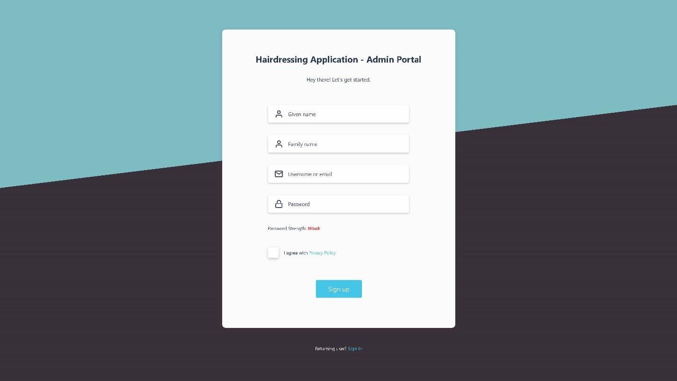

#### 4.1.2. Sign in page (desktop 1920x1080):

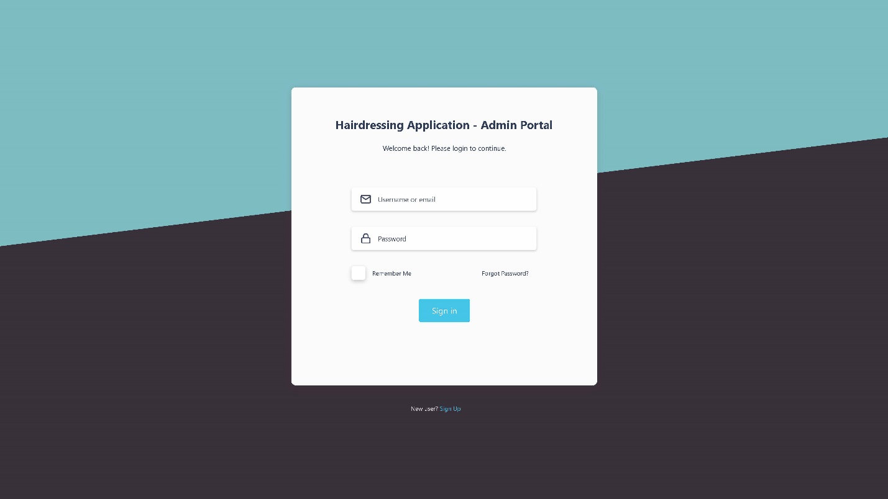

#### 4.1.3. Forgot password page (desktop 1920x1080):

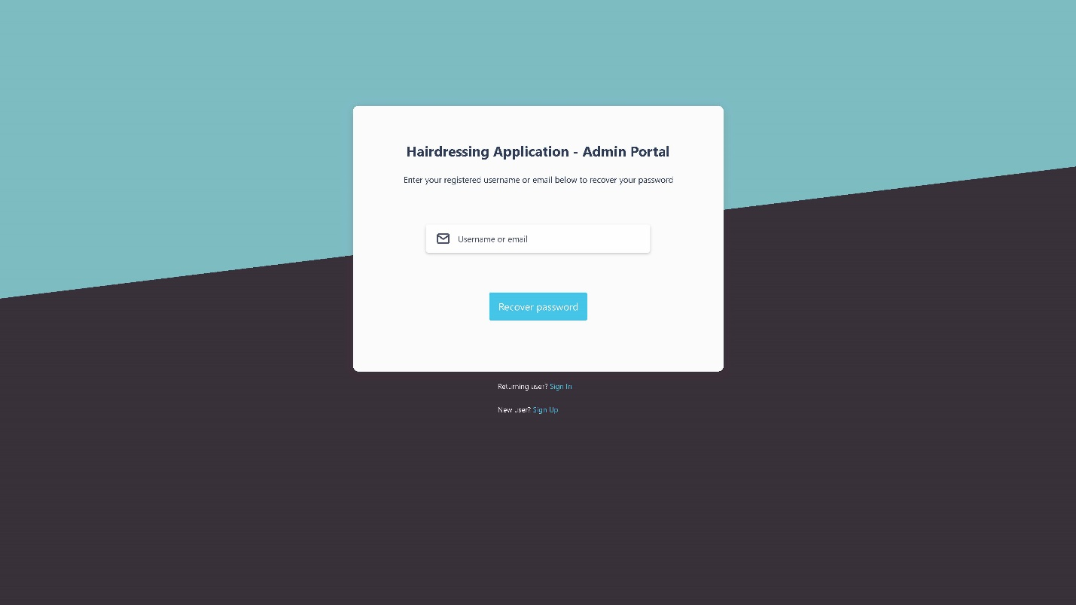

#### 4.1.4. New password page (desktop 1920x1080):

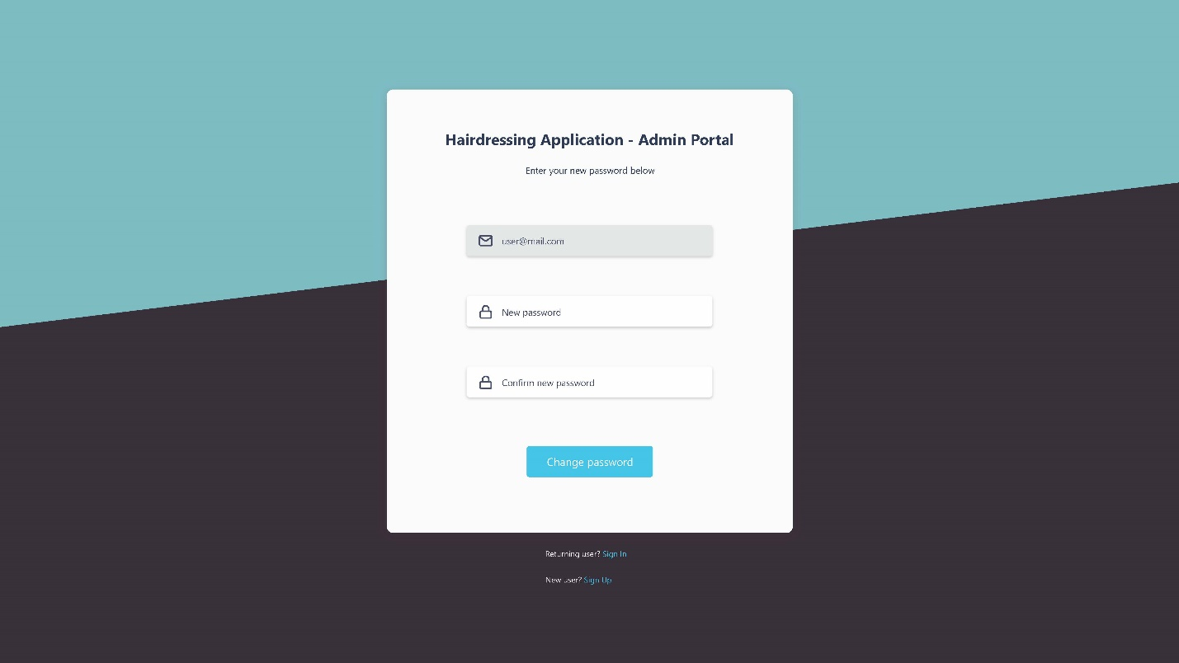

#### 4.1.5. Dashboard (home) page (desktop 1920x1080)

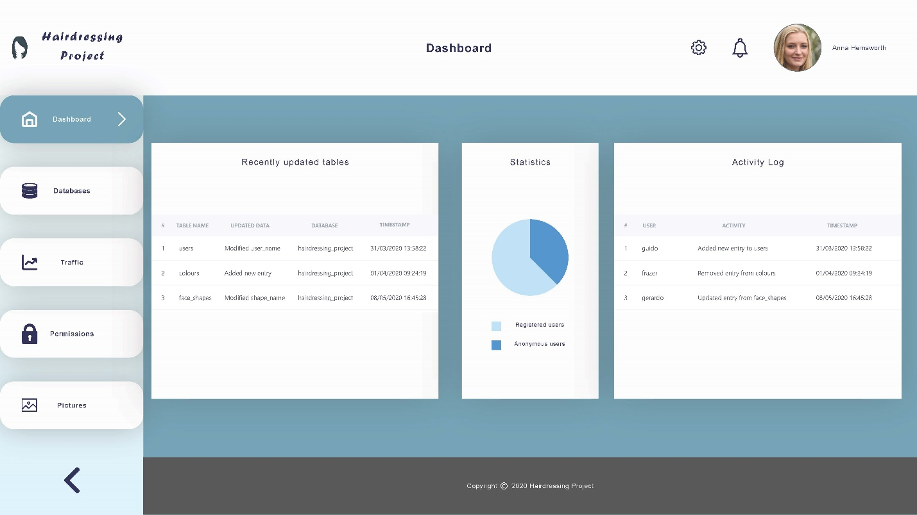

#### 4.1.6. Databases page (desktop 1920x1080)

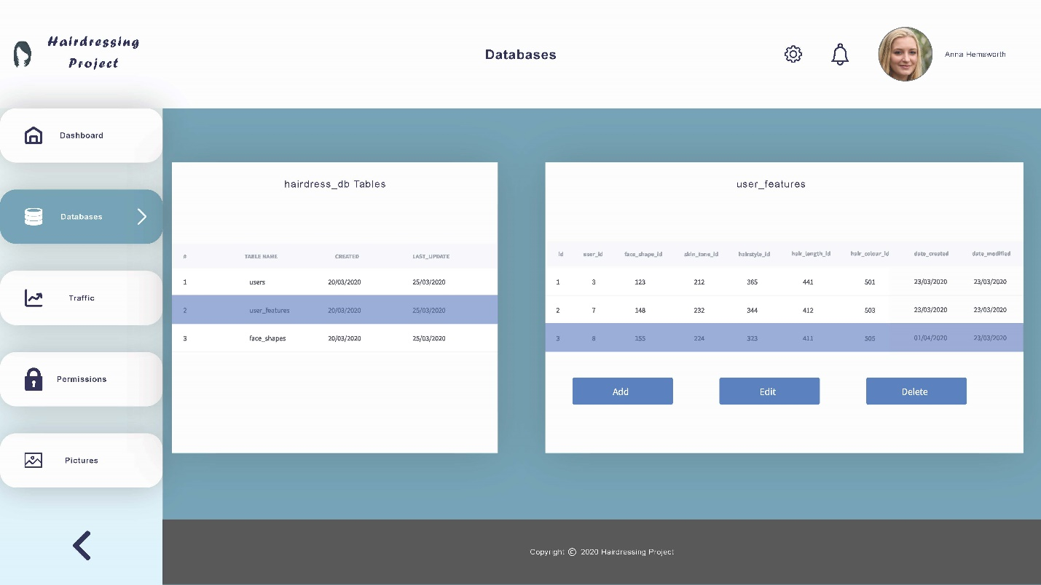

#### 4.1.7. Traffic page (desktop 1920x1080)

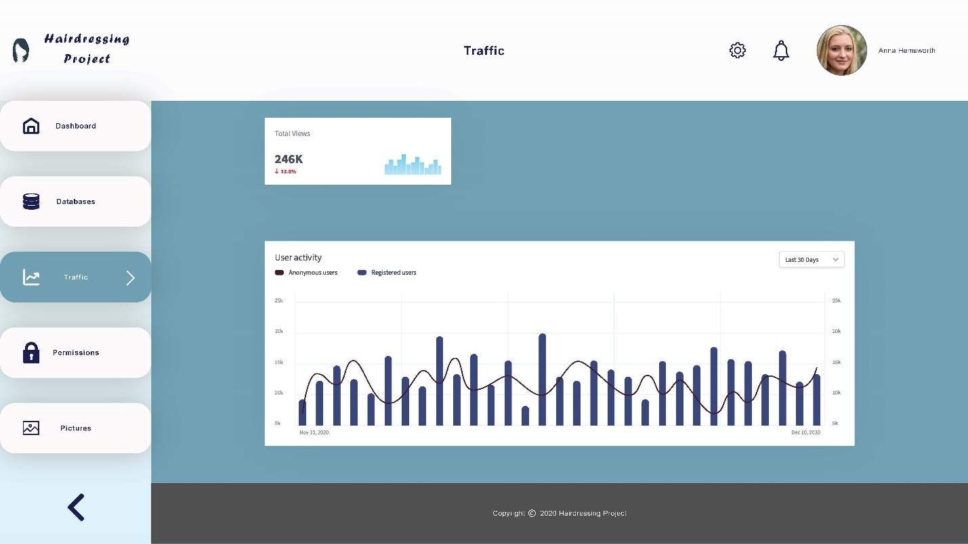

#### 4.1.8. Permissions page (desktop 1920x1080)

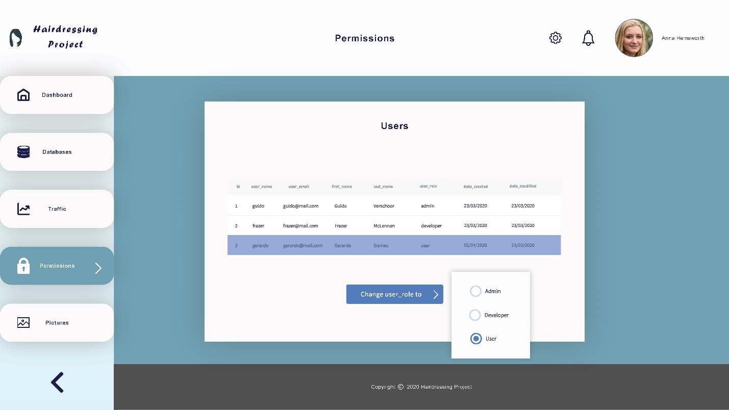

#### 4.1.9. Pictures page (desktop 1920x1080)

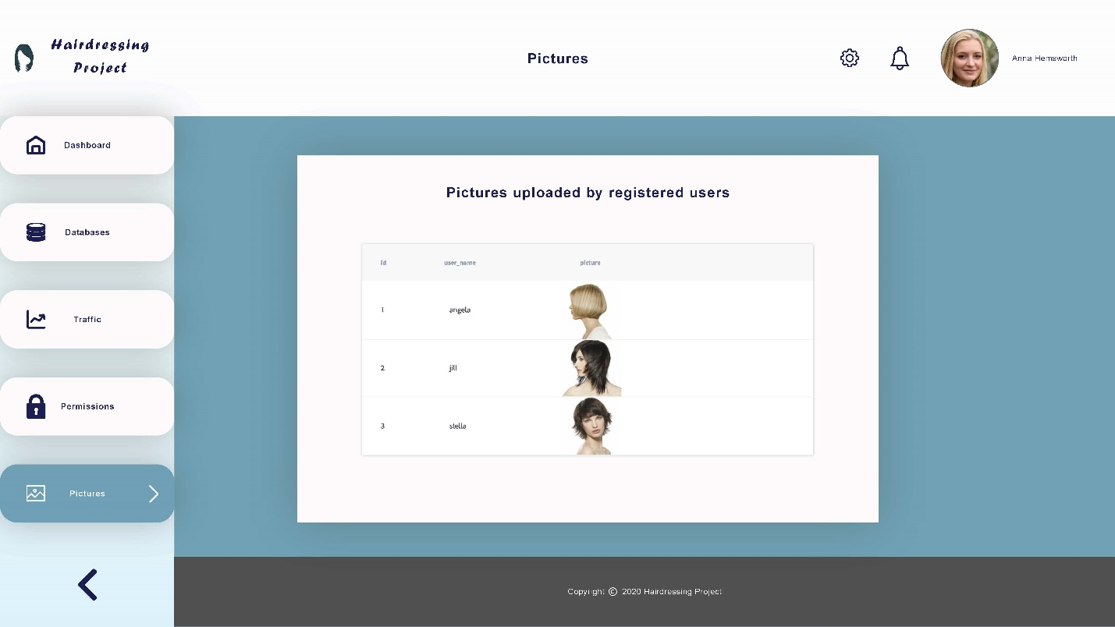

### 4.2. Database

*(Diagrams go here)*

The diagrams can be visualised in more detail at: <https://dbdiagram.io/d/5e82af534495b02c3b890292>

Where “user_role” is an enum with three options: user, admin and developer.

### 4.3. Hairdressing Application

*(Wireframes and mock-ups go here)*

## Tech stack

### 5.1. Admin Portal

*(Describe what languages / frameworks we are going to use for the admin portal here)*

### 5.2. Hairdressing Application

*(Describe what languages / frameworks we are going to use for the hairdressing app here)*