Comparisons take 1

S. Haire

2022-09-02

### A first report exploring data distributions between sample years, burn severity classes, and vegetation/cover types.

### Basic boxplots and comparison statistics

The first plot compares the distribution of basal area values measured in 1996 and 2015. The p-value gives a sense of difference in the two groups from a t-test. The graphs divide the data into cover types (columns doing down) and severity levels (rows going across).

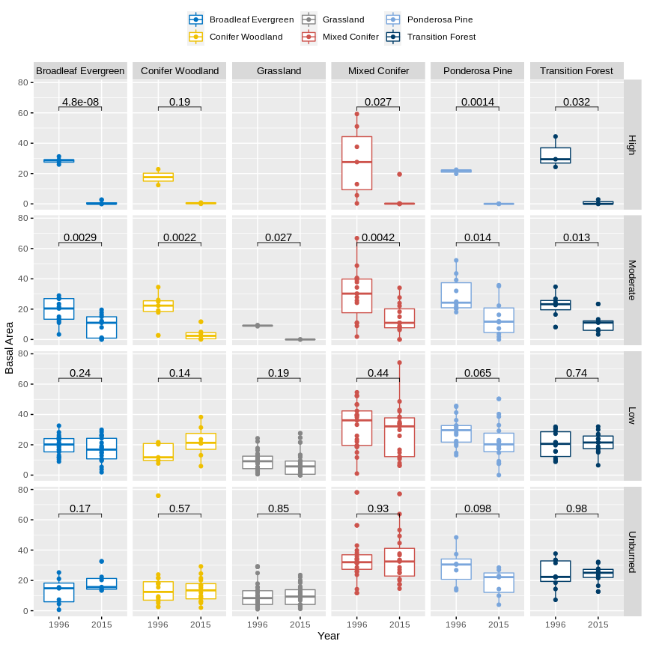

The second plots compare measured values of Trees per Hectare.

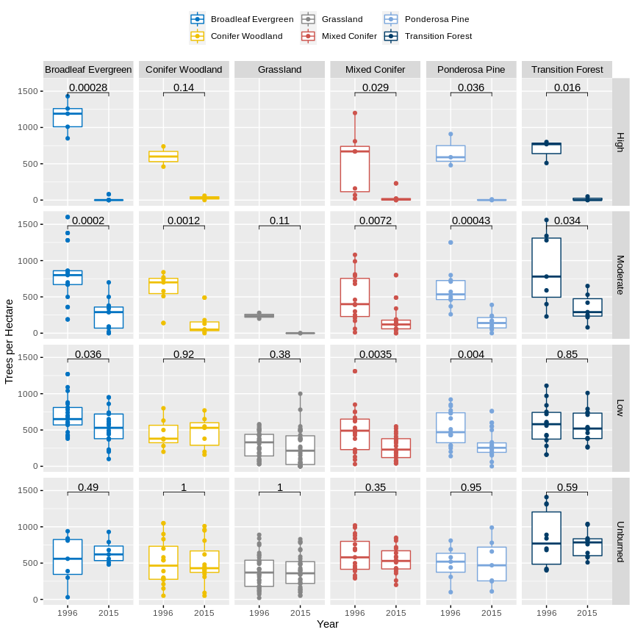

Trying out a new package! Coming soon…“corset plots.” These are pretty cool:) <https://cran.r-project.org/web/packages/ggcorset/vignettes/corset_plot_intro.html>