Terrain plots

S. Haire

2022-09-02

### Exploring terrain metrics at the field plot locations

### Topography can influence many ecological processes because it is closely related to microclimates and their effects on soil properties, seed dispersal and germination, tree regeneration and growth. It is also a major factor in fire spread, both in facilitating spread and creating shelters or firebreaks. This report takes a first look at the topographic characteristics of the plot locations by covertype and by mountain range.

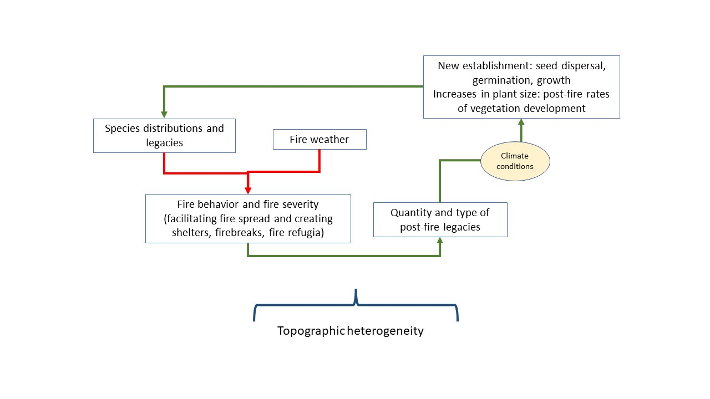

Conceptual model of the patterns and processes influenced by topographic heterogeneity

#### A summary of sample size for each cover type.

| covertype | n |
| --- | --- |
| Mixed Conifer Forest | 62 |
| Broadleaf Evergreen Woodland | 46 |
| Ponderosa Pine Forest | 38 |
| Conifer Woodland | 32 |

### Plots of topographic variables

