Tools and Language that we use

* PHP
* HTML
* CSS
* JavaScript
* Laragon

1. Login Page

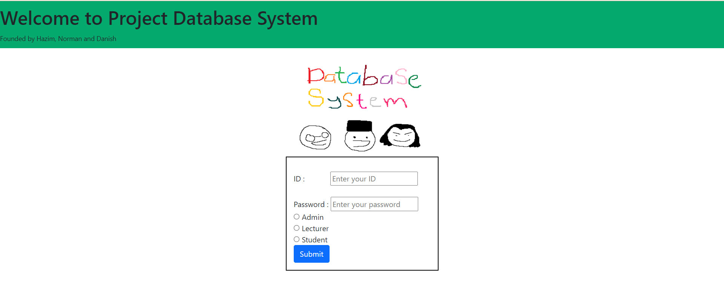

1. Module for Admin

* Register Admin

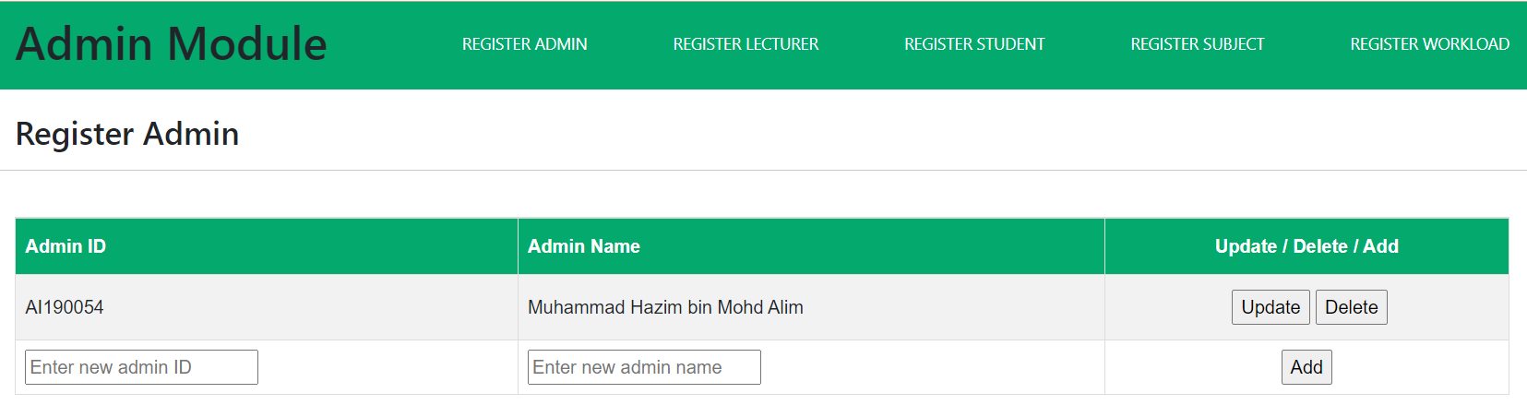

* Register Student

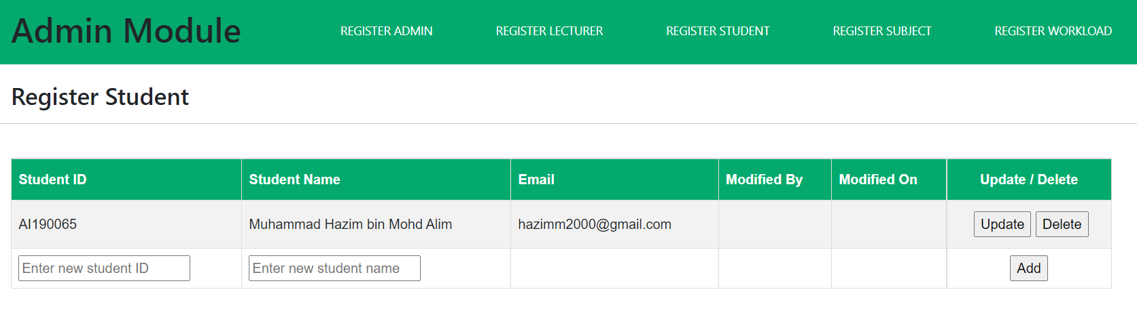

* Register Lecturer

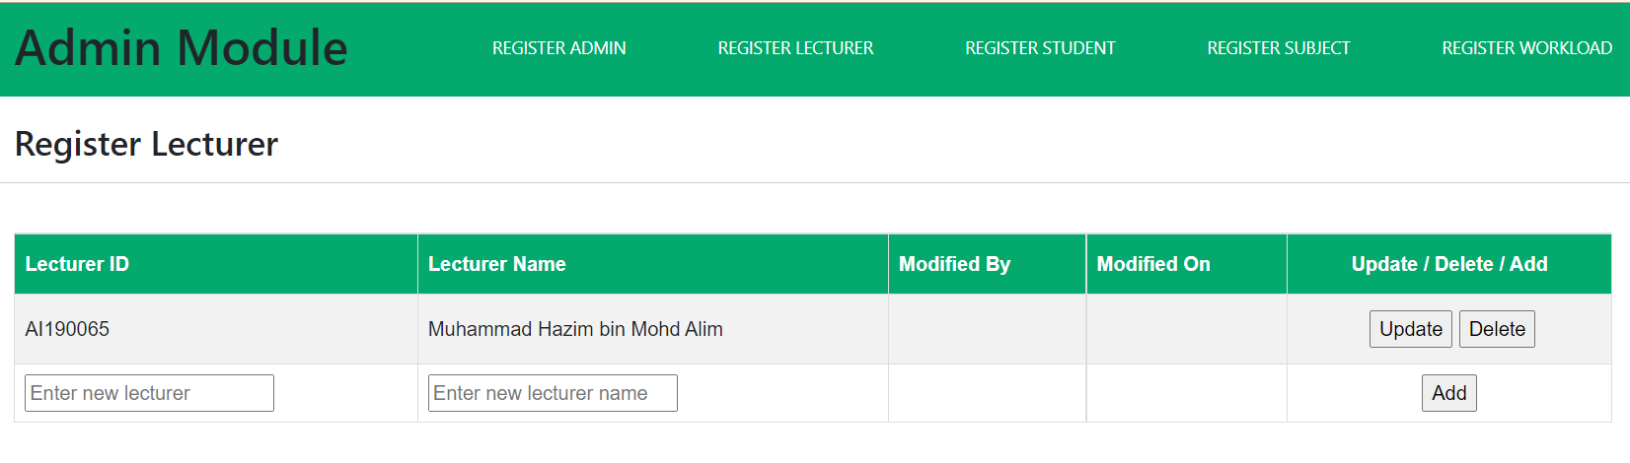

* Register Subject

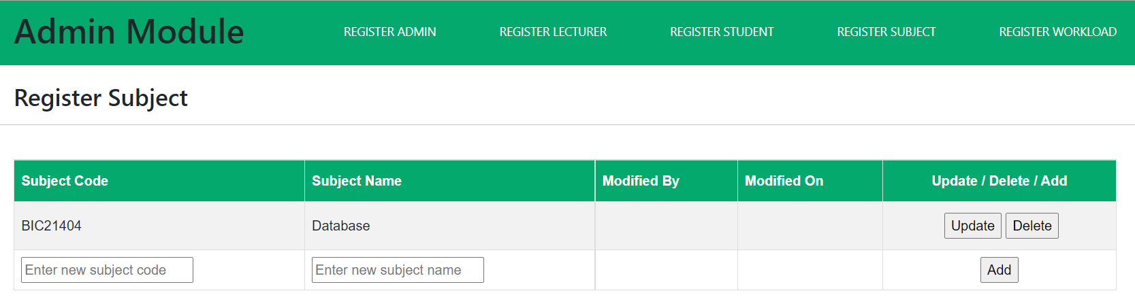

* Register Workload

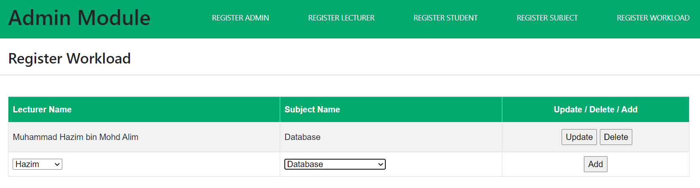

1. Module for Lecturer

* Lecturer model homepage

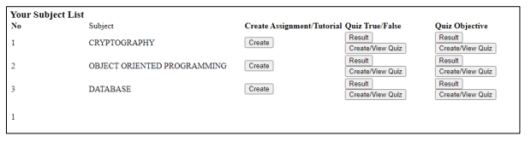

1. Module for Student

* Student Register Subject

