OOP Project: Plants vs Zombies

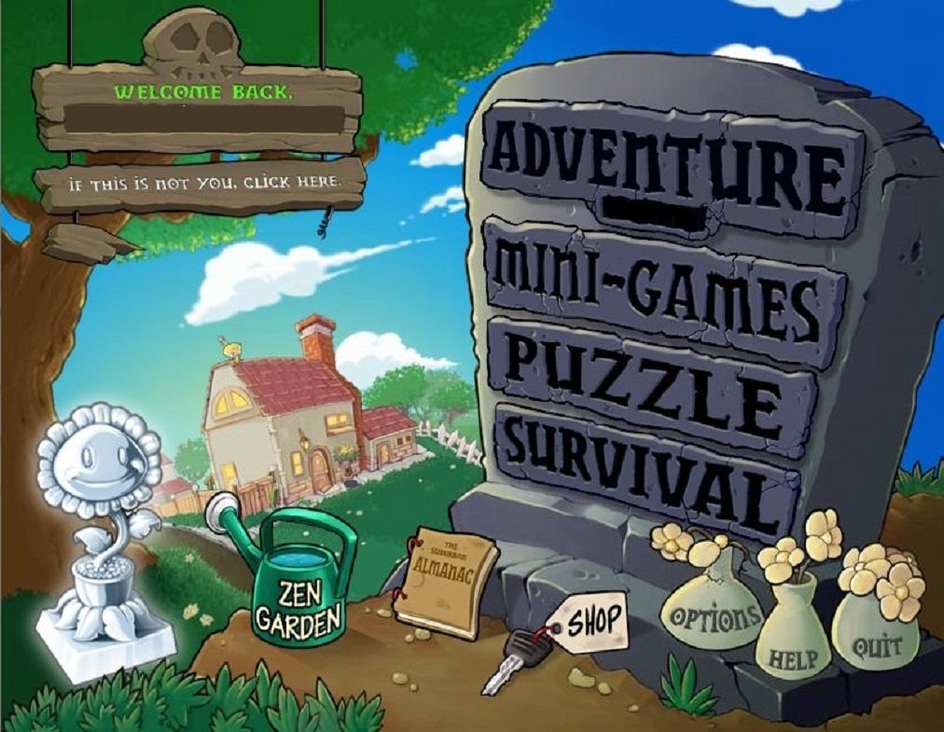

Member

Nguyễn Văn Hào ITITIU18278

Phạm Đông Hải ITITUN18014

I/ Introduction

In our report, we remake the other versions of Plants vs Zombies was made by PopCap Games. I will briefly introduce our game.

This link is connect to github where we store our source code.

<https://github.com/Haiseal/PlantvsZom>

II/ Game rule

The game has 2 levels.

Level 1 will end when you kill 15 zombies.

Level 2 is similar to level 1, but it has ConeHeadZombie with higher health.

Each level you are provided 150 sun and three kinds of plant (Peashooter, FreezePeashooter, Sunflower) to help you against zombies.

IV/ UML and Desgin

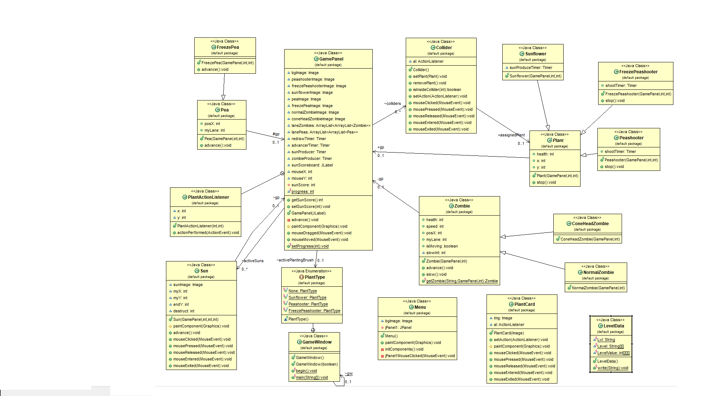

.GamePanel is a super class tool for displaying Zombie type plants and zombies, LanePea and LaneZombies, Matchtime and Element Regeneration

.We create PlantType enum class to build three types of plants: Sunflower, Peashooter,FreezePeaShooter.

.FreezePea,Pea and Sun are three subclass of GamePanel: They include position and Lane . FreezePea is a subclass of Pea .Sun class show user position and the user must click mouse to get Sunscore.

.Zombie class is a gamepanel subclass. Zombie has two types: ConeHead and Normal. Class show heath, speed, position, laneZombie, zombie moving status,...

.The Plants class includes 3 subclasses: Peashooter, FreezePeaShooter, Sunflower. In addition, the Plants class shows heath and plant position 3 subclasses also show the time life of each plant.

.PlantCard class allow the user set appropriate plant by click mouse.

.Menu class is used to perform tasks before starting the game.

.LevelData class is used to store the level achieved by the player after each level of play.