VHDL Code for the vending machine
entity myvend is
Port ( clock : in STD_LOGIC;
reset : in STD_LOGIC;
money : in STD_LOGIC_VECTOR (1 downto 0);
vend : out STD_LOGIC);
end myvend;

architecture moore of myvend is
type states is (zerocents, fivecents, tencents, fifteencents);
signal currentstate: states;

begin
process(clock,reset)
begin
if reset='1' then
currentstate <= zerocents;
elsif(clock'event and clock='1') then
case currentstate is
when zerocents =>
if money="00" then currentstate <= zerocents;
elsif money="01" then currentstate <= fivecents;
elsif money="10" then currentstate <= tencents;
elsif money="11" then currentstate <= zerocents;
end if;

when fivecents =>
if money="00" then currentstate <= fivecents;
elsif money="01" then currentstate <= tencents;
elsif money="10" then currentstate <= fifteencents;
elsif money="11" then currentstate <= fifteencents;
end if;

when tencents =>
if money ="00" then currentstate <= tencents;
elsif money="01" then currentstate <= fifteencents;
elsif money="10" then currentstate <= fifteencents;
elsif money="11" then currentstate <= fifteencents;
end if;

when fifteencents =>
if money="00" then currentstate <= fifteencents;
elsif money="01" then currentstate <= fifteencents;
elsif money="10" then currentstate <= fifteencents;
elsif money="11" then currentstate <= fifteencents;
end if;

end case;
end if;
end process;

process(currentstate)
begin
case(currentstate) is
when zerocents => vend <= '0';
when fivecents => vend <= '0';
when tencents => vend <= '0';
when fifteencents => vend <= '1';
end case;
end process;

end moore;

Waveform Capture from the Vending Machine Simulation

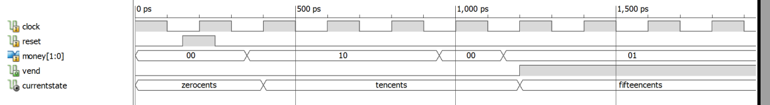

Top Level Design

2.1: VHDL Code for the top level design with debouncers

entity top_level is
Port ( clock : in STD_LOGIC;
money : in STD_LOGIC_VECTOR (1 downto 0);
reset : in STD_LOGIC;
vend : out STD_LOGIC);
end top_level;

architecture Behavioral of top_level is

component clkdiv is
Port ( clk : in STD_LOGIC;
clkdiv : out STD_LOGIC);
end component;

component debounce is
Port ( D_IN : in STD_LOGIC;
reset : in STD_LOGIC;
clock : in STD_LOGIC;
Q_OUT : out STD_LOGIC);
end component;

component myvend is
Port ( clock : in STD_LOGIC;
reset : in STD_LOGIC;
money : in STD_LOGIC_VECTOR (1 downto 0);
vend : out STD_LOGIC);
end component;

signal sysclk: STD_LOGIC;
signal signalbounce: STD_LOGIC_VECTOR(1 downto 0);
begin
theclkdiv: clkdiv port map(clock, sysclk);
debounce1: debounce port map(money(0), reset, sysclk, signalbounce(0));
debounce2: debounce port map(money(1), reset, sysclk, signalbounce(1));
thevend: myvend port map( sysclk, reset, signalbounce, vend);

end Behavioral;

Complete Waveform Captures from the Top Level Simulation

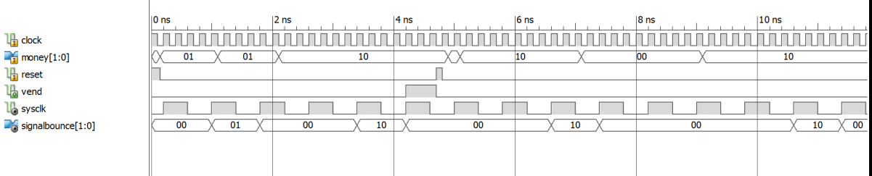Timing and Area Summary

Timing Summary:
---------------
Speed Grade: -1

Minimum period: 2.445ns (Maximum Frequency: 409.082MHz)
Minimum input arrival time before clock: 0.940ns
Maximum output required time after clock: 1.551ns
Maximum combinational path delay: No path found

Timing Details:
---------------
All values displayed in nanoseconds (ns)

=========================================================================
Timing constraint: Default period analysis for Clock 'theclkdiv/clkcount_15'
Clock period: 1.905ns (frequency: 524.934MHz)
Total number of paths / destination ports: 20 / 6
-------------------------------------------------------------------------
Delay: 1.905ns (Levels of Logic = 2)
Source: debounce1/Q1 (FF)
Destination: thevend/currentstate_FSM_FFd2 (FF)
Source Clock: theclkdiv/clkcount_15 rising
Destination Clock: theclkdiv/clkcount_15 rising

Data Path: debounce1/Q1 to thevend/currentstate_FSM_FFd2
Gate Net
Cell:in->out fanout Delay Delay Logical Name (Net Name)
---------------------------------------- ------------
FDC:C->Q 2 0.478 0.722 debounce1/Q1 (debounce1/Q1)
LUT3:I0->O 2 0.124 0.427 debounce1/Q_OUT1 (signalbounce<0>)
LUT6:I5->O 1 0.124 0.000 thevend/currentstate_FSM_FFd1-In1 (thevend/currentstate_FSM_FFd1-In)
FDC:D 0.030 thevend/currentstate_FSM_FFd1
----------------------------------------
Total 1.905ns (0.756ns logic, 1.149ns route)
(39.7% logic, 60.3% route)

Usage Summary:

Primitive and Black Box Usage:
------------------------------
# BELS : 53
# GND : 1
# INV : 1
# LUT1 : 15
# LUT2 : 1
# LUT3 : 1
# LUT6 : 2
# MUXCY : 15
# VCC : 1
# XORCY : 16
# FlipFlops/Latches : 24
# FD : 16
# FDC : 8
# Clock Buffers : 1
# BUFGP : 1
# IO Buffers : 4
# IBUF : 3
# OBUF : 1

Device utilization summary:
---------------------------

Selected Device : 7a100tcsg324-1

Slice Logic Utilization:
Number of Slice Registers: 24 out of 126800 0%
Number of Slice LUTs: 20 out of 63400 0%
Number used as Logic: 20 out of 63400 0%

Slice Logic Distribution:
Number of LUT Flip Flop pairs used: 26
Number with an unused Flip Flop: 2 out of 26 7%
Number with an unused LUT: 6 out of 26 23%
Number of fully used LUT-FF pairs: 18 out of 26 69%
Number of unique control sets: 2

IO Utilization:
Number of IOs: 5
Number of bonded IOBs: 5 out of 210 2%

Specific Feature Utilization:
Number of BUFG/BUFGCTRL/BUFHCEs: 1 out of 128 0%

Total memory usage is 446424 kilobytes

Number of errors : 0 ( 0 filtered)
Number of warnings : 0 ( 0 filtered)
Number of infos : 1 ( 0 filtered)

