Link Budget Calculation: Wireless Link Project

Haitham Babbili, Hozaifa Abdelgadir, Josefine ˚Aberg, Oscar Wallin, Yagnasri Eswarasai Pavankumarreddy Telluri

November 2021

# Introduction

In the course Wireless link project (MCC125) the task is to design and construct a wireless commu- nication system that can communicate over 100 m. This document explains the link budget for the project.

# Design

The system is designed to operate at QPSK and 16-QAM. Assuming a maximum *BER* = 10*−*5 which requires a *SNR* = 24*.*7 dB for QPSK and a *SNR* = 28*.*5 dB for 16-QAM respectively according to equation below.

SNR= $\frac{EbRb}{n0B}$

|  |  |  |  |
| --- | --- | --- | --- |
| Modulation | Eb/n0 db | Rb/B | SNR dB |
| 16-QAM | 13.4 | 4 | 28*.*5 |
| QPSK | 9.6 | 2 | 24*.*7 |

The transmitted message is a text message using a bit rate of 80 Kbps. The sampling rate is 1562500 Hz and the bandwidth is 40 KHz for QPSK and 20 KHz when using 16-QAM.

* 1. **Hardware Design**

The transmitter is designed as shown in the figure 1.

The specifications of the transmitter elements @2.4 GHz@+25C are shown in the table 1. The calculated gain delivered by the transmitter is 19.2 dB with an output power of 16.4 dBm.

Table 1: Transmitter Block Elements

|  |  |  |  |  |  |
| --- | --- | --- | --- | --- | --- |
| **Elements** | **Input Power**  **(dBm)** | **Output Power**  **(dBm)** | **Gain**  **(dB)** | **Noise Figure**  **(dB)** | **Input P1dB**  **(dBm)** |
| USRP Transm (N210) | - | -2.8 | - | - | - |
| Attenuator | -2.8 | -10 | -12.8 |  |  |
| Power Amplifier -1:  (HMC480) | -12.8 | 4.2 | 10 | 3 | 8 |
| Mixer:  (HMC213 RF) | 4.2 | -5.6 | -9.8 | 5 | 9 |
| Power Amplifier - 2:  (HMC347) | -5.6 | 4.4 | 10 | 3 | 8 |
| Power Amplifier - 3:  (HMC636ST89E) | 4.4 | 16.4 | 12 | 3 | 22 |

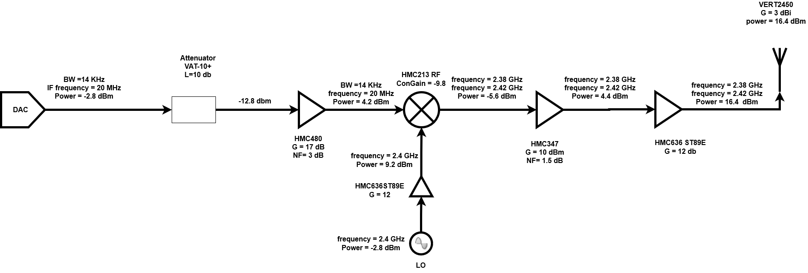

Figure 1: Transmitter Block Diagram

Free space propagation:

100 meter is considered short distance, we can neglect attenuation and we will only have free space loss which according to equation is depends on the frequency and antennas gain Gt, Gr, for both Tx and Rx we will use VERT2450 antenna with 3 dbi gain.

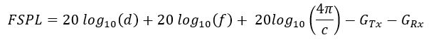

FSL = 74 db.

The specifications of the Receiver elements @2.4 GHz@+25C are shown in the table 2.

Table 2: Receiver Block Elements

|  |  |  |  |  |
| --- | --- | --- | --- | --- |
| **Elements** | **Input Power**  **(dBm)** | **Output Power**  **(dBm)** | **Gain**  **(dB)** | **Noise figure**  **(dB)** |
| Bandpass filter:  VBF2435+ | -57.6 | -59.5 | -1.9 | - |
| Low Noise Amplifier:  HMC374E | -59.5 | -49.5 | 10 | 1.5 |
| Mixer  HMC213 IF | -49.5 | -59.5 | -10 | 5 |
| Power Amplifier  HMC480 | -59.5 | -44.5 | 15 | 3 |
| Power Amplifier  HMC480 | -44.5 | -29.5 | 15 | 3 |
| Low-pass Filter  SBLP-39+ | -29.5 | -31.5 | -2 | 2 |

The receiver is designed as shown in the figure 2. The noise figure of receiver is 4 dB with a total gain of 28.3 dB.

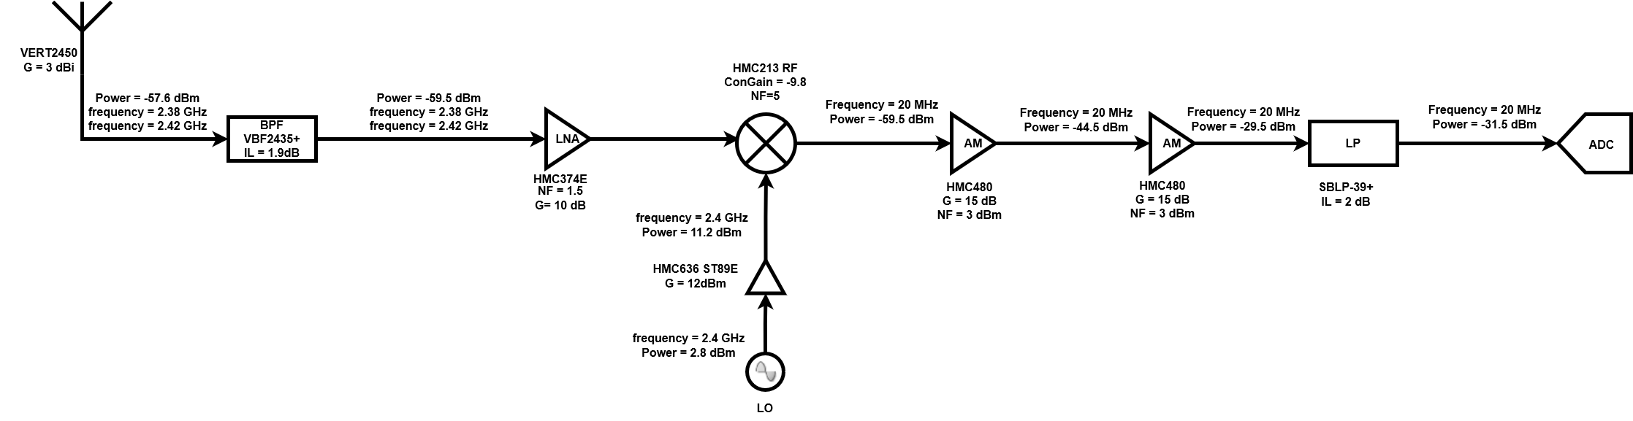

Figure 2: Receiver Block Diagram

Receiver calculation:

Noise figure, gain and 1 db compression point as equations below

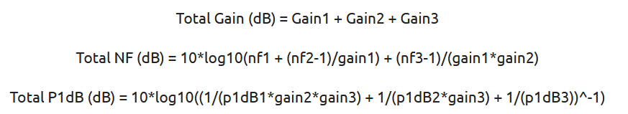

NF = 4 db (for first 3 stages)

Gain = 28.3 db

P1db = 4.8 dbm

# Frequency

The frequency of the local oscillator (*Flo*) is set to 2.4 GHz. The intermediate frequency (*FIF* ) is set to 20 MHz. The transmitted frequency can be calculated as Eq.(1).

*FRF* = *Flo ± FIF* (1)

Hence, the *FRF* = 2*.*4 *±* 0*.*02.

# Noise Performance

The noise figure of the receiver is calculated to be 4 dB. The system input thermal noise depends on the antenna temperature which can be calculated from Eq.(2).

*Ta* = *er × Tb* + (1 *− er*) *× Tp*

Where:

er: anttena radiation efficiency = 0.9 , Tb: Brightness temperature = 300K, Tp: physical temperature = 300K

Ta= 300 K

Below table show the targeted 16QAM, QPSK related SNR sensitivity and SNR margin for our case (-2.8 dbm from USRP and -57.6 dbm at the receiver input), we can calculate the receiver sensitivity according to the equation below:



Where Fsys is the receiver noise figure, T0 room temperature in K and B is Bandwidth.

|  |  |  |  |
| --- | --- | --- | --- |
| Modulation | SNR (dB) | Receiver sensitivity(dBm) | SNR Margin (dB) |
| 16-QAM | 28*.*5 | -99 | 39 |
| QPSK | 24*.*7 | -101 | 41 |