**Exercise 2.14**

Running the command **analyzeNetwork(net)** in the command window, will give a GUI with breakdown of the trainable parameters

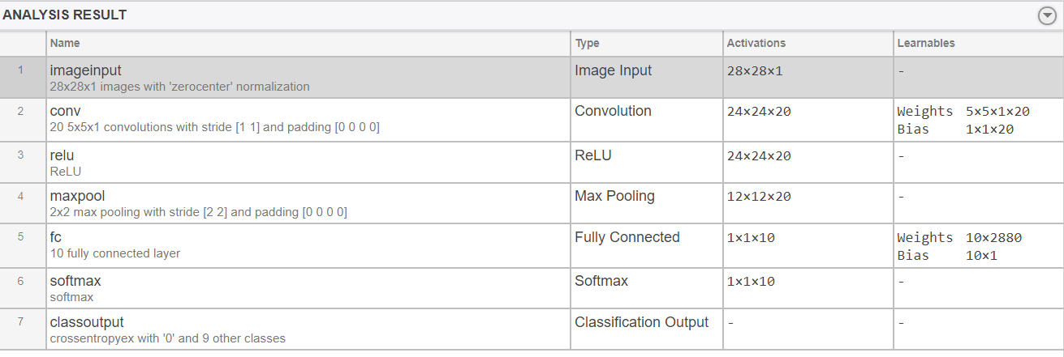

(Dimensions x Filters) + Bias

conv = (20x(5x5) x1) +20 = 520

full con-layer= (2880X10) + 10= 28810

total trainable parameters = 520+ 28810= 29330

**Exercise 2.16**



**Blue layer =** 10x(5x5) x 1 +1

This implies 250 multiplications and 251 additions

The Blue layer time consumption is c250

In our case this implies about c250 multiplications at one position. To apply it to the image, we will multiply it by number of pixels in the image, and it result to c250 x Npix.

**Red layer**: This is placed after two dimensions with 2 maxpooling layer. At each maxpooling layer, the image sizes will reduce by a factor of 2 in each dimension. So after two maxpooling layers, it will go from 5x5 pixels to (5/4) x (5/4) = 5x5/16 pixels

**Exercise 2.17**

Blue layer = 10x(3x3) x1 +1 = 90

When we replace (5x5, 10) convolutional boxes with two (3x3, 10) convolutional boxes. The accuracy will be reduced. It will also take more computational time to perform because we reduced the filter size as compared to the previous scenario. As we decreased the filter size, we decreased the convolutional size that is why it takes more time and give us less accuracy.

**Exercise 2.18**

The better_cnn_classifier.m function file

$$Precision for class label = \frac{number of training set correctly classified as label }{number of training set classified as class label}X100$$

$$Recall for class label = \frac{number of training set correctly classified label}{number of training set from classes }X100$$

classify_accuracy = sum(pred == labels)/length(labels)*100;

Percentage accuracy is 100

recall = sum(pred(rand_trial) == labels(rand_trial))/num_digits *100;

Recall percentage is 100

**Exercise 2.19**

$$Precision for class label_test = \frac{number of image_test correctly classified label_test }{number of label_test classified as class label_test}X100$$

$$Recall for class label_test = \frac{number of image_test correctly classified as label_test }{number of label_test from classes }X100$$

pred_accuracy = sum(pred(rand_trial) == labels_test(rand_trial))/length(rand_trial)*100;

recall = sum(pred(rand_trial) == labels_test(rand_trial))/num_digits *100;

**Percentage accuracy for classification = 1 is 99.3988**

**Recall percentage for classification = 1 is 99.2**

**Percentage accuracy for classification = 2 is 99.1935**

**Recall percentage for classification = 2 is 98.4**

**Percentage accuracy for classification = 3 is 98.9919**

**Recall percentage for classification = 3 is 98.2**

**Percentage accuracy for classification = 4 is 97.8261**

**Recall percentage for classification = 4 is 99**

**Percentage accuracy for classification = 5 is 99.8**

**Recall percentage for classification = 5 is 99.8**

**Percentage accuracy for classification = 6 is 99.8**

**Recall percentage for classification = 6 is 99.8**

**Percentage accuracy for classification = 7 is 99.3927**

**Recall percentage for classification = 7 is 98.2**

**Percentage accuracy for classification = 8 is 98.419**

**Recall percentage for classification = 8 is 99.6**

**Percentage accuracy for classification = 9 is 99.5984**

**Recall percentage for classification = 9 is 99.2**

**Percentage accuracy for classification = 10 is 98.8119**

**Recall percentage for classification = 10 is 99.8**

**For 10 classes**

**98.8119% was classified accurately**

**99.8% was classified accurately**