5G New Radio (NR): Next Generation Radio Access Network

Olalekan Peter Adare  Chalmers University of Technology  SE-412 96 Gothenburg, Sweden  peterad@student.chalmers.se | Haitham Babbili  Chalmers University of Technology  SE-412 96 Gothenburg, Sweden  haitham@student.chalmers.se

Abstract

The mobile network is an ever-growing one, thanks to more demand in the services it offers. The major services simply classified as voice, video, and data. Demand for various new services as off-shoots of multimedia and data services, as well as new use cases, have pushed for a major change in the existing network technology and infrastructure. This has led to optimized solutions for the use of the wireless channel. The wireless channel offers mobility which is the background of quadruple play services and other new services to be offered. There will be greater flexibility, better spectrum efficiency, and support for very low applications. The 5th generation new radio (5G NR) will address a variety of usage scenarios which mainly include enhanced mobile broadband, very low-latency communications and interconnection of a massive number of devices, or the internet of things (IoT). It will leverage on Key technology features like ultra-lean transmission, better support for low latency, more advanced antenna technologies, and spectrum flexibility which covers the use of both the high-frequency bands, inter-working with the low-frequency bands. The write-up gives a concise but yet detailed look into the 5G NR, as put forward by 3GPP (The 3rd Generation Partnership Project), covering standards, design, deployment, and benefits.

Background
This is a research work in partial fulfillment of the requirements for completing the Wireless Network Course, SSY145. The project is built on 5G New Radio (NR), as an innovation in Wireless Access Networks. This is to acquire the needed knowledge of the 5G network, and other related specifications by 3GPP. It will try to answer what pushed for this huge development and its superiority over the previous generational technologies, as well as its compatibility with future technologies.

Introduction
5G new radio (NR) is the access air interface into the 5G network. 5G NR offers a unified and more capable air interface. It has been designed with an extended capacity to enable next-generation user experiences, empower new deployment models, and deliver new services. This is to be achieved with very high data rates in the wireless space, with superior reliability and very low latency. 5G NR covers higher data modulation, channel coding, waveform generation, network slicing, MIMO, frame structures, numerology, hybrid automatic repeat request (HARQ), and duplexing. 5G will expand the mobile ecosystem into new realms. It will improve every industry, from safer transportation, remote healthcare, precision agriculture, digitized logistics, and much more. Incisively, 1G, 2G, 3G, and 4G all led to 5G, which is designed to provide more connectivity than was ever available before.
Going forward, 5G will serve as the foundation for other newer technologies. It will focus on the breakthroughs to support the expansion and enhancement of mobile internet and the Internet of Things (IoT). The future 5G mobile applications defined by the International Telecommunication Union (ITU) in June 2015 are categorized into three types. They are Enhanced Mobile Broadband (eMBB), Massive Machine Type Communication, and Ultra-Reliable and Low-Latency Communication.
Enhanced Mobile Broadband (eMBB) is to facilitate people-to-people exchange as a fundamental requirement set out for mobile communications. eMBB focuses on larger bandwidth and shorter, leading to a tremendous improvement of a user's perceived experience, quality of experience (QoE). Massive Machine Type Communication (mMTC) promotes the increasingly interconnected, Internet of Things (IoT) and other vertical industries, that will bring about a large number of wireless sensor networks, putting a new demand network access quantities and power consumption efficiency. Then, Ultra-Reliable and Low-Latency Communication (uRLLC) revolves around Industry automation, telemedicine, smart grid, and other vertical industries that require high reliability and low latency. Consequently, the key features of the 5G NR encompass ultra-lean carrier design, Scalable OFDM based air-interface, UE Massive MIMO and beamforming, Usage of sub 6GHz, and mmWave spectrum, and scalable numerology. A couple of technological solutions released and standardized over the years have actually made this a reality.

Before 5G
The telecom operators basically offer voice, video, and data services, over varying architectures and technological standards. Building a wireless mobile communication system started in early in the 1980s with first-generation (1G), second-generation (2G) in the 1990s, and Third Generation (3G). 1G was more voice service, 2G was for better voice and now data services. 3G was a unified architecture for voice, video and data, but with reduced capability. High-Speed Packet data Access (HSPA) has been an upgrade to WCDMA (Wideband Code Division Multiple Access) networks used to increase packet data performance. It was upgraded with the advent of High-Speed Packet Access (HSPA/HSPA+) into what was regarded 3.5G, or 3.75G. There has been a push for an All-IP network, like the internet, which is the biggest network in the world, based on the internet protocol. It can be accessed from both the wired and wireless interfaces.
Every generational mobile technology came with a number of limited features and availability until the 4th generation Long Term Evolution (LTE) mobile network released in 2009. The LTE mobile network was offered very high speed for down-link and up-link of data as compared to the previous generation, wider coverage area than before which now opens the door for an enormous amount of applications connected to the mobile network such as Device-to-Device Communication, V2V/V2X, sTTI, remote-controlled drones, massive machine-type communication. Cloud computing networks were growing as well, which could be hosted on the 4G network as well. The features that come with 4G LTE such as spectrum flexibility, Multi-antenna techniques and densification makes its application more than just for mobile networks. The 4G LTE network promised a baseline of 100Mbps for the downlink and more depending on the improvements made. In addition to reduced cost of newer technologies and Low data rates (10 – 100 kbit/s), that can allow for a large number of devices to connect to the network, the latest statistic from Ericsson Mobility Report gave insight a prediction of 160 exabytes per month by the end of 2024. This will come with more need to ultra-low latency, in the order of nanoseconds and milliseconds, high connection density and reliability, especially with IoT, making one-third of the new subscriptions for the network to be for machines.

5G NR
5G NR (New Radio) is an air interface developed for 5G. An air interface is the radio frequency part of the radio access network, between the mobile device and its base station. It is using the wireless channel to connect mobile devices, mobile stations, and, generally, user equipment to the base station. There a couple of base stations that make up the network and are geographically spread out. This helps to achieve expected service coverage and handoff of service from one base station to another, thus enabling service accessibility even with mobility.
Furthermore, 5G NR, as a new radio access technology (RAT), was developed by 3GPP (3rd Generation Partnership Project) for the 5G (fifth generation) mobile networks. It was designed to be the global standard for the air interface of 5G networks. A Radio Access Technology or (RAT) is the underlying physical connection method for a radio-based communication network. 5G also uses OFDM (orthogonal frequency-division multiplexing), a spectral efficient technique already being used by WiMAX, LTE, and IEEE 802.11 (Wi-Fi). The three major applications enabled by 5G NR are eMBB, URLLC and mMTC.
Furthermore, its operation will be from low to very high bands: 0.4 – 100Ghz, with the possibility for standalone operation in unlicensed bands. It has access to Ultra-wide bandwidth Up to 100MHz bandwidth in wireless bands less than 6GHz, and up to 400MHz in wireless bands above 6GHz. It will also offer various sets of different numerologies, which means channel spacing, for optimal operation in different frequency ranges. [1, 2]
The 5G System architecture is defined to support data connectivity and services enabling deployments to use techniques such as e.g. Network Function Virtualization (NFV) and Software-Defined Networking (SDN). 5G performance requirement is higher than 4G, including the capability to support between 100Mbps to 1Gbps user experience speed, 1 million connections density per kilometer square, millisecond-level of end-to-end latency of less than 10ms, Tbps level of traffic flow density per kilometer square, mobility of up to 500km/h. All of these makeup to the top three (3) key performance indicators of 5G network (user experience, connection density, and latency). Meanwhile, 5G is required to improve the efficiency of network deployment and operation & maintenance. To compare with 4G, the spectrum efficiency improved between 5 to 15 times, and the cost efficiency improved more than a hundred times.

Architecture of the 5G Network
It is proposed to have flat network architecture, with the respect node functionalities bundled together, and or close to each other for efficient processing and very low end-to-end latency. Incisively, the 5G network is divided into access and core networks. The access network consists of the gNodeB (gNB) which is the wireless access base station of the 5G network. The 5G NR consists of a set of gNodeBs which all connect to the 5G core network (5GC).
The 5G NR node (gNB) is defined to support three functional split options which are (i) non-split option, (ii) two split option with Centralized Unit (CU) and distributed unit (DU), (iii) three split option with its control plane (CP) and user plane(UP) depicted as CU-CP, CU-UP, and DU). A simplified 5G Network architecture is shown in figure1. The mobile device, or generally referred to as the user entity (UE) connects to the network via the NR access layer of the network. [3,4]

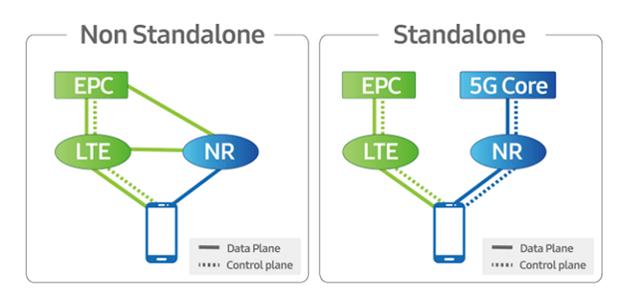
Figure 1: Simplified 5G Network [5]

5G NR Design
Engineers identify and solve problems using detailed engineering designs. Empirically, to increase the data rate is to increase the bandwidth of the system, supported by a given modulation technique. The key principles behind the 5G NR design are Flexibility, ultra-lean design, and forward compatibility. The flexibility of deploying NR using a wide range of frequencies and different deployment types (macro, micro, picocells), with diverse use cases covering eMBB, mMTC and URLLC. The physical layer components of NR are flexible and scalable. There is a wide range of QAM based modulation schemes, OFDM waveform with scalable numerology, LDPC codes with rate-compatible structure (Low-Density Parity Codes), polar codes, and frame structure with flexible slot durations. The reference signals can be beamformed in both frequency domain and time domain, and with pre-conceived densities. There are also varying multi-antenna techniques with flexible channel state information acquisition and reporting framework. Core specifications support any bandwidth from 1.4 to 20 MHz. One OFDM slot is comprised of 14 symbols. QPSK, 16QAM, 64QAM, and 256QAM (with the same constellation mapping as in LTE) are supported. Numerology is about the channel spacing. NR supports scalable numerology to address different spectrum, bandwidth, deployment, and services. Subcarrier spacing (SCS) of 15, 30, 60, 120 kHz is supported for data channels. In figure 2, shows the NR frame structure and the duration for each subframe. [5,9]
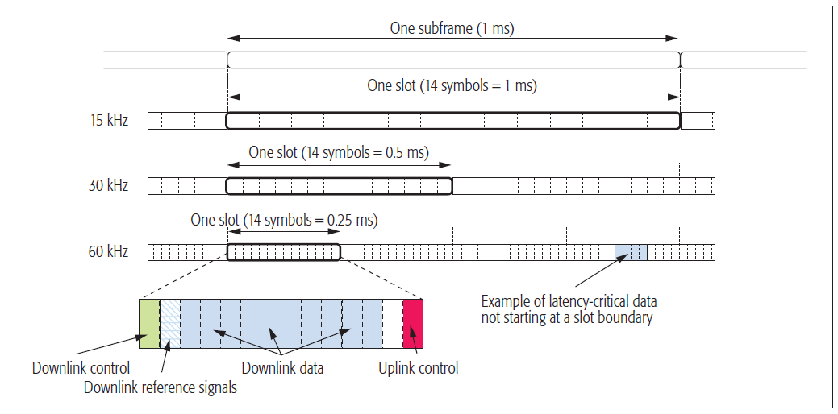
Figure 2: 5G NR frame Structure [3]

Through the guided releases of 5G NR, 3GPP has made it compatible with future innovations. NR achieved forward compatibility is by self-contained and well-confined transmissions. Self-containment means that data in a slot and a beam is decodable without dependency on other slots and beams. Well-confined transmissions refer to the approach of keeping transmissions confined in time and frequency domains to allow future inclusion of new types of transmissions in parallel with the existing backhauling transmission technologies.
Basically, Cellular networks are designed to transmit certain signals at regular intervals even when there is no data to transmit to any user. Examples of such specific signals are Reference signals, synchronization signals, and system broadcast information. Ultra-design, therefore, reduces the “always-on” transmissions. The network should transmit signals only when necessary. The ultra-lean design significantly improves network energy efficiency, reducing network operational expenses, and enabling network deployments without access to reliable power grids. This also reduces interference in high traffic load situations. The ultra-lean design also enhances the forward compatibility of NR because it is hard to modify “always-on” transmissions without degrading performance of legacy devices.NR offers four (4) main reference signals. They are demodulation reference signals, phase tracking reference signals, sounding reference signals, and channel state information reference signals. These signals are only transmitted when necessary, making NR design ultra-lean.[1]. Specifically, there are no cell-specific reference signals, a Synchronization signal is sent every 20 ms and Broadcast signal, every 20 ms, respectively [7, 8, 11].

5G Standardization and Specifications
Like the generations that have come before, 5G standardization is spearheaded by the 3rd Generation Partnership Project (or 3GPP, as it’s more commonly known). Release 15 of the 3GPP specifications started in March 2017, ends in June 2018, and contains the first complete specification of 5G NR. Let me share with you some insights into how the standardization works in practice.
3GPP first came out with release 15 standard document as at 2018. Since then, newer requirements and other use cases have given rise to release 16 and 17. This makes it reasonably technology and location neutral. Standardization of Non-Standalone (NSA) NR was intended to meet early commercial deployments, cooperating with the existing 4G LTE network. Then, the Standalone (SA) version was released to operate without relying on LTE for mobility and initial access. [9,13]
The 3GPP standardization is an open and contribution-driven process, bringing together (telecommunications) companies from all over the world in order to establish an international standard for 5G. Anyone can join 3GPP to contribute to the 5G standard and the specifications are publicly available, even to non-members.

Spectrum Allocation for 5G NR
Frequency bands for 5G NR are being separated into two different frequency ranges. First, there is Frequency Range 1 (FR1) that includes sub-6GHz frequency bands, some of which are bands traditionally used by previous standards, but has been extended to cover potential new spectrum offerings from 410 MHz to 7125 MHz. The other is Frequency Range 2 (FR2) that includes frequency bands from 24.25 GHz to 52.6 GHz. Bands in this millimeter-wave range have shorter range but higher available bandwidth than bands in the FR1
5G NR supports the use of all available spectrum types and spectrum bands. This encompasses the licensed spectrum (exclusive right), unlicensed spectrum (Shared use), and shared spectrum (New shared spectrum paradigms). Spectrum sharing unlocks more spectrum possibilities, new deployment scenarios, and Increased spectrum utilization, with higher efficiency. Spectrum can be shared both horizontally and vertically. This is defined as FDD and TDD. FDD is frequency division duplex and TDD is Time division duplex. Benefits of the 5G NR TDD self-contained slot structure is a much faster, more flexible TDD switching, with better spectrum utilization and a guaranteed bandwidth. [3,8,9]

5G and 4G LTE Coexistence
The frequency spectrum is a limited resource and so efficient utilization must be promoted. This is can be achieved by spectrum sharing which can be static or dynamic. Static spectrum sharing means that there will be a dedicated carrier frequency for each wireless access technology within the same band. It is transparent to the UE but not too spectrally efficient. Data rate increases with bandwidth. Any current or future technology stifled of bandwidth will not meet its goal. This gave rise or the dynamic approach, called Dynamic Spectrum Sharing (DSS). Overlapped and non-overlapped LTE and NR carrier frequencies transition is more efficient for 5G and 4G coexistence
The DSS concept is based on the flexible design of NR physical layer. It uses the idea that NR signals are transmitted over unused LTE resources. With LTE, all the channels are statically assigned in the time-frequency domain, whereas the NR physical layer is extremely flexible for reference signals, data, and control channels, thus allowing dynamic configurations that will minimize a chance of collision between the two technologies.
One of the main concepts of DSS is that only 5G users are made aware of it, while the functionalities of the existing LTE devices remain unaffected (i.e. LTE protocols in connected or idle mode). Re-farming is the process of re-purposing certain parts of the frequency spectrum for newer technological uses. [10,11]
Re-farming low band carriers from 4G without a corresponding increase in 5G devices penetration might lead to congestion of the remaining LTE carriers, degrading indoor coverage for LTE users who still represent the majority of the subscriber base. This co-existence between 5G and 4G LTE can thus be considered as a flexible re-farming

Deployment modes of 5G

3GPP has defined possible deployment modes to integrate elements of different generations in different configurations with 5G. They are broadly divided into two modes: SA (standalone) and NSA (non-standalone). SA scenario uses only one radio access technology (5G NR or 4G LTE radio cells) and the core networks are operated alone. Data and control information are handled by the 5G network. NSA scenario combines NR radio cells and LTE radio cells using dual-connectivity to provide radio access and the core network may be either 4G EPC (Evolved Packet Core) or 5GC [12]. For this option, the 5G control information is carried by the 4G LTE network, while the data traffic is carried by the 5G NR network. This is to enable a smooth upgrade of the existing network to support 5G services seamlessly. Figure 3 below enunciates
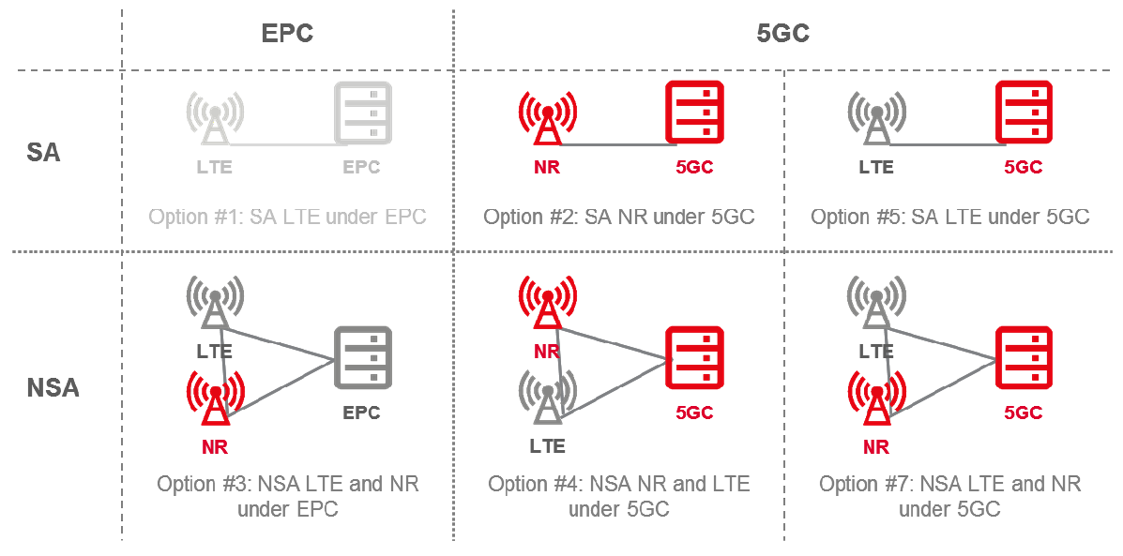
Figure 3: 4G and 5G Deployment Options [12]

Benefits of 5G Network
Based on the initial driving forces for higher data rates, very low latency, the massive interconnection of devices, and more efficient spectrum utilization. This is given rise to many use cases outside just mobile communication. Inherently, SDN and NFV are two enabling technologies behind a couple of these use cases. Software-Defined Networking (SDN) paved with way for a centralized end-to-end AI-driven transport solution. This is vendor and service neutral. Then, Network Function Virtualization (NFV) took this innovation to another level by making network functions and resources to be provisioned as virtual machines. This is what gave rise to network slicing, which is a core network NFV-solution that intelligently and securely share resources across the network for varying number of services at the same time, keeping to their service level agreements (SLA). This means the telecom operators can have a huge return on investment as their network is able to support as many services as possible, being network neutral. This promotes an All-IP network leading to full convergence in the ICT world. [13]
Furthermore, the use of various band across the frequency spectrum increases both data rate and network coverage. Home broadband penetration is greatly increased, even with the advent of unlicensed frequency for the NR technology.
IoT has can be better achieved with the interconnection of devices for varying purposes. This covers V2V communication, self-driving cars, use of drones, and other later intelligent devices. It has also become a platform for telemedicine, improved agricultural management, and for other industrial purposes. Virtual reality (VR) and augmented reality (AR) are also covered as multimedia-related services actually pushed for an increase in the possible data rates offered by the wireless network.

Conclusion
Pin-pointedly, the 5G NR offers a wide range of use cases is expected to lead to significant socio-economic benefits. The three key components have been maturely achieved. 3GPP approved the highly anticipated standalone 5G NR specifications in June 2018. This article provided an overview of the 5G NR in the wireless technology circle, dwelling more on more efficient use of the wireless access channel, or air interface. 5G NR can co-exist with the 4G LTE network both riding on the legacy backhaul transmission network. SDN and NFV have introduced the logical and more efficient use of the mobile network to support many use cases, services, deployments, and future possibilities. The 5G NR is the beginning of the future of the mobile communication network.

References

- Ericsson Technology review, February 2020, 5G New Radio Evolution, IEEE Communications Standards Magazine, December 2017. pp 2-14
- Stefan Parkvall, Erik Dahlman, Anders Furuskär, and Mattias Frenne. December 2017, “NR: The New 5G Radio Access Technology”, IEEE Communications Standards Magazine, December 2017 pp. 24-30,
- Qualcomm Technologies, Inc. September, 2016. Making 5G NR a reality Leading the technology innovations for a unified, more capable 5G air interface. pp 2-63
- Qualcomm Technologies Inc., September 2018, Expanding the 5G NR ecosystem. 5G NR roadmap in 3GPP Release 16 and beyond. pp 3-25
- Non-Standalone 5G-NR vs Standalone 5G NR. Available at https://www.everythingrf.com/community/non-standalone-5g-nr-vs-standalone-5g-nr
- Joaquin RESTREPO, September 2019, “Spectrum Allocation for 5G International Framework, Workshop on Economics, Finance and Business models for 5G and new Technologies for Digital Africa (RED-AFR19)”, pp. 2-33
- Alexander Serbin, May 2018, “On the roads to 5G: theory and practice”. Huawei Technologies, ITU Seminar. pp 2-18
- Amitabha Ghosh, Nokia, May 2018, “5G New Radio (NR): Physical Layer Overview and Performance”, IEEE Communication Theory Workshop 2018. pp 2-37
- 3GPP publication. The 5G Evolution: 3GPP Releases 16-17, Jan 2020. pp 22-27
- Qualcomm Technologies Inc., December 2017, “What can we do with 5G NR Spectrum Sharing that isn’t possible today?” Available at https://www.qualcomm.com/media/documents/files/new-3gpp-effort-on-nr-in-unlicensed-spectrum-expands-5g-to-new-areas.pdf. pp. 4-32
- Ericsson,”Three design principles of 5G New Radio”. Available at https://www.ericsson.com/en/blog/2017/8/three-design-principles-of-5g-new-radio
- GSMA publication, April 2018, Road to 5G: Introduction and Migration. pp 6-27

- Shiv K. Bakhshi, Ph.D., February 2018, “5G and standards: managing complexity, ensuring interoperability”. Ericsson presentation. pp 2-18

