SRTI - Simple run-time interface

v2 GUI Documentation

V0.68.01 – 2019-09-12

**Table of Contents:**

|  |  |
| --- | --- |
|  | Chapter 0 – Release Notes |
| Page 2 | * 1. Summary |
| Page 2 | * 1. Third-Party Licenses |
| Page 2 | * 1. Release Updates |
|  | **Chapter 1 – User Introduction** |
| Page 4 | * 1. Definitions |
| Page 5 | * 1. What is SRTI? |
| Page 6 | * 1. Core Concepts – v1.00.00 |
| Page 9 | * 1. Core Concepts – v2.00.00 |
| Page 11 | * 1. Simulator Configuration File Format – SRTI v2.00.00 |
| Page 17 | * 1. Detailed Concepts (for Developers) (v2.00.00) |
|  | **Chapter 2 – User Example** |
| Page 23 | 1. Airport Example – Synopsis |
| Page 25 | ii. Airport Example – Version 1 (Java) |
| Page 34 | iii. Airport Example – Version 2 (Java) |
| Page 40 | * 1. Airport Example – Version 3 (Matlab) |
| Page 41 | * 1. Airport Example – Version 4 (NetLogo) |
| Page 43 | **Chapter 3 – Additional Notes** |
|  |  |
|  |  |
|  |  |
|  |  |
|  |  |
|  |  |
|  |  |
|  |  |

**Chapter 0 – Release Notes**

1. **Summary**

This is an introduction to the SRTI v2 GUI, an optional complimentary software to use with the SRTI v2 system. This free, open-source application was written in HTML, CSS and JavaScript, compiled with Electron. This is not to be confused with the “Server GUI” that is written in Java’s Swing library, already included inside the SRTI .jar file.

For compatibility, the SRTI v2 GUI (**v0.68.1**) should be used with SRTI **v2.20.02** (both RTI Server and Wrapper), or else the most recent up to that version.

SRTI (Simple Real-Time Interface) is a portable software solution to allow data transfer between different programs, be they in different languages or on different computer systems, be they local or connected through a network. This was built with the intention of being easy to use and maintain, primarily for scientific simulations to cooperate with each other in real time but can also be utilized in related IoT (Internet of Things) projects.

The project began in 2017 and is still under continuous development to add functions and improve efficiency. SRTI is free and open-source and is funded in part by the University of Michigan.

The full public source code, pre-compiled libraries, documentation, and other information can be found at <https://github.com/hlynka-a/SRTI> .

1. **Release Updates**

2019-09-12

* This covers SRTI v2 GUI v0.68.1, which includes a compiled desktop GUI for Windows that can output configuration files for a SRTI v2 Wrapper, and launch a series of simulators from within the GUI itself. This is considered to be an alpha version of the app, which may contain bugs, and may be subject to changes by the time the full version is released.

**Chapter 1 – Introduction**

1. **What is the SRTI v2 GUI?**

SRTI (Simple Real-Time Interface) is a free, open-source and portable software solution that allows external software simulations to connect with each other and share information in real-time.

SRTI v1.00.00 is purely a data-transmission system. It uses a single RTI Server as the shared access point for individual simulator programs to join. Each simulator needs to locally reference the provided RTI Lib API to make a connection, which abstracts most of the low-level details of the connection. Sockets are used for the communication channel between RTI Server and RTI Lib. Messages sent through the system are transmitted in ‘string’ format, for better interoperability between languages, compared to pure byte code. To assist with this, JSON is used as the standard message format (although any string-representation can be used for the content from each simulator).

SRTI v2.00.00 is a more advanced and specialized update of v.1.00.00. Building upon the original data-transmission protocol, it adds new functionality based on a different goal: to explicitly support artificial simulation systems. In addition to the RTI Server and RTI Lib API, it adds an RTI Manager (coupled with RTI Server) and RTI Wrapper. Instead of having simulators control themselves and how they parse information from the SRTI, the RTI Wrapper takes over much of the responsibility, allowing easier design of larger simulation systems without explicit recoding.

The SRTI v2 GUI is a helper application meant to work with SRTI v2.00.00. Normally, v2.00.00 requires a configuration file to be written for each simulator, written in JSON format according to a set definition. After this, the user would have to launch every simulator individually to connect to the RTI Server. The SRTI v2 GUI makes these steps easier: the user gets an **interactive graphic interface** to describe their simulator system (and how different simulators correspond to each other), and it can **output the configuration files based on the user’s design**. Buttons inside the GUI can also **launch the RTI Server and simulators**, rather than having the user to it manually one at a time.

**DISCLAIMER**: It is **strongly recommended** that the user read through the documentation for SRTI_v2_00_00, to understand how the SRTI, the Wrapper, and the configuration variables work, before attempting to use the SRTI v2 GUI, and before reading this document.

1. **Downloading and Launching**

The SRTI v2 GUI can be downloaded from the same public location as the rest of the SRTI files, on GitHub. The root branch can be found at <https://github.com/hlynka-a/SRTI> , and the compiled GUI can be found at <https://github.com/hlynka-a/SRTI/tree/master/SRTI_GUI/compiled_example/gui> .

Compiled with Electron and “electron-builder,” there are 2 versions of the SRTI v2 GUI that can be downloaded. The first is a single standalone .exe (“SRTI-v2-00-00-Manager-GUI 0.68.1.exe”), above the “win-unpacked” folder. The second is the entirety of the “win-unpacked” folder, including another .exe (“SRTI-v2-00-00-Manager-GUI.exe”). They are both functionally identical; the standalone .exe is a packed version of the other, easier to download and copy between computers. Consequently, opening the standalone .exe may take several seconds (it must unpack itself), whereas opening the “win-unpacked” version is quicker. Both versions do not need to be formally installed, and can be transferred between systems or folder locations.

Both versions include a version of the RTI Server (“SRTI_v2_20_02.jar”) that it references. A function is in place to allow the user to reference a different version (currently not functional) within the GUI.

As of 2019-09-12, only a Windows version of the app is compiled. The source code can be downloaded on Mac and Linux machines to compile a version for other operating systems (Electron required to compile). For basic testing, the GUI can also be opened in a web-browser on a local machine, but access to a local file system from a browser is restricted, preventing saving/opening projects or launching a system.

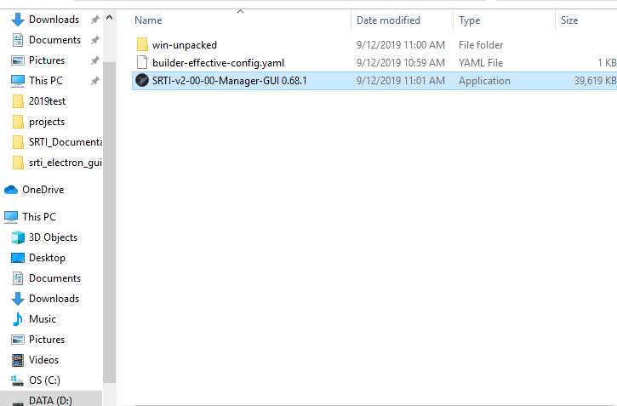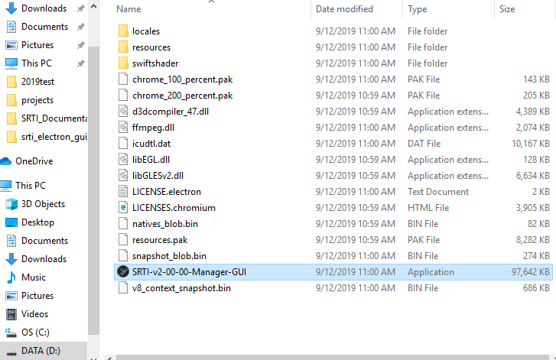To open, double-click on the .exe.

Figure - Location of packed standalone GUI .exe

Figure - Location of unpacked GUI .exe

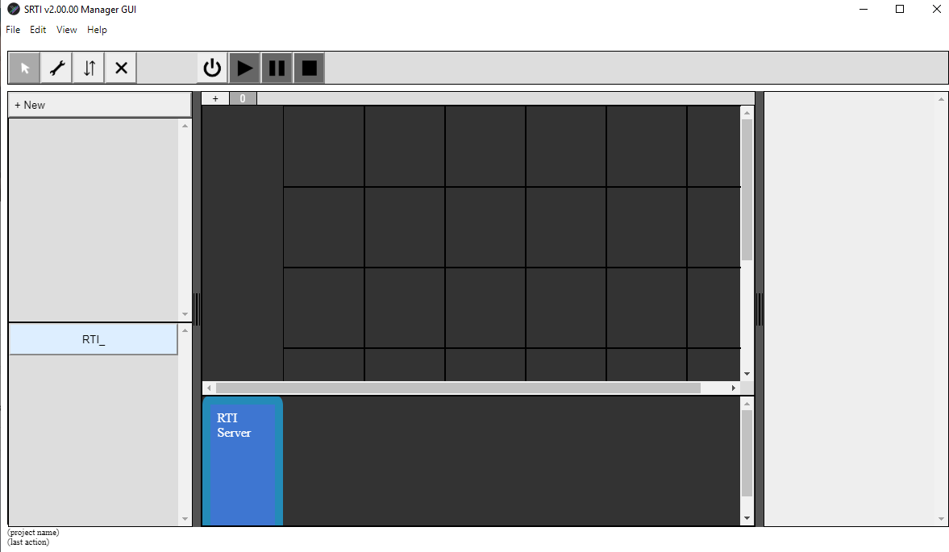

Figure - SRTI v2 GUI with empty project.

**Chapter 3 – Additional Notes**

For assistance or questions, users can contact developer Andrew (Andy) Hlynka at [ahlynka@umich.edu](mailto:ahlynka@umich.edu) .